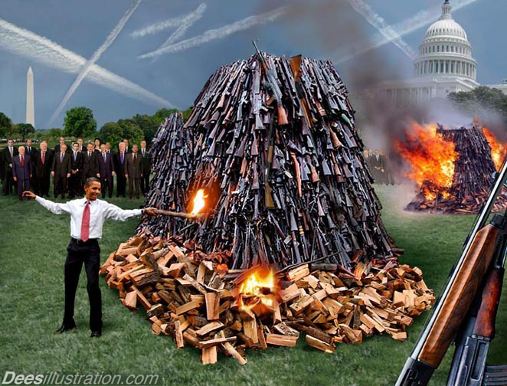

Now I Can Take Your Guns

- ATF using mentally disabled men as straw purchasers – pg. 2
- Bob Marley and Jamaica – 3
- Gun stolen from trains – pg. 3
- Wesley Felix and National Survival Store – pg. 4
- The 2017 Gun Trace Report for Chicago – pg. 4
- Additional info related to Chicago and the trace report – pg. 34
- Must-see extras – pg. 40
- A little 2A news – pg. 41
- Solutions – pg. 42

ATF using mentally disabled men as straw purchasers
Read this:
Allegations Against the ATF: Using The Mentally Disabled as Pawns
https://www.theatlantic.com/national/archive/2013/12/allegations-against-the-atf-using-the-mentally-disabled-as-pawns/282226/
“We have constantly been told by ATF officials that this was an isolated incident and merely the result of inadequate supervision. It is now clear that is not the case after the Milwaukee Journal Sentinel reported similar botched ATF operations elsewhere around the country. ATF is the primary agency entrusted with enforcing our gun laws but cannot seem to lawfully run a basic sting operation.” These are not botched operations. And it’s clear that nothing from the ATF can be trusted, and it would be criminal for anyone in government to act on information from the ATF without first verifying the information.

Congressional committees to investigate botched ATF stings
https://archive.jsonline.com/watchdog/watchdogreports/congressional-committees-to-investigate-botched-atf-stings-b99185409z1-240559861.html/

“‘To say this is just a few people, a few bad apples, I don’t buy it,’ David Harris, a professor at the University of Pittsburgh School of Law and an expert on law enforcement tactics and regulation, told the Journal Sentinel. ‘If your agency is in good shape with policy, training, supervision and accountability, the bad apples will not be able to take things to this level.’”
Source: ATF uses rogue tactics in storefront stings across nation
https://archive.jsonline.com/watchdog/watchdogreports/atf-uses-rogue-tactics-in-storefront-stings-across-the-nation-b99146765z1-234916641.html/

Additional information:
A Journal Sentinel investigation uncovered deep flaws and a profound lack of government oversight in undercover ATF stings across the country, including in Milwaukee.
http://archive.jsonline.com/watchdog/backfire-190528221.html?_ga=2.212495254.366999931.1596958567-1516699433.1596580924
Archived: http://archive.today/kg0Cj

What happens to the guns the ATF collects from operations like these? Are they stored, traced, sorted, and then distributed in select cities?

Bob Marley and Jamaica
one love concert 1978 Bob Marley
https://www.youtube.com/watch?v=Reo5hD-dEYM

Who Killed Bob Marley Documentary - Strange Universe Documentary
https://www.youtube.com/watch?v=ZG0RSFZZOO8

How the C.I.A and Edward Seaga Destroyed Jamaica
https://www.youtube.com/watch?v=q6bgBN41bms

Gun stolen from trains
Gangs reap guns from trains in violent Chicago neighborhoods
https://apnews.com/0ed63f11c9ba4cdf9da464f2d9604b6b

'Serial train robber' gets 10 years in gun thefts from Chicago rail yard
https://abc7chicago.com/guns-stolen-from-train-chicago-gang-member-gangs/2485318/

Wesley Felix and National Survival Store
National Survival Store, Julie Shields. ATF Fast v
https://www.youtube.com/watch?v=IXCYe28SLc8

Questionable Gun Store Bank Transactions Merit Congressional Inquiry of ATF
https://www.ammoland.com/2016/05/questionable-gun-store-bank-transactions-merit-congressional-inquiry-atf/#axzz6UYwnnfTt
*Also read the comments section.
https://www.facebook.com/Axj-National-Survival-Store-News-1670894293168919/
https://twitter.com/wesleyfelixpsi/status/969956908890312704?lang=en
https://twitter.com/wesleyfelixpsi/status/971051302892589059

Additional information:
http://wellsfargoandatf.blogspot.com/
A Wells Fargo personal banker pleaded guilty to helping launder millions of dollars for drug traffickers like the Sinaloa cartel
https://www.businessinsider.com/wells-fargo-banker-money-laundering-drug-cartel-sinaloa-mexico-2019-5
Fines for Laundering Money are Just the Cost of Doing Business for Big Banks
https://www.ourvalleyvoice.com/2019/08/18/fines-for-laundering-money-are-just-the-cost-of-doing-business-for-big-banks/
How a big US bank laundered billions from Mexico's murderous drug gangs
https://www.theguardian.com/world/2011/apr/03/us-bank-mexico-drug-gangs

The 2017 Gun Trace Report for Chicago
Let’s take a look at the 2017 Gun Trace Report for the city of Chicago (https://www.chicago.gov/content/dam/city/depts/mayor/Press%20Room/Press%20Releases/2017/October/GTR2017.pdf).
Note: I didn’t try to point out every discrepancy, and this still turned out larger than I expected.
Page numbers in red denote information is from the report.
Things really start to heat up at page 20 so just hang in there.
Remember, this report is from a totally corrupt agency and city government that has, and is, scheming, even through mass murder, to convince the nation that certain states and the nation needs stricter gun control laws. What could go wrong?

“Gun Trace Report 2017 issued at the direction of the Chicago Mayor’s Office outlines a comprehensive public safety strategy, certain elements of which the firearms industry would endorse including increasing the number of police officers on the street and tough sentences for criminals who use guns. The bulk of the report, however, starts from a purposely misleading premise and represents what we have heard before as a political narrative from the administration of Mayor Rahm Emanuel. As to the premise, a tracing request is simply a law enforcement tool. As the Bureau of Alcohol Tobacco Firearms and Explosives (ATF) ATF has repeatedly stated, ‘The appearance of [a licensed dealer] or a first unlicensed purchaser of record in association with a crime gun or in association with multiple crime guns in no way suggests that either the federal firearms licensed dealer (FFL) or the first purchaser has committed criminal acts. Rather, such information may provide a starting point for further and more detailed investigation.’ (Crime Gun Trace Analysis Reports, ATF, 1998).”
Source: NSSF Issues Statement on Chicago Gun Trace Report – pg. 1
November 1, 2017
https://www.nssf.org/nssf-issues-statement-on-chicago-gun-trace-report/

“It should be noted that unsuccessful traces are not the only problem in using trace data to characterize the supply chain of guns that end up in the hands of gang members. In effect, guns recovered by the police are just a sample from the much larger ‘population’ of guns in the hands of gang members. That sample may or may not be representative of the relevant individuals (gang members with ready access to a gun). If not, conclusions reached on the basis of analyzing recovered guns, especially recovered guns that have been successfully traced, may be misleading.⁷⁵”
Source: SOME SOURCES OF CRIME GUNS IN CHICAGO: DIRTY DEALERS, STRAW PURCHASERS, AND TRAFFICKERS - pg. 737
https://scholarlycommons.law.northwestern.edu/cgi/viewcontent.cgi?referer=&httpsredir=1&article=7538&context=jclc

Here are the first two sentences of the 2017 Chicago Trace Report:
“Since 2013, the Chicago Police Department has recovered nearly 7,000 ‘crime guns’ each year. For the purposes of this report, a crime gun refers to a firearm recovered by CPD that was illegally possessed, used, or suspected to be used in furtherance of a crime.¹”
¹ Bureau of Alcohol, Tobacco, Firearms, and Explosives. Fact Sheet – National Tracing Center. (March, 2016). Available at https://www.atf.gov/resource-center/fact-sheet/fact-sheet-national-tracing-center
Their source says nothing about the definition of a crime gun, but the definition is confirmed in another report:
“A crime gun is defined, for purpose of firearms tracing, as any firearm that is illegally possessed, used in a crime, or suspected by enforcement officials of being used in a crime.”
Source: ATF CRIME GUN TRACE ANALYSIS REPORT Seattle, Washington - pg. 3 (of report, not pdf)
https://www.atf.gov/resource-center/docs/seattle1pdf/download
I’m having flashbacks of my COVID-19 research – how to fill out a death certificate (whether it caused or was assumed to have caused….). The first two sentences of the report prove that it can’t be trusted. There’s really no reason to continue.
Crime guns include guns that were recovered by CPD and were suspected to be used in furtherance of a crime.
1. Suspected
2. In furtherance of a crime
Are you serious?
What’s their definition of “in furtherance of a crime”?
And actual government employees made decisions based on this!
The report goes on to state:
“The overwhelming majority of these firearms were originally purchased outside of the city limits and brought into Chicago. So far in 2017, CPD is already on pace to exceed last year’s gun recoveries. It is self-evident that the availability of illegally circulated firearms in Chicago is directly connected to its deadly street violence. Simply put, each conflict becomes potentially more lethal due to easy access to a gun.² In an unfortunate but persistent reality, certain retailers and jurisdictions disproportionately account for the guns trafficked into Chicago that sustain its illegal gun market and associated violent crime.
“There is no greater priority for the City of Chicago than the safety and security of its residents. The City of Chicago and Chicago Police Department have partnered with the University of Chicago Crime Lab to examine available firearm trace data and identify the source of each crime gun recovered in order to develop more impactful solutions that address the root causes of gun violence. This is the second such report. In its 2014 report, CPD compiled firearm trace data from 2009 to 2013.³ This report analyzes available firearm trace data over four years, from 2013 to 2016, spanning almost 15,000 firearms traced back to more than 5,000 federally licensed dealers. Using this data, law enforcement and policymakers have identified the regular sources of crime guns trafficked into Chicago with pinpoint accuracy. More importantly, they are now better equipped to develop policies that will help prevent these guns from getting into the hands of high-risk individuals.
“Chicago is in many ways a microcosm of a national epidemic. The United States’ gun homicide rate is nearly 20 times higher than any other industrialized nation.⁴ Not surprisingly, its rate of gun ownership per capita far exceeds that of these nations as well.⁵ The Graduate Institute of International and Developmental Studies in Geneva estimates nearly half of all guns in circulation worldwide are in the United States, although it makes up just over four percent of the global population.⁶ As the trace data and illegal firearm recovery numbers demonstrate, Chicago faces a unique predicament in enforcement efforts against illegal gun trafficking. Illinois is surrounded by states that lack comprehensive firearms regulations, with particularly little oversight of secondary sales markets.⁷” – pg. 1
How much of that do you think is true?
Chicago homicides are used to drive the argument for tougher laws in Indiana and the nation. “Your guns are causing our homicides.” Okay, what percentage of crime guns are crime guns by homicide? You would think that this would be included in this report, right? It’s not. It’s nowhere to be found.
“From 2013 to 2016, without adjusting for population density, Chicago’s total firearm recoveries outnumbered Los Angeles and New York City each year. For the last four years, CPD’s firearm recovery rate has not wavered, with police in Chicago seizing just below 7,000 illegal guns per year.” – pg. 3
What part does the programs in the city of Chicago play in that? What part do police actions in Chicago play in that? Couldn’t that be controlled like water from a faucet? What if Chicago is doing something other cities are not?

“Analyzing available gun traces between 2013 and 2016, federally licensed Illinois dealers primarily located in suburban Cook County were the original point of purchase for approximately two out of every five crime guns recovered in Chicago: This proportion is nearly identical to what was observed in previous trace data from 2009-2013.¹¹ … Federally licensed firearms dealers (“FFL”) in suburban Cook County and Illinois collar counties, as well as several located just across the state border in Indiana, are the primary source of illegal guns seized in Chicago.”
¹¹ Author’s Note: The data used in this report represents firearms that were recovered by the Chicago Police Department and successfully traced to a federally licensed firearms dealer based on the firearm’s make, model, and serial number maintained in ATF records from the initial point of sale.

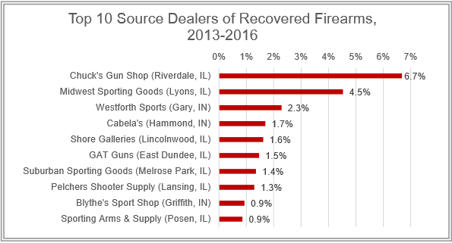
“For the better part of a decade, Chuck’s Gun Shop and Midwest Sporting Goods have consistently remained the top two FFL source dealers for crime guns recovered by police in Chicago. Chuck’s Gun Shop and Midwest Sporting Goods continue to provide a strikingly large portion of the total number of traceable crime guns that includes more than 5,000 separate FFL dealers from all 50 states.” – pg. 4
The top two FFL sources, according to them, are in Illinois, but where’s all the uproar over this? Why is this left out?
And this is supposed to be some legitimate report, but throughout the report all they show is the top ten.

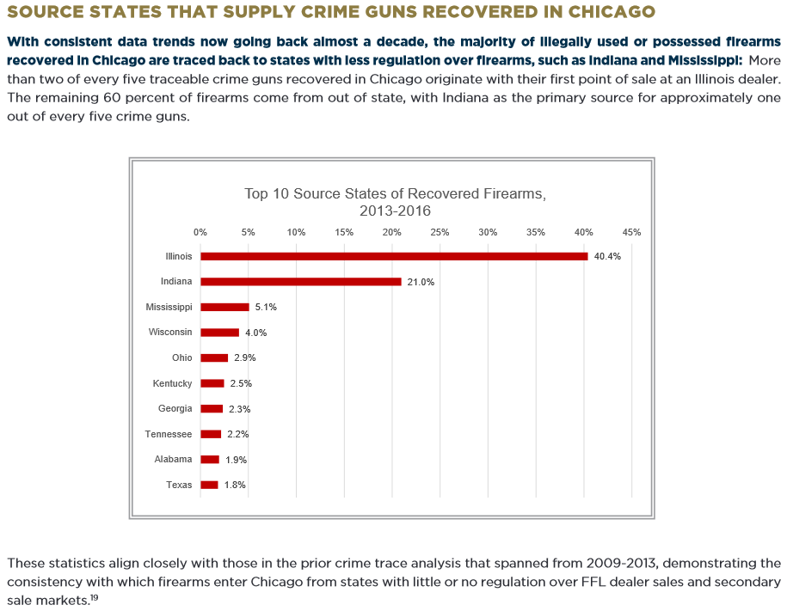
pg. 8

This is supposed to be a legitimate report, but the language is not even consistent. They state that these are the states that supply crime guns recovered in Chicago. They then go on to state “the majority of illegally used or possessed firearms recovered in Chicago are traced back to states with less regulation over firearms, such as Indiana and Mississippi; and then state “Top 10 Source States of Recovered Firearms”. In addition, they state “More than two of every five traceable crime guns … The remaining 60 percent….” – from fractions to percentages.
“Trace data going back almost a decade demonstrates that roughly two out of every five of Chicago’s crime guns come into the city from Illinois source dealers, making Illinois the single largest source state for Chicago’s illegal guns.” – pg. 12
60% of these guns come from other states, the other 49 states. And 40% come from Illinois. That gives a totally different impression than what the media and government officials are screaming.
And how does this compare to other states? Where do the crime guns of other states come from?

“… the majority of illegally used or possessed firearms recovered in Chicago are traced back to states with less regulation over firearms, such as Indiana and Mississippi.”
Less regulation? Like what? Which laws?
They’re report focuses on purchases made at FFLs, not private party transfers, right? So, what are the specific laws that made purchasing handguns in Indiana so different than elsewhere?

“… the majority of illegally used or possessed firearms recovered in Chicago are traced back to states with less regulation over firearms, such as Indiana and Mississippi.” Or, are they traced back to states, or a state, that is closer to Chicago, making location a key factor also?
“Indiana is directly adjacent to Illinois and just a short drive from Chicago, particularly from the high-crime south side of the city.”
Source: SOME SOURCES OF CRIME GUNS IN CHICAGO: DIRTY DEALERS, STRAW PURCHASERS, AND TRAFFICKERS - pg. 747
https://scholarlycommons.law.northwestern.edu/cgi/viewcontent.cgi?referer=&httpsredir=1&article=7538&context=jclc
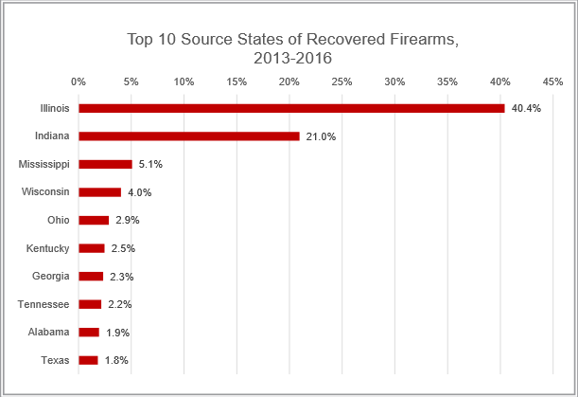
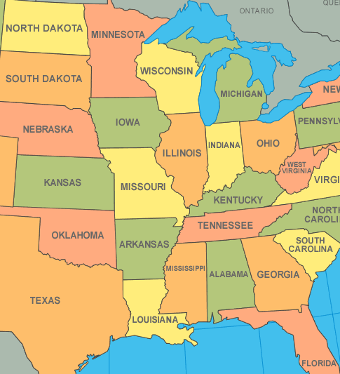

But what’s really going on?
Note: Many people want you to believe that if you don’t need a license to buy a gun, or you don’t need to register your gun, it’s an invisible gun and invisible purchase. No. If purchased from an FFL there is always a background check, and usually a type of test, and your name is always recorded and associated with that gun. It’s still traceable.
Compare the laws of Indiana to the laws of Missouri:
Wikipedia 2014:
Gun laws in Indiana
https://web.archive.org/web/20141120085352/https://en.wikipedia.org/wiki/Gun_laws_in_Indiana
Wikipedia 2014:
Gun laws in Missouri
https://web.archive.org/web/20141202024806/https://en.wikipedia.org/wiki/Gun_laws_in_Missouri

Indiana
“A report from Chicago authorities found that nearly 60% of illegal guns recovered in the city from 2009 to 2013 were first sold in states with more lax gun laws. The largest portion came from Indiana, which accounted for 19% of the illegal guns in Chicago. The report blames Indiana’s lax gun laws, which allow gun owners to sell their weapons to other people without background checks or paperwork recording the sale. ‘This makes it incredibly easy for gun traffickers, violent offenders and other prohibited purchasers to buy guns undetected,’ the report said.”
Source: Is Indiana to blame for Chicago's gun violence?
October 28, 2015
https://www.usatoday.com/story/news/politics/2015/10/28/lax-indiana-gun-laws/74740388/
They don’t have a source for this statement so I don’t know what report they’re referring to. The trace report we’ve been looking at, and the information that we’re hearing, is that crime guns traced back to sales at FFLs are the source, and it’s done through straw purchases. So, which one is it, straw purchases or private party transfers?

Take a look at this:
Important Information About Gun Ownership In Indiana By: James W. McNew September 2013
https://www.awmlaw.com/articles-by-our-attorneys/articles-of-general-interest/indiana-gun-law-an-overview/
Is there something there that is so drastically different than elsewhere? You don’t have to register your gun in California either. And having some sort of permit, which in California is passing a safety certificate test on paper, would do little to deter straw purchasing.
“f. A person may not sell or give a firearm to any person who has reason to believe that person has been convicted of a felony, is a drug abuser or under the influence of a drug, is an alcohol abuser or in a state of intoxication or is mentally incompetent.
g. A dealer may not sell, rent, trade or transfer a handgun to a person until the dealer has complied with the federally mandated requirement of obtaining a NCIS background check.”
Where are the laws that are enabling these guns to flow into Chicago, and that makes Indiana so different than surrounding states?

According to this 2010/2011 ATF document on Indiana (and from the info above), a person purchasing a handgun from an FFL still had to go through the background check required by federal law. All I could find that might affect straw purchasing is this law applying to dealers, if still applicable from 2013-2016: “Except as otherwise provided in this chapter, a dealer who knowingly or intentionally sells, rents, trades, or transfers a handgun in violation of this chapter commits a Class A misdemeanor.”
Source: https://www.atf.gov/resource-center/docs/guide/state-laws-and-published-ordinances-2010-2011-indiana/download

Missouri
“The increase in murders with firearms in Missouri began in the first full year after the PTP handgun law was repealed when data from crime gun traces revealed simultaneous large increases in the number of guns diverted to criminals and in guns purchased in Missouri that were subsequently recovered by police in border states that retained their PTP laws.
‘This study provides compelling confirmation that weaknesses in firearm laws lead to deaths from gun violence,’ said Daniel Webster, ScD, MPH, director of the Johns Hopkins Center for Gun Policy and Research and the study's lead author. ‘There is strong evidence to support the idea that the repeal of Missouri's handgun purchaser licensing law contributed to dozens of additional murders in Missouri each year since the law was changed.’
Webster and colleagues found that the spike in murders in Missouri following the PTP law repeal only occurred for murders in Missouri committed with a firearm and was widespread across the state's counties. Following the change in Missouri's gun laws, none of the states bordering Missouri experienced significant increases in murder rates and the U.S. murder rate actually declined by over five percent. The researchers also analyzed annual data from death certificates through 2010 compiled by the Centers for Disease Control and Prevention, and determined that the repeal of Missouri's PTP law was associated with a twenty-five percent increase in firearm homicides rates.
For firearm sales by federally licensed firearm dealers, federal law requires prospective purchasers to pass a criminal background check and sellers to maintain records of the sale. But federal law and laws in most states exempt these regulations when the firearm seller is unlicensed. The researchers suggest that universal background checks and firearm purchaser licensing affect homicide rates by reducing the availability of guns to criminals and other prohibited groups.
‘Because many perpetrators of homicide have backgrounds that would prohibit them from possessing firearms under federal law, they seek out private dealers to acquire their weapons,’ said study author Jon Vernick, JD, MPH, deputy director for the Johns Hopkins Center for Gun Policy and Research. ‘Requiring a background check on all gun sales is a commonsense approach to reducing gun violence that does not infringe upon the Second Amendment rights of law-abiding gun owners.’”
Source: Repeal of Missouri's Background Check Law Associated with Increase in State's Murders
February 17, 2014
https://www.jhsph.edu/news/news-releases/2014/repeal-of-missouris-background-law-associated-with-increase-in-states-murders.html
- “Webster and colleagues found that the spike in murders in Missouri following the PTP law repeal only occurred for murders in Missouri committed with a firearm and was widespread across the state's counties. Following the change in Missouri's gun laws, none of the states bordering Missouri experienced significant increases in murder rates and the U.S. murder rate actually declined by over five percent.” Guns didn’t start flowing into Illinois? Interesting.

Take a look at these excerpts from In Missouri, Fewer Gun Restrictions and More Gun Killings By SABRINA TAVERNISE
In the past decade, Missouri has been a natural experiment in what happens when a state relaxes its gun control laws. For decades, it had one of the nation’s strongest measures to keep guns from dangerous people: a requirement that all handgun buyers get a gun permit by undergoing a background check in person at a sheriff’s office.
But the legislature repealed that in 2007 and approved a flurry of other changes, including, last year, lowering the legal age to carry a concealed gun to 19. What has followed may help answer a central question of the gun control debate: Does allowing people to more easily obtain guns make society safer or more dangerous?
… It is difficult to isolate the impact of gun laws in a single state, given the pervasiveness of interstate trafficking and illegal markets, but a variety of measures, including a marked increase in police seizures of guns bought in-state, suggest the changes in Missouri’s laws have had some effect.
Research by Daniel Webster, the director of the Johns Hopkins Center for Gun Policy and Research, found that in the first six years after the state repealed the requirement for comprehensive background checks and purchase permits, the gun homicide rate was 16 percent higher than it was the six years before. During the same period, the national rate declined by 11 percent. After Professor Webster controlled for poverty and other factors that could influence the homicide rate, and took into account homicide rates in other states, the result was slightly higher, rising by 18 percent in Missouri.
Federal death data released this month for 2014 showed a continuation of the trend, he said. Before the repeal, from 1999 to 2006, Missouri’s gun homicide rate was 13.8 percent higher than the national rate. From 2008 to 2014, it was 47 percent higher. (The new data also showed that the national death rate from guns was equal to that from motor vehicle crashes for the first time since the government began systematically tracking it.)
Other measures suggested that criminals had easier access to guns after the permit law was repealed. Professor Webster analyzed data from the federal Bureau of Alcohol, Tobacco, Firearms and Explosives, and found that the share of guns that were linked to crimes soon after they were bought doubled in the state from 2006 to 2010. The portion of guns confiscated by the police in Missouri that had been originally bought in the state — ordinarily a very stable statistic — rose to 74 percent last year, from 56 percent before the law changed.
Expert Disagreement
In interviews, researchers cautioned that causation is hard to prove, and that just because the gun homicide rate rose after 2007, it does not mean the repeal was the reason. Still, most of them were convinced that the data suggested an effect.
A few were not. Gary Kleck, a professor of criminology at Florida State University, said he doubted that Missouri’s permit law had ever blocked many criminals from getting guns. Gun homicides in California rose after the state banned one category of guns, so-called junk guns, he said, suggesting tighter laws were not safer. Professor Webster noted that the rise in California disappeared with more years of data.
… Of all the gun law changes, the one that most affected homicides was the repeal of the permit law requiring a background check at a sheriff’s office, Professor Webster argued. It had applied to any prospective gun buyer — even someone buying from a private seller.
Now permits are no longer required. Gun buyers must still pass background checks if they buy guns in stores, which send applicants’ personal information to the F.B.I. Gun control proponents say those checks are less rigorous than before, though gun rights supporters insist they are just as thorough. Buying from a private seller requires no check at all.
Some gun rights supporters say the change was less significant than it appeared because people buying from private sellers rarely bothered with permits even under the old system.
“A lot of people didn’t even know there was a permit system,” said Kevin L. Jamison, a lawyer in Missouri who concentrates on weapons cases.
Professor Webster said there was no way to tell for sure that the old system worked, because there was no central repository for permits, but that the rise in crime guns originally purchased in Missouri suggests that the previous law was effective.
Source: In Missouri, Fewer Gun Restrictions and More Gun Killings By SABRINA TAVERNISE - DEC. 21, 2015
https://www.nytimes.com/2015/12/22/health/in-missouri-fewer-gun-restrictions-and-more-gun-killings.html
- “In interviews, researchers cautioned that causation is hard to prove, and that just because the gun homicide rate rose after 2007, it does not mean the repeal was the reason.” Exactly. And how is it that Missouri didn’t become a major supplier of the crime guns in Chicago?

Maybe there’s another reason certain states top the charts for crime guns in Chicago. According to the ATF’s Federal Firearms Reference Guide of 2014 (pgs. 220-222), the ATF had field offices in the following states, with some states having multiple offices:
NM, GA, MD, AL, MA, NY, WV, NC, OH, SC, TX, CO, MI, IL, CA, VA, FL, PA, CT, MT, IN, MS, MO, NV, AR, KY, WI, AL, TN, LA, NJ, OK, NE, AZ, OR, UT, WA, MN
Some of these were established after the 2009 map you’re about to see, so just fill it in mentally.
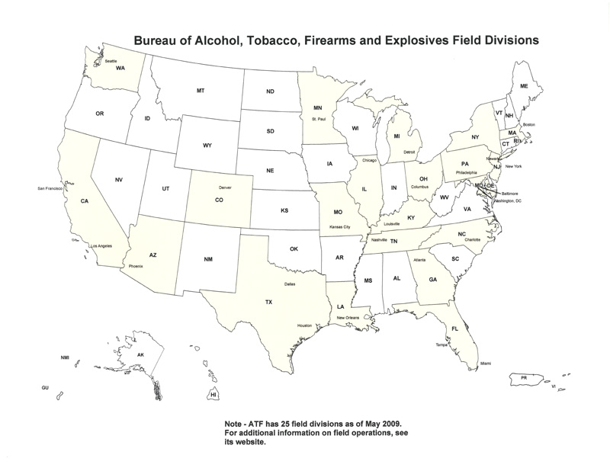
Source: https://www.justice.gov/jmd/organization-mission-and-functions-manual-bureau-alcohol-tobacco-firearms-and-explosives
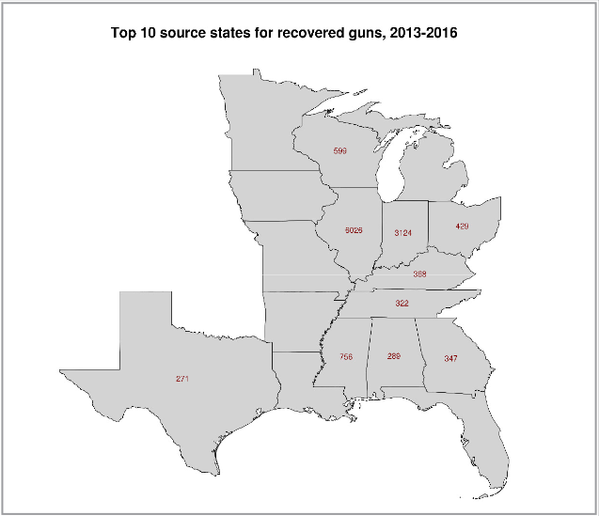
pg. 26

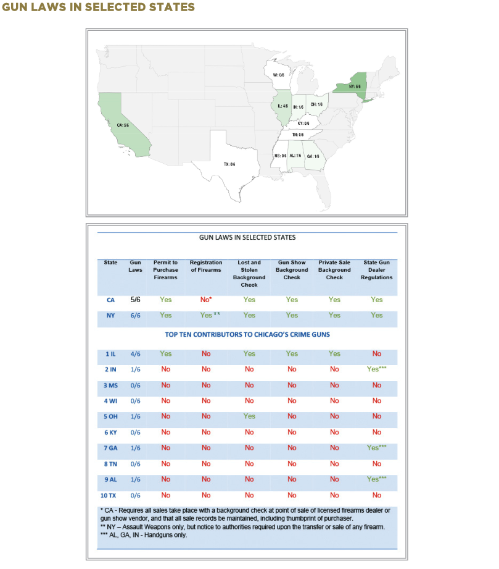
pg. 17

This outlines their plan! These are their targets. The goal is to make “these states” like “those states”.
They’re basically saying: “Do you see how they have these laws? That’s why their guns aren’t coming over here like with the other states.” And yet they say that 40% of Chicago crime guns, the biggest total for any state, come from Illinois. Huh? I thought the laws were the reason?
And look at how they try to make an excuse for California not having registration, trying to make that column a green “yes” also. The info under the asterisk has nothing to do with registration, and federal law requires all of that, except the part related to gun show vendors, in all states.
And there seems to be a correlation between “lax gun laws,” ATF offices, and guns.

“Recent research has identified comprehensive background check laws coupled with firearm permit requirements as having an independent impact on lowering illegal firearm transfers.⁴⁴ Additionally, in a comprehensive state-to-state study examining a broad range of firearm regulations and their relationship to homicide rates, states with stronger background check requirements had lower firearm fatalities.⁴⁵ Finally, the strongest policies shown to lower homicide rates came from states with permit requirements to purchase handguns, coupled with comprehensive background check laws.⁴⁶ Illinois already has a statewide permit system, requiring all gun owners to pass a background check and obtain a Firearm Owner’s Identification (“FOID”) card in order to lawfully purchase and possess a firearm.⁴⁷ A FOID card is valid for 10 years before a gun owner must reapply and renew the permit.⁴⁸ Currently, both federal and Illinois law require background checks at all firearm sales that are sold by an FFL dealer.⁴⁹ Illinois further requires a state background check on all firearm sales that take place at a gun show.⁵⁰ Illinois also mandates that all sellers check a person’s FOID card prior to completing the sale or transfer of a firearm, regardless of where the firearm is sold.⁵¹ This removes an important regulatory gap, since it applies to private sales as well.” – pg. 13
And yet they say that 40% of Chicago crime guns, the biggest total for any state, come from Illinois.

“Seventeen states, including Illinois, impose some additional regulation on private transfers.³⁸ In Illinois, anyone who acquires a gun from any source must have a Firearm Owners Identification card (FOID), and as of 2013, anyone who transfers a gun privately must keep a record of that transfer for ten years after the sale.³⁹”
Source: SOME SOURCES OF CRIME GUNS IN CHICAGO: DIRTY DEALERS, STRAW PURCHASERS, AND TRAFFICKERS - pg. 727
https://scholarlycommons.law.northwestern.edu/cgi/viewcontent.cgi?referer=&httpsredir=1&article=7538&context=jclc

So, the amount of guns in Chicago has little to nothing to do with laws related to how a citizen legally purchases a firearm. If Illinois basically has the same laws as California, New York and other states, how the heck are they the number one source of crime guns in Chicago if these laws are the reason for the season?

California’s Background Check Law Had No Impact on Gun Deaths, Johns Hopkins Study Finds
https://fee.org/articles/california-s-background-check-law-had-no-impact-on-gun-deaths-johns-hopkins-study-finds/?fbclid=IwAR3LUK8kxc8cFMp7NbtlweG67-L9_vIJXUXtvA1sCMQm8hXFg-WvQuuPP3k&utm_campaign=meetedgar&utm_medium=social&utm_source=meetedgar.com

“The vast majority of crime guns were handguns possessed by adults who were not the original purchaser of the firearm, and if arrested, were charged with illegal firearm possession. When analyzing the gun trace data from 2013-2016, some statistical patterns stood out, most of which reinforce commonly held beliefs about the illegal gun market: Handguns are overwhelmingly the weapon of choice for committing a gun-related crime in Chicago. More than 90 percent of crime gun recoveries were handguns….” – pg. 9

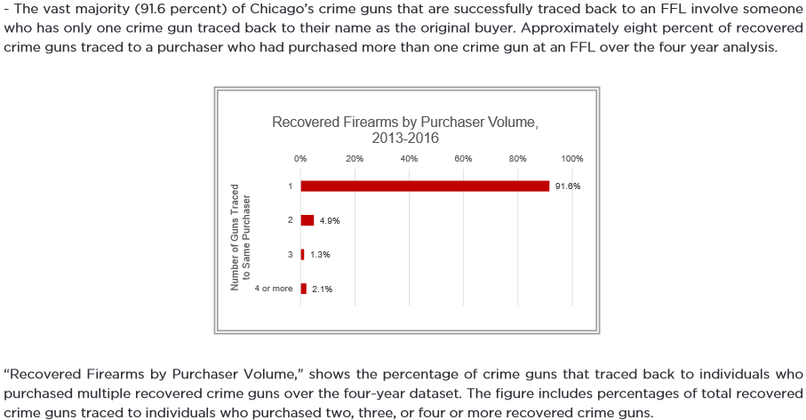
pg. 10

“The vast majority (91.6 percent) of Chicago’s crime guns that are successfully traced back to an FFL involve someone who has only one crime gun traced back to their name as the original buyer.” “‘Recovered Firearms by Purchaser Volume,’ shows the percentage of crime guns that traced back to individuals who purchased multiple recovered crime guns over the four-year dataset.” Why not say “who purchased one or more”? How do we know they’re not getting over on us?
Even if you consider the fact that they’re not retrieving every single gun, or successfully tracing every single gun, should this 91.6% be the case? This report is used to argue that weak gun laws of other states allow straw purchasers to purchase guns outside of Chicago and sell them in Chicago, or to someone from Chicago. That many people, that many straw purchasers, only have one crime gun to their name?! One? That’s it? Does that sound like a straw purchaser to you? And they have their names, so where are all the arrests of all these straw purchasers? Where’s the news stories about the hundreds to thousands of straw purchasers nabbed by the heroic ATF? This is not adding up.

“The vast majority (91.6 percent) of Chicago’s crime guns that are successfully traced back to an FFL involve someone who has only one crime gun traced back to their name as the original buyer.”
“… traced back to their name as the original buyer”? So, the ATF has names. So obviously there was some kind of system/laws in place. “Currently, federal law requires an FFL dealer to record the initial gun purchaser’s information in a firearms transaction record, along with the make, model, and unique serial number of the gun.⁷⁰ ATF then maintains a record of the initial sale information.⁷¹” – pg. 15

And what is “involve”? It involves someone? In what way? Where’s the details?
Having a crime gun traced back to your name doesn’t mean you committed any crime.
Isn’t the government-created violence in Chicago forcing law-abiding citizens to seek guns to protect themselves? How many are seeking guns out of state? How many bought a crime gun from off the streets?
If someone legally purchases a gun, and that gun is later stolen and used in a crime, that gun would be a crime gun, and that person would have at least one crime gun traced back to their name. In fact, if a stolen gun is found in the possession of someone who was not the legal owner, it would be illegally possessed, so it would be a crime gun even though it wasn’t used in a crime (or “in furtherance” of a crime).
According to the trace report, theft occurs in very few cases.

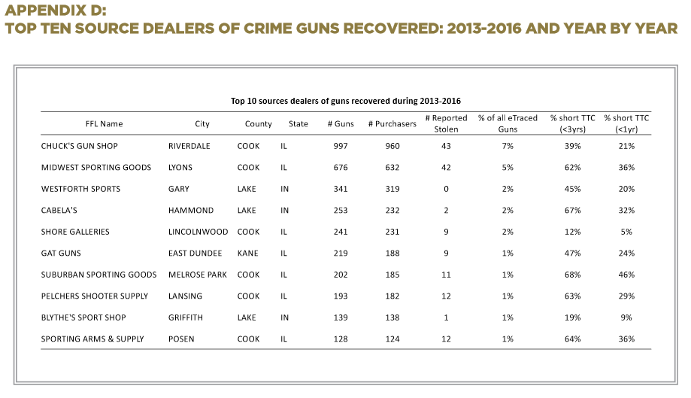
pg. 24

“Crime guns” to “guns recovered”? How do we know they’re talking about the same thing?
And even this does not tell you how the gun ended up becoming a crime gun in Chicago.
Almost 100% of the guns traced back to these FFLs were purchased, and the numbers are showing one purchaser. But that doesn’t mean anything illegal took place in the purchase, such as straw purchasing. That gun could have been purchased legally at Chuck’s Gun Shop, for instance, and then legally sold to a law-abiding citizen; then legally sold to another law-abiding citizen, and then the same again and again for years until one person used it in a crime or was suspected to have done so; or that person sold it to someone illegally or let someone borrow it illegally, and then it became a crime gun afterwards (or was suspected to be). There’s no straw purchasing in that.

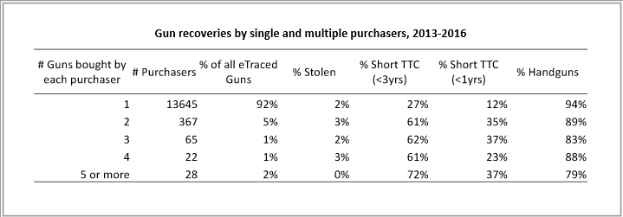
pg. 27

Report multiple firearms purchases? Why? There’s only one purchase being made for crime guns!

When reading this next one, pay attention to “of new,” meaning out those that were new, and realize that they may be referring to their definition of “new” - confiscated within 2 years of its first retail sale (pg. 743).
Excerpts from SOME SOURCES OF CRIME GUNS IN CHICAGO: DIRTY DEALERS, STRAW PURCHASERS, AND TRAFFICKERS
This Article assembles a unique dataset that combines five years (2009–2013) of crime gun trace requests submitted to the Bureau of Alcohol, Tobacco, Firearms and Explosives (ATF) National Tracing Center (NTC) by the Chicago Police Department (CPD), linked to other CPD data sources about the person who was caught with the gun.
…
“Dirty dealers”—that is, dealers who intentionally violate the law—appear to account for a small share of all crime guns that wind up in the hands of gang members. Guns carried by gang members tend to be quite old—over ten years old on average—and to have changed hands many times. Direct, well-documented sales of guns by dealers to gang members account for less than 2% of the total. Of course, dealers may be supplying gang members through other types of transactions that are not observable using trace data: straw purchases, undocumented sales, transactions involving used guns, or theft. We do not find much evidence for large-scale illegal diversion of inventory by gun dealers. Our data do provide suggestive evidence, however, that when gang members are carrying new guns, those guns are relatively likely to come from a “straw purchase,” in which someone (often assumed to be a girlfriend or wife) buys a gun on behalf of someone else who is legally prohibited from owning a gun. We also find that gun trafficking may be a more important source of guns to gang members than to other gun violators.
We find that only a small percentage of crime guns were directly obtained new from a Federal Firearms License (FFL) dealer in a documented sale.²³ This pattern holds true for crime guns confiscated from gang members as well as non-gang members. One challenge with estimating this percentage from administrative data sources is matching individually-identifying information in the ATF crime-gun trace data to CPD arrest records and other data sources, given the presence of data entry errors and missing data. We use probabilistic match techniques and estimate that 11% of adults acquired their crime guns new from an FFL dealer in a documented sale. This estimate is quite close to a comparable estimate (11.4%) based on the most recent national survey of adult prisoners, which was conducted in 2004.²⁴
We also find that relatively few crime guns wind up in the hands of gangs because of illegal diversions of inventory by FFL dealers, at least as best as we can tell in our data. We use our dataset to calculate the share of crime guns that could be traced back to an identified FFL dealer but for which the paperwork kept by the FFL dealer was not available. We use this as a proxy for off-the-books transactions, such as selling inventory illegally out the back door; such transactions account for 5% of guns associated with gang members, almost identical to the share of guns taken from violators who are not in gangs.
Straw purchases seem to be a more important source of crime guns to gangs compared to other types of dealer sales. As one indication of the volume of straw purchases, we estimate that 15% of new guns that were sold within two years of confiscation and were taken from male gang members were first sold to a woman. Our data provide no direct way to tell how often dealers knew or suspected that a given sale was a straw purchase.
For enforcement purposes, a major concern is the possibility that gang members get their guns directly from “dirty dealers,” that is, FFL dealers who are willing to violate the law by selling guns to people who should not be legally allowed to have them—including by looking the other way during a straw purchase. One indication for whether this is happening would be that guns found in the hands of gang members should come from a smaller set of FFL dealers compared to what we see for crime guns found among non-gang members. We do see one locale where there is somewhat greater dealer concentration for gang than non-gang guns: among guns first sold in Cook County,²⁵ the three most common dealers account for 76% of guns recovered from gang members and 65% of guns recovered from others. But for guns first sold in other Illinois counties or out of the state, the pattern is reversed.
Most gang guns come from central or southern Illinois, or another state (especially Indiana), even more so than what we see among crime guns found among non-gang members. Interestingly, Indiana sources are more prominent for new guns than older guns, suggesting that they are more likely to be trafficked directly.²⁶ We also find that compared to crime guns taken from people not in a gang, a higher share of crime guns from gang members have obliterated serial numbers (5.4% vs. 3.4%), one indicator of trafficking.
One clear conclusion is that most guns taken from gang members in Chicago pass through the hands of at least one intermediary—a third party that helped the gun move from dealer to gang member. This result suggests the potential value of investigations focused on those in the underground gun market who help put guns into the hands of violent street gangs.
Another conclusion from our findings is that enforcement efforts to reduce gang member access to guns are not futile. Crime guns tend to be remarkably old in Chicago, with an average age of 12.6 years (median of 10.4), and in fact are older for gang members than non-gang members (a median of 11.6 versus 6.9 years). Since criminals are widely reported to prefer newer guns, this is one indication that barriers exist to getting guns in the underground gun market even for gang members, consistent with the findings in Underground Gun Markets.²⁷ We also find some indication that gun violators are likely to have been in possession of a particular gun for a relatively brief period of time, which also supports the basic premise of enforcement efforts that try to reduce gun access to high-risk people.
…
Guns used in crimes are far less likely to be acquired from a licensed dealer than are other guns in private hands. Much violent crime is committed by those under the age of twenty-one, who are barred from buying a handgun from a dealer.⁴⁷ Many adult criminals are disqualified from buying or possessing a gun due to a felony conviction and would fail a background check if they attempted to purchase a gun under their true identity.⁴⁸ An additional barrier in Illinois is the necessity of obtaining a Firearm Owner Identification (FOID) card before purchasing a gun.49 One guide to how criminals obtain their guns is a 2004 survey of inmates of state prisons conducted by the U.S. Department of Justice. Restricting the sample to just those that have been in prison for two years or fewer (who can provide relatively current information), the survey data indicate that 12% of guns last possessed by the inmates had been purchased from a dealer.⁵⁰ Most guns acquired by these inmates came from their family and social network, or from “street” sources.⁵¹
…
Yet gang members tend to carry guns that have been in circulation for many years. In fact, the median elapsed time between first retail sale and confiscation from a gang member is11.6 years if the gun is successfully traced (see Figure 1). The true age may be greater still, since one reason traces are unsuccessful is that the gun is too old. Only about 10% of guns in the hands of gang members are less than two years old. The comparison group of those not in a gang is carrying newer guns on average, with a median age of 6.9 years; around 25% are less than two years old. The overall median age of all confiscated guns is 10.4.
The fact that these gang guns tend to be quite old presumably is not because gang members prefer old guns. In fact, in interviews they often express a preference for guns that are “new in the box.”⁷⁷ Rather, the prevalence of older guns likely reflects what is available and affordable to these individuals. Even for gang members, the underground market does not work as well as the licit market.
Source: SOME SOURCES OF CRIME GUNS IN CHICAGO: DIRTY DEALERS, STRAW PURCHASERS, AND TRAFFICKERS – pgs. 723-725, 729, 739
https://scholarlycommons.law.northwestern.edu/cgi/viewcontent.cgi?referer=&httpsredir=1&article=7538&context=jclc

- “…other types of transactions that are not observable using trace data: straw purchases….”

Here are some excerpts from Sources of guns to dangerous people: What we learn by asking them.
This paper focuses on reducing access to firearms by dangerous offenders, contributing original empirical data on the gun transactions that arm offenders in Chicago. Conducted in the fall of 2013, analysis of an open-ended survey of 99 inmates of Cook County Jail focuses on a subset of violence-prone individuals with the goal of improving law enforcement actions.
… The CCJ Pilot Survey, like previous surveys, demonstrates that a large percentage of respondents are willing to provide information about (mainly-illegal) gun transactions. Results from CCJ inmates are generally consistent with those of comparable surveys of offender populations. While not all respondents give truthful responses, and some refuse to respond at all, we believe that the information generated from this type of survey provides a reasonably accurate characterization of the “retail” aspect of Chicago's underground gun market. Due to small sample size (n = 99) and limitations of the open-ended survey method, our characterization is more qualitative than quantitative. It is deemed a “pilot” survey in that it was intended to inform the development of a subsequent closed-ended offender survey.
… Most of the 99 respondents offered some account of how guns were getting into their neighborhood, although often prefaced with a statement such as “I don't know.” Some Rs were clearly better informed than others. R42 gave a brief lecture that appears quite accurate:
“Several ways actually…there's probably only one gun store that's located throughout the whole city of Chicago which is famous. It's Chuck's Gun Store…. [b]ut as far as Chicago it's so close to Indiana and in Indiana … there's gun laws but it's easier to get access to guns in Indiana so most people either go to the down-South states or go to Indiana to get guns or people obtain gun licenses, go to the store and then resell.”
Our recent research on retail sources of guns recovered by the Chicago Police Department tells a similar story (Cook et al., 2015): of new (less than two years old) guns recovered from gang members, 60% originated from out of state – half in Indiana – and of the remaining 40%, most originated in suburban Cook County, with Chuck's playing a dominant role. (In point of fact, there are no gun stores within the city limits, but Chuck's is located nearby and is the largest single source of Chicago crime guns.)
Among the themes that showed up in at least five responses each are these:
People with an FOID card supply others. R17 opined that “All they need is one person who got a gun card in the ‘hood’ and everybody got one.” R58 noted that people with gun cards buy guns, report them stolen, and then resell them. “That's how we get them personally ourselves.”
Local people buy guns out of state, sometimes on behalf of gangs. R32: “Six out of 10 times, people go out of state and brings them back.” R69: “The gang leaders, they'll choose and pick who to go out and get the guns and bring 'em back.” There is also some mention of outsiders who bring guns into the neighborhood, either from other neighborhoods in Chicago, or from out of state. R8: “I know the person, they purchase a lotta guns, it's called a crate” (which are then distributed within “the organization”). R85: “Some people getting on a train and bring them back, can be up to 5 or 6 guns depending on how much risk they want to take.”
Guns are stolen. R21: “Sometimes people rob freight cars to get guns to sell.” R62: “People break into trains to get crates of guns.” R10: “The people from the neighborhood go buy the guns from the people who've stolen them.” R68: “A few years ago some guns in the neighborhood were from a robbed Indiana gun store.” Several respondents mentioned the possibility of stealing guns from houses in the neighborhood.
Guns are from the “government” or corrupt police. R52. “Police take guns and put them back on the street.” R69: “Crooked officers put guns back on the streets.” Two respondents mentioned a systematic plan by the government to distribute guns.
A number of respondents drew some connection to the drug trade, sometimes blaming “crackheads” for selling guns, or mentioning a connection with the “Mexicans” (presumably a reference to the Mexican gang that has been a principal wholesale supplier of drugs to and through Chicago (Mcgahan, 2013)).
Several respondents mentioned arrangements in which outside traffickers were the source. In one case (R75), the son of a gunstore owner was “bringing crazy guns to the Southside,” apparently in exchange for drugs. Another (R88) also reported the source as the son of a gunstore owner, in the western suburbs, who was selling to local gangs. It is possible that the reference was to the same individual. In a third case, a “white man” was bringing in many guns from the South.
… The “players” in the local underground gun market include some who do enough selling to be identified as “point sources” of guns (Cook and Braga, 2001). None of our respondents operated on a large scale, but there were reports of transacting on both sides of the market, playing the roles of retailer or broker. It is also clear that the gangs played some role, sometimes buying “crates” of guns from outside the city and distributing them to members. Several respondents reported dealing with traffickers who were bringing guns into Chicago. But for the most part even these transactions involved prior connections.
Source: Preventive Medicine Volume 79, October 2015, Pages 28–36 - Special Issue on the Epidemiology and Prevention of Gun Violence - Sources of guns to dangerous people: What we learn by asking them
http://www.sciencedirect.com/science/article/pii/S0091743515001486

“… the son of a gunstore owner was ‘bringing crazy guns to the Southside,’ apparently in exchange for drugs.” That sounds just like an ATF operation.
You might have noticed that they picked and highlighted the one that matched the narrative. And I’m sure you noticed the statements about the trains, crates, out-of-town dealers, and Mexicans, further verifying what’s in the video. But did you notice the following? “Our recent research on retail sources of guns recovered by the Chicago Police Department tells a similar story (Cook et al., 2015): of new (less than two years old) guns recovered from gang members, 60% originated from out of state – half in Indiana – and of the remaining 40%, most originated in suburban Cook County, with Chuck's playing a dominant role.” So, is the 2017 Chicago Trace Report, which gives an average on the years 2013-2016, only talking about new guns?
I wonder if this has anything to do with it:
“In practice, legitimate gun owners acquire their guns from a variety of sources by a variety of means. Unfortunately, there is little documentation of the pattern of gun transactions. One notable exception is the National Survey of Private Ownership of Firearms inthe United States (NSPOF), which was conducted in 1994 and was one of the first nationally representative surveys to ask about the stock and flow of guns in the United States.⁴² The NSPOF asked respondents to describe how they obtained their most recent gun, including whether they bought the gun (and, if so, from what source) or obtained it as a loan or gift.⁴³ Focusing on guns acquired during the two years preceding the survey (1993−1994), about 60% were obtained from what appears to be a licensed dealer.⁴⁴ Put differently, about 40% changed hands in a transaction that did not involve a licensed gun dealer, what Cook, Molliconi, and Coletermed the ‘secondary market.’⁴⁵ That NSPOF survey is the origin of the 40% statistic that became famous during the 2013 national debate over universal background checks.⁴⁶”
Source: SOME SOURCES OF CRIME GUNS IN CHICAGO: DIRTY DEALERS, STRAW PURCHASERS, AND TRAFFICKERS - pgs. 727-728
https://scholarlycommons.law.northwestern.edu/cgi/viewcontent.cgi?referer=&httpsredir=1&article=7538&context=jclc

According to that report, in 2013 most of Chicago’s crime guns were old. So, were most of these guns initially purchased at an FFL, but ended up being stored somewhere before becoming a crime gun (or crime gun again)?
One gun is purchased by one person, and it ends up on a train where it is stolen? Another gun is purchased by one person and it ends up in a crate with other guns and is sold to someone from Chicago by the crate-load? Another gun is purchased by one person and it ends up with Mexicans, but is sold to blacks in Chicago? And another gun is purchased by one person and ends up with out of town traffickers, but is sold to blacks in Chicago along with other guns – multiple guns? The trace report is not adding up at all.
And who was selling them crate-loads of guns?

“Consistent with the results of our 2015 analysis, our preliminary analysis of the updated data suggests that the guns confiscated by the police from gang members tend to be quite old with every indication that they have gone through a series of transactions before being acquired by the current owner. Our preliminary analysis also suggests that it is very rare for these guns to be purchased new from a gun dealer in a documented sale.
“… We surveyed 221 recently sentenced males between March and September, 2016, who were incarcerated in seven IDOC prisons for gun- or weapons-charges. Interviews were semi-structured, with both multiple choice and open-ended questions that covered a range of topics, including individual and neighborhood characteristics, experiences with guns and gun violence, perceptions of the criminal justice system, and additional information about ammunition, gangs, and guns in Chicago. One key strength of this study was the set of administrative data sets the research team was able to access and link to the IDOC survey sample. We used IDOC sentencing data, CPD arrest and victim data, ATF Chicago Trace Data, and Cook County disposition data to better understand respondents’ criminal history and to validate self-reported responses. The interviews revealed that respondents were extensively involved with guns and violence. Fully 93% of respondents said they had been shot at on at least one occasion, and more than 40% reported having actually been shot and wounded at least once. About 77% of respondents admitted to owning a gun within six months prior to their arrest. Since virtually none of these individuals were eligible for an Illinois gun license (FOID) to purchase a gun legally, our study population was well-situated to speak about the secondary gun market in Chicago.
“Respondents discussed the sources and methods of acquisition for guns they possessed within six months of their arrest. As expected, less than 1% of the guns were purchased from a store. Most reported obtaining guns from voluntary transactions with friends and acquaintances – their social network. The transactions included purchases, trades, loans, gifts, and sharing arrangements. Only 7% of respondents reported acquiring a gun through theft. Ammunition was also obtained through street sources, though about 15% of respondents reported that someone else straw purchased ammunition for them, compared with just 5% who reported obtaining a gun by straw purchase.”
Source: Underground Gun Markets in Chicago - pgs. 4, 5, 9, 10
https://nij.ojp.gov/library/publications/underground-gun-markets-chicago

This confirms what we’ve discovered, that straw purchases and lax gun laws are NOT the reason for the abundance of crime guns in Chicago.

“Both three-year and one-year ‘time to crime’ analyses were conducted for crime guns traced back to the top ten source dealers. A firearm’s ‘time to crime’ refers to the amount of time that lapsed between the initial retail sale and the subsequent recovery of that firearm by law enforcement.¹³ A shorter time to crime serves as an indicator than illegal trafficking or transfer activity took place before the firearm came into the hands of law enforcement.¹⁴”

All of these are less than 3 years old:
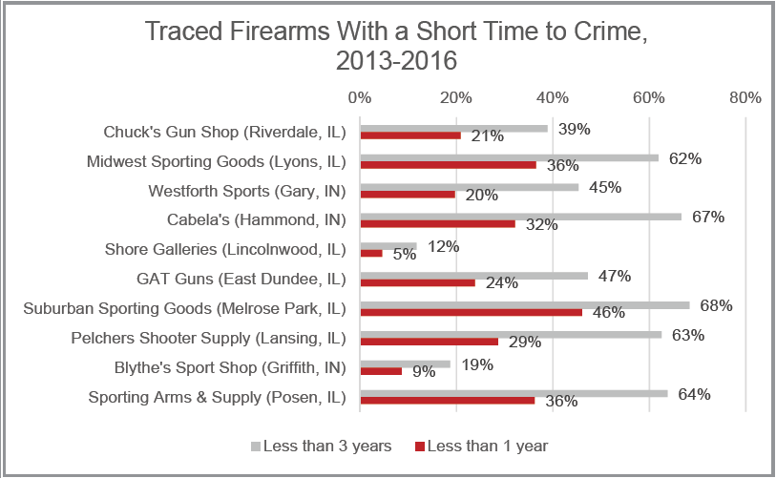
pg. 7

These FFLs are said to have been the source of most crime guns in Chicago, and yet for most of them, over 50% of their guns are less than 3 years old.

The trace report is clearly trash, but let’s just say that a large number of Chicago crime guns actually were initially purchased at certain FFLs, the problem would be related to these certain FFLs, and for a reason that involves the government. Think about it: Certain FFLs top the charts for years. The only way an FFL could continue to do this year after year is if government agencies are involved with the store, or have allowed them to carry out illegal business year after year. There’s no other way. You mean to tell me that if the ATF told an FFL that they were watching them, that FFL would continue that illegal activity? And if ATF was in the parking lot, installing cameras, or conducting stings, that would mean nothing to that FFL? What about tough prison sentences? These businesses haven’t been shut down yet? How is that? Stop playing and put your name on the business … it’s yours.

“Since 1986, absent a warrant, Congress has limited ATF’s ability to conduct gun dealer inspections to a single annual compliance audit.³⁹ Citing a lack of resources, the U.S. Office of the Inspector General found that ATF actually inspects a surprisingly small portion, or roughly 5 percent of the more than 50,000 FFLs in the U.S. each year. Finally, federal law also prohibits ATF from requiring FFLs to submit to regular firearm inventory inspections.⁴⁰” – pg. 12
So, if their data is correct, much of the fault lies at their feet! And if they lack resources it’s because their higher-ups, those who are really behind all this deceit, want it to be that way so that they can’t conduct inspections, or so that they would have an excuse for why they’re allowing illegal activity to take place. They’re letting the bad apples run wild. And what the heck does that have to do with law abiding citizens who legally purchase firearms? So, infringe upon the Constitutional rights of citizens because you’re not doing your job?
“Under the framework proposed in the Gun Dealer Licensing Act, local law enforcement could simply step in and assist where ATF cannot due to manpower or other federal restrictions. This is an especially important tool to address the small subgroup of FFLs that contribute a disproportionate number of guns to the illegal market. ATF’s national data demonstrates how significant certain FFLs can be in contributing to the illegal market of firearms, where less than 10 percent of dealers were associated with nearly half of trafficked firearms in a two-year study.⁴¹ CPD data certainly reflects a similar trend, with just 10 dealers making up almost a quarter of all successfully traced crime guns recovered in Chicago.” – pg. 13
As stated in that other report, that’s a sign that certain dealers are engaging in illegal activity, not a sign of lax laws or straw purchases! And that’s if their data on this is correct. This could just be a cover-story just in case the original fails.

“Altogether, there are 441 federally licensed dealers in suburban Cook County and the five collar counties, according to the latest ATF data. Most of these suburban shops, officials say, are law-abiding businesses that operate responsibly. But a small percentage—fewer than 1 percent, the city says—are responsible for nearly half of all the firearms used in crimes in Chicago.”
Source: Where Do Chicago’s Guns Come From?
Published Aug. 1, 2012
https://www.chicagomag.com/Chicago-Magazine/The-312/July-2012/Where-Do-Chicagos-Guns-Come-From/

“It turns out that virtually all crime guns come from a relatively small number of gun dealers that we call ‘bad apple’ gun dealers. Just 5 percent of gun dealers in the U.S. sell 90 percent of crime guns, and they often do it with business practices that they know are irresponsible or even illegal.”
Source: THE TRUTH ABOUT GUN DEALERS IN AMERICA - pg. 1
https://gunviolence.issuelab.org/resources/30185/30185.pdf

“By reforming or shutting down these ‘bad apple’ dealers we can dramatically reduce gun crimes and gun deaths in our nation.”
Source: THE TRUTH ABOUT GUN DEALERS IN AMERICA - pg. 4
https://gunviolence.issuelab.org/resources/30185/30185.pdf

If all of that is true, then, as they stated, shutting them down would practically solve the problem! So, what’s going on with that? Shouldn’t they have been shut down by now if they’re at fault? And isn’t this the government’s job, and fault, if they’re not shut down? So, why has this been used blame states, laws, and citizens? Why are they giving federal prison time to people in Chicago, even those who want to protect themselves from violent people with guns?

Take a look at this:
ATF raids Parker City gun shop; owner arrested
https://www.wthr.com/article/news/local/atf-raids-parker-city-gun-shop-owner-arrested/531-5a338db5-189b-46f4-8143-f6da3230de71
Whether the ATF lied about this case or not, they still shut that dealer down. So, what about the rest of these FFLs? Are they not actually committing any crimes, and their guns are just being used, or does the ATF have a relationship with particular dealers the same way the CIA has a relationship with particular drug dealers – they make a bust every now and then, but they pretty much just allow certain dealers to carry out illegal activity in order to keep the supply lines open? And it’s interesting how just like the war on “drugs” from the CIA’s drugs, they put all their resources into catching the last people to possess the guns – black people. And the harsh prison sentences are for them. The examples are made out of them.

“From 2009 to 2013, more than 1,500 guns found at Chicago crime scenes were traced to Chuck’s, the most of any gun dealer and more than the next two gun dealers combined.⁴⁸ During the same time period, the average number of crime guns traced back to other neighboring gun dealers was three. … Nationwide, from 1996 to 2000, more crime guns were traced to Chuck’s — 2,370 — than any other gun dealer in the country.⁵⁰ Over the course of an undercover investigation in the late 1990s by Chicago police, Chuck’s Gun Shop & Pistol Range sold pistols, rifles and large-capacity magazines (some of which were illegal under federal law at the time) to people they knew to be residents of Chicago and instructed the buyer on how to avoid attention from the ATF.⁵¹”
Source: THE TRUTH ABOUT GUN DEALERS IN AMERICA - pg. 13
https://gunviolence.issuelab.org/resources/30185/30185.pdf

2009 to 2013? How? And looking at pages 24 and 25 of the trace report, Chuck’s was number one for Chicago crime guns in 2013, 2014, 2015, and 2016. How is this possible?

Additional info related to Chicago and the trace report
Fast Facts
- ATF’s National Tracing Center is the United States’ only crime gun tracing facility.
- ATF’s National Tracing Center is authorized to trace firearms by the Gun Control Act of 1968.
- ATF’s National Tracing Center is only authorized to trace a firearm for a law enforcement agency involved in a bona fide criminal investigation.
The National Tracing Center (NTC) traces firearms associated with crimes and provides investigative leads for local, state, federal and foreign law enforcement agencies. NTC uses leading-edge technologies and tools such as eTrace to detect firearms trafficking and track the movement of crime guns across police jurisdictions, state lines and national borders.
…
Firearms tracing begins when ATF or another law enforcement agency discovers a firearm at a crime scene and wants to learn where it came from. NTC receives the trace request and uses the gun’s serial number to identify its original manufacture or importer. From their records, NTC is able track the firearm through the wholesale and resale distribution chain to its first retail purchaser.
…
If a firearm’s serial number has been altered or destroyed in any way, NTC uses forensic expertise and technology to identify its origins and piece together its history. This data helps to detect, deter and disrupt firearms trafficking patterns and related crimes.
Source: Fact Sheet - National Tracing Center
https://www.atf.gov/resource-center/fact-sheet/fact-sheet-national-tracing-center

A totally corrupt agency that lies, cheats and kills to pass gun control laws, operates the only gun tracing facility in the US, and their gun traces are used to create gun control laws. And this same agency which gives the federal and state governments data used to create gun control laws, has been caught supplying Mexican guns drug cartels with weapons and then saying how the lax gun laws of the US were to blame for guns making their way into the hands of those same Mexican drug cartels. If there is not emergency legislation enacted now to reverse the laws that you as a citizen knows infringes on your 2nd Amendment rights, then those individuals involved in the passing of such laws should be identified and hunted down like the trash that they are. #PurgeTheGovernment
And those crime guns, firearms recovered by CPD that were illegally possessed, used, or suspected to have been used in furtherance of a crime, are traced by serial number OR “forensic expertise and technology”. So, basically, we believe a gun that was, or could have been used, in a crime could have come from this gun store based on our forensic expertise and technology.

Take a look at this propaganda for a desire to have a registry.
ATF Tracing Guns | I-Team Investigation
https://www.youtube.com/watch?v=Srs3729tdkk

Tracing The Gun: The Archaic Way The U.S. Tracks Gun Ownership | Think | NBC News
https://www.youtube.com/watch?v=COBmaqs43tY
- 2:45 – The boxes are records kept by dealers who have now gone out of business? That’s not what the previous video was conveying. Those boxes wouldn’t be searched for every gun trace request. They would only be searched if a manufacturer or wholesaler told the ATF that a gun was sold to a dealer/FFL who had gone out of business. But that’s not how they were trying to make it seem in that last video.
- 3:31 – “If a trace request came in today for one of these dealers that’s gone out of business a tracer is going to walk out here, find the shipping container that they need to find that dealer in….”
- 5:15 – “We complete a routine trace in between 4 and 7 days.” That’s not what they said in the previous video.
- 5:27 – “… then we’ll get those traces down within 24 hours; oftentimes we get them completed in a matter of hours or minutes. But a routine trace takes between 4 and 7 days.”
- 6:36-6:45 – There it is.
- 6:54-7:00 – There it is.

This next video is a perfect example of how the media works. They’ll cook up something to give a certain impression/message, but throw the truth in there, buried or in small print, knowing the listener or reader won’t catch it or be affected by it.
Inside America’s Ridiculously Old-Fashioned Gun-Tracing Center
https://www.youtube.com/watch?v=rMQ2b6ZwwCU
- 0:38 – In response to assassinations carried out by the government, the government established a Firearms Tracing Division in Martinsburg, WV.

Here’s another one with the same trickery. The average person is not going to know that the guy whose statements GQ has pieced together was initially talking about searching dealers that have gone out of business. They’re going to see this the way it was designed to be seen – “this is what the ATF has to go through to trace guns, all guns. Don’t you agree that this shouldn’t be?”
Inside the Real-Life Database of America’s Firearms | GQ
https://www.youtube.com/watch?v=1N118jYj2cA
Now look at the titles of all four videos.

And sometimes the officers involved in a trace are not trustworthy.
Cases Linked To Gun Trace Task Force Could Be Overturned, Dismissed After Officers' Convictions
https://www.youtube.com/watch?v=HyAgnB_Fk1U

Gun Trace Task Force members sentenced to length prison terms
https://www.youtube.com/watch?v=SNCs-uHmWEY

Here’s further proof on how corrupt Chicago PD is. But I’m sure their trace report done in cooperation with the ATF is trustworthy, especially since it was done when Rahm Emmanuel was mayor of Chicago.
Men framed by corrupt Chicago cop speak out
https://www.youtube.com/watch?v=ryTW2T_jw9s

How a Corrupt Chicago Cop Framed Dozens of People | The Backstory | The New Yorker
https://www.youtube.com/watch?v=g0_ZUrvJ8XA

Chicago's culture of corruption
https://www.youtube.com/watch?v=fo3Qcml7dL4

Read these excerpts from Why Mexico’s Sinaloa Cartel Loves Selling Drugs in Chicago
In Chicago, the cartel has a near monopoly. “I’d say 70 to 80 percent of the narcotics here are controlled by Sinaloa and Chapo Guzmán,” says Jack Riley, director of the DEA’s Chicago office. “Virtually all of our major investigations at some point lead back to other investigations tied to Sinaloa.”
In August 2009, five months after Zambada’s capture, a federal grand jury in Chicago indicted him and 45 others tied to a Sinaloa-led drug ring in the city. Patrick Fitzgerald, the U.S. attorney at the time, called the indictments “the most significant drug importation conspiracies ever charged in Chicago,” claiming that the cartel imported and distributed nearly $6 billion worth of illegal narcotics mostly to the Chicago area between 1990 and 2008.
…
Indeed, today the Sinaloa cartel and its rivals are selling record amounts of heroin and methamphetamine in Chicago, according to drug seizure data and law enforcement officials (see “Sizing Up the Big Four,” below). In May, the regenerative powers of the cartel led Chicago’s police superintendent, Garry McCarthy, to call America’s war on drugs a “wholesale failure.”
The failure is as much Chicago’s as the nation’s. For this city has replaced Miami as the primary U.S. distribution point for illegal narcotics—mainly cocaine, heroin, marijuana, and methamphetamine—imported from Mexico.
In a 2010 report, the U.S. Department of Justice named the Chicago metro area the No. 1 destination in the United States for heroin shipments, No. 2 for marijuana and cocaine, and No. 5 for methamphetamine. Chicago is the only U.S. city to rank in the top five for all four major drug categories. No wonder Sinaloa boss Guzmán was quoted in a recent New York Times Magazine article calling Chicago his cartel’s “home port.”
It might seem odd that a city some 1,500 miles north of the Mexican border has become the nation’s narcotics center. But there are four main reasons: transportation, ethnic makeup, size, and gang culture.
Chicago is the transportation hub of America, a fact not lost on the Mexican cartels (just as it wasn’t on Capone and his fellow bootleggers almost a century ago). It’s ideally located within a day’s drive of 70 percent of the nation’s population. Six interstate highways crisscross the region, connecting east and west. Only two states (Texas and California) have more interstate highway miles than Illinois.
As for rail transport, Chicago welcomes six of the seven major railroads and accounts for a quarter of the country’s rail traffic. Water? The Port of Chicago is one of the nation’s largest inland cargo ports, and the city is the world’s third-largest handler of shipping containers (after Singapore and Hong Kong). And let’s not forget about Midway and O’Hare: More than 86 million passengers and 1.5 million tons of cargo passed through these airports combined in 2011, the latest year for which data are available.
Second, the Chicago metro area has a large Hispanic immigrant population, making it easy for Mexican cartel operatives to blend in. (Only Los Angeles, San Antonio, and Houston have more residents of Mexican descent, according to the 2010 census.)
Because many of these immigrants—especially those who are here illegally—are poor or underemployed, the area provides a fertile recruiting ground for cartel operatives.
According to a Cook County law enforcement officer familiar with the local drug trade, the Pilsen and Little Village neighborhoods, which are more than 80 percent Hispanic, are el eje (the axis) of drug distribution in the city.
Source: Why Mexico’s Sinaloa Cartel Loves Selling Drugs in Chicago
https://www.chicagomag.com/Chicago-Magazine/October-2013/Sinaloa-Cartel/
True title: Why CIA loves selling drugs in Chicago. Chicago should be called little Mexico.

This next video shows one way drugs and guns are put into the hands of local drug dealers and gang bangers. The only difference is that this was a sting, and these people were arrested. Think of all the officers throughout the US who are recruited to do this and allowed to continue to do this.
3 Miami cops arrested on federal drug charges
https://www.youtube.com/watch?v=w56S_H4IhAE

Firefighter, retired police officer among 29 charged in Orange County drug bust
https://www.youtube.com/watch?v=AeQhz9gjDiQ

3 Long Island officers arrested after drug bust
https://www.youtube.com/watch?v=E15Bund81YU

7 NYPD officers arrested in connection with prostitution ring
https://www.youtube.com/watch?v=I_jPvn42nAM

And you can go on and on with videos like these.

Must-see extras
CDC admits gun violence data "unreliable"
https://www.youtube.com/watch?v=UGWtIQ6jAWY

Flawed CDC gun violence data concerns researchers
https://www.hsph.harvard.edu/news/hsph-in-the-news/flawed-cdc-gun-violence-data-concerns-researchers/
The same CDC that’s lying about COVID-19?

The High-Level Hypocrisy of Mayors for Gun Control
https://www.nraila.org/articles/20170804/the-high-level-hypocrisy-of-mayors-for-gun-control

When is a crime gun no longer a crime gun? Three, not 11, Fast & Furious guns linked to U.S. violent crimes
https://www.politico.com/blogs/under-the-radar/2011/09/three-not-11-fast-furious-guns-linked-to-us-violent-crimes-038861

Documents Suggest Bush Administration Used 'Fast And Furious' Tactics
https://www.npr.org/sections/thetwo-way/2012/01/05/144761413/documents-suggest-bush-administration-used-fast-and-furious-tactics

A little 2A news
https://www.facebook.com/notes/alquist-arms/ammunition-questions/2500507980024950/?comment_id=2500561873352894

https://www.gunownersca.com/2019/07/11/ammo-registration-send-us-horror-stories/

Why New Gun Owners Should Fear A Joe Biden Presidency
https://www.youtube.com/watch?v=1fimR2znLTg

The Government Doesn't Trust You With Body Armor!
https://www.youtube.com/watch?v=D0z9waXFQ2g

This Is Bad California AB 2847 Moves On
https://www.youtube.com/watch?v=fdnp0VGSRI8

How To Contact Your Representatives
https://www.youtube.com/watch?v=xgRAs7YgibE
http://www.house.gov/representatives/find/
http://www.house.gov/representatives/
http://www.usa.gov/Contact/Elected.shtml

Solutions
Here’s a basic template for those of you who are looking for change.
1. The citizens should make and change their own Constitution, and no one in government should be allowed to alter it. Consequences for doing so may include death.
2. No one in government should be allowed to accept bribes or anything resembling a bribe (to be determined by the citizens in a vote), nor be associated with someone or something (like an organization) who is, has or will.
3. No one in government should be allowed to engage in war, except for true defensive measures, without the consent of the citizens (not “its citizens”).
4. The military can only be used against the citizens by vote of the citizens.
5. The military can be used by the citizens against the government at any time.
6. No one in government should be allowed to collude with the enemy or someone or something that has, does or will.
7. No one in government should be allowed to authorize anything harmful to the citizens.
8. Everyone applying for a position of government must pass extensive psychological and moral examinations.
9. The citizens must be allowed to veto any law at will at any time, by mail or internet.
10. The citizens must be allowed to replace any member of government at will at any time, with enactment taking place within the amount of time they determine.
11. There should be laws against having monopolies over detrimental sectors/fields or any element capable of impacting that sector/field. This is especially true for sectors impacting water, food, air, land, shelter, money and communications (including the distribution of information).
12. No citizen shall be deprived of clean air, the ability to build or live in anything for shelter as long as there’s no potential to harm others around them, the ability to grow their own food, or the ability to collect rain water or water from a body of water as long as it does not negatively impact that body of water.
13. No property tax.
14. No income tax.

If you can’t get the changes implemented.
Governments do what they do because they don’t face any consequences, or severe enough consequences. That’s why you, the citizen, has to make them face these consequences. If you can’t get these consequences into law, with adequate consequences for not enforcing these consequences, you have to give them the consequences yourself. And other citizens should come to the aid of that person or people who administers those consequences. And if a judge or whoever makes it so that the citizens can’t help that person or people, there should be severe consequences for that judge or whomever as well. And all of this must be done by any means necessary. “This is a logical result of the way in which our democratic society is organized. Vast numbers of human beings must cooperate in this manner if they are to live together as a smoothly functioning society.”

“When in the Course of human events, it becomes necessary for one people to dissolve the political bands which have connected them with another, and to assume, among the Powers of the earth, the separate and equal station to which the Laws of Nature and of Nature's God entitle them, a decent respect to the opinions of mankind requires that they should declare the causes which impel them to the separation.
We hold these truths to be self-evident, that all men are created equal, that they are endowed by their Creator with certain unalienable Rights, that among these are Life, Liberty, and the pursuit of Happiness. That to secure these rights, Governments are instituted among Men, deriving their just powers from the consent of the governed, That whenever any Form of Government becomes destructive of these ends, it is the Right of the People to alter or to abolish it, and to institute new Government, laying its foundation on such principles and organizing its powers in such form, as to them shall seem most likely to effect their Safety and Happiness. Prudence, indeed, will dictate that Governments long established should not be changed for light and transient causes; and accordingly all experience hath shown, that mankind are more disposed to suffer, while evils are sufferable, than to right themselves by abolishing the forms to which they are accustomed. But when a long train of abuses and usurpations, pursuing invariably the same Object evinces a design to reduce them under absolute Despotism, it is their right, it is their duty, to throw off such Government, and to provide new Guards for their future security. —Such has been the patient sufferance of these Colonies; and such is now the necessity which constrains them to alter their former Systems of Government. The history of the present King of Great Britain is a history of repeated injuries and usurpations, all having in direct object the establishment of an absolute Tyranny over these States. To prove this, let Facts be submitted to a candid world.” – The Declaration of Independence.

