The Babylonian System



GENESIS
CHAPTER 10
6 ¶ And the sons of Ham; Cush, and Mizraim, and Phut,
and Canaan.
7 And the sons of Cush; Seba, and Havilah, and Sabtah, and
Raamah, and Sabtecha: and the sons of Raamah; Sheba, and
Dedan.
8 And Cush begat Nimrod: he began to be a mighty one in
the earth.
9 He was a mighty hunter before the LORD: wherefore it is
said, Even as Nimrod the mighty hunter before the LORD.
10 And the beginning of his kingdom was Babel, and
Erech, and Accad, and Calneh, in the land of Shinar.
11 Out of that land went forth Asshur, and builded
Nineveh, and the city Rehoboth, and Calah,
12 And Resen between Nineveh and Calah: the same is a
great city.

He didn’t just have Babel, he had a kingdom.

A book that was originally part of early Bible translations, The Book of Jasher, contains a more detailed account of this time period.
http://www.sacred-texts.com/chr/apo/jasher/

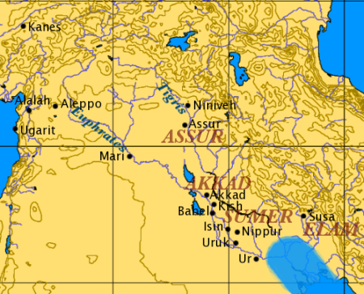

https://en.wikipedia.org/wiki/File:Mesopotamia.PNG

MARDUK (Bibl. Merodach²), the name of the patron deity
of the city of Babylon, who, when Babylon permanently became
the political centre of the united states of the Euphrates valley
under Khammurabi (c. 2250 B.C.), rose to the position of the
head of the Babylonian pantheon. His original character
was that of a solar deity, and he personifies more specifically the
sun of the spring-time who conquers the storms of the winter
season. He was thus fitted to become the god who triumphs
over chaos that reigned in the beginning of time. This earlier
Marduk, however, was effaced by the reflex of the political
development through which the Euphrates valley passed and
which led to imbuing him with traits belonging to gods who at
an earlier period were recognized as the heads of the pantheon.
There are more particularly two gods—Ea and Bel—whose
powers and attributes pass over to Marduk. In the case of Ea
the transfer proceeds pacifically and without involving the effacement
of the older god. Marduk is viewed as the son of Ea.
The father voluntarily recognizes the superiority of the son and
hands over to him the control of humanity. This association
of Marduk and Ea, while indicating primarily the passing of the
supremacy once enjoyed by Eridu to Babylon as a religious and
political centre, may also reflect an early dependence of Babylon
upon Eridu, not necessarily of a political character but, in view
of the spread of culture in the Euphrates valley from the south
to the north, the recognition of Eridu as the older centre on the
part of the younger one. At all events, traces of a cult of Marduk
at Eridu are to be noted in the religious literature, and the most
reasonable explanation for the existence of a god Marduk in
Eridu is to assume that Babylon in this way paid its homage to
the old settlement at the head of the Persian Gulf.
While the relationship between Ea (q.v.) and Marduk is thus
marked by harmony and an amicable abdication on the part of the
father in favour of his son, Marduk's absorption of the power and
prerogatives of Bel of Nippur was at the expense of the latter's
prestige. After the days of Khammurabi, the cult of Marduk
eclipses that of Bel (q.v.), and although during the five centuries
of Cassite control in Babylonia (c. 1750-1200 B.C.), Nippur and
the cult of the older Bel enjoy a period of renaissance, when
the reaction ensued it marked the definite and permanent
triumph of Marduk over Bel until the end of the Babylonian
empire. The only serious "rival to Marduk after 1200 B.C. is
Assur (q.v.) in Assyria. In the south Marduk reigns supreme,
and his supremacy is indicated most significantly by making
him the Bel, " the lord," par excellence.
The old myths in which Bel of Nippur was celebrated as the
hero were transformed by the priests of Babylon in the interest
²'The name Mordecai denotes "belonging to Maduk."
of the Marduk cult with the chief role assigned to their favourite.
The hymns once sung in the temple of Bel were re-edited and
adapted to the cult of Babylon. In this process the older Bel
was deliberately set aside, and the climax was reached when the
conquest of the monster Tiamat, symbolizing the chaos prevailing
in primeval days, was ascribed to Marduk instead of, as in the
older form of the epic, to Bel. With this stroke Marduk became
the creator of the world, including mankind—again setting aside
the far older claims of Bel to this distinction.
Besides absorbing the prerogatives of Ea and Bel, Marduk
was also imbued with the attributes of other of the great gods,
such as Adad, Shamash, Nergal and Ninib, so that, more
particularly as we approach the days of the Neo-Babylonian
Empire, the impression is created that Marduk was the only real
deity recognized, and that the other gods were merely the various
forms under which he manifested himself. So far as one can
speak of a monotheistic tendency in Babylonia it connects
itself with this conception that was gradually crystallized in
regard to the old solar deity of Babylon.
The history of the city of Babylon can now be traced back to
the days of Sargon of Agade (before 3000 B.C.) who appears to
have given the city its name. There is every reason to assume,
therefore, that the cult of Marduk existed already at this early
period, though it must always be borne in mind that, until the
days of Khammurabi, his jurisdiction was limited to the city
of which he was the patron and that he was viewed solely as a
solar deity.
On monuments and cylinders he is represented as armed with
the weapon with which he despatched the monster Tiamat.
At times this monster is also depicted lying vanquished at his
feet, and occasionally the monster with the lance or the lance
alone is reproduced instead of the god himself.
In the astral-theological system, Marduk is identified with the
planet Jupiter. As the creator of the world, the New Year's
festival, known as Zagmuk and celebrated at the time of the
vernal equinox, was sacred to him. The festival, which lasted
for eleven days, symbolized the new birth of nature—a reproduction
therefore of the creation of the world. The arbiter of
all fates, Marduk, was pictured as holding an assembly of the
gods during the New Year's festival for the purpose of deciding
the lot of each individual for the year to come. The epic reciting
his wonderful deed in despatching the monster Tiamat and in
establishing law and order in the world in the place of chaos
was recited in his temple at Babylon known as E-Saggila,
" the lofty house," and there are some reasons for believing
that the recital was accompanied by a dramatical representation
of the epic.
The meaning of the name Marduk is unknown. By a species
of word-play the name was interpreted as " the son of the
chamber," with reference perhaps to the sacred chamber of fate
in which he sat in judgment on the New Year's festival. Ideographically
he is represented by two signs signifying " child of
the day " (or " of the sun ") which is a distinct allusion to his
original solar character. Other ideographic signs describe him
as the " strong and universal ruler." The name of his consort
was Sarpanit, i.e. the shining or brilliant one—again an allusion
to Marduk's solar- traits—and this name was playfully twisted
by the Babylonian priests to mean ""the seed-producing" (as
though compounded of zer, seed, and banit, producing,
which was regarded as an appropriate appellation for the female
counterpart of the creator of mankind and of life in general.
The punning etymology betrays the evident desire of the priests
to see in Marduk's consort a form or manifestation of the great
mother-goddess Ishtar (q.v.), just as in Assyria Ishtar frequently
appears as the consort of the chief god of Assyria, known as
Assur (q.v.).

Encyclopedia Britannica (1911)

Here are some of the key statements which will help you understand upcoming information

- His original character was that of a solar deity, and he personifies more specifically the sun of the spring-time who conquers the storms of the winter season. He was thus fitted to become the god who triumphs over chaos that reigned in the beginning of time.

- In this process the older Bel was deliberately set aside, and the climax was reached when the conquest of the monster Tiamat, symbolizing the chaos prevailing in primeval days, was ascribed to Marduk instead of, as in the older form of the epic, to Bel. With this stroke Marduk became the creator of the world, including mankind—again setting aside
the far older claims of Bel to this distinction.

- Besides absorbing the prerogatives of Ea and Bel, Marduk was also imbued with the attributes of other of the great gods, such as Adad, Shamash, Nergal and Ninib, so that, more particularly as we approach the days of the Neo-Babylonian Empire, the impression is created that Marduk was the only real deity recognized, and that the other gods were merely the various forms under which he manifested himself. So far as one can speak of a monotheistic tendency in Babylonia it connects itself with this conception that was gradually crystallized in regard to the old solar deity of Babylon.

- On monuments and cylinders he is represented as armed with the weapon with which he despatched the monster Tiamat. At times this monster is also depicted lying vanquished at his feet, and occasionally the monster with the lance or the lance alone is reproduced instead of the god himself.

- In the astral-theological system, Marduk is identified with the planet Jupiter.

- As the creator of the world, the New Year's festival, known as Zagmuk and celebrated at the time of the vernal equinox, was sacred to him. The festival, which lasted for eleven days, symbolized the new birth of nature—a reproduction therefore of the creation of the world.

- The arbiter of all fates, Marduk, was pictured as holding an assembly of the gods during the New Year's festival for the purpose of deciding the lot of each individual for the year to come.

- The epic reciting his wonderful deed in despatching the monster Tiamat and in establishing law and order in the world in the place of chaos was recited in his temple at Babylon known as E-Saggila, " the lofty house" ….

You have to keep watching the following video in order to understand what he’s trying to say. Over time, it will become clear, and he will prove his point. Even if you disagree with the main premise, you will learn needed information on Marduk and Babylon.

Babylonian Sciences from Genesis to Revelations
http://www.youtube.com/watch?v=OhYtyzyeEfk

I don’t agree with his interpretation of the Babylon of Revelation at the end the video.

PSALMS
PSALM 73
22 So foolish was I, and ignorant: I was as a beast before
thee.

Today, the “gods” are called the Elite (those that are known by some of the public, and those that are not). They even call themselves “gods,” and practice a religion which teaches that godhood is obtainable. A major portion of their power is derived from their control of information/knowledge, which they horde and only distribute as censored, molded information/knowledge designed to have a desired affect upon the consumer of that information/knowledge (the population). The totality of this consumed information/knowledge in a person’s mind (the sum of their beliefs) creates a reality, a reality crafted by the Elite, which mirrors the movie The Matrix (which is based on real life). No one knows what’s being done to them because they are born into it (it’s just life). They are born into a life where all their sources of information/knowledge – from parents, schools, and TV shows; to music, scientists, and books – are already controlled by the Elite, and are already distributing the desired information/knowledge. This remains a constant from birth to death. While having this false reality, the people unknowing work as slaves for the Elite, and their work actually powers the System which enslaves them. The Elite got the idea of this false reality, for the most part, from Plato’s The Cave. Plato seems to have gotten it from Egypt, or from Solon or Socrates who got it from Egypt, and before Egypt it was at Babylon (as you’ve seen). With the aid of modern technology and greater understanding, they’ve gone beyond just making savage man. They’ve created a reality for their savage men. The only way out of this reality, this Matrix, is to obtain the correct knowledge. Freemasonry offers a way out, and claims to be the only way out.

The Elite have countries set up in such a way that knowledge is virtually unobtainable, with the “higher knowledge” costing money and being locked behind college degrees. This knowledge that is locked behind degrees is knowledge that they have certified for the citizens, so it’s still select knowledge. On top of that, the knowledge is only for the citizens to work more, or work better. The only way for the citizens to gain true knowledge is to seek it themselves, but they can’t do this if they’re kept busy (work, school/indoctrination, etc.), distracted (which sometimes is their own fault), or are conditioned to not search, only sit back and receive.

“Fictions are necessary for the people, and the Truth becomes deadly to those who are not strong enough to contemplate it in all its brilliance. In fact, what can there be in common between the vile multitude and sublime wisdom? The Truth must be kept secret, and the masses need a teaching proportioned to their imperfect reason.” – Albert Pike

“Private capitalists inevitably control, directly or indirectly, the main sources of information. It is thus extremely difficult, and indeed in most cases quite impossible, for the individual citizen to come to objective conclusions and to make intelligent use of his political rights.” – Albert Einstein

“The most potent weapon in the hands of the oppressor is the mind of the oppressed.” – Steve Biko

You might think to yourself, “They give us free education in grade school.” This is true. But have you ever wondered why this is so? Have you ever wondered why it’s mandatory/compulsory – why you’re forced to go to grade school? Well, just like college, you’re being given select knowledge, and one of the main purposes is to make you into a worker. As one person brought up in the video, from grade school they ask you, “What do you want to be when you grow up?” And this question remains the central focus of your education throughout grade school. Most students even take a career evaluation assessment before graduation to see where they would best fit, which field they would be best suited for. And if you didn’t know, the Bee Movie was also about you.

Grade school is also where the desired, necessary transformations of the mind are made, along with the desired, necessary implantation of select beliefs pertaining to building of the false reality, and living life in the System. A more correct term for their schools would be “indoctrination centers”. If you research into the indoctrination done to Native Americans in early America you’ll see that what was later carried out on all Americans was not new.

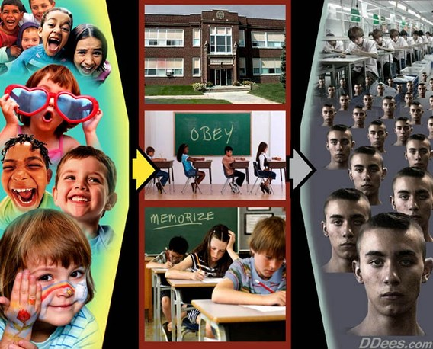

"In our dreams, we have limitless resources and the people yield themselves with perfect docility to our molding hands. The present education conventions fade from their minds, and unhampered by tradition, we work our own good will upon a grateful and responsive rural folk. We shall not try to make these people or any of their children into philosophers or men of learning, or men of science. We have not to raise up from among them authors, editors, poets or men of letters. We shall not search for embryo great artists, painters, musicians nor lawyers, doctors, preachers, politicians, statesmen, of whom we have an ample supply…The task we set before ourselves is very simple as well as a very beautiful one, to train these people as we find them to a perfectly ideal life just where they are. So we will organize our children and teach them to do in a perfect way the things their fathers and mothers are doing in an imperfect way, in the homes, in the shops and on the farm." – General Education Board, Occasional Papers, No. 1 (General Education Board, New York, 1913) p. 6.

Read this: http://www.thrivemovement.com/follow-money-education

Everything in this next clip is important, but particular interest should be paid to what’s said about your children and school towards the end.
Rockefeller Reveals 9 11 FRAUD and New World Order to Aaron Russo
https://www.youtube.com/watch?v=FuinaIm-kd4

There’s so much more to all of this, but this is not the time or place to go into it all. I just wanted to further prove that this is the Babylonian system at work.

“For more than a century, ideological extremists at either end of the political spectrum have seized upon well-publicized incidents to attack the Rockefeller family for the inordinate influence they claim we wield over American political and economic institutions. Some even believe we are part of a secret cabal working against the best interests of the United States, characterizing my family and me as "internationalists" and of conspiring with others around the world to build a more integrated global political and economic structure – one world, if you will. If that's the charge, I stand guilty, and I am proud of it.” – David Rockefeller

The peonage and sharecropping systems of early America which enslaved Blacks in a new type of slavery, slavery by circumstances, slavery by debt, were later set up over the entire US population after the Elite’s (the Industrialists) Industrial Revolution. The Elite got the American people off of their farmlands, which they owned (abolition of property), and into suburbs and cities they created for them. In these created environments, the people have to work to gain “money” – the only thing that can be used to obtain needs and wants, goods and services, in the environment. And whereas before their job benefited them and their community directly, it now directly or indirectly benefits the Elite, the bankers and/or their associates. In this environment, the people pay a bank for a loan for a plot of land to live on. They pay a bank for a loan for a home to live in. They pay a bank for a loan to get a higher education to work at a “better job” (even the schools by which they obtain their higher education were created by the Elite). They pay a bank for a loan to have transportation to and from work and school. They pay a bank to store their money, and to be able to use their money in different ways in the environment. And the environment is set up so that each citizen needs a credit score and credit history. In other words, they have to borrow. And that seems to be the name of the game.

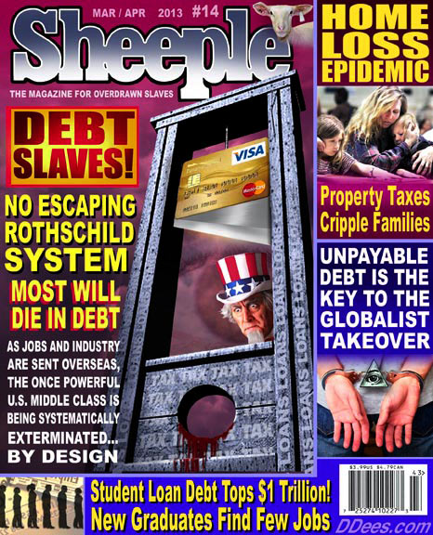

[With the Elite’s creation of the United Nations and it’s World Bank, along with central banks and commercial banks, they were able to enslave the countries of the world through debt.]

As stated, in this environment, the people need the banker’s “money” to obtain their needs and wants. One important need, in which the people actually relinquished control over, is food (production, and now even preparation). They don’t grow their own food, and no one in their community grows food; instead, they have to buy “food” from corporations, or stores that are owned and/or controlled by corporations, which are owned and/or controlled by the bankers and/or their associates. With this being the case, they need money, so they have to work (and work for a job that directly or indirectly benefits the Elite). And it’s the same for clothes, furniture, appliances, tools, and all – no one in their community makes them, they buy them from corporations, or stores that are owned and/or controlled by corporations, which are owned and/or controlled by the bankers and/or their associates. (The environment isn’t filled with independent merchant men competing against one another. This is only an illusion similar to the race for Presidency.) When it comes to their wants, the people in the environment are scientifically induced to spend their money on wants, which feel like needs, causing them to need more money. This in turn causes them to work more, or continue to work.



In the board game Monopoly, two or more people are competing against one another to obtain money, houses, and become landowners. For the entire duration of the competition there’s one entity in the shadows, not playing the game as the others, only supplying the fuel for the competition. That entity is the Bank. In the Elite’s environments, the central banks and the commercial banks run the country.

“The Power of financial capitalism had a far reaching plan, nothing less than to create a world system of financial control in private hands able to dominate the political system of each country and the economy of the world as a whole. This system was to be controlled in a feudalistic fashion by the central banks of the world acting in concert, by secret agreements arrived at in frequent meetings and conferences. The apex of the system was to be the Bank for International Settlements in Basel, Switzerland, a private bank owned and controlled by the world's central banks, which were themselves private corporations. Each central bank sought to dominate its government by its ability to control treasury loans, to manipulate foreign exchanges, to influence the level of economic activity in the country, and to influence co-operative politicians by subsequent rewards in the business world.” – Carrol Quigley (Bill Clinton's mentor and Georgetown University professor.), Tragedy and Hope (1966)

“I believe that banking institutions are more dangerous to our liberties than standing armies. Already they have raised up a monied aristocracy that has set the government at defiance. The issuing power should be taken from the banks and restored to the people, to whom it properly belongs.” – Thomas Jefferson

“I am a most unhappy man. I have unwittingly ruined my country. A great industrial nation is controlled by its system of credit. Our system of credit is concentrated. The growth of the nation, therefore, and all our activities are in the hands of a few men. We have come to be one of the worst ruled, one of the most completely controlled and dominated governments in the civilized world. No longer a government by free opinion, no longer a government by conviction and the vote of the majority, but a government by the opinion and duress of a small group of dominant men.” – Woodrow Wilson, after signing the Federal Reserve Act (1916)

“Under the Federal Reserve Act, panics are scientifically created. The present panic is the first scientifically created one, worked out as we figure a mathematical equation.” – Congressman Charles Lindbergh (1921), speaking on the panic of 1920

“When the Federal Reserve Act was passed, the people of these United States did not perceive that a world banking system was being set up here. A super-state controlled by international bankers and industrialists acting together to enslave the world for their own pleasure. Every effort has been made by the Fed to conceal its powers but the truth is, the Fed has usurped the government.” – Congressman Louis McFadden, June 10, 1932.

“The real truth of the matter is, as you and I know, that a financial element in the larger centers has owned the government since the days of Andrew Jackson.” – President Franklin Roosevelt, November 21, 1933

“We are grateful to the Washington Post, The New York Times, Times Magazine and other great publications whose directors have attended our meetings and respected their promises of discretion for almost 40 years. It would have been impossible for us to develop our plan for the world if we had been subjected to the lights of publicity during those years. But, the world is more sophisticated and prepared to march towards a world government. The supranational sovereignty of an intellectual elite and world bankers is surely preferable to the national auto-determination practiced in past centuries.” – David Rockefeller at a meeting of the Council on Foreign Relations

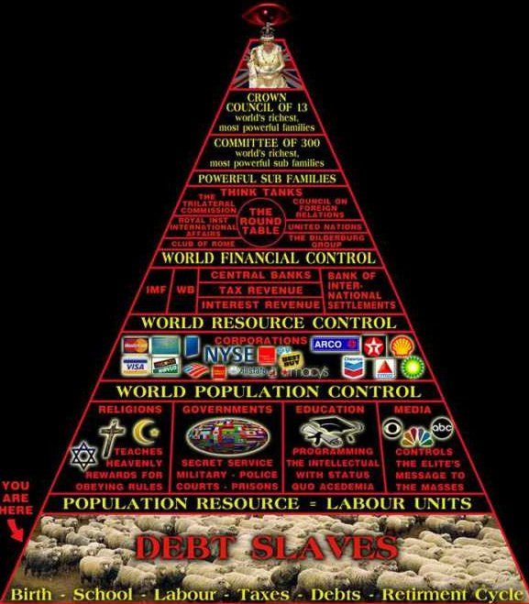

Feminism Was Created To Destabilize Society, Tax Women and set up the NWO - Aaron Russo
https://www.youtube.com/watch?v=zCpjmvaIgNA

Don’t put all of your focus on a chip, they could easily change this plan.

The political and economic systems that run the nations of the world have their roots in Babylon because they have their roots in Europe. From Babylon, to Egypt, to Greece, to Rome. From Babylon, to Greece, to Rome.

The Elite’s Religion

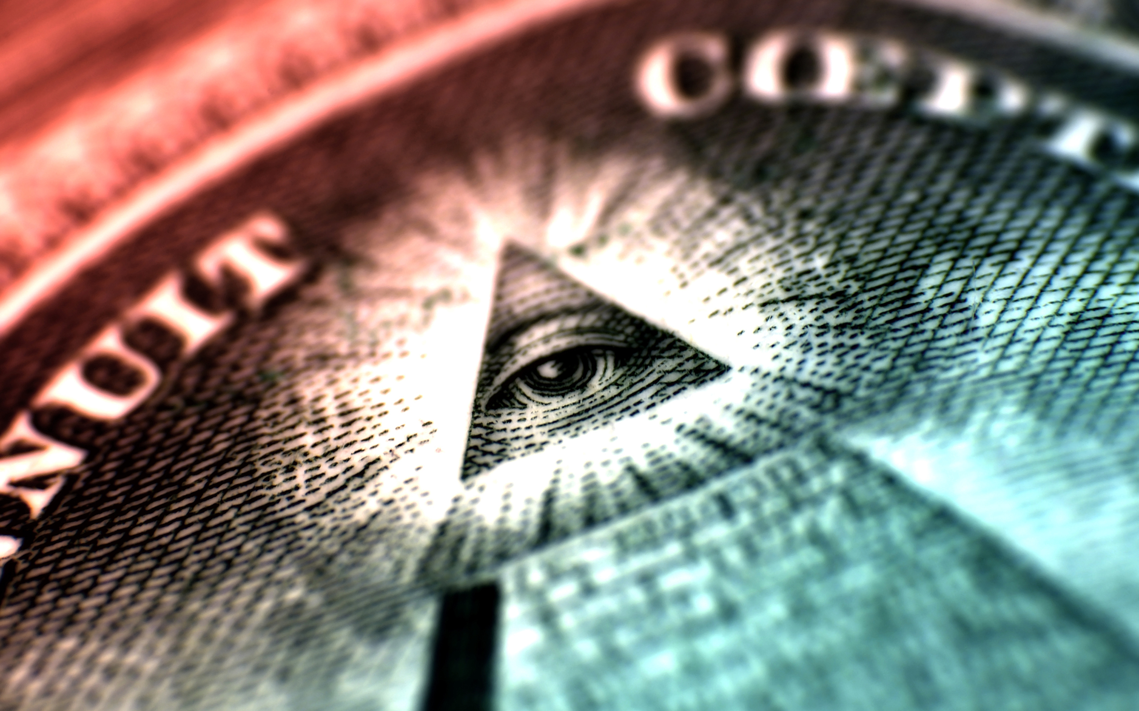

This section goes into the spiritual side of things. You can always research into these matters if you don’t believe they are true.

It’s rare for a ruling class to solely embrace the same religion as the population they rule over. They usually practice the same religion outwardly, and another in secret. For thousands of years, whether it’s kings or priests, the preferred secret religion has usually been a mystery religion.

Today, most of the world’s population is under the religion of the Babylon of Revelation, but the Elite are under the mystery religions of Babylon, and the religion of Nimrod – the belief that man can become god.

This next video gets choppy for about the last 15 minutes (typical Youtube censorship), but you need to at least keep listening.

The Luciferian Philosophy/Religion vs. The Truth
http://www.youtube.com/watch?v=mARrtQxUQTY

It must be understood that depending on which global Elite you’re looking at, there are those who believe Lucifer/Satan is god, and there are those who believe man is god and only use the idea of Lucifer as a metaphor. In truth, as much as they lie and deceive, there’s no telling what some of them actually believe.

As stated in the video (some of things made reference to are not known by most people):
It’s said that many of the most powerful men in the world believe Satan/Lucifer to be the source of all things – a holy, sacred, force and source of Wisdom, Truth, and Knowledge – what people refer to as God.

It’s also said that Man’s/Mankind’s intellect, or own mental capabilities, is “God” … and so Man/Mankind/Self is God.

You are God? You are God? So, how is that you are taking orders from other people, or even Gods? You are God? Why aren’t you ruling, that is, the one at the very top, giving the orders? You are God? Why are you following the rules, or laws, of others? How is it that you are a slave to a Plan, not the one making the Plan? You are God? How is that you learn, you’re not All-Knowing? What sort of God are you? What do you do? What can you do? Isn’t it true that what you do is what others require of you? You are God? How many of the other men and women who have said that, have died?

Satan, or Lucifer, is God? He is “a fan of Man,” that is, he’s Man’s best friend? Why has there been so many murders – which includes wars – famines, diseases, and disasters? Why so much injustice around the world? Why so much hate and wickedness? Man is being harmed. Man is suffering! Where is Lucifer? Is he sleeping on the job? You say he’s God, and has Man’s best interest in mind? I don’t see peace and love when I look out at the World. What kind of God allows this? What kind of God is that? And if chaos (New World Order) comes in the future, that will be another thing he didn’t stop from happening to Man/Mankind.

When it comes to Yahweh, this is exactly what He said would happen to a sick world such as this. So, once again, He told The Truth. And, not only did He tell The Truth, He foretold the future.

To whom it may concern:
If Satan/Lucifer/Lightbearer, or whatever you want to call him, is the greater of two gods, the other being Yahweh/Jehovah, why is it that Adam and Eve died? The fact that they did indeed die, shows (proves) that Satan/Lucifer lied. Didn’t Satan/Lucifer say to Adam and Eve, “Ye shall not surely die.”? Well, he lied; they died. If he were God, they wouldn’t have died. If he was so great, and loved Man so much, and was God, couldn’t he have prevented that? Wouldn’t he have prevented that? Couldn’t he have at least resurrected them? If Satan/Lucifer was greater than Yahweh/Jehovah, couldn’t he …?
The “Wisdom,” the beliefs, it doesn’t add up, especially when what Yahweh/Jehovah said would happen, DID happen. Who told the truth? Who lied? … trust a Lie before the Truth?

To whom it may concern:
You say that Yahweh/Jehovah didn’t want Man/Mankind to be wise/knowledgeable like Himself (like God), so didn’t let him partake of the Tree of the Knowledge of Good and Evil?
A major source of your power in the Earth is built on doing just that – withholding Knowledge from Man/Mankind (… ancient texts, new discoveries …) … and with one of the reasons for doing so being so that other Men/Man can’t be like you, that is, can’t be on your level of understanding, at your height, ever … or “yet”.¹ And this is even done through many means, from education to initiation.

¹The reason the Rulers of this World hold back Knowledge from Man/Mankind is said to be done for Man’s own good. Man is not ready yet.

And not only is wisdom and knowledge withheld, a carefully crafted continuous flow of “wisdom” and “knowledge”/information is pushed upon Man/Mankind (for purposes too sick to mention).

[No disrespect intended, I have no choice but to speak The Truth.]

How can you do that, think and live like that, and at the same time believe and/or state that Yahweh/Jehovah is the “cruel God” out of He and Satan/Lucifer for withholding Wisdom/Knowledge (or ___) from Man/Mankind? And when you, a mere Man does this, is it not cruel? How can you base your religions, secret societies, and other groups on such an impurity – on such an impure/imperfect foundation? Wouldn’t that be heresy and/or blasphemous in the presence of Logic, Truth, and Wisdom (which you proclaim to possess and have exclusivity to)?

The Prophet of the New Age is said by some to be “The Perfected Man.” A rumored name is Maitreya.
Man, and a man, that has been worked on – “Perfected” – over time, using Man’s (Mankind’s) mental capabilities/intellect? Man, “bred”/created the “perfect vessel”?
The “perfect” Temple?
He can’t be Perfect if he believed any of the beliefs that were just disproved (Satan/Lucifer is God, Man is God …).
The Perfected Man?
What’s your definition of Perfection?

Can an imperfect being know Perfect/Perfection? And yet everyone involved in the “Perfecting” is imperfect.
Can an imperfect being Perfect himself or others by/through any means; by/through manipulating procreation, laboratory ventures, secret societies (“Knowledge”/“Wisdom” Schools)?²
Would a Perfect being ever arrive at a moment in his/her/it’s life/existence where/when he/she/it questioned/wondered – doubted – his/her/it’s own Perfection, if he/she/it were Perfect?
Or, is the “Perfect” being not able to know his/her’s/it’s own moment of doubt (know that he/she/it doubted), even for a split second, rendering he/she/it Imperfect?

You could be Perfected if you were Perfected by Perfection/Perfect.
Note: That’s not what the “Ascended Masters” are doing – if they even exist, and no matter who or what they are – their prophets are all clearly imperfect.

² … especially when he/she/it was created/born, or even “reborn,” by/through, and into, imperfection … for Man/Mankind that’s billions of years of imperfection because the Earth is billions of years old, right?

“Ascended Masters”?
No proof, there’s stories (from men and women) and paintings and drawings (which, if worshiped, is idolatry). Now, compare that to the Bible and the history of followers of Yeshua/Jesus.

No pyramid in all the world, at any time, nor tower back in Babylon, was Perfect.

Helena Blavtsky, Albert Pike, Aleister Crowley, Alice Bailey, Acharya S., Jordan Maxwell, and many others …. How that came out, them being lined up and then cut down like that, I didn’t plan that out; I just went with the flow of the Spirit (as usual), and that’s what came out (as usual).

And let me add to what I already stated …

You believe that knowledge is everything, and knowing is everything. Knowledge is not always good. One negative affect of knowledge was seen in the Garden of Eden. Knowledge can destroy innocence, leaving the possessor of that knowledge responsible for his own decisions. It’s like comparing a baby to an adult. “He doesn’t know any better.” He doesn’t know right from wrong/good from bad. What happens when he does, and then does wrong? He is now guilty. Being guilty, there is now punishment, if there is justice. If he didn’t know right from wrong and did “wrong,” he couldn’t be held accountable. So, the whole idea that knowledge is always good is false.

Now, think about the Luciferian philosophy. It’s believed that Lucifer helped man, or saved man, by giving him knowledge; when in fact, he did the exact opposite. He took man from innocence to guilt; from pure to impure; from unaccountable to accountable.
That’s not a gain. That’s a major loss.

So, as you can see, the Luciferian philosophy is as false as Lucifer.

And there’s no religion higher than truth, right?

“LUCIFER, the Light-bearer! Strange and mysterious name to give to the Spirit of Darkness! Lucifer, the Son of the Morning! Is it he who bears the Light, and with its splendors intolerable blinds feeble, sensual, or selfish Souls? Doubt it not!” – Morals and Dogma by Albert Pike

If he lied, and is a liar, where is the light in that?

Excerpt from OCCULT THEOCRACY – ALBERT PIKE AND GIUSEPPE MAZZINI
The theological dogma of Albert Pike is explained in the 'Instructions' issued by him, on July 14, 1889, to the 23 Supreme Councils of the world and have been recorded by A. C. De La Rive in La Femme et l' Enfant dans la Franc-Maconnerie Universelle (page 588) from which book we translate and quote as follows :
"That which we must say to the crowd is – We worship a God, but it is the God that one adores without superstition.
"To you, Sovereign Grand Inspectors General, we say this, that you may repeat it to the Brethren of the 32nd, 31st and 30th degrees – The Masonic religion should be, by all of us initiates of the high degrees, maintained in the purity of the Luciferian doctrine.
"If Lucifer were not God, would Adonay (The God of the Christians) whose deeds prove his cruelty, perfidy, and hatred of man, barbarism and repulsion for science, would Adonay and his priests, calumniate him ?
"Yes, Lucifer is God, and unfortunately Adonay is also God. For the eternal law is that there is no light without shade, no beauty without ugliness, no white without black, for the absolute can only exist as two Gods : darkness being necessary to light to serve as its foil as the pedestal is necessary to the statue, and the brake to the locomotive.
"In analogical and universal dynamics one can only lean on that which will resist. Thus the universe is balanced by two forces which maintain its equilibrium : the force of attraction and that of repulsion. These two forces exist in physics, philosophy and religion. And the scientific reality of the divine dualism is demonstrated by the phenomena of polarity and by the universal law of sympathies and antipathies. That is why the intelligent disciples of Zoroaster, as well as after them, the Gnostics, the Manicheans and the Templars have admitted, as the only logical metaphysical conception, the system of the two divine principles fighting eternally, and one cannot believe the one inferior in power to the other.
"Thus, the doctrine of Satanism is a heresy; and the true and pure philosophic religion is the belief in Lucifer, the equal of Adonay; but Lucifer, God of Light and God of Good, is struggling for humanity against Adonay, the God of Darkness and Evil."
One must not lose sight of the fact that Pike occupied simultaneously the positions of Grand Master of the Central Directory of Washington, that of Grand Commander of the Supreme Council of Charleston and that of Sovereign Pontiff of Universal Freemasonry.
Source: http://www.theforbiddenknowledge.com/hardtruth/morals_and_dogma_freemasonry.htm

“To you, Sovereign Grand Inspectors General, we say this, that you may repeat it to the Brethren of the 32nd, 31st and 30th degrees – The Masonic religion should be, by all of us initiates of the high degrees, maintained in the purity of the Luciferian doctrine.”

How about the impurity of the Luciferian doctrine?

Pike said that the reason “Adonay” and Lucifer are both God is because of something he called the eternal law.

No light without shade?
No beauty with ugliness?
No white without black

In the beginning, there was darkness, and no light. Darkness existed without light. Where there’s no light, there’s darkness. Darkness exists without light. If you can keep a light source going, light would exist without darkness. Darkness without light would still be darkness. It would still have the same qualities and characteristics. Light without darkness would still be light. It would still have the same qualities and characteristics. There would be nothing for it to be in contrast to, but it would still exist.

The “eternal law”? It’s dead now. And Albert Pike was wrong once again.

After the eternal law nonsense, Pike then goes on to try to prove his false statements by spewing out poetic scientific knowledge. But with the “eternal law” being false, all that smart talk means nothing.

I can’t believe all these leaders around the world have bought into this mess. They must believe in Santa Claus too.

Lucifer is the god of light and good, struggling for humanity/man/mankind against the true God?

His aim is to help man, to provide that knowledge, that fire, but in his first conversation with man he deceived him (darkness, not light), and in doing so caused him to be taken from a condition of immortality to mortality, and his seed after him, the same. That’s the exact opposite, and I mean exact opposite, of someone who is beneficial to man. He caused the first man to die. The first one! And that’s not even all the wrong that fell upon man because of Lucifer’s lie. You can’t get more anti-man than that. And you guys that believe in this are smart fellows who posses great knowledge and wisdom? You’re the “illuminated ones”? “… the Truth becomes deadly to those who are not strong enough to contemplate it in all its brilliance. In fact, what can there be in common between the vile multitude and sublime wisdom?”

According to author, researcher, and radio host William Cooper, at the highest levels of all the secret societies, collectively known as The Brotherhood, they teach the Luciferian Philosophy. If this is true, all secret societies are flawed/imperfect/impure/false because the Luciferian Philosophy is incorrect. They all have a crack in their dams. They all have an infection. And worst, if this is their foundation, they have no foundation, and without a foundation there is no house (or temple, or House of the Temple). If William Cooper is incorrect, and it’s only some of the secret societies that believe this falsehood at the higher levels, then those that do so are false. They all know who they are.

“Masonry is a search after Light. That search leads us directly back, as you see, to the Kabalah. In that ancient and little understood medley of absurdity and philosophy, the Initiate will find the source of many doctrines; and may in time come to understand the Hermetic philosophers, the Alchemists, all the Anti-papal Thinkers of the Middle Ages, and Emanuel Swedenborg.” – Morals and Dogma by Albert Pike

If Masonry is a search after light, then depending on his definition of light, they are clearly looking in the wrong place (as you’ve seen). And he said they are looking to the Kabbalah. If the light which he spoke of is truth, wisdom, or understanding, then the Kabbalah is not the thing to go to for that. He has proven that.

He stated that the initiate would find the source of many doctrines in the Kabbalah. How many of them are true? How about the Luciferian doctrine? And the initiate is trying to be like those at the highest degrees, those that believe in the falseness of Luciferian doctrine. So, the Kabbalah …? And we’ve already seen what the Kabbalah has produced in this world, and it isn’t truth, wisdom, or understanding. Unbeknownst to the world, behind the wars, terror, revolutions, assassinations, starvation, and enslavement for almost the past one thousand years has been Kabbalistic “Jews”. They’ve deceived and manipulated every other people on earth into doing their dirty work and taking the blame for it, which is the main purpose of the secret societies they’ve created using the Kabbalah. They brought the Masonic Lodges to the American colonies. They are behind the secret societies. They ran the entire Trans-Atlantic Slave Trade (and blamed it on White Christians). And the New World Order is there’s. And they’re not even Israelites, God’s chosen people! They’re descendants of converts! For the full details of everything I just stated, and more, see Wake Up Jacob pages 1018 – 1270.

[How would what you’ve just read look as a movie scene, or vision like those in the book of Revelation? Like this? Or maybe like this?]

Many of these people believe in a doctrine of good deeds vs. bad deeds. I don’t know the exact details of how this belief system works, but part of it seems to be that as long as your “good deeds” outweigh your “bad deeds” you’re okay.

If this is true, how do you determine the amount of “goodness” or “badness” of a deed? You or some other man decides?

What is “good” and what is “bad”? You or some other man decides?

Selling deadly pills to a population is justified by one hundred million dollars in donations to a foundation? If it’s like that, what type of nonsense is that? I hope that’s not the way it is. I hope those at the top just deceive those below them into believing this because there’s no way anyone should be at the top of anything believing something like this.

Your deeds/actions have a ripple effect whether perceived or not. What you act upon reacts upon something else, and that upon something else, and on and on. So, how could you trace all of that, tally it up, and then determine if the initial deed/action was “good” or “bad”? Is it based on “good” or “bad” intentions? If you do “good” in order to justify your “bad,” you’re “good” was not good at all. The reason you did it was for “bad”.

Picture this: You intentionally cause a bank panic in a country, then get your men in government to give you trillions of dollars and pass the debt on to the citizens of that country. The country then goes into a deep recession. One man loses his job as a result. This guy ends up losing his home, car, and ability to pay for his education. He commits suicide as a result. The guy’s brother develops an anger issue as a result. Years later, the guy’s brother, having an anger issue as a result of his brother’s death, gets drink spilled on him at a bar and snaps, something he wouldn’t have done without the anger issue. He then stabs the person who spilled the drink on him. Months later, the person who got stabbed is healed, but starts carrying a gun everywhere he goes. And I’ll stop there.

Your deeds/actions create changes in many different circumstances. The effects are endless. Being endless, how can you track them all; then calculate them all?

The universe does it? The universe is a creation. Did the Creator tell you that that’s what His creation does? The creation balances things out? The creation calculates your deeds then gives you what you deserve. If this is true, it’s obvious that you don’t get a recompense immediately, right? With that being the case, how would you know how much “good” or “bad” you’ve done? Does the universe send you something in the mail at the beginning of the month? Then how do you know? What if you’re all in the negative right now? You wouldn’t even know. That would mean you all would be doing more bad than good, and wouldn’t even know it. That would mean your methods and so-called intentions don’t match. You claim to be concerned with mankind’s well being, and seeking a utopia. Your methods don’t reflect that at all. You’re methods are too unreliable for you to be truly seeking that.

Occult knowledge? You have no choice but to keep your beliefs and doctrine hidden. If you brought it out, you know what would happen to it.

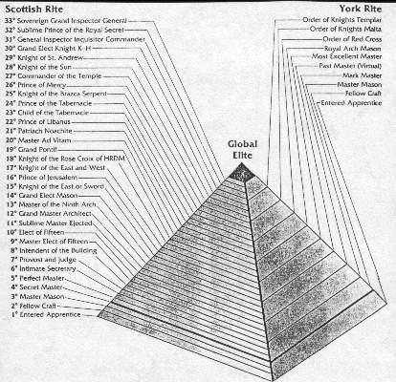

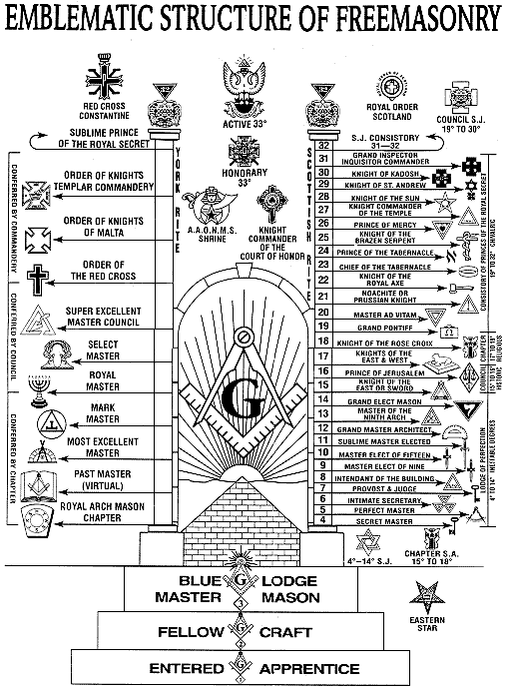

At each level of the pyramid the Mason is not told the truth – information is intentionally withheld, and he is told outright lies. This is a known fact in Masonry. So, going up 31 levels means you’ve been lied to at least 31 times in a row. Being lied to 31 times in a row, you’re going to believe that the next time, at the next level, they are telling you the truth? How about the 33rd? “I just know they’re telling me everything now.” “I just know they’re telling me the truth now.” You fool. You work to reach the highest degrees where people still don’t tell you everything, still lie to you, and don’t even have things correct themselves (the Luciferian doctrine). This is clearly not the path to enlightenment.

In Freemasonry, knowledge isn’t distributed freely. It’s locked behind degrees that must be obtained while paying monthly dues. Does that sound familiar?

Each level of Freemasonry has specific doctrine the Mason is introduced to. How many people possess the wisdom or discernment to see through the falsehood in the doctrines they are introduced to? Few, if any. The result is that they are indoctrinated. It’s no different than the Elite’s schools/indoctrination centers. The higher they progress up the pyramid, the more their minds are molded. So, even in this they are being “enlightened” at the cost of being transformed. By the time they reach the top of the pyramid they are the perfect slave, created for a particular purpose, exactly what the system, Freemasonry, was designed to make them. By the time you graduate college ….

It’s not only the secret knowledge that draws the Mason in and upward, it’s also the pride, power, and privilege they can acquire. Imagine having access to a secret, hidden world where you see and experience things almost no other man around you has ever seen or experienced; or has ever heard of. Imagine a life of secret handshakes, words, and gestures that can communicate information to a fellow Mason, and even win you favor in many situations in your life (court, being one). Imagine being taught information in Masonry, then going out into the world and being able to see their markings on buildings, in advertisements, in business logos, and many more places. The same things you had always seen are now different, and only you and others in the group know what these things truly mean (or at least you think you do). How would all of this make you feel? What affect would this have on your thoughts of Masonry? Even the blood oaths a Mason takes as they enter and advance upward can give a sense of power and pride.

It was known decades ago that about 85% of Masons never progress beyond the first three degrees (the Blue Lodge). With people in the society being made dumber since then I don’t see how that percentage hasn’t increased by now, but we’ll stick with 85%. You might have heard it said that the lower three degrees of Masonry are very important to the whole pyramid. As stated, about 85% of Masons are in the first three degrees. Most of these people don’t really know what Freemasonry is truly about. They believe they are only part of some secret fraternity that aims to benefit mankind. These people are your everyday people. These are your average citizens. These people are spread throughout the country. These people are of different ages and nationalities, and can be found in all professions. These people are used for grunt work.

Picture this: A judge presiding over a certain case is a Mason. Someone higher up in Masonry wants the case to have a certain outcome. The Masonic judge is contacted by a fellow Lodge member and is told what to do, and he may be offered advancement. In this situation, do you think the judge will do it? Of course he will. What then takes place, and why it truly took place, remains hidden from the outside world.

Alternatively: It may be that the security guard watching monitors in a building is a Mason, and he’s contacted by a Lodge member and told to turn off a certain camera for exactly 40 seconds. It may be that a corporate CEO …. It may be that a police officer … a mayor … a congressman … a president … a doctor … a scientist … a Christian pastor … a rapper … an actor …. That's the definition of “hidden power”. Most of these people don’t advance very far in Masonry, and don’t have any real power, so they really just remain available to be used like call-girls.

VERSACE UNVEILED
https://www.youtube.com/watch?v=-raVplg6nSE

Order out of chaos – New World Order out of chaos. Do you remember what was said of Marduk/Nimrod of Babylon and chaos? And do you remember how he was made the supreme ruler of the world?

Note: Some of the interpretations of Scripture in this next video are not entirely correct.

Aquarius: The Age of Evil (Full Movie)
https://www.youtube.com/watch?v=EBJftihe1yc

Please realize that they could have easily lied about what happened with Maitreya in Kenya. And the so-called being of light dancing … we live in the age of deception and advanced technology, you can’t always believe your eyes, especially grainy camera footage from people who already tried to create a “Christ”. Me, personally, if he was actually able to appear as light or not, it’s all the same to me. I wouldn’t care if he was actually pure light or pure fire. But that’s just me.

All of this is similar to Sabbatai Sevi. And why shouldn’t it be ….

For additional information into what is believed and taught by some of these people:

The Legend of Atlantis
https://www.youtube.com/watch?v=0gv1qb56FTs

Yeah, something like this:

300 - Leonidas Meets Xerxes Scene - Full HD
http://www.youtube.com/watch?v=1NV9DSykTbo

