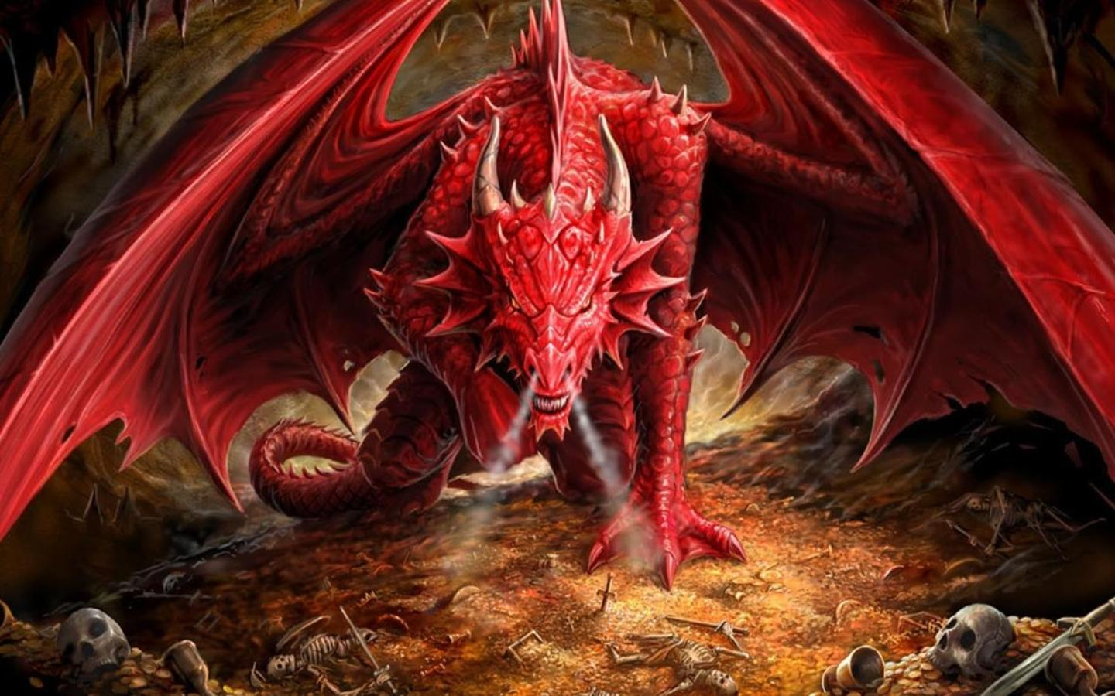
In order for you to fully understand the beasts of the book of Revelation I have to start with the prophecies in the book of Daniel. I don’t address the details of everything written in each verse, so don’t sigh, thinking you’ll have to go over tons of information you’ve already heard before. My focus is on the real “meat” of the prophecies so don’t worry.
*Read from a Bible text that has the original language, if you can, or use a KJV or ESV, if possible. Do not use an NIV.

The Book of Daniel

A spiritual, or prophetic, vision or dream can be a scene that is an actual, real life event, or a symbolic scene that needs to be interpreted.
DANIEL
CHAPTER 2
24 ¶ Therefore Daniel went in unto Arioch, whom the king
had ordained to destroy the wise men of Babylon: he went
and said thus unto him; Destroy not the wise men of
Babylon: bring me in before the king, and I will shew unto
the king the interpretation.
25 Then Arioch brought in Daniel before the king in haste,
and said thus unto him, I have found a man of the captives
of Judah, that will make known unto the king the
interpretation.
26 The king answered and said to Daniel, whose name was
Belteshazzar, Art thou able to make known unto me the
dream which I have seen, and the interpretation thereof?
27 Daniel answered in the presence of the king, and said,
The secret which the king hath demanded cannot the wise
men, the astrologers, the magicians, the soothsayers, shew
unto the king;
28 But there is a God in heaven that revealeth secrets, and
maketh known to the king Nebuchadnezzar what shall be in
the latter days. Thy dream, and the visions of thy head upon
thy bed, are these;
29 As for thee, O king, thy thoughts came into thy mind
upon thy bed, what should come to pass hereafter: and he
that revealeth secrets maketh known to thee what shall
come to pass.
30 But as for me, this secret is not revealed to me for any
wisdom that I have more than any living, but for their sakes
that shall make known the interpretation to the king, and
that thou mightest know the thoughts of thy heart.
31 ¶ Thou, O king, sawest, and behold a great image. This
great image, whose brightness was excellent, stood before
thee; and the form thereof was terrible.
32 This image’s head was of fine gold, his breast and his
arms of silver, his belly and his thighs of brass,
33 His legs of iron, his feet part of iron and part of clay.
34 Thou sawest till that a stone was cut out without hands,
which smote the image upon his feet that were of iron and
clay, and brake them to pieces.
35 Then was the iron, the clay, the brass, the silver, and the
gold, broken to pieces together, and became like the chaff
of the summer threshingfloors; and the wind carried them
away, that no place was found for them: and the stone that
smote the image became a great mountain, and filled the
whole earth.
36 ¶ This is the dream; and we will tell the interpretation
thereof before the king.
37 Thou, O king, art a king of kings: for the God of heaven
hath given thee a kingdom, power, and strength, and glory.
38 And wheresoever the children of men dwell, the beasts
of the field and the fowls of the heaven hath he given into
thine hand, and hath made thee ruler over them all. Thou
art this head of gold.
39 And after thee shall arise another kingdom inferior to
thee, and another third kingdom of brass, which shall bear
rule over all the earth.
40 And the fourth kingdom shall be strong as iron:
forasmuch as iron breaketh in pieces and subdueth all
things: and as iron that breaketh all these, shall it break in
pieces and bruise.
In verse 37, the king has a kingdom, and he and his kingdom are seen as one. So, a reference to a king could also be a reference to his kingdom as well.
41 And whereas thou sawest the feet and toes, part of
potters’ clay, and part of iron, the kingdom shall be divided;
but there shall be in it of the strength of the iron, forasmuch
as thou sawest the iron mixed with miry clay.
42 And as the toes of the feet were part of iron, and part of
clay, so the kingdom shall be partly strong, and partly
broken.
43 And whereas thou sawest iron mixed with miry clay,
they shall mingle themselves with the seed of men: but they
shall not cleave one to another, even as iron is not mixed
with clay.
44 And in the days of these kings shall the God of heaven
set up a kingdom, which shall never be destroyed: and the
kingdom shall not be left to other people, but it shall break
in pieces and consume all these kingdoms, and it shall stand
for ever.
45 Forasmuch as thou sawest that the stone was cut out of
the mountain without hands, and that it brake in pieces the
iron, the brass, the clay, the silver, and the gold; the great
God hath made known to the king what shall come to pass
hereafter: and the dream is certain, and the interpretation
thereof sure.

Verses 32-34:
1. Head - Gold
2. Breast and Arms - Silver
3. Belly and Thighs - Brass
4. Legs - Iron
5. Feet - Iron and Clay

Verse 44 [Hebrew is read from right to left.] states that in the days of “these kings” Yahua/God shall set up a kingdom which shall never be destroyed, nor left to other people, but it shall break in pieces and bring to an end the previous kingdoms, and it shall stand forever. In verse 34, the stone smote the image on the feet that were of iron and clay, and the stone became a great mountain that filled the whole earth (verse 35). The king of Babylon is told that after his kingdom another kingdom would arise, and another after that, and so on. The stone bringing those kingdoms to an end must mean that after the stone hits, the previous kingdoms will be a thing of the past, forgotten; and the stone will be or bring forth a kingdom that will last forever.
Now, what kingdom is going to be set up? Most people don’t know that there are actually two kingdoms – one, the physical Jerusalem were the Israelites will rule; the other is the spiritual kingdom, eternity. I have this proof in another project, along with a full breakdown of the book of Revelation so I won’t be going into that proof here. You may believe that since “forever” is used in that verse the verse is referring to the latter, but I don’t believe so, and you’ll see why. With that, the physical kingdom doesn’t end; it merges with the spiritual kingdom after the judgment. And think about the statement “the kingdom shall not be left to other people”. That’s definitely not in reference to the spiritual, eternal kingdom. For references to the physical kingdom see: Luke 21:24; Romans 11:1-26; Acts 1:1-7; Revelation 7:1-8. There are also many additional verses in the Old Testament that you can look at. These would have to be seen as additional fulfillments of prophecy, as the events of Babylon and Rome mirrored one another, but it’s all centered around a prophetic king David. You can look into that yourself (do a word search in the Prophets on “David”). It’s after certain events in the book of Revelation that this kingdom is firmly established, being a new Jerusalem (but in the natural sense), outlined in the book of Isaiah, where the newly gathered true Israelites/Jews will dwell. It’s basically what the Jews of today claim their “return” to the land represented, but the circumstances and events of their “return” didn’t match the prophecies at all (many people just don’t know this). According to my studies, this is the time period wherein the book of Revelation states that Satan will be chained, and kept from deceiving the nations (Revelation 20:1-3).
In verse 44, where it states “in the days of these kings,” it’s referring to the time of the feet, although he doesn’t mention any kings. This may be referring to the ten kings in Revelation, those gathered to make war against the lamb, represented as ten horns on the beast of that time period (Revelation 13:1, 17:3, 7, 12). And depending on how you define “in the days of these kings,” and how you interpret Daniel chapter 7, it may correspond to the ten horns in Daniel chapter 7, particularly 7:24. This may seem incorrect to some people, but it’s not.

DANIEL
CHAPTER 7
IN the first year of Belshazzar king of Babylon Daniel had
a dream and visions of his head upon his bed: then he wrote
the dream, and told the sum of the matters.
2 Daniel spake and said, I saw in my vision by night, and,
behold, the four winds of the heaven strove upon the great
sea.
3 And four great beasts came up from the sea, diverse one
from another.
4 The first was like a lion, and had eagle’s wings: I beheld
till the wings thereof were plucked, and it was lifted up
from the earth, and made stand upon the feet as a man, and
a man’s heart was given to it.
5 And behold another beast, a second, like to a bear, and it
raised up itself on one side, and it had three ribs in the
mouth of it between the teeth of it: and they said thus unto
it, Arise, devour much flesh.
6 After this I beheld, and lo another, like a leopard, which
had upon the back of it four wings of a fowl; the beast had
also four heads; and dominion was given to it.
7 After this I saw in the night visions, and behold a fourth
beast, dreadful and terrible, and strong exceedingly; and it
had great iron teeth: it devoured and brake in pieces, and
stamped the residue with the feet of it: and it was diverse
from all the beasts that were before it; and it had ten horns.
Theory: In the days of its feet, what’s left after the destruction it caused when it was whole is even crushed when it’s divided.
And the description of this beast is very similar to the description of the kingdom we saw in Daniel 2:40 where in the time period of the feet of that kingdom of iron Yahua/God sets up a kingdom. So, it appears to be the same kingdom being shown in a different way. Daniel chapter 2 seems to be more of a timeline.
DANIEL
CHAPTER 2
40 And the fourth kingdom shall be strong as iron:
forasmuch as iron breaketh in pieces and subdueth all
things: and as iron that breaketh all these, shall it break in
pieces and bruise.
41 And whereas thou sawest the feet and toes, part of
potters’ clay, and part of iron, the kingdom shall be divided;
but there shall be in it of the strength of the iron, forasmuch
as thou sawest the iron mixed with miry clay.
42 And as the toes of the feet were part of iron, and part of
clay, so the kingdom shall be partly strong, and partly
broken.

8 I considered the horns, and, behold, there came up among
them another little horn, before whom there were three of
the first horns plucked up by the roots: and, behold, in this
horn were eyes like the eyes of man, and a mouth speaking
great things.
9 ¶ I beheld till the thrones were cast down, and the Ancient
of days did sit, whose garment was white as snow, and the
hair of his head like the pure wool: his throne was like the
fiery flame, and his wheels as burning fire.
10 A fiery stream issued and came forth from before him:
thousand thousands ministered unto him, and ten thousand
times ten thousand stood before him: the judgment was set,
and the books were opened.
This is not the white throne judgment; it’s more like court proceedings.
11 I beheld then because of the voice of the great words
which the horn spake: I beheld even till the beast was slain,
and his body destroyed, and given to the burning flame.
Is “the beast” in reference to the fourth beast, and all that grew out of it, or is the horn being called a beast (it was a beast/kingdom or became a beast/kingdom)?
Compare to this:
REVELATION
CHAPTER 19
17 And I saw an angel standing in the sun; and he cried
with a loud voice, saying to all the fowls that fly in the
midst of heaven, Come and gather yourselves together unto
the supper of the great God;
18 That ye may eat the flesh of kings, and the flesh of
captains, and the flesh of mighty men, and the flesh of
horses, and of them that sit on them, and the flesh of all
men, both free and bond, both small and great.
19 And I saw the beast, and the kings of the earth, and their
armies, gathered together to make war against him that sat
on the horse, and against his army.
20 And the beast was taken, and with him the false prophet
that wrought miracles before him, with which he deceived
them that had received the mark of the beast, and them that
worshipped his image. These both were cast alive into a
lake of fire burning with brimstone.
21 And the remnant were slain with the sword of him that
sat upon the horse, which sword proceeded out of his
mouth: and all the fowls were filled with their flesh.
12 As concerning the rest of the beasts, they had their
dominion taken away: yet their lives were prolonged for a
season and time.
https://biblehub.com/interlinear/daniel/7-12.htm
This verse speaks of a remainder/remnant of beasts. Is this in reference to the previous three beasts, or are the ten horns being called beasts/kingdoms (they were beasts or became beasts)?
Compare to this:
REVELATION
CHAPTER 13
AND I stood upon the sand of the sea, and saw a beast rise
up out of the sea, having seven heads and ten horns, and
upon his horns ten crowns, and upon his heads the name of
blasphemy.
REVELATION
CHAPTER 17
3 So he carried me away in the spirit into the wilderness:
and I saw a woman sit upon a scarlet coloured beast, full of
names of blasphemy, having seven heads and ten horns.
12 And the ten horns which thou sawest are ten kings,
which have received no kingdom as yet; but receive power
as kings one hour with the beast.
13 These have one mind, and shall give their power and
strength unto the beast.
14 These shall make war with the Lamb, and the Lamb
shall overcome them: for he is Lord of lords, and King of
kings: and they that are with him are called, and chosen,
and faithful.
15 And he saith unto me, The waters which thou sawest,
where the whore sitteth, are peoples, and multitudes, and
nations, and tongues.
16 And the ten horns which thou sawest upon the beast,
these shall hate the whore, and shall make her desolate and
naked, and shall eat her flesh, and burn her with fire.
17 For God hath put in their hearts to fulfil his will, and to
agree, and give their kingdom unto the beast, until the
words of God shall be fulfilled.

13 I saw in the night visions, and, behold, one like the Son
of man came with the clouds of heaven, and came to the
Ancient of days, and they brought him near before him.
14 And there was given him dominion, and glory, and a
kingdom, that all people, nations, and languages, should
serve him: his dominion is an everlasting dominion, which
shall not pass away, and his kingdom that which shall not
be destroyed.
Verses 12 and 13 are not a part of the previous verses/scenes. Verse 13 shows an ascension into heaven. One like a son of man/the son of man/a man went from the “clouds of heaven”/clouds of shamayin, clouds of the sky in this case, to Yahua/God who was in heaven, and was brought before Him. That’s an ascension. See: 2 Kings 2:9-17 and Revelation 11:7-12. But where else can we find this? John 6:62, 20:17; Acts 1:9-11; Ephesians 1:19-23, 4:7-10; Philippians 2:5-11; Hebrews 1:13, 2:5-9; 10:12, 13; Revelation 5:1-13. I have some additional information that can prove this even further, but it’s a part of another project, and I don’t want to jeopardize it (it will get preyed on, twisted and turned). In addition, it would be too long to place here.
15 ¶ I Daniel was grieved in my spirit in the midst of my
body, and the visions of my head troubled me.
16 I came near unto one of them that stood by, and asked
him the truth of all this. So he told me, and made me know
the interpretation of the things.
17 These great beasts, which are four, are four kings, which
shall arise out of the earth.
They are called “kings,” but as you’ll see later they are also called “kingdoms”.
https://biblehub.com/interlinear/daniel/7-17.htm
https://www.blueletterbible.org/lang/lexicon/lexicon.cfm?Strongs=H4430&t=KJV
18 But the saints of the most High shall take the kingdom,
and possess the kingdom for ever, even for ever and ever.
As you can see, it’s speaking of a physical kingdom/dominion.
The book of Daniel is a part of the Old Testament; from the time of the Babylonian captivity. The word translated to “saints” means “holy ones”. But these verses are in Aramaic so things tend to get a little thrown off.
https://biblehub.com/interlinear/daniel/7-18.htm
https://www.blueletterbible.org/lang/lexicon/lexicon.cfm?Strongs=H6922&t=KJV
They state that this word corresponds to Strong’s H6918 – qadosh. This would be the Israelites fulfilling their purpose (Exodus 19:6). This is most likely the setting up of the kingdom stated in Daniel 2:44. But one issue is that it states that they will possess “the kingdom”. Is the Aramaic word used here correctly translated to “the kingdom”? Will they possess the beast’s kingdom? Is “the kingdom” Jerusalem? Does it represent dominion over the world? Is it what we see made reference to in Acts 1:1-7?

19 Then I would know the truth of the fourth beast, which
was diverse from all the others, exceeding dreadful, whose
teeth were of iron, and his nails of brass; which devoured,
brake in pieces, and stamped the residue with his feet;
20 And of the ten horns that were in his head, and of the
other which came up, and before whom three fell; even of
that horn that had eyes, and a mouth that spake very great
things, whose look was more stout than his fellows.
21 I beheld, and the same horn made war with the saints,
and prevailed against them;
22 Until the Ancient of days came, and judgment was given
to the saints of the most High; and the time came that the
saints possessed the kingdom.
Here are those court proceedings.
23 Thus he said, The fourth beast shall be the fourth
kingdom upon earth, which shall be diverse from all
kingdoms, and shall devour the whole earth, and shall tread
it down, and break it in pieces.

Here, it’s stated that the fourth beast is the fourth kingdom. So, the beasts are kingdoms.
https://biblehub.com/interlinear/daniel/7-23.htm
https://www.blueletterbible.org/lang/lexicon/lexicon.cfm?Strongs=H4437&t=KJV
In verse 17, the four beasts are called kings/rulers. This shows how “king” and “kingdom” are interchangeable, or that the kings/rulers can also represent kingdoms.

24 And the ten horns out of this kingdom are ten kings that
shall arise: and another shall rise after them; and he shall be
diverse from the first, and he shall subdue three kings.
https://biblehub.com/interlinear/daniel/7-24.htm

So, the ten horns represent ten kings, or kings and/or their kingdoms. This means that the remnant of beasts in 7:12 very well could be the ten horns, not the three previous beasts. And the beast of 7:11 very well could be the one horn, since a beast and a horn is a king/kingdom.
Ten kings/kingdoms/beasts shall arise out of the fourth beast. And after them another king/kingdom shall arise (verse 24)...
25 And he shall speak great words against the most High,
and shall wear out the saints of the most High, and think to
change times and laws: and they shall be given into his
hand until a time and times and the dividing of time.
26 But the judgment shall sit, and they shall take away his
dominion, to consume and to destroy it unto the end.
27 And the kingdom and dominion, and the greatness of the
kingdom under the whole heaven, shall be given to the
people of the saints of the most High, whose kingdom is an
everlasting kingdom, and all dominions shall serve and
obey him.
In Daniel 2:44, Yahua/God sets up an eternal kingdom.

28 Hitherto is the end of the matter. As for me Daniel, my
cogitations much troubled me, and my countenance
changed in me: but I kept the matter in my heart.

We can find something similar in the book of Revelation. You’ll see a beast at a certain time in its existence:

REVELATION
CHAPTER 13
AND I stood upon the sand of the sea, and saw a beast rise
up out of the sea, having seven heads and ten horns, and
upon his horns ten crowns, and upon his heads the name of
blasphemy.
2 And the beast which I saw was like unto a leopard, and
his feet were as the feet of a bear, and his mouth as the
mouth of a lion: and the dragon gave him his power, and his
seat, and great authority.
3 And I saw one of his heads as it were wounded to death;
and his deadly wound was healed: and all the world
wondered after the beast.
4 And they worshipped the dragon which gave power unto
the beast: and they worshipped the beast, saying, Who is
like unto the beast? who is able to make war with him?
5 And there was given unto him a mouth speaking great
things and blasphemies; and power was given unto him to
continue forty and two months.
6 And he opened his mouth in blasphemy against God, to
blaspheme his name, and his tabernacle, and them that
dwell in heaven.
7 And it was given unto him to make war with the saints,
and to overcome them: and power was given him over all
kindreds, and tongues, and nations.

The beast is a king/kingdom, and it was given a mouth to speak blasphemies. This beast seems to be the eleventh horn in Daniel 7:24, the one that comes up after the ten horns/kings/kingdoms and makes war with the saints. Everything matches except the part where it states that he will subdue/humble/depress/cast down three kings and think to change the time(s), appointed time, or age and law. If this is the same entity, those may be other things that he/it does that are not mentioned here.
When the Greek word being translated to “saints” – hagios, Strong’s G40 – is used throughout the New Testament to refer to a group, that group is almost always a group of believers in Christ. But is this verse in reference to believers? The group spoken of in Daniel was definitely not believers. And both “restored Israel” and believers are holy groups to the Father and Son. And both, coming out of the bondage of sin, mirror the Israelites and the mixed multitude (non-Israelites under the covenant) coming out of Egypt and becoming one body. Now read Ephesians 2:11-22, with special attention paid to verse 19. The Israelites are called hagios, the saints.

REVELATION
CHAPTER 17
12 And the ten horns which thou sawest are ten kings,
which have received no kingdom as yet; but receive power
as kings one hour with the beast.

This means that the ten kings/kingdoms in Revelation are present while the first beast is present. So, there will be ten kings/kingdoms while there is one dominate king/kingdom.

And here it states that the ten horns of the first beast in the book of Revelation represent ten kings who have not received a kingdom yet, but will reign as kings over a kingdom with the beast for a time. This pretty much confirms that these ten horns are kings with kingdoms. This seems to be the same ten as those in Daniel chapter 2 (the ten toes, Daniel 2:44).
In addition: When you see “king” it may actually be “ruler” or “sovereign”.

An alternative interpretation of Daniel chapter 7

DANIEL
CHAPTER 7
7 After this I saw in the night visions, and behold a fourth
beast, dreadful and terrible, and strong exceedingly; and it
had great iron teeth: it devoured and brake in pieces, and
stamped the residue with the feet of it: and it was diverse
from all the beasts that were before it; and it had ten horns.
8 I considered the horns, and, behold, there came up among
them another little horn, before whom there were three of
the first horns plucked up by the roots: and, behold, in this
horn were eyes like the eyes of man, and a mouth speaking
great things.

11 I beheld then because of the voice of the great words
which the horn spake: I beheld even till the beast was slain,
and his body destroyed, and given to the burning flame.

20 And of the ten horns that were in his head, and of the
other which came up, and before whom three fell; even of
that horn that had eyes, and a mouth that spake very great
things, whose look was more stout than his fellows.
21 I beheld, and the same horn made war with the saints,
and prevailed against them;
22 Until the Ancient of days came, and judgment was given
to the saints of the most High; and the time came that the
saints possessed the kingdom.

24 And the ten horns out of this kingdom are ten kings that
shall arise: and another shall rise after them; and he shall be
diverse from the first, and he shall subdue three kings.
25 And he shall speak great words against the most High,
and shall wear out the saints of the most High, and think to
change times and laws: and they shall be given into his
hand until a time and times and the dividing of time.
26 But the judgment shall sit, and they shall take away his
dominion, to consume and to destroy it unto the end.
27 And the kingdom and dominion, and the greatness of the
kingdom under the whole heaven, shall be given to the
people of the saints of the most High, whose kingdom is an
everlasting kingdom, and all dominions shall serve and
obey him.

The vision may be focused on, seen at, a certain period in history, so you have to catch it at the right time in history. There were ten horns/kings/kingdoms, and another came up after them.
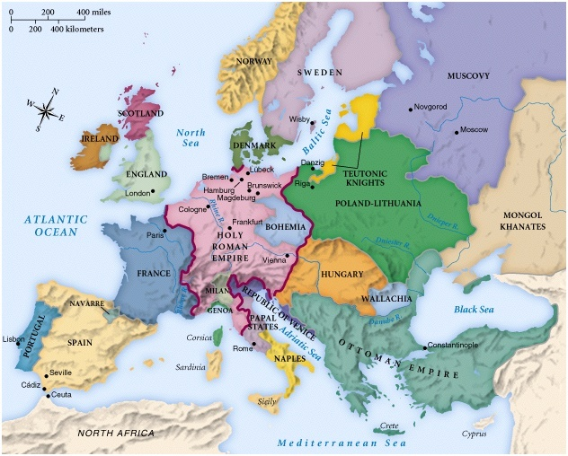
Here you have the remains/remnant of the fourth beast – the Roman Empire as the Holy Roman Empire/the Eastern Empire – Babylon/Rome (the whore) and the Papal States, and 10 nations outside of the Holy Roman Empire:
Portugal
Spain
France
England
Ireland
Scotland
Denmark
Norway
Sweden
Naples/Italy
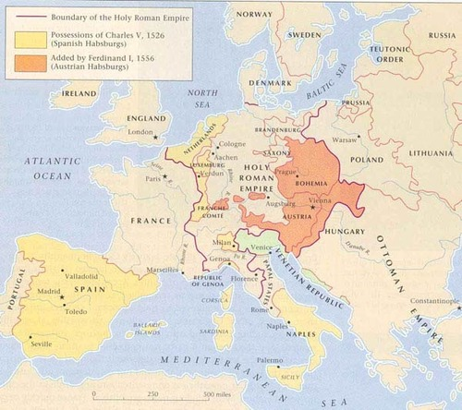

Another possible 10:
Portugal
Spain
France
Netherlands
England
Ireland
Scotland
Denmark
Norway
Sweden
Italy may be left out because of its connection to Rome/Babylon.

Netherlands:
“The southern part of the country was part of the Holy Roman Empire until it was acquired piece by piece by the Burgundians. At the end of the Middle Ages, it became a Spanish possession (together with what is now Belgium). Little survives from this period, except a few historic city centres, and a few castles.
Following the Dutch Revolt, led by national hero William of Orange (Willem van Oranje), the Netherlands became a de facto independent republic in 1572. The (first) split with Belgium came when the northern provinces (including Flanders) signed the Union of Utrecht in 1579.”
Source: http://wikitravel.org/en/Netherlands
Additional information:
https://en.wikipedia.org/wiki/Dutch_Republic
You can get 10 out of this also:

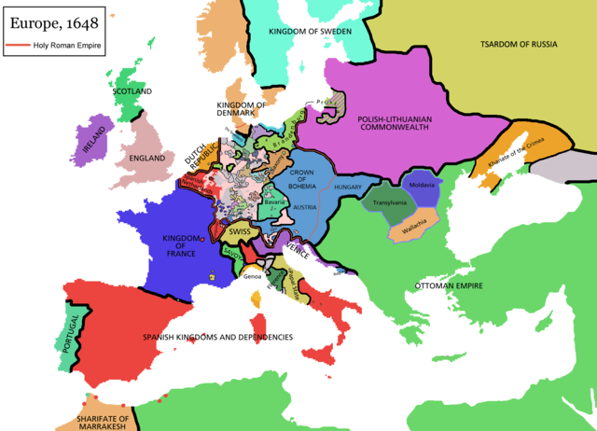

Source: https://commons.wikimedia.org/wiki/File:Europe_map_1648.PNG

Here is a different time period:
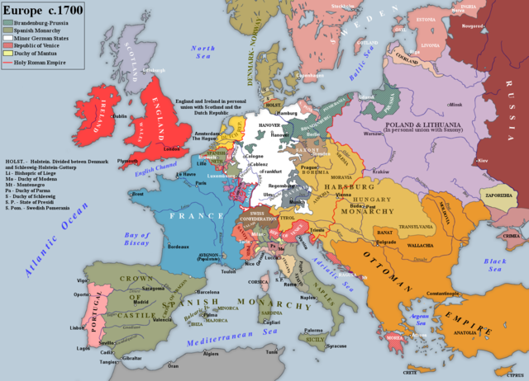
Source: https://commons.wikimedia.org/wiki/File:Europe_c._1700.png

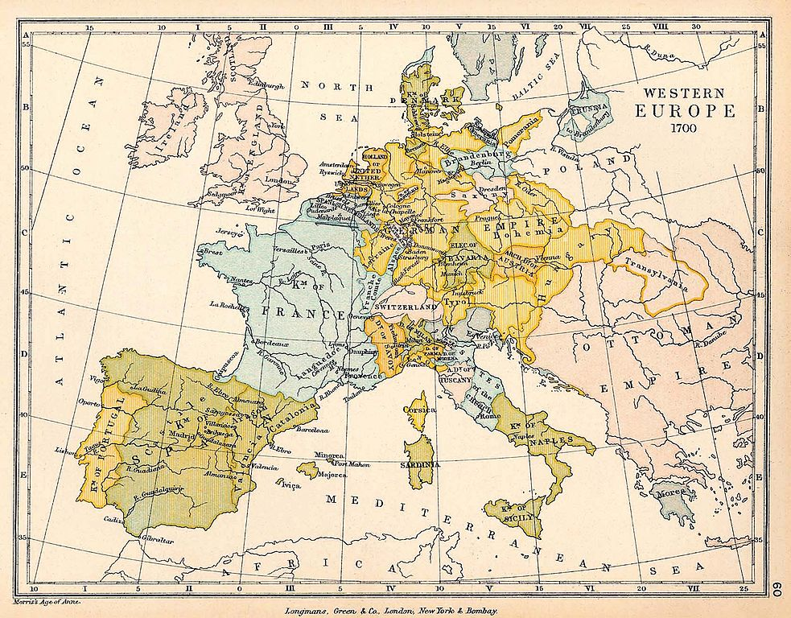

Source: https://commons.wikimedia.org/wiki/File:Western_Europe_1700.jpg

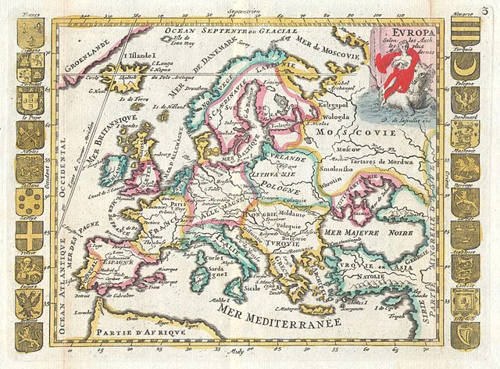
Source: https://commons.wikimedia.org/wiki/File:1706_De_La_Feuille_Map_of_Europe_-_Geographicus_-_Europe-lafeuille-1706.jpg

Additional Map:

http://www.lib.utexas.edu/maps/historical/colbeck/western_europe_utrecht_treaty.jpg

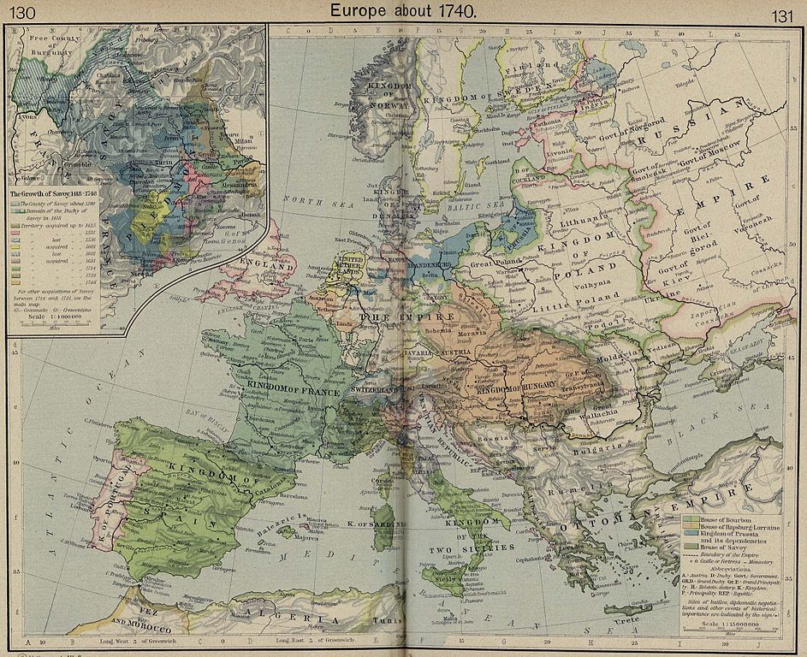

Source: https://commons.wikimedia.org/wiki/File:Europe_1740.jpg

By 1740 Wales was a part of England, and England and Scotland had joined to form Great Britain.
Sources:
https://en.wikipedia.org/wiki/Laws_in_Wales_Acts_1535_and_1542
https://en.wikipedia.org/wiki/Kingdom_of_Great_Britain

You can still get 10 out of that.

And these countries/kingdoms aren’t just some ordinary countries/kingdoms. They played a significant role in world history after the fall of the Roman Empire. Didn’t these countries trample the residue? They traversed the globe, and only came to kill, steal, and destroy. They acted like miniature Roman Empires.
Since the maps are in chronological order, looking at them from first to last, you can actually see 10 nations/kingdoms emerge from the Roman Empire.

DANIEL
CHAPTER 7
7 After this I saw in the night visions, and behold a fourth
beast, dreadful and terrible, and strong exceedingly; and it
had great iron teeth: it devoured and brake in pieces, and
stamped the residue with the feet of it: and it was diverse
from all the beasts that were before it; and it had ten horns.
8 I considered the horns, and, behold, there came up among
them another little horn, before whom there were three of
the first horns plucked up by the roots: and, behold, in this
horn were eyes like the eyes of man, and a mouth speaking
great things.

11 I beheld then because of the voice of the great words
which the horn spake: I beheld even till the beast was slain,
and his body destroyed, and given to the burning flame.

20 And of the ten horns that were in his head, and of the
other which came up, and before whom three fell; even of
that horn that had eyes, and a mouth that spake very great
things, whose look was more stout than his fellows.
21 I beheld, and the same horn made war with the saints,
and prevailed against them;
22 Until the Ancient of days came, and judgment was given
to the saints of the most High; and the time came that the
saints possessed the kingdom.

24 And the ten horns out of this kingdom are ten kings that
shall arise: and another shall rise after them; and he shall be
diverse from the first, and he shall subdue three kings.
25 And he shall speak great words against the most High,
and shall wear out the saints of the most High, and think to
change times and laws: and they shall be given into his
hand until a time and times and the dividing of time.
26 But the judgment shall sit, and they shall take away his
dominion, to consume and to destroy it unto the end.
27 And the kingdom and dominion, and the greatness of the
kingdom under the whole heaven, shall be given to the
people of the saints of the most High, whose kingdom is an
everlasting kingdom, and all dominions shall serve and
obey him.

After the fourth beast/kingdom, which most people identify as the Roman Empire, came ten horns/kings/kingdoms; and another grew up after them, a little one. This little horn/king/kingdom that came up was diverse from the first horns (the ten), and ended up subduing/humbling/depressing/casting down three of the ten.

America subdued/humbled England/Great Britain, Spain, and France.

If the description of the horn was based on a time that was early in its existence:

Eyes like the eyes of man?

PROVERBS
CHAPTER 27
20 Hell and destruction are never full; so the eyes of man
are never satisfied.

If you start off with small colonies on the east coast of a continent, then spread westward taking land that belongs to others until you’ve taken the whole continent, I think that would qualify as having eyes that were never satisfied.

DANIEL
CHAPTER 7
25 And he shall speak great words against the most High,
and shall wear out the saints of the most High, and think to
change times and laws: and they shall be given into his
hand until a time and times and the dividing of time.
https://biblehub.com/interlinear/daniel/7-25.htm

Many presidents, and founding fathers of America, have said many great words against the Most High/God. These deists, atheists, high level Freemasons, Illuminists, and Humanists said and wrote many derogatory things against Yahua/God that the people of America have been kept from knowing. One documentary that outlines some of this is The Hidden Faith of The Founding Fathers by Adullam Films.
Could it think to change the time(s), appointed time, or age and law by wearing out/continually harassing the saints of the Most High? Who were the saints? Israelites. Who are the Israelites today? A short and simple definition: They are the descendants of the Israelites and Africans who were carried away in the Trans-Atlantic Slave Trade.
If the description of the horn was based on a time that was later in its existence:
The description of the horn speaking great words and blasphemies and making war with the saints matches what’s said of the beast in Revelation 13. It could be that the horn/America becomes the beast of Revelation 13 and 17, and it’s at that time depicted in Revelation 13 that it fulfills Daniel 7:25.
The holy ones in the Old Testament referred to Israelites (Israelites, not “the Jews” – descendants of converts). America did, and is now, making war with Israelites/black people – a hardcore psychological war with enormous amounts of brainwashing that almost led them into a war with the police, and could lead them into a race war now. But the war in that verse could also be something else that is yet to occur.
Do they think to change the time(s), appointed time, or age and law by wearing out/continually harassing the saints of the Most High? Do they intend to change the time in 7:22, the time the Israelites were to possess the kingdom? Do they intend on doing so by laws? I can think of one agenda that matches that right now, the agenda to make America seem extremely racist so that they can pass laws against “hate” – “hate laws”. Having already set up hate groups called Israelite camps, and having already labeled them as hate groups, they only need to pass the “hate laws” and then ban the belief system they, and others, sent the camps to represent.
For the past several years America has also been going through an anti-Christian/anti-religion New World Order agenda where the most insane things have been said and done against Yahua/God, Yahusha/Jesus, and Christians. They have been making war with Christians as well. This is a psychological war that was heavy on defamation. So, that’s war with both holy groups.

Alternative for “changing time(s) and law”: It could be referring to the manipulation of literal time (clocks) and seasons (using a patch of chemtrail in conjunction with the horizon to create a false horizon and false sunset) that they are doing today (something most people don’t know about). I have a project on this, and I’ve seen it with my own eyes.

Note: Maybe there are two different sets of ten kings/kingdoms, one set near the time of America’s birth, and one set that will be around during the time of the beast of Revelation.

Another interpretation of Daniel chapter 7

DANIEL
CHAPTER 7
7 After this I saw in the night visions, and behold a fourth
beast, dreadful and terrible, and strong exceedingly; and it
had great iron teeth: it devoured and brake in pieces, and
stamped the residue with the feet of it: and it was diverse
from all the beasts that were before it; and it had ten horns.
8 I considered the horns, and, behold, there came up among
them another little horn, before whom there were three of
the first horns plucked up by the roots: and, behold, in this
horn were eyes like the eyes of man, and a mouth speaking
great things.

11 I beheld then because of the voice of the great words
which the horn spake: I beheld even till the beast was slain,
and his body destroyed, and given to the burning flame.

20 And of the ten horns that were in his head, and of the
other which came up, and before whom three fell; even of
that horn that had eyes, and a mouth that spake very great
things, whose look was more stout than his fellows.
21 I beheld, and the same horn made war with the saints,
and prevailed against them;
22 Until the Ancient of days came, and judgment was given
to the saints of the most High; and the time came that the
saints possessed the kingdom.

24 And the ten horns out of this kingdom are ten kings that
shall arise: and another shall rise after them; and he shall be
diverse from the first, and he shall subdue three kings.
25 And he shall speak great words against the most High,
and shall wear out the saints of the most High, and think to
change times and laws: and they shall be given into his
hand until a time and times and the dividing of time.
26 But the judgment shall sit, and they shall take away his
dominion, to consume and to destroy it unto the end.
27 And the kingdom and dominion, and the greatness of the
kingdom under the whole heaven, shall be given to the
people of the saints of the most High, whose kingdom is an
everlasting kingdom, and all dominions shall serve and
obey him.

Portugal
Spain
France
England (England and Wales)
Ireland
Scotland
Denmark
Norway
Sweden
Naples/Italy
A horn is symbolic of a power, king, or kingdom. If you look at the words in Daniel 7:24 in a different way, the following may fit.

James VI and I
James VI and I (19 June 1566 – 27 March 1625) was King of Scotland as James VI from 24 July 1567 and King of England and Ireland as James I from the union of the Scottish and English crowns on 24 March 1603 until his death. The kingdoms of Scotland and England were individual sovereign states, with their own parliaments, judiciary, and laws, though both were ruled by James in personal union.
He succeeded to the Scottish throne at the age of thirteen months, after his mother Mary, Queen of Scots, was compelled to abdicate in his favour. Four different regents governed during his minority, which ended officially in 1578, though he did not gain full control of his government until 1583. In 1603, he succeeded the last Tudor monarch of England and Ireland, Elizabeth I, who died without issue.^{[1]} He continued to reign in all three kingdoms for 22 years, a period known as the Jacobean era after him, until his death in 1625 at the age of 58. After the Union of the Crowns, he based himself in England (the largest of the three realms) from 1603, only returning to Scotland once in 1617, and styled himself "King of Great Britain and Ireland".^{[2]} He was a major advocate of a single parliament for both England and Scotland. In his reign, the Plantation of Ulster and British colonisation of the Americas began.
Source: http://en.wikipedia.org/wiki/James_VI_and_I

James VI of Scotland became king of England and Ireland also. England and Wales were already one by this time. The union of Scotland and England made Great Britain.

Kingdom of Great Britain
The Kingdom of Great Britain, officially Great Britain /ɡreɪt ˈbrɪ.tən/,^{[1][2][3]} was a sovereign state in western Europe from 1 May 1707 to 31 December 1800. The state came into being following the Treaty of Union in 1706, ratified by the Acts of Union 1707, which united the kingdoms of England and Scotland to form a single kingdom encompassing the whole island of Great Britain and its outlying islands. It did not include Ireland, which remained a separate realm within the British Empire. The unitary state was governed by a single parliament and government, based at Westminster. The former kingdoms had been in personal union since James VI, King of Scots, became King of England and King of Ireland in 1603 following the death of Queen Elizabeth I, bringing about a "Union of the Crowns".

…
The early years of the unified kingdom were marked by Jacobite risings which ended with defeat for the Stuart cause at Culloden in 1746. Later, in 1763, victory in the Seven Years' War led to the dominance of the British Empire, which was to be the foremost global power for over a century and later grew to become the largest empire in history.
On 1 January 1801, the kingdoms of Great Britain and Ireland merged to form the United Kingdom of Great Britain and Ireland.^{[4]} In 1922, five-sixths of Ireland seceded from the United Kingdom, and the state was renamed the "United Kingdom of Great Britain and Northern Ireland" – its formal name at present.
Source: https://en.wikipedia.org/wiki/Kingdom_of_Great_Britain
United Kingdom
The United Kingdom of Great Britain and Northern Ireland,[nb 6] commonly known as the United Kingdom (UK) or Britain (/ˈbrɪ.tən/), is a sovereign state located off the north-western coast of continental Europe. The country includes the island of Great Britain (a term sometimes loosely applied to the whole state), the north-eastern part of the island of Ireland, and many smaller islands. Northern Ireland is the only part of the UK that shares a land border with another state: the Republic of Ireland.^{[nb 7]} Apart from this land border, the UK is surrounded by the Atlantic Ocean, with the North Sea in the east, the English Channel in the south and the Irish Sea in the west.
The UK's form of government is a constitutional monarchy^{[10][11]} with a parliamentary system and its capital city is London. The current British monarch—since 6 February 1952—is Queen Elizabeth II. The United Kingdom consists of four countries: England, Scotland, Wales and Northern Ireland.^{[12]} The latter three have devolved administrations,^{[13]} each with varying powers,^{[14][15]} based in their capital cities, Edinburgh, Cardiff and Belfast, respectively.
Source: http://en.wikipedia.org/wiki/United_Kingdom
The Difference between the United Kingdom, Great Britain and England Explained
http://www.youtube.com/watch?v=rNu8XDBSn10
One will come up and humble three of the first? King James and the United Kingdom came about by humbling England (England and Wales), Scotland, and Ireland. So, we have King James as the horn, and/or the United Kingdom as the horn.
“This chart outlines the descent of the late Princess Diana and Prince Charles from their common ancestor, King James VI & I.”
Source: http://www.jesus-is-lord.com/kjchart.htm

Charles and Diana had Prince William, so the bloodline is ongoing. This means that this reign could be seen as one entity.

DANIEL
CHAPTER 7
25 And he shall speak great words against the most High,
and shall wear out the saints of the most High, and think to
change times and laws: and they shall be given into his
hand until a time and times and the dividing of time.

If this is to be interpreted as occurring early in the horn’s existence:

“The state of monarchy is the supremest thing upon earth; for kings are not only God's lieutenants upon earth, and sit upon God's throne, but even by God himself they are called Gods... Kings are justly called Gods, for that they exercise a manner or resemblance of divine power upon earth. For if you will consider the attributes to God, you shall see how they agree in the person of a king. God hath power to create, or destroy, make or unmake at his pleasure, to give life or send death, to judge all, and to be judged nor accountable to none. To raise low things, and to make high things low at his pleasure, and to God are both soul and body due. And the like power have Kings: they make and unmake their subjects: they have power of raising, and casting down: of life and of death: judges over all their subjects, and in all causes, and yet accountable to none but God only. They have power to exalt low things, and abase high things, and make of their subjects like men at the chess. A pawn to take a bishop or a knight, and to cry up or down any of their subjects, as they do their money. And to the king is due both the affection of the soul, and the service of the body of his subjects...

… I conclude then this point touching the power of kings with this axiom of divinity, that as to dispute what God may do, is blasphemy, but quid vult Deus, that divines may lawfully, and do ordinarily dispute and discuss; for to dispute A posse ad esse is both against logic and divinity: so is it sedition in subjects to dispute what a king may do in the height of his power. But just kings will ever be willing to declare what they will do, if they will not incur the curse of God. I will not be content that my power be disputed upon, but I shall ever be willing to make the reason appear of all my doings, and rule my actions according to my laws.”
Source: http://www.luminarium.org/sevenlit/james/1609speech.htm

Additional information may be found here (I don’t care to go through it):

http://www.luminarium.org/sevenlit/james/jamesbib.htm

https://archive.org/details/politicalworksj00igoog
To really understand the part King James played in history you have to look into his connection with the merchants in London who ran Britain’s slave trade and trading companies; and his connection to the Jacobites and their connection to the Illuminati. With that, you would also have to look into Freemasonry and Rosicrucianism during this time. And then there’s the Knights Templar connection to his family line (the Stuarts).

With the part he played, I know he had more blasphemous words than what’s known to the public. And within the King James Bible is an all-out attack against the Law/the Torah, which can be looked at as changing appointed times and laws. Certain words in certain verses are translated so as to make the reader believe the Torah is done away with, and to cause confusion. When you uncover some of them, you see a pattern, or theme that cannot be coincidental.
For this theory to be correct it would have to be seen from the standpoint of who actually controls America, and then you would have to look at America as just a part of the British kingdom. This is not a stretch at all, it’s actually a fact. America, from its inception, was a British Rothschild, and Jewish, creation and was controlled from overseas. Behind the veil, it wasn’t an independent nation (the history we were taught is a lie). But I don’t think the other visions of the kingdoms in Daniel were seen from this standpoint.

The Beasts of Revelation

The first thing you must understand is that most of what you’re reading in this book is a vision that was written down. John didn’t sit down and think of how he wanted to describe it. He didn’t create the symbolism at all. He simply wrote down what he saw and heard, and probably didn’t know what any of it meant. It’s just like what you saw in the previous passages of Daniel, and what you find elsewhere in the Bible – there’s a dream or vision, and that dream or vision has to be interpreted. The book of Revelation is comprised of visions, and these visions are in a symbolic, dream-like form, and have to be interpreted. In addition, most of this book is not in chronological order.

REVELATION
CHAPTER 1
THE Revelation of Jesus Christ, which God gave unto him,
to shew unto his servants things which must shortly come
to pass; and he sent and signified it by his angel unto his
servant John:
2 Who bare record of the word of God, and of the testimony
of Jesus Christ, and of all things that he saw.
3 Blessed is he that readeth, and they that hear the words of
this prophecy, and keep those things which are written
therein: for the time is at hand.
4 JOHN to the seven churches which are in Asia: Grace be
unto you, and peace, from him which is, and which was,
and which is to come; and from the seven Spirits which are
before his throne;
5 And from Jesus Christ, who is the faithful witness, and
the first begotten of the dead, and the prince of the kings of
the earth. Unto him that loved us, and washed us from our
sins in his own blood,
6 And hath made us kings and priests unto God and his
Father; to him be glory and dominion for ever and ever.
Amen.
7 Behold, he cometh with clouds; and every eye shall see
him, and they also which pierced him: and all kindreds of
the earth shall wail because of him. Even so, Amen.
8 I am Alpha and Omega, the beginning and the ending,
saith the Lord, which is, and which was, and which is to
come, the Almighty.
9 I John, who also am your brother, and companion in
tribulation, and in the kingdom and patience of Jesus Christ,
was in the isle that is called Patmos, for the word of God,
and for the testimony of Jesus Christ.
10 I was in the Spirit on the Lord’s day, and heard behind
me a great voice, as of a trumpet,
11 Saying, I am Alpha and Omega, the first and the last:
and, What thou seest, write in a book, and send it unto the
seven churches which are in Asia; unto Ephesus, and unto
Smyrna, and unto Pergamos, and unto Thyatira, and unto
Sardis, and unto Philadelphia, and unto Laodicea.

He was told to write down what he saw and send it to the seven churches in Asia (Asia Minor).

12 And I turned to see the voice that spake with me. And
being turned, I saw seven golden candlesticks;
13 And in the midst of the seven candlesticks one like unto
the Son of man, clothed with a garment down to the foot,
and girt about the paps with a golden girdle.
14 His head and his hairs were white like wool, as white as
snow; and his eyes were as a flame of fire;
15 And his feet like unto fine brass, as if they burned in a
furnace; and his voice as the sound of many waters.
16 And he had in his right hand seven stars: and out of his
mouth went a sharp twoedged sword: and his countenance
was as the sun shineth in his strength.
17 And when I saw him, I fell at his feet as dead. And he
laid his right hand upon me, saying unto me, Fear not; I am
the first and the last:
18 I am he that liveth, and was dead; and, behold, I am
alive for evermore, Amen; and have the keys of hell and of
death.
19 Write the things which thou hast seen, and the things
which are, and the things which shall be hereafter;

Here he is told to write the things he has already seen, the things he sees at that moment, and the things he will see later.

REVELATION
CHAPTER 4
AFTER this I looked, and, behold, a door was opened in
heaven: and the first voice which I heard was as it were of a
trumpet talking with me; which said, Come up hither, and I
will shew thee things which must be hereafter.
2 And immediately I was in the spirit: and, behold, a throne
was set in heaven, and one sat on the throne.

And he wrote down all the things he saw while in the spirit.
REVELATION
CHAPTER 12
AND there appeared a great wonder in heaven; a woman
clothed with the sun, and the moon under her feet, and upon
her head a crown of twelve stars:
The woman is not the Church if the baby is Yahusha/Jesus. It is Mary or Israel/the Israelites, as the Israelites were likened to a woman many times in the Old Testament. You can determine if this woman is Mary or Israel on your own (if you want). For what I’m focusing on here, it doesn’t matter.

A similar vision can be found in the Old Testament:
GENESIS
CHAPTER 37
AND Jacob dwelt in the land wherein his father was a
stranger, in the land of Canaan.
2 These are the generations of Jacob. Joseph, being
seventeen years old, was feeding the flock with his
brethren; and the lad was with the sons of Bilhah, and with
the sons of Zilpah, his father’s wives: and Joseph brought
unto his father their evil report.
3 Now Israel loved Joseph more than all his children,
because he was the son of his old age: and he made him a
coat of many colours.
4 And when his brethren saw that their father loved him
more than all his brethren, they hated him, and could not
speak peaceably unto him.
5 ¶ And Joseph dreamed a dream, and he told it his
brethren: and they hated him yet the more.
6 And he said unto them, Hear, I pray you, this dream
which I have dreamed:
7 For, behold, we were binding sheaves in the field, and, lo,
my sheaf arose, and also stood upright; and, behold, your
sheaves stood round about, and made obeisance to my
sheaf.
8 And his brethren said to him, Shalt thou indeed reign over
us? or shalt thou indeed have dominion over us? And they
hated him yet the more for his dreams, and for his words.
9 ¶ And he dreamed yet another dream, and told it his
brethren, and said, Behold, I have dreamed a dream more;
and, behold, the sun and the moon and the eleven stars
made obeisance to me.
10 And he told it to his father, and to his brethren: and his
father rebuked him, and said unto him, What is this dream
that thou hast dreamed? Shall I and thy mother and thy
brethren indeed come to bow down ourselves to thee to the
earth?
2 And she being with child cried, travailing in birth, and
pained to be delivered.
3 And there appeared another wonder in heaven; and
behold a great red dragon, having seven heads and ten
horns, and seven crowns upon his heads.
4 And his tail drew the third part of the stars of heaven, and
did cast them to the earth: and the dragon stood before the
woman which was ready to be delivered, for to devour her
child as soon as it was born.
Looking at Matthew 2:all, you can see that this was played out through the Roman Empire. In Isaiah 14:3-23 you see the king of Babylon being likened to Satan. So, you can see how the dragon is acting through kings/kingdoms.
5 And she brought forth a man child, who was to rule all
nations with a rod of iron: and her child was caught up unto
God, and to his throne.
6 And the woman fled into the wilderness, where she hath a
place prepared of God, that they should feed her there a
thousand two hundred and threescore days.
7 And there was war in heaven: Michael and his angels
fought against the dragon; and the dragon fought and his
angels,
8 And prevailed not; neither was their place found any
more in heaven.
9 And the great dragon was cast out, that old serpent, called
the Devil, and Satan, which deceiveth the whole world: he
was cast out into the earth, and his angels were cast out
with him.
10 And I heard a loud voice saying in heaven, Now is come
salvation, and strength, and the kingdom of our God, and
the power of his Christ: for the accuser of our brethren is
cast down, which accused them before our God day and
night.
11 And they overcame him by the blood of the Lamb, and
by the word of their testimony; and they loved not their
lives unto the death.
12 Therefore rejoice, ye heavens, and ye that dwell in them.
Woe to the inhabiters of the earth and of the sea! for the
devil is come down unto you, having great wrath, because
he knoweth that he hath but a short time.
13 And when the dragon saw that he was cast unto the
earth, he persecuted the woman which brought forth the
man child.
14 And to the woman were given two wings of a great
eagle, that she might fly into the wilderness, into her place,
where she is nourished for a time, and times, and half a
time, from the face of the serpent.
15 And the serpent cast out of his mouth water as a flood
after the woman, that he might cause her to be carried away
of the flood.
16 And the earth helped the woman, and the earth opened
her mouth, and swallowed up the flood which the dragon
cast out of his mouth.
17 And the dragon was wroth with the woman, and went to
make war with the remnant of her seed, which keep the
commandments of God, and have the testimony of Jesus
Christ.
REVELATION
CHAPTER 13
AND I stood upon the sand of the sea, and saw a beast rise
up out of the sea, having seven heads and ten horns, and
upon his horns ten crowns, and upon his heads the name of
blasphemy.
2 And the beast which I saw was like unto a leopard, and
his feet were as the feet of a bear, and his mouth as the
mouth of a lion: and the dragon gave him his power, and his
seat, and great authority.
DANIEL
CHAPTER 7
IN the first year of Belshazzar king of Babylon Daniel had
a dream and visions of his head upon his bed: then he wrote
the dream, and told the sum of the matters.
2 Daniel spake and said, I saw in my vision by night, and,
behold, the four winds of the heaven strove upon the great
sea.
3 And four great beasts came up from the sea, diverse one
from another.
4 The first was like a lion, and had eagle’s wings: I beheld
till the wings thereof were plucked, and it was lifted up
from the earth, and made stand upon the feet as a man, and
a man’s heart was given to it.
5 And behold another beast, a second, like to a bear, and it
raised up itself on one side, and it had three ribs in the
mouth of it between the teeth of it: and they said thus unto
it, Arise, devour much flesh.
6 After this I beheld, and lo another, like a leopard, which
had upon the back of it four wings of a fowl; the beast had
also four heads; and dominion was given to it.
7 After this I saw in the night visions, and behold a fourth
beast, dreadful and terrible, and strong exceedingly; and it
had great iron teeth: it devoured and brake in pieces, and
stamped the residue with the feet of it: and it was diverse
from all the beasts that were before it; and it had ten horns.
The dragon is Satan (Revelation 12:9), and Satan rules the earth. So, this first beast may have world-wide power and authority, even if it’s concealed. This beast has a throne/seat and kingdom/dominion (Revelation 16:10).

3 And I saw one of his heads as it were wounded to death;
and his deadly wound was healed: and all the world
wondered after the beast.

A possible cause of the wound (and even this is symbolic):

REVELATION
CHAPTER 1
13 And in the midst of the seven candlesticks one like unto
the Son of man, clothed with a garment down to the foot,
and girt about the paps with a golden girdle.
14 His head and his hairs were white like wool, as white as
snow; and his eyes were as a flame of fire;
15 And his feet like unto fine brass, as if they burned in a
furnace; and his voice as the sound of many waters.
16 And he had in his right hand seven stars: and out of his
mouth went a sharp twoedged sword: and his countenance
was as the sun shineth in his strength.

REVELATION
CHAPTER 2
16 Repent; or else I will come unto thee quickly, and will
fight against them with the sword of my mouth.

REVELATION
CHAPTER 19
11 And I saw heaven opened, and behold a white horse; and
he that sat upon him was called Faithful and True, and in
righteousness he doth judge and make war.
12 His eyes were as a flame of fire, and on his head were
many crowns; and he had a name written, that no man
knew, but he himself.
13 And he was clothed with a vesture dipped in blood: and
his name is called The Word of God.
14 And the armies which were in heaven followed him
upon white horses, clothed in fine linen, white and clean.
15 And out of his mouth goeth a sharp sword, that with it
he should smite the nations: and he shall rule them with a
rod of iron: and he treadeth the winepress of the fierceness
and wrath of Almighty God.

21 And the remnant were slain with the sword of him that
sat upon the horse, which sword proceeded out of his
mouth: and all the fowls were filled with their flesh.

REVELATION
CHAPTER 13
14 And deceiveth them that dwell on the earth by the means
of those miracles which he had power to do in the sight of
the beast; saying to them that dwell on the earth, that they
should make an image to the beast, which had the wound
by a sword, and did live.

4 And they worshipped the dragon which gave power unto
the beast: and they worshipped the beast, saying, Who is
like unto the beast? who is able to make war with him?

These verses show that what you are reading is a description of the beast at a particular time in its existence (like a snapshot in time).

One of its seven heads was wounded to death, and then healed. Afterwards, the world marveled and worshipped this first beast.
Note: The person in Revelation 19:11 (above) makes war. “What do you mean ‘the person’? That’s Jesus!” I have information that makes that questionable, so I have to leave it at “the person” for now.

5 And there was given unto him a mouth speaking great
things and blasphemies; and power was given unto him to
continue forty and two months.

It may be that the mouth is symbolic of a representative, spokesman, ruler, or king of the first beast. See: Exodus 4:10-16 and 7:1- 2.

6 And he opened his mouth in blasphemy against God, to
blaspheme his name, and his tabernacle, and them that
dwell in heaven.
7 And it was given unto him to make war with the saints,
and to overcome them: and power was given him over all
kindreds, and tongues, and nations.
8 And all that dwell upon the earth shall worship him,
whose names are not written in the book of life of the Lamb
slain from the foundation of the world.
Those whose names are not written in the Lamb’s book of life will worship this beast (the first beast).

9 If any man have an ear, let him hear.
10 He that leadeth into captivity shall go into captivity: he
that killeth with the sword must be killed with the sword.
Here is the patience and the faith of the saints.
11 And I beheld another beast coming up out of the earth;
and he had two horns like a lamb, and he spake as a dragon.

This beast comes out of the earth, not the sea. This beast has two horns like a lamb has two horns, or two horns like a lamb’s two horns. It didn’t say “two horns like the lamb” (Yahusha/Jesus), but there is a possibility that it is related to the Messiah. Most people teach on this with surety when there’s nothing to make it sure. It could mean that he/it, or his/its two weapons or means of defense, are harmless and nothing to be feared; but he/it is a devious, lying, manipulator.

12 And he exerciseth all the power of the first beast before
him, and causeth the earth and them which dwell therein to
worship the first beast, whose deadly wound was healed.

This second beast has a role where he acts on behalf of the first beast (the beast with seven heads, ten horns, ten crowns on his horns, and heads of blasphemy). He is the one who makes/causes the world to worship the first beast after his wound is healed (Revelation 13:3-4). He may be the mouth of the first beast (Revelation 13:5-6).

13 And he doeth great wonders, so that he maketh fire
come down from heaven on the earth in the sight of men,
14 And deceiveth them that dwell on the earth by the means
of those miracles which he had power to do in the sight of
the beast; saying to them that dwell on the earth, that they
should make an image to the beast, which had the wound
by a sword, and did live.

The first beast allows the second to do great wonders/signs/miracles by which he deceives the earth. He then tells them that they should make an image/likeness/representation to (maybe in honor of) the first beast who was wounded by the sword but lived.

15 And he had power to give life unto the image of the
beast, that the image of the beast should both speak, and
cause that as many as would not worship the image of the
beast should be killed.

Remember, this is a symbolic vision, so it may play out totally different than what most people believe.

16 And he causeth all, both small and great, rich and poor,
free and bond, to receive a mark in their right hand, or in
their foreheads:
17 And that no man might buy or sell, save he that had the
mark, or the name of the beast, or the number of his name.

Possibilities:
1. The mark – the name of the beast or the number of the beast’s name.
2. The mark, the name of the beast, or the number of the beast’s name.
http://biblehub.com/interlinear/revelation/13-17.htm

REVELATION
CHAPTER 15
2 And I saw as it were a sea of glass mingled with fire: and
them that had gotten the victory over the beast, and over his
image, and over his mark, and over the number of his
name, stand on the sea of glass, having the harps of God.

In this source it just says “… image and number of his name.” It doesn’t have “mark”.
http://biblehub.com/interlinear/revelation/15-2.htm

REVELATION
CHAPTER 14
11 And the smoke of their torment ascendeth up for ever
and ever: and they have no rest day nor night, who worship
the beast and his image, and whosoever receiveth the mark
of his name.
http://biblehub.com/interlinear/revelation/14-11.htm

It seems to be number 1 – the mark is the name of the beast or the number of its name. And in several places in Revelation a person or people is mentioned as either worshipping the beast or having its mark (Revelation 14:9, 16:2, 19:20, 20:4).

18 Here is wisdom. Let him that hath understanding count
the number of the beast: for it is the number of a man; and
his number is Six hundred threescore and six.

The second beast (based on the Greek, not the translation):
1. Exercises the authority of the first beast
2. Does great signs, literally or figuratively causing fire, heat, or lightening to come down from the sky
3. Causes people to pay reverence to the first beast
4. Causes people to make an image/likeness/representation to the first beast, which is also worshipped (Revelation 13:15, 14:11)
5. Gives life to the image/likeness/representation so that it speaks, and makes it so that those who don’t pay reverence to the image/likeness/representation are killed/put to death
6. Causes people to take the mark/stamp/engraving/puncture in the skin of the first beast, which is the name of the first beast or the number of his name, on the right hand or forehead

This information identifies the second beast as the false prophet of Revelation 19:20. This makes it even more likely that the mouth of the first beast (Revealtion13:5) is a person speaking on his behalf, this beast.

As you can see, somehow the world has been made to only focus on a man and a number. But the number is associated with the first beast, not the second beast (the false prophet/the man/the woman).

The mark is given in the right hand or forehead. One characteristic of this mark is that you cannot buy or sell without it. So, it seems as though it replaces money. Or maybe circumstances will make it so that you need identification to buy or sell. And buy or sell where? All businesses? All businesses will be required…. And the mark is the name of the first beast or the number of his name. The number is 666.

The word translated to “count” also means to compute or calculate. This means the actual number may not be 666. Something else to realize is that verse 18 says that the number is six hundred sixty six; not six, six, six (this may make a difference).
And to show you that it’s not far-fetched at all: You can multiply and then add, as man was always told to do in the Old Testament, 666 and you’ll get 9. 9, representing your 9-digit Social Security Number which you have in your head and your right hand (right thumbprint). When you’re born in the US you’re injected, fingerprinted, and given a number – your life-long identification number/“Social Security” number. And if there’s an economic crisis that’s so severe that the country totally switches over to Socialism or Communism, I’m sure your Social Security number will be needed to buy and sell. But these are just thoughts. Don’t focus on one thing. It should be easy to spot when it comes about anyway.

REVELATION
CHAPTER 14
6 And I saw another angel fly in the midst of heaven,
having the everlasting gospel to preach unto them that
dwell on the earth, and to every nation, and kindred, and
tongue, and people,
7 Saying with a loud voice, Fear God, and give glory to
him; for the hour of his judgment is come: and worship him
that made heaven, and earth, and the sea, and the fountains
of waters.
8 And there followed another angel, saying, Babylon is
fallen, is fallen, that great city, because she made all nations
drink of the wine of the wrath of her fornication.
This matches Revelation 18:1-3.
9 And the third angel followed them, saying with a loud
voice, If any man worship the beast and his image, and
receive his mark in his forehead, or in his hand,

If any man:
1. Worships the beast
2. Worships the image of the beast
3. Receives the mark of the beast in his forehead or hand

10 The same shall drink of the wine of the wrath of God,
which is poured out without mixture into the cup of his
indignation; and he shall be tormented with fire and
brimstone in the presence of the holy angels, and in the
presence of the Lamb:
11 And the smoke of their torment ascendeth up for ever
and ever: and they have no rest day nor night, who worship
the beast and his image, and whosoever receiveth the mark
of his name.
12 Here is the patience of the saints: here are they that keep
the commandments of God, and the faith of Jesus.
13 And I heard a voice from heaven saying unto me, Write,
Blessed are the dead which die in the Lord from
henceforth: Yea, saith the Spirit, that they may rest from
their labours; and their works do follow them.
Now we are going to take a look at the martyrs of the beasts.
REVELATION
CHAPTER 6
9 And when he had opened the fifth seal, I saw under the
altar the souls of them that were slain for the word of God,
and for the testimony which they held:
MATTHEW
CHAPTER 10
28 And fear not them which kill the body, but are not able
to kill the soul: but rather fear him which is able to destroy
both soul and body in hell.
10 And they cried with a loud voice, saying, How long, O
Lord, holy and true, dost thou not judge and avenge our
blood on them that dwell on the earth?
11 And white robes were given unto every one of them; and
it was said unto them, that they should rest yet for a little
season, until their fellowservants also and their brethren,
that should be killed as they were, should be fulfilled.
A certain number of martyrs has to be reached, and then these who have been waiting will be released; and they, those that were waiting (dead), and those that are recently killed will all get “jobs”. This number will most likely be fulfilled during the time of the mark.
I personally don’t believe that the book of Enoch we have is entirely authentic (maybe partially), but there is a similar reference made in that book.
The Book of Enoch
Section II. Chapters XXXVII-LXXI
The Parables
Chapter 46
1 And there I saw One who had a head of days, And His head was white like wool, And with Him was another being whose countenance had the appearance of a man, And his face was full of graciousness, like one of the holy angels.
2 And I asked the angel who went with me and showed me all the hidden things, concerning that
3 Son of Man, who he was, and whence he was, (and) why he went with the Head of Days? And he answered and said unto me: This is the son of Man who hath righteousness, With whom dwelleth righteousness, And who revealeth all the treasures of that which is hidden, Because the Lord of Spirits hath chosen him, And whose lot hath the pre-eminence before the Lord of Spirits in uprightness for ever.
4 And this Son of Man whom thou hast seen Shall raise up the kings and the mighty from their seats,
[And the strong from their thrones] And shall loosen the reins of the strong, And break the teeth of the sinners.
5 [And he shall put down the kings from their thrones and kingdoms] Because they do not extol and praise Him, Nor humbly acknowledge whence the kingdom was bestowed upon them.
6 And he shall put down the countenance of the strong, And shall fill them with shame. And darkness shall be their dwelling, And worms shall be their bed, And they shall have no hope of rising from their beds,
Because they do not extol the name of the Lord of Spirits.
7 And these are they who judge the stars of heaven, [And raise their hands against the Most High], And tread upon the earth and dwell upon it. And all their deeds manifest unrighteousness, And their power rests upon their riches, And their faith is in the gods which they have made with their hands, And they deny the name of the Lord of Spirits,
8 And they persecute the houses of His congregations, And the faithful who hang upon the name of the Lord of Spirits.
Chapter 47
1 And in those days shall have ascended the prayer of the righteous, And the blood of the righteous from the earth before the Lord of Spirits.
2 In those days the holy ones who dwell above in the heavens Shall unite with one voice And supplicate and pray [and praise, And give thanks and bless the name of the Lord of Spirits On behalf of the blood of the righteous which has been shed, And that the prayer of the righteous may not be in vain before the Lord of Spirits, That judgement may be done unto them, And that they may not have to suffer for ever.
3 In those days I saw the Head of Days when He seated himself upon the throne of His glory, And the books of the living were opened before Him: And all His host which is in heaven above and His counselors stood before Him,
4 And the hearts of the holy were filled with joy; Because the number of the righteous had been offered, And the prayer of the righteous had been heard, And the blood of the righteous been required before the Lord of Spirits.
REVELATION
CHAPTER 20
4 And I saw thrones, and they sat upon them, and judgment
was given unto them: and I saw the souls of them that were
beheaded for the witness of Jesus, and for the word of God,
and which had not worshipped the beast, neither his image,
neither had received his mark upon their foreheads, or in
their hands; and they lived and reigned with Christ a
thousand years.
5 But the rest of the dead lived not again until the thousand
years were finished. This is the first resurrection.
6 Blessed and holy is he that hath part in the first
resurrection: on such the second death hath no power, but
they shall be priests of God and of Christ, and shall reign
with him a thousand years.
I already have a project on the book of Revelation so I don’t want to match up and explain everything here, but “lived” means they were let out of/raised from the place souls are kept, which might have been a special abode of the dead for all martyrs or just those martyred after the time period of verse 14:13. All the martyrs will then get to be priests in the temple in heaven, and they will reign with Christ (who is reigning) in heaven for one thousand years, not on earth. The one thousand years is about their reign, not Christ’s. That’s their reward. I know these statements conflict with nearly everyone’s interpretations of prophecies, but it’s true. Prophecies are being misinterpreted, and people are learning false, traditional interpretations. There’s tons of additional information that has to be understood to know that this is true, so you can just disregard this if you want and wait until I release it.
The apostles never mention a first resurrection. They only mentioned the main one that occurs with the seventh trumpet, a little over one thousand years away (from the present). And even this resurrection is a resurrection to a spiritual body.

1 CORINTHIANS
CHAPTER 15
12 Now if Christ be preached that he rose from the dead,
how say some among you that there is no resurrection of
the dead?
13 But if there be no resurrection of the dead, then is Christ
not risen:
14 And if Christ be not risen, then is our preaching vain,
and your faith is also vain.
15 Yea, and we are found false witnesses of God; because
we have testified of God that he raised up Christ: whom he
raised not up, if so be that the dead rise not.
16 For if the dead rise not, then is not Christ raised:
17 And if Christ be not raised, your faith is vain; ye are yet
in your sins.
18 Then they also which are fallen asleep in Christ are
perished.
19 If in this life only we have hope in Christ, we are of all
men most miserable.
20 But now is Christ risen from the dead, and become the
firstfruits of them that slept.
21 For since by man came death, by man came also the
resurrection of the dead.
22 For as in Adam all die, even so in Christ shall all be
made alive.
23 But every man in his own order: Christ the firstfruits;
afterward they that are Christ’s at his coming.
I have a project on the second coming; sorry to tell you, but it’s a little over one thousand years away, near the time of the seventh trumpet, the time all the major events take place. That doesn’t change the fact that he’s ruling right now though.
24 Then cometh the end, when he shall have delivered up
the kingdom to God, even the Father; when he shall have
put down all rule and all authority and power.
25 For he must reign, till he hath put all enemies under his
feet.
26 The last enemy that shall be destroyed is death.
27 For he hath put all things under his feet. But when he
saith, all things are put under him, it is manifest that he is
excepted, which did put all things under him.
28 And when all things shall be subdued unto him, then
shall the Son also himself be subject unto him that put all
things under him, that God may be all in all.
29 Else what shall they do which are baptized for the dead,
if the dead rise not at all? why are they then baptized for the
dead?
30 And why stand we in jeopardy every hour?
31 I protest by your rejoicing which I have in Christ Jesus
our Lord, I die daily.
32 If after the manner of men I have fought with beasts at
Ephesus, what advantageth it me, if the dead rise not? let us
eat and drink; for to morrow we die.
33 Be not deceived: evil communications corrupt good
manners.
34 Awake to righteousness, and sin not; for some have not
the knowledge of God: I speak this to your shame.
35 But some man will say, How are the dead raised up? and
with what body do they come?
36 Thou fool, that which thou sowest is not quickened,
except it die:
37 And that which thou sowest, thou sowest not that body
that shall be, but bare grain, it may chance of wheat, or of
some other grain:
38 But God giveth it a body as it hath pleased him, and to
every seed his own body.
39 All flesh is not the same flesh: but there is one kind of
flesh of men, another flesh of beasts, another of fishes, and
another of birds.
40 There are also celestial bodies, and bodies terrestrial:
but the glory of the celestial is one, and the glory of the
terrestrial is another.
41 There is one glory of the sun, and another glory of the
moon, and another glory of the stars: for one star differeth
from another star in glory.
42 So also is the resurrection of the dead. It is sown in
corruption; it is raised in incorruption:
43 It is sown in dishonour; it is raised in glory: it is sown in
weakness; it is raised in power:
44 It is sown a natural body; it is raised a spiritual body.
There is a natural body, and there is a spiritual body.
45 And so it is written, The first man Adam was made a
living soul; the last Adam was made a quickening spirit.
46 Howbeit that was not first which is spiritual, but that
which is natural; and afterward that which is spiritual.
47 The first man is of the earth, earthy: the second man is
the Lord from heaven.
48 As is the earthy, such are they also that are earthy: and
as is the heavenly, such are they also that are heavenly.
49 And as we have borne the image of the earthy, we shall
also bear the image of the heavenly.
50 Now this I say, brethren, that flesh and blood cannot
inherit the kingdom of God; neither doth corruption inherit
incorruption.
51 Behold, I shew you a mystery; We shall not all sleep,
but we shall all be changed,
52 In a moment, in the twinkling of an eye, at the last
trump: for the trumpet shall sound, and the dead shall be
raised incorruptible, and we shall be changed.
53 For this corruptible must put on incorruption, and this
mortal must put on immortality.
54 So when this corruptible shall have put on incorruption,
and this mortal shall have put on immortality, then shall be
brought to pass the saying that is written, Death is
swallowed up in victory.
55 O death, where is thy sting? O grave, where is thy
victory?
After the number of martyrs is reached, and the souls of all the martyrs are “resurrected”:
REVELATION
CHAPTER 15
AND I saw another sign in heaven, great and marvellous,
seven angels having the seven last plagues; for in them is
filled up the wrath of God.
2 And I saw as it were a sea of glass mingled with fire: and
them that had gotten the victory over the beast, and over his
image, and over his mark, and over the number of his
name, stand on the sea of glass, having the harps of God.
https://biblehub.com/interlinear/revelation/15-2.htm
This sea of glass/sea of something transparent seems to be the floor/ground in front of the throne, just as some kings on earth have a carpet in front of their throne. It has, or looks to have, fire in it now, and this is probably because it’s a time of wrath. Basically, the martyrs are in front of the throne, and they are playing harps (as the 24 elders and 4 beasts around the throne do in Revelation 5:8) and singing (verse 3 below).
The throne area:
REVELATION
CHAPTER 4
2 And immediately I was in the spirit: and, behold, a throne
was set in heaven, and one sat on the throne.
3 And he that sat was to look upon like a jasper and a
sardine stone: and there was a rainbow round about the
throne, in sight like unto an emerald.
4 And round about the throne were four and twenty seats:
and upon the seats I saw four and twenty elders sitting,
clothed in white raiment; and they had on their heads
crowns of gold.
5 And out of the throne proceeded lightnings and
thunderings and voices: and there were seven lamps of fire
burning before the throne, which are the seven Spirits of
God.
6 And before the throne there was a sea of glass like unto
crystal: and in the midst of the throne, and round about the
throne, were four beasts full of eyes before and behind.
3 And they sing the song of Moses the servant of God, and
the song of the Lamb, saying, Great and marvellous are thy
works, Lord God Almighty; just and true are thy ways,
thou King of saints.
4 Who shall not fear thee, O Lord, and glorify thy name?
for thou only art holy: for all nations shall come and
worship before thee; for thy judgments are made manifest.
5 And after that I looked, and, behold, the temple of the
tabernacle of the testimony in heaven was opened:
6 And the seven angels came out of the temple, having the
seven plagues, clothed in pure and white linen, and having
their breasts girded with golden girdles.
7 And one of the four beasts gave unto the seven angels
seven golden vials full of the wrath of God, who liveth for
ever and ever.
8 And the temple was filled with smoke from the glory of
God, and from his power; and no man was able to enter into
the temple, till the seven plagues of the seven angels were
fulfilled.

REVELATION
CHAPTER 16
AND I heard a great voice out of the temple saying to the
seven angels, Go your ways, and pour out the vials of the
wrath of God upon the earth.
2 And the first went, and poured out his vial upon the earth;
and there fell a noisome and grievous sore upon the men
which had the mark of the beast, and upon them which
worshipped his image.
3 And the second angel poured out his vial upon the sea;
and it became as the blood of a dead man: and every living
soul died in the sea.
4 And the third angel poured out his vial upon the rivers
and fountains of waters; and they became blood.
5 And I heard the angel of the waters say, Thou art
righteous, O Lord, which art, and wast, and shalt be,
because thou hast judged thus.
6 For they have shed the blood of saints and prophets, and
thou hast given them blood to drink; for they are worthy.
7 And I heard another out of the altar say, Even so, Lord
God Almighty, true and righteous are thy judgments.
8 And the fourth angel poured out his vial upon the sun;
and power was given unto him to scorch men with fire.
Most people have already experienced how the sun’s light shining through chemtrails causes the light to be scorching no matter the weather or season. I believe it’s in the documentation for the patent on chemtrails where they discuss how a halt in spraying would cause the sun’s light to scorch (I guess even more).
And take a look at this (take it how you want to):
First ever sun-dimming experiment will mimic volcanic eruption in attempt to reverse global warming
https://www.independent.co.uk/news/science/sun-dimming-solar-geoengineering-volcano-eruption-global-warming-climate-change-harvard-a8667141.html
Harvard Scientists Begin Experiment To Block Out The Sun
https://www.forbes.com/sites/trevornace/2018/12/05/harvard-scientists-begin-experiment-to-block-out-the-sun/#436dd86140c2
9 And men were scorched with great heat, and blasphemed
the name of God, which hath power over these plagues: and
they repented not to give him glory.
10 And the fifth angel poured out his vial upon the seat of
the beast; and his kingdom was full of darkness; and they
gnawed their tongues for pain,
This could possibly have something to do with blocking the sun.
11 And blasphemed the God of heaven because of their
pains and their sores, and repented not of their deeds.
12 And the sixth angel poured out his vial upon the great
river Euphrates; and the water thereof was dried up, that the
way of the kings of the east might be prepared.
13 And I saw three unclean spirits like frogs come out of
the mouth of the dragon, and out of the mouth of the beast,
and out of the mouth of the false prophet.

Here, the second beast is called the false prophet again. Though this is stated, with the high level of symbolism in this book the title of false prophet may be symbolic as well.

14 For they are the spirits of devils, working miracles,
which go forth unto the kings of the earth and of the whole
world, to gather them to the battle of that great day of God
Almighty.
15 Behold, I come as a thief. Blessed is he that watcheth,
and keepeth his garments, lest he walk naked, and they see
his shame.
16 And he gathered them together into a place called in the
Hebrew tongue Armageddon.

REVELATION
CHAPTER 19
17 And I saw an angel standing in the sun; and he cried
with a loud voice, saying to all the fowls that fly in the
midst of heaven, Come and gather yourselves together unto
the supper of the great God;
18 That ye may eat the flesh of kings, and the flesh of
captains, and the flesh of mighty men, and the flesh of
horses, and of them that sit on them, and the flesh of all
men, both free and bond, both small and great.
19 And I saw the beast, and the kings of the earth, and their
armies, gathered together to make war against him that sat
on the horse, and against his army.
20 And the beast was taken, and with him the false prophet
that wrought miracles before him, with which he deceived
them that had received the mark of the beast, and them that
worshipped his image. These both were cast alive into a
lake of fire burning with brimstone.
21 And the remnant were slain with the sword of him that
sat upon the horse, which sword proceeded out of his
mouth: and all the fowls were filled with their flesh.

17 And the seventh angel poured out his vial into the air;
and there came a great voice out of the temple of heaven,
from the throne, saying, It is done.
18 And there were voices, and thunders, and lightnings; and
there was a great earthquake, such as was not since men
were upon the earth, so mighty an earthquake, and so great.
19 And the great city was divided into three parts, and the
cities of the nations fell: and great Babylon came in
remembrance before God, to give unto her the cup of the
wine of the fierceness of his wrath.

See: Revelation 18:4 - 19:5

20 And every island fled away, and the mountains were not
found.
21 And there fell upon men a great hail out of heaven, every
stone about the weight of a talent: and men blasphemed
God because of the plague of the hail; for the plague thereof
was exceeding great.

REVELATION
CHAPTER 17
AND there came one of the seven angels which had the
seven vials, and talked with me, saying unto me, Come
hither; I will shew unto thee the judgment of the great
whore that sitteth upon many waters:
2 With whom the kings of the earth have committed
fornication, and the inhabitants of the earth have been made
drunk with the wine of her fornication.
3 So he carried me away in the spirit into the wilderness:
and I saw a woman sit upon a scarlet coloured beast, full of
names of blasphemy, having seven heads and ten horns.

He sees a vision of a woman sitting upon a scarlet beast, full of names of blasphemy, and having seven heads and ten horns – which additional information confirms is the first beast. This woman, according to my research thus far, is Rome/the Catholic Church. That means that whatever the first beast is, Rome/the Catholic Church is sitting upon it, carried by it.

4 And the woman was arrayed in purple and scarlet colour,
and decked with gold and precious stones and pearls,
having a golden cup in her hand full of abominations and
filthiness of her fornication:
5 And upon her forehead was a name written, MYSTERY,
BABYLON THE GREAT, THE MOTHER OF HARLOTS
AND ABOMINATIONS OF THE EARTH.
6 And I saw the woman drunken with the blood of the
saints, and with the blood of the martyrs of Jesus: and when
I saw her, I wondered with great admiration.
7 And the angel said unto me, Wherefore didst thou
marvel? I will tell thee the mystery of the woman, and of
the beast that carrieth her, which hath the seven heads and
ten horns.

The beast is carrying Rome/the Catholic Church.

Here’s one possibility. And if you listen closely you’ll hear much of what you’ve just read.
Eustace Mullins ~ The Rothschilds & the Vatican
https://www.youtube.com/watch?v=FNg6xwwc48Y

“However, in the early 19th century, the Rothschild family of Naples built up close relations with the Vatican Bank, and the association between the family and the Vatican continued into the 20th century. In 1832, when Pope Gregory XVI was seen meeting Carl von Rothschild, observers were shocked that Rothschild was not required to kiss the Pope's feet, as was then required for all other visitors to the Pope, including monarchs. The 1906 Jewish Encyclopedia described the Rothschilds as ‘the guardians of the papal treasure’.”
Source: https://en.wikipedia.org/wiki/Rothschild_family
The Medici bankers, if not truly Jewish themselves, were certainly allied with the Jewish bankers of Italy and they were already selecting Popes during the Italian Renaissance; therefor, the control of Rome/the Catholic Church didn’t begin with the Rothschilds. These Renaissance Popes were the ones to give the okay for Europeans to enslave the people they found in the lands they “explored”. In other words, just as banks and corporations select their president to get laws passed today, these Popes were selected to “pass the laws” that enabled the Jewish slave trade, also known as the Trans-Atlantic Slave Trade. There so much more to this, but this is not the time or place for it.

This beast has seven heads and ten horns (verse 3), but no crowns on its horns, as depicted in Revelation 13:1. Either it’s just not mentioned in this verse, or this may be a description of the beast before the ten horns/kings receive power as kings with the beast (17:12). If the latter, what’s in Revelation 13 happens after the ten kings receive power with the beast.

8 The beast that thou sawest was, and is not; and shall
ascend out of the bottomless pit, and go into perdition: and
they that dwell on the earth shall wonder, whose names
were not written in the book of life from the foundation of
the world, when they behold the beast that was, and is not,
and yet is.

The beast was, and is not, and is going to, or is about to, ascend/come out of the bottomless pit/the abyss and go to destruction/damnation.
https://biblehub.com/interlinear/revelation/17-8.htm

This beast will ascend/rise out of the bottomless pit/the abyss. This is also said of the beast that will kill the prophets in Revelation 11:7.

The abussos – bottomless pit/the abyss – can also be the abode of the dead or abode of demons.
It may be that this beast comes out of the pit many years later (related to Revelation 20:1-3).

The earth, specifically those who are not written in the book of life, will wonder when they see the beast that was, is not, and yet is (“ascended out of the pit” is absent). Verse 8 could be referring to Revelation 13:3-8, the death wound, and the recovery from the death wound.

REVELATION
CHAPTER 13
AND I stood upon the sand of the sea, and saw a beast rise
up out of the sea, having seven heads and ten horns, and
upon his horns ten crowns, and upon his heads the name of
blasphemy.
2 And the beast which I saw was like unto a leopard, and
his feet were as the feet of a bear, and his mouth as the
mouth of a lion: and the dragon gave him his power, and his
seat, and great authority.
3 And I saw one of his heads as it were wounded to death;
and his deadly wound was healed: and all the world
wondered after the beast.
4 And they worshipped the dragon which gave power unto
the beast: and they worshipped the beast, saying, Who is
like unto the beast? who is able to make war with him?
5 And there was given unto him a mouth speaking great
things and blasphemies; and power was given unto him to
continue forty and two months.
6 And he opened his mouth in blasphemy against God, to
blaspheme his name, and his tabernacle, and them that
dwell in heaven.
7 And it was given unto him to make war with the saints,
and to overcome them: and power was given him over all
kindreds, and tongues, and nations.
8 And all that dwell upon the earth shall worship him,
whose names are not written in the book of life of the Lamb
slain from the foundation of the world.

9 And here is the mind which hath wisdom. The seven
heads are seven mountains, on which the woman sitteth.

This is about the woman. I have another project on her so I won’t go into that here.

10 And there are seven kings: five are fallen, and one is,
and the other is not yet come; and when he cometh, he must
continue a short space.

The seven heads also represent seven kings/kingdoms/reigns.

Possibilities:
1. At the time the vision was given, during the Roman Empire, five had fallen.…
2. At the period in time the vision focuses on, five will have fallen.…

And it’s a possibility that the word translated to “fallen” may be describing something different than you believe.

11 And the beast that was, and is not, even he is the eighth,
and is of the seven, and goeth into perdition.

The beast that was, and is not, is in verse 8, not verse 10. This beast is the eighth king/kingdom/reign. It is also from/out of the seven.

Here is one interpretation:

1. Egypt
2. Assyria
3. Babylon
4. Medo-Persia
5. Greece
6. The Roman Empire
7. The United Kingdom/The British Empire
8. The United States of America/The US Empire
And maybe the US Empire is number 7. The prophecies in Daniel sure can be interpreted that way. Maybe number 8 is the new British Empire. And it could be something different. The United Nations could be in there somewhere. The New World Order could be in there somewhere. Maybe the United Nations is the New World Order. Maybe America dies and comes back as the United Nations or New World Order. Israel could be in there somewhere. The Papacy could be in there somewhere. And maybe this red beast is the “Jewish” and/or red sign/Rothschild “Jewish” amalgamation of Britain, America, and Israel (an actual amalgamation that can easily be proven). You’re just going to have to wait and see.
Here’s some information (and only some of the information) that supports these ideas:
British Israelism (by Michael Fugazi)
https://www.youtube.com/watch?v=Me5EXx_jcCM
How the Jewish Rothschild Zionists Created Modern Israel
https://www.youtube.com/watch?v=2qlGVkHaeFc
Inside the Mind of Edward Mandell House, Administrator
https://www.youtube.com/watch?v=ivexO-wxIdY
(If you listen to it in its entirety you’ll spot the clues.)
City of London
https://en.wikipedia.org/wiki/City_of_London

12 And the ten horns which thou sawest are ten kings,
which have received no kingdom as yet; but receive power
as kings one hour with the beast.
13 These have one mind, and shall give their power and
strength unto the beast.
14 These shall make war with the Lamb, and the Lamb
shall overcome them: for he is Lord of lords, and King of
kings: and they that are with him are called, and chosen,
and faithful.
15 And he saith unto me, The waters which thou sawest,
where the whore sitteth, are peoples, and multitudes, and
nations, and tongues.
16 And the ten horns which thou sawest upon the beast,
these shall hate the whore, and shall make her desolate and
naked, and shall eat her flesh, and burn her with fire.
17 For God hath put in their hearts to fulfil his will, and to
agree, and give their kingdom unto the beast, until the
words of God shall be fulfilled.
18 And the woman which thou sawest is that great city,
which reigneth over the kings of the earth.

Please understand that some of the things you just read were only theories. I don’t know exactly how it’s going to play out, or who will be the players, so don’t put all of your focus on the people and nations that were stated.

Additional Information

Here’s a little more information on some of the “potentials”.

REVELATION
CHAPTER 2
8 And unto the angel of the church in Smyrna write; These
things saith the first and the last, which was dead, and is
alive;
9 I know thy works, and tribulation, and poverty, (but thou
art rich) and I know the blasphemy of them which say they
are Jews, and are not, but are the synagogue of Satan.
12 And to the angel of the church in Pergamos write; These
things saith he which hath the sharp sword with two edges;
13 I know thy works, and where thou dwellest, even where
Satan’s seat is: and thou holdest fast my name, and hast not
denied my faith, even in those days wherein Antipas was
my faithful martyr, who was slain among you, where Satan
dwelleth.
REVELATION
CHAPTER 3
7 And to the angel of the church in Philadelphia write;
These things saith he that is holy, he that is true, he that
hath the key of David, he that openeth, and no man
shutteth; and shutteth, and no man openeth;
8 I know thy works: behold, I have set before thee an open
door, and no man can shut it: for thou hast a little strength,
and hast kept my word, and hast not denied my name.
9 Behold, I will make them of the synagogue of Satan,
which say they are Jews, and are not, but do lie; behold, I
will make them to come and worship before thy feet, and to
know that I have loved thee.
In the 1st century, Satan’s throne was in southern Europe, along with a synagogue of Satan which had fake Jews. If you look back in history you’ll see that the power, and problem, in the world has been the Catholic Church, fake Christians, and fake Jews; and all of them from Europe. What you see in those verses is exactly what you see in history, and the present.

Rothschild family
The first member of the family who was known to use the name "Rothschild" was Izaak Elchanan Rothschild, born in 1577. The name is derived from the German zum rothen Schild (with the old spelling "th"), meaning "with the red sign", in reference to the house where the family lived for many generations. (At the time, houses were designated by signs with different symbols or colours, not numbers.)
…
Niles' Weekly Register, Volume 49 had the following to say about the Rothschilds influence on international high finance in 1836:
"The Rothschilds are the wonders of modern banking … we see the descendants of Judah, after a persecution of two thousand years, peering above kings, rising higher than emperors, and holding a whole continent in the hollow of their hands. The Rothschilds govern a Christian world. Not a cabinet moves without their advice. They stretch their hand, with equal ease, from Petersburgh to Vienna, from Vienna to Paris, from Paris to London, from London to Washington. Baron Rothschild, the head of the house, is the true king of Judah, the prince of the captivity, the Messiah so long looked for by this extraordinary people. He holds the keys of peace or war, blessing or cursing. … They are the brokers and counselors of the kings of Europe and of the republican chiefs of America. What more can they desire?"^{[31]}
…
In 1917 Walter Rothschild, 2nd Baron Rothschild was the addressee of the Balfour Declaration to the Zionist Federation,^{[42]} which committed the British government to the establishment in Palestine of a national home for the Jewish people.
After the death of James Jacob de Rothschild in 1868, his eldest son Alphonse Rothschild took over the management of the family bank and was the most active in support for Eretz Israel.^{[43]} The Rothschild family archives show that during the 1870s the family contributed nearly 500,000 francs per year on behalf of Eastern Jewry to the Alliance Israélite Universelle.^{[44]} Baron Edmond James de Rothschild, youngest son of James Jacob de Rothschild, was a patron of the first settlement in Palestine at Rishon-LeZion, and bought from Ottoman landlords parts of the land which now makes up present-day Israel. In 1924, he established the Palestine Jewish Colonisation Association (PICA), which acquired more than 125,000 acres (50,586 ha) of land and set up business ventures.^{[45]} In Tel Aviv, the Rothschild Boulevard is named after him, as are a number of localities throughout Israel which he assisted in founding, including Metulla, Zikhron Ya'akov, Rishon Lezion and Rosh Pina. A park in Boulogne-Billancourt, Paris, the Parc Edmond de Rothschild (Edmond de Rothschild Park), is also named after its founder.^{[46]} The Rothschilds also played a significant part in the funding of Israel's governmental infrastructure. James A. de Rothschild financed the Knesset building as a gift to the State of Israel^{[47]} and the Supreme Court of Israel building was donated to Israel by Dorothy de Rothschild.^{[48]} Outside the President's Chamber is displayed the letter Mrs. Rothschild wrote to the then current Prime Minister Shimon Peres expressing her intention to donate a new building for the Supreme Court.^{[49]}
…
In 2012, RIT Capital Partners announced it is to buy a 37 per cent stake in a Rockefeller family wealth advisory and asset management group.^{[69]} Commenting on the deal, David Rockefeller, a current patriarch of the Rockefeller family, said: "The connection between our two families remains very strong."^{[70]}
Source: https://en.wikipedia.org/wiki/Rothschild_family
Take a look at this excerpt from The Reece Committee: Social Science as a Tool for Control
The Interchurch World Movement
An early project of the Rockefeller family was the Interchurch World Movement, started in 1919. John D. Rockefeller Jr., the son of John D. Rockefeller the 3rd, founded the IWM. Charles E. Harvey, professor of history at California State University, wrote a history of the Interchurch World Movement in a 1982 paper titled “John D. Rockefeller, Jr., and the Interchurch World Movement of 1919-1920: A Different Angle on the Ecumenical Movement. The IWM goal was to consolidate the churches into a single organization that would control the direction of the churches as a whole. The IWM, in Rockefeller’s own words had a globalist slant. He writes,
“I do not think we can overestimate the importance of this Movement. As I see it, it is capable of having a much more far-reaching influence than the League of Nations in bringing about peace, contentment, goodwill and prosperity among the people of the earth.”
A revealing letter written by Rockefeller himself showed that he saw a potential for ensured “stability” by gaining control over the churches.
“I know of no better insurance for a businessman for the safety of his investments, the prosperity of the country and the future stability of our government than this movement affords…” [1]
The Federal Council of Churches
A later organization, the Federal Council of Churches, also highlights Rockefeller’s investment in world government promoting organizations.
Not surprisingly, the Federal Council of Churches – which was merged with the National Council of Churches in 1950 – received significant funding from John D. Rockefeller Jr. [1] Using a similar corporate structure of churches that the Interchurch World Movement first pioneered, the program developed several agendas for churches to adopt, with world government named as the ultimate goal. As reported by Time magazine in 1942,
“These are the high spots of organized U.S. Protestantism’s super-protestant new program for a just and durable peace after World War II:
>Ultimately, “a world government of delegated powers.”
>Complete abandonment of U.S. isolationism.
>Strong immediate limitations on national sovereignty.
>International control of all armies & navies.
> “A universal system of money … so planned as to prevent inflation and deflation.”
> Worldwide freedom of immigration.
> Progressive elimination of all tariff and quota restrictions on world trade.
> “Autonomy for all subject and colonial peoples” (with much better treatment for Negroes in the U.S.).
> “No punitive reparations, no humiliating decrees of war guilt, no arbitrary dismemberment of nations.”
> A “democratically controlled” international bank “to make development capital available in all parts of the world without the predatory and imperialistic aftermath so characteristic of large-scale private and governmental loans.”
This program was adopted last week by 375 appointed representatives of 30-odd denominations called together at Ohio Wesleyan University by the Federal Council of Churches. Every local Protestant church in the country will now be urged to get behind the program. “As Christian citizens,” its sponsors affirmed, “we must seek to translate our beliefs into practical realities and to create a public opinion which will insure that the United States shall play its full and essential part in the creation of a moral way of international living.” [2]
Source: http://www.oldthinkernews.com/2008/07/01/the-reece-committee-social-science-as-a-tool-for-control/
Also included in this is the creation and control of Christian televangelists who influence and control Christian churches and individuals the same way controlled celebrities do.
Pope
The Pope (Latin: papa; from Greek: πάππας pappas,^{[1]} a child's word for father)^{[2]} is the Bishop of Rome and the leader of the worldwide Catholic Church.^{[3]}
…
The office of the Pope is the papacy. His ecclesiastical jurisdiction, the Diocese of Rome, is often called "the Holy See"^{[5]} or "the Apostolic See", the latter name being based upon the belief that the Bishop of Rome is the successor of Peter the Apostle.^{[6]} The pope is also head of state of Vatican City,^{[7]} a sovereign city-state entirely enclaved within the Italian capital city of Rome.
The papacy is one of the most enduring institutions in the world and has had a prominent part in world history.^{[8]}
…
Position within the Church
The Catholic Church teaches that the pastoral office, the office of shepherding the Church, that was held by the apostles, as a group or "college" with Saint Peter at their head, is now held by their successors, the bishops, with the bishop of Rome (the pope) at their head.^{[23]}
The Catholic Church teaches that Jesus personally appointed Peter as leader of the Church and in its dogmatic constitution Lumen gentium makes a clear distinction between apostles and bishops, presenting the latter as the successors of the former, with the pope as successor of Peter in that he is head of the bishops as Peter was head of the apostles.^{[24]} Some historians have argued that the notion that Peter was the first bishop of Rome and founded the episcopal see there can be traced back no earlier than the 3rd century.^{[25]} The writings of the Church Father Irenaeus who wrote around AD 180 reflect a belief that Peter "founded and organised" the Church at Rome.^{[26]} Moreover, Irenaeus was not the first to write of Peter's presence in the early Roman Church. Clement of Rome wrote in a letter to the Corinthians, c. 96,^{[27]} about the persecution of Christians in Rome as the "struggles in our time" and presented to the Corinthians its heroes, "first, the greatest and most just columns", the "good apostles" Peter and Paul.^{[28]} St. Ignatius of Antioch wrote shortly after Clement and in his letter from the city of Smyrna to the Romans he said he would not command them as Peter and Paul did.^{[29]} Given this and other evidence, many scholars agree that Peter was martyred in Rome under Nero, although some scholars argue that he may have been martyred in Palestine.^{[30][31][32]}
Protestants contend that the New Testament offers no proof that Jesus established the papacy nor even that he established Peter as the first bishop of Rome.^{[33]} Others, using Peter's own words, argue that Christ intended himself as the foundation of the church and not Peter.^{[34][35]} Others have argued that the church is indeed built upon Jesus and faith, but also on the disciples as the roots and foundations of the church on the basis of Paul's teaching in Romans and Ephesians, though not primarily Peter.^{[36][37]}
…
Pontiff
The term "pontiff" is derived from the Latin: 'pontifex', which literally means "bridge builder" (pons + facere) and which designated a member of the principal college of priests in ancient Rome.^{[120][121]} The Latin word was translated into ancient Greek variously: as Ancient Greek: ἱεροδιδάσκαλος, Ancient Greek: ἱερονόμος, Ancient Greek: ἱεροφύλαξ, Ancient Greek: ἱεροφάντης (hierophant),^{[122]} or Ancient Greek: ἀρχιερεύς (archiereus, high priest)^{[123][124]} The head of the college was known as the Pontifex Maximus (the greatest pontiff).^{[125]}
In Christian use, pontifex appears in the Vulgate translation of the New Testament to indicate the High Priest of Israel (in the original Koine Greek, ἀρχιερεύς).^{[126]} The term came to be applied to any Christian bishop,^{[127]} but since the 11th century commonly refers specifically to the Bishop of Rome,^{[128]} who is more strictly called the "Roman Pontiff". The use of the term to refer to bishops in general is reflected in the terms "Roman Pontifical" (a book containing rites reserved for bishops, such as confirmation and ordination), and "pontificals" (the insignia of bishops).^{[129]}
The Annuario Pontificio lists as one of the official titles of the pope that of "Supreme Pontiff of the Universal Church" (Latin: 'Summus Pontifex Ecclesiae Universalis').^{[130]} He is also commonly called the Supreme Pontiff or the Sovereign Pontiff (Latin: 'Summus Pontifex').^{[citation needed]}
Pontifex Maximus, similar in meaning to Summus Pontifex, is a title commonly found in inscriptions on papal buildings, paintings, statues and coins, usually abbreviated as "Pont. Max" or "P.M." The office of Pontifex Maximus, or head of the College of Pontiffs, was held by Julius Caesar and thereafter, by the Roman emperors, until Gratian (375-383) relinquished it.^{[122][131][132]} Tertullian, when he had become a Montanist, used the title derisively of either the Pope or the Bishop of Carthage.^{[133]} The Popes began to use this title regularly only in the 15th century.^{[133]}
…

Political role

Though the progressive Christianisation of the Roman Empire in the 4th century did not confer upon bishops civil authority within the state, the gradual withdrawal of imperial authority during the 5th century left the pope the senior imperial civilian official in Rome, as bishops were increasingly directing civil affairs in other cities of the Western Empire. This status as a secular and civil ruler was vividly displayed by Pope Leo I's confrontation with Attila in 452. The first expansion of papal rule outside of Rome came in 728 with the Donation of Sutri, which in turn was substantially increased in 754, when the Frankish ruler Pippin the Younger gave to the pope the land from his conquest of the Lombards. The pope may have utilized the forged Donation of Constantine to gain this land, which formed the core of the Papal States. This document, accepted as genuine until the 15th century, states that Constantine the Great placed the entire Western Empire of Rome under papal rule. In 800, Pope Leo III crowned the Frankish ruler Charlemagne as Roman Emperor, a major step toward establishing what later became known as the Holy Roman Empire; from that date onward the popes claimed the prerogative to crown the Emperor, though the right fell into disuse after the coronation of Charles V in 1530.

Source: https://en.wikipedia.org/wiki/Pope

Excerpts from the documentary A Lamp In The Dark

- Early Christians and the Reformers were very familiar with the blasphemous declarations from the Papacy, which were often the subject of intense debate because from ancient times the popes had declared themselves to be equal with God. Jesus said, “And call no man your father upon the earth, for one is your Father, which is in heaven.” Yet the popes took to themselves the name “holy father,” along with all claims of authority that might be assumed by such a title. Pope Innocent III who fathered the Inquisition said, “The pope holdeth place on earth, not simply of a man, but of the true God.” Meanwhile, Pope Nicolas said of himself “I am in all, and above all, so that God Himself, and I, the vicar of God, hath both one consistory … And I am able to do almost all that God can do. I then, being above all … seem by this reason, to be above all gods.” Nicolas even claimed that the popes have the power to change the Gospel itself saying, “Wherefore, no marvel if it be in my power to dispense with all things, yea, with the precepts of Christ.”

- Yet despite these Biblical warnings, the popes repeatedly claimed they were equal to, and above God; and were even called by Catholics “our lord god the pope”. The Lateran council, while addressing Pope Julius II, said to him, “Take care that we lose not that salvation, that life and breath which thou hast given us … for thou art shepherd, thou art physician, thou art governor, thou art husbandman … thou, finally art another god on earth.” In the 19th century, Cardinal Giuseppe Sarto, who would later become Pope Pius X, declared, “The Pope is not simply the representative of Jesus Christ: On the contrary, he is Jesus Christ, himself, under the veil of the flesh. Does the Pope speak? It is Jesus Christ who is speaking … Hence … when anyone speaks of the Pope, it is not necessary to examine but to obey.” Jesus said of himself, “I am the way, the truth, and the life, no man cometh unto the Father, but by me.” Yet Pope Pius IX blasphemously declared, “I alone … am the successor of the Apostles, the vicar of Jesus Christ … I am the way, the truth, and the life …” The popes have not only made claims to be God, but have insisted that salvation itself depends directly on obedience to them. Pope Boniface VIII said, “We declare, say, define and pronounce, that it is absolutely necessary for the salvation of every human creature to be subject to the Roman Pontiff.” Pope Clemet VI said, “No man outside obedience to the Pope of Rome can ultimately be saved.” “All who have raised themselves against the faith of the Roman Church, and died in final impenitence have been damned, and gone down to Hell.” Even in modern times, Pope John XXIII in 1958 declared, “Into this fold of Jesus Christ no man may enter unless he be led by the Sovereign Pontiff … and only if they be united to him can men be saved …” In 1984, Pope John Paul II was quoted as saying, “Don’t go to God for forgiveness of sins: come to me.” The quote was based on a Los Angeles Times article which reported “Rebutting a belief widely shared by Protestants and a growing number of Roman Catholics, Pope John Paul II … dismissed the ‘widespread idea that one can obtain forgiveness directly from God’ …” Furthermore, according to traditional Catholicism, obedience to the Papacy is said to be required no matter how dreadful the Pope might be. Catherine of Sienna, one of the patron saints of Italy, whose mummified head is still preserved in Rome today, said, “Even if the Pope were Satan incarnate, we ought not to raise up our heads against him, but calmly lie down to rest in his bosom.” “He who rebels against our father is condemned to death, for that which we do to him, we do to Christ.” “We honor Christ if we honor the Pope.” Such demands for blind obedience were confirmed by the Popes themselves, but confronted by the reformers. By men like Martin Luther who said, “The Pope, possessed by demons, defends his tyranny with the canon, ‘Si papa’ (or, “yes father”). This canon states clearly: if the Pope should lead the whole world into the control of hell, he is nevertheless not to be contradicted.” “It’s a terrible thing that on account of the authority of this man, we must lose our souls, which Christ redeemed with His precious blood.” Because of this evidence, Luther declared, “I believe the Pope is the masked and incarnate devil … because he is the Antichrist.”

Additional Information
To find out what the antichrist is, and is not, read the following:
http://howmanyknow.com/2018/12/breaking-news-the-antichrist-is-dead/

*I don’t care if you use this information, but at least say where you got it from. Don’t act like you did the work.

Franklin Miller (Writeous1)
http://howmanyknow.com/
https://www.facebook.com/franklin.miller.169
https://www.youtube.com/channel/UC6UWuuP9KUSYMIYU-nxmHNw

