
Mexicans, Native Americans And The Chart
If a video in this project is no longer available at the link given, go here or here and search for it by its title, or search Youtube by its title.
If a link to a webpage becomes unavailable go here, enter the address in the search bar, and then select a date when you get to the calendar screen.
Mexicans and Native Americans are Israelites? The 12 tribes chart is correct? These are issues I tackled a long time ago, but I see it’s still being taught. So, once again, here is the truth (an updated version).
This is not an attack on any ethnic groups. This is not an attempt to hurt any ethnic group. This is about the truth, and this truth actually keeps ethnic groups from being deceived the way many Jews in Israel and throughout the world have been deceived.
Here are some of the charts that are being shown all over the world:
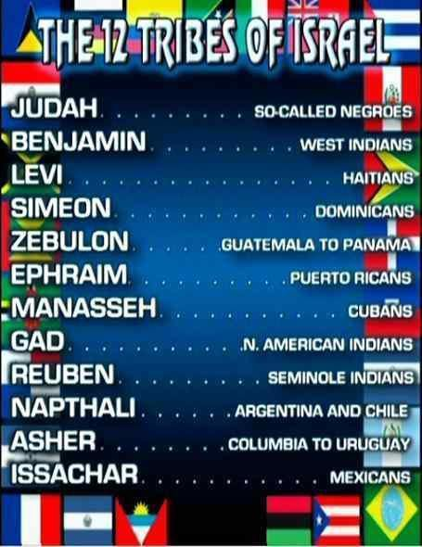
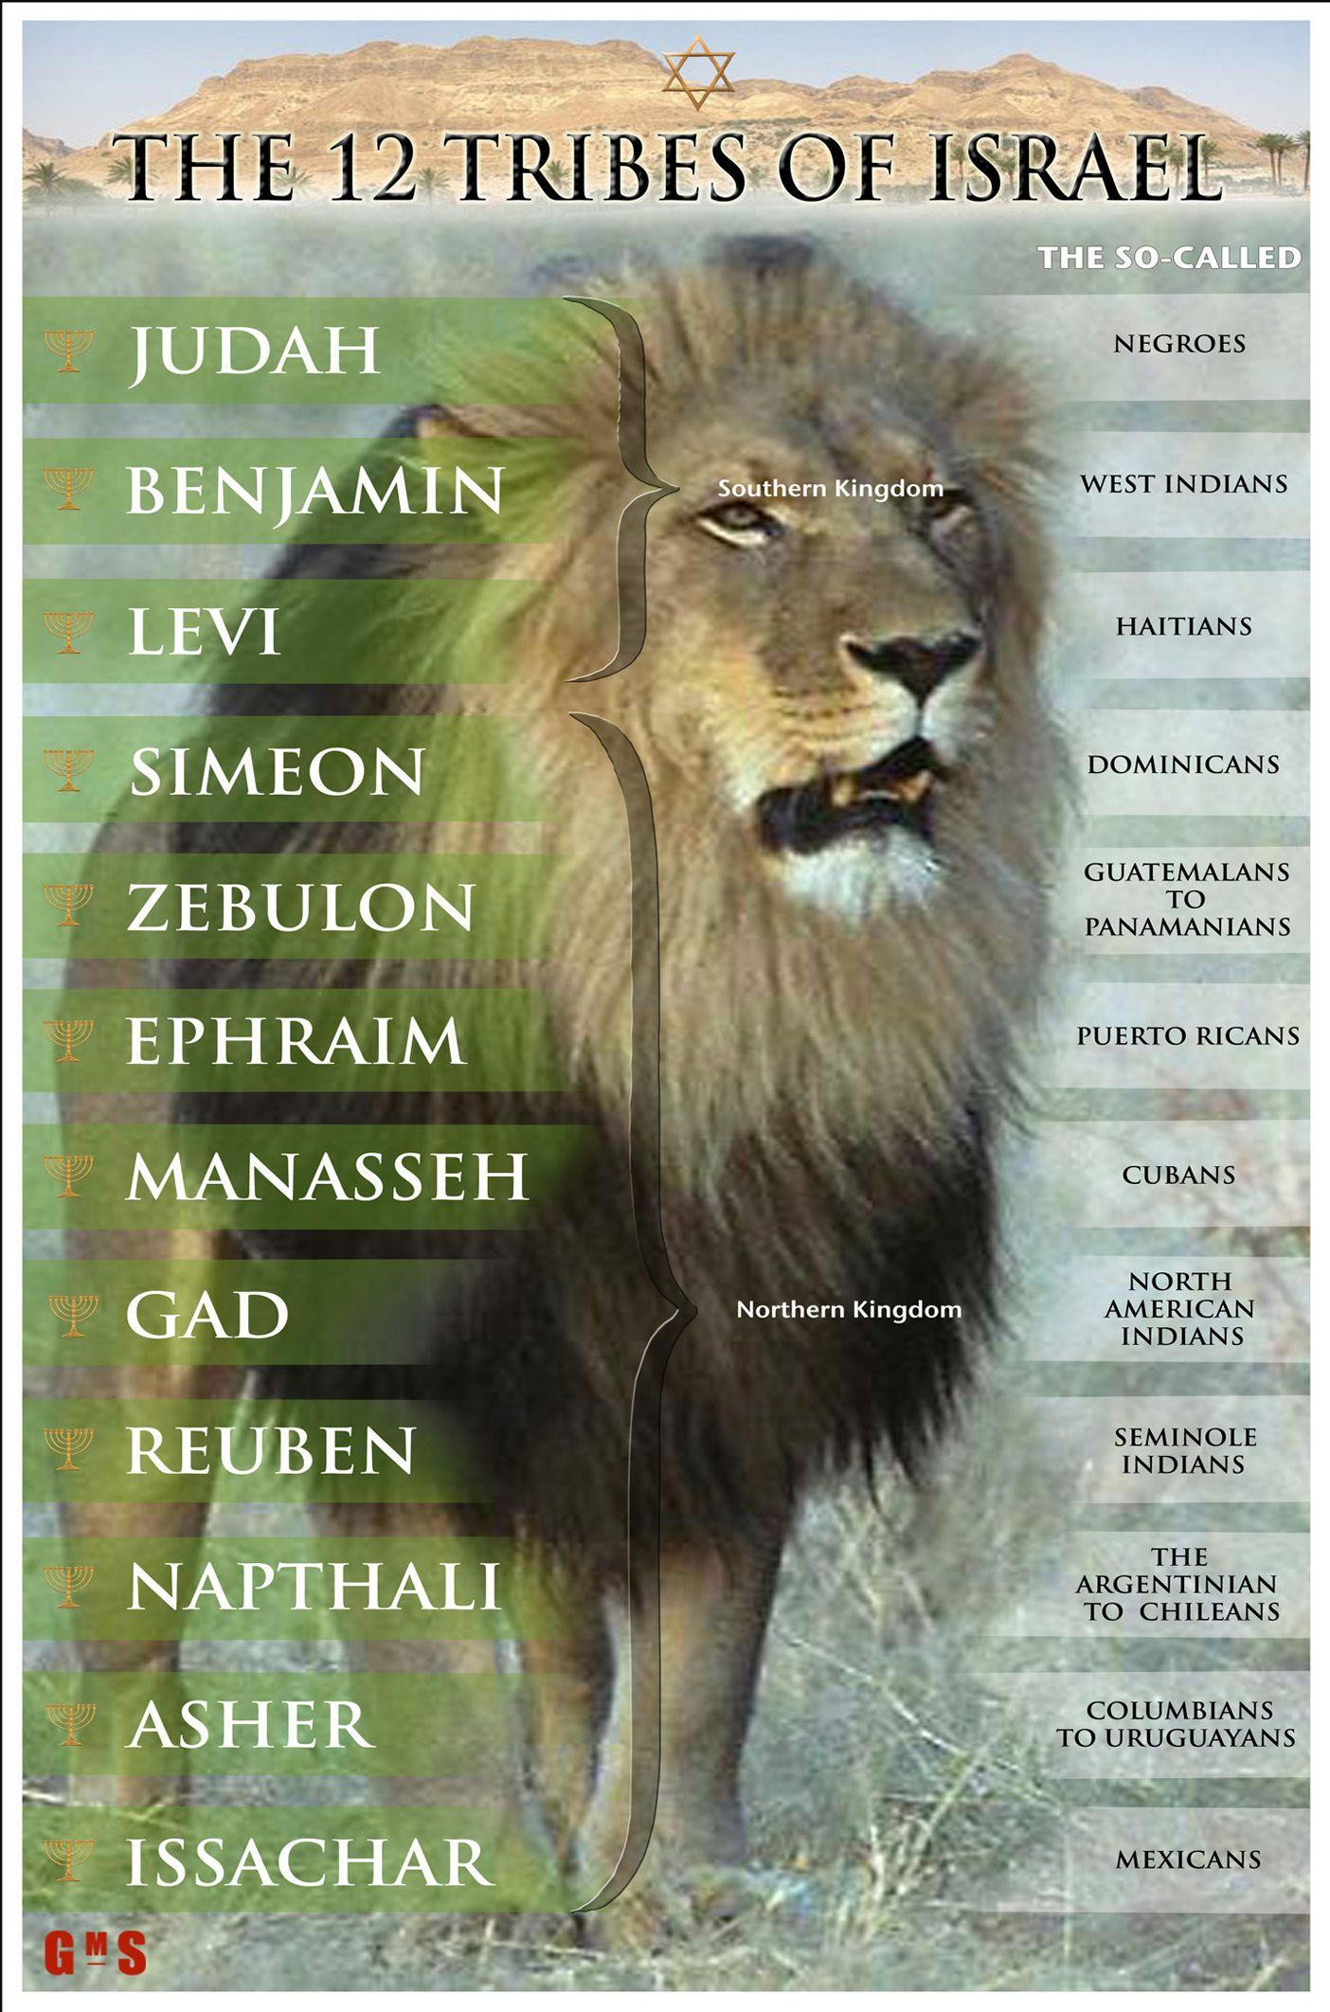

This is what the charts are saying:
So-called Negroes are the tribe of Judah
West Indians are the tribe of Benjamin
Haitians are the tribe of Levi
Dominicans are the tribe of Simeon
Guatemala to Panama is the tribe of Zebulon
Puerto Ricans are the tribe of Ephraim
Cubans are the tribe of Manasseh
North American Indians are the tribe of Gad
Seminole Indians are the tribe of Reuben
Argentina to Chile is the tribe of Napthali
Columbia to Uruguay is the tribe of Asher
Mexicans are the tribe of Issachar
1. All Negroes are the tribe of Judah? So, all the black people from the Trans-Atlantic Slave Trade are from the tribe of Judah? If not, what is a Negro then?
2. All the North American Indians are the tribe of Gad? That is insane.
All of these people were/are the tribe of Gad?
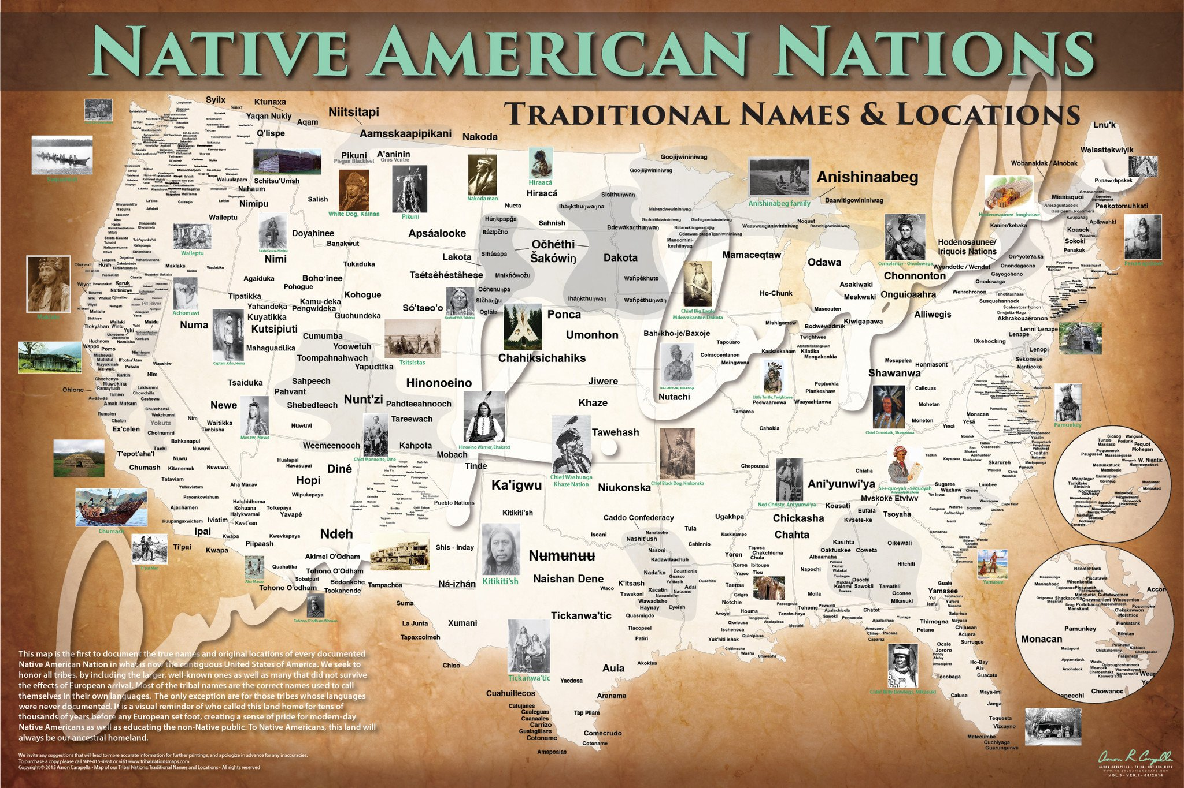
Source: http://www.npr.org/sections/codeswitch/2014/06/24/323665644/the-map-of-native-american-tribes-youve-never-seen-before
A bigger size:
https://cdn.shopify.com/s/files/1/0804/8571/products/us-map-nan_1ecf7415-b794-41ea-ac11-f85863a67434_2048x2048.jpeg?v=1458856710
http://www.npr.org/assets/news/2014/06/Tribal_Nations_Map_NA.pdf

3. Why does the chart refer to people and lands? Columbia to Uruguay? Argentina to Chile? Guatemala to Panama? That doesn't make sense. So, the people dwelling in those lands are Israelites? That's idiotic. People move for various reasons. Was this accounted for? So, you’re telling me that the people who live in those lands now are descendants of people who lived in those lands hundreds of years ago, and no foreigner has ever went to live there? And where is the proof of any of this? It doesn’t exist.
4. How are Haitians separate from so-called Negroes/Blacks? They arrived in the Western hemisphere by the Trans-Atlantic Slave Trade too.
Natives of North America, Central America, South America, and surrounding islands (the non-Blacks on the chart) are not the Israelites of the Bible. They couldn’t be the Israelites of the Bible. For one, they don’t fit all of the prophecies (most people have other criteria).
“They were oppressed.”
Every non-White was oppressed after Europeans spread throughout the world, taking over their lands. Whites, or Europeans, have been oppressed as well.
“They were enslaved.”
Many Africans were enslaved by Arabs, that doesn’t make them Israelites. Other nations were enslaved, that doesn’t make them Israelites. When were the non-Blacks on that chart sent as captives into all nations, and scattered in all four directions?
“They have dark skin.”
Dark skin means nothing. There are people in Africa with dark skin, that doesn’t make them Israelites. The first natives of many lands were dark-skinned and had “Negro features” because those lands were first populated by people who would be called Africans today. That doesn’t make them Israelites.
“Israelites were the first people of the Americas.”
Out of all the people on the earth, it was the Israelites who populated North America, Central America, South America, and the islands like Haiti? And some say coming from a Babylonian captivity. Really? And then their descendants were brought to those same lands as slaves by Jews and Europeans? And then when they arrived, they looked nothing alike, they only had dark skin and black hair in common? How did this happen?
Look at the nose, lips, and hair. Where are the so-called Negro features?

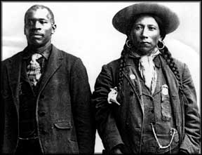

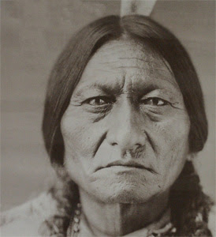

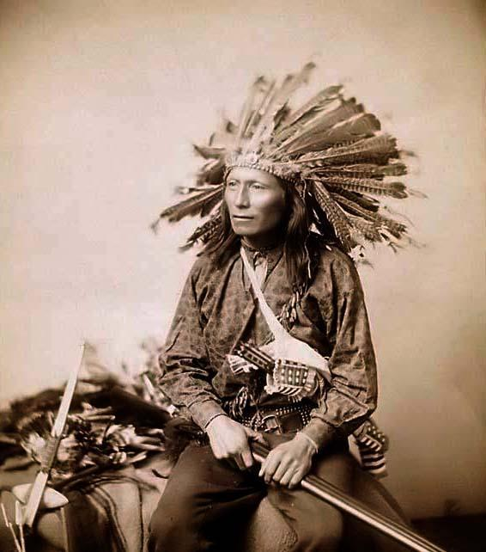

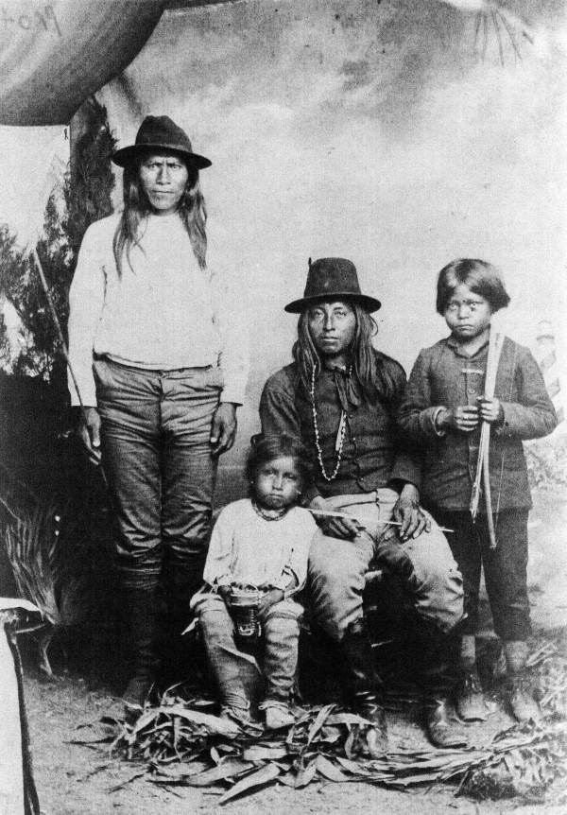

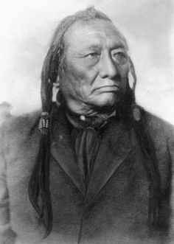

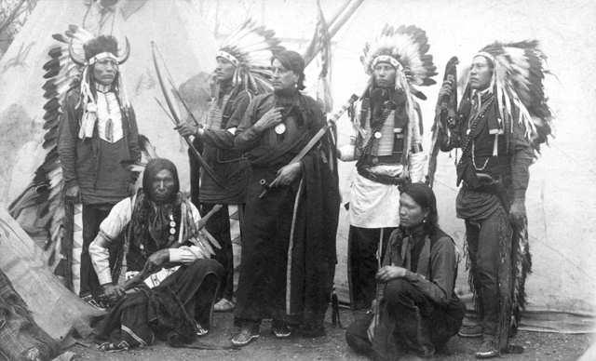

Before these dark skinned natives of the Americas and islands mixed with Europeans, who did they mix with to get their hair like that? If they were Israelites, and are from the same stock as you are, they would have had to mix with someone to get hair like that. They mixed with Europeans who came before the Trans-Atlantic Slave Trade? How did they remain so dark? Look at them now after mixing with Europeans. And what happened to their so-called Negro features?

Which Native American tribe are these people from?






No tribe. They are Tibetans.
Native American Indians Are NOT Israelites!
http://www.youtube.com/watch?v=GaAV1eEA0is
ABBA BIVENS ADMITTED THE 12 TRIBE CHART WAS CREATED AS A HOOK TO RECRUIT MEMBERS, IT'S A LIE
https://www.youtube.com/watch?v=jZXcrKVSRNM
Isn’t that “hook” just like the one the Nation of Islam used – you’re from the tribe of (new identity)?
- According to Naphtali Ben Naphtali, Abba Bivens and others believed the chart was false.
- Yahanna said he heard about Ahrayah’s twelve tribe vision directly from Ahrayah. He also stated that when Ahrayah got the vision he brought it to Bivens who knew it was right and brought it out/taught it to others.
Who’s lying, one of them, both of them, or none of them? Did Yahanna simply believe a lie? One thing is for sure, Naphtali Ben Naphtali stated that several people knew the chart was false. If true, that means they knowingly taught falsehood/lies. That means they were fully aware that they were telling Native Americans, Hispanics, and others lies. How sick is that? So, either this sickness happened, or Naphtali Ben Naphtali is lying. Which one is it?
This next video is pretty long, but a lot of good points are made. You don’t have to listen to it. It really doesn’t matter.
The 12 Tribes Chart is Fake!!
http://www.youtube.com/watch?v=7pZplNxKYps
You might have heard people trying to justify the classifications on the chart by saying what it means although that’s not what it states, nor is it what they teach—“It really means Israelites of those areas.” That’s a lie. They are lying. Look at the chart. If that were the case it would say “So-called Negro in _______” for every location. The chart names people and locations.
They are outright lying. Why would anyone want to learn from liars?
My personal reply to some of the statements made in the video
- And I guess they don’t realize that just because something is written in a book outside of scripture doesn’t mean it’s true. With them, somehow books written by regular men are gospel, and every word is true. In addition, just because someone said they were from a tribe doesn’t mean they were. Look at the Jews today.
- You have a different chart? Any chart you come up with is going to be wrong.
- “If you go to South America you see people that look like ….” “If you go to South America you see people with dark skin, wooly hair ….” And how did those people who gave them those features (their descendants) get there in South America?
- “They found the ten commandments in the Americas.”
Pyramids were over here too, so I guess that makes them Egyptian too. You don't know when it was carved, who carved it, or if it was brought over here.
- “They found Hebrew inscriptions on a stone in the Americas.”
Who wrote it? What if slaves from the Trans-Atlantic Slave Trade wrote it? What if the stone wasn’t native to the Americas?
This is what they’re speaking of:
Ancient Hebrew artifacts found in America proving the Israelites (NEGROES) were here first
https://www.youtube.com/watch?v=sknMe0KiPw4
At 2:08 he stated that it was Phoenician, ancient Hebrew. Which one? You can clearly see the deceit taking place here. So, are they calling Phoenician ancient Hebrew?
Here is some information on the ancient Hebrew alphabet that will show how the ancient Hebrew alphabet came from the Phoenician alphabet:
https://en.wikipedia.org/wiki/Hebrew_alphabet
https://en.wikipedia.org/wiki/Paleo-Hebrew_alphabet
https://en.wikipedia.org/wiki/Phoenician_alphabet
So, they probably found Phoenician writings.
Watch from 2:20 - end
Ancient Hebrew found in Native American Mounds
https://youtu.be/gMbFgFNTtYs?t=2m20s
Listen to the hard-hitting proof that it’s not a hoax at 3:43 - 4:23. That’s hilarious.
Here’s a good comment on the video:
“So Glenn Beck spread Mormon propaganda on Fox News?"
Yes. Take a look at this:
Ancient Israelites In America - Part 1 - Evidences For The Book of Mormon
https://www.youtube.com/watch?v=hUeYSsQZsCY
Native Americans are Israelites? Or could it have been that Israelites came over here to this land of the Native Americans? And don’t you know that the Jews were over here too. They are the ones who chose this land to build America. This country is their project. Slavery was entirely their project. So, they were here before the Trans-Atlantic Slave Trade. The artifacts could have been from them. The Hebrew customs of some of the natives could have originated with them. So, as you can see, the artifacts don't prove Native Americans are Israelites at all.
And then there's the proof that black people may have lived here long ago. Okay, but that doesn't mean they were the first to live here, and it doesn’t mean that they or the Native Americans were Israelites. How do you know those black people were not from some African nation (the seed of Ham)?
Take a look at this:

The Templars and the "New World"
https://www.youtube.com/watch?v=msVaUxJWFPU
That's right, many people have been here. We were lied to (Rockefeller education system). So, imagine what they brought over here with them. And did you catch the part about Phoenicians being over here?
Native Americans being Israelites is one thing; Africans, Israelites, and others going to the Americas and living among the Native Americans is another. And one or a few Native American tribes do not equal all Native American tribes, but that’s not what some people state. They say “the Native Americans”.
The Legend of Timbuktu
https://www.youtube.com/watch?v=li8UgaYLFFQ
*But don’t let this lead you to believe the psychological operation going on today which states that all blacks are Native to America.
This next article is bias, states a few things that can’t be proven, and states many opinions as facts (“Semitic features”), but many findings are brought out:
http://hope-of-israel.org/hebinusa.htm
Do you recall from the video Native American Indians are not Israelites that the guy said his Native American friend was told he was a Jew by some Mormons/Latter Day Saints? And remember later in the video when the presenter read the following from that website: “Mormons contend that two groups of Israelites left from Israel and set sail, landing in America.”
Doesn’t that sound familiar (those of you who know about these camps)?
Take a look at this:
“Mormonism is the predominant religious tradition of the Latter Day Saint movement of Restorationist Christianity. This movement was founded by Joseph Smith in the 1820s. During the 1830s and 1840s, Mormonism gradually distinguished itself from traditional Protestantism. Mormonism today represents the new, non-Protestant faith taught by Smith in the 1840s. After Smith's death, most Mormons followed Brigham Young on his westward journey, calling themselves The Church of Jesus Christ of Latter-day Saints (LDS Church).”
Source: http://en.wikipedia.org/wiki/Mormonism
And remember, this is one of those religions that was created for a purpose.
Black people and Mormonism
Racial restriction policy
Under the racial restrictions that lasted from the presidency of Brigham Young until 1978, persons with any black African ancestry could not hold the priesthood in the LDS Church and could not participate in most temple ordinances, including the endowment and celestial marriage. Black people were permitted to be members of the church, and to participate in some temple ordinances, such as baptism for the dead.[30]
The racial restriction policy was applied to black Africans, persons of black African descent, and any one with mixed race that included any black African ancestry. The policy was not applied to Native Americans, Hispanics, Melanesians, or Polynesians.
Priesthood
The priesthood restriction was particularly limiting, because the LDS Church has a lay priesthood and all worthy male members may receive the priesthood. Young men are generally admitted to the Aaronic priesthood at age 12, and it is a significant rite of passage. Virtually all white adult male members of the church held the priesthood. Holders of the priesthood officiate at church meetings, perform blessings of healing, and manage church affairs. Excluding black people from the priesthood meant that they could not hold significant church leadership roles or participate in certain spiritual events.
Don Harwell, a black LDS Church member, said, "I remember being in a Sacrament meeting, pre-1978, and the sacrament was being passed and there was special care taken by this person that not only did I not officiate, but I didn't touch the sacrament tray. They made sure that I could take the sacrament, but that I did not touch the tray and it was passed around me. That was awfully hard, considering that often those who were officiating were young men in their early teens, and they had that priesthood. I valued that priesthood, but it wasn't available."[31]
Temple ordinances
Between 1844 and 1977, most black people were not permitted to participate in ordinances performed in the LDS Church temples, such as the endowment ritual, celestial marriages, and family sealings. These ordinances are considered essential to enter the highest degree of heaven, so this meant that they could not enjoy the full privileges enjoyed by other Latter-day Saints during the restriction.
Latter-day Saints believe that marriages that are sealed in a celestial marriage would bind the family together forever, whereas those that are not sealed were terminated upon death. Church president David O. McKay taught that black people "need not worry, as those who receive the testimony of the Restored Gospel may have their family ties protected and other blessings made secure, for in the justice of the Lord they will possess all the blessings to which they are entitled in the eternal plan of Salvation and Exaltation."[32]
Brigham Young taught that "When the ordinances are carried out in the temples that will be erected, [children] will be sealed to their [parents], and those who have slept, clear up to Father Adam. This will have to be done ... until we shall form a perfect chain from Father Adam down to the closing up scene."[33] Once black people were allowed to participate in temple ordinances, they could also perform the ordinances for their ancestors.
Entrance to the highest heaven
A celestial marriage is considered unnecessary to gain access into the celestial kingdom, but it is required to obtain a fullness of glory or exaltation within the celestial kingdom.[34] The Doctrine and Covenants reads, "In the celestial glory there are three heavens or degrees; And in order to obtain the highest, a man must enter into this order of the priesthood [meaning the new and everlasting covenant of marriage]; And if he does not, he cannot obtain it."(D&C 131:1-3) The righteous who do not have a celestial marriage would still make it into heaven, and live eternally with God, but they would be "appointed angels in heaven, which angels are ministering servants."(D&C 132:16)
Some interpreted this to mean black people would be treated as unmarried whites, being confined to only ever live in God's presence as a ministering servant. In 1954, apostle Mark E. Petersen told Brigham Young University students: "If that Negro is faithful all his days, he can and will enter the celestial kingdom. He will go there as a servant, but he will get a celestial resurrection."[35] Apostle George F. Richards, in a talk at a General Conference, similarly taught: "The Negro is an unfortunate man. He has been given a black skin. But that is as nothing compared with that greater handicap that he is not permitted to receive the Priesthood and the ordinances of the temple, necessary to prepare men and women to enter into and enjoy a fullness of glory in the celestial kingdom."[36]
Several leaders, including Joseph Smith,[37] Brigham Young,[38] Wilford Woodruff,[39] George Albert Smith,[40] David O. McKay,[41] Joseph Fielding Smith,[42] and Harold B. Lee[43] and taught that black people would eventually be able to receive a fullness of glory in the celestial kingdom.
When the priesthood ban was discussed in 1978, apostle Bruce R. McConkie argued for its change using Mormon scriptures and the Articles of Faith. The Third Article states that "all mankind may be saved, by obedience to the laws and ordinances of the Gospel" (Articles of Faith 1:3). From the Book of Mormon he quoted, "And even unto the great and last day, when all people, and all kindreds, and all nations and tongues shall stand before God, to be judged of their works, whether they be good or whether they be evil—If they be good, to the resurrection of everlasting life; and if they be evil, to the resurrection of damnation" (3 Nephi 26:4-5)' The Book of Abraham in the Pearl of Great Price states that through Abraham's seed "shall all the families of the earth be blessed, even with the blessings of the Gospel, which are the blessings of salvation, even of life eternal" (Abraham 2:11), According to McConkie's son, Joseph Fielding McConkie, the highlighting of these scriptures played a role in changing the policy.[44]
Other racial discrimination
Further information: Racism in the United States
Like most Americans between the 19th and mid-20th centuries, some Mormons held racist views, and exclusion from priesthood was not the only discrimination practiced toward black people. In the late 1800s, blacks living in Cache Valley were forcibly relocated to Ogden and Salt Lake City. In the 1950s, the San Francisco mission office took legal action to prevent black families from moving into the church neighborhood.[59] In 1965, a black man living in Salt Lake City, Daily Oliver, described how —as a boy—he was excluded from an LDS-led boy scout troop because they did not want blacks in their building.[60] LDS Church apostle Mark E. Petersen describes a black family that tried to join the LDS Church: "[some white church members] went to the Branch President, and said that either the [black] family must leave, or they would all leave. The Branch President ruled that [the black family] could not come to church meetings. It broke their hearts."[61] Until the 1970s hospitals with connections to the LDS Church, including LDS Hospital, Primary Children's and Cottonwood Hospitals in Salt Lake City, McKay-Dee Hospital in Ogden, and Utah Valley Hospital in Provo, kept separate the blood donated by blacks and whites, and even after the church's volte face in 1978 patients who expressed concern about receiving blood from black donors were given reassurance from hospital authorities that this would not happen.
Source: http://en.wikipedia.org/wiki/Black_people_and_Mormonism
“The racial restriction policy was applied to black Africans, persons of black African descent, and any one with mixed race that included any black African ancestry. The policy was not applied to Native Americans, Hispanics, Melanesians, or Polynesians.”
Replace “black” with “white” and who’s doctrine does it resemble? Remember, the Natives were said to be Jews.
- White Mormons/Church of Latter Day Saints: Blacks will only be servants in the kingdom.
- Black Hebrew Israelites with the chart who hate whites and black women: Whites will only be servants in the kingdom.
- Most whites of the Church of Latter day Saints have consistently taught racism against blacks as a part of their doctrine. Most black Hebrew Israelites, nearly all of those who promote that chart, have consistently taught racism against whites as a part of their doctrine.

And what else do some of those same Israelite camps strongly promote?
“The status of women in the LDS Church has been a source of public debate beginning in the 19th century, when the church found itself at odds with the United States federal government over its practice of polygamy.”
Source: http://en.wikipedia.org/wiki/Mormonism_and_women
“Smith had by some accounts been teaching a polygamy doctrine as early as 1831, and there is evidence that Smith was a polygamist by 1835.[274][275] Although the church had publicly repudiated polygamy, in 1837 there was a rift between Smith and Oliver Cowdery over the issue.[276] Cowdery suspected that Smith had engaged in a relationship with his serving girl Fanny Alger.[277] Smith never denied a relationship, but insisted it was not adulterous, presumably because he had taken Alger as a plural wife.[278]
In April 1841, Smith wed Louisa Beaman; and during the next two-and-a-half years he married or was sealed to about 30 additional women,[279] ten of whom were already married to other men (this was generally done with the knowledge and consent of their husbands).[280] Ten of Smith's plural wives were between the ages of fourteen and twenty. Others were over fifty.[281]”
Source: http://en.wikipedia.org/wiki/Joseph_Smith

Origin of Latter Day Saint polygamy
Before Smith's death
Records show that Smith publicly preached and wrote against the doctrine of plural marriage;[60] however, it is also clear that Smith performed dozens of plural marriages.[3][61] Allegedly, "several were still pubescent girls, such as fourteen-year-old Helen Mar Kimball".[62] Kimball, Smith's 28th wife,[30] wrote of her experience in 1843–44,[3]
“[My father] asked me if I would be sealed to Joseph ... [Smith explained] the principle of Celestial marriage .... After which he said to me, 'If you will take this step, it will ensure your eternal salvation & exaltation and that of your father's household & all of your kindred.['] This promise was so great that I willingly gave myself to purchase so glorious a reward. ... I felt quite sore about [not being allowed to go out and dance] and thought it a very unkind act in father to allow William to go and enjoy the dance unrestrained with other of my companions, and fetter me down, for no girl danced better than I did, and I really felt it was too much to bear. It made the dull school more dull, and like a wild bird I longed for the freedom that was denied me; and thought to myself an abused child, and that it was pardonable if I did not murmur .... Besides my father was very kind and indulgent in other ways, and always took me with him when mother could not go, and it was not a very long time before I became satisfied that I was blessed in being under the control of so good and wise a parent who had taken counsel and thus saved me from evils.”
Written accounts of Smith's alleged liaisons are recorded as early as 1831, including Smith's relationship with Fanny Alger (age 16),[63][64] and with Marinda Nancy Johnson (age 16) in 1831.[64]
Source: http://en.wikipedia.org/wiki/Origin_of_Latter_Day_Saint_polygamy
So, what is the doctrine of Mormans/the Church of Latter Day Saints doing in these Israelite camp’s doctrine? If you look into it, you’ll see that the powers that be were behind Joseph Smith and Mormonism. You’ll also see that Mormonism has Masonic roots which still shine through to this day, along with strong ties to the CIA and FBI.
Joseph Smith
Joseph Smith Jr. (December 23, 1805 – June 27, 1844) was an American religious leader and founder of Mormonism and the Latter Day Saint movement. When he was 24, Smith published the Book of Mormon. By the time of his death fourteen years later, he had attracted tens of thousands of followers and founded a religious culture that continues to the present.
Smith was born in Sharon, Vermont. By 1817, he had moved with his family to what became known as the burned-over district of western New York, an area of intense religious revivalism during the Second Great Awakening. According to Smith, he experienced a series of visions, including one in which he saw "two personages" (presumably God the Father and Jesus Christ) and others in which an angel directed him to a buried book of golden plates inscribed with a Judeo-Christian history of an ancient American civilization. In 1830, Smith published what he said was an English translation of these plates, the Book of Mormon. The same year he organized the Church of Christ, calling it a restoration of the early Christian church. Members of the church were later called "Latter Day Saints", or "Mormons", and in 1838, Smith announced a revelation that renamed the church as the Church of Jesus Christ of Latter Day Saints.
In 1831, Smith and his followers moved west, planning to build a communalistic American Zion. They first gathered in Kirtland, Ohio, and established an outpost in Independence, Missouri, which was intended to be Zion's "center place".
…
The Book of Mormon has been called the longest and most complex of Smith's revelations.^{[209]} It is organized as a compilation of smaller books, each named after its main named narrator or a prominent leader. It tells the story of the rise and fall of a religious civilization beginning about 600 BC and ending in 421 AD.^{[210]} The story begins with a family that leaves Jerusalem, just before the Babylonian captivity.^{[211]} They eventually construct a ship and sail to a "promised land" in the Western Hemisphere.^{[212]} There, they are divided into two factions: Nephites and Lamanites. The Nephites become a righteous people who build a temple and live the law of Moses, though their prophets teach a Christian gospel.
Source: https://en.wikipedia.org/wiki/Joseph_Smith

Here are some things I’ve just recently come across.
Ahrayah's 1 West/Mormon/Jesuit Doctrine EXPOSED!!!
https://www.youtube.com/watch?v=mlNk9xhDcJU
Here’s some proof that the “Native Americans are Israelites” doctrine already existed before Joseph Smith wrote about it.
As you read the following information, recall the information from Camps Exposed about the 1800’s, New York, Jews, Freemasonry, and the creation of religions.
From the previous information on Joseph Smith:
“Smith was born in Sharon, Vermont. By 1817, he had moved with his family to what became known as the burned-over district of western New York, an area of intense religious revivalism during the Second Great Awakening.”
Read this:
Burned-over district
https://en.wikipedia.org/wiki/Burned-over_district
Now we have to go back, then build up to this time period so you can really see.
“The strength of the nationalist feeling was practically tested in the 16th century, when a Jewish impostor, David Reubeni {circa 1530), and his disciple, Solomon Molcho (1501-1532), came forward as would-be liberators of their people. Throughout Spain, Italy and Turkey they were received with enthusiasm by the bulk of their brethren. In the following century the influence of the Christian Millenarians gave a fresh impulse to the national idea. Owing to the frenzy of persecution and the apocalyptic teachings of the Chiliasts, it now appeared in a more mystical form, but a practical bias was not wanting. Menasseh ben Israel (1604-1657) co-operated with English Millenarians to procure the resettlement of the Jews in England as a preliminary to their national return to Palestine, and he regarded his marriage with a scion of the Davidic family of Abarbanel as justifying the hope that the new Messiah might be found among his offspring. The increasing dispersion of the Marranos or crypto-Jews of Spain and Portugal through the Inquisition, and the persecution of the Jews in Poland, deepened the Jewish sense of homelessness the while the Millenarians encouraged their Zionist dreams. The Hebraic and Judeophil tendencies of the Puritan revolution in England still further stirred the prevailing unrest, and some Jewish rabbis are said to have visited England in order to ascertain by genealogical investigations whether a Davidic descent could be ascribed to Oliver Cromwell. It only wanted a leader to produce a national movement on a formidable scale. In 1666 this leader presented himself at Smyrna, in the person of a Jew named Sabbatai Zevi (1626-1676), who proclaimed himself the Messiah. The news spread like wildfire, and despite the opposition of some of the leading rabbis, the Jews everywhere prepared for the journey to Palestine. Not alone was this the case with the poor Jews of Lithuania and Germany, but also with well-to-do communities like those of Venice, Leghorn and Avignon, and with the great Jewish merchants and bankers of Hamburg, Amsterdam and London. Throughout Europe the nationalist excitement was intense. Even the downfall and apostasy of Sabbatai were powerless to stop it. Among the wealthier Jews it partially subsided, but the great bulk of the people refused for a whole century to be disillusionized. A Messianic frenzy seized upon them. Encouraged on the one hand by Christian Millenarians like Pierre Jurien, Oliger Pauli, and Johannes Speeth, pandered to by Sabbataic impostors like Cardoso, Bonafoux, Mordecai of Eisenstadt, Jacob Qucrido, Judah Chassid, Nehemiah Chayon and Jacob Franks, and maddened by fresh oppressions, they became fanaticized to the verge of demoralization.”
Source: Zionism, Encyclopedia Britannica (1911)
This actually connects with the information on King James you’ll see in The King James Theories: “…the great Jewish merchants and bankers of Hamburg, Amsterdam and London.”
Ten Lost Tribes

Christianity
The increased currency of tales relating to lost tribes that occurred in the 17th century was due to the confluence of several factors. According to Parfitt:
As Michael Pollack shows, Menasseh's argument was based on "three separate and seemingly unrelated sources: a verse from the book of Isaiah, Matteo Ricci's discovery of an old Jewish community in the heart of China and Antonio Montezinos' reported encounter with members of the Lost Tribes in the wilds of South America".^{[5]:69}
In 1649 Menasseh published his book, The Hope of Israel, in Spanish and in Latin in Amsterdam; it included Montezinos' account of the Lost Tribes in the New World.^{[12][13]} An English translation was published in London in 1650. In it Menasseh argued, and for the first time tried to give learned support in European thought and printing, to the theory that the native inhabitants of America at the time of the European discovery were actually descendants of the [lost] Ten Tribes of Israel.^{[12]} Menasseh noted how important Montezinos' account was,
for the Scriptures do not tell what people first inhabited those Countries; neither was there mention of them by any, til Christop. Columbus, Americus, Vespacius [sic], Ferdinandus, Cortez [sic], the Marquesse Del Valle [sic], and Franciscus Pizarrus [sic] went thither ...^{[14]}
He wrote on 23 December 1649: "I think that the Ten Tribes live not only there ... but also in other lands scattered everywhere; these never did come back to the Second Temple and they keep till this day still the Jewish Religion ..."^{[15]:118}
In 1655, Menasseh ben Israel petitioned Oliver Cromwell to allow the Jews to return to England in furtherance of the Messianic goal. (Since the Edict of Expulsion in 1290, Jews had been prohibited by law from living in England.) With the approach of 1666, considered a significant date, Cromwell was allegedly interested in the return of the Jews to England because of the many theories circulating related to millennial thinking about the end of the world. Many of these ideas were fixed upon the year 1666 and the Fifth Monarchy Men who were looking for the return of Jesus as the Messiah; he was expected to establish a final kingdom to rule the physical world for a thousand years. Messianic believers supported Cromwell's Republic in the expectation that it was a preparation for the fifth monarchy—that is, the monarchy that should succeed the Babylonian, Persian, Greek, and Roman world empires.^{[citation needed]}
…

Native Americans
See also: Northern Cherokee Nation of the Old Louisiana Territory § The "Lost Tribe"
In 1650, a British minister named Thomas Thorowgood, who was a preacher in Norfolk, published a book entitled Jewes in America or Probabilities that the Americans are of that Race,^{[52]} which he had prepared for the New England missionary society. Parfitt writes of this work: "The society was active in trying to convert the Indians but suspected that they might be Jews and realized they better be prepared for an arduous task. Thorowgood's tract argued that the native population of North America were descendants of the Ten Lost Tribes."^{[5]:66}
In 1652 Sir Hamon L'Estrange, an English author writing on topics such as history and theology published an exegetical tract called Americans no Jews, or improbabilities that the Americans are of that Race in response to the tract by Thorowgood. In response to L'Estrange, Thorowgood published a second edition of his book in 1660 with a revised title and included a foreword written by John Eliot, a Puritan missionary to the Indians who had translated the Bible into an Indian language.^{[5]:66, 76}
American diplomat and journalist Mordecai Manuel Noah purported the idea in his publication The American Indians Being the Descendants of the Lost Tribes of Israel (1837).^{[53]}
Source: https://en.wikipedia.org/wiki/Ten_Lost_Tribes
Now read these excerpts from: NILES' WEEKLY REGISTER ON THE JEWS By ISAAC M. FEIN (1825/1826) Reprinted from: Publication of the American Jewish Historical Society - Vol. L, No. 1 (September, 1960)
There were two events in American Jewish life to which Niles returned time and again and which the Register reported in great detail. To one, Mordecai Manuel Noah's project to settle the Jews on Grand Island, New York, we alluded earlier.⁶³ Niles and Noah were bitter political opponents.
…
To the report of the ceremonies in connection with the laying of the cornerstone, Niles added:
Mr. Noah, editor of the New York National Advocate, issued a ridiculous proclamation to the Jews proclaiming himself “governor and judge of Israel.”
…
This is followed by the highlights of the proclamation to the Jews
of the world:
Mr. Noah has NOMINATED HIMSELF “Governor and judge of Israel,” which he says that he is, aye, and by, “the grace of God” too! He tells us that the island is to be an asylum for the Jews. He REVIVES the government of the Jewish nation, and COMMANDS all the venerable Rabbies, Elders, etc. to respect his proclamation and to give it credence and effect. He ORDERS a census of all the Jews, and DIRECTS that they shall be registered. The Jews that are in military employment of emperors, kings, etc. he ENJOINS to conduct themselves bravely and with fidelity "until further ORDERS." He COMMANDS them to be neutral in the war between the Greeks and the Turks, PRESCRIBES the giving of gift to his "pious brethern" at Jerusalem. He ABOLISHES polygamy forever, and PROHIBITS marriages, unless the parties can read and write. ORDERS the saying of prayers, DIRECTS that the black Jews of India and Africa shall have an equality of rights, and DECREES that all the American Indians are the descendants of the lost tribes! HE LEVIES A CAPITATION TAX, OF ONE DOLLAR PER ANNUM ON EVERY JEW THAT THERE IS IN THE WORLD [TO] PASS INTO HIS TREASURY! Names commissioners to act for him in different countries, to whom he will send INSTRUCTIONS. He appoints a day in February next, to be observed as a general thanksgiving, and wishes to be remembered in the prayers of his brethern. All which is "given in Buffalo, the second day of Tisri, in the year of the world 5586, corresponding with the 15th of September, 1825," a strange mixture of Christianity and Judaism, and the whole is signed, "By the judge, A. B. Seixas, sec. pro tem."
Source: http://msa.maryland.gov/megafile/msa/speccol/sc3500/sc3520/001700/001747/pdf/msa_sc5458_51_4378.pdf
Mordecai Manuel Noah
Mordecai Manuel Noah (July 14, 1785, Philadelphia, Pennsylvania – May 22, 1851, New York) was an American sheriff, playwright, diplomat, journalist, and utopian. He was born in a family of Portuguese Sephardic ancestry.^{[1]} He was the most important Jewish lay leader in New York in the early 19th century,^{[2]} and the first Jew born in the United States to reach national prominence.^{[3]} His negative reviews of black plays produced and hosted by William Brown at the African Grove have caused African-American studies and drama scholars to name Noah as the author of typical black archetypes employed in minstrel shows.^{[4]}

Career
Noah engaged in trade and law. After moving to Charleston, South Carolina, he dedicated himself to politics.

Diplomat
In 1811, he was appointed by President James Madison as consul at Riga, then part of Imperial Russia, but declined, and, in 1813, was nominated Consul to the Kingdom of Tunis, where he rescued American citizens kept as slaves by Moroccan masters. In 1815, Noah was removed from his position;^{[5]} in the words of US Secretary of State James Monroe, his religion was "an obstacle to the exercise of [his] Consular function." The incident caused outrage among Jews and non-Jews alike.^{[6]}
Noah sent many letters to the White House trying to get an answer as to why they felt his religion should be a justifiable reason for taking the office of consul away. He had done well as consul and had even been able to accommodate the United States request to secure the release of some hostages being held in Algiers. Noah never received a legitimate answer as to why they took the office of Consul away from him. This worried Noah, since he was afraid that this would set a precedent for the United States. He worried that this would block future Jews from holding publicly elected or officially granted offices within the United States.
Noah protested and gained letters from John Adams, Thomas Jefferson, and James Madison supporting church-state separation and tolerance for Jews.^{[7]} Prominent Reform Judaism leader Isaac Harby was moved to write, in a letter to Monroe,
[Jews] are by no means to be considered as a religious sect, tolerated by the government. They constitute a portion of the People. They are, in every respect, woven in and compacted with the citizens of the Republic.^{[8]}

Later career
Noah moved to New York, where he founded and edited The National Advocate, The New York Enquirer (later merged into the New York Courier and Enquirer), The Evening Star, and The Sunday Times newspapers. Noah was known to use his power as an editor of The National Advocate and law enforcement official as a sheriff to personally shut down rival plays produced by black theater groups that drew attention and revenue away from his own productions, with some reports that the performers continued to recite their lines as they were dragged from the stage to their cells.^{[9]}
In 1819, Noah's most successful play, She Would Be a Soldier, was produced. That play has since established Noah as America's first important Jewish American writer. She Would Be a Soldier is now included in college level anthologies.
In 1825, with virtually no support from anyone-not even his fellow Jews-in a precursor to modern Zionism, he tried to found a Jewish "refuge" at Grand Island in the Niagara River, to be called "Ararat," after Mount Ararat, the Biblical resting place of Noah's Ark.^{[10]} He purchased land on Grand Island for $4.38 per acre to build a refuge for Jews of all nations.^{[11]} He had brought with him a cornerstone which read "Ararat, a City of Refuge for the Jews, founded by Mordecai M. Noah in the Month of Tishri, 5586 (September, 1825) and in the Fiftieth Year of American Independence."
Noah also shared the belief among various others that some of the Native American Indians were from the Lost Tribes of Israel,^{[10]} from which he wrote the Discourse on the Evidences of the American Indians being the Descendants of the Lost Tribes of Israel.^{[12]} ^{[13]} In his Discourse on the Restoration of the Jews^{[14]} Noah proclaimed his faith that the Jews would return and rebuild their ancient homeland and called on America to take the lead in this endeavor.
On September 2, 1825, soon after Noah's arrival in Buffalo from New York, thousands of Christians and a smattering of Jews assembled for a historic event. Noah led a large procession headed by Masons, a New York militia company, and municipal leaders to St. Paul's Episcopal church.^{[15]} Here, there was a brief ceremony-including a singing of the psalms in Hebrew-the cornerstone was laid on the communion table, and the new proclamation establishing the refuge was read. "Proclamation – day ended with music, cannonade and libation. 24 guns, recessional, masons retired to the Eagle Tavern, all with no one ever having set foot on Grand Isle." ^{[16]} This was the beginning and the end of Mordecai Noah's venture: he lost heart and returned to New York a couple days later without once having set foot on the island. The cornerstone was taken out of the audience chamber of the church and laid against the back of the building.^{[17]} It is now on permanent display at the Buffalo Historical Society in Buffalo, New York. However, afterwards and despite the failure of his project, he developed the idea of settling the Jews in Palestine and, as such, he can be considered a forerunner of modern Zionism.^{[10]}
Source: https://en.wikipedia.org/wiki/Mordecai_Manuel_Noah
“Noah was rediscovered in the late nineteenth century when the Zionist idea emerged and he was hailed as an authentic American precursor of a movement eager to establish its American credentials. Since that time he continues to draw attention as the ‘first Zionist,’ the American patriot and political ‘leader’ who dreamed of a Jewish homeland more than seventy years before Theodore Herzl.”
Source: https://academic.oup.com/jah/article-abstract/68/4/932/709594?redirectedFrom=PDF
You can see that this idea of Native Americans being Israelites is connected to Zionism, and Zionism to the fulfillment of Biblical prophecies. It turns out that people within the Jewish community had been for centuries going around the world converting native populations and having them say they were the Jews of ______. I call it “the convert conspiracy”. This was done to manufacture the fulfillment of prophecies, to make it so that “Jews” were scattered all over the world, and even brought back to Israel. So, thinking about Native Americans, I can see at least one reason why this idea of them being Israelites/Jews was pushed. They were to be the Jews at this end of the globe. And one “rule” of this particular “prophecy fulfillment scheme” seems be that they all have to be descendants of converts, no real descendants of Israelites are allowed (and this is part of the intent to block and sabotage coming from the camps and the System).
“In 1644, Menasseh met Antonio de Montezinos, a Portuguese traveler and Marrano Sephardic Jew who had been in the New World. Montezinos convinced him of his conclusion that the South America Andes' Indians were the descendants of the lost ten tribes of Israel. This purported discovery gave a new impulse to Menasseh's Messianic hopes, as the settlement of Jews throughout the world was supposed to be a sign that the Messiah would come.”
Source: https://en.wikipedia.org/wiki/Menasseh_Ben_Israel
“Noah was born July 19, 1785, in Philadelphia of Portuguese Jewish ancestry. His father, Manuel M. Noah, served with General Marion in the Revolutionary War and contributed a considerable sum of money to the cause.”
Source: https://www.jewishvirtuallibrary.org/mordecai-manuel-noah

“Mordecai was born in Philadelphia in 1785, a few years after the end of the American war of independence. At a young age his mother died and his father went back to his homeland, Germany. Mordecai and his brother were brought up by their paternal grandparents, who belonged to the newly formed American elite.
…
In the 1812 war between the United States and the United Kingdom he published anti British manifests declaring that in the United States, unlike any other country at the time – Jews had full equal rights just like all Americans, regardless of their religion.”
Source: https://www.bh.org.il/blog-items/down-town-ararat-the-failed-creation-of-a-jewish-city-in-upstate-new-york/
“Noah presented a cornerstone and inaugurated the plan in a highly theatrical ceremony held in Buffalo in 1825. Dressed in Shakespearean getup, he assumed the title ‘Judge of Israel,’ and in the local Episcopal church, he delivered a consecration speech in which he claimed to ‘revive, renew and re-establish the Government of the Jewish Nation under the auspices and protection of the constitution and laws of the United States of America,’ also calling for the ingathering of Native Americans as descendants of the Ten Lost Tribes.³”
Source: https://www.jstor.org/stable/27564261?seq=1#page_scan_tab_contents
“In fact, although Noah would continue his singular career as ambassador, politician, journalist and playwright, he never set foot on the island he called ‘a land of milk and honey … surrounded by every commercial, industrial and agricultural advantage, and from its location is pre-eminently calculated to become, in time, the greatest trading and commercial depot in the new and better world,’ McAllen quotes Noah as saying in ‘Cinderella Island.’”
Source: https://www.niagara-gazette.com/news/local_news/video-mordecai-manuel-noah-a-visionary/article_056c2424-3faa-58fb-87d2-a069fa1a4b5e.html

Read this excerpt from Major Noah: an American Patriot, American Zionist By Jerry Klinger
Monday, January 24, 1820, Noah applied to the State of New York to purchase Grand Island.
"Mr. Ulshoeffer from the select committee to whom was referred the memorial of Mordecai M. Noah, of the city of New York, relative to the purchase of Grand Island, reported:
That the petitioner applies to the State for a grant of the said island, for the purpose of attempting to have the same settled by emigrants of the Jewish religion from Europe; that he not only considers the situation of Grand Island as well adapted for the contemplated purpose, but that the obtaining of the tile from the State would be very advantageous in inducing the emigration of capitalists, as well as others. "
Bill was reported out of the house favorably for sale to Noah but nothing came of it. Nearly a year later after the failure he began a promotion of bringing the Jews to Newport, for a settlement."¹⁶
His hopes for the Jewish people, his people, though defeated never remained down.
"There is nothing visionary or even difficult in promoting an extensive Jewish emigration to this country. Men everywhere consult their safety and happiness; and when once they are satisfied that their civil and religious liberty will be respected -their health and enterprise preserved and encouraged, they will venture upon an experiment which promises every advantage. I am tired seeing a nation of seven millions of people, rich and intelligent, wandering about the world, without a home, which they can claim as their own, and looking to the restoration to an ancient country, which one eight would not inhabit, if they recovered it tomorrow. Where the Jews can be protected by laws which they will have some agency in enacting and where a laudable ambition will lead to the possession of posts of honor and confidence., and where they can mingle their voice freely in the councils of the nation and have the privilege of taking their place in the field and in the cabinet, I do consider that they will posses every temporal blessing which has been promise them. " ¹⁷
He proposed a new project to create a Jewish refuge, this time in Newport, Rhode Island. It too came to naught.
…
His concern for his people was never far from his mind. Noah returned to the Grand Island project in 1824-1825. His associations with Freemasonry convinced Noah of the possibility of a union of interests between Christians and Jews.
America was engrossed in the Second Great Awakening; a grass roots Evangelical movement that sprang up in America's interior and spread across the country, 1790-1840. Christians began calling for a restoration of the Jewish people to Palestine. In a later time it would be called Christian Zionism. Christians supported Noah's idea, to create a safe refuge, a homeland under American protection for the Jews near Buffalo. Western New York was the center of many Evangelical, utopian, and idealistic sect movements. It was also in Western New York that the greatest American born faith found its origins, Mormonism.
Noah, as did many of the contemporary editors of his time, disparaged the young, dynamic and rapidly growing Mormon faith. Some have argued that Joseph Smith, Mormonism's founder, may have been influenced by Noah and his efforts to establish a New Zion in Western New York. Mormons are a valued mainstay of American political support for Israel (2010).
The universality of Freemasonry idealism and commonality, its regard for all humanity, linked with the Evangelical support of Christians for Jewish restoration, especially in the "burned over district¹⁸" of Western New York, brought Noah back to focus on his Grand Island project. Working with friends among the Freemasons, land was purchased on Grand Island. Noah's project evolved from conjecture, to speculation, from theory to practice.
Using his best theatrical skills, his finest efforts at publicity and showmanship, the pulpit of his newspaper, Noah proclaimed himself "Governor and Judge of Israel". He called for the creation of a Jewish refuge he named Ararat. His principal Jewish supporter was, A.B. Siexas of New York City, his Secretary Pro-Temp.
September 15, 1825, thousands of Christians and a smattering of Jews came together just outside of Buffalo, to inaugurate the Ararat refuge for the Jews.
Speaking before the enormous crowd, some came for millenarist reasons, some for justice, others for economic reasons and some for the simple entertainment of the event, Noah proclaimed:
"Brothers, Countrymen, and Friends:
Having made known by proclamation the re-establishment of the Hebrew government, having laid the foundations of a city of refuge, an asylum for the oppressed in this free and happy republic, I avail myself of that portion of my beloved brethren here assembled, together with this concourse of my fellow citizens, to unfold the principles, explain the views, and detail the objects contemplated in the great work of regeneration and independence to which it has pleased the Almighty God to direct my attention.
…..Looking forward to a period of regeneration and to the fulfillment of prophecies, the Jews have preserved within themselves the elements of government in having carefully preserved the oracles of God assigned to their safe keeping, and the time has arrived when their rights as a nation can be recognized, when, in the enjoyment of independence the light of learning and civilization, and the obligation of industry and morality, they can cultivate a friendly and affectionate understand with the whole family of mankind and have no longer enemies on earth.
In calling the Jews together under the protection of the American Constitution and laws, and governed by our happy and salutary institutions, it is proper for me to state that this asylum is temporary and provisionary. The Jews never should and never will relinquish the just hope of regaining possession of their ancient heritage, and events in the neighborhood of Palestine indicate an extraordinary change of affairs."
Noah continued expounding on the decline of the Ottoman Empire, the rise of Christian influence and the need for the Jews to return to Palestine as a buffer state. The restoration of the Jews would restore prosperity and hope to that part of the world.
He continued in his address:
"Called together to the Holy Land by the slow, but unerring finger of Providence, the Jews, coming from every quarter of the globe, would bring with them the language, habits and prejudices of each country."
Culturally divergent and needing to learn how to govern as one people, Noah recognized that Ararat would be a learning center of self government for the Jews, preparing them for the return to Palestine.
Assimilating only in religious doctrines, and divided on temporal affairs, they would present innumerable difficulties in organizing under any form of government, and the diversity of opinions and views would create factions as dangerous and difficult to allay as those fatal ones which existed in the time of the first and second Temples. It is in this country that the government of the Jews must be organized. Here, under the influence of perfect freedom, they may study laws – cultivate their minds, acquire liberal principles as to men and measures, and qualify themselves to direct the energies of a just and honorable government n the land of the Patriarchs.
"Why should the parent of nations, the oldest of people, the founders of religion, wander among the governments of the earth, entreating succor and protection when we are capable of protection ourselves? The time has emphatically arrived to do something calculated to benefit our own condition and excite the admiration of the world: and we must commence the work in a country free from ignoble prejudices and legal disqualifications – a country in which liberty can be insured to the Jews without the loss of one drop of blood…."
…
An eyewitness to the momentous day, Lewis Falley Allen, recorded:
"Sept. 15, 1825, 10: AM Military and Masonic companies had lined up before the Masonic Lodge. Grand Marshal Colonel Potter, military, state and municipal officers marched to where the cornerstone was being laid.
"By ten o'clock the military and Masonic companies had lined up before the Masonic Lodge. Within an hour the procession, led by Grand Marshal Colonel Potter on a prancing steed, was moving. The tramp of soldiery, of national state and municipal officers, advanced to the spot where the corner stone of a New Canaan was to be laid. Behind the band and the vanguard filed stewards, apprentices and representatives of their associated crafts, master masons, senior and junior deacons, senior and junior wardens, asters and past-masters of Lodges, members of the reverend clergy, more stewards bearing the symbolic corn, wine and oil, and a principal architect, with square, level and plub, flanked on either side by a Globe, and backed by a Bible. There must have been, too, in this paradoxical pageantry, a sprinkling of the Chosen People for whom this new Promised Land, this Ararat, had been chosen….
And now all eyes were fixed upon a portly gentleman of forty, proudly erect of carriage, florid of face, keen of eye, sandy-haired over fleshy cheeks and an eagle's beak, who strode just ahead of the rear guard of Royal Arch Masons and Knights Templar.
…
In contemporary terms his discussion about the nature of the American Indian, and if he was a descendent of the ten lost tribes of Israel, seems eccentric. From Columbus's time and the age of discovery on into the early 20th century serious respected claims, studies, research and book written that the American Indian were and are part of the tribes of Israel. Noah's views were very much mainstream thought in 1837. It was no accident that Noah had Seneca Chief Red Jacket participated in the dedication program of Ararat.
Noah delivered his research talk before the Mercantile Library Association in New York's Clinton Hall. It was entitled, Discourse on Evidences of the American Indians being descendents on the lost tribes of Israel. The ethnological study may be discounted as an artifact of obscure American social history but for the summation and interpretation that Noah concluded his discourse. The talk was understood in Noah's time and by his audience as a strong affirmation of the truth of scripture. Arguing that American Indians are the lost tribes of Israel is alien and absurd to modern ears.
Noah's talk was a clear affirmation of modern American Christian Zionism. To Noah, there was little Christian about his presentation. His was a very Jewish affirmation of the truth of prophecy and of the ultimate redemption and restoration to Zion of the Jewish people.
…
October 28, 1844, Noah spoke before a crowd of thousands of Jews and Christians at the dedication of the Tabernacle in New York.
"I confidently believe in the restoration of the Jews, and in the coming of the Messiah; and believing that political events are daily assuming a shape which may finally lead to that great event, I consider it a duty to call upon the free people of this country to aid us in any efforts which, in our present position, it may be deemed prudent to adopt…"
"….Remember, therefore, my countrymen, you whose aid is invoked to assist in the restoration that we are to return as we went forth; to bring back to Zion the faith we carried away with us. The temple under Solomon, which we built as Jews, we must again erect as the chosen people. You believe that the Messiah has come; you are right in believing so; you have the evidences I the power and dominion, the wealth, the happiness, the glory that surrounds you. He has come for you, but how for us? We are still the peeled, the banished, scattered, and oppressed people: the oil on the surface of the ocean, which mingles not with the heaving billow. For us he is yet to come, and will come.
Source: http://www.jewishmag.com/142mag/mordecai_manuel_noah/mordecai_manuel_noah.htm
“In 1819 Noah published at New York his ‘Travels in England, France, Spain, and the BarbaryStates,’ in which he very lucidly describes all his experiences abroad, the services he had rendered to his government while in Tunis, and the manner in which he was requited for his unselfish acts. Other books by him are: ‘Gleanings from a Gathered Harvest’ (New York, 1845), a collection of essays and editorials; ‘Discourse on the Restoration of the Jews’ (ib. 1845), and an English translation of the ‘Book of Yashar’ (ib. 1840), which he prefaced with an article on the history of the book.
During his lifetime Noah enjoyed the reputation of being the most popular American playwright of the day. Most of his plays were based upon American life and history, which fact greatly accounted for their popularity.”
Source: http://www.jewishencyclopedia.com/articles/11573-noah-mordecai-manuel
Considering his jobs, and his works listed here, he was no stranger to literature. I was definitely shocked to see that he worked on the Sefer ha-yashar (the so-called book of Jasher). This work is actually exposed later on in this overall project, in Who is Esau?

Sefer haYashar (midrash)

Moses Samuel's English translation
The first translation of the 1625 Venice edition into English was that published by Mordecai Manuel Noah and A. S. Gould in 1840. Mordecai Noah was a prominent Jewish newspaper editor and publisher, as well as playwright, diplomat, journalist, and utopian. The translator of the 1840 edition was not published, but indicated as an eminent Jewish scholar in Britain in the comments of one of the four certificating Hebraist scholars to the publisher in the preface to the 2nd editions:
To Mssrs Noah and Gould. Gentlemen - I am acquainted with the 'Book of Jasher,' having read a considerable part of it while in the hands of the translator in England. The Hebrew is very purely written, and the translator is an eminent scholar.
— Rabbi H. V. Nathan, Kingston Synagogue, Jamaica, April 14, 1840
Subsequently, the translator identified himself as Moses Samuel of Liverpool (1795–1860), who obtained a copy of the 1625 Hebrew edition and became convinced that the core of this work truly was the self-same Book of the Upright referenced in Hebrew scriptures. He translated it into English, and in 1839 sold it to Mordecai Manuel Noah. Samuel gave the reason his name did not appear on the translation thus: "I did not put my name to it as my Patron and myself differed about its authenticity" — the NYC publisher Noah having had a lower opinion of the work's authenticity than Samuel.^{[7]} Samuel had in fact originally tried to persuade The Royal Asiatic Society at Calcutta to publish the work, a fact alluded to obliquely in the preface to Noah's 1840 edition, but eventually Samuel sold the work to Noah for £150. Even so, Noah in his promotional materials did enthusiastically claim that the historian Josephus had said of the Book of Jasher: "by this book are to be understood certain records kept in some safe place on purpose, giving an account of what happened among the Hebrews from year to year, and called Jasher or the upright, on account of the fidelity of the annals." No such statement is found in Josephus' works. Noah's 1840 preface contained endorsements by Hebrew scholars of the day, all of whom praised the quality of the translation, but these said nothing to indicate they believed it to be the work referred to in Joshua and 2 Samuel. In fact one of them, Samuel H. Turner (1790–1861), of the General Theological Seminary, NYC, referred to the "Rabbinical writer" in this way: "The work itself is evidently composed in the purest Rabbinical Hebrew, with a large intermixture of the Biblical idiom, ..." indicating that Turner was not of the opinion that it was an ancient text.
Source: https://en.wikipedia.org/wiki/Sefer_haYashar_(midrash)
Think about it, he was an editor and a playwright who translated this book of Jasher, which means he knew it well.
Sefer haYashar (midrash)

Acceptance by Latter-day Saints
Joseph Smith, founder of the Latter Day Saint movement, acquired a copy in 1841 or 1842 and wrote in the September 1, 1842 edition of the Times and Seasons, in reference to the patriarch Abraham: "the book of Jasher, which has not been disproved as a bad author, says he was cast into the fire of the Chaldeans".^{[8]}
In 1886, Joseph Hyrum Parry of Salt Lake City acquired the rights to the translation from Mordecai Noah's estate. It was published by J. H. Parry & Company in Salt Lake City in 1887.
A number of Mormon scholars^{[who?]} consider this Book of Jasher to be of authentic ancient Hebrew origin.^{[citation needed]} Some of these scholars suggest that the book likely contains many original portions of the Sefer HaYashar referenced in the Old Testament but also has a number of added interpolations. This Joseph Hyrum Parry edition of the Book of Jasher continues to be held in high repute by many Mormons. A number of Mormons^{[who?]} have pointed to certain portions of the book that have commonalities to parts of the Joseph Smith Translation of the Bible, particularly those parts dealing with the antediluvian period. The Bible has only scant information about pre-flood times, but both the Book of Jasher and parts of the Joseph Smith Translation of the Bible contain additional information, some of which is strikingly similar.^{[citation needed]} The LDS Church does not officially endorse this Book of Jasher.
Source: https://en.wikipedia.org/wiki/Sefer_haYashar_(midrash)
And remember: Joseph Smith, a Freemason; Mormonism, clear ties to Freemasonry. Just more coincidences I guess.
If you are a teacher who is truly aiming to represent the Father and the Son, get rid of the chart and the false doctrine. This false information is getting people’s hopes up, and leading many to believe they are saved by race. And this is not to say that the people on the chart are lost; they can still be saved.

Franklin Miller (Writeous1)
http://howmanyknow.com/
writeousservant@gmail.com
writeous1@howmanyknow.com
https://www.facebook.com/franklin.miller.169
https://www.youtube.com/channel/UC6UWuuP9KUSYMIYU-nxmHNw

