- This is only one small section of Is Your Religion the Problem pt. 1. -
Hijacking the Church - Agents of the System Posing as Christians

You can read in the Bible where the Church, the very first body of believers, was infiltrated and even under attack by “agents” posing as Christians. This continued for centuries until the total hijacking of the title “the Church” by Rome/the Catholic Church. It was through the Catholic Church that we got the Jesuits. If you don’t know, the Jesuits are a secret society, a part of the singular body of secret societies which includes societies like the Freemasons and Rosicrucians.
From A Lamp In The Dark: untold history of Bible:
“The plan of the society was to overthrow the Bible based education of the Protestants. In his book on the Jesuits, Rulers of Evil, F. Tupper Saussy writes that ‘By 1556, three-fourths of the Society’s membership were dedicated in 46 Jesuit colleges to learning against learning … to indoctrinating minds with the learning of illuminated humanism as opposed to the learning of Scripture.’ ‘This network would expand by 1749 to 669 colleges, 176 seminaries, 61 houses of study, and 24 universities … partly of wholly under Jesuit direction.’ In the 19th century, Charles Spurgeon warned of the impact of Jesuit education. He spoke of certain preachers, saying, ‘… they keep back a portion of the gospel … having studied in the devil’s new Jesuitical college.’”
The Jesuits and their doings are one way the Elite tries to shape and control the total body of believers on earth. But there are other ways.
Take a look at this excerpt from The Reece Committee: Social Science as a Tool for Control
The Interchurch World Movement
An early project of the Rockefeller family was the Interchurch World Movement, started in 1919. John D. Rockefeller Jr., the son of John D. Rockefeller the 3rd, founded the IWM. Charles E. Harvey, professor of history at California State University, wrote a history of the Interchurch World Movement in a 1982 paper titled “John D. Rockefeller, Jr., and the Interchurch World Movement of 1919-1920: A Different Angle on the Ecumenical Movement. The IWM goal was to consolidate the churches into a single organization that would control the direction of the churches as a whole. The IWM, in Rockefeller’s own words had a globalist slant. He writes,
“I do not think we can overestimate the importance of this Movement. As I see it, it is capable of having a much more far-reaching influence than the League of Nations in bringing about peace, contentment, goodwill and prosperity among the people of the earth.”
A revealing letter written by Rockefeller himself showed that he saw a potential for ensured “stability” by gaining control over the churches.
“I know of no better insurance for a businessman for the safety of his investments, the prosperity of the country and the future stability of our government than this movement affords…” [1]
The Federal Council of Churches
A later organization, the Federal Council of Churches, also highlights Rockefeller’s investment in world government promoting organizations.
Not surprisingly, the Federal Council of Churches – which was merged with the National Council of Churches in 1950 – received significant funding from John D. Rockefeller Jr. [1] Using a similar corporate structure of churches that the Interchurch World Movement first pioneered, the program developed several agendas for churches to adopt, with world government named as the ultimate goal. As reported by Time magazine in 1942,
“These are the high spots of organized U.S. Protestantism’s super-protestant new program for a just and durable peace after World War II:
>Ultimately, “a world government of delegated powers.”
>Complete abandonment of U.S. isolationism.
>Strong immediate limitations on national sovereignty.
>International control of all armies & navies.
> “A universal system of money … so planned as to prevent inflation and deflation.”
> Worldwide freedom of immigration.
> Progressive elimination of all tariff and quota restrictions on world trade.
> “Autonomy for all subject and colonial peoples” (with much better treatment for Negroes in the U.S.).
> “No punitive reparations, no humiliating decrees of war guilt, no arbitrary dismemberment of nations.”
> A “democratically controlled” international bank “to make development capital available in all parts of the world without the predatory and imperialistic aftermath so characteristic of large-scale private and governmental loans.”
This program was adopted last week by 375 appointed representatives of 30-odd denominations called together at Ohio Wesleyan University by the Federal Council of Churches. Every local Protestant church in the country will now be urged to get behind the program. “As Christian citizens,” its sponsors affirmed, “we must seek to translate our beliefs into practical realities and to create a public opinion which will insure that the United States shall play its full and essential part in the creation of a moral way of international living.” [2]
Source: http://www.oldthinkernews.com/2008/07/01/the-reece-committee-social-science-as-a-tool-for-control/
“The National Council of the Churches of Christ in the USA, usually identified as the National Council of Churches (NCC), is the largest ecumenical body in the United States.^{[1]} NCC is an ecumenical partnership of 38 Christian faith groups in the United States. Its member communions include Mainline Protestant, Orthodox, African American, Evangelical, and historic peace churches. Together, they encompass more than 100,000 local congregations and 40 million adherents.^{[2]} It began as the Federal Council of Churches in 1908, and expanded through merger with several other ecumenical organizations to become the National Council of Churches in 1950.^{[3]}”
Source: https://en.wikipedia.org/wiki/National_Council_of_Churches
And controlling the head of each body is going to result in influence on each body.
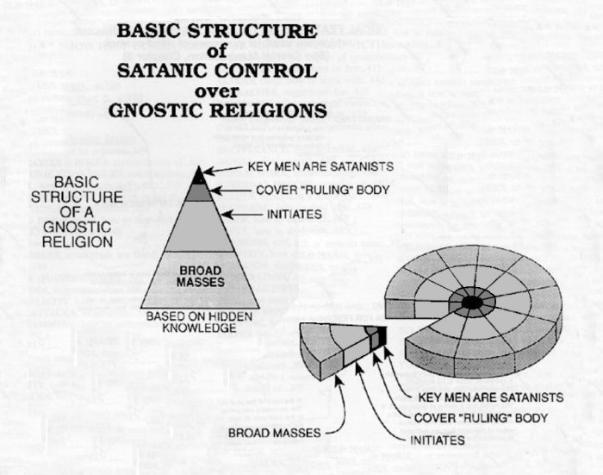
Additional influence
In order to be a pastor you have to be certified by “them”. This means you have to be taught by “them” what to preach/teach and what not to preach/teach (you have to be indoctrinated). It’s no different than school teachers who are unknowingly indoctrinated to indoctrinate others.
A 501 (3)(C) status is another way Christian churches are manipulated by the System. And then there’s magazines, newsletters, and conferences (information).
Think of the past ten years, what made Christianity really start looking bad? Wasn’t it the prosperity preaching and greed of televangelists, particularly those at TBN?
Lifestyles of The Tele-Evangelist… Fleecing The Flock by Carol Brooks
http://www.inplainsite.org/html/tele-evangelist_lifestyles.html
Well, it was all done intentionally. It was/is character assassination.
Think back to all of the examples of Christians and churches you’ve seen in the past 10 years. How many of them showed churches feeding and clothing the poor and homeless, something that goes on ALL THE TIME? How about other charitable deeds? How many stories have you heard where people have went to church and have had their lives changed for the better? What have you been hearing the most? Money-hungry pastors and churches.
The people in control of mass media have been showing you the people and things they want you to see as Christians and Christianity. And who are these people who control mass media, especially Hollywood and the music industry? Luciferians and other occultists. That’s clear to most people now as they watch the shows and look at the music artists, but it didn’t just happen recently, they’ve always controlled it. Think about that. Luciferians are the ones who have been showing you Christians and Christianity your whole life. Like always, they give you something upright, and after you’re drawn in they slowly start to twist and pervert it. This is a routine trick they use, and you can even see it with artists, especially the Disney pop stars. Showing you what they want you to see as Christians and Christianity is the reason you got this during the peak of the anti-religion/anti-Christian agenda:
‘Preachers of Atlanta’ Have Their Own Approach to Inspiring Faith
https://www.youtube.com/watch?v=z6bpMn3pA9w
“Somehow” it produces the same image in the minds of the viewers that the televangelists produce, and fuels the same ideas being preached by them. What a coincidence.
‘Preachers of Atlanta’ pastor defends passing out condoms, cigarettes for ministry
https://www.youtube.com/watch?v=tKgGfMpeo8M
Some of the comments on Youtube
– I’m not buying this, I’m sorry this preacher with the lip stud, No not buying it. I mean passing out cigarettes and condoms please. Its like AA passing out alcohol at a bar and trying to get people sober. Or having her to preach about not having sex outside of marriage with her wearing those tight jeans and stud in her lip. Try this, how about teaching God’s Word and using his Word to entice his children to have a relationship with him. Just because she said God talk to her about this, doesn’t mean its so. Her perceived good intentions are just a little off base.
– “God told her to pass out cigarette” which god was she talking to? #Falseprophet.
In one comment it was brought up how this so-called pastor was showing her breasts on Periscope. You can look that up, it’s true. She was also drunk.
And that so-called pastor in the video, Kimberly Jones-Pothier, is a definite puppet. At 3:52 she states the belief that’s constantly being pushed through this agenda – “I know how hard it is in religion with especially Christians, they are the first to beat you down….” Watch the video again at the point she says, “all of those ‘saints’ and all of those ‘Christians.’” You can see “puppet” in her body language and hear it in her words, or at least I can.
‘Preachers of LA’ Spark Controversy with Flashy Faith
https://www.youtube.com/watch?v=WIWN7Jv3VPc
Some of the comments on Youtube
– Christianity is a career for these guys not a walk..
– really straight crooks..these preachers are doing this for worldly possessions and fame..not for God..there’s people starving and these so called men of God can’t get enough houses and cars.. preachers like this make Christians look bad..Shame on you wanna be preachers
– im a christian….. but who else thinks this is simply ridiculous??
– I’m a Christian. This makes me sick. He who is of the world hates God.
– I’m Christian and watching this made me sick>:(
– I’m a Christian and I have to say that this is so stupid and I am utterly ashamed of these men who call themselves “Christians”…they are NOT real Christians people. This is not the example that Christ gave nor is it how the Bible describes the Christian life should be like.
– I m not here to judge these men for what they do, but I know Jah (God) is not the author of confusion or doubt. It’s not wrong for any religious person to have riches, but it also a sin to flash it around when you know there are people struggling and they give there last to a churches and the pastors, preachers, bishops, deacons, deaconess, members of the board and they are living better than the community which they serve.This type of behavior is the same anywhere I been to several churches, white and black and I see the Man of God driving expensive cars and wearing expensive clothing sometime it hard to truly see Jah through all of this, but I must say everybody needs to know Jah for themselves these men are not your God they are men who just happen to be preaching the word of God, I know the word of Jah for self so this type of shows will not confuse me on who Jah is and always be. Much Respect.
The System had Preachers of L.A., Preachers of Atlanta, and Preachers of Detroit. Any others, I’m not aware of (I don’t watch TV). And which network did this trash air on? The Oxygen Network, the network Oprah became the face of, drawing millions of viewers to the network.
“The privately held company Oxygen Media was founded in 1998 by former Nickelodeon executive Geraldine Laybourne, talk show host Oprah Winfrey, and producers Marcy Carsey, Tom Werner and Caryn Mandabach (of Carsey-Werner fame). Laybourne was the service’s founder, chairwoman, and CEO, staying with the channel until the NBCUniversal sale. The company’s cable network Oxygen launched on February 2, 2000.”
“The channel later began to focus chiefly on reality shows, reruns, and movies. For a time during the talk show’s syndication run, Oxygen aired week-delayed repeats of The Tyra Banks Show. The yoga/meditation/exercise program Inhale was the last inaugural Oxygen program on air into the channel’s NBC Universal era, albeit in repeats; it was canceled in 2010.
Campus Ladies, Bliss, Oprah After the Show, Talk Sex with Sue Johanson, The Janice Dickinson Modeling Agency, Snapped, Girls Behaving Badly and Bad Girls Club, a reality series, were the highlight shows of the network at this time.”
Source: https://en.wikipedia.org/wiki/Oxygen_(TV_channel)
“She was an initial investor in the Oxygen cable channel in 1998, but she soon cut many of her ties to that company.
Asked about the difference between Oxygen, which was sold to NBC in October for $925 million, and the latest venture, Ms. Winfrey said Oxygen ‘did not reflect my voice.’ That assertion is subject to interpretation, however; Ms. Winfrey was host of a 12-part series called ‘Oprah Goes Online’ on Oxygen. The show was sort of a primer on the Internet. She also was frequently referred to as a co-founder of the channel in news reports at the time.
‘I was not a participant in the development of the channel,’ she said. ‘That’s why after a couple of board meetings I took myself off the board.’”
Source: http://www.nytimes.com/2008/01/16/arts/television/16oprah.html
Was she used, and agreed to be used, to draw people in without harming her image?
It’s almost as if only certain “pastors” and “Christians” are selectively being shown to the public. Go figure. And it actually goes much deeper than this. You have to understand that when “they” do these things, “they” don’t just do them out of the blue. They’re planned out (your life is all planned out), and some things take years to complete. “They” condition you slowly. Take Obama, for instance. Years before his election you were shown movies where a black male was a president, right? And it happened again and again. That was conditioning. Without that conditioning your reaction to Obama, especially if you’re white, would have been totally different. It’s the same with this agenda. The conditioning was slow, and over many years.
Did you know that nearly everything most Americans know about the Bible and the God of the Bible has come from consuming information through mass media, they just don’t realize it? They have never even read the Bible, and this includes most people in church. Being one of these people, do you want to know what happened after I read the Bible all the way through for the first time? I was highly disturbed. I was disturbed at how it was the opposite of what I had always heard. I actually had to examine the book to see if there was something wrong with my copy. So, nearly everyone has already been brainwashed, and now we’ve come to the peak of the brainwashing.
Something extra: The way Christian pastors were pit against homosexuals and homosexuality right before “they” elevated homosexuals and homosexuality for the homosexual agenda was not coincidental.
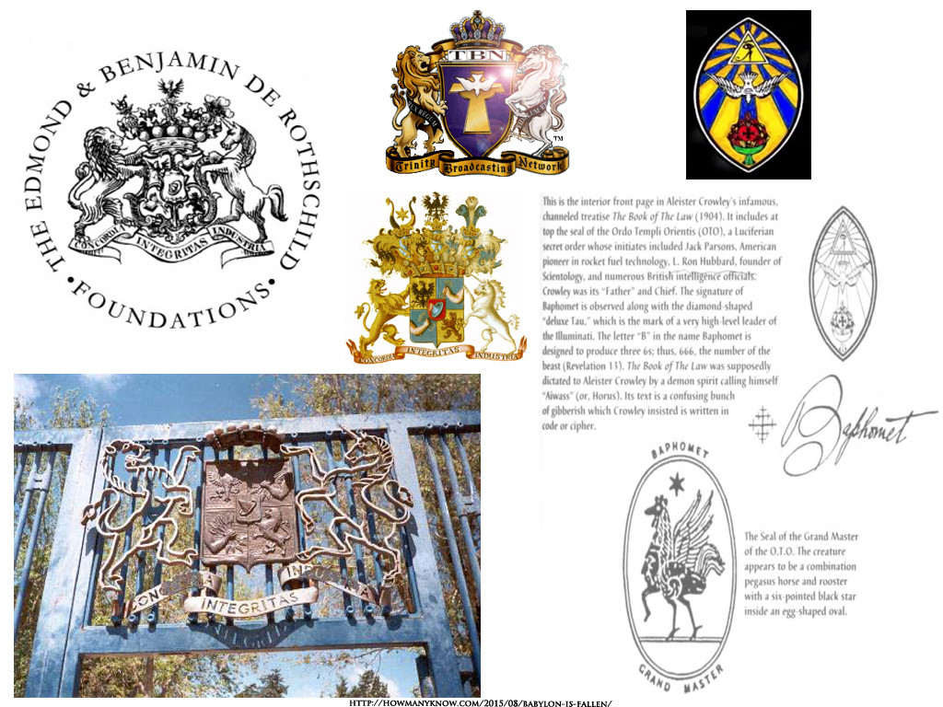

As you can see, even the bird in the TBN logo doesn’t represent the Holy Spirit as some people, especially Christians, might assume. You can see that same bird, in that same position, in the logo of the Ordo Templi Orientis.
Ordo Templi Orientis
Ordo Templi Orientis (O.T.O.) ('Order of the Temple of the East' or 'Order of Oriental Templars') is an international fraternal and religious organization founded at the beginning of the 20th century by Carl Kellner and Theodor Reuss. English author and occultist Aleister Crowley is the best-known and most influential member of the order.
Originally it was intended to be modelled after and associated with European Freemasonry,^{[1]} such as Masonic Templar organizations, but under the leadership of Aleister Crowley, O.T.O. was reorganized around the Law of Thelema as its central religious principle. This Law—expressed as "Do what thou wilt shall be the whole of the Law"^{[2]} and "Love is the law, love under will"^{[3]}—was promulgated in 1904 with the writing of The Book of the Law.
…

Philosophy of O.T.O.
O.T.O. was described by Crowley as the "first of the great Old Æon orders to accept The Book of the Law". O.T.O. originally borrowed ritual material from irregular Masonic organizations,^{[12]} and although some related symbolism and language remains in use, the context has changed to Thelema and its tenets.
The Order offers esoteric instruction through dramatic ritual, guidance in a system of illuminated ethics, and fellowship among aspirants to the Great Work of realizing the divine in the human.^{[23]}
O.T.O. has two core areas of ritual activity: initiation into the Mysteries, and the celebration of Liber XV, the Gnostic Mass. In addition, the Order organizes lectures, classes, social events, theatrical productions and artistic exhibitions, publishes books and journals, and provides instruction in Hermetic science, yoga, and magick.
Source: https://en.wikipedia.org/wiki/Ordo_Templi_Orientis
Another source for the logo: https://en.wikipedia.org/wiki/File:OTOlogo.png
If you look at some of TBN’s earlier logos you can actually see an O, T, and O.
Pat Robertson the Mason
https://www.youtube.com/watch?v=gnSxC6DFkis
… Freemasonry.

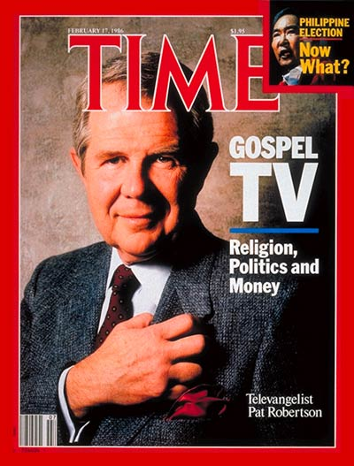
Additional information can be found in Codex Magica by Texe Marrs
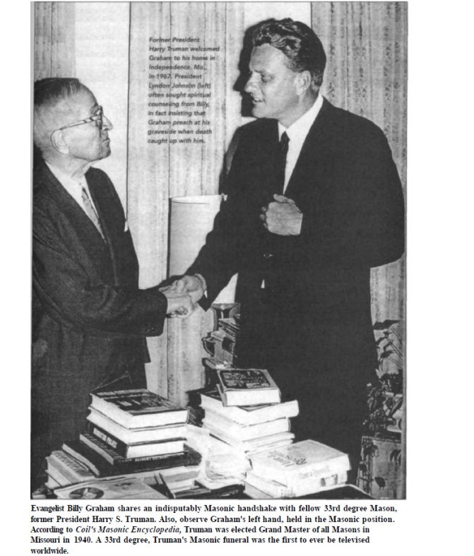

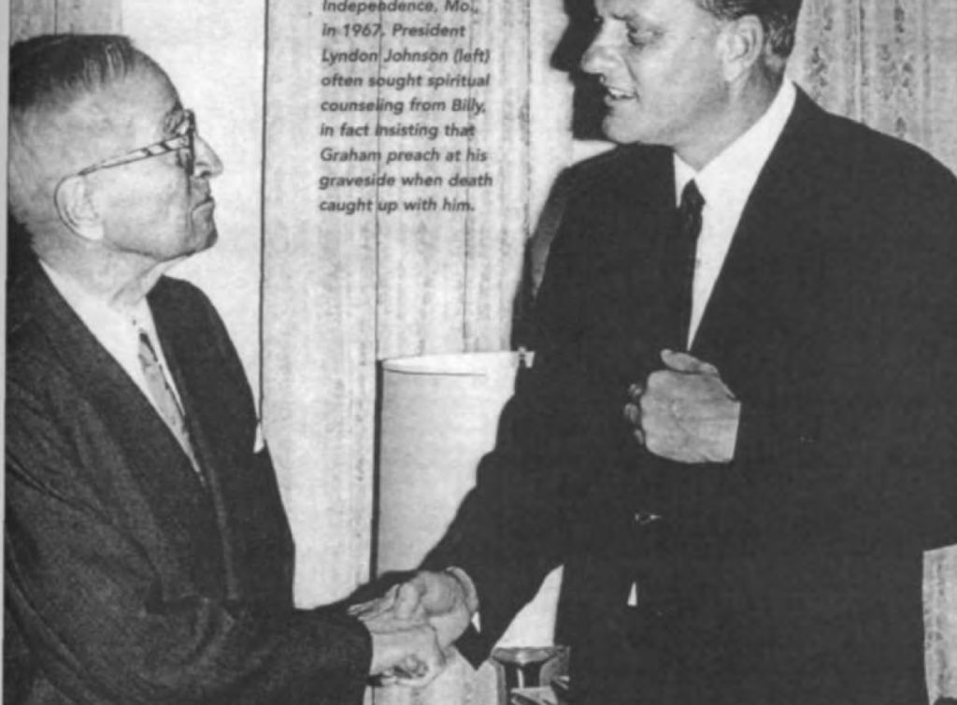Source: Codex Magica by Texe Marrs
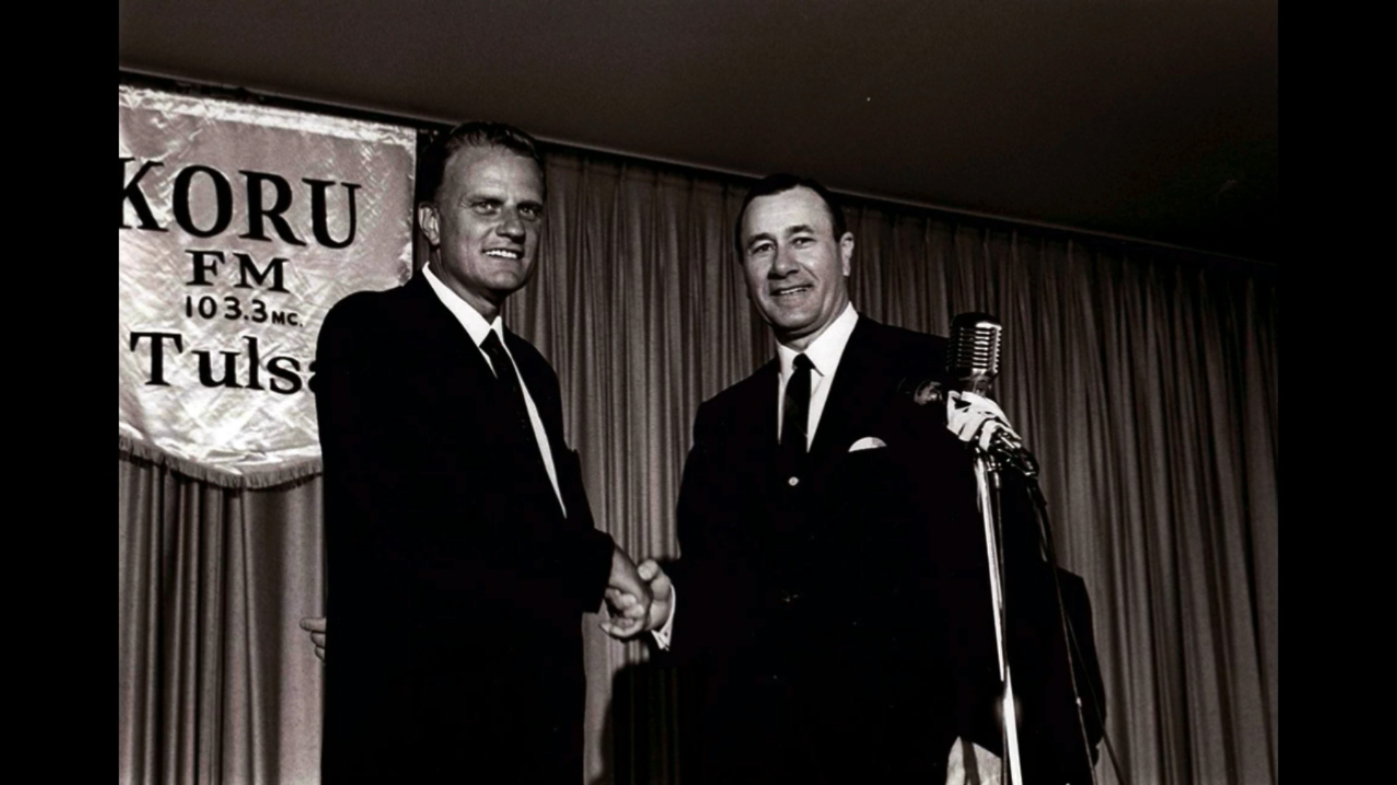
Billy Graham and Oral Roberts.
20- 33rd DEGREE MASONIC "PREACHERS" *FOR THE LOVE OF MONEY*
https://www.youtube.com/watch?v=Yv2bSRvSRfI
HEBREWS: The American Church Has Been Taken Over!
https://www.youtube.com/watch?v=eWQ_dQvQKC4
John Hagee Exposed – ZIONIST FALSE PROPHET
https://www.youtube.com/watch?v=-xYY4JUq_-M
With Luciferians and other occultists actually controlling TBN and other televangelist networks, what is their true purpose? It should be clear that those pastors and churches are used to be the image of Christians and Christianity. Those pastors and churches are also used to infect and mold their members, listeners, and smaller churches the same way celebrities (controlled puppets of the System) are used to infect and mold the general population. It’s the same psychological and sociological (science) setup. Those infected Christians then become examples of Christians and Christianity to non-Christians.
- Listen how the hosts in this next video are trained-up like newscasters.
- It’s stated that the false doctrine being stated by people like Kenneth Copeland is accidental. This a totally false. It’s 100% desired, and even prepackaged.
- TBN went on to become one of the leading “Christian” peddlers of New Age doctrine.
This Preacher was thrown off TBN for telling the truth
https://www.youtube.com/watch?v=0FeJvuln4fE
What most of the popular televangelists preach, at its core, is a gospel of self. It’s a total focus on self. And that is the same as the New Age Movement. Do you really think this is a coincidence? Can’t you see how this connects with the self being god and Christ Consciousness being pushed from other platforms? Even the trend of “selfies” is a part of it. It’s all social engineering.
I have another project on TBN and televangelists so I don’t want to go too deep into it here, but I will leave you with some addition information on them.
These televangelists were modeled after the traveling con man preachers, who were copies of the old snake oil salesmen (like the progenitor of the Rockefeller dynasty). One of the most influential to TBN was a well-known con man named Oral Roberts. Oral Roberts was so good that, although there’s no physical proof, it’s clear the powers that be selected him to be a head of this con game.
Here are some clips of a documentary featuring a guy who was scamming around the same time Oral Roberts was. He exposes the whole system. You can fast forward past the singing and preaching parts if you want.
Marjoe - subtitulado - Los primeros años
https://vimeo.com/93458511
Marjoe - subtitulado - El final
https://vimeo.com/97080054
FYI: Real healings do take place in real churches.
Marjoe - subtitulado - El ministerio
https://vimeo.com/94297889
Marjoe
https://www.amazon.com/gp/video/detail/B018ISEFCE
As usual, America has outsourced its wickedness. The scam of fake pastors is now flourishing overseas and is very big in Nigeria.
Billy Graham And Freemason Televangelists Exposed
https://www.youtube.com/watch?v=Mqjxkm6xRWQ
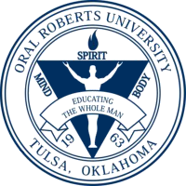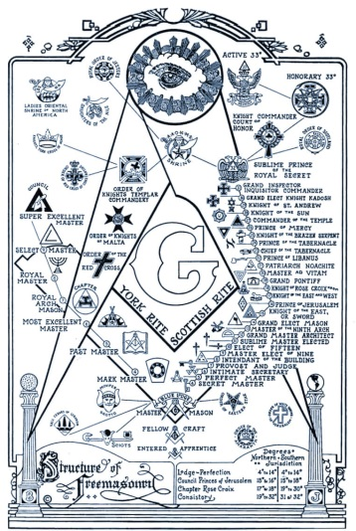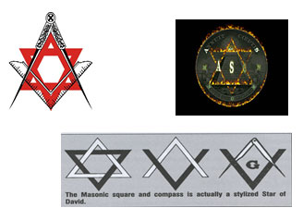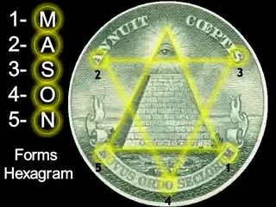
Additional information on the televangelists
https://www.youtube.com/channel/UCNCcrpEaCTt7CBjnHnOclRA/videos
But please understand, what you’ve seen is not the Church. People keep looking that those frauds and their churches and speaking on the state of the Church. They are falling for one of the schemes of the powers that be. And these frauds definitely don’t represent all Christians because the bulk of the people who expose and attack all of these frauds are Christians. But, with that being said, most Christians are deceived by the frauds.
All of the Christian singers, preachers, black empowerment teachers, and nearly every person that is shown on television are people “they” put up there for you to see, learn from, and follow. Yes, the ones that claim to be Christian as well. It’s one huge stage. They are all planted there. And I’m telling you, it’s almost all of the ones that claim to be Christian, if not all of them.
A gospel artist takes a picture with a blatantly sinful artist, depending on who the blatantly sinful artist is and why they took the picture, that’s not a problem. A gospel artist having dinner or meeting with a blatantly sinful artist, depending on who the blatantly sinful artist is and what the meeting was for, that’s not a problem. A gospel artist using certain beats or styles of music from blatantly sinful artists or genres, depending on the original source, that’s not a problem. The problem is the oneness with such artists and institutions, especially those that are anti-Christian. Doing business with such a person is being one with them, being yoked with them. Working for a person or company, or that company or person working for you, is being one with them, being yoked with them.
At this point in time there are special circumstances which exist in mainstream music and movies – Satanism, the occult, and anti-Christian material are blatant and widespread – so how could any real Christian be a part of that?
This is the industry they are friends with, work with, and even work under:
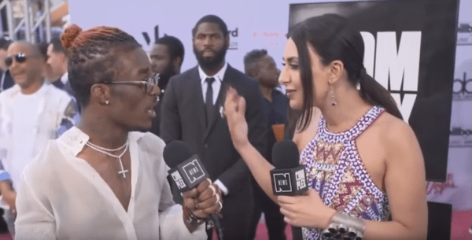

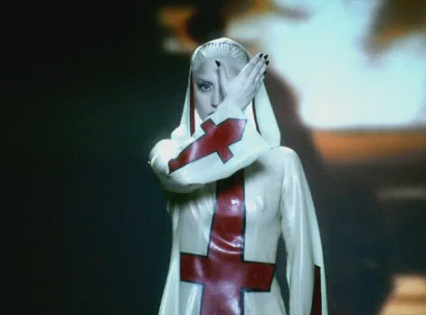

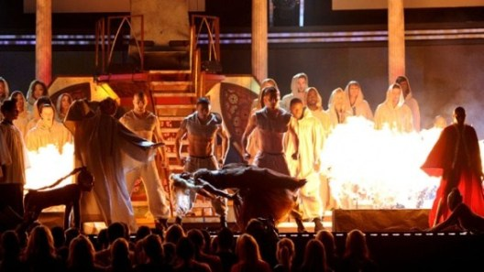
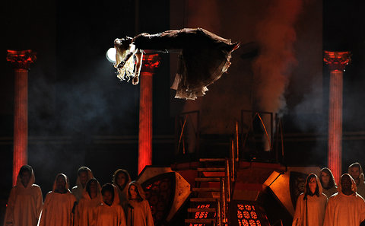

Who goes into the music or film industry and doesn’t know that this has been going on for years?
This is from the early days of exposing the madness:
American Idols pt. 2 of 2
https://www.youtube.com/watch?v=0QfGGjpS-cI
What type of fool are you to believe that a real Christian could work in that industry or side-by-side with those artists? Some very special circumstance would have to exist to do so.
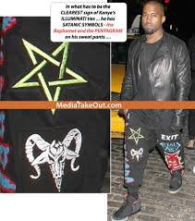
Take a look at this excerpt from Beyonce Speaks of Doing the Unimaginable with the Bible by Chad Davidson
While all the fuss about Beyonce’s latest visual album, “Lemonade,” has been, “Who was Becky with the good hair?”, (reportedly speaking of someone her husband committed an extra-marital affair with), one thing that might have been missed was the fact that Beyonce does a spoken word performance where she makes mention of using the Bible as a Tampon!
WARNING: EXPLICIT LYRICS BELOW
“I plugged my menses with pages from the holy book
But still inside me coiled deep was the need to know
Are you cheating on me?”
(From the song “Denial” by Beyonce)
Source: https://www.goodfight.org/articles/music/beyonce-speaks-unimaginable-bible/
“Beyonce, believe it or not, managed to mock Jesus Christ and exalt herself as though she were God…all in the same photo! Just as the New Year was coming to a close, a scantily clad Beyonce posted an Instagram snapshot of herself sitting seductively in front of a painting of Jesus and His disciples at the ‘Last Supper.’”
Here: https://www.goodfight.org/wp-content/uploads/2016/10/beyonce_blasphemy_1_main_large.jpg
Source: https://www.goodfight.org/articles/music/beyonces-blasphemy/#
Bizzle (@MyNameIsBizzle) - Explaining to do (Jay-Z Expos'e)
https://www.youtube.com/watch?v=POB407UoI18
KANYE & A.$.A.P - BAPHOMET AGENDA
https://www.youtube.com/watch?v=TxbCTWdAOAM
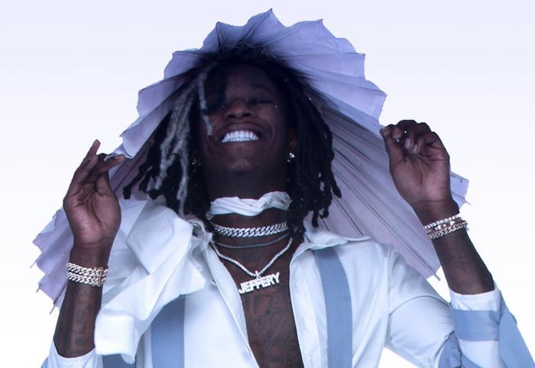
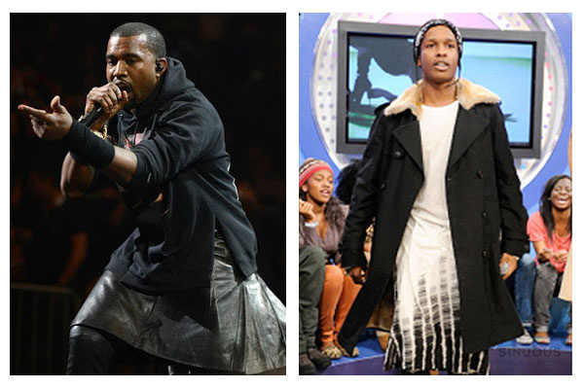

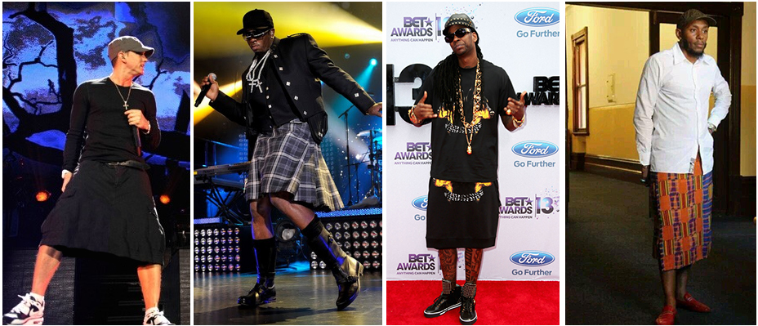

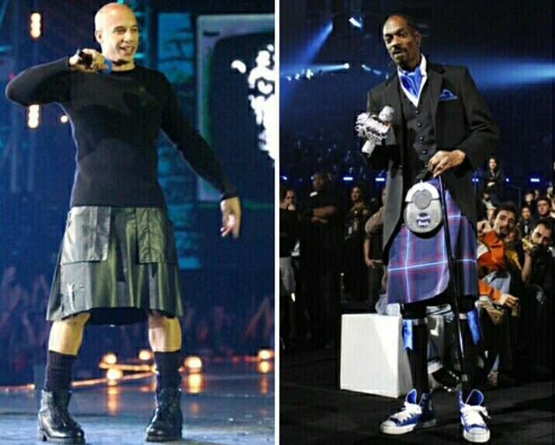

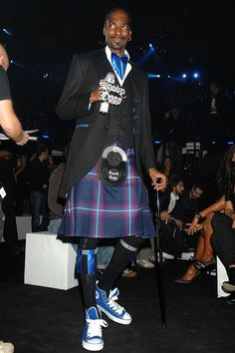

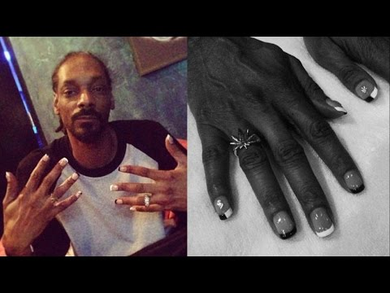
Moving on up …
Did you hear that Kirk Franklin wore a red dress/skirt to the Grammys? Do you know what that means? He’s a puppet. He is just like the other celebrities.
Kirk Franklin’s Gender Bending Red Dress At The Grammys
https://www.youtube.com/watch?v=4UBT4BsZubg
Kirk Franklin Wears Red Dress At Gender Bending Gospel Grammy Performance! – The LanceScurv Show
https://www.youtube.com/watch?v=KiCeXWTwgSY
You may believe that Kirk Franklin just recently sold out. No, this was always the case. Kirk served several purposes in this agenda. When he first came on the scene with his groundbreaking music many were offended by it. As the television interviews increased, along with support from mega church pastors, he became more accepted. His music was not only about introducing and merging “worldly music” (“the world”) with gospel music (the church), as was the movie Sister Act, it was also about breaking down the Church’s resistance to trying new things. The Church didn’t try new things at all. He helped to break that, and after he did, the floodgates were opened. Others like him, and the televangelists, were then able to get their new things into the Church. And if you remember, Kirk also went around preaching with a “worldly” edge, with “worldly” words and ideas, seen as appealing to the youth and those from the street. It was really about mixing the holy with the profane, blurring the lines.
Kirk Franklin EXPOSED: Says Jesus Christ is Cocky – Glory in Shame
https://www.youtube.com/watch?v=Lt_DMWt2FBU

You then saw him mingling with Satanic celebrities like Kanye West, even calling him his friend. And that was done even after what you’ll see in this next video.
Kanye West “Bible” replaces every mention of God in ‘Book of Yeezus’ w/ Kanye
https://www.youtube.com/watch?v=T9Fh9PxHRvA

You heard Kirk state things that could be taken more than one way, and one of those ways promoted the anti-Christian agenda. “Losing my religion” is one example. You also heard him say things that you hear from televangelists, the underhanded, sly attacks of Jesus and Christianity.
Kirk Franklin Is Waking Up #JesusIsALie
https://www.youtube.com/watch?v=b3gr55p9bho
*I definitely don’t agree with the title of the video.
The System fired false accusations at Christians and Christianity for the agenda. In the battle “they” created, Christians/Christianity/the Christian Church vs. Homosexuals, the System kept repeating the idea that Christians/Christianity/the Christian Church had been attacking homosexuals—the newly protected, celebrated, and downtrodden group—relentlessly. Kirk’s role was to play the Christian speaking on behalf of Christians/Christianity/the Christian Church who confirmed it. And he did this over and over again. The attack coming from the System using this idea was so relentless that no one even realized how false it was. For instance, it was also stated that the Church was hypocritical because everywhere you looked there were homosexual choir directors. Question—How can the Church be homophobic to the extreme stated, and at the same time have homosexual choir directors? Exactly. Someone lied. And this is what Kirk was a part of. He’s been working this whole time. This is the Matrix.
I had several videos exposing Kirk Franklin bookmarked (better than what you’ve seen), but as I went through each one I found that either the Youtube channel or video had been deleted. And immediately after writing this, I found this next video. And after seeing the title, I thought the same thing he states—“the oath”.
WHY IS GOOGLE PROTECTING KIRK FRANKLIN?
https://www.youtube.com/watch?v=GltuM_URgwQ
And notice how many of these videos and comments I’m using are from Christians who don’t agree with what’s going on. But how can that be, I keep hearing that all Christians are the same? It’s always “Christians” and “Christianity”.
And it’s not just Kirk Franklin that’s a fraud; it’s almost all of the Christians in the limelight, if not all of them. There are plenty of videos online exposing all of them, or at least there was.
Most people can’t see past the fake Christianity because the “Christians” they’re looking at are celebrities, gods who they idolize. Most people don’t even realize that gospel music is under the umbrella of the mainstream music industry. Think about that. It’s just as “they” control the televangelists.
I had made a Facebook post about gospel music using a Christian rapper’s song. In that post, I stated: “And like Bizzle said in this song, ‘Them same people singing all them choruses you yelling, got it looking like Sodom and Gomorrah at the Stellars.’ And speaking of the Stellars, how and why would Beyonce be performing at the 2015 Stellar Awards, an awards show for Christian gospel music? Do you not know about Beyonce? You don’t think the people who invited her know about her? What is the music industry’s occult queen doing performing at a Christian gospel awards show? Yeah, let that sink in.”
The video showing LL Cool J ending one of the Christian gospel awards shows with an occult hand sign has been removed. And don’t get me started on Lecrae, the bold sellout. I wanted to fully expose him a while again, but I didn’t have time.
Here’s a little something on him:
Lecrae "BEFRIENDING" The World & Snoop Dogg's "Gospel" Album Deceiving The Church!
https://www.youtube.com/watch?v=qRvNQlvyg8c
I don’t know if the maker of this next video was right about the move role, but everything else he says is definitely on point.
My Thoughts On Lecrae, Yet Again!...
https://www.youtube.com/watch?v=l9N05XekqzM
Certain acts get you rewarded, from sexual acts with higher-ups to embarrassing acts and acts that support agendas. That’s how the entertainment industry works.
Just as the powers that be blurred the lines between male and female, they’ve blurred the lines between holy and profane.
Fred Hammond and Why I Stopped Listening to Most Gospel Music
https://www.youtube.com/watch?v=T9alMlvXct4
You should stop listening to all of his music! The same with the others! They are puppets of the System who are deceiving you. And praying for these people …. What are you going to pray about? Are you praying like you’re praying for a friend or an enemy? Hopefully an enemy because these people are your enemies. And they are even worst than the enemies who don’t hide that they’re you’re enemies because these puppets take money from them to deceive you while pretending to be your friend. Do you realize that they, their family, down to their pets deserve to die?
The Compromiser Pt1: Marvin Sapp On The Monique Show.
https://www.youtube.com/watch?v=CS1rVh05H0U
The reason secular music is sampled by these particular gospel artists really boils down to psychological warfare.
Servants Of the Savior or Satan Part 2: Mary Mary
https://www.youtube.com/watch?v=sqj3E30B1Ak
Listen to these two. They literally turn my stomach. They are not real Christians!
Tina & Erica Campbell of Mary Mary Says “Hoes Got It Wrong!”
https://www.youtube.com/watch?v=zVSJx8wjclQ
You really believe they’re real Christians? Erica’s husband is a producer who worked on R&B Divas. Do you see what I’m saying … one with the industry?
They had a TV show? Oh no. I don’t watch TV, but I’m sure there were a lot of agendas being carried out in it (like every TV show).
Mary Mary: Sexuality Interview – Deleted Scene – YouTube
https://www.youtube.com/watch?v=LCsOzRAoOZU
Looking at them you see the same theme—“Who said Christians can’t dress sexy?” There was so much crap stated in the clip that I don’t even want to address it.
Here are some good comments from the comments section
– Christians understand that they are called OUT of the world to be different. They are to reflect Christ in all aspects of their lives yes INCLUDING the way that they dress. The lord tells us we are to dress Modestly ( 1 Timothy 2:9) we don’t have to be “sexy” to feel good. Only because God created sex does not mean we should want to be looked at in a sexual way by the rest of the world. We are in the world but we are not to be of the world… That is absolutely CLEAR in the scriptures. Secular artist like La gaga and Nicki are not claiming to be saved so you can not compare to that. Christians should lead by example.
– They Trippin’ ! don’t need to feel Beautiful by Showing off my curves and trying to feel “sexy”. I feel beautiful by knowing that I am made in my creator’s image and that I am fearfully and wonderfully made! Sexuality is for marriage and should not be displayed outside of it. Their clothing choices can also be a stumbling block for our brothers. Pray for them church! we are not the judge!
– Exactly I’m half their age and I know that
– You should not judge yourself by the standards of the world but by the standards God has set for us!
– Your curves and your sexy was made for only your husband to see and you had to go all the way down to the bottom of the pole to get to nicki minaj and lady gaga for comparison and who are about as wicked and perverted as they come. What a disgrace before God.
– DECEIVED! Bottom line! First of all, did not the Word tell us that comparing ourselves among ourselves is not wise and furthermore, ungodly. 2ndly, you dress immodestly, the both of you. If you say it is not your intention to show off every curve, Tina,I can’t tell.Everything you wear is too tight, too low, and too short. It’s very intentionaly. Also, the two of you did not dress like this when you first came out.Why would you want people to find you sexually apealling–Ur gospel artist.
– So now secular artist are the measuring stick for the “Believer?” You guys do recognize that you not saying much? Since when was ANYTHING of the world used a meter except for what NOT to do in scripture? You like the rest of these gospel celebrities (oxymoron btw) have sold out for 30 pieces….you have your reward!
– These women need a wakeup call. Mary Mary wears their clothes waay to tight. I don’t consider half the stuff they wear as modest..not even close. They’re too big to be wearing half the stuff they be wearing.
– I don’t think Mary Mary is “safe” or “modest” when it comes to dressing. I totally think they wana keep up with the Jones’ instead of keeping up with Jesus! Ijs
Yolanda Adams on stage singing John Lennon’s Imagine:
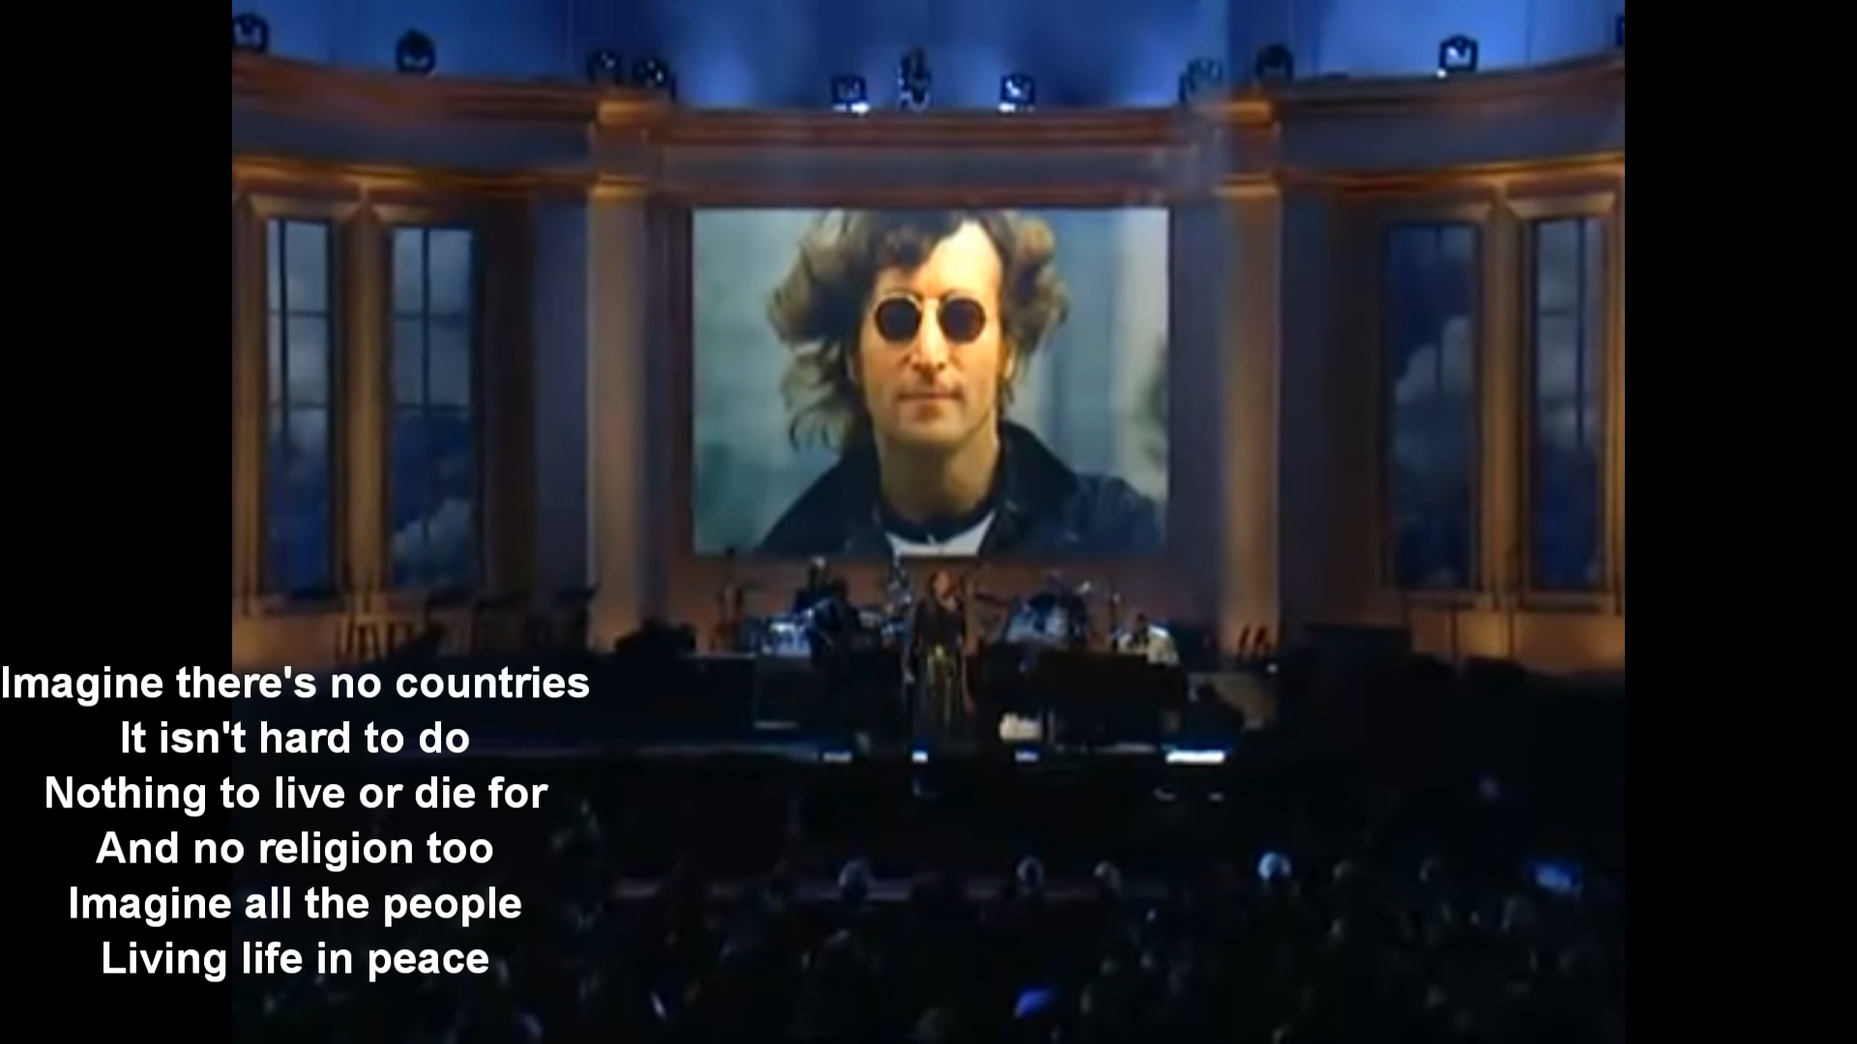
Tasha Cobb, TD Jakes, and the "Other Sheep" of John 10:16
https://www.youtube.com/watch?v=9o_cOhJMkAg
Let’s stop playing stupid, these gospel artists know exactly what’s going on in the music and film industries, and still they collaborate with these people and work in these industries. Get it through your heads, these people are frauds!
SNOOP DOGG, CREFLO DOLLAR, & TOP GOSPEL ARTISTS EXPOSED FOR FAKE GOSPEL ALBUM
https://www.youtube.com/watch?v=NwrkUUnzi9I
“Bible of Love (also known by its full title Snoop Dogg Presents Bible of Love) is the sixteenth studio album by American rapper Snoop Dogg.^{[5]} It was released on March 16, 2018 by RCA Inspiration.^{[6]} Bible of Love serves as his debut gospel album much like Reincarnated (under his different persona Snoop Lion) served as his debut reggae album. Snoop himself served as executive producer over the entirety of the project, alongside Lonny Bereal.^{[7]}”
Source: https://en.wikipedia.org/wiki/Bible_of_Love
“Joseph A. ‘Lonny’ Bereal is an American R&B singer, songwriter and producer. He is also a member of Flipmode Squad with other rappers such as Busta Rhymes, Spliff Star and Reek da Villian.”
Source: https://en.wikipedia.org/wiki/Lonny_Bereal
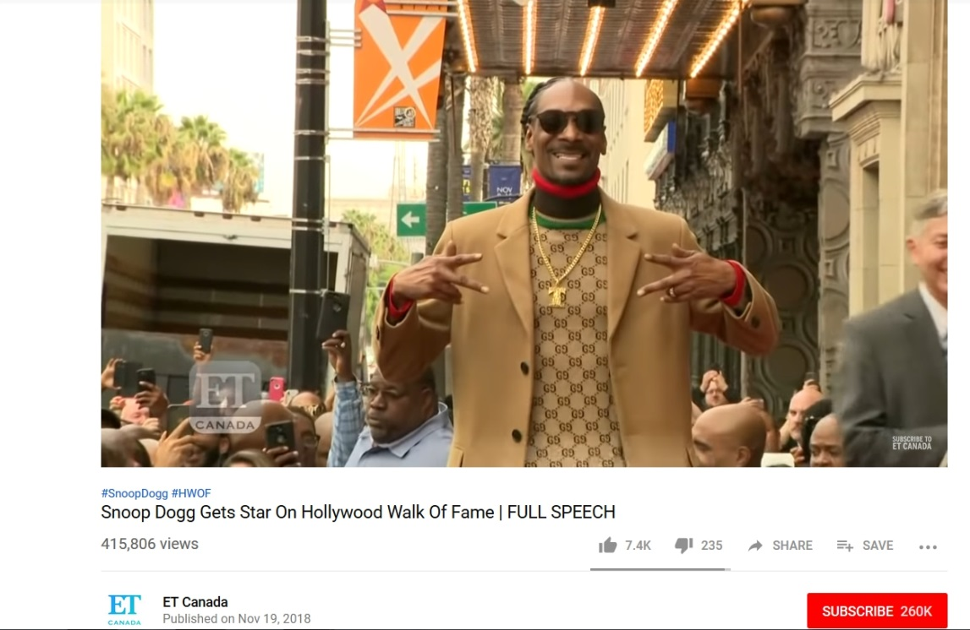
In this next video the lady says the puppets you’ve just learned about, the gospel artists and other fake Christians, don’t have discernment. You should know by now that this is not the case. They are puppets, agents of the System. Other than that, this is a great, eye-opening video.
Black Gospel Singers Exposed YouTube
https://www.youtube.com/watch?v=8rII2i45WfU
Looking to the other side of the stage … the actors.
These people are not real Christians, and most of them know this themselves. You’re the fool who believes them. If they were Christian, something that’s internal, they could never be yoked to the mainstream music or film industry.
From New Age to Jesus - My Testimony
https://www.youtube.com/watch?v=Yy-Vn_Th4Ec
No real Christian could go into these industries. It’s impossible.
Angus T Jones I Was a Paid Hypocrite New Religious Calling
https://www.youtube.com/watch?v=A91MrAgm7mQ
There’s no excuse you can make for your idols now. None. Not for T.D. Jakes who is one with your idols, to actors who claim to be Christians. They’re all frauds no matter what you believe.
Because there was actually a true conversion, the industry and a TV show was put was put in a bad light, and the structural integrity of the mind control programming that Christians and the industry can be one was in jeopardy, they went on the attack and tried to destroy his credibility. This first video only has some minor attacks.
Angus T. Jones 'Two and a Half Men' 'Filth' Video: Actor Blasts Show in Interview on Faith
https://www.youtube.com/watch?v=IxV4DYSQc5s
Angus T. Jones Apologizes for Meltdown!
https://www.youtube.com/watch?v=gWcyLgdxinc
And they even attacked Chris!
Angus T. Jones -- The Crazy Spiritual Downfall | TMZ
https://www.youtube.com/watch?v=Uy4fGjHDdJo
INSIDE EDITION EXPOSED: ANGUS T JONES MELTDOWN???
https://www.youtube.com/watch?v=P0lHcO0G78A
And that’s how it’s done.
Listen to how this next guy came from the Devil’s playground.
DeVon Franklin Testimony at The Potter’s House in Dallas, TX
https://www.youtube.com/watch?v=F3M24vYDTkA
They’re going to change Hollywood. Ha! That’s hilarious. That’s the lie they tell you.
The Devon Franklin Deception
https://www.youtube.com/watch?v=x2VQorhHhfc
It’s funny that he brought up arranged marriages because I thought the same thing.
Devon and Meagan went to the Los Angeles Potter’s House to promote their book. This next video is the full video of that event, but you don’t have to watch it because a clip of the part in question is below it.
“The Wait: Kingdom Love 2” w/ DeVon Franklin & Meagan Good – Touré Roberts
https://www.youtube.com/watch?v=uNGEMl6WnaI
Watch this:
Woman comes at Meagan Good incorrectly
https://www.youtube.com/watch?v=OuePUOqnRxE
One issue: The issue of how she dresses, and what he said about it. There was a good video on Youtube about this issue, but it’s been taken down. Devon said: “She’s not go cover up. She go wear what she wanna wear … in the name of Jesus.” He then went on to basically state that the way she dresses doesn’t change how Christian she is. That’s one issue.
And now, the main issue: Go to the point in the video right before Devon and Touré stand up and slap hands, then pause the video there. Now, in the Youtube window frame, click on the gear icon; click on “Speed,” select “0.25” and play the video. You will see that they rise at the same time. Devon was already moving in the chair, and though Touré was looking at him there’s no way he would have known Devon was going to get up. Devon was not looking at Touré at all, but they rose at the same time and did the same thing. And are three slaps something normal for them? Though it may be hard to accept, what you saw was staged.
They rose and slapped hands because of what he said (or so it seems), right? What he said was directly connected to, and because of, what the lady in the audience said. That means the lady in the audience was a part of it as well. Why is it so hard to believe when you’re living in a time, and country, where crisis actors, paid crowds, and staged celebrity beef is the norm? It may even be that he staged it without Meagan’s knowledge.
“All this was inspired by the principle—which is quite true within itself—that in the big lie there is always a certain force of credibility; because the broad masses of a nation are always more easily corrupted in the deeper strata of their emotional nature than consciously or voluntarily; and thus in the primitive simplicity of their minds they more readily fall victims to the big lie than the small lie, since they themselves often tell small lies in little matters but would be ashamed to resort to large-scale falsehoods. It would never come into their heads to fabricate colossal untruths, and they would not believe that others could have the impudence to distort the truth so infamously. Even though the facts which prove this to be so may be brought clearly to their minds, they will still doubt and waver and will continue to think that there may be some other explanation. For the grossly impudent lie always leaves traces behind it, even after it has been nailed down, a fact which is known to all expert liars in this world and to all who conspire together in the art of lying.” — Adolf Hitler, Mein Kampf, vol. I, ch. X
Source: https://en.wikipedia.org/wiki/Big_lie
But what you saw was just another Potter’s House production. It’s nothing new.
God Uses Tyler Perry To Lay Hands On Bishop TD Jakes
https://www.youtube.com/watch?v=sNejZAmdIG4
Now watch it again, but only watch Tyler Perry. Do you see how he keeps positioning his hand and putting it in suit? Those of you who are familiar with Freemasonry know what he’s doing.
Watch this:
IF THIS VIDEO DOESN’T WAKE PEOPLE UP THEN I DON’T KNOW WHAT WILL…
https://www.youtube.com/watch?v=Br8r5qLiu3s
And I don’t know how someone can look like a Mason, but T.D. Jakes looks like a Mason.
Listen to how the Devon and Meagan stunt is flipped in this piece:
Meagan Good Caught Hell For Wearing This Dress!
https://www.youtube.com/watch?v=PYBD8xFV9k0
So, it seems that the other thing being pushed besides the book was indeed the idea that you as Christian can dress like a slut. And the whole ordeal was used to attack real Christians, the uncompromising Christians, called “certain Christians with unreal expectations”. It’s the evil, judgmental Christians again, stating right from wrong. We can’t have that. “If I knew that I was presenting a gospel award I would have worn something different; it would have been sexy, without a doubt ….” Wow. It would have been sexy without a doubt. “God is not trippin’ off that.” Really? We can go to some verses.
1. If you’re Christian you shouldn’t be dressing like that in public no matter the occasion. 2. If you’re married you shouldn’t be dressing like that in public no matter the occasion. 3. If you’re the wife of a minister ….
Meagan Good Talks About The Way She Was Treated By Church Members
https://www.youtube.com/watch?v=hdUp8PeoFcc
She’s full of crap just like her husband. She sure doesn’t have to worry about pleasing people, she pleases a lot of people dressing the way she does. Think about it, as a man you’re almost forced to look at her, another man’s wife, sexually, or you’re put in a position where you’re forced to fight not doing so. You really think that’s okay? Sex, sexual, and sexy comes from sexually pleasing and sexually tempting. Sex is only for those in a marriage. So, sexy, sexually pleasing and tempting, would be confined to where? A man’s wife, or alleged wife, purposely tries to be sexy for others? Wow. And no, a person doesn’t dress sexy for themselves. They may dress sexy because they’re used to it, it’s regular clothes to them now, but other than that, no. If you were stranded on an island, and you had a mirror and all types of clothing, would you choose something sexy because it was sexy? “If I knew that I was presenting a gospel award I would have worn something different; it would have been sexy, without a doubt ….”
Even thousands of years ago within the Israelite community there was such a thing as whore’s attire.
PROVERBS
CHAPTER 7
MY son, keep my words, and lay up my commandments
with thee.
2 Keep my commandments, and live; and my law as the
apple of thine eye.
3 Bind them upon thy fingers, write them upon the table of
thine heart.
4 Say unto wisdom, Thou art my sister; and call
understanding thy kinswoman:
5 That they may keep thee from the strange woman, from
the stranger which flattereth with her words.
6 ¶ For at the window of my house I looked through my
casement,
7 And beheld among the simple ones, I discerned among
the youths, a young man void of understanding,
8 Passing through the street near her corner; and he went
the way to her house,
9 In the twilight, in the evening, in the black and dark night:
10 And, behold, there met him a woman with the attire of
an harlot, and subtil of heart.
*Warning, strong language*
Hoes uniform.
https://www.youtube.com/watch?v=_uscmRI9ZrE
Fans Attack Meagan Good For Saying She’s A Christian But Celebrating Halloween With A Full Catsuit
https://www.youtube.com/watch?v=nptTcUstMmQ
Meagan Good Ain’t No Good
https://www.youtube.com/watch?v=e3eRGq2pC44
There are clips of them appearing on just about every mainstream TV show promoting the book, Oprah and T.D. Jakes included. The Satanic System is promoting them, and favoring them. That’s a red flag.
I’ve heard them speak in interviews and state how there are other things a couple can do while waiting to have sex. So, I’m guessing the book is Christian bait. I’m guessing one thing that’s stated is that it’s okay to kiss, rub, touch here and there while waiting to have sex. In essence, it’s okay to play with fire. Try it, you won’t get burned. Look at him in Hollywood, he’s not getting burned. I don’t know exactly what’s in the book, but I do know it’s impossible for the purpose behind this book to be good.
One purpose of the book is most definitely to draw attention to them. They seem to be superheroes of purity in an oversexualized country. They seem to be real Christians. But, she, by her words and actions, teaches that it’s okay for a Christian woman to dress like a slut. He, by his words and actions, teaches that Hollywood is not that bad; Hollywood is redeemable; and Christians can be in Hollywood.
Is their book drawing you in for false doctrine within this book below?
https://www.harpercollins.com/9780062684257/the-hollywood-commandments
https://www.amazon.com/Hollywood-Commandments-Spiritual-Secular-Success/dp/0062684256
https://devonfranklin.com/the-hollywood-commandments/
https://books.google.com/books?id=R7_3DQAAQBAJ&pg=PT4&source=kp_read_button#v=onepage&q&f=false
It’s One Big Stage
Oprah & Denzel Summon Spirits
https://www.youtube.com/watch?v=D5oOY2C9wdI
Beloved came out in 1998. That means that since at least 1998 she’s been lying to you. And though Christians are leading the charge in exposing the New Age Movement, most Christians don’t know that Oprah is like a demonic portal for the New Age Movement (she’s Satan’s womb.) She’s introduced all the popular New Age teachers and their doctrine to America, along with self-help gurus. She is truly the new Helena Blavatsky. And if you really took a close look at all that Oprah is responsible for and the effects of it you would be hard pressed to find a more wicked, anti-Christian woman on earth.
Watch the beginning – 8:04
The Gospel Of The Church Of Oprah: Jesus Did Not Come To Die On The Cross
https://www.youtube.com/watch?v=2ElYy6MLUVU
Read these:
https://en.wikipedia.org/wiki/The_Secret_(2006_film)
https://herescope.blogspot.com/2007/11/oprah-and-friends-to-teach-course-on.html
https://amos37.com/conversations-with-god-actually-just-the-opposite/
Combine the statements that are made in this next video and you will see that they are saying “you are god”. And he’s also speaking about meditation.
Eckhart Tolle’s Definition of God | SuperSoul Sunday | Oprah Winfrey Network
https://www.youtube.com/watch?v=MW7ld4CCPoA
Excerpt from A Day of Worship at the Church of Oprah: ‘It’s Gonna Be All Right!’
One woman grew up in Johannesburg. Others were Harlem locals beaming with pride that Ms. Winfrey herself would be gracing their hallowed Apollo stage. They were women excited, but they were also women searching: for solace, reassurance, and guidance toward the light in what’s been a spiritually and morally dark time for them and society.
“She’s the perfect person to lead us into this point in history,” said a woman named Lindsey. “Everyone loves Oprah. She brings everyone together, and people listen when Oprah speaks!”
People dress to the nines when they are going to be in the same room as Oprah, we learned. (And will even be late, if need be, in order to do so; things got started almost an hour behind schedule as stragglers hurried in to the Apollo.) There was even a sense of nervousness, the kind of anticipation that comes when one feels they’re about to experience something profound.
“For me, being a black woman growing up, Oprah has just always been someone I looked up to and seen myself in,” said a woman named Jessica. “She’s important to me as an individual as a reminder of who I am and the strength that brings.”
Jessica subscribes to the Super Soul Conversations podcast for the same reason so many of us do: It’s a healing, invigorating antidote to the negativity and fear that threatens to suffocate you when you’re tuned into the news cycle.
To that regard, she says, we need Oprah now more than ever: “She doesn’t feel any more important to me than she ever has. But I think people who aren’t black women and haven’t seen themselves in her, she’s speaking to a lot of those people who feel marginalized right now. People for whom she hasn’t been their North Star before I think are realizing we all need someone to look up to and help feel important, feel empowered.”
Source:
https://www.thedailybeast.com/a-day-of-worship-at-the-church-of-oprah-its-gonna-be-all-right
That article ends with: “I’ve not been touched by an angel. But I’ve been touched by Oprah. Amen.” Yes, many people have been touched by her, but what have they been infected with as a result?
Additional information
https://christinprophecy.org/articles/the-new-age-church/
https://www.lifesitenews.com/news/the-worlds-most-dangerous-spiritual-guru-oprah-begins-10-week-online-new-ag
Someone agrees: “Oprah, who is a self-labeled ‘Christian’, was recently named the ‘most dangerous woman in the world’ by Bill Keller, considered by some to be the world’s leading Internet evangelist.”
http://www.christiananswersforthenewage.org/Articles_NewEarthSpirituallyElite.html
Okay, now pan to your left and look at that side of the stage … government.
The Hidden Faith of The Founding Fathers 2010
https://www.youtube.com/watch?v=xU24fJ4NQxo
George Bush (The Universalist) Denies Jesus As The Only Way, Says All Religons Worship the Same God
https://www.youtube.com/watch?v=Oq8E8ZSca2Q
Do you see it now? Do you see how he did all of that evil in the name of Christianity, being seen by everyone as a super-Christian, but clearly he was not? I could include many videos from Barrack Obama and Pope Francis, but it’s not even worth it. And these are just some of the people.
As I stated, it’s almost all of the Christians in the limelight (which are “Christians” “they” show you), if not all of them.
2 CORINTHIANS
CHAPTER 11
13 For such are false apostles, deceitful workers,
transforming themselves into the apostles of Christ.
14 And no marvel; for Satan himself is transformed into an
angel of light.
15 Therefore it is no great thing if his ministers also be
transformed as the ministers of righteousness; whose end
shall be according to their works.
And to the Church …
REVELATION
CHAPTER 3
17 Because thou sayest, I am rich, and increased with
goods, and have need of nothing; and knowest not that thou
art wretched, and miserable, and poor, and blind, and
naked:
18 I counsel thee to buy of me gold tried in the fire, that
thou mayest be rich; and white raiment, that thou mayest be
clothed, and that the shame of thy nakedness do not appear;
and anoint thine eyes with eyesalve, that thou mayest see.
19 As many as I love, I rebuke and chasten: be zealous
therefore, and repent.
MATTHEW
CHAPTER 3
10 And now also the axe is laid unto the root of the trees:
therefore every tree which bringeth not forth good fruit is
hewn down, and cast into the fire.
P4CM Presents JIG-A-BOO by Featured P4CM Poet Jackie Hill @JackieHillPerry
https://www.youtube.com/watch?v=ePsZNMJGMHs
All Glory to Yahua (God) and Yahusha (Jesus)

Franklin Miller (Writeous1)
http://howmanyknow.com/
writeousservant@gmail.com
writeous1@howmanyknow.com
https://www.facebook.com/franklin.miller.169
https://www.youtube.com/channel/UC6UWuuP9KUSYMIYU-nxmHNw

