

Camps Exposed

If a video in this project is no longer available at the link given, go here or here and search for it by its title, or search Youtube by its title.
If a link to a webpage becomes unavailable go here, enter the address in the search bar, and then select a date when you get to the calendar screen.
Due to the amount of information given in some instances, the information that is recommended for further understanding (“If you want more information….”) should be looked at after completing the main document or else you may lose the context of the original subject matter. But if you are a person with a good memory, go for it.
This was originally only focused on the Israelite camps, but ….
This is a lot of information for some people, and they might become discouraged as a result. My advice to you is to treat this like a book – go through as much as you can, again and again, until you finish. By the end of this document, you will clearly see the big picture.

The FBI and Their Tactics – pg. 3
Agencies, Cults and Culture – the Connection – pg. 12
Charles Manson – pg. 19
Father Divine – pg. 21
The Nation of Islam – pg. 26
Noble Drew Ali and the Moorish Science Temple of America – pg. 45
The Occult Connection to Black Groups – pg. 46
A Community Agenda – pg. 56
True Agents – pg. 74
The Israelite Camps – pg. 79
The FBI and Their Tactics
Watch the beginning - 19:12
Lies The FBI Told Me
https://www.youtube.com/watch?v=g-vVqieLG_c
At 13:07 of the video the narrator stated that the FBI stepped up its efforts to recruit blacks for the purpose of infiltrating the Black Panther Party. So, they used black people against black people. Keep that in mind.

At 13:12 of the video the guy said the FBI had a potential case against him for a crime he committed. To get out of trouble he worked as an informant for them. He was asked to gain membership into a group the FBI was targeting. Keep that in mind.

Watch 4:32 - the end

One Nation Under Siege 4 of 9 – COINTELPRO
https://youtu.be/WcxdQAZBA6g?t=4m32s
Combating perceived threats to the existing social and political order means combating perceived threats to unwanted change. This means the existing order is to remain the same unless the Elite makes changes to it. When it comes to blacks, the Elite are going to make sure they stay at the level they are at unless they desire them to be moved.

Watch 19:33 - 44:08
FBI WAR ON BLACK AMERICA
https://youtu.be/6055xW_VTUU?t=19m33s
In case you don’t believe him, watch 25:15 - 26:26 of this next video.
The Fire This Time (Documentary on South Central LA and race)
https://youtu.be/r97uOfo2Tic?t=25m15s
Take a look at these excerpts from COINTELPRO Revisited - Spying & Disruption By Brian Glick (author of War at Home, South End Press):
WHAT WAS COINTELPRO?
"COINTELPRO" was the FBI's secret program to undermine the popular upsurge which swept the country during the 1960s. Though the name stands for "Counterintelligence Program," the targets were not enemy spies. The FBI set out to eliminate "radical" political opposition inside the US. When traditional modes of repression (exposure, blatant harassment, and prosecution for political crimes) failed to counter the growing insurgency, and even helped to fuel it, the Bureau took the law into its own hands and secretly used fraud and force to sabotage constitutionally-protected political activity. Its methods ranged far beyond surveillance, and amounted to a domestic version of the covert action for which the CIA has become infamous throughout the world.

HOW DO WE KNOW ABOUT IT?
COINTELPRO was discovered in March, 1971, when secret files were removed from an FBI office and released to news media. Freedom of Information requests, lawsuits, and former agents' public confessions deepened the exposure until a major scandal loomed. To control the damage and re-establish government legitimacy in the wake of Vietnam and Watergate, Congress and the courts compelled the FBI to reveal part of what it had done and to promise it would not do it again. Much of what has been learned, and copies of some of the actual documents, can be found in the readings listed at the back of this pamphlet.

HOW DID IT WORK?
The FBI secretly instructed its field offices to propose schemes to "misdirect, discredit, disrupt and otherwise neutralize "specific individuals and groups. Close coordination with local police and prosecutors was encouraged. Final authority rested with top FBI officials in Washington, who demanded assurance that "there is no possibility of embarrassment to the Bureau." More than 2000 individual actions were officially approved. The documents reveal three types of methods:
• 1. Infiltration: Agents and informers did not merely spy on political activists. Their main function was to discredit and disrupt. Various means to this end are analyzed below.
• 2. Other forms of deception: The FBI and police also waged psychological warfare from the outside--through bogus publications, forged correspondence, anonymous letters and telephone calls, and similar forms of deceit.
• 3. Harassment, intimidation and violence: Eviction, job loss, break-ins, vandalism, grand jury subpoenas, false arrests, frame- ups, and physical violence were threatened, instigated or directly employed, in an effort to frighten activists and disrupt their movements. Government agents either concealed their involvement or fabricated a legal pretext. In the case of the Black and Native American movements, these assaults--including outright political assassinations--were so extensive and vicious that they amounted to terrorism on the part of the government.

WHO WERE THE MAIN TARGETS?
The most intense operations were directed against the Black movement, particularly the Black Panther Party. This resulted from FBI and police racism, the Black community's lack of material resources for fighting back, and the tendency of the media--and whites in general--to ignore or tolerate attacks on Black groups. It also reflected government and corporate fear of the Black movement because of its militance, its broad domestic base and international support, and its historic role in galvanizing the entire Sixties' upsurge. Many other activists who organized against US intervention abroad or for racial, gender or class justice at home also came under covert attack. The targets were in no way limited to those who used physical force or took up arms. Martin Luther King, David Dellinger, Phillip Berrigan and other leading pacifists were high on the list, as were projects directly protected by the Bill of Rights, such as alternative newspapers.
The Black Panthers came under attack at a time when their work featured free food and health care and community control of schools and police, and when they carried guns only for deterrent and symbolic purposes. It was the terrorism of the FBI and police that eventually provoked the Panthers to retaliate with the armed actions that later were cited to justify their repression.
Ultimately the FBI disclosed six official counterintelligence programs: Communist Party-USA (1956-71); "Groups Seeking Independence for Puerto Rico" (1960-71); Socialist Workers Party (1961-71); "White Hate Groups" (1964-71); "Black Nationalist Hate Groups" (1967-71); and "New Left" (1968- 71).The latter operations hit anti-war, student, and feminist groups. The "Black Nationalist" caption actually encompassed Martin Luther King and most of the civil rights and Black Power movements. The "white hate" program functioned mainly as a cover for covert aid to the KKK and similar right-wing vigilantes, who were given funds and information, so long as they confined their attacks to COINTELPRO targets. FBI documents also reveal covert action against Native American, Chicano, Philippine, Arab- American, and other activists, apparently without formal Counterintelligence programs.

WHAT EFFECT DID IT HAVE?
COINTELPRO's impact is difficult to fully assess since we do not know the entire scope of what was done (especially against such pivotal targets as Malcolm X, Martin Luther King, SNCC and SDS),and we have no generally accepted analysis of the Sixties. It is clear, however, that:
-COINTELPRO distorted the public's view of radical groups in a way that helped to isolate them and to legitimize open political repression.
-It reinforced and exacerbated the weaknesses of these groups, making it very difficult for the inexperienced activists of the Sixties to learn from their mistakes and build solid, durable organizations.
-Its violent assaults and covert manipulation eventually helped to push some of the most committed and experienced groups to withdraw from grass-roots organizing and to substitute armed actions which isolated them and deprived the movement of much of its leadership.
-COINTELPRO often convinced its victims to blame themselves and each other for the problems it created, leaving a legacy of cynicism and despair that persists today.
-By operating covertly, the FBI and police were able to severely weaken domestic political opposition without shaking the conviction of most US people that they live in a democracy, with free speech and the rule of law.

THE DANGER WE FACE

DID COINTELPRO EVER REALLY END?
Public exposure of COINTELPRO in the early 1970s elicited a flurry of reform. Congress, the courts and the mass media condemned government "intelligence abuses." Municipal police forces officially disbanded their red squads. A new Attorney General notified past victims of COINTELPRO and issued Guidelines to limit future operations. Top FBI officials were indicted (albeit for relatively minor offenses), two were convicted, and several others retired or resigned. J. Edgar Hoover--the egomaniacal, crudely racist and sexist founder of the FBI--died, and a well-known federal judge, William Webster, eventually was appointed to clean house and build a "new FBI."
Behind this public hoopla, however, was little real improvement in government treatment of radical activists. Domestic covert operations were briefly scaled down a bit, after the 60s' upsurge had largely subsided, due in part to the success of COINTELPRO. But they did not stop. In April, 1971, soon after files had been taken from one of its offices, the FBI instructed its agents that "future COINTELPRO actions will be considered on a highly selective, individual basis with tight procedures to insure absolute security." The results are apparent in the record of the subsequent years:
-A virtual war on the American Indian Movement, ranging from forgery of documents, infiltration of legal defense committees, diversion of funds, intimidation of witnesses and falsification of evidence, to the para-military invasion of the Pine Ridge Reservation in South Dakota, and the murder of Anna Mae Aquash, Joe Stuntz and countless others;
-Sabotage of efforts to organize protest demonstrations at the 1972 Republican and Democratic Party conventions. The attempted assassination of San Diego Univ. Prof. Peter Bohmer, by a "Secret Army Organization" of ex-Minutemen formed, subsidized, armed, and protected by the FBI, was a part of these operations;
-Concealment of the fact that the witness whose testimony led to the 1972 robbery-murder conviction of Black Panther leader Elmer "Geronimo" Pratt was a paid informer who had worked in the BPP under the direction of the FBI and the Los Angeles Police Department;
-Infiltration and disruption of the Vietnam Veterans Against the War, and prosecution of its national leaders on false charges (Florida, 1971-74);
-Formation and operation of sham political groups such as "Red Star Cadre," in Tampa, Fla., and the New Orleans "Red Collective" (1972-76);
-Mass interrogation of lesbian and feminist activists, threats of subpoenas, jailing of those who refused to cooperate, and disruption of women's health collectives and other projects (Lexington, KY., Hartford and New Haven,Conn., 1975);
-Harassment of the Hispanic Commission of the Episcopal Church and numerous other Puerto Rican and Chicano religious activists and community organizers (Chicago, New York City, Puerto Rico, Colorado and New Mexico, 1977);
-Entrapment and frame-up of militant union leaders (NASCO shipyards,San Diego, 1979); and
-Complicity in the murder of socialist labor and community organizers (Greensboro, N.C., 1980).

IS IT A THREAT TODAY?
All this, and maybe more, occurred in an era of reform. The use of similar measures in today's very different times cannot be itemized in such detail, since most are still secret. The gravity of the current danger is evident, however, from the major steps recently taken to legitimize and strengthen political repression, and from the many incidents which are coming to light despite stepped-up security.
The ground-work for public acceptance of repression has been laid by President Reagan's speeches reviving the old red-scare tale of worldwide "communist take-overs" and adding a new bogeyman in the form of domestic and international "terrorism." The President has taken advantage of the resulting political climate to denounce the Bill of Rights and to red-bait critics of US intervention in Central America. He has pardoned the FBI officials convicted of COINTELPRO crimes, praised their work, and spoken favorably of the political witch hunts he took part in during the 1950s.
For the first time in US history, government infiltration to "influence" domestic political activity has received official sanction. On the pretext of meeting the supposed terrorist threat, Presidential Executive Order 12333 (Dec. 4, 1981) extends such authority not only to the FBI, but also to the military and, in some cases, the CIA. History shows that these agencies treat legal restriction as a kind of speed limit which they feel free to exceed, but only by a certain margin. Thus, Reagan's Executive Order not only encourages reliance on methods once deemed abhorrent, it also implicitly licenses even greater, more damaging intrusion. Government capacity to make effective use of such measures has also been substantially enhanced in recent years:
-Judge Webster's highly-touted reforms have served mainly to modernize the FBI and make it more dangerous. Instead of the back- biting competition which impeded coordination of domestic counter- insurgency in the 60s, the Bureau now promotes inter-agency cooperation. As an equal opportunity employer, it can use Third World and female agents to penetrate political targets more thoroughly than before. By cultivating a low-visibility corporate image and discreetly avoiding public attack on prominent liberals, the FBI has regained respectability and won over a number of former critics.
-Municipal police forces have similarly revamped their image while upgrading their repressive capabilities. The police "red squads" that infiltrated and harassed the 60s' movements have been revived under other names and augmented by para-military SWAT teams and tactical squads as well as highly-politicized community relations and "beat rep" programs, in which Black, Hispanic and female officers are often conspicuous. Local operations are linked by FBI-led regional anti-terrorist task forces and the national Law Enforcement Intelligence Unit (LEIU).
-Increased military and CIA involvement has added political sophistication and advanced technology. Army Special Forces and other elite military units are now trained and equipped for counter-insurgency (known as"low-intensity warfare"). Their manuals teach the essential methodology of COINTELPRO, stressing earlier intervention to neutralize potential opposition before it can take hold.
The CIA's expanded role is especially ominous. In the 60s, while legally banned from "internal security functions," the CIA managed to infiltrate the Black, student and antiwar movements. It also made secret use of university professors, journalists, labor leaders, publishing houses, cultural organizations and philanthropic fronts to mold US public opinion. But it apparently felt compelled to hold back--within the country--from the kinds of systematic political destabilization, torture, and murder which have become the hallmark of its operations abroad. Now, the full force of the CIA has been unleashed at home.
-All of the agencies involved in covert operations have had time to learn from the 60s and to institute the "tight procedures to insure absolute security" that FBI officials demanded after COINTELPRO was exposed in 1971. Restoration of secrecy has been made easier by the Administration's steps to shield covert operations from public scrutiny. Under Reagan, key FBI and CIA files have been re-classified "top secret." The Freedom of Information Act has been quietly narrowed through administrative reinterpretation. Funds for covert operations are allocated behind closed doors and hidden in CIA and defense appropriations.
Government employees now face censorship even after they retire, and new laws make it a federal crime to publicize information which might tend to reveal an agent's identity. Despite this stepped-up security, incidents frighteningly reminiscent of 60s' COINTELPRO have begun to emerge.
The extent of the infiltration, burglary and other clandestine government intervention that has already come to light is alarming. Since the vast majority of such operations stay hidden until after the damage has been done, those we are now aware of undoubtedly represent only the tip of the iceberg. Far more is sure to lie beneath the surface.
Considering the current political climate, the legalization of COINTELPRO, the rehabilitation of the FBI and police, and the expanded role of the CIA and military, the recent revelations leave us only one safe assumption: that extensive government covert operations are already underway to neutralize today's opposition movements before they can reach the massive level of the 60s.
…
Agents are law enforcement officers disguised as activists.
Informers are non-agents who provide information to a law enforcement or intelligence agency. They may be recruited from within a group or sent in by an agency, or they may be disaffected former members or supporters.
Infiltrators are agents or informers who work in a group or community under the direction of a law enforcement or intelligence agency. During the 60s the FBI had to rely on informers (who are less well trained and harder to control) because it had very few black, Hispanic or female agents, and its strict dress and grooming code left white male agents unable to look like activists. As a modern equal opportunity employer, today's FBI has fewer such limitations.
What They Do: Some informers and infiltrators quietly provide information while keeping a low profile and doing whatever is expected of group members. Others attempt to discredit a target and disrupt its work. They may spread false rumors and make unfounded accusations to provoke or exacerbate tensions and splits. They may urge divisive proposals, sabotage important activities and resources, or operate as "provocateurs" who lead zealous activists into unnecessary danger. In a demonstration or other confrontation with police, such an agent may break discipline and call for actions which would undermine unity and detract from tactical focus.
Infiltration As a Source of Distrust and Paranoia: While individual agents and informers aid the government in a variety of specific ways, the general use of infiltrators serves a very special and powerful strategic function. The fear that a group may be infiltrated often intimidates people from getting more involved. It can give rise to a paranoia which makes it difficult to build the mutual trust which political groups depend on. This use of infiltrators, enhanced by covertly-initiated rumors that exaggerate the extent to which a particular movement or group has been penetrated, is recommended by the manuals used to teach counter-insurgency in the U.S. and Western Europe.
Covert Manipulation to Make A Legitimate Activist Appear to be an Agent: An actual agent will often point the finger at a genuine, non-collaborating and highly-valued group member, claiming that he or she is the infiltrator. The same effect, known as a "snitch jacket," has been achieved by planting forged documents which appear to be communications between an activist and the FBI, or by releasing for no other apparent reason one of a group of activists who were arrested together. Another method used under COINTELPRO was to arrange for some activists, arrested under one pretext or another, to hear over the police radio a phony broadcast which appeared to set up a secret meeting between the police and someone from their group.
…
OTHER FORMS OF DECEPTION
Bogus leaflets, pamphlets, etc.: COINTELPRO documents show that the FBI routinely put out phony leaflets, posters, pamphlets, etc. to discredit its targets. In one instance, agents revised a children's coloring book which the Black Panther Party had rejected as anti-white and gratuitously violent, and then distributed a cruder version to backers of the Party's program of free breakfasts for children, telling them the book was being used in the program.
False media stories: The FBI's documents expose collusion by reporters and news media that knowingly published false and distorted material prepared by Bureau agents. One such story had Jean Seberg, a noticeably pregnant white film star active in anti-racist causes, carrying the child of a prominent Black leader. Seberg's white husband, the actual father, has sued the FBI as responsible for her resulting still-birth, breakdown, and suicide.
Forged correspondence: Former employees have confirmed that the FBI and CIA have the capacity to produce "state of the art" forgery. The U.S. Senate's investigation of COINTELPRO uncovered a series of letters forged in the name of an intermediary between the Black Panther Party's national office and Panther leader Eldridge Cleaver, in exile in Algeria. The letters proved instrumental in inflaming intra-party rivalries that erupted into the bitter public split that shattered the Party in the winter of 1971.
Anonymous letters and telephone calls: During the 60s, activists received a steady flow of anonymous letters and phone calls which turn out to have been from government agents. Some threatened violence. Others promoted racial divisions and fears. Still others charged various leaders with collaboration, corruption, sexual affairs with other activists' mates, etc. As in the Seberg incident, inter-racial sex was a persistent theme. The husband of one white woman involved in a bi-racial civil rights group received the following anonymous letter authored by the FBI:
--Look, man, I guess your old lady doesn't get enough at home or she wouldn't be shucking and jiving with our Black Men in ACTION, you dig? Like all she wants to integrate is the bedroom and us Black Sisters ain't gonna take no second best from our men. So lay it on her man--or get her the hell off [name]. A Soul Sister
False rumors: Using infiltrators, journalists and other contacts, the Bureau circulated slanderous, disruptive rumors through political movements and the communities in which they worked.
Other misinformation: A favorite FBI tactic uncovered by Senate investigators was to misinform people that a political meeting or event had been cancelled. Another was to offer non- existent housing at phony addresses, stranding out-of-town conference attendees who naturally blamed those who had organized the event. FBI agents also arranged to transport demonstrators in the name of a bogus bus company which pulled out at the last minute. Such "dirty tricks" interfered with political events and turned activists against each other.

SEPARATE BOX:
Fronts for the FBI: COINTELPRO documents reveal that a number of Sixties' political groups and projects were actually set up and operated by the FBI.
One, "Grupo pro-Uso Voto," was used to disrupt the fragile unity developing in l967 among groups seeking Puerto Rico's independence from the US. The genuine proponents of independence had joined together to boycott a US-administered referendum on the island's status. They argued that voting under conditions of colonial domination could serve only to legitimize US rule, and that no vote could be fair while the US controlled the island's economy, media, schools, and police. The bogus group, pretending to support independence, broke ranks and urged independistas to take advantage of the opportunity to register their opinion at the polls.
Source: COINTELPRO Revisited - Spying & Disruption By Brian Glick (author of War at Home, South End Press)
I could shower you with a lot more information, even the actual declassified documents, but that would make this project too long; and I think the information given was sufficient enough to give you eyes to see.
Because all intelligence agencies can use COINTELPRO-like tactics it’s hard to say for certain who is behind what, but you will be able to see that someone is behind these people and groups we’re familiar with today.

Agencies, Cults and Culture – the Connection
You’re about to see how creating and/or controlling religious leaders and groups is nothing new for the powers that be.

Watch from 49:08 - 55:45
The New Phoenix Program
https://youtu.be/wAGBVtYZeUk?t=49m8s
According to this documentary:
Intelligence agencies have infiltrated and created some Satanic (religious) groups. Anton Lavey, founder of the Church of Satan, worked in the San Francisco Police Department crime lab and as an informant for Interpol. His most famous associate was the National Security Agency general, Michael Aquino. At the time of his membership in Lavey’s group, Aquino was an Army specialist in intelligence and psychological warfare. Aquino founded the Church of Set, and at least two members of the Council of Nine (of the Church of Set) were members of Army Intelligence.
“General Aquino’s psychological warfare campaign has started or infiltrated cults and other closed systems as part of a concerted effort to control large numbers of people and to destabilize the centers of Constitutional and legal authority both here in the United States and in other nations.”
“In 1981, the survivors sued the former head of the CIA for ‘enhancing the economic and political powers of James Warren Jones’ and of conducting mind control and drug experimentation on the Temple flock.”
Additional Information on General Aquino (if you want)
NSA Michael Aquino Satanic Mind Control Cult - Oprah Show
https://www.youtube.com/watch?v=4NmN_or-ASU
Satan's Soldiers: Devil Worship in the US Military
https://www.youtube.com/watch?v=B55-Ep6BHp0
Watch these:
Jonestown - CIA Mind Control 1 of 2
https://www.youtube.com/watch?v=HULqx4SP46Y
Jonestown - CIA Mind Control 2 of 2
https://www.youtube.com/watch?v=Ikn3AMaZ_Qk
“There is a body of information being used by government to control the way people think and act, and experiments are systematically designed to increase government’s knowledge about that.” Exactly! And you can find information that proves they know all about cults and cult leaders, and how they work. With all of these agencies sharing information, they are all experts on black culture and how to manipulate black people (and all people) in a religious setting.
Mind Control Project - The CIA Linked to the Jonestown Massacre 1/2
https://www.youtube.com/watch?v=HSYt_epOLzc
Mind Control Project - The CIA Linked to the Jonestown Massacre 2/2
https://www.youtube.com/watch?v=Yun0FT14FaQ
Interesting information can be found here:
The CIA Connections to the Mind Control Cults
http://wariscrime.com/new/the-cia-connections-to-the-mind-control-cults/
- “Testimony before the 1977 Church Committee’s probe of the CIA hinted that, as of 1963, the scientific squalor of the CIA’s mind control regimen, code-named MKULTRA, had abandoned military and academic laboratories, fearing exposure, and mushroomed in cities across the country. Confirmation arrived in 1980 when Joseph Holsinger, an aide to late Congressman Leo Ryan (who was murdered by a death squad at Jonestown) exposed the formation of eccentric religious cults by the CIA. Holsinger made the allegation at a colloquium of psychologists in San Francisco on ‘Psychosocial Implications of the Jonestown Phenomenon.’ Holsinger maintained that a CIA rear-support base had been in collusion with Jones to perform medical and mind control experiments at People’s Temple. The former Congressional aide cited an essay he’d received in the mail, ‘The Penal Colony,’ written by a Berkeley psychologist. The author had emphasized: Rather than terminating MKULTRA, the CIA shifted its programs from public institutions to private cult groups, including the People’s Temple.”
- “Like Jonestown, the Symbionese Liberation Army was a mind control creation unleashed by the Agency. The late political researcher Mae Brussell, whose study of The Firm commenced in 1963 after the assassination of John Kennedy, wrote in 1974 that the rabid guerrilla band ‘consisted predominantly of CIA agents and police informers.’ This unsavory group was, Brussell insisted, ‘an extension of psychological experimentation projects, connected to Stanford Research Institute, Menlo Park.’ (She went on to lament that “many of the current rash of ‘senseless killings,’ ‘massacres,’ and ‘zombie-type murders’ are committed by individuals who have been in Army hospitals, mental hospitals or prison hospitals, where their heads have been literally taken over surgically to create terror in the community.”)”
- “Also known as The Solar Lodge of the OTO, which followed the teachings of cult messiah Aleister Crowley, whose fixed gaze on the astral equinox resulted in instructions from his deities to form a religious order. Crowley, high priest of the OTO and a British intelligence agent, gave Winifred T. Smith a charter to open an OTO lodge in Pasadena. The high priest of the lodge was Jack Parsons, a rocket expert and founder of the California Institute of Technology. Parsons, who took the oath of the anti-Christ in 1949, contributed to the design of the Pentagon under subsequent CIA director John J. McCloy. He was killed in a still unexplained laboratory explosion. There is a crater on the moon named after him.
The OTO’s Solar Lodge in San Bernardino was presided over by Georgina ‘Jean’ Brayton, the daughter of a ranking Air Force officer in the 1960s. The cult subscribed to a grim, apocalyptic view of the world, and like Charles Manson believed that race wars would precipitate the Big Cataclysm.”
This is a must-see.
CIA Hippie Mind Control: Inside Laurel Canyon with Dave McGowan
https://www.youtube.com/watch?v=o2GjY8DN-7I
There is no separating intelligence agencies from secret societies.
“Marilyn Manson is an official minister of the Church of Satan. Manson is hell bent on evil and is so filled with bitterness and anger toward the creator, God, and others, that he aspires to take as many people as possible with him down the greased pole to destruction! Brian Warner took the first name of a well-known glamour queen (Marilyn Monroe) and the last name of an infamous serial killer (Charles Manson) to come up with the name Marilyn Manson. Other members of the band followed suit and chose similar names i.e., Daisy Berkowitz, Twiggy Ramirez, Madonna, Wayne Gacy, Sara Lee Lucas, etc. It was not enough, though, that the last names chosen were those of serial killers, but the names adopted are usually from serial killers associated with Satanism, child molestation or both.”
“Brian Warner states that another reason he chose the name Marilyn Manson was:
‘As a performer, I wanted to be the loudest, most persistent alarm clock I could be, because there didn’t seem like any other way to snap society out of its Christianity….’”
Source: https://www.goodfight.org/articles/music/marilyn-manson/
These people are experts at social engineering. And life in America is a life of constant social engineering. Constant.
From previous information: “Also known as The Solar Lodge of the OTO, which followed the teachings of cult messiah Aleister Crowley, whose fixed gaze on the astral equinox resulted in instructions from his deities to form a religious order. Crowley, high priest of the OTO and a British intelligence agent, gave Winifred T. Smith a charter to open an OTO lodge in Pasadena. The high priest of the lodge was Jack Parsons, a rocket expert and founder of the California Institute of Technology. Parsons, who took the oath of the anti-Christ in 1949, contributed to the design of the Pentagon under subsequent CIA director John J. McCloy. He was killed in a still unexplained laboratory explosion. There is a crater on the moon named after him.

The OTO’s Solar Lodge in San Bernardino was presided over by Georgina ‘Jean’ Brayton, the daughter of a ranking Air Force officer in the 1960s.”
Ordo Templi Orientis
Ordo Templi Orientis (O.T.O.) ('Order of the Temple of the East' or 'Order of Oriental Templars') is an international fraternal and religious organization founded at the beginning of the 20th century by Carl Kellner and Theodor Reuss. English author and occultist Aleister Crowley is the best-known and most influential member of the order.
Originally it was intended to be modelled after and associated with European Freemasonry,^{[1]} such as Masonic Templar organizations, but under the leadership of Aleister Crowley, O.T.O. was reorganized around the Law of Thelema as its central religious principle. This Law—expressed as "Do what thou wilt shall be the whole of the Law"^{[2]} and "Love is the law, love under will"^{[3]}—was promulgated in 1904 with the writing of The Book of the Law.
…

Philosophy of O.T.O.
O.T.O. was described by Crowley as the "first of the great Old Æon orders to accept The Book of the Law". O.T.O. originally borrowed ritual material from irregular Masonic organizations,^{[12]} and although some related symbolism and language remains in use, the context has changed to Thelema and its tenets.
The Order offers esoteric instruction through dramatic ritual, guidance in a system of illuminated ethics, and fellowship among aspirants to the Great Work of realizing the divine in the human.^{[23]}
O.T.O. has two core areas of ritual activity: initiation into the Mysteries, and the celebration of Liber XV, the Gnostic Mass. In addition, the Order organizes lectures, classes, social events, theatrical productions and artistic exhibitions, publishes books and journals, and provides instruction in Hermetic science, yoga, and magick.
Source: https://en.wikipedia.org/wiki/Ordo_Templi_Orientis
Watch 29:22 - 41:55
The Luciferian Philosophy/Religion vs. The Truth
https://youtu.be/mARrtQxUQTY?t=29m22s
The New Atlantis - Secret Mysteries Of America's Beginnings 07/17
https://www.youtube.com/watch?v=qEygM5samgY
The “do your own thing” mentality dedicated to sex, drugs, and rock n’ roll? Quite similar to the do your own thing mentality dedicated to sex, drugs, and rap music that we see today, right? And do notice how both time periods were immersed in the occult and New Age Movement? All of this is because “they” fully control the environment. “They” made it this way.
It all connects to this:
Bizzle (@MyNameIsBizzle) - Explaining to do (Jay-Z Expos'e)
https://www.youtube.com/watch?v=POB407UoI18
He is one of the many agents of change. And now rap music is blatantly occultic and anti-Christian. Both? What a coincidence. And what do you think this is doing to society? And more recently people with no musical talent whatsoever who display the most perverse image, language and behavior are being signed and given huge signing bonuses. And what do you think this is doing to society?
Illuminati Mass Mind Control: There's a Reason It's Called 'TV Programming' https://www.youtube.com/watch?v=nQRGrC05Uro
You saw and heard about the OTO? Well, think about Christian televangelists, who are self-help gurus/cult leaders who steer Christians in the wrong direction, even into occult teachings, while they and their ministries are shown to the public, by a Luciferian controlled mass media, as the ultimate example of Christianity. Now look at this:
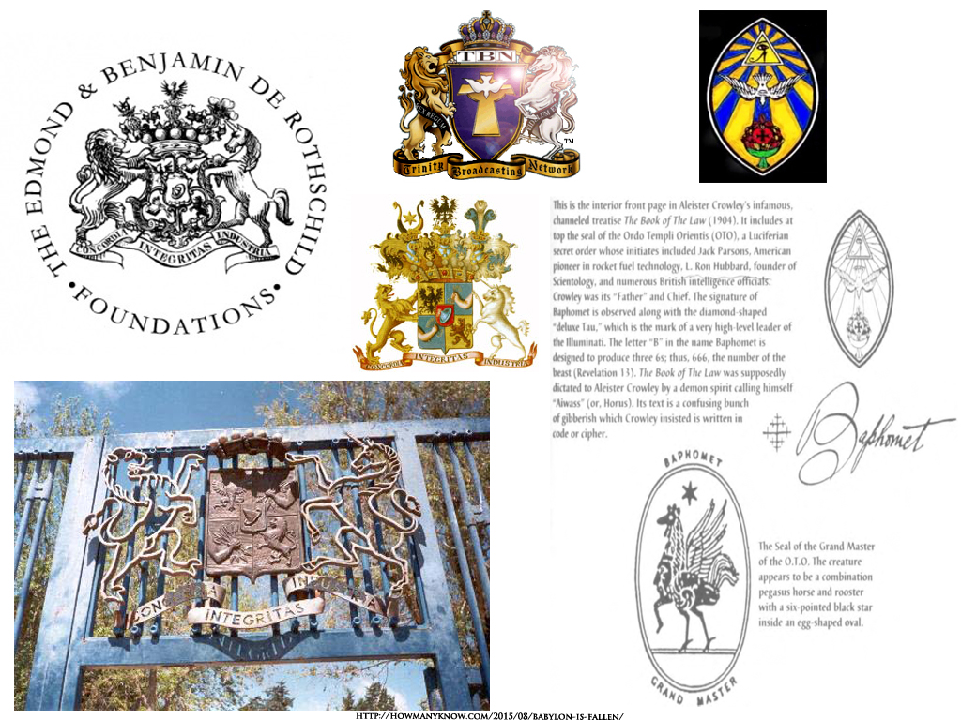
If you look at some of TBN’s earlier logos you can actually see an O, T, and O.
And this all connects to what many Christian churches have been duped into believing – through televangelists, religious informants/assets, many of whom are Freemasons – and pushing strongly the past ten years or so – there is no Biblical Law, there is no wrong, there is no correction, there is no punishment; do not teach these things, and stay away from the Old Testament. While this was going on, the social controllers silenced the Christian rebuke by getting the population, through celebrities and mass-media, to call it “judging”. As a result, the population no longer had anyone pointing out wrongs (like the laws in the Old Testament). All things were right. And all of these things together enabled the “do what thou wilt” mentality you see today (this is how they accomplished it). And it’s all connected to the anti-Christianity agenda and the New World Order. This just goes to show you how much control these people have over this country, and how hands-on they are in manipulating the population. It’s not even a country, it’s more like a slave plantation mixed with a prison and a psych ward where the inhabitants are made to believe they are free and that their lives are what they themselves make it.
As you should be able to see by now, people behind the scenes are using gurus/teachers/cult leaders, groups, and movements to change and direct society; and have been doing so for a long time. And even actors, movies, musicians, and music are being used. This is what life is in America (the Matrix), totally controlled, but most citizens don’t know it. “The conscious and intelligent manipulation of the organized habits and opinions of the masses is an important element in democratic society. Those who manipulate this unseen mechanism of society constitute an invisible government which is the true ruling power of our country. …We are governed, our minds are molded, our tastes formed, our ideas suggested, largely by men we have never heard of. This is a logical result of the way in which our democratic society is organized. Vast numbers of human beings must cooperate in this manner if they are to live together as a smoothly functioning society. …In almost every act of our daily lives, whether in the sphere of politics or business, in our social conduct or our ethical thinking, we are dominated by the relatively small number of persons…who understand the mental processes and social patterns of the masses. It is they who pull the wires which control the public mind.” ― Edward L. Bernays, Propaganda
The same people who control the federal government (not the government officials) are the same people who control the intelligence agencies, the news media, Hollywood and the rest of the entertainment industry, Youtube, Facebook, and more – your entire environment. And it all works together as one System, which you call reality, but is really a fabricated reality (the Sims game is modeled after your life). You are trapped in their world.
Charles Manson
The Truth About Charles Manson as a CIA Creation - Jay Dyer
https://www.youtube.com/watch?v=ZVWNsRax7Og
Trauma Based Mind Control
https://www.youtube.com/watch?v=i-4a1iW0z5E
Manson Family
The Manson Family was a desert commune and cult^{[1][2]} formed in California in the late 1960s. Led by Charles Manson, the group consisted of approximately 100 of his followers who lived an unconventional lifestyle with habitual use of hallucinogenic drugs.^{[3]}
…
Manson taught his followers that they were the reincarnation of the original Christians, and that the Romans were the establishment. He strongly implied that he was Christ; he often told a story envisioning himself on the cross with the nails in his feet and hands. Sometime around 1967, he began using the alias "Charles Willis Manson." He often said it very slowly ("Charles's Will Is Man's Son")—implying that his will was the same as that of the Son of Man.^{[7]:315}
…
The account given in Manson in His Own Words is that Manson first met Wilson at a friend's San Francisco house where Manson had gone to obtain cannabis. The drummer supposedly gave Manson his Sunset Boulevard address and invited him to stop by when he came to Los Angeles.^{[8]} Wilson himself said, in a 1968 Record Mirror article, that after mentioning the Beach Boys' involvement with Maharishi Mahesh Yogi to a group of strange women, "they told me they too had a guru, a guy named Charlie."^{[18]}
Source: https://en.wikipedia.org/wiki/Manson_Family
“This was the height of the ’60s. It's no coincidence that he was so influenced by the Beatles. There was this sense in the air, this kind of expectation that those kids were somehow special, separated from every other generation before them. They were gonna be the initiators of a new age of man.”
Source: https://www.vox.com/conversations/2017/11/27/16704574/charles-manson-true-crime-young-charlie
“Death Valley, Calif. In the land of make-believe, this plays the part of the end of the world. Once it was the godforsaken Eldorado of wild-eyed gold prospectors, once a hideout for western outlaws, and once, for a time, in the twilight of the age of Aquarius, here up a gash in the valley's side, was the family home of that most dysfunctional of American families, the Mansons.”
Source: http://www.nbcnews.com/id/26396401/ns/dateline_nbc/t/devils-business/#.XDogQGl7mpo
“The NBC crime-drama stars David Duchovny as Sam Hodiak, an LAPD cop investigating the disappearance of a young woman from a respectable family. Emma Karn (Emma Dumont) is a fictionalized example of the many women that serial killer and cult leader Charles Manson drew into his murderous “Family” nearly 50 years ago. The reality of the story still haunts us today. (His legacy even loomed over Mad Men. Isn’t that right, Megan Draper conspiracy theorists?) But, what’s there to make of the series celestial title? Why is it called Aquarius when it's a show about Charles Manson and his West Coast reign of terror?”
Source: https://www.bustle.com/articles/86245-what-does-aquarius-mean-for-nbcs-new-show-the-charles-manson-thriller-spotlights-the-culture-of
NBC, those truly controlling the network, know exactly why they titled the show Aquarius. They would have never made the statement in the previous quote – “in the twilight of the age of Aquarius” – if they didn’t. All of this ties into the occult, the New Age Movement, and the so-called Age of Aquarius they believe in.
Father Divine
Father Divine: A Case Study in Charisma
https://www.youtube.com/watch?v=hG09gRuBVhE
“Father Divine is one of the more perplexing figures in twentieth-century African American history. The founder of a cultish religious movement whose members regarded him as God, Father Divine was also an untiring champion of equal rights for all Americans regardless of color or creed, as well as a very practical businessman whose many retail and farming establishments flourished in the midst of the Great Depression.
Regarded by many members of the traditional black church as an imposter or even a lunatic, Divine was praised by other observers as a powerful agent of social change, alone among the many cult leaders in Depression-era New York in providing tangible economic benefits for thousands of his disciples.”
Source: https://www.encyclopedia.com/people/philosophy-and-religion/protestant-christianity-biographies/father-divine
“The relationship between Jim Jones and Father Divine was a complicated one. The leader of Peoples Temple visited the Peace Mission in Philadelphia a number of times between 1960 and 1971, sometimes as a student of Father Divine’s techniques, sometimes as a competitor for Divine’s followers, and at least once as a self-appointed heir apparent to Divine’s ministry, membership and assets. The two men met on several occasions before Father Divine’s death in 1965, and found themselves in agreement on issues related to integration and civil rights, even as they differed on others, such as the nature of Armageddon.”
Source: https://jonestown.sdsu.edu/?page_id=13779
Rev. Jim Jones instructs Father Divine's followers.
https://www.youtube.com/watch?v=c-i7nViXD3o

Read this excerpt from Casting off the Material Body by E. Black. Two things I want you to keep in mind are “the East Coast” and “New Thought,” which is directly connected to the New Age Movement and information you’ll see later on. This mention of a religious explosion on the East Coast will not only come into play later in this document, but also in Mexicans, Native Americans and the Chart.
At the turn of the 20th century, 40 years after the Civil War, liberated black slaves and their descendants still did not experience either racial equality or economic and social justice which they had been promised.[16] In this context, urban centers on the East Coast gave birth to a collection of black autodidact intellectuals, spiritual leaders and sages, who in turn would generate eclectic spiritual responses and grassroots socio-political movements to reassert the humanity of African descendants.[17] One such eclectic spiritual movement became known as the “Live Ever, Die Never” movement.[18]
A subset of this spiritual movement used the motifs of Christianity, including beliefs in the expected Second Advent and the ideas of heterodox New Thought, to present and describe itself. It kept this theosophical core as it morphed and expanded to confront and undermine the socio-political realities of racism, sexism and classism. This movement underscored interracial unity, an eclectic mix of radical democratic and socialist ideas economics, and the practice of intentional community for its adherents to realize its vision of how the world should be and – because of its purposeful intervention – would inevitably become.
This subset of the larger utopian spiritualistic movement might well have withered away, without the individual ministries of four men – three African American and one white – over the course of three successive generations. Each man proclaimed himself to be the physical incarnation of divine principle, the eternal Father, God, and Jesus Christ, all stemming from the basic concept of “God in a body.”
The first such minister, Samuel Morris, who called himself Father Jehovia, was an autodidact spiritual leader and sage who founded the Fairmount Avenue house church in Baltimore, Maryland in the early 20th century.[19] This ultimately transient House Church, as tiny and marginal as it was, turned out to be the incipient organized class of this developing and unique tendency. After the Fairmount Ave House Church became defunct two former disciples of Father Jehovia developed ministries of their own. One disciple, George Hickerson, who called himself Saint John Devine, founded the now-defunct Church of the Living God in Harlem, New York City.[20] A second disciple, George Baker Jr., called himself Father Divine, and formed the International Peace Mission Movement, the membership of which peaked in the 1930s but which still exists today. Although never directly in contact with either Morris or Hickerson, the final God in a body was Jim Jones, a white man who claimed to be the reincarnation of Father Divine. His ministry of Peoples Temple Christian Church, which ended in Jonestown in 1978, was the last expression of this unique utopian radical activist subset.[21]
Source: https://jonestown.sdsu.edu/?page_id=70713
This next part, covering certain core beliefs, relates to information you’ll see later on the Theosophical Society and the New Age Movement, which incorporated elements of Hinduism and Buddhism. It’s an important piece of the puzzle.
“Orthodox New Thought axiom holds that God is Universal Mind or universal ultimate intelligence, according to New Thought writer, H. Emilie Cady.[4] Orthodox New Thought teaches that God, Divine Mind or principle is within each individual.[5]
Not only did Father Jehovia, Father Divine and Jim Jones agree with this axiom, they also taught that the Divine Mind in its highest expression could be – and was – incarnated, reincarnated and transmuted and embodied, in actuality, in a particular human form or body and that they were, individually and respectively, that special individual. In other words, each was God (Ultimate Divine Mind or Principle) in a Body who had come or was transmuted among humanity to bring the potential God in each individual into the actual reality of God (Divine Mind) in each of them.[6] The reality that these incarnated divine minds came to bring and to manifest was a non-sexist, non-racist, non-classist, communal utopia. These utopias are known to history as the Fairmount Avenue Sect, the Peace Mission Movement and Peoples Temple respectively.”
Source: https://jonestown.sdsu.edu/?page_id=65080
“Another example of the doctrine of the transmutation of divine mind or spirit in the Peace Mission, the transmutation or reincarnation of an elderly Black woman, Peninnah Divine – Father Divine’s first wife and the first Mother Divine – into the 18-year-old body of Edna Rose Ritchings, a Caucasian. Ritchings became the new Mrs. Divine and was so acknowledged with Father Divine’s announcement in 1946 that his second wife was the reincarnation of Mother Divine.
The same rationale was active in Jim Jones’ declaration that he was Father Divine reincarnated. Father Divine did not deny that Jim Jones was his reincarnation or successor, but he did not make any practical plans to implement him as such either.”
Source: https://jonestown.sdsu.edu/?page_id=65080
Additional Information
https://jonestown.sdsu.edu/?page_id=16538
On New Thought: “This practical emphasis had a much broader appeal than Theosophy’s quest for the inner, esoteric secretes, especially among the many health seekers in southern California, yet the two movements were akin in their metaphysical foundations. The Divine Self within and oneness with the Infinite Spirit were variations on the same theme: an invisible principle was the source of all knowledge and well-being, and one could grasp that principle with one’s mind. The most prominent of the three new movements, the one that produced the most powerful organization, was the Church of Christ, Scientist, often called Christian Science.”
Source: California's Spiritual Frontiers: Religious Alternatives in Anglo-Protestantism, 1850-1910 by Sandra Sizer Frankiel pg. 66
https://books.google.com/books?id=_VCRWA-3oXcC

“Spiritualism was a point of origin for other nineteenth-century movements that would affect the development of the New Age and Neopagan movements: New Thought through mental healer Phineas Quimby and the Theosophical Society through Madame Helena Blavatsky (discussed in the next section).
One of the most significant twentieth-century metaphysical religious traditions to influence New Age beliefs had its beginnings in the nineteenth century in the writings of Emerson, Mesmer, and Swedenborg and in the healing work of Phineas Quimby, and came to be known as New Thought. It also colors Neopagans’ attitude toward healing, though to a lesser extent. During the twentieth century Theosophy and Spiritualism became less prominent, but their metaphysical teachings dispersed throughout American religious culture and were carried by New Thought.
New Thought emerged as an identifiable movement in the 1890s and described an attitude toward mind and body that would characterize the New Age movement to come; both put responsibility for health and illness on the individual. … Quimby taught that hidden secret knowledge was another illusion of the mind and an impediment to health. He encouraged his followers to pursue health and prosperity by taking a positive attitude toward life and dispelling negative thoughts and emotions. Visualization, usually accompanied by meditation and relaxation, was the most commonly used technique.³⁵”
Source: New Age and Neopagan Religions in America by Sarah M. Pike pg. 53
https://books.google.com/books?id=2DoK_bUwSR0C
Additional Information
https://en.wikipedia.org/wiki/Father_Divine
https://archive.org/details/HarmonyMagazineNo.36TheDivinityOfFatherDivine
“Rare 1930s copy of Australian Theosophy publication, ‘Harmony Magazine,’ dedicated to the topic of ‘The Divinity of Father Divine as the Great Avatar or Logos, the Creator of our Solar System, Personified in the Fathership Degree,’ American leader of the International Peace Mission Movement. Article by John Roine fills entire issue. The copy bears the initials ‘J.W.’ and is heavily annotated (obviously by a sympathetic follower of Father Divine).”
Here are a couple of cults that sprang up later
Yahweh Ben Yahweh
https://www.youtube.com/watch?v=EvJShgcqyp8
Was he on drugs, possessed, or under mind control? He also taught that white people were devils, and made to be destroyed. Interesting.
The Nuwaubian Cult
https://www.youtube.com/watch?v=RX8YxsbeSHE
The Pot Calling The Kettle Black
https://www.youtube.com/watch?v=NKye1fMXQ3M
You’ve just seen a quick highlight of a cult leader from the Israelite Community, and a cult leader from the Conscious Community. We’ll get back to these two communities (“closed systems”) later.
The Nation of Islam
Wallace Fard Muhammad
Wallace D. Fard aka Wallace Fard Muhammad /fə.ˈrɑːd/ (born February 26, 1877^{[2]}) was a co-founder of the Nation of Islam. He arrived in Detroit in 1930 with an obscure background and several aliases, and taught a distinctive form of religion based on Islam to members of the city's African-American population. He was also known as being a seller of silk, incense, and perfume and was described as a white Arab man, but remembered as being a "light-skinned" black man by leaders of the Nation of Islam. Fard was last seen in 1933 by Elijah Muhammad, when Fard took off in an airplane from the Detroit airport.^{[3]}

Beynon's account of Fard and his followers
In 1938, an article by sociologist Erdmann Doane Beynon was published in the American Journal of Sociology, giving Beynon's first-hand account of several interviews that he conducted with followers of Fard in Michigan.^{[4]} From those interviews, Beynon wrote that Fard lived and taught in Detroit from 1930–34.^{[5]} He came to the homes of black families who recently migrated to Detroit from the rural south.^{[6]} He began by selling silks door to door, telling his listeners that the silks came from their home country. At his suggestion, he came back to teach the residents, along with guests.^{[7]}
In the early stage of his ministry, Fard "used the Bible as his textbook, since it was the only religious book with which the majority of his hearers were familiar. With growing prestige over a constantly increasing group, [Fard] became bolder in his denunciation of the Caucasians and began to attack the teachings of the Bible in such a way as to shock his hearers and bring them to an emotional crisis."^{[7]}
Those interviewed by Beynon told him that reports of Fard's message spread throughout the black community. Attendance at the house meetings grew until the listeners were divided into groups and taught in shifts. Finally, the community contributed money and rented a hall to serve as a Temple where meetings were conducted.^{[5]} The Quran was soon introduced as the most authoritative of all texts for the study of the faith according to those interviewed by Beynon.^{[8]} Fard prepared texts himself, which served as authoritative manuals of the faith and were memorized verbatim by those who followed him.^{[8]}
From his interviews, Beynon described disputes and tension that arose between the new community and the police surrounding the groups' refusal to send their children to public schools, and members of the group who some alleged to have participated in "human sacrifice" in 1932 in an effort to obey lessons given to the community regarding the sacrifice of devils.^{[9][Note 1]} These incidents drew police attention to the group, according to Beynon, and contributed to persecutions and schisms.^{[10]}
Fard named his community the Nation of Islam.^{[11]} Following the rapid increase in membership, Fard instituted a formal organizational structure.^{[12]} He established the University of Islam, where school age children were taught, rather than in the public schools.^{[12]} He established the Moslem Girls' Training and General Civilization Class, where women were taught how to keep their houses, clean, and cook. The men of the organization were drilled by captains and referred to as the Fruit of Islam. The entire movement was placed under a Minister of Islam.^{[12]}
According to Beynon, Fard’s followers grew to approximately eight thousand.^{[11]} "Within three years the prophet not only began the movement but organized it so well that he himself was able to recede into the background, appearing almost never to his followers during the final months of his residence in Detroit."^{[12]}
From interviews with approximately two hundred families who followed Fard, Beynon concluded:
Although the prophet lived in Detroit from July 4, 1930 until June 30, 1934, virtually nothing is known about him, save that he "came from the East" and that he "called" the Negroes of North America to enter the Nation of Islam. His very name is uncertain. He was known usually as Mr. Wali Farrad or Mr. W. D. Fard, though he used also the following names: Professor Ford, Mr. Farrad Mohammed, Mr. F. Mohammed Ali. One of the few survivors who heard his first addresses states that he himself said: "My name is W.D. Fard and I came from the Holy City of Mecca. More about myself I will not tell you yet, for the time has not yet come. I am your brother. You have not yet seen me in my royal robes." Legends soon sprang up about this mysterious personality ...
Fard used the name W. F. Muhammad on several lessons written in 1933 and 1934.^{[13]} In 1933, he began signing his name W. F. Muhammad, which stands for Wallace Fard Muhammad.^{[14]}

Efforts to trace Fard’s history
A declassified FBI memorandum dated May 16, 1957 states: "From a review of instant file it does not appear that there has been a concerted effort to locate and fully identify W. D. Fard. Inasmuch as Elijah Muhammad recognizes W.D. Fard as being Allah (God) and claims that Fard is the source of all of his teachings, it is suggested that an exhaustive effort be made to fully identify and locate W. D. Fard and/or members of his family."^{[15]} The FBI took note of the article written by Erdmann Doane Beynon, and it conducted a search for Fard using various aliases including the name "Ford".^{[16]}
The search produced two Fords of interest, one of whom was Wallace Ford, a prominent movie actor. The other was Wallie D. Ford of California, arrested by Los Angeles police on November 17, 1918, on a charge of assault with a deadly weapon; by the Los Angeles police January 20, 1926, for violation of the California Woolwine Possession Act;^{[17]} and by the Los Angeles police on February 15, 1926, for violation of the State Poison Act, for which he was sentenced to six months to six years at San Quentin Penitentiary on June 12, 1926.^{[18]} According to San Quentin records, Wallie D. Ford was born in Portland, Oregon on February 25, 1891, the white son of Zared and Beatrice Ford, who were both born in Hawaii.^{[19]}
On October 17, 1957, the FBI located and interviewed Hazel Barton-Ford, Wallie Ford's common-law wife, with whom he had a son named Wallace Dodd Ford, born September 1, 1920.^{[20]} Barton-Ford gave a description of Wallie Ford, and described him as a Caucasian New Zealander.^{[20]} The FBI's search for Fard was officially closed one year later on April 15, 1958.^{[21]}
On August 15, 1959, the FBI sent a story to the Chicago New Crusader newspaper, stating that Fard was a "Turkish-born Nazi agent who worked for Hitler in World War II."^{[22]} According to the story from the FBI, Fard was a "Muslim from Turkey who had come to the United States in the early 1900s. He had met Muhammad in prison … where the two men plotted a confidence game in which followers were charged a fee to become Muslims."^{[22]} After the story was published, Elijah Muhammad and Malcolm X were subsequently able to charge Black media outlets, who re-printed the accusation in large numbers, with running the story without requesting a response from the Nation of Islam.^{[22]}
A February 19, 1963, FBI memorandum states: "In connection with efforts to disrupt and curb growth of the NOI, extensive research has been conducted into various files maintained by this office. Among the files reviewed was that of Wallace Dodd Ford."^{[23]} Five months later, in July 1963, the FBI told the Los Angeles Evening Herald-Examiner that Fard was actually Wallace Dodd Ford.^{[24]} The paper published the story in an article titled: "Black Muslim Founder Exposed As White."^{[25]} An FBI memorandum dated the following month, August 1963, states that the FBI had not been able to verify his birth date or birthplace, and "he was last heard from in 1934."^{[1]}

Chroniclers' history of Fard from FBI file
Karl Evanzz of the Washington Post conducted a Freedom of Information Act request to the FBI in 1978 requesting its file on Fard.^{[26]} Evanzz based his account of the life of Fard on the declassified portion of the FBI file that he received about a decade after his request. Evanzz detailed the experience of several other authors who based their accounts of the life of Fard on the FBI file as well.^{[27]}
From the FBI's response to the Freedom of Information Act request, Karl Evanzz claimed that Fard, using the name Fred Dodd, married Pearl Allen in Multnomah County, Oregon, on May 9, 1914, with their first child, a son, born the next year.^{[28][29]}
Dodd left his family in 1916 and moved to Los Angeles, using the name Wallie Dodd Ford. A World War I draft registration card for Wallie Dodd Fard^{[30]} from 1917 indicated he was living in Los Angeles, unmarried, as a restaurant owner, and reported that he was born in Shinka, Afghanistan on February 26, 1893. He was described as being of medium height and build with brown eyes and black hair. On the draft card, "Ford" is written in parenthesis. No reason is given. At the bottom of the card, he signed his name as "Wallie Dodd Ford".^{[31]}
As of 1920, Ford was still living in Los Angeles, as 26-year-old Wallie D. Ford, with his 25-year-old wife, Hazel. In the 1920 United States Census he reported his race as white, his occupation as a proprietor of a restaurant, and gave his place of birth as New Zealand. He provided no known place of birth for his parents, nor his date of immigration.^{[32]}
A marriage certificate dated June 5, 1924, was issued to Wallie Dodd Ford and Carmen Trevino in Orange County, California. Ford reported he was a cook, age 26, born in Oregon, but living in Los Angeles.^{[33]}
It has been reported that Ford had roots in what is today Pakistan.^{[34]} His father was Zared Fard, an East Indian; either Zared or his parents immigrated to New Zealand from what is present-day Pakistan.^{[35]} Fard Muhammad's mother Beatrice was a white Englishwoman living in New Zealand.^{[35]}

Moorish Science Temple of America
In addition to claiming that Fard was Ford, Evanzz also claimed that Fard was once a member of the Moorish Science Temple of America,^{[36]} citing as a primary source the 1945 publication by Arna Bontemps and Jack Conroy titled They Seek A City.^{[37]} Authors have also cited E.U. Essien-Udom for this proposition as well.^{[38]} In his 1962 book titled Black Nationalism: The Search for an Identity, E. U. Essien-Udom included the following passage:
Noble Drew Ali was shot and stabbed in his offices at the Unity Club in Chicago on the night of March 15, 1929 … He was eventually released on bond, but a few weeks later, he died under mysterious circumstances. Some people claim that he died from injuries inflicted by the police while he was in jail. Others, however, suggest that he was killed by [Sheik Claude] Greene's partisans. For some time, one W. D. Fard assumed leadership of the Moorish movement. According to Bontemps and Conroy, Fard claimed that he was the reincarnation of Noble Drew Ali. By 1930 a permanent split developed in the movement. One faction, the Moors, remains faithful to Noble Drew Ali, and the other, which is now led by Elijah Muhammad, remains faithful to Prophet Fard (Master Wallace Fard Muhammad). However, Minister Malcolm X and other leaders of the Nation of Islam have emphatically denied any past connection whatsoever of Elijah Muhammad, Master Wallace Fard Muhammad, or their movement with Nobel Drew Ali's Moorish American Science Temple.^{[39]}
On the question of a connection between the Nation of Islam and the Moorish Science Temple of America, Beynon wrote the following from his interviews with Fard's followers:
Awakened already to a consciousness of race discrimination, these migrants from the South came into contact with militant movements among northern Negroes. Practically none of them had been in the North prior to the collapse of the Marcus Garvey movement. A few of them had come under the influence of the Moorish-American cult which succeeded it. The effect of both these movements upon the future members of the Nation of Islam was largely indirect. Garvey taught the Negroes that their homeland was Ethiopia. The Noble Drew Ali, the prophet of the Moorish-Americans, proclaimed that these people were "descendants of Morrocans".^{[40]}
Beynon also noted: "The prophet’s message was characterized by his ability to utilize to the fullest measure the environment of his followers. Their physical and economic difficulties alike were used to illustrate the new teaching. Similarly, biblical prophecies and the teachings of Marcus Garvey and Noble Drew Ali were cited as foretelling the coming of the new prophet".^{[8]}

Relationship with Elijah Muhammad
With regard to Elijah Muhammad, Beynon’s article stated: "From among the larger group of Muslims there has sprung recently an even more militant branch than the Nation of Islam itself. This new movement, known as the Temple People, identifies the prophet, Mr. W. D. Fard, with the god Allah. To Mr. Fard alone do they offer prayer and sacrifice. Since Mr. Fard has been deified, the Temple People raise to the rank of prophet the former Minister of Islam, Elijah Mohammed, now a resident of Chicago. He is always referred to reverently as the 'Prophet Elijah in Chicago.'"^{[41]}
Elijah Muhammad, who led the Nation of Islam from 1934 to 1975, heard Fard teach for the first time in 1931.^{[42]} Elijah Muhammad stated that he and Fard became inseparable between 1931 and 1934, where he felt "jailed almost" due to the amount of time that they spent together with Fard teaching him day and night.^{[42]}
A hand-written lesson written by Fard states:
Twelve Leaders of Islam from all over the Planet have conferred in the Root of Civilization concerning the Lost-Found Nation of Islam – must return to their original Land. One of the Conference Members by the name of Mr. Osman Sharrieff said to the Eleven Members of the Conference: "The Lost-Found Nation of Islam will not return to their original Land unless they, first, have a thorough Knowledge of their own." So they sent a Messenger to them of their own. Now, the Messenger and his Laborers worked day and night for the last three and one-half years, and their accomplishments are approximately twenty-five thousand ...^{[13]}
In this lesson, Fard places the number of converts obtained in Detroit at twenty-five thousand, and he describes a "Messenger" sent to the "Lost-Found Nation of Islam" who is "of their own".^{[13]} Nation of Islam theology states that this "Messenger" is Elijah Muhammad.^{[43]}
Fard wrote, in his instructions to the leaders of his community, that they should "copy the Answers of Lesson of Minister Elijah Muhammad."^{[13]} He went on to state: "Why is Stress made to the Muslims to Copy, the Minister, Elijah Muhammad's Answers? The past History shows that the ALMIGHTY ALLAH sends Prophets and Apostles for the people's Guide and Example, and through them HIS Mystery was Revealed. And those who follow the Apostle would see the Light."^{[13]}
Fard wrote several lessons which are read and committed to memory by members of the Nation of Islam.^{[13][Note 2]} Some of the lessons are in the form of questions asked by Fard to Elijah Muhammad.^{[13]} One such lesson concludes with the text: "This Lesson No. 2 was given by our Prophet, W.D. Fard, which contains 40 questions answered by Elijah Muhammad, one of the lost found in the wilderness of North America February 20th, 1934."^{[13]}

Ideology
Beynon described the substance of Fard’s teaching as follows:
The black men in North America are not Negroes, but members of the lost tribe of Shabazz, stolen by traders from the Holy City of Mecca 379 years ago. The prophet came to America to find and to bring back to life his long lost brethren, from whom the Caucasians had taken away their language, their nation and their religion. Here in America they were living other than themselves. They must learn that they are the original people, noblest of the nations of the earth. The Caucasians are the colored people, since they have lost their original color. The original people must regain their religion, which is Islam, their language, which is Arabic, and their culture, which is astronomy and higher mathematics, especially calculus. They must live according to the law of Allah, avoiding all meat of "poison animals", hogs, ducks, geese, possums and catfish. They must give up completely the use of stimulants, especially liquor. They must clean themselves up – both their bodies and their houses. If in this way they obeyed Allah, he would take them back to the Paradise from which they had been stolen – the Holy City of Mecca.^{[44]}
Fard's lessons actually state that the "trader" referenced by Beynon, came to Africa, not Mecca.^{[45]}
Modern Nation of Islam theology is based upon the belief that Fard’s teaching of Elijah Muhammad was fulfillment of scripture regarding God’s teaching of an Apostle, where Fard is described as "God in Person", the "Messiah", and the "Mahdi".^{[46][47]} Fard wrote the following for his followers:
[T]he LESSONS that OUR SAVIOUR (ALLAH) gave us to Study and Learn is the Fulfillment of the Prophecies of All the Former Prophets concerning the Beginning of the Devils, and the Ending of the Civilization, and of our Enslavement by the Devils, and Present Time of our Delivery from the Devils by OUR SAVIOUR (ALLAH). PRAISE HIS HOLY NAME! There is No God but ALLAH. How that ALLAH would separate us from the Devils and, then destroy them; and Change us into a New and Perfect People; and Fill the Earth with FREEDOM, JUSTICE and EQUALITY as it was filled with wickedness; and Making we, the Poor Lost-Founds, the Perfect RULERS.^{[13]}
In his 1965 book Message to the Blackman in America, which is a compilation of articles written by Elijah Muhammad for various newspapers throughout the early part of his Ministry, he summarized what Fard taught him as follows:
He began teaching us the knowledge of ourselves, of God and the devil, of the measurement of the earth, of other planets, and of the civilization of some of the planets other than earth. ... He measured and weighed the earth and its water; the history of the moon; the history of the two nations, black and white, that dominate the earth. He gave the exact birth of the white race; the name of their God who made them and how; and the end of their time, the judgment, how it will begin and end. ... He taught us the truth of how we were made "slaves" and how we are kept in slavery by the "slave-masters"' children. He declared the doom of America, for her evils to us was past due. And that she is number one to be destroyed. Her judgment could not take place until we hear the truth. ... He declared that we were without the knowledge of self or anyone else. How we had been made blind, deaf and dumb by this white race of people and how we must return to our people, our God and His religion of peace (Islam), the religion of the prophets. We must give up the slave names of our slave-masters and accept the name of Allah (God) or one of His divine attributes. He also taught us to give up all evil doings and practices and do righteousness or be destroyed from the face of the earth. He taught us that the slave-masters had taught us to eat the wrong food and that this wrong food is the cause of our sickness and short span of life. He declared that he would heal us and set us in heaven at once, if we would submit to Him. Otherwise he would chastise us with a severe chastisement until we did submit. And that He was able to force the whole world into submission to his will. He said that he loved us (the so-called Negroes), his lost and found, so well that he would eat rattlesnakes to free us if necessary, for he has power over all things.^{[14]}
He was also noted for his anti-Hindu sentiments, scholar A. James Gregor precising that "Fard taught Elijah Muhammad than the Messenger’s entirely negative references to Hindus. Fard, as a Muslim in what was to become Pakistan, bore an irrepressible prejudice against Hindus".^{[48]}
Source: https://en.wikipedia.org/wiki/Wallace_Fard_Muhammad
The teachings sound like those you’ll hear in the Israelite Community and Black Conscious Community.
So, who was Wallace F. Muhammad? Was he carrying out a mission for an intelligence agency, Masonic lodge, or private backer? The information you just read may have caused you to eliminate the FBI as a suspect, but you might want to reconsider. Something to realize: The FBI’s structure, like the structure of other intelligence agencies, is compartmentalized (creating esoteric knowledge and exoteric knowledge). Similar to a secret society (which intelligence agencies spawn from), you have to have special credentials to know higher information/knowledge. Lower level agents, such as those in the field, may say or do things for the reasons they’re told, and they’ll pretty much believe those reasons, but the higher-ups will know the real reasons. Because of this you could have someone be an FBI informant/asset, and at the same time be investigated, at a distance, by the FBI So, when you read the files and see that a person was being investigated by the FBI, they still could have been working for the FBI, or some other intelligence agency. Something else to consider: There are times when the CIA or other agencies use a person, an agent or informant, to do a job, and that person ends up being investigated by the FBI The FBI is then kept at a distance while continuing to investigate, or called off of the investigation completely. In addition, when you read through the files you may believe you’re doing something akin to reading someone’s diary. This is not true. Because of the compartmentalized structure of the agency, you’re reading the dialogue of people who may not have known what they were actually doing or why. Some of them may have even believed they were doing something good. This makes the FBI seem benign. “Read this. They were really trying to stop the spread of Communism, not trying to stop black people.” Wrong. In addition, they are extremely devious. They will purposely try to throw you off the trail.
Is W. Fard Muhammad God? Let's see the facts...
https://www.youtube.com/watch?v=QUQLcE-5sc0
“And it just so happens that as soon as this guy Wallace Ford is released from San Quentin in 1929, just months later this guy with almost the exact same name and exact same look appears in Detroit as Wallace Fard.” He then went on to state other “coincidences”.
My comment from the video Lies the FBI Told Me: “At 13:12 of the video the guy said the FBI had a potential case against him for a crime he committed. To get out of trouble he worked as an informant for them. He was asked to gain membership into a group the FBI was targeting. Keep that in mind.” A criminal as an informant?
Farrakhan Admits That W D Fard Was NOT The Originator
https://www.youtube.com/watch?v=JbpvcI5jN1g
Christian alternative. And I know you heard the parts about him being God, and being white. From the Wikipedia article on Wallace Fard Muhammad: “With growing prestige over a constantly increasing group, [Fard] became bolder in his denunciation of the Caucasians and began to attack the teachings of the Bible in such a way as to shock his hearers and bring them to an emotional crisis.” Interesting.
Watch 25:03 - 26:36
Jonestown The Life and Death of Peoples Temple 2006
https://youtu.be/gVJJijESlko?t=25m3s
And you may have noticed that some of what he said sounded exactly like teachers in the Black Conscious Community. What a coincidence.
Who Is Master Fard Muhammad according to the Honorable Minister Louis Farrakhan?
https://www.youtube.com/watch?v=ZesVbGYXQ34
He said it correctly. His mission was to hunt down the lost sheep. It was also to entice others out of the pen.

NOBLE DREW ALI FILM
https://www.youtube.com/watch?v=NfbcAe3Kvig
If you are going to view any of these documentaries, I would suggest you come to your own conclusions and figure out what’s fact, and what’s opinion.
Additional Information on Wallace Fard Muhammad (if you want). You can skip this until later, but do read the text below now.
FBI Documents on Wallace Fard Muhammad
https://archive.org/details/FBI-Wallace-Fard-Muhammad
Get On Board The Wheel | Part 1: Master Fard Muhammad and India
https://www.youtube.com/watch?v=62cOIQ5ljL8
He has another video where he shows that Fard actually taught Buddhism. Fard may have just been another Indian sent to the West to spread religious ideas as an alternative to Christianity (with intelligence agency aid and protection). This all connects to the New Age Movement, which is fully exposed here: Is Your Religion the Problem? Those seeking a New World Order made British/Rothschild India into a kind of workshop, and had even tried to make a few Indians their New World Order messiah. The Theosophical Society and Freemasonry were used heavily to carry out goals. They were even used to give Indians a religion and a sense of unity and identity, an image for the West to look up to.

If you get a chance to go through Is Your Religion the Problem? you’ll see how the information there, along with the previous information in this project, links up with the following information.
How do the Ahmadiyya feel about Freemasonry?
https://www.quora.com/How-do-the-Ahmadiyya-feel-about-Freemasonry
“As I have stated, Webb’s connections with the Ahmadi community are fairly well known to scholars, but there are also a few less well-known ties between Americans and Mirza Ghulam Ahmad during this same period. One of the most fascinating possible connections appeared during the same time and at nearly the same location that Webb first took an interest in Islam. It seems that Mirza Ghulam Ahmad’s first exposure to Americans came by way of an article published in 1886 in a journal for members of the Theosophical Society, a liberal spiritual organization that was devoted to studying the various religions of the world. Webb was a member of this organization at the time, and it seems to have served as the intellectual and organizational model for his later Islamic movement. Interestingly, though, an acquaintance of Webb who was also in the Theosophical Society — a man named Thomas Johnson — may have similarly been inspired by the article about Mirza Ghulam Ahmad, for in early 1887 he established his own organization devoted to studying Sufism, or Islamic mysticism — which had been precisely one of the key elements of Islam Mirza Ghulam Ahmad was promoting at the time. Johnson’s group, known as the Sufic Circle, was the first Sufi organization in the United States, and it may have influenced later Sufi movements that were to spread in America and throughout Europe.”
Source: http://webcache.googleusercontent.com/search?q=cache:5yxTdFW_c9oJ:ahmadiyya.org/movement/lahore-ahmadiyya-in-america-bowen.pdf+&cd=5&hl=en&ct=clnk&gl=us&client=firefox-b-1
“Trained in Avicennan Peripateticism, Shihab al-Din al-Suhrawardi (1154–1191) became the founder of an Illuminationist (ishraqi) philosophical tradition in the Islamic East. Since none of his works were translated into Latin, he remained unknown in the West; but from the 13th century onwards, his works were studied in a number of philosophical circles in the Islamic East. In the mid-20th century, Henry Corbin worked relentlessly to edit and study his writings, which led to renewed interest in Suhrawardi's works and thought, especially in the later part of the 20th century.”
Source: https://plato.stanford.edu/entries/suhrawardi/
“Ahmad’s writings and record of revelations are replete with metaphors (not similes) of light, flame/ fire, illumination, halos around celestial bodies of earthly persons, and doors. All this evokes the Illuminatist theosophy of Suhravardi, which there is no record of Ahmad ever having read or quoted. He also relies on the complex theosophist terminology, brought to fruition by Ibn-al-’Arabi, of the barzakh, or intermediary realm between the created world and the heavens (typically plural in Ahmad’s writings). It is precisely this that Corbin designated Mundus Imaginalis. However, it is his epistemology rather than his literary style that connects Ahmad to the Persian classical theosophy as described by Henry Corbin.”
Source: http://www.mdpi.com/2077-1444/9/4/91/htm
Or, maybe he got it from the Theosophical Society, which compiled all of these late Eastern works.
“The Ahmadiyya faith claims to represent the latter-day revival of the religion of Islam. Overseas Ahmadiyya missionary activities started at an organized level as early as 1913 (for example, the UK mission in Putney, London). For many modern nations of the world, the Ahmadiyya movement was their first contact with the proclaimants from the Muslim world.^{[106]} The Ahmadiyya movement is considered by some historians^{[107]} as one of the precursors to the Civil Rights Movement in America. According to some experts,^{[108]} Ahmadiyya were "arguably the most influential community in African-American Islam" until the 1950s. Today, the Ahmadiyya Muslim Community has one of the most active missionary programs in the world. It is particularly large in Africa. In the post colonial era, the Community is credited for much of the spread of Islam in the continent.^{[109]}”
Source: https://en.wikipedia.org/wiki/Ahmadiyya
From COINTELPRO Revisited - Spying & Disruption: “The ‘white hate’ program functioned mainly as a cover for covert aid to the KKK and similar right-wing vigilantes, who were given funds and information, so long as they confined their attacks to COINTELPRO targets.”
Malcolm X Exposes Nation of Islam PACT with the KKK
https://www.youtube.com/watch?v=TFr4GACTGX4

A pact with the KKK is a pact with the FBI. Anyone who researches into the FBI and their dealings will find this to be true. And if you didn’t know, the Nation of Islam wouldn’t be around today if the powers that be didn’t want it around. One of the reasons for its existence is to be an alternative to Christianity for blacks.
"Remote Control: H.L. Hunts Nation Of Islam" Documentary Trailer
https://www.youtube.com/watch?v=BpUknAaEo1I
If this information is accurate, and H.L. Hunt was giving money to the Nation of Islam and the KKK (funding both sides), you do have to ask what his motivation was. White racism was represented by the KKK; black racism was represented by the Nation of Islam. Blacks vs. whites. Interesting. If you knew who ran this country from the shadows from its inception till now, this would make sense. If you knew the additional roots of the KKK, behind Albert Pike – Judah P. Benjamin, Knights of the Golden Circle, and B'nai B'rith – this would make sense.
If these elitists see a person or group that can be used to aid their own agenda or the agenda of their group, they’ll fund it, and even try to influence it. This was the case with the Jewish involvement in the Civil Rights Movement. Once the Civil Rights Act of 1964 was passed, most of these people, and even the government, were done with Martin Luther King and the Civil Rights Movement. They didn’t even bother holding the fake smiles anymore. They got what they wanted – laws that would enable New World Order agendas, agendas we see at their peak today. For instance, laws against racial and religious discrimination were really to protect and enable Jews and occultist to rise with less hindrance. This country was created with the freedom of religion for the same reason. Another one was the emancipation and protection of women, which enabled them to elevate the woman above the man, gaining all that came with it (including religious benefits … making the feminine supreme). Two others were for homosexuality and race mixing (and I’m not saying I’m against “race mixing”; it’s an agenda). But Martin Luther King wasn’t a part of these schemes; he was doing what he was doing for his people.
Take a look at this except from Lifestyles of the Rich and Infamous:
Bryan Burrough’s new book, The Big Rich: The Rise and Fall of the Greatest Texas Oil Fortunes, covers almost a century of Texas oil, and the players who prospered and failed in its pursuit.
For those with an interest in contemporary Texas history this is a must-read; indeed, its reach stretches well beyond Texas. The oil rich of Texas loomed large on the national horizon, and there was a time that if they pawed the earth, politicians trembled.
We all know the names of the core players-H.L. Hunt, Sid Richardson, Clint Murchison and Hugh Roy Cullen-but Burrough’s research adds a fascinating wealth of detail not seen elsewhere, and conjures lesser players Diamond Jim West, George Strake, John Mecom and the flamboyant Glenn McCarthy as well.
…
So it was that by the end of World War II, the Texas oilmen had become “big rich,” and extreme wealth was no longer the sole province of the Eastern Seaboard. With that wealth came increasingly extravagant behavior. They bought ranches, haciendas and islands, and built mansions in Dallas and Houston. Of greater import was their involvement in right-wing politics.
In 1944, infuriated by Franklin D. Roosevelt’s presidency (including wartime caps on oil prices), conservative Texas Democrats made an unsuccessful attempt to take over the state party. Failing that, they formed a third party, the Texas Regulars, “whose membership was dominated by independent oilmen like Maco Stewart Jr. and Arch Rowan of Fort Worth. The Regulars mounted an elaborately financed anti-Roosevelt campaign … the message was broadly anti-labor and anti-government-and openly white supremacist. One of the party’s planks actually called for a restoration of the supremacy of the white race.”
Source: https://www.texasobserver.org/2913-lifestyles-of-the-rich-and-infamous/

“Under Muhammad, the Nation of Islam developed its domestic and foreign relations largely on the basis of economic opportunism and principles of racial chauvinism that, in Clegg's words, revealed ‘striking consistencies’ with fascist ideology. Ties were cultivated with ultra-rightists like H.L. Hunt, the Texas oil billionaire, and white supremacist groups, including the Ku Klux Klan and American Nazi Party.”
Source: http://articles.latimes.com/1997-03-02/books/bk-33849_1_elijah-muhammad/2

“In June of 1964, I spent the majority of the day with Malcolm on a daily basis. As we would walk down the street, eat lunch at 22 West Restaurant, ride in his car or meet with friends and representatives from other countries or community leaders, I would repeatedly ask him questions. I wanted to learn more about the one African-American man who RAM felt could mobilize 22 million African-Americans. One day Malcolm said, ‘Brother, I have to be assassinated.’ I asked, ‘Why?’ Malcolm replied, ‘As national spokesman for the Nation of Islam, I had secrets of the Nation, and they can't afford to let me live.’ Not knowing anything about the situation, I just listened. Malcolm said, ‘Brother, you see, as national representative of the Nation, I met with H.L. Hunt (right wing Texas billionaire) and George Lincoln Rockwell of the American Nazi Party. It was just the Messenger (Elijah Muhammad) and myself. I was his national representative. We discussed helping the Nation. It was discussed that Elijah Muhammad and the Nation of Islam would be given the state of Mississippi when fascism came into power in the country. I asked the Messenger why he negotiated with them. He said, "Sometimes you have to deal with the Devil.” ’ ” [Malcolm X, “Conversation with Max Stanford, June 1964]
Source: http://blackpolitics.org/malcom-x-assassinated-insiders-view/

There’s also another Hunt, E. Howard Hunt, who doesn’t seem to be related to H.L. Hunt but was a CIA agent and seemed to be connected to H.L. Hunt.
“The Rolling Stone piece fails to go after the roles of Richard Nixon and George Herbert Walker Bush. But the Hunt [E. Howard Hunt] confession, if accurate, leads directly to them, to their lifelong associates, and all the way to the present George W. Bush administration.
The Dallas-Watergate-Iran-Contra connection has been thoroughly documented by the key JFK researchers, and in particular, in the work of Peter Dale Scott, one of the very first to show the deep political continuity across three decades. Daniel Hopsicker's Barry and the Boys goes into even more detail on the players.
Consider the career of George H.W. Bush. He was a Texas oilman (Zapata Oil) and a CIA operative, involved with the Bay of Pigs. Bush's name was found in the papers of George DeMohrenschildt, one of Lee Harvey Oswald's CIA handlers. As documented by Pete Brewton, author of The Mafia, the CIA and George Bush, Bush was deeply connected with a small circle of Texas elites tied to the CIA and the Mafia, as well as the Florida-based CIA/anti-Casto Cuban exile/ Mafia milieu As Richard Nixon's hand-picked Republican National Committee chairman, and later as CIA director, Bush constantly covered-up and stonewalled for his boss about Watergate, which itself (by the admission of Frank Sturgis and others) was a cover-up of the JFK assassination.

Tracking any of the individual CIA operatives involved with the Bay of Pigs, it is impossible to ignore or deny direct connections to George H.W. Bush and his crime family, across the Kennedy assassinations, covert operations in Indochina and, later, Latin America.”
Source: https://rense.com//general76/hunt.htm
Texas oilmen and the CIA have a strong relationship.
“WASHINGTON, April 1—A Dutch journalist said today he had told the House Assassinations Committee that the mysterious potential witness who allegedly committed suicide Tuesday had told him that Texas oilmen and anti‐Castro Cubans had conspired with Lee Harvey Oswald to kill President Kennedy.
Willem Oltmans, a television newsman, was called before the panel after he said in various morning press and television interviews that the alleged conspiracy to assassinate President Kennedy involved not only Mr. Oswald but also George de Mohrenschildt, who apparently shot himself in Palm Beach, Fla.; the Federal Bureau of Investigation, the Central Intelligence Agency, H. L. Hunt, the late Texas oil millionaire, and Mr. Oswald's assassin, Jack Ruby.
Source: https://www.nytimes.com/1977/04/02/archives/long-island-opinion-witness-ties-oswald-to-oilmen-and-cubans.html
You’ll probably have to go to a library to find out more connections and deeper secrets. I’m not worried about that. I’m just trying to give a glimpse into the hidden world, and show that there are puppet-masters.
There are many similarities between the NOI, Israelite camps, and New Black Panthers but I’ll highlight a few. They have the same military structure and militancy. Another thing they have in common, something almost all government created black groups have in common, is racism. I don’t know when black people as a whole will catch on to this. Let me state it plainly for you. If a person or group is preaching racism or violence, especially unprovoked violence, they are probably an asset of an intelligence agency or private puppet-master, or they’re being taught by such an asset (knowingly or unknowingly).
Now listen to what they state and allege here:
Master Fard Muhammad and the "Jehovah's Witnesses"
https://www.youtube.com/watch?v=NcHTmWRPCq0
He supports Jehovah's Witnesses and Mormons! These are other manufactured religions with ties to Freemasonry. Proof can be found here:
Charles T. Russell - Jehovah's Witness - Occult Roots
https://www.youtube.com/watch?v=XGqKq1jQwOw
Go here, scroll down and look at the images. You’ll see the Masonic Templar crown and cross was not only used by the Jehovah’s Witnesses, but by Christian Science (a New Age religion mentioned previously).
“If you look at the roots of Socialism and Communism you’ll see it goes back to these occult secret societies.” Yes, and if you look at the roots of Socialism and Communism (and actually all the “isms”) you’ll see it goes back to Jews. This is a fact, but people want to ignore it because of who it pinpoints and because it seems racist. Now, if the evidence of one crime after another keeps leading you back to a certain group, should you ignore it? It would be somewhat different if we were talking about a huge group like all Europeans, but no, we’re talking about a small minority of people that’s equivalent in size to an organization.
Farrakhan said that Fard taught Charles Taze Russell and “Judge” Rutherford (Joseph Franklin Rutherford). That’s something that would have to be verified, and should be verified.

And then the Nation of Islam took this turn:

Scientology and Nation of Islam Watch OUT
https://www.youtube.com/watch?v=8XI6y8fY__I

Farrakhan Goes Clear with Dianetics
https://www.youtube.com/watch?v=1Hii9mDffco

Nation of Islam and Scientology .wmv
https://www.youtube.com/watch?v=iS0tKBotA9M

Scientology, Louis Farrakhan & the Nation of Islam
https://www.youtube.com/watch?v=PLbODhCP3GA

UFOs? Hmmmm … just like Dr. York, some of these camps, and people in the New Age Movement. There’s no telling where his followers are going to be led next. They may be getting prepped for something.

And let me explain something about his so-called hate for Jews. It may be real; it may be fake. Either way it’s wanted by the Jewish elite. It’s just as Hitler was a puppet of the Jewish elite, and his presence was wanted by them. The Jewish elite have always used anti-Semitism to aid their goals. One of the tricks they have is to put the truth in the mouth of a racist person, hated person, or one who embodies “anti” before the truth spreads to the public. For example, they’ll have a racist person say how the Jews are responsible for certain events. This then becomes that person’s argument/belief. Most of the people who hear this argument/belief later in any kind of setting will flee from this argument/belief because it’s that racist person’s argument/belief; it’s that hated person’s argument/belief. The result is that they will be rejecting what is actually the truth. They will never come to the conclusion that Jews were responsible for those certain events. Another example: When rap music turned hardcore (carried out by those controlling the industry, who happen to be Jewish) the mainstream media (Jewish) attacked it, highlighting its influence and negativity, especially how it led to violence. The response of those who liked rap was to defend it and fight against those ideas. “You’re not going to take this from us!” In reality, they were fighting against the truth. They were fighting to keep the very thing that was deliberately being used as a weapon against them, to negatively influence them. The result? They sustained the use (continue to be poisoned). The same trick was used with the use of the word “nigga”.

If you want, you can take a look at these videos of Farrakhan explaining why he uses Scientology:

The Honorable Minister Louis Farrakhan on Scientology
https://www.youtube.com/watch?v=yRg0NFlahvU

Minister Louis Farrakhan- Why We Use Dianetics
https://www.youtube.com/watch?v=sA_g30eoJ1Y

For further information on Scientology and what it connects to see the following:
Scientology & Satanism
https://www.youtube.com/watch?v=xBfMjHEw8Zw
And this brings it right back to Satanism, Army Intelligence, and the NSA. I suggest you watch that clip of The New Phoenix Program again, but this time watch it to the end of the video.

The Elite have brought the Nation of Islam further into the occult fold, just as they’ve done with mainstream Christianity through the televangelists (religious informants/assets). If you want a little information on that, see this:
Joel Osteen: Origins & Errors of His Teaching (a Film by Keith Thompson)
https://www.youtube.com/watch?v=c_CRWZNUkrk

And remember, this is the same Nation of Islam that worked with the government to assassinate Malcolm X. And Farrakhan had full knowledge of it.
Listen to this innocent, truthful, man whom you can trust.
THE VIDEO THEY DON'T WANT YOU TO SEE ABOUT MALCOLM, LOUIS FARRAKHAN & The Nation Of Islam
https://www.bitchute.com/video/gMPnnNzdUxrR/
Here were some good comments (it’s been deleted from Youtube)
- MalcolmX said out of his own mouth the NOI sent assassins on multiple accusations...﻿
- this government agent named Farrakahn is a masterful liar!
- There is NO way Farrakhan can compare himself to Malcolm X. Farrakhan is a CIA asset.﻿
- I think the real issue isn't about who specifically killed Malcolm X, but who was used to kill Malcolm. Yeah the government had something to do with but it had to use Black Muslims to do it. The government conspired with Malcolm's rivals and had them do it for them for a price as well. This is one of the oldest war tactics in history but yet so effective still today.﻿
- The N.O.I cooperated with the government to assassinate Malcolm.. They're just as guilty as the government﻿
The media script in this next piece is funny. It’s whipped-up to place all blame on Farrakhan and the Nation of Islam.
Malcolm X's Daughter Exposes Farrakhan (The Extended Clip)
https://www.youtube.com/watch?v=hVohi61DcRM
And just like today, you have black people working for the powers that be, not working for white citizens.
If the statements in this next video (also shown in the previous video) were in context he might be saying “if,” as in “if we did” – hypothetically speaking. But even if that’s the case, how could this come out of his mouth?
Farrakhan Confession of Malcolm X Murder!!! "A Nation DEALS with Traitors!!"
https://www.youtube.com/watch?v=6pV-7IYq7DA
Farrakhan Praises Malcolm X Killers [1972]
https://www.youtube.com/watch?v=ArEklsMTgDk
Now, compare the man in these last two videos to the man you saw in the videos prior to these last two. Do you see how well he’s able to act? And you’re surrounded by these types of people, black teachers.
Conclusion: The Nation of Islam is, and always been, a front-group. And as you can see, the Elite, through intelligence agencies, law enforcement, individuals, and secret societies can create cults and cult-like groups and communities as easy as you can make a meal.
Noble Drew Ali and the Moorish Science Temple of America
Noble Drew Ali and his Moorish Science Temple of America seems to be another one of these created groups.
The History Of Noble Drew Ali & Master Fard Muhammad & More.
https://www.youtube.com/watch?v=IirZh0-KYtc

“In addition to claiming that Fard was Ford, Evanzz also claimed that Fard was once a member of the Moorish Science Temple of America,^{[36]} citing as a primary source the 1945 publication by Arna Bontemps and Jack Conroy titled They Seek A City.^{[37]} Authors have also cited E.U. Essien-Udom for this proposition as well.^{[38]} In his 1962 book titled Black Nationalism: The Search for an Identity, E. U. Essien-Udom included the following passage:
Noble Drew Ali was shot and stabbed in his offices at the Unity Club in Chicago on the night of March 15, 1929 … He was eventually released on bond, but a few weeks later, he died under mysterious circumstances. Some people claim that he died from injuries inflicted by the police while he was in jail. Others, however, suggest that he was killed by [Sheik Claude] Greene's partisans. For some time, one W. D. Fard assumed leadership of the Moorish movement. According to Bontemps and Conroy, Fard claimed that he was the reincarnation of Noble Drew Ali. By 1930 a permanent split developed in the movement. One faction, the Moors, remains faithful to Noble Drew Ali, and the other, which is now led by Elijah Muhammad, remains faithful to Prophet Fard (Master Wallace Fard Muhammad). However, Minister Malcolm X and other leaders of the Nation of Islam have emphatically denied any past connection whatsoever of Elijah Muhammad, Master Wallace Fard Muhammad, or their movement with Nobel Drew Ali's Moorish American Science Temple.^{[39]}”
Source: https://en.wikipedia.org/wiki/Wallace_Fard_Muhammad

Watch the beginning - 3:15
Minister Farrakhan; Moor's say MWDFM taught Noble Drew Ali
https://www.youtube.com/watch?v=7LEPwEKk2QY

The Occult Connection to Black Groups
At the site below, scroll down and read through the profiles, starting at “Paschal Beverly Randolph” (the first picture). There’s a lot of information, but it’s eye-opening. To save time, stop when you get to the middle of the webpage (Drew Ali), then scroll down and read on Elijah Muhammad. When reading all of this, take note of all the connections to Masonry, Rosicrucianism, India, H. P. Blavatsky (one of the founders of the Theosophical Society), the New Age Movement/religion, and New York.
MOORISH HOLY TEMPLE OF SCIENCE OF THE WORLD
MOORISH HISTORICAL ORIGINS AND MYSTICAL CONNECTIONS
https://www.dralimelbey.com/moorish-holy-temple-of-science-of-the-world.html
Nearly everything black led back to Marcus Garvey and Freemasonry. All of the popular black religions outside of the Black Church “somehow” have roots in Freemasonry. And to be clear and fair, just because someone is/was a Freemason or member of a fraternity or sorority doesn’t mean they were/are some evil conspirator working for the Elite. Many other things (things the average person doesn’t know of) have to be considered. Among those things are time period, Masonic degree, doctrine, acquaintances, and agendas being planned or carried out during that time. With that being said, it’s highly likely that most of, if not all of, the people you’ve just read about were indeed puppets who were being controlled through Freemasonry. And it’s clear to me that Freemasonry was, and is, not only being used to infiltrate groups of all kinds, but build groups of all kinds, especially religious groups/religions.
Biographies of Black Rabbis in America
http://www.blackjews.org/Bio%20of%20Black%20Rabbis/Biographies%20of%20Black%20Rabbis%20in%20America.htm
Biography of Rabbi Arnold Josiah Ford
http://www.blackjews.org/biography-of-rabbi-arnold-josiah-ford/
And this (although I can do without the upside-down cross) sums it all up:
Freemasonry and Black Nationalism
http://lawsofsilence.blogspot.com/2014/12/freemasonry-and-black-nationalism.html
Here are some of the statements that will help you see the total picture
“I propose that an under-recognized influence on African-American NRMs is Freemasonry (which wasn't even mentioned in my original thesis). We find its influence in the organization and trappings of the UNIA, the Koran of Moorish Science, the parables of the Nation of Islam and the ‘science’ of the Five Percent. We will also look at its surprising appearance in Rastafarianism.”
“The NOI also began incorporating ideas from Theosophy into its teaching and there is clear evidence that Fard had encouraged his followers to study Jehovah’s Witnesses material.”
“This belief in being saved by a spaceship is not unique to the NOI. The Heaven’s Gate sect killed themselves en masse in order to free their souls to join a spaceship passing the earth, hidden in the tail of the Hale-Bopp comet.”
“Another NRM to grow out of Marcus Garvey’s influence is Rastafarianism. Rastas teach that Emperor Haile Selassie of Ethiopia is God and that Garvey was his prophet, his John the Baptist, much like the role the Moors claim for Garvey vis-à-vis Noble Drew Ali. Marcus was always the prophet, but for different Jesuses. Rastafarianism is not merely a derivation of Garveyism, though many Rastas, like many Moors, were Garveyites. Like the Moors, the Rastas drew from diverse sources: Caribbean folklore, western esotericism, AMORC and…Freemasonry.”
“What is clear though is that the founders were nourished in the same esoteric traditions and milieu that fed the Moors and the Nation of Islam, reaching some similar conclusions along the way. As Bob Marley sang: ‘Mighty God is a living man.’ Selassie in this case. For Elijah Muhammad, Fard. Then there was Clarence Smith.”
Here is part of an exchange I had with a leading member of ISUPK in a Facebook group years ago. I believe the topic had something to do with the camps, but I’m not sure because the link I have doesn’t work for me (the group is deleted or that’s one of the groups I was kicked out of).
Chaataza Yasharahla Slander and lies
Like · Reply · 1 · 42 mins


Franklin Miller Str8 truth.
Like · Reply · 41 mins


Chaataza Yasharahla Effeminate and a liar

Chaataza Yasharahla The reason you know your Israel is because the Most High established the Upk
Like · Reply · 19 mins


Purdiman Orlandus I agree. It just looks like that's what's going in. I've learned alot from a few camps. Can't speak for them all, but I wouldn't step to them if I as a angry edomite
Like · Reply · 1 · 18 mins


Dallas Junebug Judah Bell Aww I didn't know that,but I've never seen them,I read it in the bible myself
Like · Reply · 1 · 17 mins

Franklin Miller Chaataza Yasharahla Heck no!!!!
And there were people teaching this over a hundred years ago.
Like · Reply · 2 · 15 mins

Chaataza Yasharahla Franklin no they were didn't have the truth they taught Old Testament keep my name out your mouth faggot
Like · Reply · 1 · 14 mins

Franklin Miller Real Israelites, take a look at that response, that's what those camps produce.
Like · Reply · 1 · 12 mins

Niique Taylor See what i mean ... wow ..
Like · Reply · 1 · 11 mins

Dallas Junebug Judah Bell Umm now I see a little
Like · Reply · 7 mins

Niique Taylor Name calling like that smh ... kinda spirit u got on u bro ... ?
Them another man liked the comment smh. .
Unlike · Reply · 1 · 5 mins · Edited

Chaataza Yasharahla I call a spade a spade and yall some faggots
Like · Reply · 2 mins

I just looked up his name on Youtube, and something very interesting happened. A video I had watched a few minutes of was suggested at the right time.
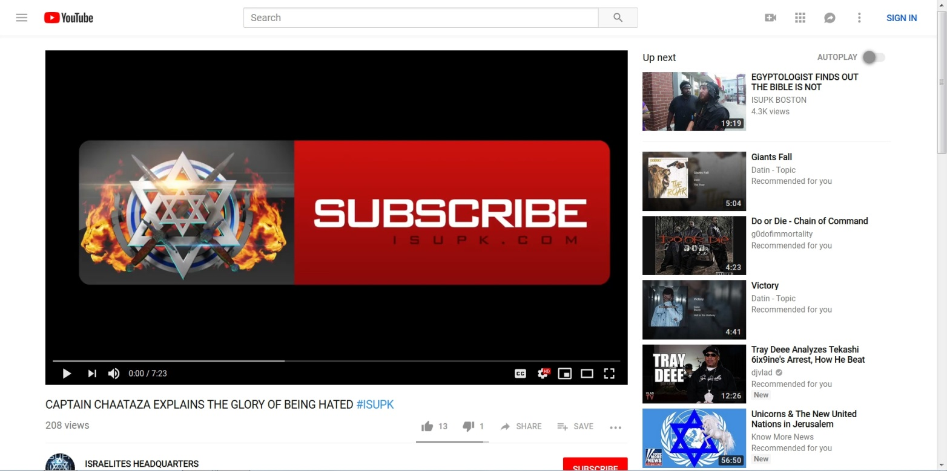
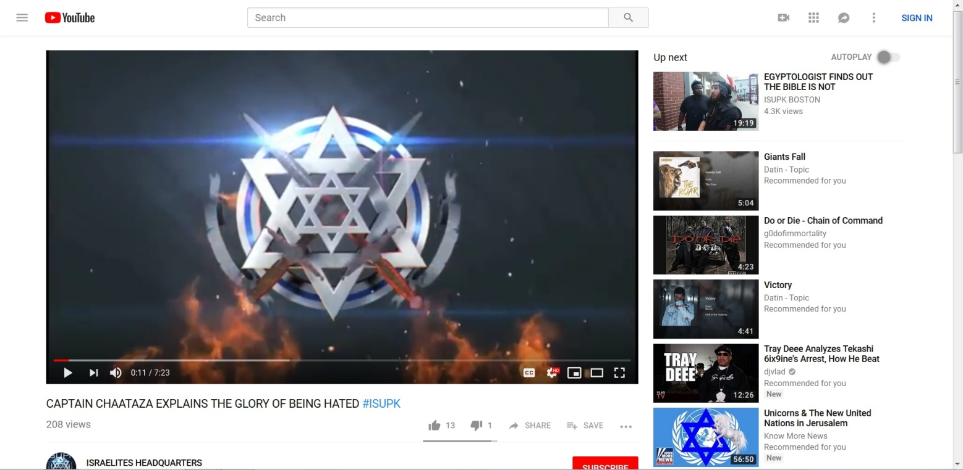
It could be a coincidence that their symbol has several rings, a star over it, a wreath around it; and these groups will cause the UN to come in.
And just so you’ll know, Know More News is not the first person to place that star over that logo. It’s been done before. And the UN can be traced back to the League of Nations; and the League of Nations back to the Elite, who are Jewish and Jewish-controlled.
Here’s a little more:
https://www.gettyimages.com/detail/news-photo/iranian-women-hold-a-placard-with-the-un-logo-bearing-the-news-photo/79184972
In case they delete it, the image was: “Iranian women hold a placard with the UN logo bearing the Jewish David Star in the middle during a protest against Israel's blockade of the Gaza Strip, in front of the United Nation's office in Tehran, 24 January 2008.”

Here’s a similar image:



Here’s the logo of the Theosophical Society:

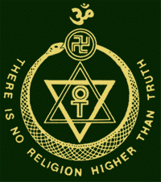

And since weren’t talking about symbolism…
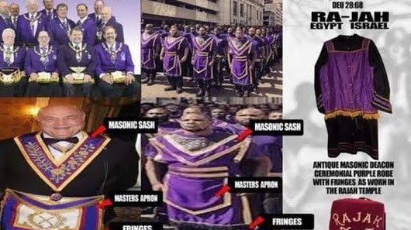

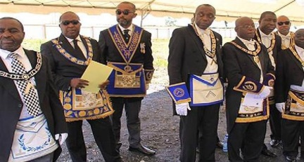

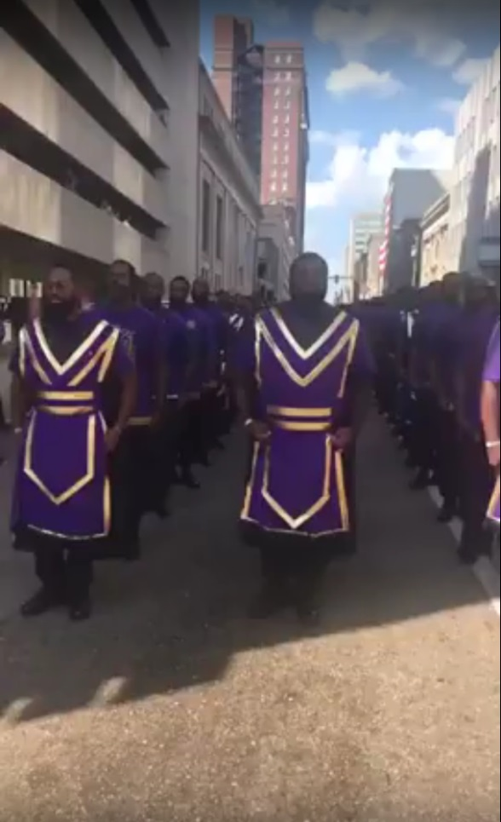

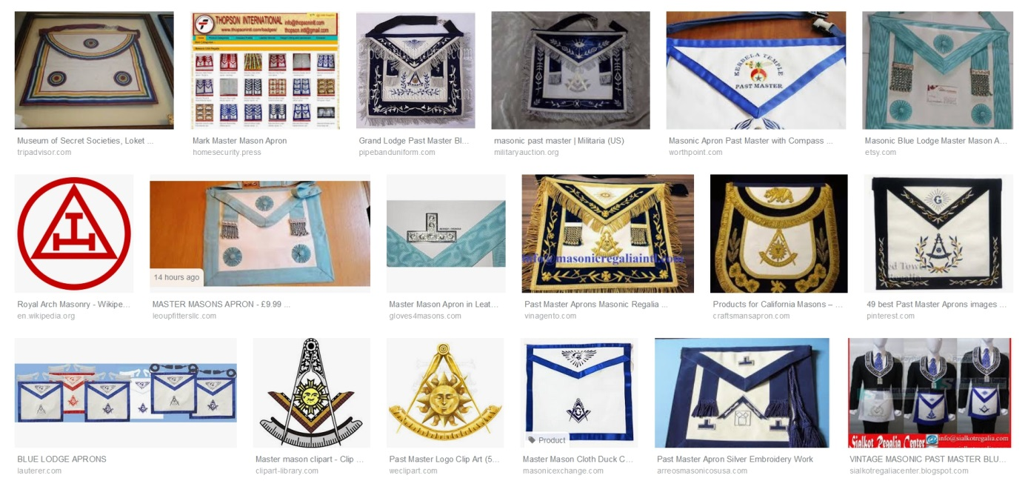

The Black Masonic Agenda
https://www.youtube.com/watch?v=_qQ0_ieVxWo

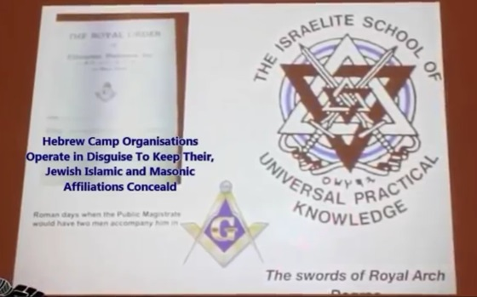

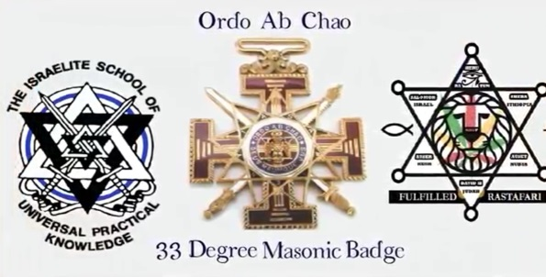

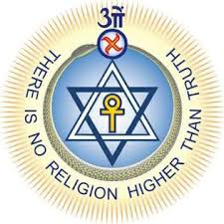

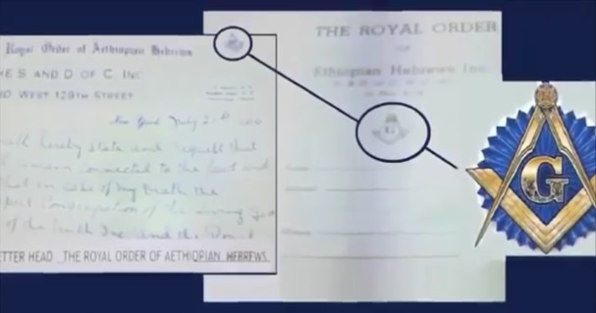
I’ve done my own research and agree with the following, and can prove the following. Watch the following video and think about all of the black individuals and institutions of the 1700’s and 1800’s that led to the false black religions we know of today.
It's Jews That Control FreeMasonry & Secret Societies
https://www.youtube.com/watch?v=eEavEtS6crg
“Masonry is a search after Light. That search leads us directly back, as you see, to the Kabalah. In that ancient and little understood medley of absurdity and philosophy, the Initiate will find the source of many doctrines; and may in time come to understand the Hermetic philosophers, the Alchemists, all the Anti-papal Thinkers of the Middle Ages, and Emanuel Swedenborg.” – Morals and Dogma by Albert Pike
The intelligence agencies we know of today were actually birthed out of secret societies and do the “dirty work” the secret societies used to do. You can look up the logo for the British CIA, MI6, and see if you see anything familiar. And if you don’t know, the intelligence agencies are controlled by the Elite (Jewish), not the government, just like the Federal Reserve (Jewish). Their actions in the 1960’s and 70’s alone can prove this.
You don’t have to take my word for it.
How Religious and Fraternal Groups are Created and Connected
https://www.youtube.com/watch?v=e2dY0jTphNo
A must-see for later that will prove all of this
If you go here (search here for a video that has been removed) you’ll see that the Christian Church has been infiltrated, mainly through televangelists; and “Christian” churches and organizations have been created and steered by Jews and Freemasons. This is not me “picking on” a particular people; this is just what the truth is.
Looking at the big picture, it seems that every major black religious group outside of the Black Church (which was really black people as a holy people) was created to bring blacks out of the Church, and capture those already outside of it (capture the wandering sheep), while using them as tools; mainly against whites.

A Community Agenda
I’m pretty sure you remember how cults/groups, movements, and individuals who acted as gurus/teachers were used to shape and move society. It’s no different today.
The powers that be created and controlled the leaders of well-known cults, the Nation of Islam, and the Christian mega churches, so how easy would it be for them to create, control, and send to you the teachers you have in the Israelite and Black Conscious communities? You know, the ones telling you that the white man is the devil while reintroducing racist history to your mind. “Look at what they did to you”; saying it was “them,” and “you”; these people today did it, and you went through it all. You know, the same thing that Hollywood movies, TV shows, the news, celebrities, Youtube, and Facebook are “coincidentally” saying to you (all coincidentally Jewish controlled). Forget the fact that when you go outside into the true reality you don’t experience anything at all. Forget the fact that most white people live in all white neighborhoods so are never near black people. Sarcastically speaking: Forget reality, pay attention to sources of information. It’s not like they can be controlled and made to deliver the same message, or messages that when combined have a desired effect. You know how all those same sources were showing you how blacks were being slaughtered in the streets by cops, and telling you that you had to do something, but when you went outside on a daily basis not one police officer was worried about you. That’s why you have to pay attention to the sources of information, and not reality. Sure, there was an abundance of black crisis actors in 2016, and there are people on Youtube right now who get paid to push products, but I’m sure no one on Youtube is being paid to push ideas. A government, and system, that is constantly creating hoaxes, psychological attacks, in the form of gun massacres in order use martial law-like decrees and push gun control wouldn’t use psychological manipulation against the population by other means. Come on, be smart and let the Camps and Conscious Community lead you into a race war. It’s time you get serious about fighting these white people (white people = white citizens). I’m sure Yah/God will back you in your mission to fight and kill people who have done absolutely nothing to you. Whites vs. blacks while the Jews kick back.
Understand this: These Israelite camps, along with many others, are a part of a project/agenda which you see unfolding today–the psychological war against blacks. This project’s aim is to create racist blacks who will fight against whites–for a race war–and enraged blacks who will fight against the police and the State, leading to the federalization of the police force and/or martial law (molding and moving a group of people for a purpose). The Black Conscious Community with their informant teachers is the main source of power for this agenda. Also involved are police departments, the government, the news media, Hollywood, celebrities, crisis actors, Youtube, Facebook, Twitter, Black Lives Matter and other protest groups; and individuals. And this is beyond the FBI and COINTELPRO (or COINTELPRO-like actions). This is the work of the real players involved in the everyday manipulation of society on behalf of the Elite; players like the RAND Corporation and others mentioned in this video. And this is connected to George Soros (who also functions as a scape goat), Mr. Revolution, backing Black Lives Matter; and the many black crisis actors who lied about police shootings.
Order out of chaos.
George SOROS: The One-Man DESTABILIZATION Machine – YouTube
https://www.youtube.com/watch?v=feGXIK--OdM
If it’s all about white supremacy and white people, why is America and Europe being destroyed by another people? Think of the movie The Wizard of Oz. White supremacy is the evil, scary wizard, but behind the curtain this ENTIRE time….
The Take Down Of George Soros
https://www.youtube.com/watch?v=lmQUkJpk4fE
Watch the beginning - 5:42
Soros got hacked. Can you guess what we found? #NewWorldNextWeek – YouTube
https://www.youtube.com/watch?v=Gn-RvN54Eos
They fund both sides….
Episode 113 – Meet George Soros : The Corbett Report
https://www.corbettreport.com/episode-113-meet-george-soros/
Meet George Soros - Globalist Hit Man & Sheep Herder
https://www.youtube.com/watch?v=VygxXR1ao3o
Charlottesville Tragedy Psyop has got me Heated.
https://www.youtube.com/watch?v=6WEw5-mcxQM
CHARLOTTESVILLE WAS PROPAGANDA AND BRAIN WASHING OF THE AMERICAN PUBLIC censored by YouTube
https://www.youtube.com/watch?v=lb-sC9u_p0s
Soros's Formula for Killing America: A Brief Guide, for Americans
https://www.youtube.com/watch?v=MeM_l5mkyYc
A comment from another video on Soros: “And Plan B .....in case no one wants my New World Order...start a race war and sneak the New World Order in the back door while everyone is fighting each other about skin color. Sneaky aint I?﻿”
Read the following excerpt from Illuminati Conspiracy Part One: A Precise Exegesis on the Available Evidence:
At about the same time Weishaupt was embarking on an academic career two important figures entered the world stage: Thomas Robert Malthus,8 born in 1766, a major influence on Darwinism, population control and the eugenics movement; four years later we see the birth of Georg Wilhelm Friedrich Hegel, in Stuttgart Germany, the inventor of what would become known as the “Hegelian Dialectic.” “For Hegelians,” Antony C. Sutton reports, “the State is almighty and seen as ‘the march of God on earth.’ Indeed, a State religion. Progress in the Hegelian State is through contrived conflict: the clash of opposites makes for progress. If you can control the opposites, you dominate the nature of the outcome” (Introduction to the 2002 edition of America’s Secret Establishment: An Introduction to the Order of Skull & Bones, no pagination PDF copy).
Source: http://www.conspiracyarchive.com/2014/01/29/illuminati-conspiracy-part-one/
“Black” and “white” are opposites, right? Did you know that hundreds of years ago white people were intentionally brainwashed into being racist, just as blacks are today? Did you know that even this has a Jewish origin? And although it plays a significant part in all of this, that’s another story for another time.
The Shocking Jewish Role in Slavery Part I: What Jewish Historians Say
https://www.youtube.com/watch?v=GUE0si2llTY
ROOTS-JEWS WANT BLACKS & WHITES TO HATE EACH OTHER
https://www.youtube.com/watch?v=aDxHLlYfEYs
The Truth About BlacKKKlansman
https://www.youtube.com/watch?v=RnK-zTzqs8w
Through the Rockefeller (Elite family) education system and the Jewish mass media your mind has been programmed with lies since the moment you were able to learn. In other words, you were given a false reality. And this part of the false reality is to culminate in a race war.
The Birth of a Nation Official Teaser Trailer #1
https://www.youtube.com/watch?v=C4TTbcXG1GQ
Black people will be totally wiped out. A segment of the white population will be wiped out, giving the Elite less to deal with. Martial law can be declared. The UN can be brought in. They can have a New World Order. And who would have thought that black people would play such a large role in bringing it in.
US Gov has legalized psychological operations against citizens
https://www.youtube.com/watch?v=LOEqFFZCsr8
As stated in the video, “… through press, publications, radio, motion pictures, the internet, and other information media including social media, and through information centers, instructors, and other direct or indirect means of communication.” Instructors! And this law only legalized what they had already been doing for many years. From COINTELPRO Revisited - Spying & Disruption: “The CIA's expanded role is especially ominous. In the 60s, while legally banned from ‘internal security functions,’ the CIA managed to infiltrate the Black, student and antiwar movements. It also made secret use of university professors, journalists, labor leaders, publishing houses, cultural organizations and philanthropic fronts to mold US public opinion.”
“The white man,” “the enemy,” “Esau,” “Edomites,” “heathens,” “the devil” … why these names? The Esau/Edomite doctrine, which, at its core, states that white people are a part of a group/gang, and that group/gang is a rival group/gang … why does it exist? If you’re in the Black Conscious community you may have been taught similar names, but why? All of you may have seen things appearing on Youtube and Facebook stating that white people are not actually human; white people have fur, not hair; white people this, and white people that; and a total concentration on white crimes and the inhumanity of white people … but why?
Neurotaylor talks about hate and the brain
https://www.youtube.com/watch?v=CIcbAy0O3mk
As stated, Facebook and Google owned Youtube are also involved (the Elite own banks and corporations; banks and corporations own and control everything in the country).

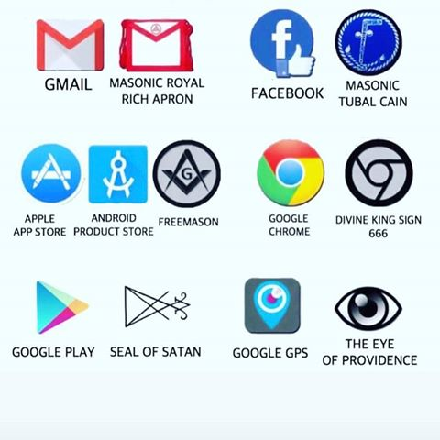

These internet giants (Facebook and Google), and even the internet itself, were developed and/or funded through the Jewish Elite-controlled government under Intelligence and Defense (source, alternative source), but were brought out to the public as companies under the control of Jews; with Mark Zuckerberg heading up Facebook, and Sergey Mikhaylovich Brin and Lawrence Edward Page heading up Google.
The Elite control these companies and others, and they can be called on at any time to advance any agenda, and they are always carrying out agendas, being that that is their true purpose (they are all front-companies). Online, Facebook is full of agents and paid trolls who run and/or dominate all Facebook groups (look up “paid government trolls” on Youtube or elsewhere) with profiles that look 100% real. You may think you’re debating a regular citizen, but you’re not. You may think that meme containing false doctrine was posted by a regular person, but it wasn’t. You may think that false doctrine was liked by hundreds of regular people, but it wasn’t. And many of the paid trolls online are Israeli students (a fact), and I wouldn’t doubt that artificial intelligence is also being used. And Youtube is no different. It’s full of paid trolls, and video-makers, who increase a person’s “thumbs up” and “thumbs down,” and comment based on an agenda. Their comments mirror the COINTELPRO tactics of the FBI (“The FBI and police also waged psychological warfare from the outside--through bogus publications, forged correspondence, anonymous letters and telephone calls, and similar forms of deceit.”), but they’re made to advance today’s agendas. The same is true for their comments on Facebook and elsewhere. One of the main weapons of these online trolls is to create what appears to be a consensus, especially by using “likes” and “thumbs up”. They want people to believe that “this” is what “everyone” is believing, feeling, saying, and doing; and the average American, being a follower, will follow; and will believe, feel, say, or do the same. This online deceit is their newest edition to the Matrix and social engineering. And from what I’ve seen, it works extremely well. It sure has black people, mostly young, believing all sorts of things. The internet is now a weapon.
BUSTED! Gov. Running #Ferguson Twitter Psyop https://www.youtube.com/watch?v=giOvj8-s8oU
As you can see, they’re causing racial tension.
Government trolls TOTALLY dominate the comment section on Youtube. And you help to propagandize each other by spreading the videos and memes they create on Facebook.

Twitter Threatens Suspension For Exposing Gov Accounts https://www.youtube.com/watch?v=6vPl89Eii6w
Let me show you how it’s done. With the agenda to have blacks face the police … a police shooting of a black person, real or staged, is made the important topic by the media. Videos are created on Youtube by regular people, puppets, and agents (actual intelligence employees); memes and videos are created and spread on Facebook by regular people, puppets, and agents (actual intelligence employees). These videos and memes express anger and a sense of urgency to act no matter the circumstances of the shooting. Puppets, agents, and paid trolls then leave comments that steer the minds of those reading. “These white people ….” “White supremacy ….” “I’m getting my weapons ready right now.” And these comments will have the most “likes” or “thumbs up,” something those controlling the profiles can do at will (I’ve even seen the comments on Facebook pop up already “liked”). This creates the consensus. And while all of this is going on online, the media is playing their part with their topics, scripts, and people they choose to interview. Celebrities/entertainers (musicians, actors, sports players, comedians, etc.), slaves under the threat of death if they don’t comply, are made to come forward and speak, especially if the event is a hoax. And teachers in these communities speak on the event, steering the minds of the people. That’s what takes place with an event, but with a long range agenda, TV shows, movies, and books are included. This is reality creation. This is the Matrix. This is how it’s done.
One angle of the racial tension agenda was to “open old wounds,” bring to the attention of blacks, especially those who had never experienced racism or even knew what it was, what “white people” did to “them”.
Now think of the pictures some of these Israelites have when they preach on the streets.
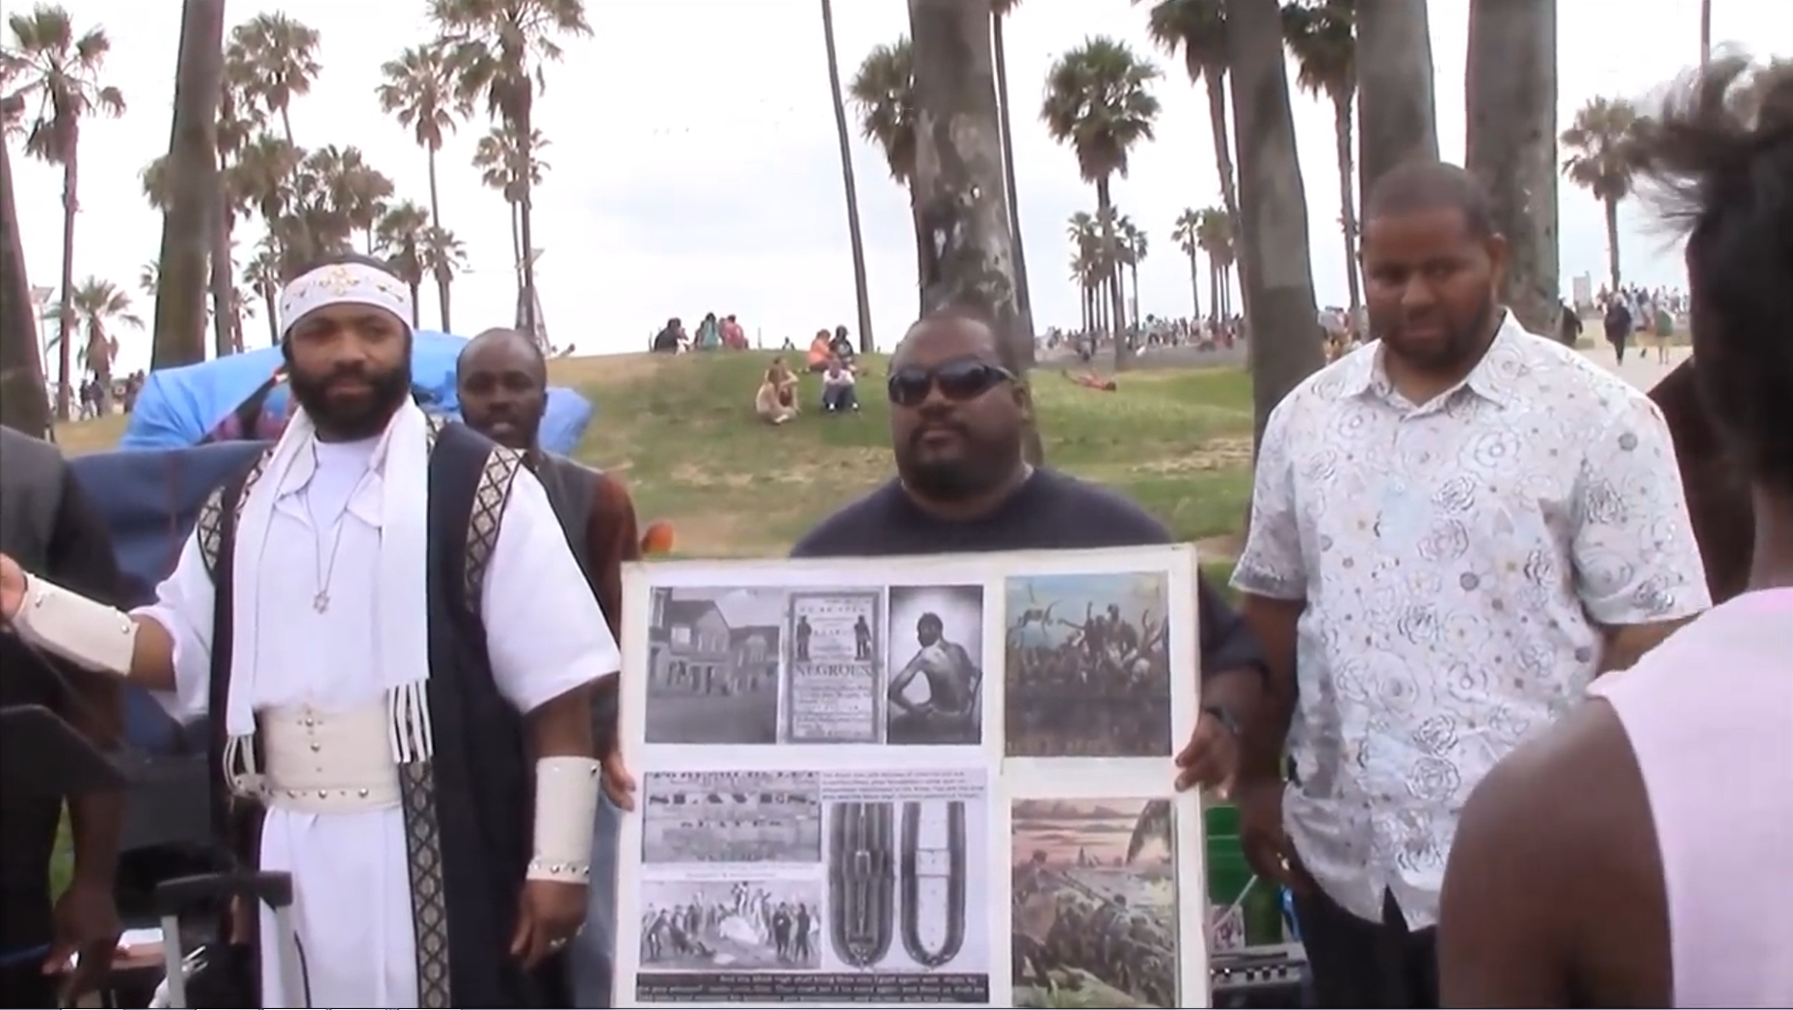
The powers that be absolutely flooded the minds of blacks with “look at what they did to you”. They had it coming from everywhere, from Facebook to movies (the sudden release of slave movies and movies on white racism).
Meet the Jews Who Own Hollywood and the Media
http://www.texemarrs.com/jews_own_hollywood.htm
“This is the secret of propaganda: Those who are to be persuaded by it should be completely immersed in the ideas of the propaganda, without ever noticing that they are being immersed in it.” – Joseph Goebbels
“The essence of propaganda consists in winning people over to an idea so sincerely, so vitally, that in the end they succumb to it utterly and can never escape from it.” – Joseph Goebbels
“Propaganda must facilitate the displacement of aggression by specifying the targets for hatred.” – Joseph Goebbels
“The whole point of brainwashing is that those being brainwashed don’t know it.” — Graham Haley
Take a look at this:
Family Guy - (S2xE5) Stewie adopted
https://www.youtube.com/watch?v=_1_avHEmtlY
In that episode, Stewie was placed into a multiracial foster home. Everything was fine between the kids; they were one happy family until Stewie started mentioning, bringing to their attention, things one person’s people/ancestors did to another person’s people/ancestors.
Family guy-Dance Puppets Dance
https://www.youtube.com/watch?v=nkF218n7A1s
There were children in the US, white and black, who actually didn’t know what racism was. Stop and think about that. Racism in the population was on its way out. Everything was pretty much fine between blacks and whites (and I have proof of this); then all of sudden, for no reason at all, white people exploded in a fit of racism, causing an epidemic of racism in America … similar to the epidemic of shootings in America (hoaxes along with law enforcement and intelligence agencies purposely doing it). Or at least that’s what was presented on all screens.

Facebook propaganda:

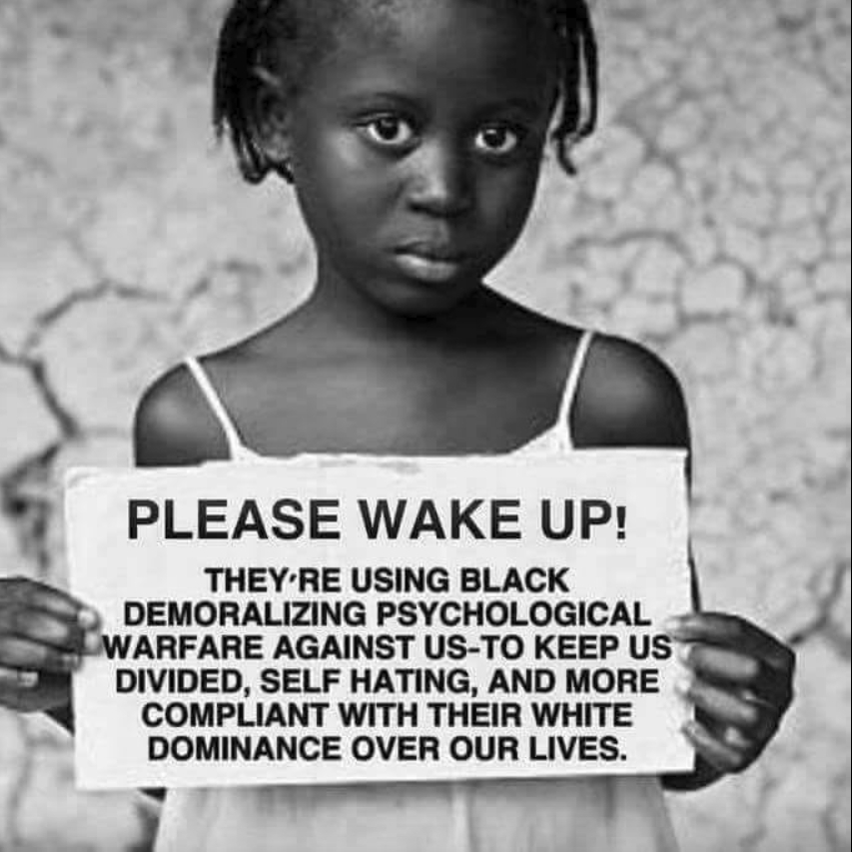
Notice how the powers that be have taken the truth about what they’re doing to white people and have said that this what whites are doing to blacks. And countless numbers of black people are consuming this every day, all day, on Facebook.
Using the fuel of the racial tension agenda, they have gone into trying to paint America as a severely racist country. This is most likely being done to pass laws on racism (called “hate”). Why? One reason may be to protect Jews from the backlash they will receive when everyone figures out they’ve been duped by so many Jews acting as one (working through black movements to pass laws benefitting themselves once again). Another reason may be to ban “the Israelite religion,” which, through their camps, they have already labeled as “hate”.
Did you know that many news stories of racism against blacks were actually hoaxes?
Here are some (you don’t have to watch them):
Student activist gets 90 days in jail for fake racial threats on Twitter
https://www.rt.com/…/347233-kean-student-kayla-mckelvey-se…/
Americans Caught Faking Hate Crimes
https://www.youtube.com/watch?v=kxs1jDxotYI
Police: Woman faked hate crime
https://www.youtube.com/watch?v=mJ2vvGNu-4o
A list of totally made-up hate crimes this week
https://www.youtube.com/watch?v=4QxxO7kyeRQ
RACIST WHITE MAN TELLS BLACK WOMAN TO GO SIT AT THE BACK OF THE CITY BUS!
https://www.youtube.com/watch?v=PbTzXpEBYE0
"Get up and Go to the Back of the Bus" (Racist White Man to Black Woman 1 2014) = 100% FAKE
https://www.youtube.com/watch?v=n4OgURig-fg
"Racist Cheerleaders" Hoax Goes Viral
https://www.youtube.com/watch?v=qRirN0Xn9W8
3 Black Students Face Charges After Alleged Racial Bus Fight
https://www.youtube.com/watch?v=vqo9jUvRroY
Psychologist Weighs In On St. Olaf Racist Note Hoax
https://www.youtube.com/watch?v=ZnBkubCWPYE
Hate Hoax Epidemic of the Left: 100 Fake Hate Crimes & Fake Racist Incidents
https://www.youtube.com/watch?v=MswvUGSpYYk
Gutfeld on the latest hate crime hoaxes
https://www.youtube.com/watch?v=LjZqI6QvUyc
So, the same act of showing real stories along with hoaxes that was done with police shootings is being done with racism in America. I guess their slogan is “Make America racist again.”
The Jews Who Own The Media
https://www.youtube.com/watch?v=hR8MNvCJBDc
The Jews Who Own The Media – Video Censored, but still available
http://jimforamerica.com/the-jews-who-own-the-media-video-censored/
Come on, you can’t tell that the racism coming from puppets (President, celebrities, etc.) is purposeful? It’s so blatant, and unrealistic. The powers that be are trying to bring in the New World Order, and they are using extreme deceit to do so.
People just don’t get it. This is the end of this country so they can have their puppets lose their careers. They’re going to lose them anyway! This is why you’re seeing blatant racism from puppets.
As I stated before, they are trying to bring in the New World Order, and they are
using extreme deceit to do so. They are going to such an extreme with reality
creation that most Americans would never believe they were being deceived in
“that way” or by “that person”.

The NFL, The Mafia and FIXED Games Dan Moldea Interview
https://www.youtube.com/watch?v=c17xlNG0rfc

NFL PLAYERS ASSOCIATION CONNECTED TO SOROS!
https://www.youtube.com/watch?v=154rrWO2amg
Whether it’s the Grammy’s, Emmy’s, or the Super Bowl the people in charge of the event bring in to perform who they want to perform. It’s not the other way around. And for a fact, the song choice and show that’s puts on has to be accepted and desired by those who are in charge of the event. So, when Beyonce performed and paid homage to the Black Panthers, it was something the NFL desired. But it was done to promote militant resistance and the New Black Panthers, the government group, who almost everyone saw as just a continuation of the original Black Panthers.
And don’t forget about the blatant occultism that takes place at the Super Bowl. This should also give you an indication of who’s running it. The Super Bowl is controlled, and all artists are controlled, so if you bring this together you get shows the powers that be want. It’s the same with other events.
Examples:
Beyoncé Knowles AKA Darth Fierce Preconditions You For A Police State
https://www.youtube.com/watch?v=ClJPT-QPTHE
2016 ILLUMINATI Superbowl Halftime Show - Beyonce, Katy Perry, Madonna & Coldplay
https://www.youtube.com/watch?v=TPlcYWgl_h8
This next video has great information, but he comes to the wrong conclusions:
Ben - Something You Should Know About Colin Kaepernick
https://www.youtube.com/watch?v=j9pu96cmZK8
HOW COME NO ONE IS TALKING ABOUT THIS WHEN IT COMES TO COLIN KAEPERNICK???
https://www.youtube.com/watch?v=WM6vgk5KkwM
And for a job well done …
Report: Colin Kaepernick paid in $60 to $80 million range by NFL
https://247sports.com/nfl/san-francisco-49ers/Article/Colin-Kaepernick-collusion-case-settlement-amount-NFL-129142821/
THE NFL HAS MANY SECRETS!
https://www.youtube.com/watch?v=tEuN7gKwFyE
Image 1
Image 2
Images 3 and 4
LeBron James Satanic Hand Gestures- Illuminati Proof
https://www.youtube.com/watch?v=8scr1_CXuKc
Do you know of anyone other person or group besides Black Lives Matter who causes racial tension? I have another project in the making which exposes certain black puppets who have been doing just that. I don’t know when I’ll be able to get to it, or if I’ll even be able to get to it (I have so many to work on, and the choice is not up to me), so let me share a little info here. The main black puppet working on this agenda is Umar Johnson. The Irritated Genie is another. Malik Zulu Shabazz and the New Black Panthers are others (even people in government know that the New Black Panthers are a government controlled group). These are people who have been sent to “light the fire in the minds of men”. Umar, along with Tariq Nasheed, Polite, and others also work on the anti-Christian agenda. My project even focuses on how these specific three purposely swindled the black community out of millions. Understand this: Just like a crisis actor, they didn’t just come on their own accord. And speaking of crisis actors, though we can’t prove who it is they are working for, we know by the role they play that they are a part of agendas that are being carried out by the most power people in, or outside of, the country. In these agendas we find members of Congress involved. We find the FBI, news media, and businesses involved. We find celebrities involved. In situations such as this, do you really need to know who these puppets are ultimately working for, or who they’ve been hired by, (something they may not even know themselves) to know that they are puppets?
Have you ever heard someone like a president (a puppet), for example, give a speech about “our enemies” and everything he says about the enemy is what he and the US government was, is, or will be; or was, is, or will be doing? This is another trick that is given for puppets to use on their target population.
(Umar On)-BLACK TRAITORS
https://www.youtube.com/watch?v=MmdD5TyBfxY
There’s another major agenda being carried out today, the anti-Christian/anti-religion agenda. A little history: Rome and the Edomites, converts to Torah observance/Judaism (ancestors of the controlling body of Luciferian Jews today), both had an extreme grudge against real Israelites and Christians. Rome and the Edomites have both taken measures to eliminate Israelites and Christians since the first century. Although they worked together at times, these Jews did not like Rome, as they did not like all of Europe, because they were ruling the world, a position the Edomites felt they should have themselves (and I’m sure were promised by Satan). Fast forward to the late 1800’s, a major step in the Jewish plan for the destruction of Christianity, the Bible, the God of the Bible, and the New Testament messiah had taken place. In British/Rothschild controlled India the New Age Movement/New World Order religion was being constructed by Helena Blavatsky, the Theosophical Society, and several others. This was to become the replacement for Christianity in the future. Think about that. That’s all the way back in the late 1800’s.
The abolition of all religions and the creation of a one-world religion are goals of the Illuminati (funded into existence by the Rothschilds), and this has been known for centuries.
This is from 1798 (you don’t have to read it):
PROOFS OF A CONSPIRACY AGAINST ALL THE RELIGIONS AND GOVERNMENTS OF EUROPE, CARRIED ON IN THE SECRET MEETINGS OF FREE MASONS, ILLUMINATI, AND READING SOCIETIES, COLLECTED FROM GOOD AUTHORITIES, BY JOHN ROBISON, A. M.
http://www.conspiracyarchive.com/PROOFS_OF_A_CONSPIRACY_John_Robison.pdf
Did you notice how it was against Europe (white people – “the white man”)?
The new age deception an illuminati movement
https://www.youtube.com/watch?v=88VRh1O7lRI
I don’t think people know what this song is really about:
Imagine by John Lennon
https://genius.com/John-lennon-imagine-lyrics
Additional Information (for later)
How the Jewish Rothschild Zionists Created Modern Israel
https://www.youtube.com/watch?v=2qlGVkHaeFc
This is packed with info, but the J-word is not used:
What You're Not Supposed to Know About America's Founding
https://www.youtube.com/watch?v=364cxeR5EAg
This agenda is why you’ve been witnessing a constant attack against Christianity coming from every direction (being that everything is controlled by them), but none against Satanism, Luciferianism, Freemasonry, Judaism (Talmud, Kabbalah, Zohar, etc.), or Illuminism; the religions that have actually caused all the mayhem in the world.
The Elite created and control Christian televangelists who give Yah/God, the Messiah, Christianity/the new covenant, and the Bible a bad name while feeding false doctrine to churches and individuals. These televangelists are also a part of the agenda. The Israelite Community and Black Conscious Community are also a part of it. Puppets operate through these communities. And victims of the anti-Christian/anti-religion agenda, which worked to tear down beliefs, have been swept up into these communities; as well as Atheism and the New Age Movement. This was by design. And “somehow” the main enemy of all of these groups is Christianity.
From The New Phoenix Program: “General Aquino’s psychological warfare campaign has started or infiltrated cults and other closed systems as part of a concerted effort to control large numbers of people and to destabilize the centers of Constitutional and legal authority both here in the United States and in other nations.”
When it comes to these communities, the powers that be either started them or infiltrated them. They also control some or all of their leaders/teachers (“shepherds”), the doctrine/curriculum, the focus (which issues they focus on), and the direction they move. You might not realize this, but it’s true, and I’ll show you even further. Take the Israelite Community – black people who believe they are descendants of the Biblical Israelites while Jews are the descendants of converts who stole their identity and are masquerading as them (and all of this is actually true). Some of them also believe that the Jew’s religion, “Judaism,” is false. Based on this, you would logically expect that most of the people in the Israelite Community would constantly attack Jews and “Judaism,” right? But that almost never happens. Instead, they attack Christians, mostly black Christians/the black Church (their own people), Christianity, and a large portion of them attack Yahusha/Jesus and the New Testament. The camps will do the previous, plus attack white people and America.

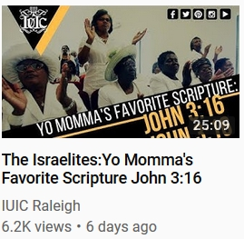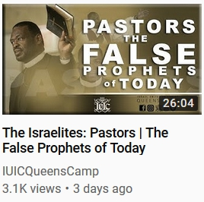

In addition, one of the biggest sins within the Israelite Community is to celebrate American holidays, labeled “pagan holidays” (actually holidays with a pagan origin). These holidays are attacked viciously, and at the same time attacks on holidays are coincidentally coming from other areas of the System (even the change to saying “happy holidays” instead of “merry Christmas” was a part of this). It’s one of the biggest sins, but why, how, and should it be? Why is this of all things pushed so strongly? “To achieve world government, it is necessary to remove from the minds of men their individualism, loyalty to family traditions, national patriotism, and religious dogmas.” – Brock Adams, Director UN Health Organization. If you don’t know, they are literally remaking society, and anything that acts as a glue in society has to be torn down so that the people can be made one. This is the reason the powers that be started taking down certain statues, and began to attack the Confederate flag (the very strong unity of South), but the citizens joined in believing it was being done for the reasons stated (the reasons that were used to motivate them). So, it’s the same thing we started off with in this document, where groups and movements were being used to further agendas.

Now look at the Black Conscious Community. Being so pro-black, you would expect them to attack rap and rappers (an actual genocidal plot against blacks), abortion and Planned Parenthood (an actual genocidal plot against blacks), the FBI and CIA, gangs, drug dealers, pimps, prostitutes, Jews, and the “just-us system” (If you’re not aware of these things, or are aware of them but not attacking them, how can you be conscious?). But who do they attack? Christians, Christianity, the Bible, the Black Church, all black history; and nearly all past black leaders, the police, white people, and America. Do you see it now? Who’s in control? Go back with your eyes or your mind and look at the places you frequent. Who’s in the driver’s seat? But it gets worst. Christians are the ones attacking rap music and rappers (an actual genocidal plot against blacks), abortion and Planned Parenthood (an actual genocidal plot against blacks), the New World Order, the Elite, Jews, “Judaism,” Christian televangelists, etc.! Whose side are you really on?
As explained here: “The Black Conscious Community is really the New World Order nursery. Followers and teachers for almost any New World Order agenda are being bred there: Blacks vs. the police. Blacks vs. whites. Breaking up relationships and families through feminism (elevating the woman far above the man). Teaching occult doctrine. The anti-religion agenda. The anti-Christian agenda. And even the agenda to keep black people believing that they are the descendants of Africans only.”
Note: Just because in recent years some of you in the “Conscious” Community have finally realized your gurus/teachers are con artists doesn’t change the fact that you have already been infected with their doctrine and the doctrine of the community (most of which can be proven to be lies, especially the things about Christianity). And you don’t even know who created the community or its core doctrine. You don’t even know that you’ve been played, or that most of the spiritual teachings of your community come straight from the occult. Just like the Christian Church, you’ve been infected (they got you too). And I noticed a long time ago that black people were being turned into racist atheists by this community. Racism? Atheism? The very thing being pushed by the rest of the System (Hollywood, TV shows, news, music, etc.). What a coincidence.
If you go here and scroll down to, or do a search for (better), “Through the Black Conscious Community (which has reached millions of blacks),” you’ll see how the New Age Movement/New Age Religion has been promoted through the Black Conscious Community for a while (as you also saw on that website on Noble Drew Ali and the Moors). In fact, it shows that the Black Conscious Community is really the Black New Age Movement, which in itself is a product of H. P. Blavatsky and the Theosophical Society. You will also see how Dr. York, his son, and KRS-One, a Freemason, are some of the people who have been secretly pushing it (“… through instructors…”). And once again, that leads us to the Theosophical Society and Freemasonry.
And there are blacks related to those same New York circles who are/were working on the anti-Christian agenda for the New World Order as attackers of Christianity (those who mainly attack, but also contribute other ways), people like Dr. Yosef Ben Jochannan, Dr. John Henrik Clarke, Ray Hagins, and Moreh Elesha Yisrael. [And I called out these names because I can prove their sick lies.] You’ll find many puppets here. Almost the whole gang is there. Aren’t those the people from Hidden Colors?
You can find other attackers in the Black Conscious Community, Israelite Community, and outside of these communities. Like I said, it’s just like black crisis actors, people are being paid (or even pressured). If you’re in the Israelite Community: Why do you think these attackers of Christianity don’t respond to clear truth, they just keep going, even lying, showing they have an unchangeable stance. And their doctrine is the same as the Jews. Some of them are even branded by their puppet-masters with six-pointed stars the same way a celebrity has to throw up hand signs or wear certain clothing with certain signs and symbols on it. Why do you think they promote and adhere to the Talmud and other Jewish works although these works are knowingly the works of people who are supposed to be their enemies? Note: There may be some who are just ignorant followers, not paid or coerced workers.
Now, think back to what Fard, Jim Jones, and others said about Christianity, and watch this next clip.
Watch 3:27 - 5:52
The Hebrews Going Hard At The Africans
https://youtu.be/XGlP_hgkitw?t=3m27s
What’s interesting is how most of the puppets are on the East Coast, mainly New York. I think they have a black informant factory out there or something. As a matter of fact, let me show you what I’m talking about. You know how New York had, or still has, more corrupt cops than any other city? It seems to be the same with black people. Think about the rap industry. Think about how many East Coast, mainly New York, rappers snitched or worked as informants. That’s one thing. New York also has the Israelite camps and the Black Conscious Community. Both! How the heck can they have both?! And there’s even individuals out there who are working on these agendas. Now add all of that up.
This guy in this video is saying the same thing!
Listen from 39:42 - 52:47
The HOT SEAT w/Nasi Yashuvel
https://youtu.be/rYAPyuYC0Gk?t=39m42s
List of urban areas by Jewish population
https://en.wikipedia.org/wiki/List_of_urban_areas_by_Jewish_population
And there are other agendas these puppets spew out poison for. One of them is so unique that it identifies puppets clearly, and identifies the FBI as the source of at least that agenda. I can’t say what it is because they’ll try to counter it. They’ll have their puppets on Youtube speak on it before I can, but when they do they’ll add a twist or use that as bait for other false doctrine. It’s happened many times before (I’m monitored).
Additional Information (for later)
And as far as all of this anti-Christian talk … if it were true then it should be addressed, but these people have been telling lies. Do you care that these people are lying to you? If you want proof go to Is Your Religion the Problem? and read the first section. More debunked lies can be found in part 2.
You will learn a lot from this:
The Two Christianities
http://howmanyknow.com/2016/05/the-two-christianities/
And you should watch these:
Did Europeans Give Us Christianity?
https://www.youtube.com/watch?v=YfngNAcvmjE
Horus Was NOT Born of A Virgin! (Hotep Hustlers - Vol. 2)
https://www.youtube.com/watch?v=eJMS_1aRtzw
And if you really want to seal the deal – if you really want actual beyond a shadow of a doubt proof that there is a God and His son, and Satan and his angles – go through all of Is Your Religion the Problem. You will gain understanding as you go, until you come to a total understanding. And just a warning, this will be life-changing.
And there’s more to come. I hope to address everyone’s comments and questions on Yahusha/Jesus and Christianity. Although I think just about everything has been addressed in the forthcoming parts of this project and in the texts referenced to above. Closed mouths don’t get fed? Open mouths do.
True Agents
From COINTELPRO Revisited - Spying & Disruption:
“Agents are law enforcement officers disguised as activists.
Informers are non-agents who provide information to a law enforcement or intelligence agency. They may be recruited from within a group or sent in by an agency, or they may be disaffected former members or supporters.
Infiltrators are agents or informers who work in a group or community under the direction of a law enforcement or intelligence agency. During the 60s the FBI had to rely on informers (who are less well trained and harder to control) because it had very few black, Hispanic or female agents, and its strict dress and grooming code left white male agents unable to look like activists. As a modern equal opportunity employer, today's FBI has fewer such limitations.
What They Do: Some informers and infiltrators quietly provide information while keeping a low profile and doing whatever is expected of group members. Others attempt to discredit a target and disrupt its work. They may spread false rumors and make unfounded accusations to provoke or exacerbate tensions and splits. They may urge divisive proposals, sabotage important activities and resources, or operate as "provocateurs" who lead zealous activists into unnecessary danger.”
Understand this: We in the “Truth Community”/“Conspiracy Community” used the word “agent” to refer to a disinformation agent or an agent of the System like you see in the movie The Matrix. Others have come along, viewed our material and started using “agent” recklessly, calling everyone an agent and meaning an intelligence agency agent. You will rarely find actual agents, employees of an intelligence agency, working these types of projects and being in the limelight; there are too many willing sellouts to choose from in the general population. And please note, “rarely” doesn’t mean “never”.
5 People You Won’t Believe Worked For the CIA
https://www.youtube.com/watch?v=6FpyED4uJwQ
Millennial dream jobs: CIA agent to coffee barista
https://www.usatoday.com/story/money/business/2013/05/11/cnbc-millennial-dream-careers/2148683/
Cynthia McKinney vs. the F.B.I.
https://www.youtube.com/watch?v=UJJe-OIbTEg
provocateurs,shills and disinfo agents
https://www.youtube.com/watch?v=HYedTmaHt1A
I added all of this information to give clarity to the next video, and because people are causing problems with misunderstandings.

I just found this next video in June of 2018. I can’t believe it, someone actually understands!
Agent Provocateurs
https://www.youtube.com/watch?v=ugTms901kGc
20:42 - 20:57 – Same here! FYI: One trick the intelligence agencies have always used is to have one puppet attack another, usually calling the other an agent. This causes you to believe that at least one of them is true when in reality both are puppets/informants/agents of the System. And they don’t even have to know that the other person is also a puppet. So, when you see Tariq fighting with Tommy or the Irritated Genie; Umar (the black Hitler) with Polite, and so on and so forth don’t automatically think that both of them can’t be puppets. And having the police, Feds, or other agency investigate, persecute, raid, or arrest an individual or group is another trick they use to make their puppets seem legit. Come on, these intelligence agencies are known to throw informants under the bus in a heartbeat; their own agents as well (even murdering them). This, along with compartmentalization means the investigations, persecutions, arrests, raids; etc. don’t prove that a person or group is not controlled or hasn’t been put up to do what they do by some hidden person or group.

She also understands!

Lesson on FBI CIA Informants Activist Provocateurs Infiltrators Deceivers Disinfo Agents
https://www.youtube.com/watch?v=CONBYyb9XXY
“They might encourage violent revolution but have stable jobs, families, children … their life will contradict how they talk. Because the idea is to get you to react violently while they sit and watch, or take note and give it to their superiors. … They might be sending you on a suicide mission while playing the motivational music, which is their chants; their subtle brainwashing, or mind control techniques. But they’re not revolutionaries, they’re deceivers, and will not go with you.”
Case in point:
"Albino" General Sara Suten Seti is This You !
https://www.youtube.com/watch?v=XOpMN3sYlpk
And she brought up another good one. At 16:39 she brought up how these people are able to create elaborate films (documentaries … Hidden Colors … Whited Out). Exactly! And these documentaries will contain what I call “the language of the System,” the deceit of the System, so I know it’s not these regular people who are behind it (there’s psychology at use in these documentaries). She also brought up another good one; she said they’ll attack Christianity. This is because the destruction of Christianity is a New World Order agenda. It’s something that has to be done, and these sellouts are doing it. And these workers are people you see as regular people, just like crisis actors; and they’ll take your donations and payments for speaking engagements just like crisis actors.
I have some theories concerning puppets: 1. Some of them are using, were probably given, mental enhancement drugs. 2. Some of them have commissioned supporters planted in the crowd/group they’re speaking in front of, sometimes maybe even the whole crowd/group. They function the same way, and serve the same purpose as, trolls in the comment sections online.

Watch the beginning - 4:10 and 28:30 - the end
Response to Tommy Sotomayor - Disinformation Agent Leading the Youth Astray
https://www.youtube.com/watch?v=_DOFVuqzafg
And I bet all of the attacks she received were not from Tommy’s followers. Some, maybe most, were from paid trolls (regular individuals, military personnel, FBI); and it’s because she exposed an agent of the System. Trolls protect the puppets on online platforms, from Facebook to Youtube.
In the “Truth Community,” it’s common knowledge that people are sent who pretend to be on your side but are not (an agent - agent of the System).

One example:
Alex Jones Exposed by Milton William Cooper
https://www.youtube.com/watch?v=d7jJMYJbAKc
Infowars Employees Expose Alex Jones
https://www.youtube.com/watch?v=wam0ZdjY57k
Infowars Callers Angry at Alex Jones for Zionist Propaganda
https://www.youtube.com/watch?v=nbtWb7lWkSY
Watch the beginning – 29:39
Christopher Bollyn Calls Alex Jones a Zionist "Gatekeeper"
https://www.youtube.com/watch?v=_xJdFWsCfvw
David Duke Exposes Alex Jones While Exposing The Global Zionist Takeover
https://www.youtube.com/watch?v=pvDHwQFdKfg
The Alex Jones Chronicles - Pt1of3
https://www.youtube.com/watch?v=-VxZyOLbpHA
The Alex Jones Chronicles - Pt2of3
https://www.youtube.com/watch?v=ce5bDvuqL7o
The Alex Jones Chronicles - Pt3of3
https://www.youtube.com/watch?v=uYqnzu8G72o
In the “Truth Community,” one sign of a possible agent was if they never or hardly ever blamed Jews or Israel when the blame was actually to be placed on them. This was made public several times, and as a result the System adjusted. They started putting out more agents who mentioned Jews and Israel, but not enough to stamp it in the minds of listeners; only enough to appear not to be an agent. And then there are some puppets who don’t even know that Jews are controlling what they’re involved in. They are sometimes allowed to speak their minds.
It’s common knowledge that documentaries are produced and shown on TV or spread underground (like Zeitgeist) to advance agendas, which is one reason why I knew what Hidden Colors was just from one clip, and never wanted to see it. We know that it’s the same with books, articles, and more. It’s normal life for us not to fully trust anyone because we know what is possible, what has been done, and what is being done. There aren’t that many black people in this community, so the black population is not used to it; and I see black people constantly falling for the people, groups, documentaries, Youtube videos, books, etc. that are actually traps created by the powers that be.
Additional Information Connected to Zeitgeist (definitely for later viewing)
The Luciferian Philosophy/Religion vs. The Truth
https://www.youtube.com/watch?v=mARrtQxUQTY
AQUARIUS -- The Age of Evil
https://www.youtube.com/watch?v=B9Gz9fU6AxE
Watch the beginning - 8:52
Malcolm X Dream - Tommy Sotomayor, Tariq Nasheed are Willie Lynch Broken Slaves Not Leaders
https://www.youtube.com/watch?v=nBG-biFGS8s
Tommy Sotomayor Works For Covert Radio - They Are On The Same Team
https://www.youtube.com/watch?v=l6v7fa31pOE
And if you don’t believe there’s an agenda being carried out by elite Jews to mix other races, look into it. It’s not a theory. Even George Soros works on this agenda, flooding Europe with foreigners. And there’s also an old, ongoing agenda to make black women unattractive to black males.
The Israelite Camps
Now, with that understanding we can get to the camps. You should be able to see clearly now.
*I do not agree with or condone any racist statement or name spoken by the makers of the videos I’m using here.

THE PAID AGENTS OF ISRAEL
https://www.youtube.com/watch?v=BUfs0YGvVyk
I believe some of these camp teachers and members were incarcerated, and it is from there that they were recruited. I believe the same is true for some of these teachers and members of the Black Conscious Community.
“Although followers of Black Judaism thought of themselves as the descendants of the biblical 12 tribes of Israel, most did not take that to mean that other people deserved condemnation or attack. One notable exception was F.S. Cherry, a self-declared prophet who in 1886 started a ‘black Jew’ church in Chattanooga, Tenn., where he preached that white people were inherently evil and hated by God. Cherry also instructed his followers that the earth is square and that Jesus would return in the year 2000 to install blacks over whites through a race war.”
Source: https://www.splcenter.org/fighting-hate/intelligence-report/2015/history-hebrew-israelism
“The OTO’s Solar Lodge in San Bernardino was presided over by Georgina ‘Jean’ Brayton, the daughter of a ranking Air Force officer in the 1960s. The cult subscribed to a grim, apocalyptic view of the world, and like Charles Manson believed that race wars would precipitate the Big Cataclysm.” From The CIA Connections to the Mind Control Cults.
F.S. Cherry may have been sent to fulfill one of the same purposes these camps are fulfilling today, racial tension. And don’t you find it strange that these fake black teachers and groups have always had the teaching that the white man is the devil, or enemy, and will be killed in the future? I mentioned it but can’t fully go into here, but there’s a reason why even all the way back to the 1800’s you see this Whites vs. Blacks theme.

You may be wondering why his beliefs seem prophetic. America is a project. Its beginning and end was planned before it was established. He was most likely taught this by insiders.
Why can these Israelite camps today get away with assault and threatening people’s lives on the streets? The same reason the New Black Panthers can get away with the things they get away with.

“In the first week of January, the Justice Department filed a civil lawsuit against the New Black Panther Party and three of its members, saying they violated the 1965 Voting Rights Act by scaring voters with the weapon, uniforms and racial slurs. In March, Mr. Bull submitted an affidavit at Justice’s request to support its lawsuit.
When none of the defendants filed any response to the complaint or appeared in federal district court in Philadelphia to answer the suit, it appeared almost certain Justice would have prevailed by default. Instead, the department in May suddenly allowed the party and two of the three defendants to walk away. Against the third defendant, Minister King Samir Shabazz, it sought only an injunction barring him from displaying a weapon within 100 feet of a Philadelphia polling place for the next three years—action that’s already illegal under existing law.”
Source: Holder’s Black Panther Stonewall
Why did the Justice Department dismiss such a clear case of voter intimidation?
http://www.wsj.com/articles/SB10001424052970203550604574361071968458430
Think about it. If a child draws a bomb or gun on a piece of paper, they’ll probably be expelled or questioned. If you make threats or carry a gun you’ll be seen as a domestic terrorist. In this post-September 11 environment you can’t do a thing without being seen as a terrorist, and you definitely can’t do it online. But the New Black Panthers and Umar Johnson can outright tell you in public to kill white people and their children. They can go on tour preaching the same message; they can even have Youtube videos preaching the same message.
Just looking at the title of these videos I was going to use for my other project, you should be able to see the truth:
“New BLACK PANTHER Party” Leader Malik Zulu Shabazz ESCALATES VIOLENCE In Ferguson, Missouri!!
Ex Gang Member Confronts The New Black Panther Party who calls for Race War In Ferguson (BLACK KKK)
New Black Panthers offer reward for capture of George Zimmerman
FERGUSON PSYOP - BUSTED! CONTROLLED OPPOSITION, Malik ShabazZ, New Black Panther Party
Black Panther Party Shabazz is Well Paid Fed
NEW BLACK PANTHER PARTY exposed Agent Provocateurs
USA: New Black Panther Party wants to “arm every black man”
New Black Panther Party Wants to Arm Every US Black Male
New Black Panther Party calls for a race war
Malik Shabazz Calls On Charleston Crowd To Finish “Mission” Killing “Slave Masters”
“Kill them all”
Michael Savage: Black Panthers Threaten to Kill White Babies
BLACK PANTHERS: OBAMA PROTECTS THOSE WHO PROMOTE "KILLING WHITES" & "THEIR BABIES"
From COINTELPRO Revisited - Spying & Disruption: “Fronts for the FBI: COINTELPRO documents reveal that a number of Sixties' political groups and projects were actually set up and operated by the FBI.”
You may still be able to find videos online of some of the original members of the Black Panthers stating that they don’t agree with this new group, are not affiliated with this new group, and tried to stop this new group from using their name to no avail.
And while we’re on this topic …
Umar Johnson Promotes Cop Killing/Looting. For $ Perps For Peace!
https://www.youtube.com/watch?v=U2n_WcAn2r0
After saying how he chooses his words carefully, he stated that black men are going to have to arm themselves and face the police, killing and dying, so that the government could step in and/or the U.N. could be called in. This is New World Order plan! This is what I showed in Exposed – The Psychological War Against Blacks.
Black man stands up against “Black Lives Matter” protest
https://www.youtube.com/watch?v=VDXgAsH2OTs
George H.W. Bush 'New World Order' (4 Different 'New World Order' Speeches)
https://www.youtube.com/watch?v=7SwWfDJheRA
Ted Turner: It's 'Good' U.S. Troops Committing Suicide; UN Should Police the Globe
https://youtu.be/sVARrcJisVg?t=53s
Here’s something I was working on a long time ago. This Umar video has since been deleted, and I was never able to get back to it to add the title or finish.
https://www.youtube.com/watch?v=rXdw4Kvln-4

1:11 - 1:16 – “… the riot was started by crackers.”

6:42 - “… the first law of behavioral science is the behavior that goes unpunished by the victim must occur more often.” Vengeance.
He’s victimizing black people for the New World Order, so he shouldn’t go unpunished.

“Our reaction to Trayvon created the environment for Michael Brown to go through the same thing.” So, what he has said is that because we didn’t retaliate, or “punish,” we caused Michael Brown to get killed. The mind of the listener concludes: We should have retaliated; we should retaliate from now on.

7:23 – Our reaction to all the other shootings ….

7:58 – “white supremacy” = all whites. Don’t believe me? 8:03 - “… your reaction to what they do….” They….

8:15 – Now he plays on fear of the future, just like the government trolls who promote the idea that a purge is coming based on the movie The Purge. The mind of the listener concludes: I have to do something now before it’s too late. I have to rise up against white people before it’s too late.

8:23 – All that he previously said was: You have let all white people, not some white people, get away with too much. You should have been retaliating against white people. You now have to retaliate against white people or you will pay the price.
Just look at the title of these videos, which are named after what he said in the videos.
Dr Umar Johnson White people Programmed Black People To Hate Themselves
MUST WATCH!!!! DR UMAR JOHNSON NO FREEDOM OR JUSTICE BECAUSE YOU LOVE WHITE PEOPLE SO MUCH!!!
DR UMAR JOHNSON IT'S NOT JUST THE WHITE MAN, IT'S ALL WHITE PEOPLE!!!
Black People It's Time We Get Serious About Fighting White People Dr. Umar Johnson
Dr Umar Johnson : BLACK PEOPLE , WAKE up , or get EXTERMINATED.
Dr. Umar Johnson "God of White Supremacy"
Dr Umar Johnson: The Church and Jesus is running game on black people.
Dr. Umar Johnson on Christ
Dr Umar Johnson: Jesus doesn't love you my brother.

And there were so many more … until Youtube started deleting the evidence after Umar started getting exposed (after letting it stay on Youtube for years). He’s the new age, old Farrakhan, right? And Farrakhan is ….
From COINTELPRO Revisited - Spying & Disruption: “COINTELPRO distorted the public's view of radical groups in a way that helped to isolate them and to legitimize open political repression.”
When it comes to the Israelite camps, it’s called a camp, and one reason it’s set up like the military is so that it can easily be labeled as militant. If it can be labeled as militant, it can be banned, or COINTELPRO-like tactics can be used against it, destroying the entire movement.
Here is the result of their work:

They sold there soul for money and fame to get (COMFY ON VH1 LOOK AT JERMAINE)
https://www.youtube.com/watch?v=XxUWqraenfo

Did you hear that last statement? That’s one of the purposes.

Topic: What is up with the Black Hebrew Israelites?
http://www.popville.com/forums/topic/what-is-up-with-the-black-hebrew-israelites/

Racist Black Hebrew Israelites Becoming More Militant
http://www.splcenter.org/get-informed/intelligence-report/browse-all-issues/2008/fall/ready-for-war

THIS IS THE MOST HATEFUL GROUP IN AMERICA (Video)
http://www.conservativeoutfitters.com/blogs/news/79845825-this-is-the-most-hateful-group-in-america-video
Black Identity Extremists
https://en.wikipedia.org/wiki/Black_Identity_Extremists
There are two gains that stand out in this. One, they give more proof of white supremacy (the FBI is persecuting ….), aiding another agenda. Two, they can use COINTELPRO-like tactics on all Israelites (“black identity extremists”).
And the mainstream media is calling this the new COINTELPRO, with people in government even bringing up COINTELPRO. The fact that they’re even using that name publicly is a red flag for me. They never used to do this. They couldn’t! And the reason they are using that name is because they are redefining the new COINTELPRO, focusing your attention away from the real, new COINTELPRO which consists of individuals, groups, propaganda in different forms on social media, agents dominating the comment sections on all websites, etc. It’s the same as when the general population started to hear about hoaxes from people who learned about them on the internet, and then the mainstream media, the ones who were helping with the hoaxes, was made to start talking about fake news. But when they did this, they redefined what it was. It’s wasn’t the hoaxes that they had helped with, it was what they determined was fake news. They kind of blended the definitions, making it seem like what people started hearing about is what they were now talking about. Fake events were even created for them to report on, making the media look trustworthy. I’m telling you, you don’t know this place you live in. It literally is the Matrix.
THE PAID AGENTS OF ISRAEL THE ALPHABET BOYS PT 1
https://www.youtube.com/watch?v=5J2ig1Nmwd0

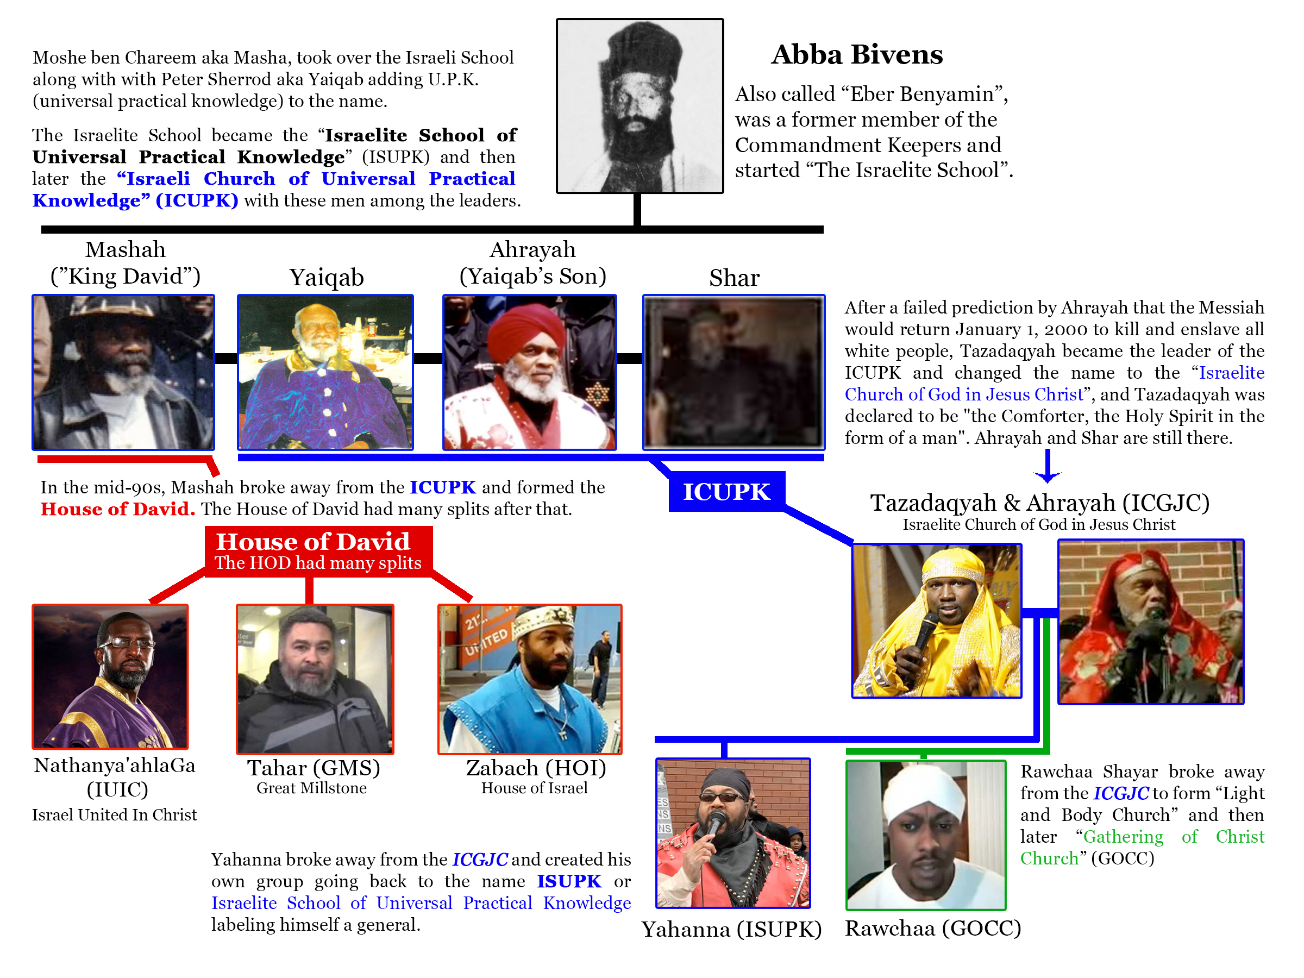

Source: http://mrhebrew1.com/show/wp-content/uploads/2016/06/ICUPK_Chart.jpg

And there are others that are not on that chart who are cut from the same menstrual cloth.
Examples:
https://www.youtube.com/channel/UC7oL1nzEzn2wCqZ_v6jx1PQ

https://www.youtube.com/channel/UCv9-PJys2IToog6qiUbq7fQ

https://www.youtube.com/user/SonsofYahawah2

https://www.youtube.com/channel/UCgQIvZGUZlb4cfqbsesnCaQ

https://www.youtube.com/channel/UCpdg71SOeGToHUhtUlTIGHg

THE PAID AGENTS OF ISRAEL THE ALPHABET BOYS PT. 2
https://www.youtube.com/watch?v=-AqSKnnn5Uc

THE PAID AGENTS OF ISRAEL THE ALPHABET BOYS PT. 3
https://www.youtube.com/watch?v=npKs-iaznLc
*The Texe Marrs book actually exposes the occult. It’s not a book on magic. But it can be used to teach.
L&N Recovers $750,000 in Malicious Prosecution Case
http://web.archive.org/web/20160720121140/http://www.lumerneville.com/news/ln-recovers-750000-malicious-prosecution-case
“Natanyel Ben Israel was born in the United States in the 1960s. He studied art in Europe and worked in the field of law enforcement.”
Source: http://jamaica-gleaner.com/article/news/20170513/israel-united-christ-offers-different-perspective-part-ii
“To support the church's activities, Nathaniel and most of his flock ‘work in either law enforcement or security.’ I asked if he felt there was a contradiction in opposing a Satanic world order in one's free time and working for that order while on the clock.”
Source: https://www.vice.com/en_us/article/dpwyqz/white-people-black-jesus-will-enslave-you
… to support the church’s activities? Yeah right. So, they joined the IUIC, and then became police officers? That’s not true, and if it were true it would still be disturbing. I guess they needed extra money like the Irritated Genie.
IUIC – Day Job
https://www.bitchute.com/video/kgruDPDuqTVq/
New York City police officers running a cult? All of this sounds familiar.
“Intelligence agencies have infiltrated and created some Satanic (religious) groups. Anton Lavey, founder of the Church of Satan, worked in the San Francisco Police Department crime lab and as an informant for Interpol. His most famous associate was the National Security Agency general, Michael Aquino. At the time of his membership in Lavey’s group, Aquino was an Army specialist in intelligence and psychological warfare. Aquino founded the Church of Set, and at least two members of the Council of Nine (of the Church of Set) were members of Army Intelligence.”
“General Aquino’s psychological warfare campaign has started or infiltrated cults and other closed systems as part of a concerted effort to control large numbers of people and to destabilize the centers of Constitutional and legal authority both here in the United States and in other nations.”
“Also known as The Solar Lodge of the OTO, which followed the teachings of cult messiah Aleister Crowley, whose fixed gaze on the astral equinox resulted in instructions from his deities to form a religious order. Crowley, high priest of the OTO and a British intelligence agent, gave Winifred T. Smith a charter to open an OTO lodge in Pasadena.”
“The OTO’s Solar Lodge in San Bernardino was presided over by Georgina ‘Jean’ Brayton, the daughter of a ranking Air Force officer in the 1960s. The cult subscribed to a grim, apocalyptic view of the world, and like Charles Manson believed that race wars would precipitate the Big Cataclysm.”
And isn’t it common for high-ranking police officers to be Freemasons?
Wasn’t it stated by many black people, mostly young, that black police officers are coons and sellouts? Wasn’t it stated by many black people that if you support the police in any way you are a coon or sellout? Wasn’t it stated by many black people that the police were “race soldiers”? Wasn’t it stated by many black people that the police only want to kill black people? And then you had the Facebook memes; one example being the one comparing the police to slave catchers. So, taking into account what all of these black people have just said, and have done, what does it mean to join or support IUIC, according to them? If you are one of those people who said these things, or supported or spread these things, what are your thoughts on IUIC?
“Hey, how did you come into the truth?” “The police.”
Watch the beginning - 25:16 and 1:53:28 - the end

THE PAID AGENTS OF ISRAEL THE ALPHABET BOYS PT. 4
https://www.youtube.com/watch?v=h2444gARk6M
GreatMillstone Rebuked and Exposed
https://www.youtube.com/watch?v=INF3M2VmMBk

After the public has been subjected to this garbage in the streets, the garbage on talk shows, news reports, and Youtube videos do you think they will want to listen to anyone who was claiming to be an Israelite? Would they want to hear anything about black people being descendants of Biblical Israelites? Their immediate thought would be, “That’s that race hating, black supremacist, cult stuff.” Mission accomplished (or so it seems).

More Dirt On Zabach Revealed
https://www.youtube.com/watch?v=ag38a__Ic8E
GUILT BY ASSOCIATION pt.1 FALSE MESSIAHS
https://www.youtube.com/watch?v=sIDuX8DQ8-E

GUILT BY ASSOCIATION pt. 2 FALSE PROPHETS, LEADERS AND TEACHERS
https://www.youtube.com/watch?v=ebLH0_x25Vg
The Comforter- Have you received the Holy Spirit?
https://www.youtube.com/watch?v=f9C5Q-CqwEk
TAZADAQYAH CONFRONTED BY S.O.T.E.R. **EXCLUSIVE** I.C.G.J.C. H.N.I.C
https://www.youtube.com/watch?v=CE2GY7ZCo5I
In this next video the lady, just like many others, calls them “the Israelites”. And that is one of the main reasons these “camps” were established, to give all Israel a bad name/a negative image. The same way the powers that be used their televangelists to portray Christian and Christianity to the nation (just as Catholicism was/is used to portray Christian and Christianity to the world), they’re using these Israelite puppets to portray Israelites and the Israelite belief system to the nation (and even the world). When you think of Christianity, they want you to think of televangelists and all that they’ve said and done (and you do). When you think of Israelites, they want you to think of these clowns and all that they’ve said and done. They want this carried out so badly that they changed IUIC’s name on Youtube, and probably elsewhere, to “the Israelites”.
As you watch, listen closely. She is right. They are NOT of Yah. And notice how they use the Bible as a weapon. They take verses out of context and use them to back what they’re saying.

ITS ON YOUR VISION TV DYMAX CONFRONTS THE ISREALITES
https://www.youtube.com/watch?v=HWoATipBil8
Those were leading members of IUIC. Many people believe the IUIC is different than the other camps. No, they’re a part of the same conspiracy. In fact, they are major players in the conspiracy. They’re probably the biggest right now.
A Christian Humbles IUIC
https://www.youtube.com/watch?v=GBqOBhbtTfM
Most people who “come into the truth” first learn from these camps (by design). Over time, this is who they’ll know, respect, protect, and think of as knowledgeable. They will also see them as leaders and believe their camps are the only congregations in existence.
"Women Are Nothing" | Marriage from Hell to Ex IUIC Officer | Divorce for Not Following IUIC Cult
https://www.youtube.com/watch?v=VtDpF1y9nWI
Part 2 Continued | Cult Dating Rituals – IUIC
https://www.youtube.com/watch?v=CqekOgPmcLg
Why I Will NEVER Join IUIC Cult or ANY Camps!!! "Truth" Doctrine & False Prophets Exposed
https://www.youtube.com/watch?v=1FGZ99Uasiw
- 2:14 - 2:22 – Someone who actually understands. No one told you to “wake anyone up”. Like she said, yeah give them the gospel. The gospel leads to the internal transformation, to righteous and salvation; back to Yah’s favor. Knowing you’re a descendant of the Israelites doesn’t mean a thing to Yah, and has nothing to do with righteousness, therefor nothing to do with being saved (any “saved”). Being born-again, getting out of sin and under the authority of Yah, not the Torah, is waking up.
- 2:22 - 2:36 – “… you never actually hear the commandments.” A community that claims to be Torah centered but the only thing out of the Torah they teach is Hebrew attire, dietary laws, and ceremonial laws; the most important laws, especially being in exile, are totally ignored. I’ve seen several of her videos, and she gives more nourishing information in her videos unintentionally than almost the entire community intentionally. And what I mean by “nourishing” is that the information feeds/fuels your spirit, not just your mind. There’s nothing spiritual going on in this community at all. Why? It’s not real, it’s a counterfeit, and it’s not of Yah. The information you’ve went through showed you it’s not of Yah, and who it comes from.
One Body In Yahawashi doesn't know the scriptures ...follows us through the parking lot.
https://www.youtube.com/watch?v=recvmn-_Jis

SICCARII False Deacon Exposed!
https://www.youtube.com/watch?v=DC9B1BkHwSA
Original X member of UPK exposes all ONE WEST CAMPS as paid off agents set up to Deceive ISRAEL
https://www.youtube.com/watch?v=3e-oQSCc9Yg
And if you want information on how inner workings of camps are indeed cults take a look at the following information
What makes a group a cult? What is considered a cult to one person may not be considered a cult to another. Because cults mimic family and religion, you may look at cults, come to some general definition of a cult, but not realize that some of what your definition includes matches that which cults have mimicked. If an actual man/woman of God gained a following, wouldn’t that be considered a cult? One thing that is a part of every cult is falsehood – the leader(s), the doctrine, and/or the purpose. And even if it’s not a cult, that doesn’t mean the group is not mentally, emotionally, physically, or spiritually dangerous.
They actually have a pretty good definition here:
“Secular cult opponents belonging to the anti-cult movement usually define a ‘cult’ as a group that tends to manipulate, exploit, and control its members. Specific factors in cult behavior are said to include manipulative and authoritarian mind control over members, communal and totalistic organization, aggressive proselytizing, systematic programs of indoctrination, and perpetuation in middle-class communities.^{[54][55][56][57][58][59]} In the mass media, and among average citizens, ‘cult’ gained an increasingly negative connotation, becoming associated with things like kidnapping, brainwashing, psychological abuse, sexual abuse and other criminal activity, and mass suicide. While most of these negative qualities usually have real documented precedents in the activities of a very small minority of new religious groups, mass culture often extends them to any religious group viewed as culturally deviant, however peaceful or law abiding it may be.^{[60][61][2][62]}”
Source: https://en.wikipedia.org/wiki/Cult
From the previous information on the Nation of Islam (you’ll see why it’s relevant later):
“The black men in North America are not Negroes, but members of the lost tribe of Shabazz, stolen by traders from the Holy City of Mecca 379 years ago. The prophet came to America to find and to bring back to life his long lost brethren, from whom the Caucasians had taken away their language, their nation and their religion. Here in America they were living other than themselves. They must learn that they are the original people, noblest of the nations of the earth. The Caucasians are the colored people, since they have lost their original color. The original people must regain their religion, which is Islam, their language, which is Arabic, and their culture, which is astronomy and higher mathematics, especially calculus. They must live according to the law of Allah, avoiding all meat of ‘poison animals’, hogs, ducks, geese, possums and catfish. They must give up completely the use of stimulants, especially liquor. They must clean themselves up – both their bodies and their houses. If in this way they obeyed Allah, he would take them back to the Paradise from which they had been stolen – the Holy City of Mecca.”
“Modern Nation of Islam theology is based upon the belief that Fard’s teaching of Elijah Muhammad was fulfillment of scripture regarding God’s teaching of an Apostle, where Fard is described as ‘God in Person’, the ‘Messiah’, and the ‘Mahdi’. Fard wrote the following for his followers:
[T]he LESSONS that OUR SAVIOUR (ALLAH) gave us to Study and Learn is the Fulfillment of the Prophecies of All the Former Prophets concerning the Beginning of the Devils, and the Ending of the Civilization, and of our Enslavement by the Devils, and Present Time of our Delivery from the Devils by OUR SAVIOUR (ALLAH). PRAISE HIS HOLY NAME! There is No God but ALLAH. How that ALLAH would separate us from the Devils and, then destroy them; and Change us into a New and Perfect People; and Fill the Earth with FREEDOM, JUSTICE and EQUALITY as it was filled with wickedness; and Making we, the Poor Lost-Founds, the Perfect RULERS.”
“We must give up the slave names of our slave-masters and accept the name of Allah (God) or one of His divine attributes.”
If certain “tricks” are purposely and deviously used against members, it may be a cult.
Watch 20:32 – the end
Captive Minds - Hypnosis and Beyond
https://youtu.be/IoPs7oDxnsg?t=1232
“In 1985 the Portland Oregonian published a 36-part, book-length series linking the cult to opium trafficking, prostitution, money laundering, arson, slave labor, mass poisonings, illegal wiretaps and the stockpiling of guns and biochemical warfare weapons. The year-long Oregonian investigation revealed cult ties to CIA-trained mercenaries in El Salvador and the Far East. Domestically, Rajneesh’s secret police force worked with Agency operatives.” From: The CIA Connections to the Mind Control Cults
Of course it’s a good idea, but what’s the true reason behind the push for natural hair/wearing your hair natural in the Black Conscious Community? An act of conformity and submission leading to a shared identity? Didn’t Umar push this strongly, even shaming people who didn’t comply? Interesting.
Facebook propaganda:

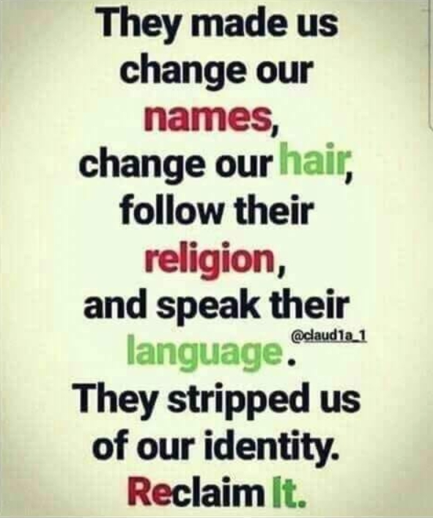

Military, the Nation of Islam, and Israelite camps … another reason for the military structure is that it trains a person to be a robot who follows commands, and follows them quickly. Think of combining that, with religious doctrine.
IUIC Army of The Most High
https://www.youtube.com/watch?v=InR5Cylwk0g
Why I left the Hebrew Israelite I C G J C CULT
https://www.youtube.com/watch?v=VQ7tK2w8H7U
You heard about the use of fear and intimidation. You heard about friendships being torn apart. You even heard that members are ordered, commanded, to stay away from certain videos, that is, information. And if you do your research you’ll see that this happens in all of the camps.
Facebook propaganda:
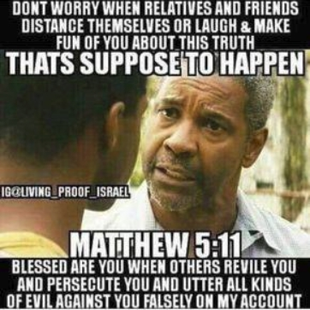
ZABACH EXPOSED PAID AGENTS 6-29-2018
https://www.youtube.com/watch?v=ozrIyL2TTPc
"THE FINANCE$" - The Truth About Your Tithes & Priest Fund - coming soon
https://www.youtube.com/watch?v=z0XOxI3J-V8
I remember watching a GMS video where their so-called elder told his followers to sell items on the street in order to bring in tithes.
This next video brings many things to light, but it’s hard to get through because the presenter gets interrupted constantly (so try to hang in there).
Proof IUIC Is a Cult
https://www.youtube.com/watch?v=6-DLwLBbx9o
Additional videos can be found here:
https://www.youtube.com/user/ttv2050/videos
https://www.youtube.com/channel/UCbKWOWeLeBBHUZb8EtCgEIw/videos
Note: Camps are not the only ones deceiving the public. There are individuals and groups of two or more, men and women, who are doing the same. And then there are the people who don’t know what they’re talking about so shouldn’t be teaching; they have the same effect.
Examples
This guy has been on my list for a very long time. And I just saw that he got into it with someone else and has been exposed. I also read a comment which stated that he was from the GOCC. If true, that would explain a lot.

https://www.youtube.com/user/JediYahReturns
These two are something special. It’s funny how they pretend not be die-hard racists. And the fact that they and Jediyah are fighting means nothing. It could be real, it could be fake; but they are all fakes.
https://www.youtube.com/user/watchmanreports

This guy…. I had to add him to the list this past year. Some of his work sounds good, until you fact-check, then you’ll find things that aren’t mistakes, but clear, purposeful lies. He is beyond devious.

https://www.youtube.com/channel/UCGr2taJjLTQHD-J0WMJPv1Q

I called these people out because I know for a fact that they are slimly snakes, not just people who are reckless or lacking in understanding (like many others who shouldn’t be teaching). And of course, you don’t have to believe me. But just like anyone else in this project I mentioned as being a fraud, I can prove it. You’re already going to see the lies of the documentary Whited Out in part 10 of this overall project, so the “Watchman” and his wife are already gone. And there are others. And all I need is the word from Yah/God and any other person will get silenced. Just like what happened here.
JAMES
CHAPTER 3
Not many of you should become teachers, my brothers, for you know that we
who teach will be judged with greater strictness.
If you join a group or attach yourself to any teacher, you’re going to be given their interpretation of things (history, religion, current affairs, etc.) by a number of different means. You will then support it, protect it, and may even teach it. You may even teach it on the streets (taking it to the people who are not getting brainwashed online). How is that different from the average Christian preacher who is first indoctrinated, then spreads what he was taught? And doesn’t the other side control his source of indoctrination (usually seminary) also? Do you realize that pretty much everything you just recently accused and disliked Christians, Christianity, preachers, and the Black Church for – laughing and mocking – you later went and did or had done to you? What did you just say about Christians and tithes? And yet people are taking tithes from you, or you’re paying for speaking engagements. What did you just say about how Christian preachers are only out for money? And it goes on and on (one example). The Black Church this; the Black Church that. And look at you, played like a prostitute. And it took less than ten years. “You older people aren’t smart like us. Your generation was asleep; we’re awake.” And speaking of being awake, when Malcolm X awakened, it was in regards to racism; and also certain facts about his teacher and group. So, when he was racist he was what? Asleep. And how did he get in that state? He was asleep, in a dream, and someone/some group enticed him into an “awakening” that was really just another dream (he thought he was now awake). And they used his talent, skill, time, and effort to push false doctrine to the masses. Malcolm X was a cult victim whose heart was in the right place, and the same is true for some people caught up in today’s groups and movements (the New Age included).
To all real Israelites
Why are you allowing these fools to stand in your neighborhood, or anywhere within driving distance, and preach hate and false doctrine in your name??? Why are you allowing these fools to preach hate and false doctrine in the name of your Father??? Why are you allowing these fools to preach hate and false doctrine in the name of your Messiah??? Why are you allowing these fools to preach hate and false doctrine in the name of your holy scriptures??? They are even hitting, kicking, spitting on, disrespecting, and threatening innocent people in your name, your Father’s name; in your Messiah’s name, and in the name of your holy scriptures. With all of this, and more, there is no way you should be idle. There is no way you should be silent. Get your butts up, gather some soldiers, and drive these fools out!

Ideas for driving them out:

Make signs that counter what they teach, or that have statements proclaiming them to be false, informants, or something similar.

Use a bullhorn or microphone to tell the people they are false, and to combat their false doctrine with truth. Make it so that they can’t get their false doctrine out. You need to tell the people that this is not what Israelites are about.

Buy some stink-bombs and use them. I’m sure you can find some on Ebay.com or Amazon.com.
[I can think of many other things, but I don’t want to tell you anything that would get you into trouble.]
Repeat, repeat, repeat … until they are gone for good.

And of course, pray before you go into battle, and make sure you are clean.
Now, when it comes to the internet all you have to do is comment using the information found here, or simply state how false they are and post a link to some other proof. And you should definitely give as many of their videos a “thumbs down” or “dislike” as possible. You should do this constantly, as much as you can. You should drive them away to the point it was like they never existed (think of it as an information war).
To foreign countries
I’ve noticed that these camps have taken their “message” overseas. Do you realize that right now, in your country, you have operatives who are spreading propaganda, creating organizations, and influencing individuals and groups? These are not regular people who have come to your country. It’s clear that they are either working for a US intelligence agency (a foreign intelligence agency) or being handled and funded like George Soros does Black Lives Matter. And there’s no telling what they are really up to in your country. In the US, one of the things they have been used to do is foment a revolution against whites, Christianity, and the police. You might want to have some type of concern. And they’re not men of Yah/God, so do whatever you want to do with them (but judge between the truly guilty and the duped).
JAMES
CHAPTER 3
13 Who is a wise man and endued with knowledge among
you? let him shew out of a good conversation his works
with meekness of wisdom.
14 But if ye have bitter envying and strife in your hearts,
glory not, and lie not against the truth.
15 This wisdom descendeth not from above, but is earthly,
sensual, devilish.
16 For where envying and strife is, there is confusion and
every evil work.
17 But the wisdom that is from above is first pure, then
peaceable, gentle, and easy to be intreated, full of mercy
and good fruits, without partiality, and without hypocrisy.
18 And the fruit of righteousness is sown in peace of them
that make peace.
MATTHEW
CHAPTER 7
15 ¶ Beware of false prophets, which come to you in
sheep’s clothing, but inwardly they are ravening wolves.
16 Ye shall know them by their fruits. Do men gather
grapes of thorns, or figs of thistles?
17 Even so every good tree bringeth forth good fruit; but a
corrupt tree bringeth forth evil fruit.
18 A good tree cannot bring forth evil fruit, neither can a
corrupt tree bring forth good fruit.
19 Every tree that bringeth not forth good fruit is hewn
down, and cast into the fire.
20 Wherefore by their fruits ye shall know them.
LUKE
CHAPTER 3
7 Then said he to the multitude that came forth to be
baptized of him, O generation of vipers, who hath warned
you to flee from the wrath to come?
8 Bring forth therefore fruits worthy of repentance, and
begin not to say within yourselves, We have Abraham to
our father: for I say unto you, That God is able of these
stones to raise up children unto Abraham.
9 And now also the axe is laid unto the root of the trees:
every tree therefore which bringeth not forth good fruit is
hewn down, and cast into the fire.
JEREMIAH
CHAPTER 2
MOREOVER the word of the LORD came to me, saying,
2 Go and cry in the ears of Jerusalem, saying, Thus saith
the LORD; I remember thee, the kindness of thy youth, the
love of thine espousals, when thou wentest after me in the
wilderness, in a land that was not sown.
3 Israel was holiness unto the LORD, and the firstfruits of
his increase: all that devour him shall offend; evil shall
come upon them, saith the LORD.
4 Hear ye the word of the LORD, O house of Jacob, and all
the families of the house of Israel:
5 ¶ Thus saith the LORD, What iniquity have your fathers
found in me, that they are gone far from me, and have
walked after vanity, and are become vain?
6 Neither said they, Where is the LORD that brought us up
out of the land of Egypt, that led us through the wilderness,
through a land of deserts and of pits, through a land of
drought, and of the shadow of death, through a land that no
man passed through, and where no man dwelt?
7 And I brought you into a plentiful country, to eat the fruit
thereof and the goodness thereof; but when ye entered, ye
defiled my land, and made mine heritage an abomination.
8 The priests said not, Where is the LORD? and they that
handle the law knew me not: the pastors also transgressed
against me, and the prophets prophesied by Baal, and
walked after things that do not profit.
9 ¶ Wherefore I will yet plead with you, saith the LORD,
and with your children’s children will I plead.
10 For pass over the isles of Chittim, and see; and send unto
Kedar, and consider diligently, and see if there be such a
thing.
11 Hath a nation changed their gods, which are yet no
gods? but my people have changed their glory for that
which doth not profit.
12 Be astonished, O ye heavens, at this, and be horribly
afraid, be ye very desolate, saith the LORD.
13 For my people have committed two evils; they have
forsaken me the fountain of living waters, and hewed them
out cisterns, broken cisterns, that can hold no water.
14 ¶ Is Israel a servant? is he a homeborn slave? why is he
spoiled?
15 The young lions roared upon him, and yelled, and they
made his land waste: his cities are burned without
inhabitant.
16 Also the children of Noph and Tahapanes have broken
the crown of thy head.
17 Hast thou not procured this unto thyself, in that thou hast
forsaken the LORD thy God, when he led thee by the way?
18 And now what hast thou to do in the way of Egypt, to
drink the waters of Sihor? or what hast thou to do in the
way of Assyria, to drink the waters of the river?
19 Thine own wickedness shall correct thee, and thy
backslidings shall reprove thee: know therefore and see that
it is an evil thing and bitter, that thou hast forsaken the
LORD thy God, and that my fear is not in thee, saith the
Lord GOD of hosts.
20 ¶ For of old time I have broken thy yoke, and burst thy
bands; and thou saidst, I will not transgress; when upon
every high hill and under every green tree thou wanderest,
playing the harlot.
21 Yet I had planted thee a noble vine, wholly a right seed:
how then art thou turned into the degenerate plant of a
strange vine unto me?
22 For though thou wash thee with nitre, and take thee
much soap, yet thine iniquity is marked before me, saith the
Lord GOD.
23 How canst thou say, I am not polluted, I have not gone
after Baalim? see thy way in the valley, know what thou
hast done: thou art a swift dromedary traversing her ways;
24 A wild ass used to the wilderness, that snuffeth up the
wind at her pleasure; in her occasion who can turn her
away? all they that seek her will not weary themselves; in
her month they shall find her.
25 Withhold thy foot from being unshod, and thy throat
from thirst: but thou saidst, There is no hope: no; for I have
loved strangers, and after them will I go.
26 As the thief is ashamed when he is found, so is the house
of Israel ashamed; they, their kings, their princes, and their
priests, and their prophets,
27 Saying to a stock, Thou art my father; and to a stone,
Thou hast brought me forth: for they have turned their back
unto me, and not their face: but in the time of their trouble
they will say, Arise, and save us.
28 But where are thy gods that thou hast made thee? let
them arise, if they can save thee in the time of thy trouble:
for according to the number of thy cities are thy gods, O
Judah.
29 Wherefore will ye plead with me? ye all have
transgressed against me, saith the LORD.
30 In vain have I smitten your children; they received no
correction: your own sword hath devoured your prophets,
like a destroying lion.
31 ¶ O generation, see ye the word of the LORD. Have I
been a wilderness unto Israel? a land of darkness?
wherefore say my people, We are lords; we will come no
more unto thee?
32 Can a maid forget her ornaments, or a bride her attire?
yet my people have forgotten me days without number.
33 Why trimmest thou thy way to seek love? therefore hast
thou also taught the wicked ones thy ways.
34 Also in thy skirts is found the blood of the souls of the
poor innocents: I have not found it by secret search, but
upon all these.
35 Yet thou sayest, Because I am innocent, surely his anger
shall turn from me. Behold, I will plead with thee, because
thou sayest, I have not sinned.
36 Why gaddest thou about so much to change thy way?
thou also shalt be ashamed of Egypt, as thou wast ashamed
of Assyria.
37 Yea, thou shalt go forth from him, and thine hands upon
thine head: for the LORD hath rejected thy confidences, and
thou shalt not prosper in them.
EZEKIEL
CHAPTER 34
AND the word of the LORD came unto me, saying,
2 Son of man, prophesy against the shepherds of Israel,
prophesy, and say unto them, Thus saith the Lord GOD unto
the shepherds; Woe be to the shepherds of Israel that do
feed themselves! should not the shepherds feed the flocks?
3 Ye eat the fat, and ye clothe you with the wool, ye kill
them that are fed: but ye feed not the flock.
4 The diseased have ye not strengthened, neither have ye
healed that which was sick, neither have ye bound up that
which was broken, neither have ye brought again that which
was driven away, neither have ye sought that which was
lost; but with force and with cruelty have ye ruled them.
5 And they were scattered, because there is no shepherd:
and they became meat to all the beasts of the field, when
they were scattered.
6 My sheep wandered through all the mountains, and upon
every high hill: yea, my flock was scattered upon all the
face of the earth, and none did search or seek after them.
7 ¶ Therefore, ye shepherds, hear the word of the LORD;
8 As I live, saith the Lord GOD, surely because my flock
became a prey, and my flock became meat to every beast of
the field, because there was no shepherd, neither did my
shepherds search for my flock, but the shepherds fed
themselves, and fed not my flock;
9 Therefore, O ye shepherds, hear the word of the LORD;
10 Thus saith the Lord GOD; Behold, I am against the
shepherds; and I will require my flock at their hand, and
cause them to cease from feeding the flock; neither shall the
shepherds feed themselves any more; for I will deliver my
flock from their mouth, that they may not be meat for them.
11 ¶ For thus saith the Lord GOD; Behold, I, even I, will
both search my sheep, and seek them out.
12 As a shepherd seeketh out his flock in the day that he is
among his sheep that are scattered; so will I seek out my
sheep, and will deliver them out of all places where they
have been scattered in the cloudy and dark day.
13 And I will bring them out from the people, and gather
them from the countries, and will bring them to their own
land, and feed them upon the mountains of Israel by the
rivers, and in all the inhabited places of the country.
14 I will feed them in a good pasture, and upon the high
mountains of Israel shall their fold be: there shall they lie in
a good fold, and in a fat pasture shall they feed upon the
mountains of Israel.
15 I will feed my flock, and I will cause them to lie down,
saith the Lord GOD.
16 I will seek that which was lost, and bring again that
which was driven away, and will bind up that which was
broken, and will strengthen that which was sick: but I will
destroy the fat and the strong; I will feed them with
judgment.
17 And as for you, O my flock, thus saith the Lord GOD;
Behold, I judge between cattle and cattle, between the rams
and the he goats.
18 Seemeth it a small thing unto you to have eaten up the
good pasture, but ye must tread down with your feet the
residue of your pastures? and to have drunk of the deep
waters, but ye must foul the residue with your feet?
19 And as for my flock, they eat that which ye have trodden
with your feet; and they drink that which ye have fouled
with your feet.
20 ¶ Therefore thus saith the Lord GOD unto them; Behold,
I, even I, will judge between the fat cattle and between the
lean cattle.
21 Because ye have thrust with side and with shoulder, and
pushed all the diseased with your horns, till ye have
scattered them abroad;
22 Therefore will I save my flock, and they shall no more
be a prey; and I will judge between cattle and cattle.
23 And I will set up one shepherd over them, and he shall
feed them, even my servant David; he shall feed them, and
he shall be their shepherd.
24 And I the LORD will be their God, and my servant David
a prince among them; I the LORD have spoken it.

*Warning – Strong Language (something different intended)*
Colors Final
https://www.youtube.com/watch?v=uUzip4dyOx4
Franklin Miller (Writeous1)
http://howmanyknow.com/
writeousservant@gmail.com
writeous1@howmanyknow.com
https://www.facebook.com/franklin.miller.169
https://www.youtube.com/channel/UC6UWuuP9KUSYMIYU-nxmHNw

