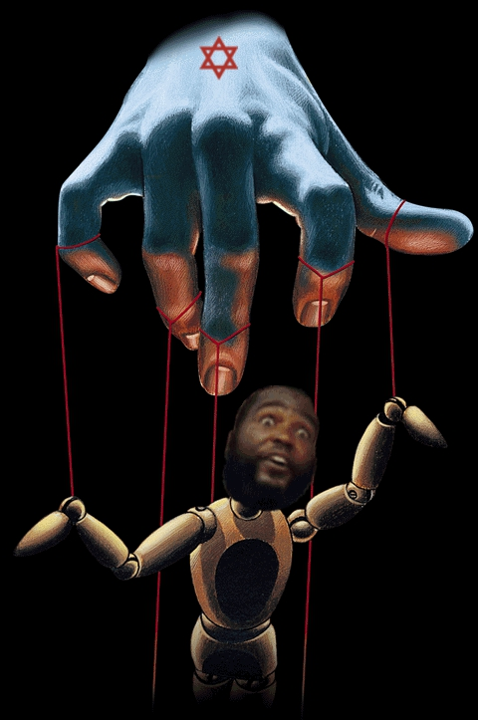
Black Lies Matter

- Let me warn you that most of these videos are filled with derogatory language. It’s so prevalent you might think there’s a Conscious community rule that you have to speak this way.
- Most of the videos exposing these people have been removed from Youtube.
- Keep in mind that a lot of what goes on online through profiles may not be the actions of regular citizens.
- What you may not know is that when plots are created every consequence is accounted for and turned into a benefit. These plots are also designed to morph into a benefit, usually aid for another agenda, if and when destroyed. For instance, Youtube is filled with videos claiming to expose black leaders of the past so blacks will not want leaders. This is another agenda. The powers that be know that if these new black “teachers” and “leaders” are exposed, black people will never trust or want a leader. This is what they hope exposing them will morph into.
DR. SEBI
DR. SEBI - THE TRUTH ABOUT THE COURT CASE HE "LOST!"
https://www.youtube.com/watch?v=fo0sEQF4I1E
Document:
https://www.casewatch.net/ag/ny/usha/consent_1988.pdf
"Doctor" Sebi was a fraud
https://www.youtube.com/watch?v=0_qwhU-mQFI
I don’t agree with every single statement in this next video, and the pauses are annoying, but he’s exposing the bigger picture. And he’s right about it.
THE DEEP DECEPTION OF WITCH DOCTOR SEBI FINALLY EXPOSED. REPOSTED FROM MAG BITTER TRUTH
https://www.youtube.com/watch?v=QiRg-f7-ou4
And if you recall, the System promoted other black puppets of this community (and outside of this community). FYI: Vlad TV is also a part of the System. And so is The Breakfast Club.
Dr. Sebi Scandal! Beware Of The Scammers!
https://www.youtube.com/watch?v=VOvrIf6U_e4
… a family of con artists.
WIFE OF DR SEBI TELLS TRUTH FINALLY!
https://www.youtube.com/watch?v=GKVCthBmcAA
Brother Polight
Polight Decoded 1 (POLIGHT TOOK DOWN THIS VIDEO)
https://www.youtube.com/watch?v=hBD0JYeb4Aw
Polight decoded 2
https://www.youtube.com/watch?v=1PZ0zNb7I1k
The video Polight doesn't want you to see Part 2
https://www.youtube.com/watch?v=7pKcUKRgShc
POLIGHT - GIVE THE PEOPLE THEIR MONEY BACK!
https://www.youtube.com/watch?v=9GYSNhJ32TM
Brother Polight comes clean about Nu-Covenant
https://www.youtube.com/watch?v=Y860GGz95pY
The Darkside of Brother Polight
https://www.youtube.com/watch?v=X0RojbNSpDc
BRO. POLIGHT'S LATEST SCAM 2018 currently
https://www.youtube.com/watch?v=qZguP0cjUWA
Brother POLIGHT Comes Clean!! Fraudulent Behaviour Exposed!!
https://www.youtube.com/watch?v=rwj1-DXMm0k
NO MERCY FOR SCAMMERS!!!
https://www.youtube.com/watch?v=W6T30b8j6Hk
Young Pharaoh
I don’t agree with the reptilian theories in this next video, but other than that it’s informative.
The Dark Side of Young Pharaoh
https://www.youtube.com/watch?v=IhN_AwT73yc
The People Call Out Young Pharaoh For Scamming
https://www.youtube.com/watch?v=Pg3rphP-_uo
Brother Polight and Young Pharaoh- Status Correction
https://www.youtube.com/watch?v=ukz2Ng4ap9w
Young Pharaoh exposed FOR SCAMMING THE BLACK COMMUNITY
https://www.youtube.com/watch?v=DNW9iyX36-Y
Pharaoh Tells More Lies About Legal Fee Scam $15,000
https://www.youtube.com/watch?v=MxWso_BPrBU
Young Pharaoh What Else Can You Say To Me?
https://www.youtube.com/watch?v=WslT5pj3mgU
Young Pharaoh Legal Fee Scam More Receipts For $15,000
https://www.youtube.com/watch?v=UReGqf2eEWE
YOUNG PHARAOH IS TRYING TO HAVE MY CHANNEL DELETED FOR THE SECOND TIME!!
https://www.youtube.com/watch?v=2JYouk-JHT8
YOUNG PHARAOH YOU SHOULD BE ASHAMED OF YOURSELF
https://www.youtube.com/watch?v=jXjwW-hxGP4
Young Pharaoh EXPOSED - Reveals His European Teacher
https://www.youtube.com/watch?v=lwZMvsJdUW0
Tariq Nasheed
Umar Johnson and TERESA Nasheed Pimping the People
https://www.youtube.com/watch?v=e2LzM2hsSIs
Hidden Colors 4 The Art of Scamming! Tariq Nasheed Exposed By Youtuber Ancient Black Americans
https://www.youtube.com/watch?v=PbpBPj9sq8I
Tariq Nasheed EXPOSED - PIMPIN The Black Community Is Easy When You Know The Game
https://www.youtube.com/watch?v=F2yHINjhPfY
Rosebudd Speaks On Tariq Nasheed
https://www.youtube.com/watch?v=_efIMx_gHlU
What Happened to Tariq Nasheed
https://www.youtube.com/watch?v=OSs8Nu2YNes
Tariq Nasheed admits to being "pro-black" for the money
https://www.youtube.com/watch?v=rF1ZzkW2tjs
Tariq Nasheed: Master Troll or Complete Imbecile?
https://www.youtube.com/watch?v=lnKKQOMI5I4
Tariq Nasheed Is a Criminal
https://www.youtube.com/watch?v=COyq4Mm9RKY
People Are Hypnotised By Slick Talkers Like Tariq Nasheed
https://www.youtube.com/watch?v=8pyNhe5nwBU
Don't trust these ProBlack Pimps Tariq Nasheed and Dr Umar Johnson
https://www.youtube.com/watch?v=QIRfKjcJiUs
Hidden Colors 2 | The Debunk
https://www.youtube.com/watch?v=cHi5Nf3rp9Y
Tariqology | The Religion of WOKE Supremacy
https://www.youtube.com/watch?v=5b6OZ6E7A1g
People donated money to Tariq, that is, they gave Tariq money to make the documentaries! And then he turned around and sold it to them at a price that was higher than regular, quality documentaries. Isn’t the bulk, or entirety, of one of the documentaries just a handful of people talking? How much money did it take to film a few people sitting down talking? His fans don’t know. Didn’t he have enough money to make the second documentary from the donations and profits from the first? How much money did it take to make each of the documentaries? His fans don’t know. How much did he make from each documentary? His fans don’t know. But they gave money to bring it about again and again. They essentially gave money to be lied to.

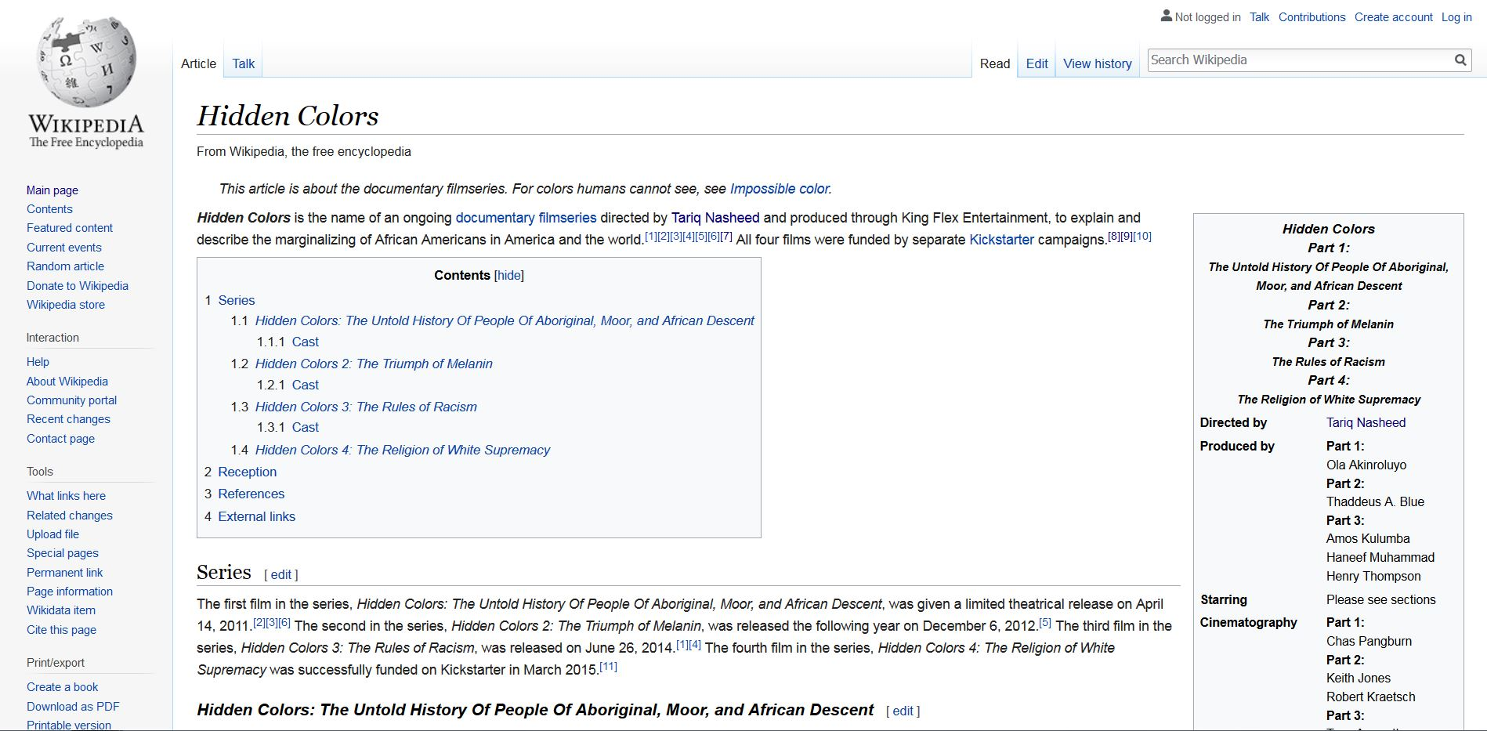

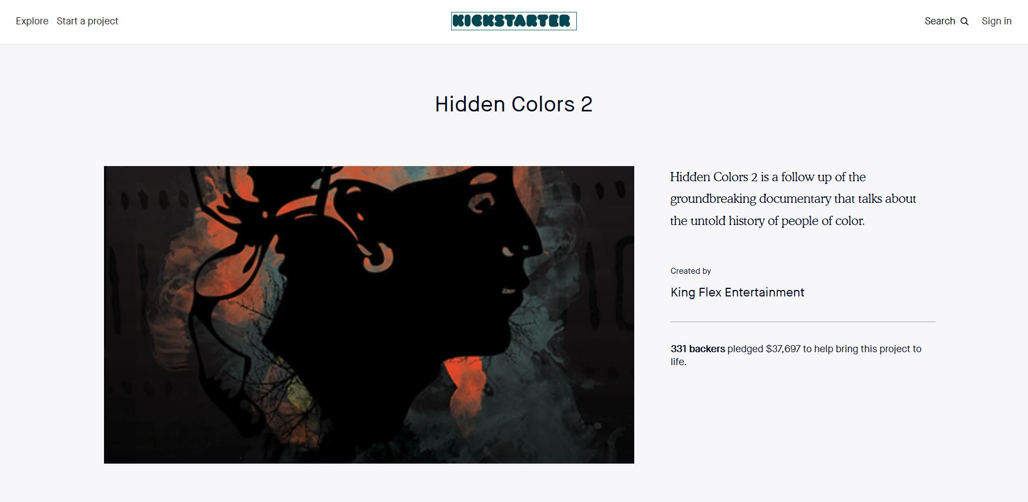
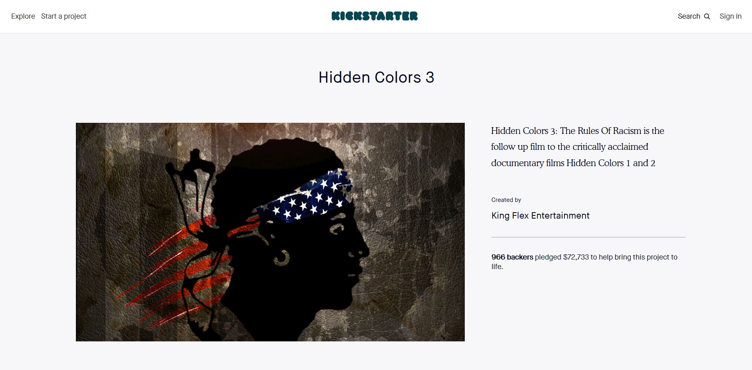

Umar Johnson
Umar Prince of Scam Africanism Johnson; 1 Million Lies Debunked: Intro
https://www.youtube.com/watch?v=AhOe8j7ZGr0
Dr. Umar Johnson Panics When Asked to Show His Accounting
https://www.youtube.com/watch?v=0pctpRgDaqE
Umar Johnson Claims PayPal Has Frozen $125000 In Donations
https://www.youtube.com/watch?v=Bl_k3E9bZP8
Umar Johnson-Busted Again! Hear His Lies! Tries To Stop GoFundMe Ban!-Same W/PayPal!
https://www.youtube.com/watch?v=ZsHQjepIhL4
The Darkside of Umar Johnson
https://www.youtube.com/watch?v=8K8_SB9XE4U
The Problems with Umar
https://www.youtube.com/watch?v=CKuV77cKYbI
umar pt2
https://www.youtube.com/watch?v=NhaDFIklGs8
Dr. Umar Johnson Exposed Himself As A Hotep Hustler
https://www.youtube.com/watch?v=HZMLp7SLbaI
General Seti VS Dr Umar Johnson!! CONSCIOUS COMMUNITY WARS PART 4. MUST WATCH!!
https://www.youtube.com/watch?v=IfJ9n5gwGto
One of the funny, sad, and disturbing parts of the rant:
Dr Umar Answers Phone while it is ringing? LoL Teach me how to do this one
https://www.youtube.com/watch?v=H-fqoeSoQxQ
That shows you the kind of person you’re dealing with.
Dr Umar Responds to the "Fake Phone Call"
https://www.youtube.com/watch?v=HDcs-AuFAzg
Umar Johnson "APOLOGIZES" then sends youtubers emails demanding that they take down his rant video
https://www.youtube.com/watch?v=tGmTzt6qu28
You can probably find a copy of the rant and so-called apology (if you want), the videos I bookmarked were deleted from Youtube.
Umar Can't Answer Basic Questions
https://www.youtube.com/watch?v=_kwj2NorKAQ
Dr Umar Johnson Answers Black Critics About His School Why We Need To Rebuild In Africa
https://www.youtube.com/watch?v=RQfE8EC59i8
Exposing a Fraudulant Leader-My Thoughts
https://www.youtube.com/watch?v=eRTjomhghwQ
Umar Johnson's St Paul's College was a SCAM FROM THE START
https://www.youtube.com/watch?v=oi0bYG8uwZw
Dr Umar Johnson Caught In Another Lie Due To Fried Chicken Eating
https://www.youtube.com/watch?v=ozmmluFoaU0
Umar Johnson was LYING, Y'all!!
https://www.youtube.com/watch?v=mfcO8IQ2WnM
Who would let their tax exempt status be taken away for not filing documents for three consecutive years? Why didn’t he file? He would have had to show where all the money was going!
Watch the beginning – 6:08
Umar Johnson’s-Delusional Dumpster Fire Of Lies Rages On-Feds REVOKE Umar’s Non-Profit Status!
https://www.youtube.com/watch?v=77yTROesfwk
Umar Johnson-FDMG Non-Profit Status REVOKED By Feds-Umar Keeps Swindling Using FDMG!
https://www.youtube.com/watch?v=eMgPKD2K6Qc
Watch/listen from 0:58 – 25:35
Umar Johnson Prince of PERJURY Continues To Be Exposed As A TOTAL Pathological LIAR!
https://youtu.be/g8t4xnQZisk?t=58s
Umar Johnson-Bragged $700,000 In Bank w/FDMG Name w/o GoFundMe-Liar Spends $$ On SELF!
https://www.youtube.com/watch?v=FtRAbYU55vQ
Chief X Drops Knowledge on Umar Johnson and Real Estate
https://www.youtube.com/watch?v=UbEl0dF6IO4
Umar Johnson w/Umarians In Tow False-Flag Rampaging After Umar's Channel Is Kicked To Da Curb!
https://www.youtube.com/watch?v=T6HjZlh6M0w
Watch 5:48 - the end
King Noble Tags Tariq Nasheed's Umar Johnson-Esque "I'm NOT Pro-Black If/When Cops Show Up" Stance!
https://youtu.be/oHPwD1bqyV4?t=5m48s
The Death Of Umar Johnson
https://www.youtube.com/watch?v=zuMwFQbCxGo
Umar Johnson: Award Winning Con Man Cold-Busted, LYING Again! 4 Million Lies Debunked!
https://www.youtube.com/watch?v=kofeK1e6IJI
Part 1 of 3: FINAL DECISION MADE In Umar Johnson Psychologist Perp Case (Details)
https://www.youtube.com/watch?v=j5Y0YPZNedk
Part 2 of 3: DECISION RENDERED In Umar Johnson Psychologist Perp Case/Charges (Commentary)
https://www.youtube.com/watch?v=NHxHwCnR4wo
Pt.1/2: New Legal Doc: ALL The LIES Umar Johnson Told During Bd. Of Psychology Case!
https://www.youtube.com/watch?v=rkcsLb-Xxkw
Pt.2/2: New Legal Doc: ALL The LIES Umar Johnson Told During Bd. Of Psychology Case!
https://www.youtube.com/watch?v=ozekMH4u5_0
P.2-Umar Johnson’s Self-Incrimination And Mega Lies Even Causes His Own Head To Spin!!
https://www.youtube.com/watch?v=wPg8FkuZhD0
Part 3 Umar Johnson's Self Incrimination: Court Certified Liar Cold Busted!
https://www.youtube.com/watch?v=ChS6C--GxSE
UMAR JOHNSON'S SCHOOL SCAM Part 6 ~ Umar Johnson’s Gofundme Drama: Is It An Excuse?
https://www.youtube.com/watch?v=OkNWKn5pty0
How much money did Umar actually raise? No one knows. How much has he made from other sources, such as speaking engagements? No one knows. There are people who would actually be content with a school even though they have no idea how much money was raised nor spent on the school. That’s sad.
Umar Johnson Has Nowhere To Hide. GoFundMe & PayPal Coming For Dat Thievin' Azz!
https://www.youtube.com/watch?v=lY9SiGt_pqQ
GoFundMe has always been the money laundering medium for paying off crisis actors.
(2/09/2019) DR. UMAR JOHNSON NEW FDMG SCHOOL
https://www.youtube.com/watch?v=qu9pVGONIW0
Dr Umar Johnson FDMG Academy Campus Look
https://www.youtube.com/watch?v=8IlfYDS34e0
Real-Deal Facts! Debunking Umar Johnson's Lies Told During His Bomb Shelter “School” Tour!
https://www.youtube.com/watch?v=qHT5Rbn7eNA
Umar Johnson's "Deed" & Blasted Out, Abandoned Bomb Shelter Perped As "School" Both D.O.A!
https://www.youtube.com/watch?v=oSuXr667fOY
UMAR JOHNSON SCHOOL FINANCING EXPOSED
https://www.youtube.com/watch?v=CVbKO9ytqWQ
I Don't Feel Sorry For Any Of You STUPID NEGROS Who Were Drinking Umar Johnsons Kool-Aid
https://www.youtube.com/watch?v=jxo9Aq0dYhI
I warned people about Umar Johnson (Jermaine SHOEMAKE), years ago!!
https://www.youtube.com/watch?v=dHAO8LOozbs
I don’t believe the donation money has been spent. And he could travel on the money from speaking engagements.
And remember, these puppets are performing on a stage having a puppet master controlling them. They are a part of something much bigger.
Dr. UMAR JOHNSON CHARLESTON S.C. NBPP RALLY
https://www.youtube.com/watch?v=fIUNGIqIqW4
Umar Johnson Loses It Blows His 1 Fuse Can't Get 18 Mil Weekly and Women Like Black Church Does
https://www.youtube.com/watch?v=eBV2nM7rynU
Miscellaneous
Now We Got Our Favorite You Tube Channels Promoting the Race War! (THE TRUTH AIN'T EASY TO TELL!)
https://www.youtube.com/watch?v=RD_o6oV5RAM
Phil From The Advise Show Exposed As A Black Women Hater
https://www.youtube.com/watch?v=Cr9gYtB1PtY
The Advise Show Tv explaining why his wife isn't Black
https://www.youtube.com/watch?v=ugDvGxhNTSQ
Sara Suten Seti Was Down With Pharaoh $12,000 Legal Fee Scam SMH
https://www.youtube.com/watch?v=qntQc43iwKE
"Albino"General Sara Suten Seti is This You !
https://www.youtube.com/watch?v=XOpMN3sYlpk
Pharaoh Said That: Sara Suten Seti Is A Fake General & Young Pharaoh Got Punk'd
https://www.youtube.com/watch?v=Fkr7XI0-5ZY
PROOF Sa Neter Knew JOEL Was A Scammer BEFORE He Introduced Joel To The Public
https://www.youtube.com/watch?v=BlFOiyWAzag
MINISTER ENQI EXPOSED.. sick of these fake health gurus
https://www.youtube.com/watch?v=8u58a6lDOXY
MESSAGE TO SaNETER and his stable of con-men/frauds
https://www.youtube.com/watch?v=CVbKO9ytqWQ
Elder of the Black "conscience" community exposes the mentality of the younger members
https://www.youtube.com/watch?v=zuid-hK4KBI
CONSCIOUS COMMUNITY EXPOSED
https://www.youtube.com/watch?v=OjiftZsivZw
Deception on Sa Neter TV
https://www.youtube.com/watch?v=QkthIwGSGeI
Seti, Ray Hagins and other Liars!
https://www.youtube.com/watch?v=3iV290XDcYo
Fake conscience scholarship
https://www.youtube.com/watch?v=CZal6icc0gQ
Conscious Community and the books they read!
https://www.youtube.com/watch?v=efoLVcTU1mA
Retiring They Came Before Columbus
https://www.youtube.com/watch?v=uJ0qE0Nxq1w
FROM ANCIENT ETHIOPIA TO THE OLMECS IN MEXICO!!! OLMEC TOUR
https://www.youtube.com/watch?v=6Bf_J6EmLsk
European influence on the conscious community
https://www.youtube.com/watch?v=QNv4EQ-KXoQ
The following has nothing to do with skin color, and it’s the same for when the Israelite Camps do it (though they may say it’s because of skin color and some may even believe it). And why do you think the Israelite Camps also do this? Sa Neter actually tells you why this is done, why it was developed by the puppet masters of the Israelite Camps and Black Conscious teachers.
Is That You White Jesus?
https://www.youtube.com/watch?v=idFOmnSHP9s
Did you catch the trick of using two different definitions of “image”?
New World Order puppets. And if you follow puppets on a string, the puppet master is controlling you as well.
Lauryn Hill - Mystery of iniquity MTV Unplugged 2.0
https://youtu.be/u-Th3EHpNQQ?t=148
Franklin Miller (Writeous1)
http://howmanyknow.com/
writeousservant@gmail.com
writeous1@howmanyknow.com
https://www.facebook.com/franklin.miller.169
https://www.youtube.com/channel/UC6UWuuP9KUSYMIYU-nxmHNw

