Here’s a bit of information proving the Botham Jean shooting was staged/a hoax. And if you don’t already know, there have been many staged shootings in this country; and not just mass shootings, shootings involving the police and black people. This is nothing new.
There’s not a lot to go through in order to expose this one, so this is going to be real quick. I added a lot of extra information after the exposé, starting at page 36, to deepen your understanding of these matters.
Tip: I suggest you download these videos and re-upload them with the same title, in the same place, or make one video out of them because they are probably going to be taken down soon.
Let’s get right into it.
It was claimed that the shooting occurred on September 6, 2018. And it may be hard for some to believe this was a hoax since that would mean the powers that be carried it out for a year, but please be aware that this is not the first time they’ve continued with a hoax long after the date of the incident. They’ve continued some for years, giving updates on how the alleged killer is doing in prison, or doing news stories about their court appearances. They’re still lying about September 11 aren’t they?
Let’s start by taking a look at this video.
Amber Guyger 911 call: What was she thinking after she shot Botham Jean?
https://www.youtube.com/watch?v=e_4FMXdDvmw
- 3:03 – “I’m inside the apartment with him.”
- 7:35 – “Hey! Over here, over here!”
- 7:39 – “No, it’s me! I’m off duty! I’m off duty.” But she was still in her uniform, as stated in the trial and seen in the body cam footage. And they were responding to an officer involved shooting.
- 7:41-7:46 – “I _____. I thought they were in my apartment … I thought this was my floor.”
- 7:46 – The phone hangs up.
Compare this to what you’re about to see and here, the body cam footage and neighbor’s footage in particular.
Alternative source:
911 Call: Dallas cop after shooting neighbor in his apartment (WARNING: STRONG LANGUAGE)
https://www.youtube.com/watch?v=nrNXXTaUiYw
Watch 11:20 - 23:08 and 48:05 - 50:59
Amber Guyger Testimony, Part 2
https://www.nbcdfw.com/news/local/guyger-testimony-full-pt-2-web_Dallas-Fort-Worth-561567902.html
- 12:54 – She said she got up to go look at what apartment she was in.
- 13:20 – She went back to Botham.
- 13:45 – She said she went back in to sit with Botham.
- 21:26 - 21:48 – Doesn’t that sound like she was inside the apartment and the officers came in to her?
- 22:39 – “After you left the apartment, officers arrived, did you….?” Huh?
- 48:27 – “I had to keep getting up to see where I was at?” Huh? Even if she just made a mistake, wouldn’t the prosecutors capitalize on this?
- 49:23 - 50:28 – Can you make any sense of this? She just said that after the officers came and told her to leave, she texted Martin Rivera the second time while in the hallway. He said no, and gave what seemed to be damage control.
- 50:29 - 50:59 – “And then you went out into the hall and you left him alone.” “When I heard the officers coming I stepped outside.”
Partial alternative source:
EMOTIONAL TESTIMONY: Former Dallas PD Officer Amber Guyger on trial in Texas
https://youtu.be/Ko8Z55c1WeQ?t=20
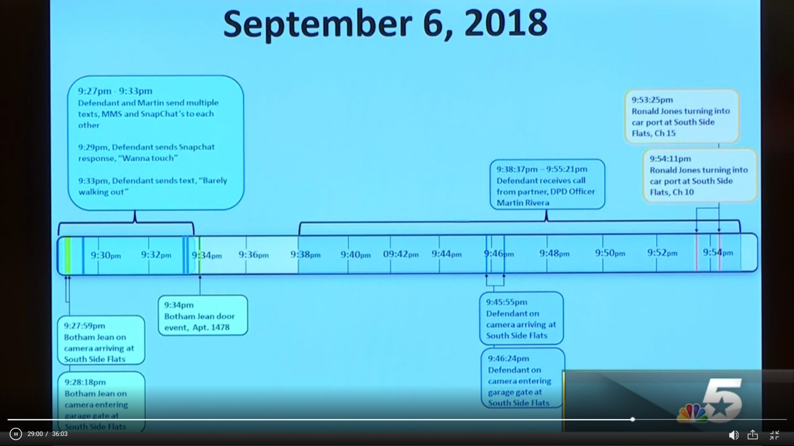

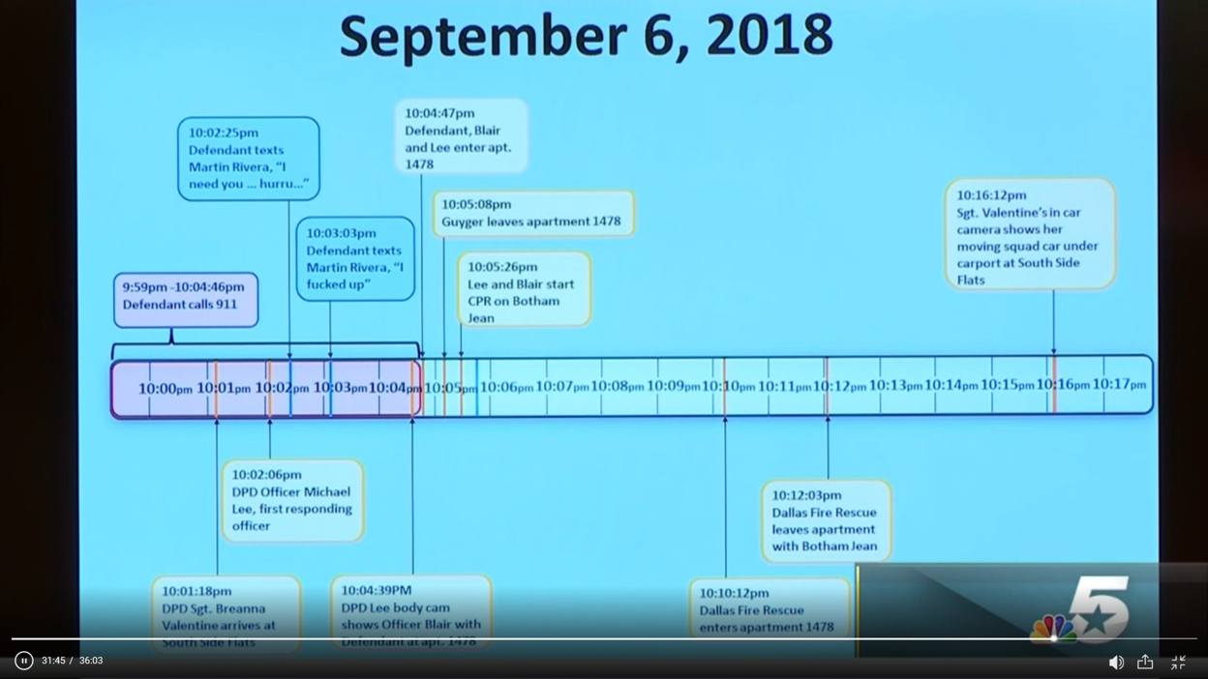
- True or false, the time markers of the 911 call are not going to be wrong? The time markers of the body cam footage are not going to be wrong?
- According to the timeline, she was still on the phone up until the exact moment both officers entered the apartment.
- According to the 911 call, about 5 seconds before the phone hung up she said, “I _____. I thought they were in my apartment … I thought this was my floor.” This should be close to 10:04:41. And less than a second after she finished that statement, the phone hung up. So, we should be able to hear this on the body cam footage.
For a full timeline watch from 18:59-31:47
https://www.nbcdfw.com/news/local/Guyger-Trial-Testimony-Christin-Noebel_Dallas-Fort-Worth-561352432.html
Now watch the body cam footage starting at 1:01:36 and compare:
https://www.nbcdfw.com/news/local/Guyger-Trial-Day-3-Testimony-David-Alexander_Dallas-Fort-Worth-561363852.html
- 1:01:44 – The officer on camera (Officer Blair) runs up to Amber who is in the hallway. Be sure to listen to her voice at 1:01:45. And then listen for the footsteps and screeching sound made on the floor; both of which should have been on the 911 call since she was supposedly on the phone at this point in time.
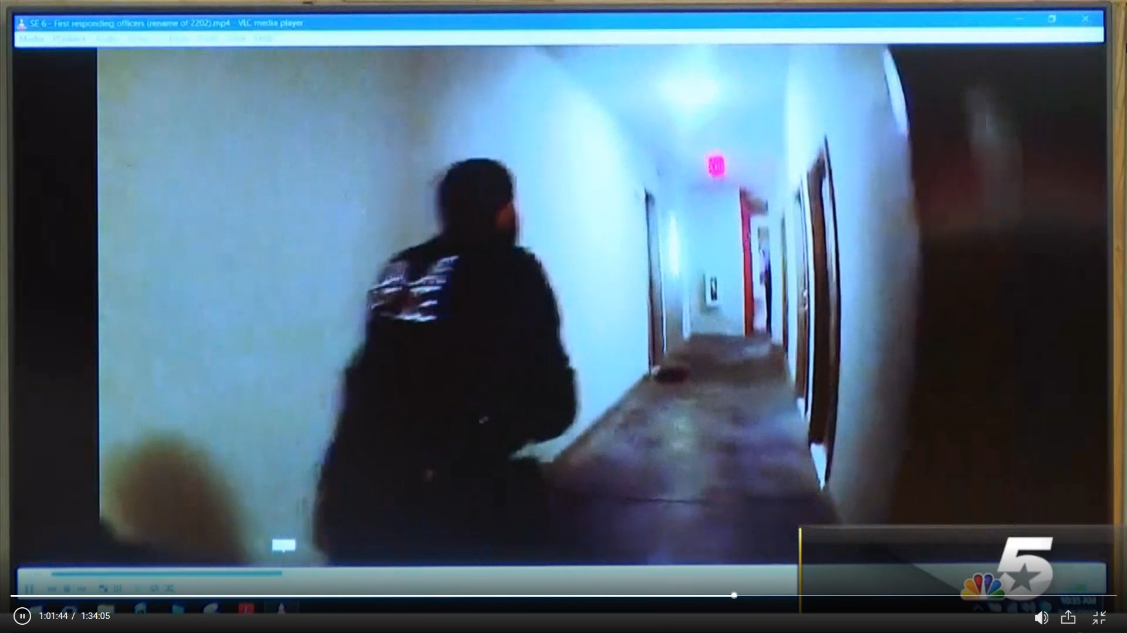

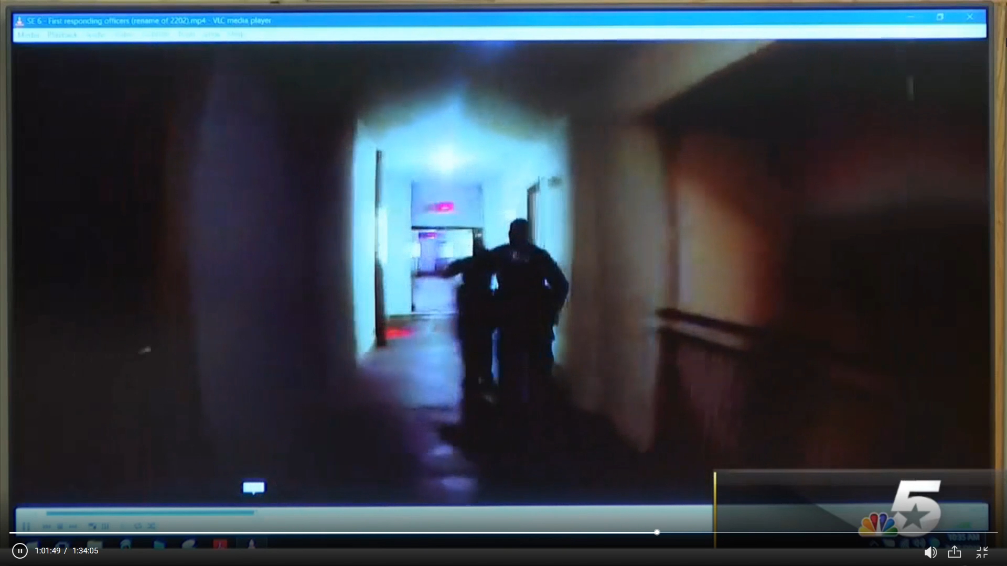
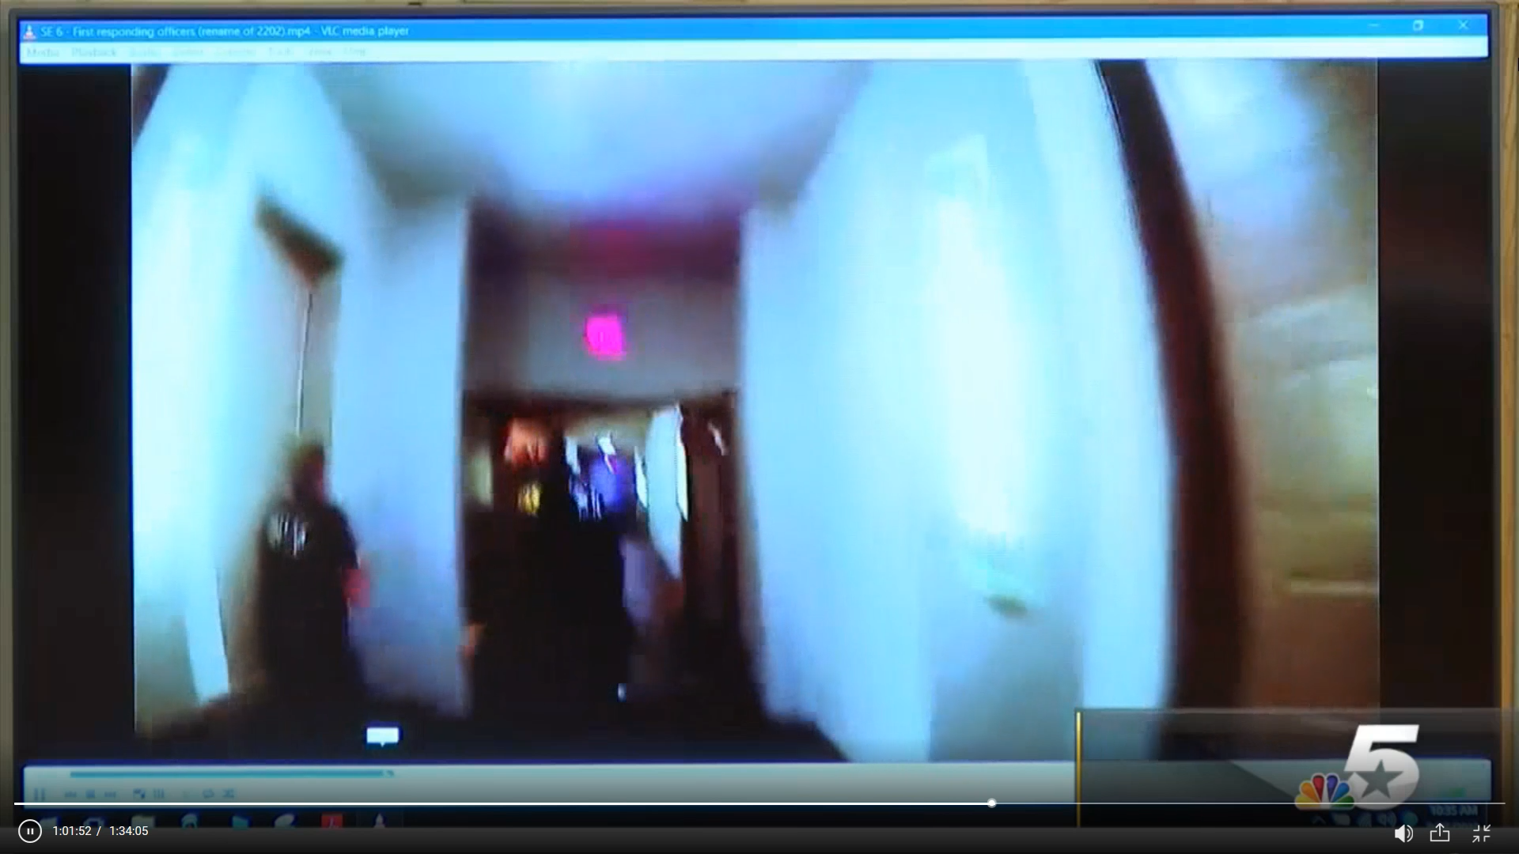
- 1:01:52 – “He’s in here.” This should have been on the 911 call! And the call ended when both responding officers entered, so the statement she made right before the call ended should have been on the body cam footage.
So, according to the body cam footage, the lead officers ran through the hallway to the apartment, and their first contact with Amber was in the hallway. Amber then led them into the apartment, somehow pushing open the door. It even looks and sounds like she turned the handle. Maybe this was one of the times the door didn’t lock. Or maybe she had sense enough to unlock it before she went out the door.
Now take a look at what ABC News did to the footage (but you can still see Amber at 0:38).
Body cam released in trial of ex-cop who shot man in his apartment l ABC News
https://www.youtube.com/watch?v=qPy9u33CHEw
Just from all of this alone you know it’s a staged event/hoax.
But that’s not all. Now scroll a little pass half way down the following page to “@bunny.babbs” videos and Instagram post, and compare this to the body cam footage and 911 call:
https://heavy.com/news/2018/09/amber-guyger/
If this was actually a real event it would have been impossible for her video to have been filmed when she said it was. If the event was actually real her video would have had to have been filmed after the officers went in the room and told Amber to leave. Why? The body cam footage, the 911 call, and the fact that an officer walks (walks, not runs) down the hallway at the end of the video (32 second mark). And it looks as though this same officer runs down the hallway at the end of the CPR video. But that’s debatable.
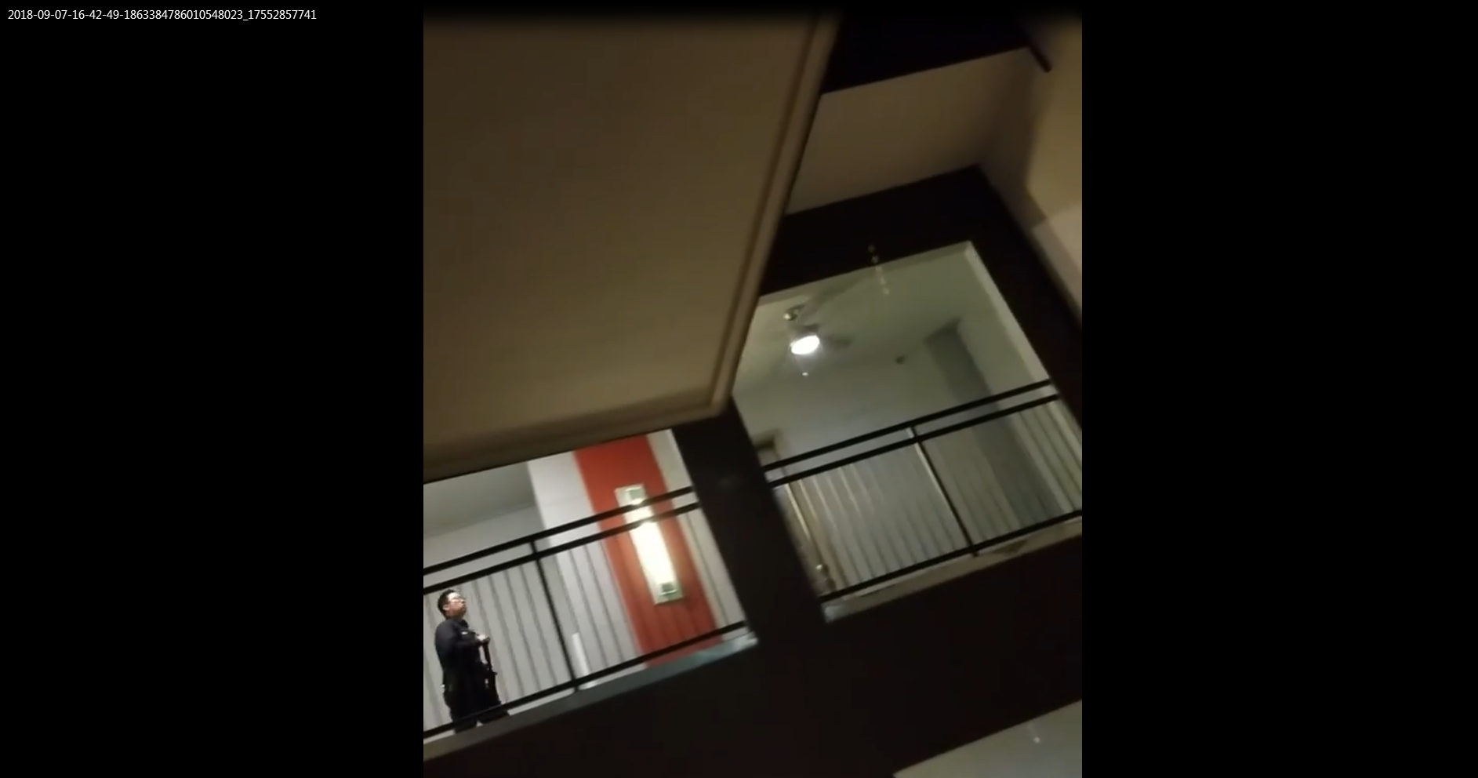
And even if you say that he’s not a police officer it still doesn’t change the fact that the 911 call, body cam footage and “Bunny’s” footage doesn’t match.
A person might say, “Bunny’s footage was taken right after the shots. The cops faked the 911 call to save Amber.” The 911 call is what added to her guilt! She wasn’t giving CPR. Wouldn’t they have had her giving CPR in the 911 call the whole time if they faked it for that reason? And where is the 6/7 minutes of pacing on the timeline? That means the experts in the trial were in on covering it up as well. That’s saying the powers that be are fully capable of staging an event.
“My night was interrupted by a cop ‘mistakenly’ murdering a neighbor. I seem to be the only one with any footage of this , so here you go.. first video is the cop a few seconds after she pulled the trigger, crying. And the second video is them pretending to revive what I believe to be an already deseased (sic) victim. These clips come from a 10 minute video. First clip is 57 seconds into the video. The second clip is at 7:33… there was 6 minutes she spent crying in the hall. I’m not intrested in selling this footage so go ahead and tag the blogs you want cause I’m sure my post and/or IG will magically disappear soon. #BothamJean.”
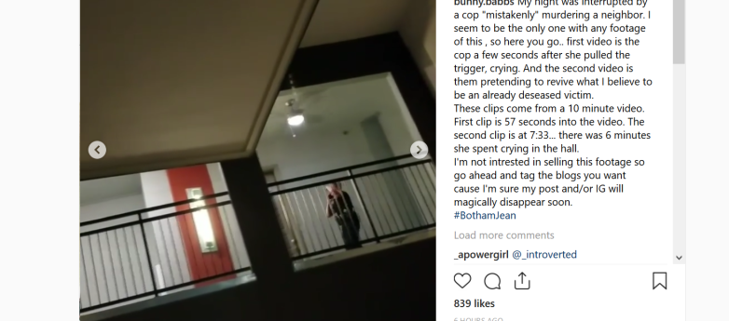
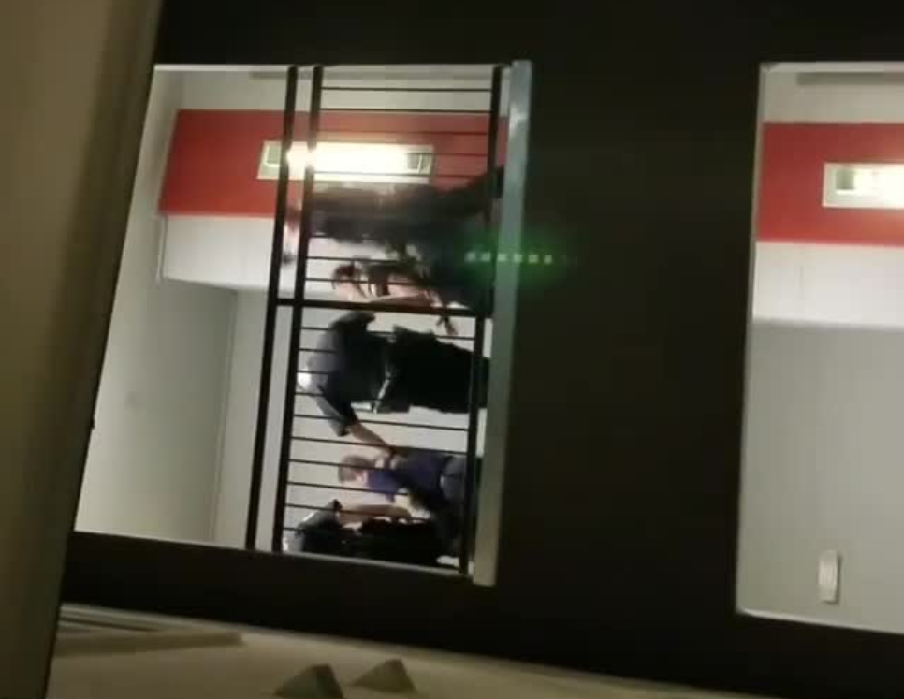
- ... first video is the cop a few seconds after she pulled the trigger, crying.
- And the second video is them pretending to revive what I believe to be an already deseased victim.
- These clips come from a 10 minute video.
- First clip is 57 seconds into the video.
- The second clip is at 7:33 …
- … there was 6 minutes she spent crying in the hall.
On Phil Scott’s show “Bunny” said she started filming “60 seconds” after the shot. On her Instagram she stated the first video clip, the one with Amber pacing, was 57 seconds into the full video which she said was 10 minutes, and later said was 7 minutes on Phil’s show. So, about three minutes after the shooting an officer, or some unidentified witness, is walking towards the apartment?
According to another neighbor who lived right next door:
“In the interview with Heavy, Kinsey said, ‘I was talking to my boyfriend, heard a shot, then some sort of commotion. Sounded like yelling/running/some loudness so I jumped up, ran to the door, looked out the peep hole, didn’t see anything at that moment but I could hear a woman calling 911 and hyperventilating.’
Kinsey gave Heavy this video showing the hallway in the apartment.
Kinsey told Heavy that she saw the female officer pacing in the apartment hallway. She heard the officer say the apartment number and the words ‘was shot,’ but she adds, ‘she was pacing away from me at that point.’
After hearing the shooting, Kinsey says, ‘I then posted on nextdoor app as a warning. I did not hear pounding or yelling before the shot. These halls are echoey so I feel like I’d hear it but maybe not.’”
Source: https://heavy.com/news/2018/09/amber-guyger/
This matches “Bunny’s” story. And if you really look at the whole incident and what the media presented you’ll see that the powers that be were running a conspiracy story coming from a bunch of black people against another story coming from Amber (a police officer) and the police. Blacks vs. the police.
Bunny Speaks On Filming Amber Guyger Video, Police Intimidation & Not Being Safe In Dallas County
https://www.youtube.com/watch?v=gzoRbl4JkgA
- 0:54 – “I did hear the actual shot, and that’s what prompted me to go outside and actually start recording the video. I heard everything prior to ….”
- 1:10 – “... and I heard a male’s voice saying, ‘Oh my God. Why did you do that?’ and that’s when I went outside.” So, from inside her apartment, downstairs and across from Botham’s, she heard these things. If you compare that to the statements made by other witnesses it doesn’t seem true at all.
- 1:15 - 1:20 – “My video actually started about sixty seconds after the actual shooting took place.” So, she heard some things, then heard gunshots, and then went outside to record.
- 3:16 - 3:21 – “… she was just pacing back and forth for at least 7 minutes … according to my video, at least 7 minutes.” We can’t prove how long she was pacing, or exactly when it occurred, but we can see it. So, where is this on the timeline and 911 call?
- 4:20 – There’s the walking officer. So, Phil, or his editor, would have had to have seen that.
- 7:52 - 8:00 – “So, after all of that happened, when did the police, Texas Rangers, etc. start coming to speak to you?”
- 8:01 – “The very next day. And they came consistently every day for at least two weeks straight.” Who did? The police, Texas Rangers, etc.
- 8:10 – “Once a day. Once a day, every day, for about two weeks.”
- 10:42 – About 30 days? Who, the Feds or the police, Texas Rangers, etc. which was about two weeks? If the Feds, it shows they spoke about this beforehand because he said, “… you stated, about 30 days?” But wouldn’t the Feds be a part of “the police, Texas Rangers, etc.” at 7:52?
- 11:46 – “People who disagree with me uploading evidence against Amber.”
- 13:50 – There seems to be a cut/edit at this time marker as if she didn’t say this immediately following her previous words. And once again the conspiracy narrative is brought up, intimidation and killing off witnesses. FYI: Two people don’t even have to be in the same room to create a video like this. She could mess up a line a thousand times, and they’ll just take the time she got it right and put it altogether in editing. In addition, they can act out a situation like a drill; then later have a participant tell what went on in an interview, making their testimony seem more believable.
- 15:48 - 16:00 – Lol.
- End of Commentary -
Southside Flats Apartments
1210 S Lamar St, Dallas, TX 75215
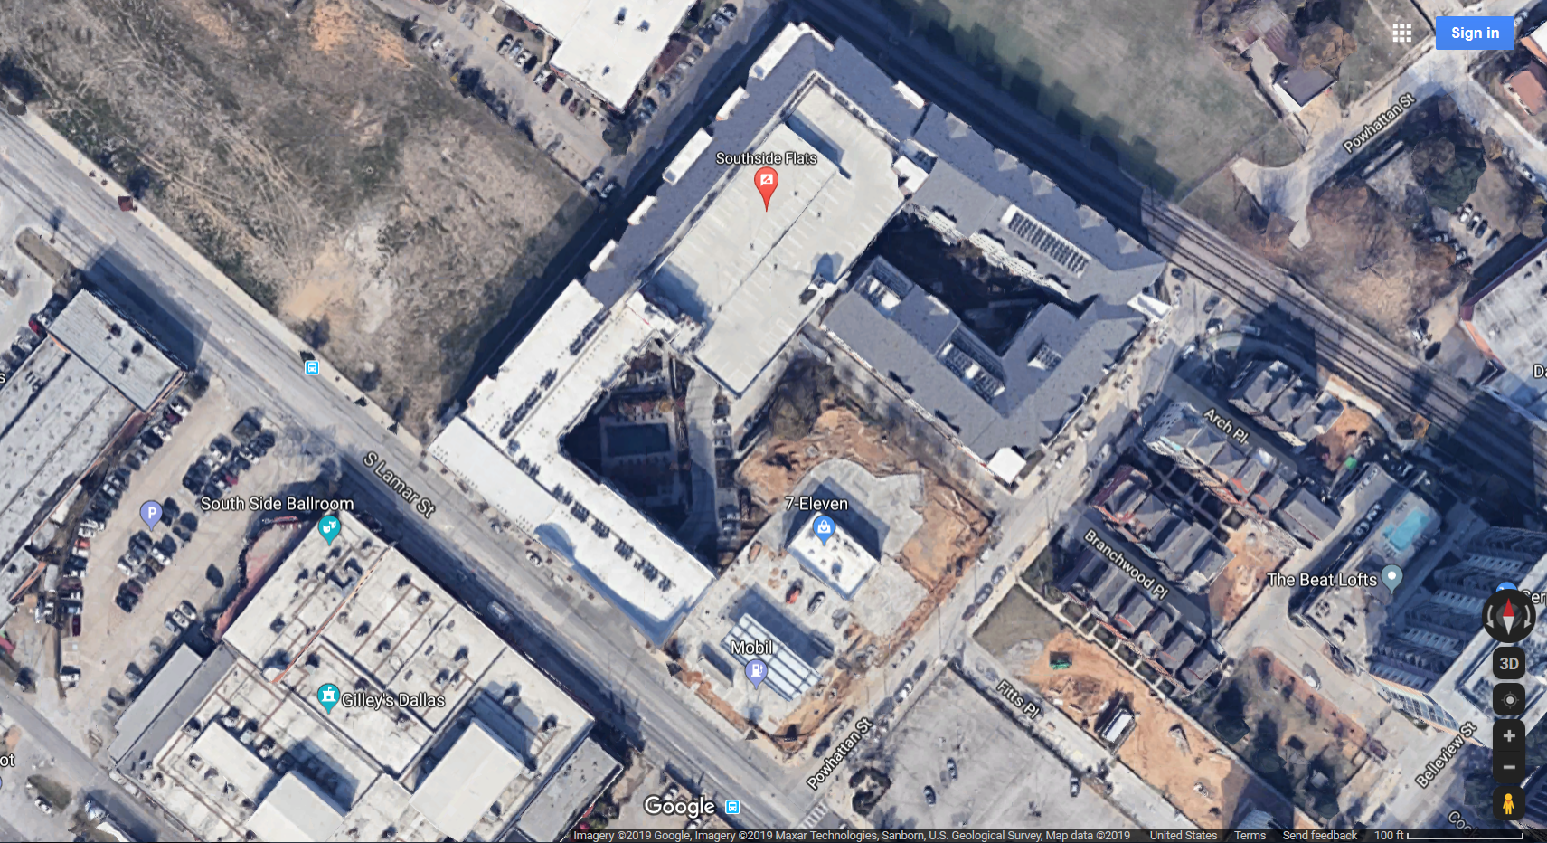
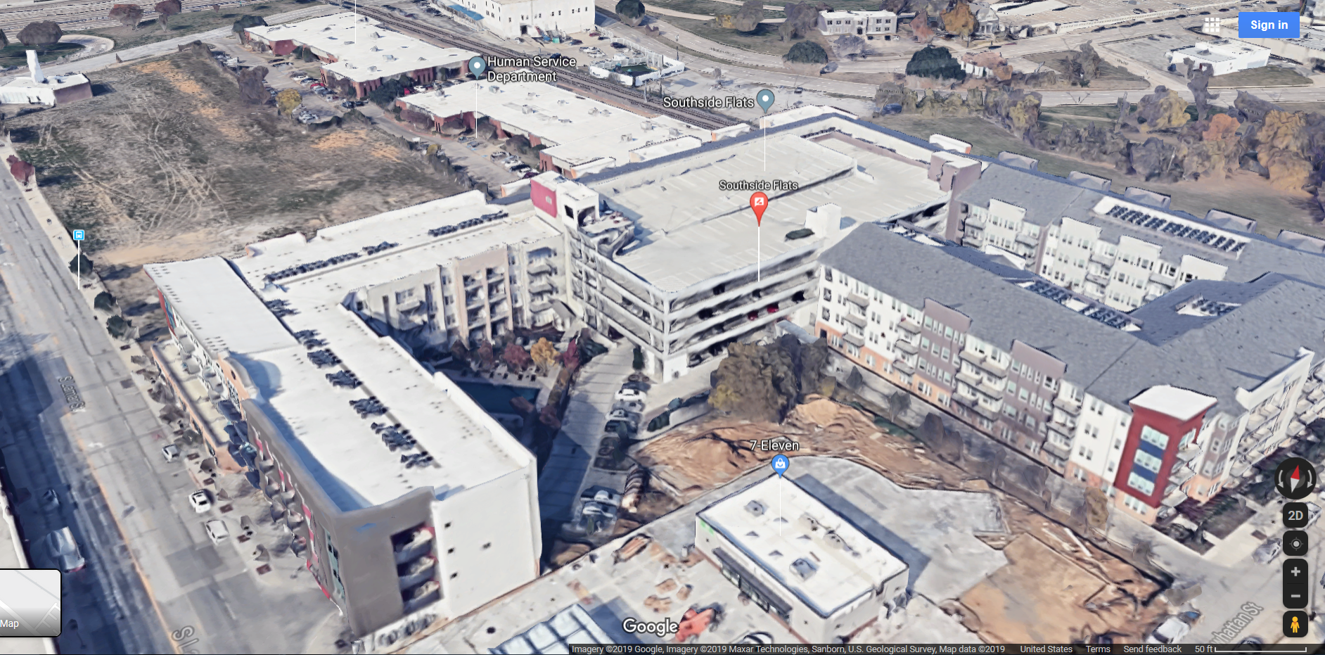

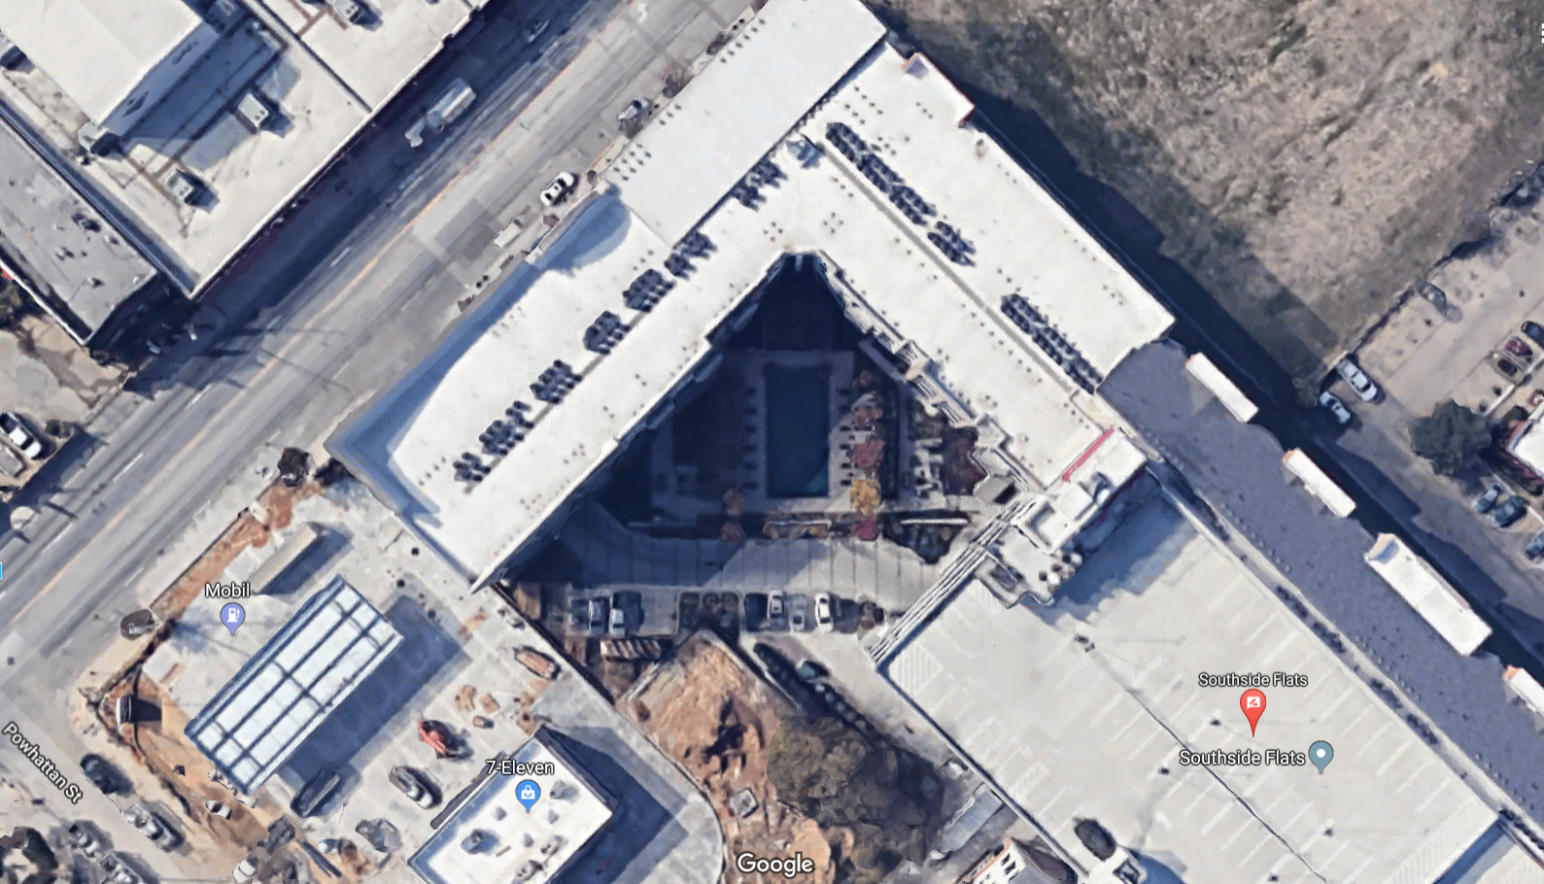

Arrows indicating the location “Bunny’s” video was taken from.
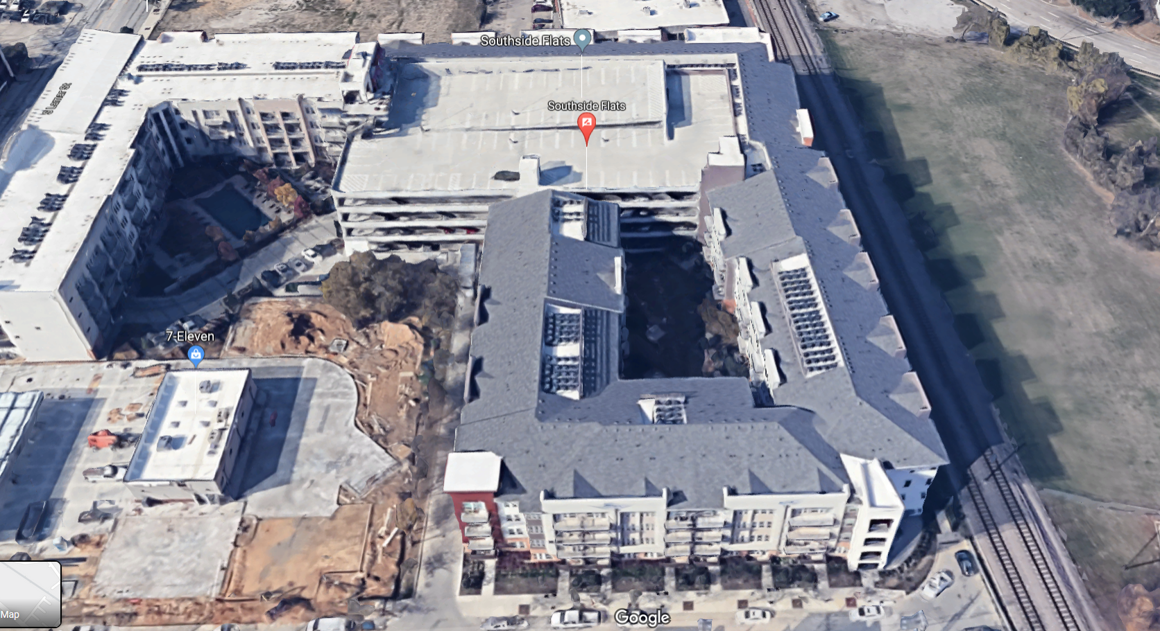
Go back to “Bunny’s” video on Heavy.com and you’ll find Kinsey’s video right below it. Her video shows the hallway and complex from this vantage point.
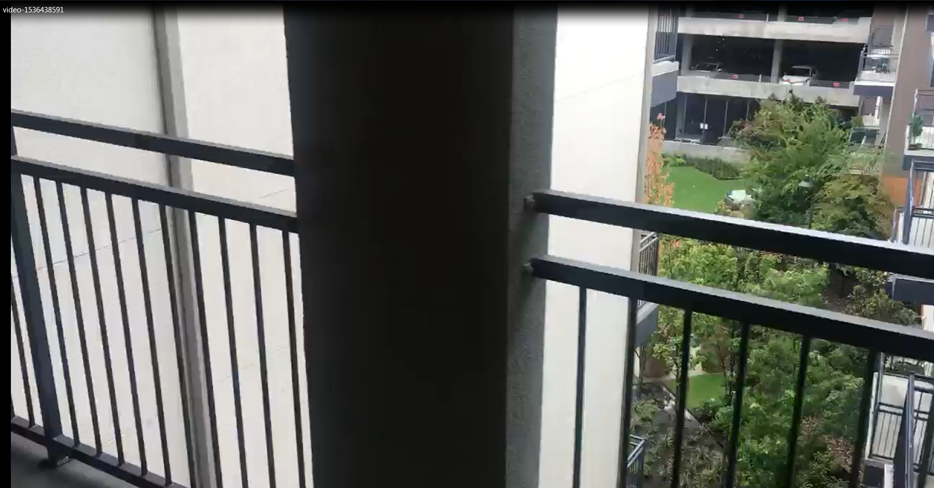

“Bunny’s” video would have had to have been shot from the balcony with the items on it.
Images rotated 90̊ clockwise:

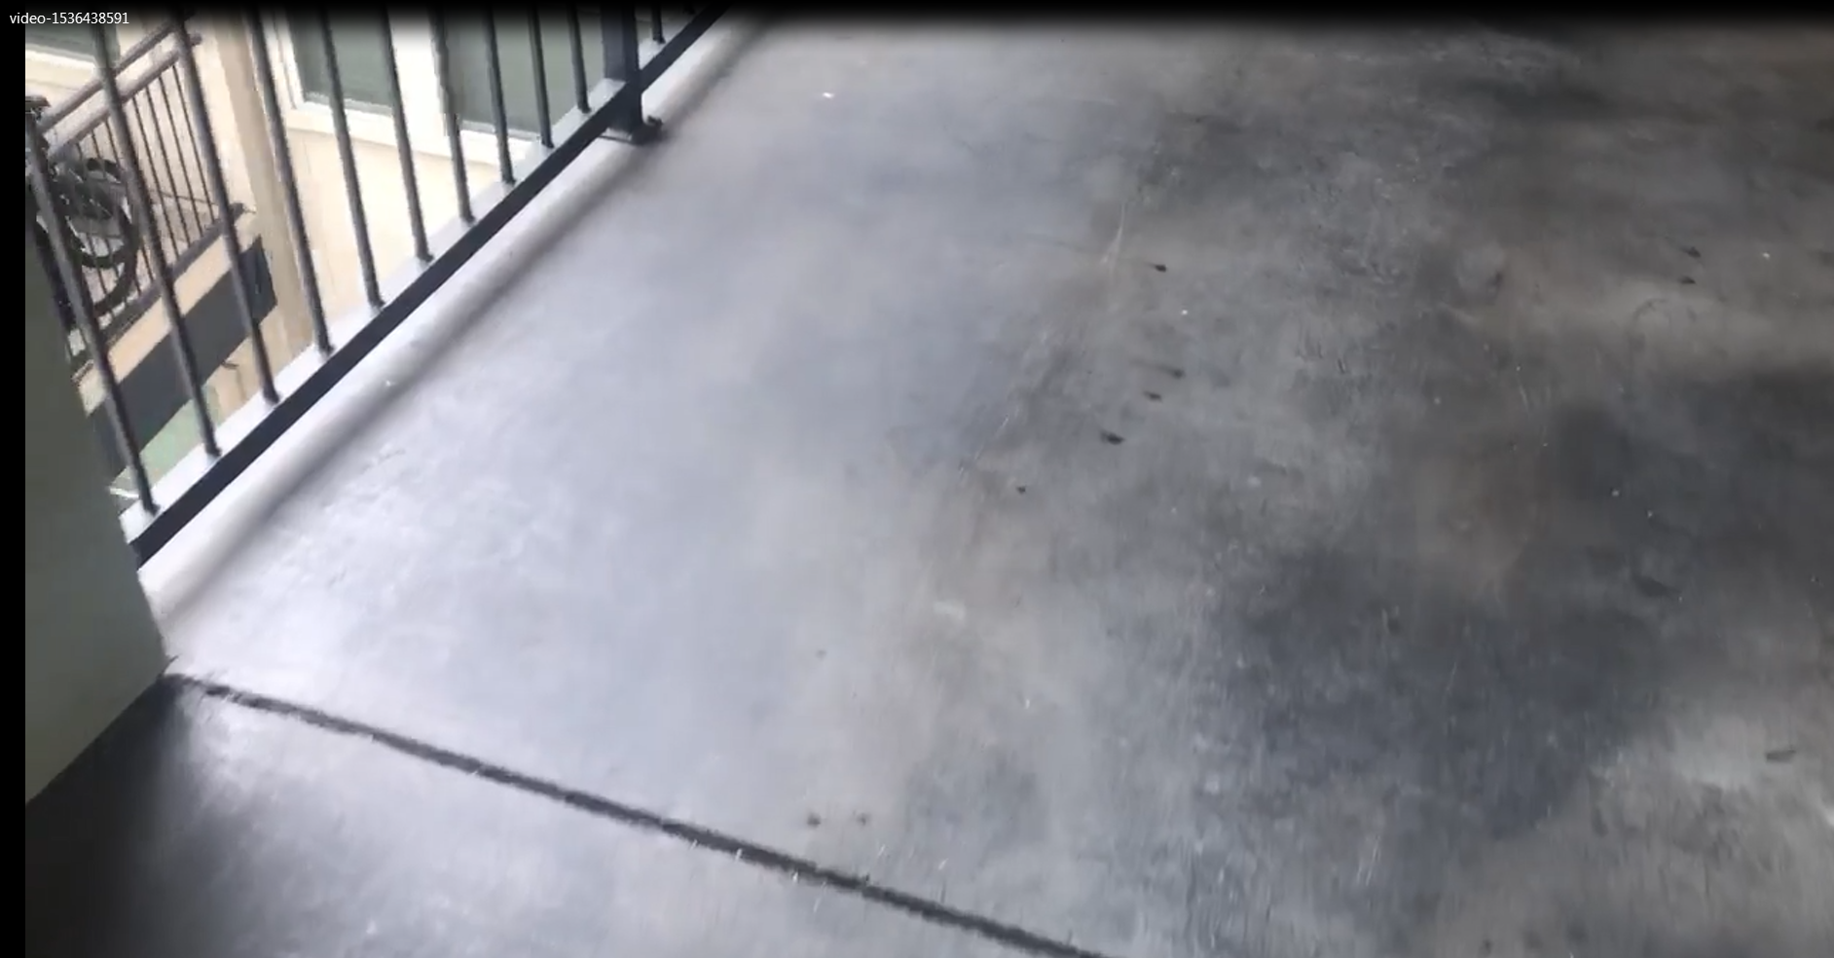
“Filming from a lower floor through the staircase railings…”
Source: https://abcnews.go.com/US/neighbor-filmed-aftermath-shooting-botham-jean-received-death/story?id=60750902
How could professionals get that wrong? You should seriously think of possible scenarios.
“Alyssa Kinsey, Jean’s next-door neighbor who was so close she shared a wall with him, wrote on Facebook, ‘This happened in the apartment next to me, to my very kind and friendly neighbor. I am absolutely heartbroken. Please, please keep his family in your prayers and send love and light their way. I cannot even begin to imagine the pain they are in.’ She shared a GoFundMe page for Jean’s family. It reads, ‘We are mourning the loss of our brother Botham Jean. He was a great Christian example and an inspiration to us all. We are asking for donations to cover funeral arrangements, his family’s travel expenses, and anything else they may encounter. He will be missed.’”
Source: https://heavy.com/news/2018/09/amber-guyger/
Here is “Bunny’s” GoFundME:
https://www.gofundme.com/f/life-after-witnessing
Things you should know
- The trial portion of the movie (calling it what it is) consisted of people who actually practiced law, doing a mock trail – something I’m sure they’ve done before.
- This wouldn’t be the first time a hoax had a staged funeral as a part of the hoax. At least this time they didn’t use a wax dummy or have the person lay in the casket.
- Not every person at the location of a hoax knows it’s fake. Their reactions are real, and that’s capitalized on.
- “It’s impossible to coordinate all these different players?” Think back to the assassinations of the 60’s. Compare the players in the MLK assassination to the players in the hoaxes. And it’s now 2019. Maybe you don’t realize just how controlled this country is.
- When the powers that be devise a plot they construct it in such a way that if it fails it will fail into a benefit, usually another agenda (ouroboros). Like a game of chess, they think steps ahead. So, even if people do realize these events are hoaxes it will play into the desires the controllers have for the population to not believe anything, and for action against “fake news,” which will probably lead to centralized control of the media. This will be along with having centralized control of the police force, one of the purposes of these “police vs. blacks” hoaxes (federalization of the police).
- They intentionally make hoaxes flawed and leave “bread crumbs” to follow for division, confusion, and to later identify the people who can see (something Youtube capitalized on, deleting numerous accounts).
- The Dallas Police Department participated in a hoax in 2016 where they staged a shootout. “Coincidentally” it was on the same street, Lamar St. The shootout footage was filmed on N. Lamar and Commerce, and N. Lamar and Main, while the Southside Flats are located on S. Lamar. And just a block away on S. Lamar is the Dallas Police Department.
“On July 7, 2016, Micah Xavier Johnson ambushed and fired upon a group of police officers in Dallas, Texas, killing five officers and injuring nine others. Two civilians were also wounded. Johnson was an Army Reserve Afghan War veteran who was angry over police shootings of black men and stated that he wanted to kill white people, especially white police officers. The shooting happened at the end of a protest against the police killings of Alton Sterling in Baton Rouge, Louisiana, and Philando Castile in Falcon Heights, Minnesota, which had occurred in the preceding days.
Following the shooting, Johnson fled inside a building on the campus of El Centro College. Police followed him there, and a standoff ensued. In the early hours of July 8, police killed Johnson with a bomb attached to a remote control bomb disposal robot. It was the first time U.S. law enforcement used a robot to kill a suspect.^{[8]}”
Source: https://en.wikipedia.org/wiki/2016_shooting_of_Dallas_police_officers
Dallas police shooting, July 7: Here's what happened
https://www.youtube.com/watch?v=6uCP3EfXvhc
Youtube has removed all the videos exposing this hoax, but I was able to find one video on another site. I don’t want to link to the video or site (I have something planned), so here’s a little bit of information from the video debunking the live stream video of that hoax.
As shown in the video exposing this hoax, the “live stream” footage doesn’t even match the media images.
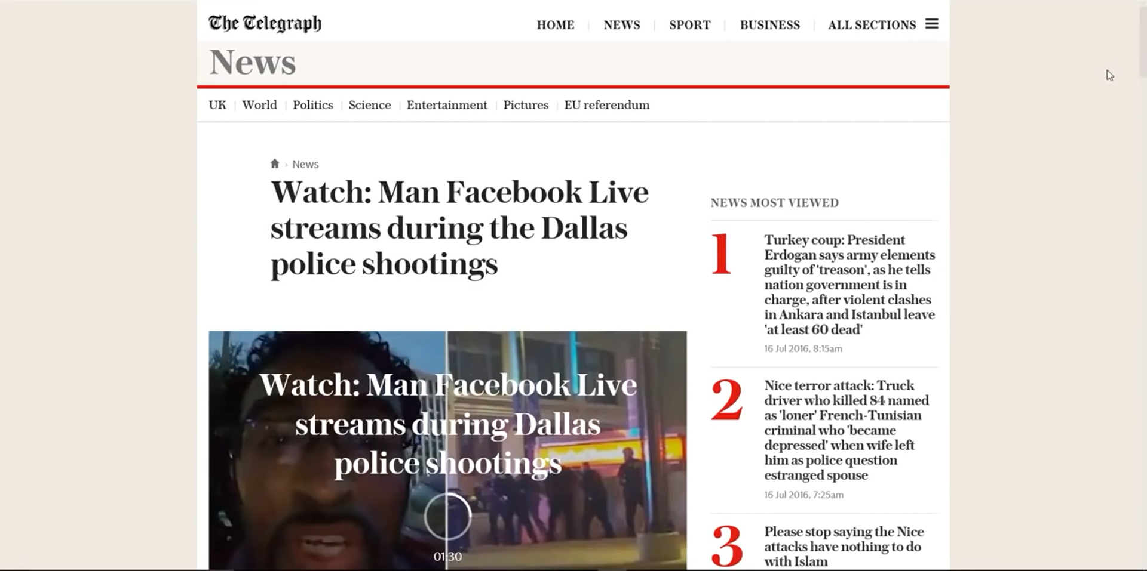
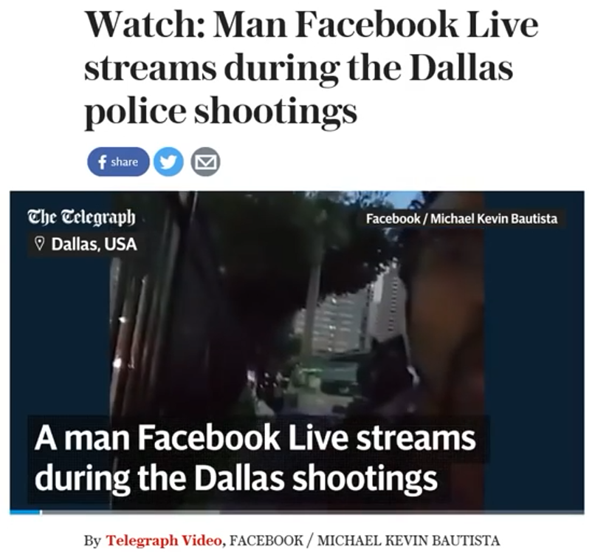
He starts off filming a “live stream” from N. Lamar and Commerce.
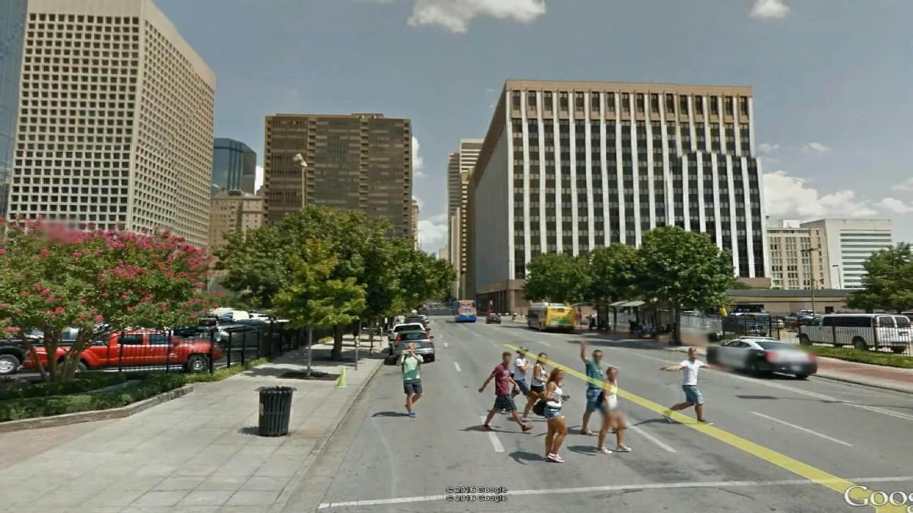
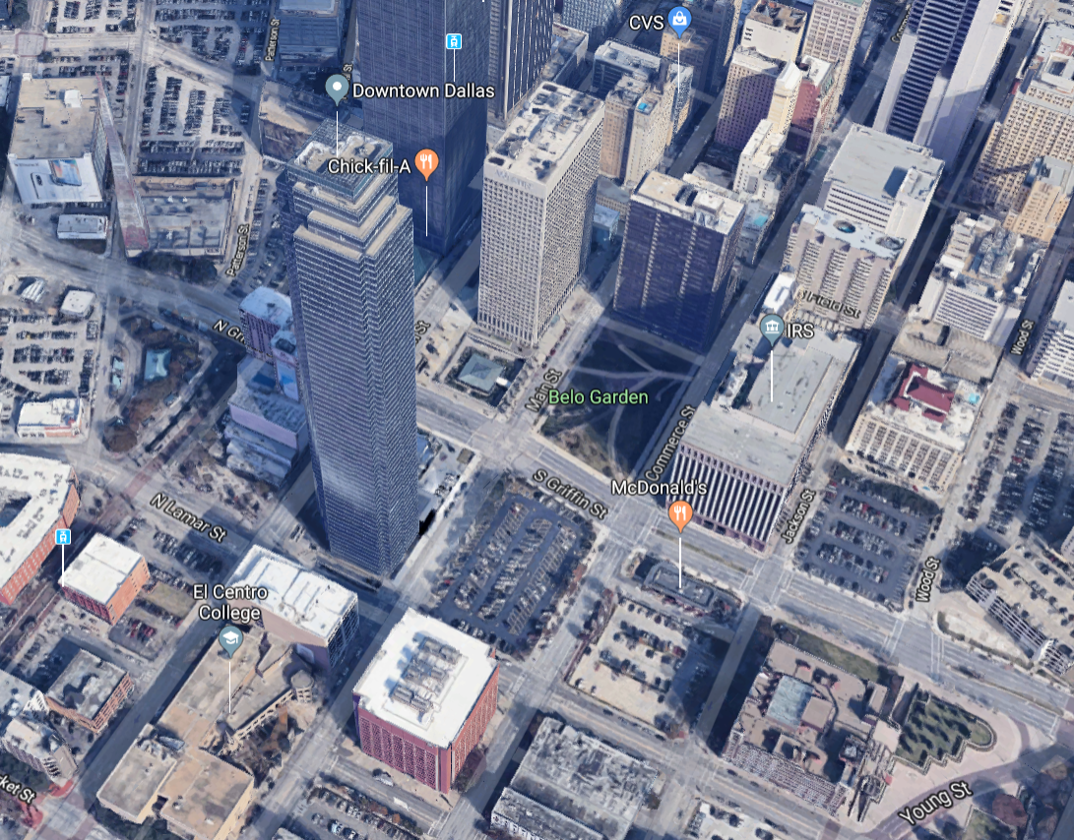
He then “switches his camera angle” on his phone, which is really an excuse for an edit at that portion of the video, and all of a sudden he’s on N. Lamar and Main (the other side of the parking lot, parallel with the “red” building). This is not the first hoax where there was a break in a “live stream” and then all of a sudden circumstances were different. The Philando Castile shooting hoax was another.
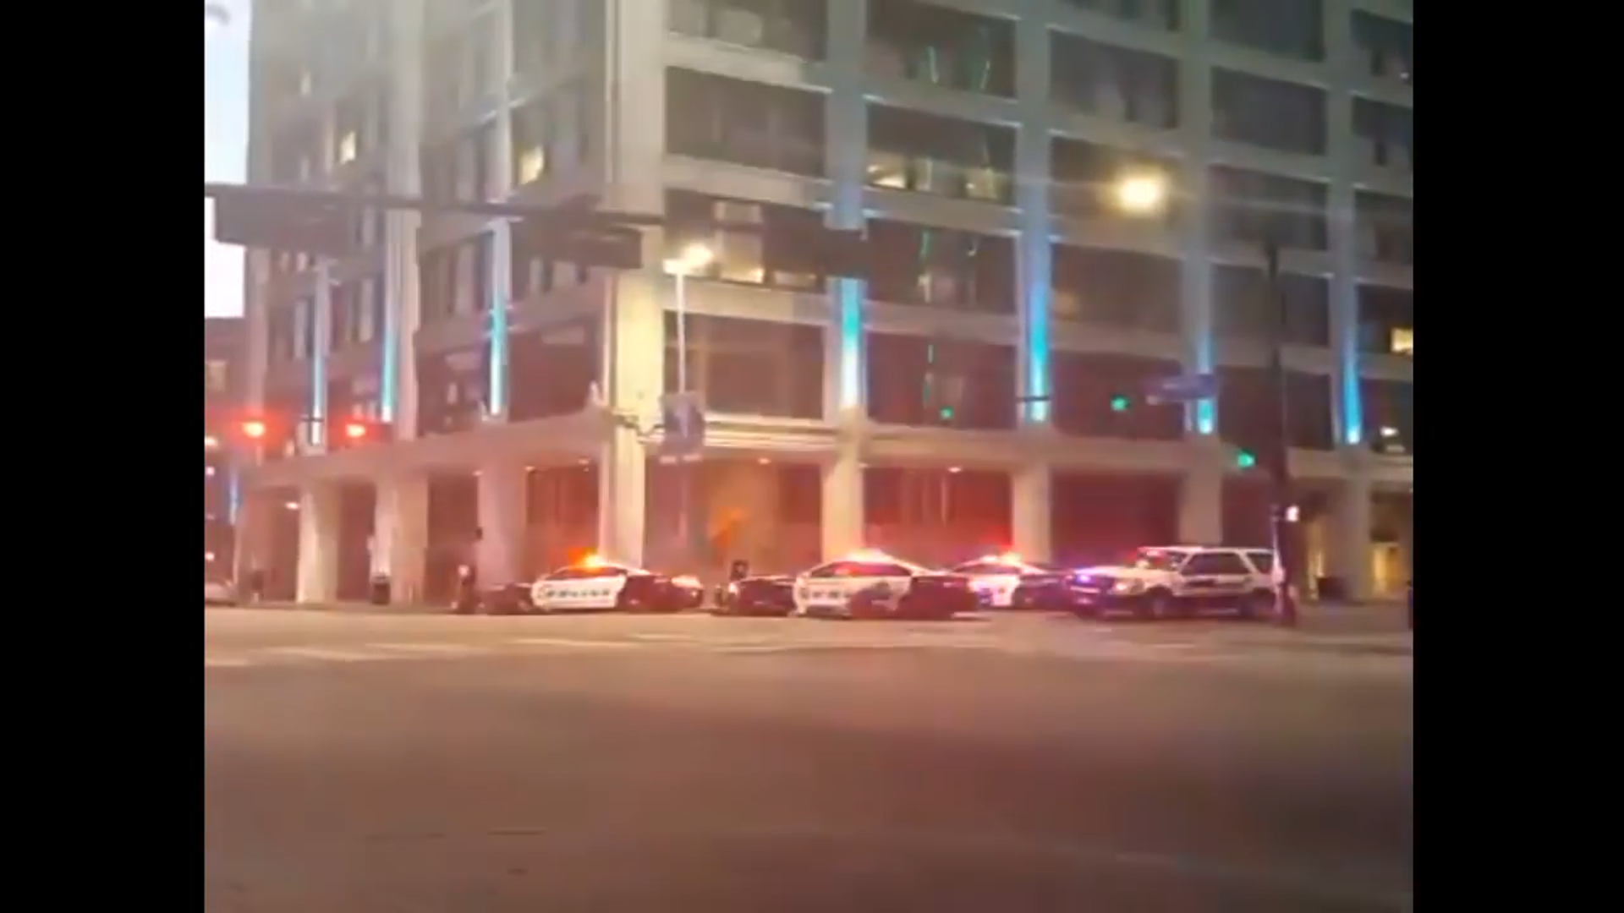
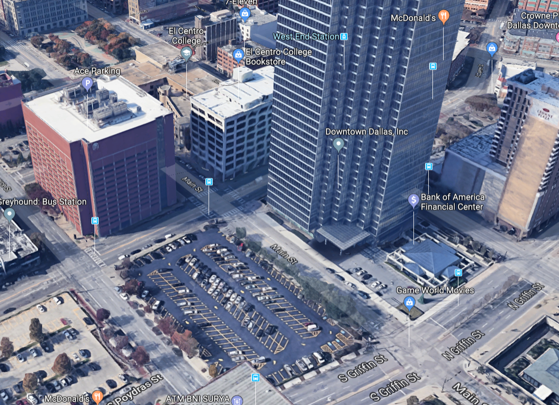
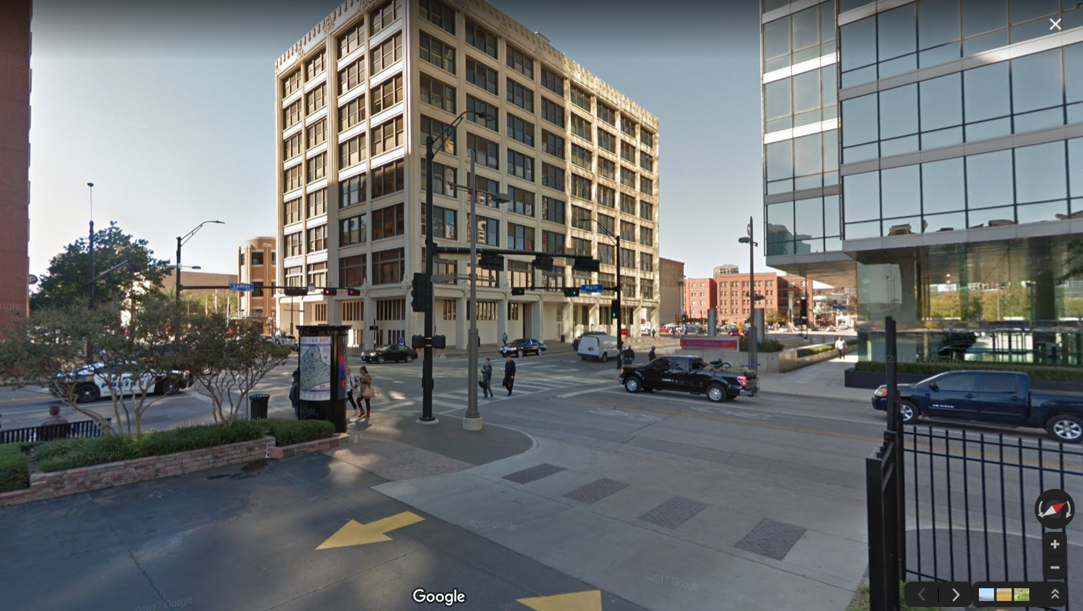

I just came across information on another shooting in Dallas. I heard about this one when it happened, but didn’t follow it. I just looked into it, and it’s another hoax. You’re not going to believe where it took place.
“DALLAS - A man who fired shots at the Earle Cabell Federal Building in Downtown Dallas is dead. FBI officials said officers from the Federal Protective Service shot and killed 22-year-old Brian Isaack Clyde after he opened fire on the federal building on Commerce Street.”
Source: https://www.fox4news.com/news/active-shooter-killed-outside-dallas-federal-building
“Officers responded to the shooting call around 8:50 a.m. at the Earle Cabell Federal Building in the 1100 block of Commerce Street.
…
The federal courthouse and El Centro College are on lockdown. A building near the intersection of Young and Lamar streets was evacuated about an hour after the shots were reported.”
Source: https://www.wfaa.com/article/news/crime/gunman-killed-in-shootout-with-officers-outside-federal-courthouse-in-downtown-dallas/287-f9dec5e2-ffc5-4dde-82be-67def26c41d6
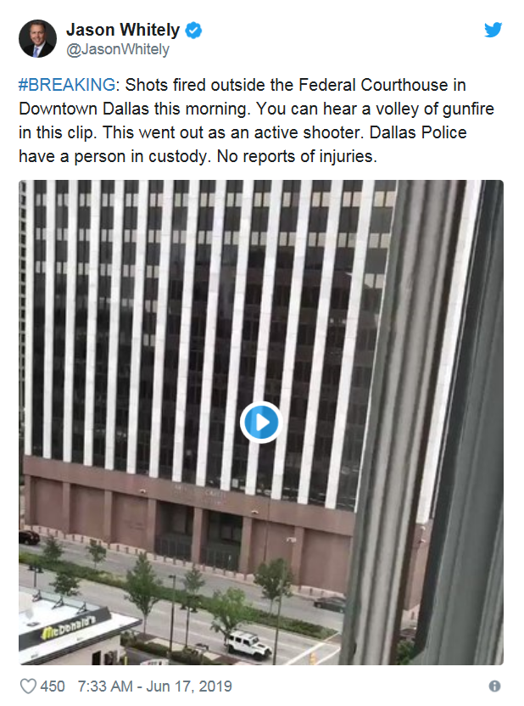
Heeeey … I know that building!

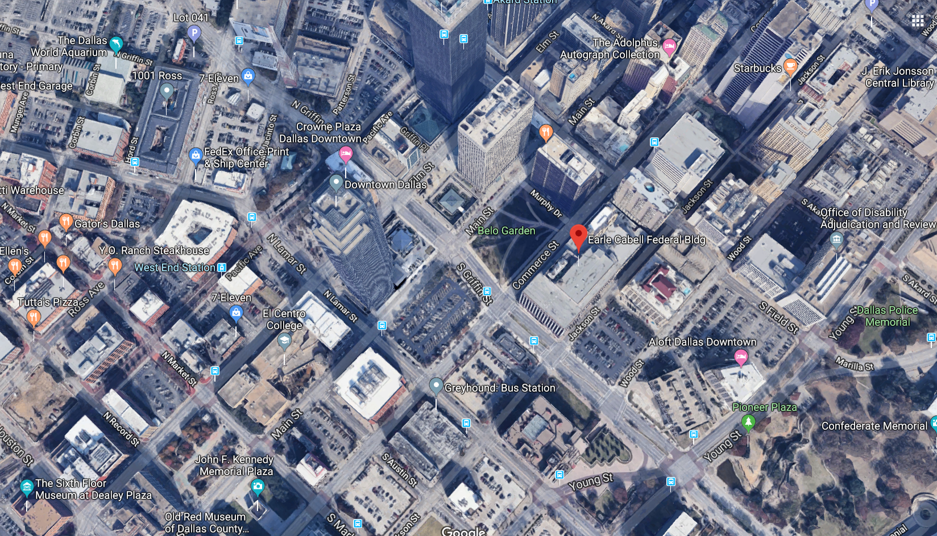
What are the odds?
And then there are other hoaxes that occurred in Texas.
And because people like me were using Youtube and Facebook to prove certain events were hoaxes, Youtube and Facebook started attacking us with censorship and penalties. Just recently Youtube went on another purge, deleting tons of videos proving many violent events to be staged hoaxes and deleting many accounts.
Go here for an example of all the evidence Youtube has disposed of (covered up):
http://howmanyknow.com/2016/08/the-pulse-nightclub-shooting-hoax/
They also changed their policies.
Under “Harassment and cyberbullying policy”: “Content claiming that specific victims of public violent incidents or their next of kin are actors, or that their experiences are false”
https://support.google.com/youtube/answer/2802268?hl=en
Under “Hate speech policy”: “Deny that a well-documented, violent event took place.”
https://support.google.com/youtube/answer/2801939?hl=en&ref_topic=9282436
Hello?! How obvious is that? Based on this and many other clues (one example: 1:40 - 10:50), it’s obvious that Youtube is a part of the System. And it’s also obvious the powers that be had more hoaxes planned.
US Gov has legalized psychological operations against citizens
https://www.youtube.com/watch?v=LOEqFFZCsr8
I recently found some of the videos exposing hoaxes elsewhere online, and I counted the hoaxes I followed and knew for a fact were hoaxes. The number was 16. Yes, 16. I didn’t even realize there were that many. And that’s just the ones I followed! I got tired of it all and left it alone. There’s the Boston Bombing, Brussels, San Bernardino, the Pulse Club, Nice truck attack, Aurora, Sandy Hook, Santa Monica, LAX, Charleston, CBS Virginia “live” shooting, and more!

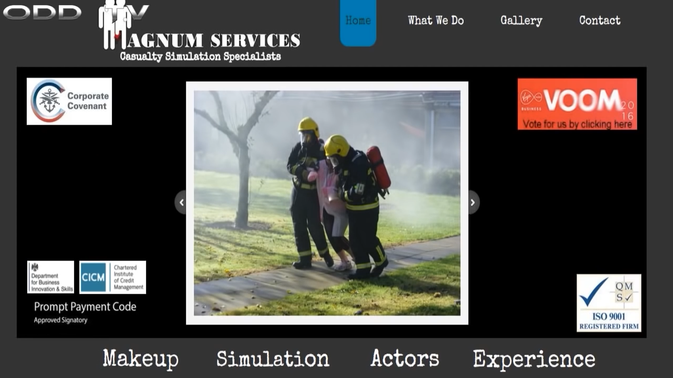

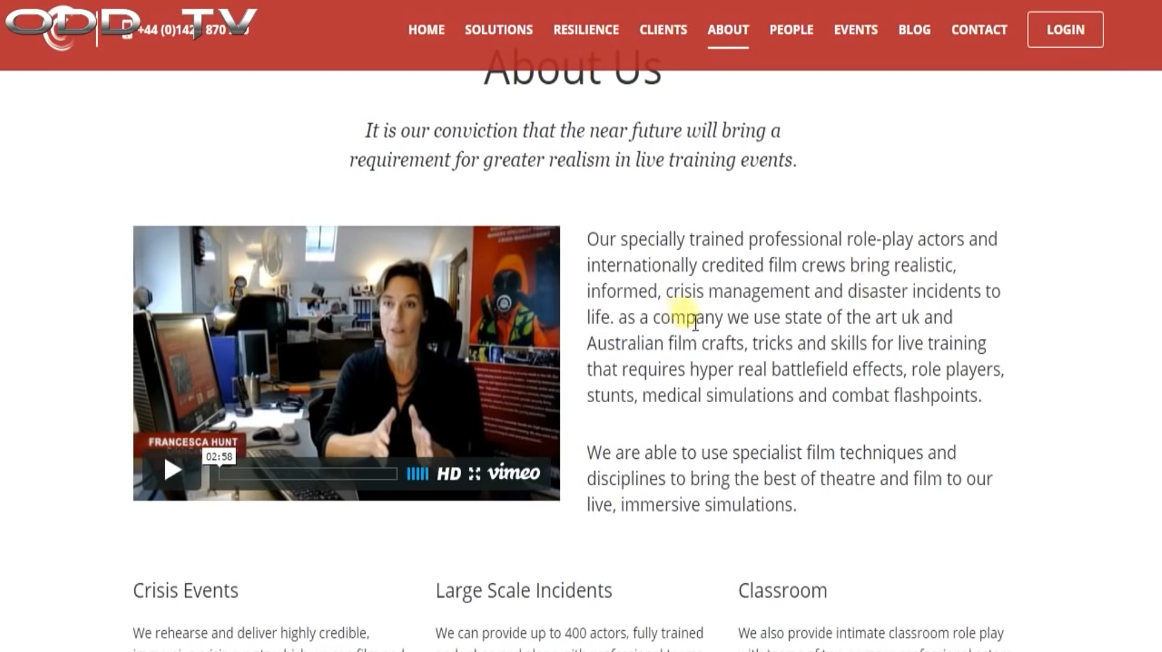

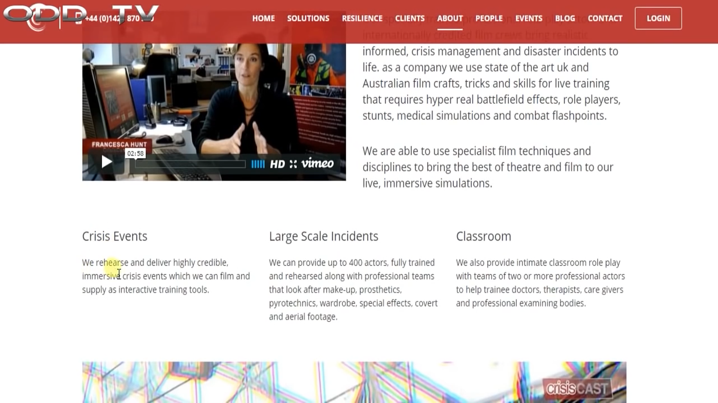

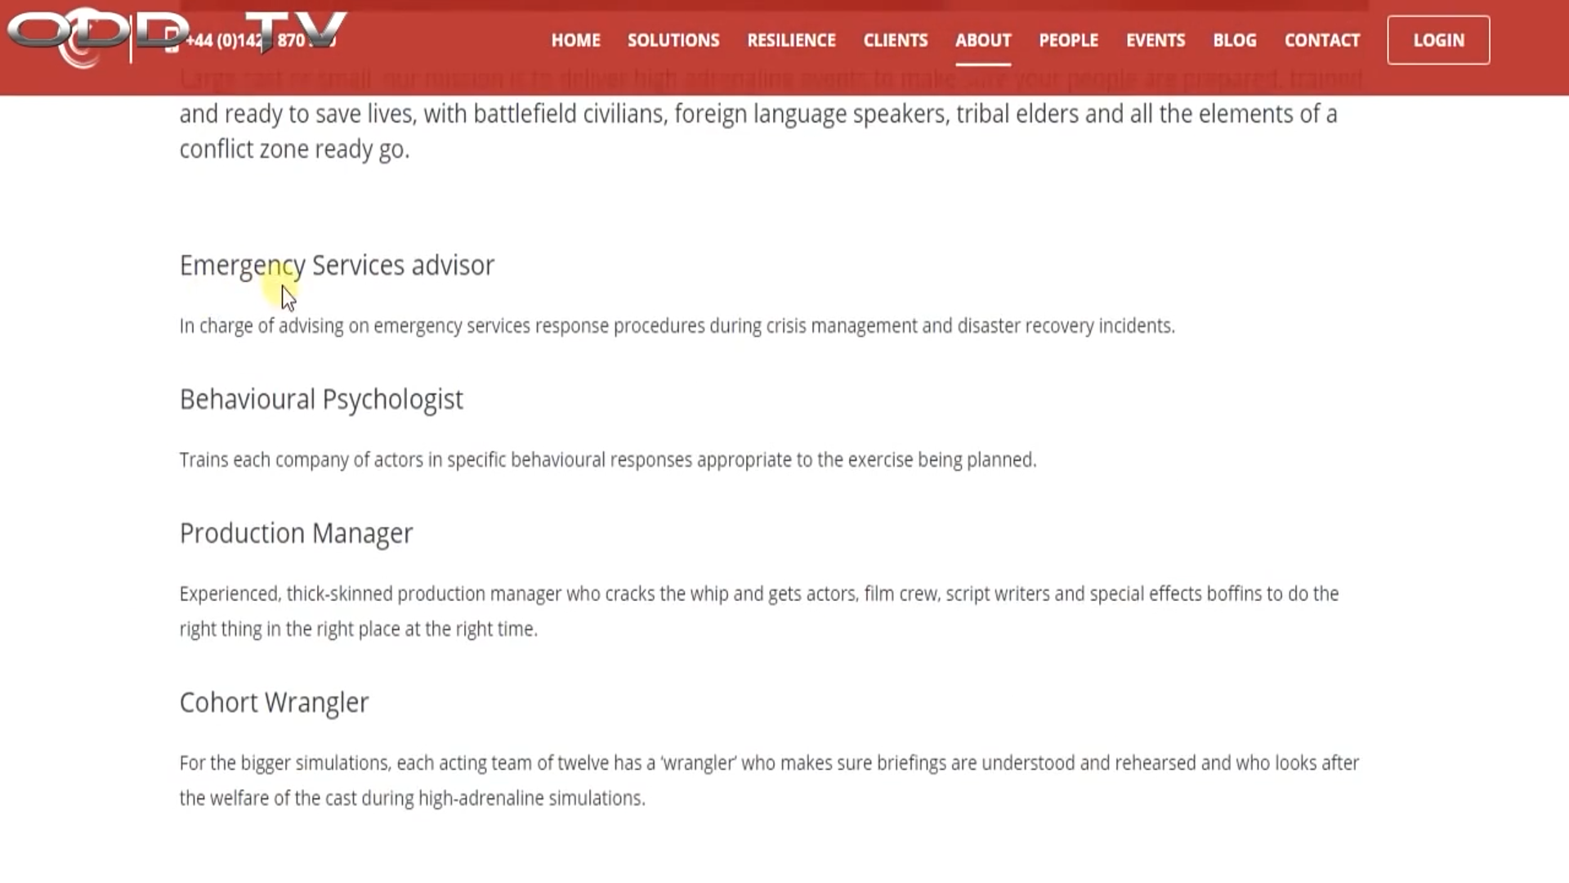

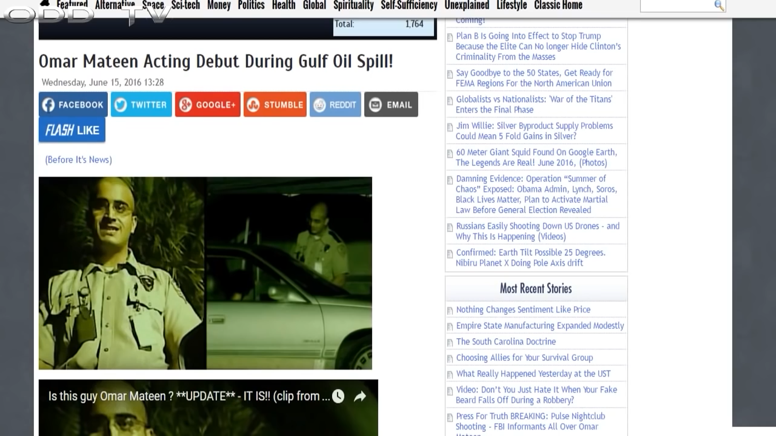
CASTING CRISIS: Orlando’s Actors, Agents and Casualty Role Players
https://21stcenturywire.com/2016/06/18/casting-crisis-orlandos-actors-agents-and-casualty-role-players/
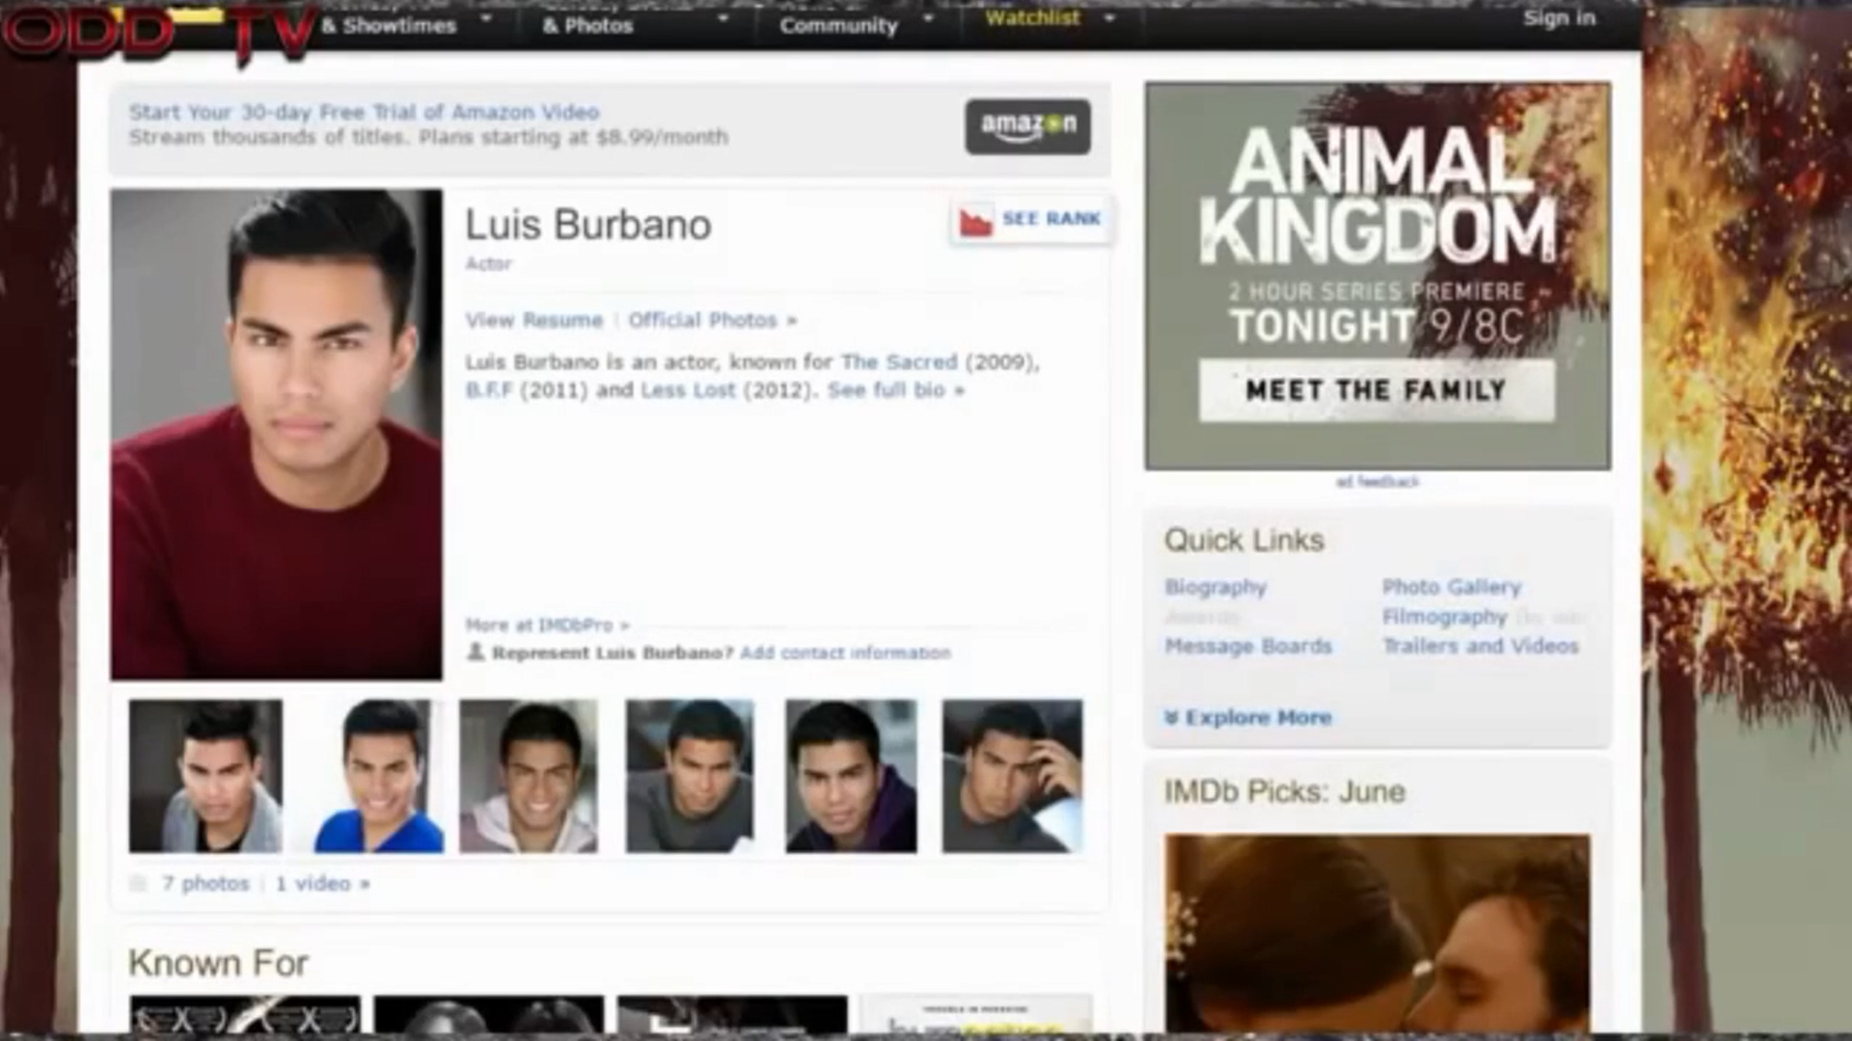
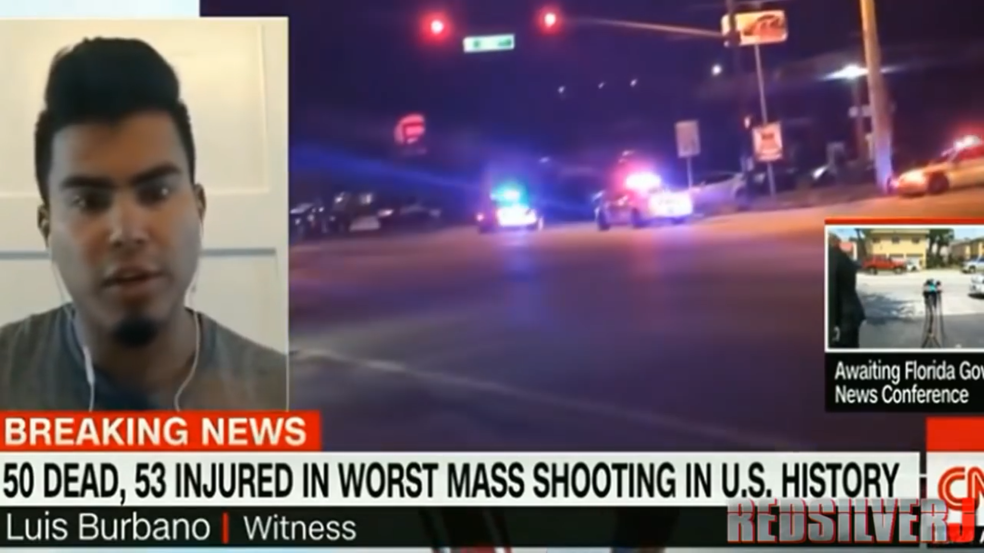
*Not every crisis actor is a former or aspiring actor.
Sometimes it gets so outrageous you just have to laugh. This guy played two roles in the Sandy Hook hoax.
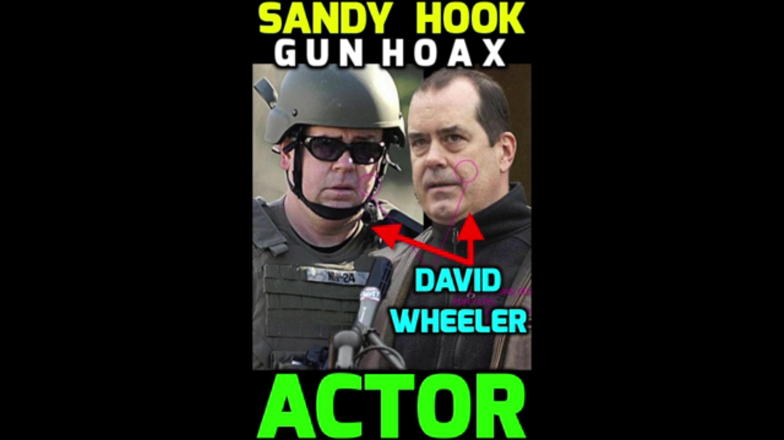
The video footage proves it even better.
And then there are those who play roles in different hoaxes.
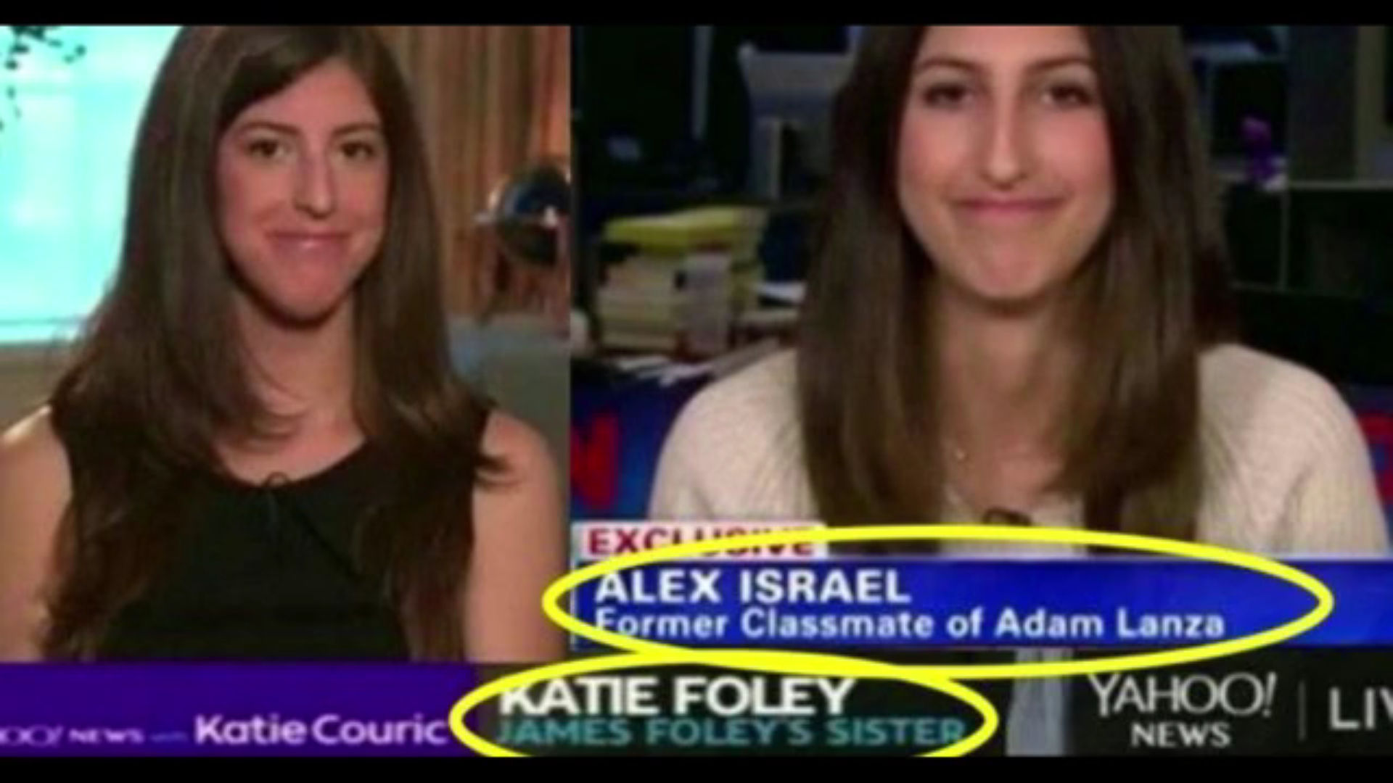
The smiling and cheerful people who just lost family members or witnessed a horrific event are too many to number.
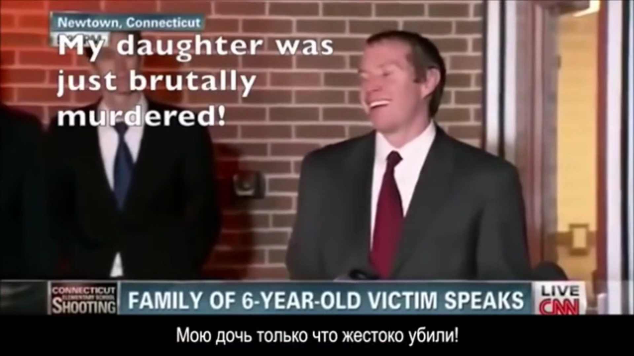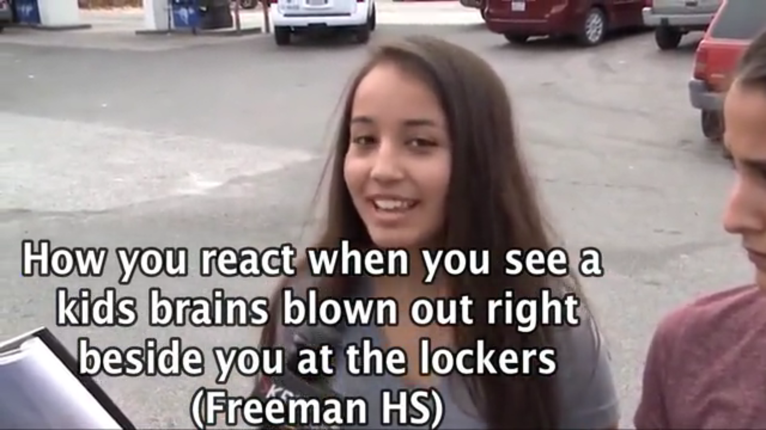
The news media, Hollywood, Google, Youtube, Facebook and other social media and mass media are putting you under a spell, and trying to keep you under a spell.
Extra Information (for your understanding)
Here’s the story that many people believed: Amber went up to the fourth floor, tried to get into Botham’s apartment, killed him because he was black, and then the Dallas Police Department intimidated and killed off the witnesses. That’s a pretty crazy story.
I wasn’t following this incident, but it’s clear that news stories/videos like the ones you’re about to see were guiding people’s beliefs about what happened. Clearly, the media was presenting evidence in such a way that the crazy story is what people would conclude.
911 call from off-duty officer after she fatally shot a man in his own apartment
https://www.youtube.com/watch?v=AU7gKstF70I
Where are these witnesses who heard her banging on the door?
Amber Guyger's ex-partner under fire for 2007 shooting of unarmed man
https://www.youtube.com/watch?v=rTHe8BNHGjQ
Botham Jean's mother defends son and refers to Amber Guyger as "the devil"
https://www.youtube.com/watch?v=p8-bQdaleI4
The news media and TV shows were supporting Botham’s side against the police. That’s a huge red flag. These outlets are a part of the System. These are the enemy’s weapons. Newsflash: If they don’t want you to see something/know something they wouldn’t show you! It’s as simple as that. They fully control what you see and don’t see. So, why would your enemy be showing you this?
*You don’t need to watch it.
Botham Jean's Character Assassination? | The View
https://www.youtube.com/watch?v=kgGPaloVUXI
These are celebrities, some of the most censored people on earth, who are saying these things. Celebrities are slaves who can never speak their mind unless it’s what their controllers want. And to be more specific, in this case it’s the network, speaking through slave celebrities, who is pushing a narrative and painting a picture of the case and those involved in the case.
To the very end, they continued the conspiracy narrative. Listen closely to this next one.
Key witness in Amber Guyger trial shot to death
https://www.youtube.com/watch?v=5xs6odlYKcc
They’re basically saying, “We think they killed him because he testified in this case.” So, you believe the news is saying this because they’re fair and caring?
- 0:31 – “… but so far they don’t have any motives, and they do not have any suspects.” So, no one has any idea why it happened. CBS has no idea why it happened, and yet…
- 1:49 – “… Brown was scared someone was after him after he was involved in a separate shooting incident in Dallas.” Now listen to what the news guy asks right after this. And please note, these scenes are a product of questions and editing.
- 2:00 – “He had been shot less than a year ago, and someone standing near him was killed. He was reluctant to testify in this case because he had been shot at and he thought some people might want … to do harm to him.” That has nothing to do with the case! He didn’t want to be out there in the open, exposed. But listen to how CBS is spinning it.
- 2:34 – They had Omar end it with a reason why “they” killed him. Absolute madness.
You don’t believe that’s what they were trying to push? Just look at the title of this one:
https://nypost.com/2019/10/07/slain-witness-joshua-brown-was-expected-to-testify-in-lawsuit-against-dallas-police/?fbclid=IwAR2tw0wzdFbNZrzVo5BbLNf_hbGqcWjxzeal-VUqV83m53YD7AzcZfp6aIs
Looking at the title and content of Phil’s video, the narrative was there from the beginning:
Bunny Speaks On Filming Amber Guyger Video, Police Intimidation & Not Being Safe In Dallas County
Now take a look at how the media was saying different things in different places, causing division within the population. This was widespread in this hoax.
“One of many notable parts of Brown’s testimony came when he said he had also walked to the wrong floor in his apartment building before, which was Guyger’s explanation for why she entered Jean’s apartment, thinking it was her own.
Brown said that on one occasion, he even put his key in the door of an apartment on the wrong floor. Yet, he noted, there was a large vase on the third level where Guyger lived that made him realize he was not on the fourth level, where he and Jean lived across from one another.
In an interview with ‘Today,’ a lawyer who represented Jean's family and is now working with Brown’s relatives, said Sunday that Brown’s role in the trial caused him to fear ‘for his life.’
The lawyer, S. Lee Merritt, attributed that fear, in part, to a shooting that occurred in recent months during a birthday party at a Dallas club that Brown attended. Brown was shot in the foot, Merritt said, and a friend of his was killed.
It wasn’t clear what caused the incident, but Merritt said Brown knew the shooter and worried the person ‘might come back to try and finish the job.’
Brown’s relatives told Merritt that he worried about how the trial’s publicity could leave him more exposed to ‘people who wished him harm,’ and how he could be viewed as a ‘snitch’ for cooperating with law enforcement in Guyger’s prosecution.
Brown heard such pushback in the days after the trial, Merritt said.
Merritt said he had no evidence to suggest Brown’s death was in retaliation for his testimony, but he added, ‘it is certainly worth investigating or looking into and we expect the city of Dallas to apply all of its resources and manpower to figure out what happened.’”
Source: https://www.nbcnews.com/news/us-news/why-joshua-brown-s-testimony-was-key-amber-guyger-s-n1063071
Take a look at this:
ANOTHER Racially-Driven Hoax Falls Flat: Media Changes It's Headline & Thumbnail Quick!
https://www.youtube.com/watch?v=oc4-zGeH-LE
This is not the only one. There are tons of these news stories on racism that have later been exposed as being hoaxes. And who knows how many were not discovered to be hoaxes. Now add that to all the fake stories from these unknown websites shared on Facebook each day, and you get a bunch of people with an altered state of reality.
- 1:10 - 1:12 – Exactly! I was just thinking about that tactic the other day when I saw the following (right after the end of the Guyger shooting hoax):
White Texas police officer fatally shots black woman, 28, inside her own home | Daily Mail Online
Published: 20:02 EDT, 12 October 2019
https://www.dailymail.co.uk/news/article-7566899/White-Texas-police-officer-fatally-shots-black-woman-28-inside-home.html
Before they started these New World Order agendas:
1. They most likely wouldn’t have even covered that story.
2. If they would have covered it, it would have been titled “Texas police officer fatally shoots woman,” “Officer shoots suspected burglar,” “Officer forced to shoot woman,” etc. Do you see and feel the difference?
Before they wanted black people to despise and fight against the police and white people, they used to protect the police and white people.
Here’s an older example:
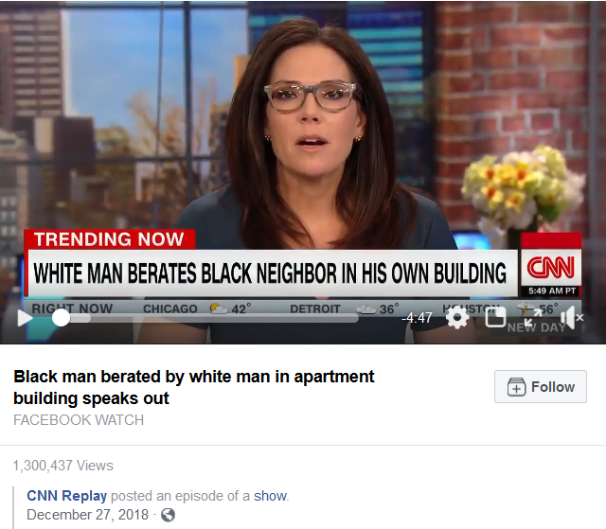
- 1:13 - 1:27 – Changing the title and thumbnail helps, but it gets sicker than that. “Facebook” can actually control what goes viral, and what doesn’t. They can control who sees what. They can manually add likes, shares, and more.
- End of Commentary -
And they followed up with things like this:
Retired Fort Worth officer: "I'm afraid when I get stopped"
•Oct 15, 2019
https://www.youtube.com/watch?v=FY7yo-SlGZQ
The System
“Bunny” claimed she turned down other interviews but just so happened to go on Phil’s show. Who is Phil? He is one of the many contracted moles/puppets in the Youtube community who I’ve had my eye on for a while now. The same way people on Youtube get paid to sell products, people on Youtube get paid to sell ideas. Just like there are crisis actors, regular people who agree to participate in staged events for agendas like “The Police vs. Blacks” and “Mass Shootings,” there are other regular people who work on Youtube. They even get paid through donations and other scams like crisis actors. Phil already got exposed as a con man not too long ago, and that’s probably why he changed his platform from The Advice Show to what it is now.
Other black workers: Tommy Sotomayer, Roland S. Martin, Boyce Watkins, and lesser-known Youtubers. Two agendas a lot of black people online actually do know about are the homosexual agenda and the feminist agenda. The black aspect of the feminist agenda actually aims to separate the black man and woman, chiefly by making black woman undesirable. This is where Tommy comes in at.
We used to deal with undercover Youtubers all the time in the Truth/Conspiracy community. And we exposed them all the time. But hardly anyone in the black community knows about this stuff because the Truth/Conspiracy community consists of almost all non-Blacks (there’s only me and a few others).
And then there are the other types of contracted moles/puppets/workers who pose as leaders and teachers. Malik Zulu Shabazz and the New Black Panthers, Black Lives Matter, Umar Johnson, Tariq Nasheed, and Polite of the Black Conscious community are some of them.
Black Lies Matter
http://howmanyknow.com/2019/06/black-lies-matter/
This just proves that they’re con artists. You would have to know about the Elite, their agendas and that realm of study to really see that some of these people are workers. And even in these videos you’ll see that some people suspect Polite of working for the intelligence agencies.
The Israelite camps (cults) of the Israelite community are also a part of this New York scene of black workers. And there are individuals and groups within the Israelite community, aside from the camps (cults) that are contracted workers. One example is the Watchman and his wife Debora.
A lot of information is piled into this one:
The Dross and the Chaff – 01 – Camps Exposed
http://howmanyknow.com/2019/04/the-dross-and-the-chaff/
*This document might have too many pages to render a preview in Google Drive.
You can see the deceit in the Watchman’s New World Order propaganda film (like Zeitgeist and Hidden Colors) here, starting at the end of page 24:
The Dross and the Chaff – 04 – Who Is Esau?
http://howmanyknow.com/2019/04/the-dross-and-the-chaff/

And then there are the black Jews, especially of New York, who pose as Israelites. And there are the older teachers in the black community who people would never suspect: Dr. Yosef Ben Jochannan, Dr. York, Dr. John Henrik Clarke, Ray Hagins, Gino Jennings, and Moreh Elesha Yisrael. And of course, all of this includes televangelists and all entertainers, which includes KRS One, Killer Mike and David Banner. Even Dr. Claude Anderson is a worker. But now I’ve lost it, right? You don’t have to believe me. I’ll get around to exposing him eventually.
This is just a little bit on Fraud Anderson:
Dr Claud Anderson Deconstructed.
https://www.youtube.com/watch?v=5NsxrZlKhZ4
Here’s some information showing you these people teach the opposite of the truth:
Tricks and Traps – Reparations for Black America
http://howmanyknow.com/2019/07/tricks-and-traps-reparations-for-black-america/
Black Histrianity and the Slave Bible
http://howmanyknow.com/2019/07/black-histrianity-and-the-slave-bible/

It’s all about controlling the information the population consumes, shaping the beliefs, and as a result reality, of the population (the Matrix). Most of these black workers work on the anti-Christianity agenda and race war agenda (Christianity this … white supremacy that), while some spew out lies for several different agendas.
FYI: One trick the intelligence agencies have always used is to have one puppet attack another, usually calling the other an agent. This causes you to believe that at least one of them is true when in reality both are puppets/informants. And they don’t even have to know that the other is also a puppet.
Here’s something interesting. Phil, Tariq and Polite have worked hard to convince blacks to be racist, but it was discovered that they themselves didn’t even practice what they preached (it was all a front). If you look in The Dross and the Chaff – 01 – Camps Exposed you’ll see it’s the same for the enemy-created cult the Nation of Islam, the main pushers of black racism and the white man this, and the white man that; and coon this, and coon that. People don’t even realize that Malcolm X snapped out of the racist brainwashing he was taught by a controlled black leader and organization (which later worked with the government to kill him).
Now, if you go to the comment section of the video you saw earlier – “Key witness in Amber Guyger trial shot to death “ – you’ll see a comment saying, “I think we all know who killed him...” These are the types of comments the fake profiles make to help push the belief the rest of the System (moles/puppets/workers, the news, Hollywood, celebrities, etc.) is pushing. FYI: They can give themselves a Thumbs Up manually. It’s the same on Facebook.
Now go to his/her channel/profile. One thing about Youtube, the fake profiles are usually pretty empty. On Facebook it’s the opposite – they usually look like a normal person’s profile, full of friends, pictures, comments, current posts, likes, shares, etc.
Now find other similar comments and go to their channels/profiles. This is the new and improved Matrix.
It’s the same thing the FBI used to do (and I’m sure still does):
“Anonymous letters and telephone calls: During the 60s, activists received a steady flow of anonymous letters and phone calls which turn out to have been from government agents. Some threatened violence. Others promoted racial divisions and fears. Still others charged various leaders with collaboration, corruption, sexual affairs with other activists' mates, etc. As in the Seberg incident, inter-racial sex was a persistent theme. The husband of one white woman involved in a bi-racial civil rights group received the following anonymous letter authored by the FBI:
--Look, man, I guess your old lady doesn't get enough at home or she wouldn't be shucking and jiving with our Black Men in ACTION, you dig? Like all she wants to integrate is the bedroom and us Black Sisters ain't gonna take no second best from our men. So lay it on her man--or get her the hell off [name]. A Soul Sister”
Source: COINTELPRO Revisited - Spying & Disruption by Brian Glick (author of War at Home, South End Press)
Here’s another Youtube example for you, but from another video. Take a look at this Youtube comment made by RickyboyH:
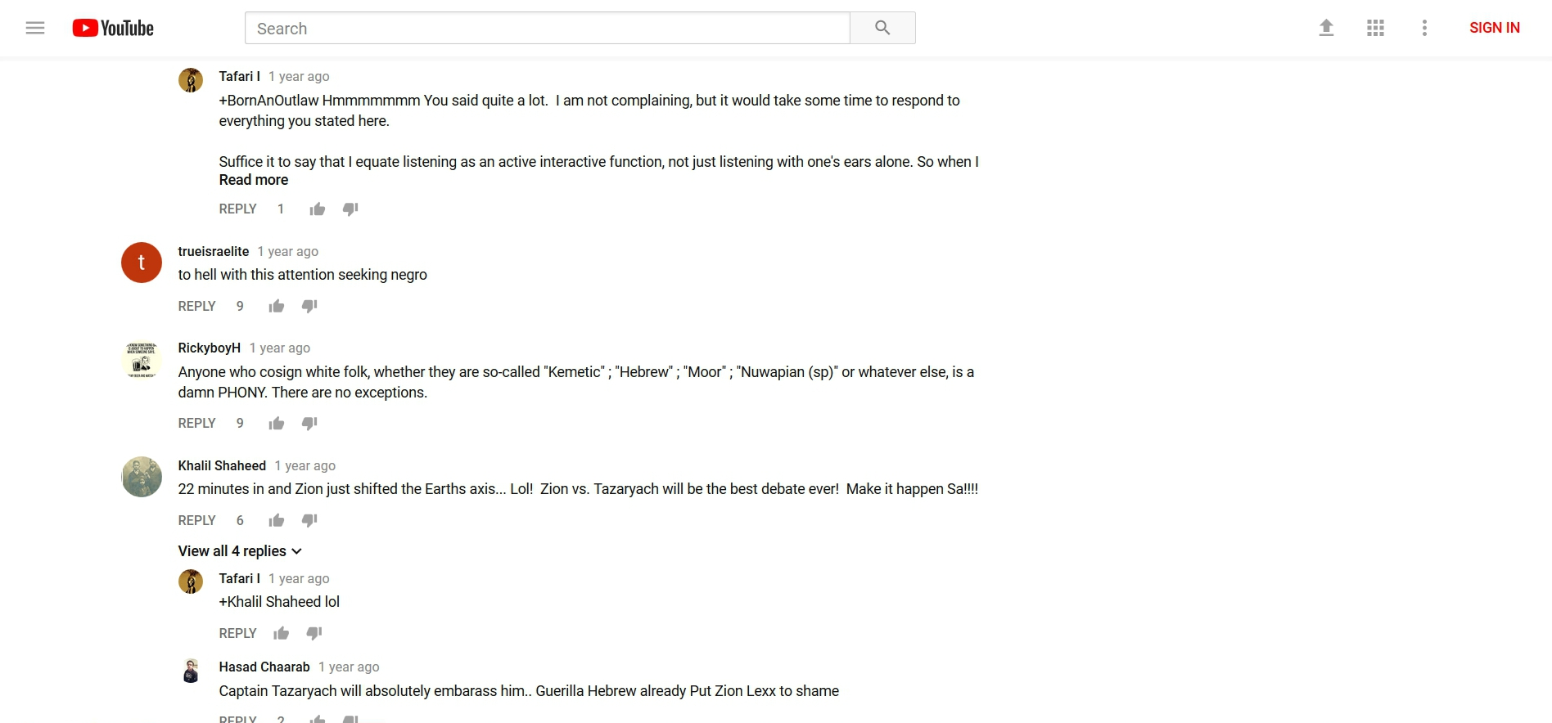

Now take a look at “his” channel:
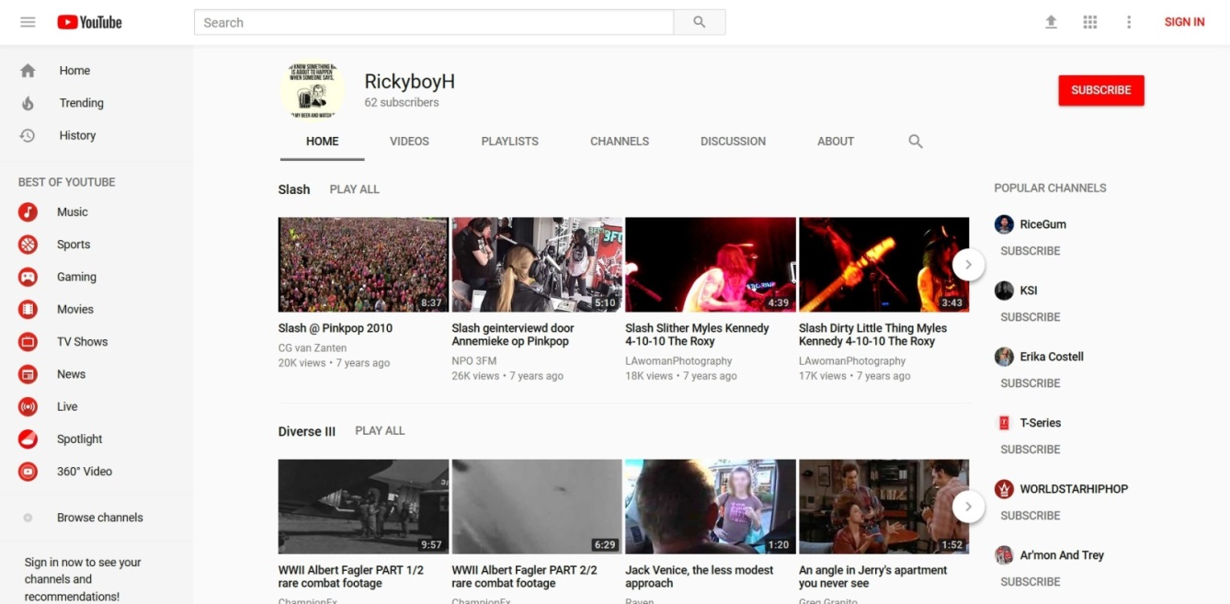
What are the odds that “he” has those tastes?
Let me show you how it’s done. With the agenda to have blacks face the police: A police shooting of a black person, real or staged, is made the important topic by the media. Videos are created on Youtube by regular people, puppets/informants (people contracted to do a job for intelligence agencies and others), and agents (actual intelligence agency employees); and memes and videos are created and spread on Facebook by regular people, puppets, and agents. These memes and videos express anger and a sense of urgency to act no matter the circumstances of the shooting. The fake profiles then leave comments that steer the minds of those reading. “These white people ….” “White supremacy ….” “I’m getting my weapons ready right now.” And these comments will have the most Likes or Thumbs up, something those controlling the profiles can do at will (I’ve even seen the comments on Facebook pop up already Liked). This creates the consensus, which the readers gravitate towards. The same occurs across the entire web on forums to other social media sites like Twitter. And while all of this is occurring online, the media is playing their part with their topics, scripts, and people they choose to interview. Celebrities/entertainers (musicians, actors, sports players, comedians, etc.), slaves under the threat of death if they don’t comply, are made to come forward and speak, especially if the event is a hoax. And teachers/leaders in the Black Conscious and Israelite communities speak on the event, steering the minds of the people further. That’s what takes place with an event, but with a long range agenda, TV shows, movies, and books are included. This is reality creation. This is the Matrix. This is how it’s done. If you control a person’s information, you can control their reality.
If you know about hoaxes, you may recall that in many of the hoaxes of the past they had the black Christian victim’s family or friends immediately forgive the killer. The same thing was written into the script of the Botham Jean shooting hoax. And in case you’re wondering why they write this into these scripts, it’s because they “get some licks in” on Christianity while they’re doing the hoaxes for other agendas (race war/racial tension/hate laws and federalizing the police). After they do this, the black moles/puppets they have planted in the black community on Youtube, Facebook, on the streets, etc. then spring into action and start attacking Christianity/the Black Church for the anti-Christianity/anti-religion agenda, trying to get black people away from Christianity and into the created communities (the Black Conscious community, New Age community and Israelite community) where they’ll be brainwashed into being weapons against Christianity, white people and the police. The fake profiles on social media also spring into action and do their part. Note: Hoaxes are not the only news stories where this happens. Regular news stories (propaganda) are also used. The story of the so-called Slave Bible is an example. Can guess which agenda this was for? Now, if you would like to see how the media outright lied, targeting the black community with lies for the agenda, read the end of page 25 to the middle of page 30 here: http://howmanyknow.com/2019/07/black-histrianity-and-the-slave-bible/
If you would like to see how black puppets have been lying to black people about Christianity as it pertains to black history, read the entire thing.
The Botham-Amber shooting hoax just proved the link between the underground black information sources, like Phil, and the mainstream information sources. But the clues where always there. For instance, why do you think these black workers constantly talk about white supremacy and white privilege, but the media does also? Just the fact that the media was saying these things should have been a red flag just by itself. I thought the media was a weapon of white supremacy? I thought Hollywood was too? So, black people are getting their proof of white supremacy and white privilege from white supremacy? Well, it makes more sense when you know who really controls the media, Hollywood, Facebook, Youtube, and more. And it just so happens to be that two of their main targets are white people and Christianity. What a coincidence. It must be another coincidence that most of the black workers come out of New York.
Extra information:
Why can these Israelite camps today get away with assault and threatening people’s lives on the streets? The same reason the New Black Panthers can get away with the things they get away with.

“In the first week of January, the Justice Department filed a civil lawsuit against the New Black Panther Party and three of its members, saying they violated the 1965 Voting Rights Act by scaring voters with the weapon, uniforms and racial slurs. In March, Mr. Bull submitted an affidavit at Justice’s request to support its lawsuit.
When none of the defendants filed any response to the complaint or appeared in federal district court in Philadelphia to answer the suit, it appeared almost certain Justice would have prevailed by default. Instead, the department in May suddenly allowed the party and two of the three defendants to walk away. Against the third defendant, Minister King Samir Shabazz, it sought only an injunction barring him from displaying a weapon within 100 feet of a Philadelphia polling place for the next three years—action that’s already illegal under existing law.”
Source: Holder’s Black Panther Stonewall
Why did the Justice Department dismiss such a clear case of voter intimidation?
http://www.wsj.com/articles/SB10001424052970203550604574361071968458430
Think about it. If a child draws a bomb or gun on a piece of paper, they’ll probably be expelled or questioned. If you make threats or carry a gun you’ll be seen as a domestic terrorist. In this post-September 11 environment you can’t do a thing without being seen as a terrorist, and you definitely can’t do it online. But the New Black Panthers and Umar Johnson can outright tell you in public to kill white people and their children. They can go on tour preaching the same message; they can even have Youtube videos preaching the same message.
Just looking at the title of these videos I was going to use for my other project. You should be able to see the truth.
“New BLACK PANTHER Party” Leader Malik Zulu Shabazz ESCALATES VIOLENCE In Ferguson, Missouri!!
Ex Gang Member Confronts The New Black Panther Party who calls for Race War In Ferguson (BLACK KKK)
New Black Panthers offer reward for capture of George Zimmerman
FERGUSON PSYOP - BUSTED! CONTROLLED OPPOSITION, Malik ShabazZ, New Black Panther Party
Black Panther Party Shabazz is Well Paid Fed
NEW BLACK PANTHER PARTY exposed Agent Provocateurs
USA: New Black Panther Party wants to “arm every black man”
New Black Panther Party Wants to Arm Every US Black Male
New Black Panther Party calls for a race war
Malik Shabazz Calls On Charleston Crowd To Finish “Mission” Killing “Slave Masters”
“Kill them all”
Michael Savage: Black Panthers Threaten to Kill White Babies
BLACK PANTHERS: OBAMA PROTECTS THOSE WHO PROMOTE "KILLING WHITES" & "THEIR BABIES"
From COINTELPRO Revisited - Spying & Disruption: “Fronts for the FBI: COINTELPRO documents reveal that a number of Sixties' political groups and projects were actually set up and operated by the FBI.”
You may still be able to find videos online of some of the original members of the Black Panthers stating that they don’t agree with this new group, are not affiliated with this new group, and tried to stop this new group from using their name to no avail.
And while we’re on this topic …
Umar Johnson Promotes Cop Killing/Looting. For $ Perps For Peace!
https://www.youtube.com/watch?v=U2n_WcAn2r0
After saying how he chooses his words carefully, he stated that black men are going to have to arm themselves and face the police, killing and dying, so that the government could step in and/or the U.N. could be called in. This is New World Order plan! This is what I showed in Exposed – The Psychological War Against Blacks.
George H.W. Bush 'New World Order' (4 Different 'New World Order' Speeches)
https://www.youtube.com/watch?v=7SwWfDJheRA
Ted Turner: It's 'Good' U.S. Troops Committing Suicide; UN Should Police the Globe
https://youtu.be/sVARrcJisVg?t=53s
Here’s something I was working on a long time ago. This Umar video has since been deleted, and I was never able to get back to it to add the title or finish it.
https://www.youtube.com/watch?v=rXdw4Kvln-4

1:11 - 1:16 – “… the riot was started by crackers.”

6:42 - “… the first law of behavioral science is the behavior that goes unpunished by the victim must occur more often.” Vengeance.
“Our reaction to Trayvon created the environment for Michael Brown to go through the same thing.” So, what he has said is that because we didn’t retaliate, or “punish,” we caused Michael Brown to get killed. The mind of the listener concludes: We should have retaliated; we should retaliate from now on.

7:23 – Our reaction to all the other shootings ….

7:58 – “white supremacy” = all whites. Don’t believe me? 8:03 - “… your reaction to what they do….” They…

8:15 – Now he plays on fear of the future, just like the government trolls who promote the idea that a purge is coming based on the movie The Purge. The mind of the listener concludes: I have to do something now before it’s too late. I have to rise up against white people before it’s too late.

8:23 – What he said altogether: You have let all white people, not some white people, get away with too much. You should have been retaliating against white people. You now have to retaliate against white people or you will pay the price.
Just look at the title of these videos, which are named after what he said in the videos.
Dr Umar Johnson White people Programmed Black People To Hate Themselves
MUST WATCH!!!! DR UMAR JOHNSON NO FREEDOM OR JUSTICE BECAUSE YOU LOVE WHITE PEOPLE SO MUCH!!!
DR UMAR JOHNSON IT'S NOT JUST THE WHITE MAN, IT'S ALL WHITE PEOPLE!!!
Black People It's Time We Get Serious About Fighting White People Dr. Umar Johnson
Dr Umar Johnson : BLACK PEOPLE , WAKE up , or get EXTERMINATED.
Dr. Umar Johnson "God of White Supremacy"
Dr Umar Johnson: The Church and Jesus is running game on black people.
Dr. Umar Johnson on Christ
Dr Umar Johnson: Jesus doesn't love you my brother.

And there were so many more … until Youtube started deleting the evidence after Umar started getting exposed (after letting it stay on Youtube for years).
Here’s a mainstream-like source (really controlled opposition) stating how celebrities are puppets for agendas. This is actually pleading to a lesser charge with a drop of disinformation. The control is far beyond this. There’s no need for the string pullers to go through the government to have celebrities, TV networks and others do their bidding.
Watch from 5:22 - 8:57
Emails describe Ellen as gov’t propaganda tool (Full show)
https://youtu.be/vkunhmA8v_Y?t=322
- 7:49 - 7:57 – Wait. What was that again? “… and you really realize it’s a whole system working hand-in-glove to manufacture consent from Americans. It’s very elaborate, and it is a system.”
Some of the comments:
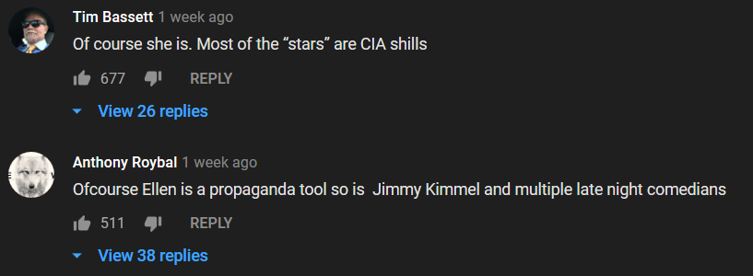
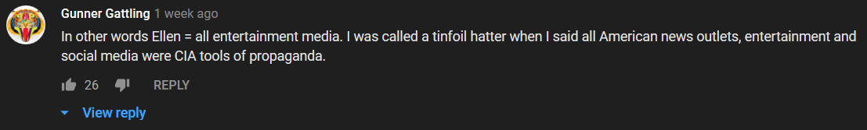
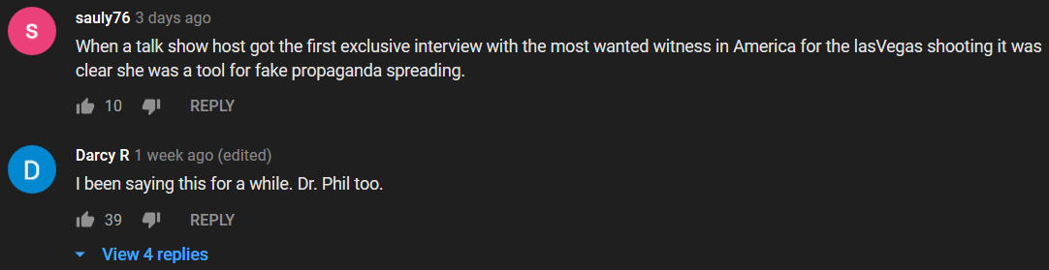
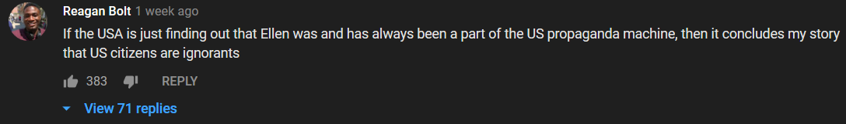
Even platforms like Vlad TV and the Breakfast Club show are a part of the System.
Though this woman is speaking on something different than what I’m presenting she confirms the system that’s in place, and how it’s shaping your reality.
Former CBS Reporter Exposes Media Lies, Internet Shills _ Astroturfing - MUST SEE!!!
https://www.youtube.com/watch?v=0s__qs0cBek
- The beginning - 1:27 – There you have it. It’s a system of reality management (create, maintain and tear down). And when people like me go through and around this system to dig up the truth and bring it to the public (the victims), this is where the censorship, punishment and defamation from the System comes in.
- 2:20 - 2:27 – “The whole point of AstroTurf is to try to give the impression there’s widespread support for or against an agenda when there’s not.”
So, groups of people believe that other groups of people like, dislike, or have a certain opinion when they don’t. Everyone may not like a thing, and they’ll all wonder why “everyone else” does. Everyone may not believe a thing, but they’ll all wonder why “everyone else” does. I think they’re going even further than this. I think it’s even being used in the music industry to give the illusion of popularity to newly signed artists. It’s definitely being used on Youtube for the puppets working on agendas – their subscribers, views, troll comments (and the Thumbs up on their comments), and the Thumbs up on their videos. It makes a New World Order puppet seem popular, and they will become popular as a result (because people are trained to go to what’s popular).
- End of Commentary -
A guy posted this on his blog, and someone posted it on Facebook not too long ago: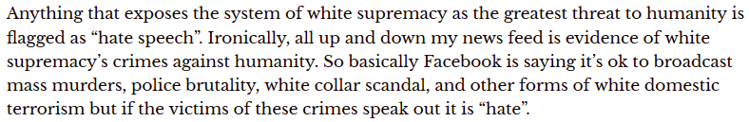
He actually debunks his theory on what’s flagged and not flagged, but what he said about the news feed is true. That’s what you’ll find in all black people’s feeds and in groups related to the Black Conscious community and Israelite community.
And speaking of censorship, my Facebook is totally censored. It went from partial censorship to total censorship after I exposed hoax after hoax in 2016. Almost no to no one sees my posts or comments. And they make sure any post of mine that’s shared isn’t seen. No one will see what shared of mine.
Here is a post I recently did about Facebook’s filtration system:
https://www.facebook.com/franklin.miller.169/posts/3394517273893530
Here’s the text of that post:
Why are videos like these almost nonexistent on Facebook?
*
If you can choose what people see and don’t see, like the media and Facebook does, you can make them see life how you want them to see it.
*
FYI: Facebook is a propaganda/brainwashing tool, and Facebook is WORSE than the media. Do you know how bad something has to be in order to be worse than the media???
*
As you watch the videos, do note that I didn’t even do an exhaustive search to find these videos.
*
And make sure you look at the dates of these videos.
*
What if I was Facebook or the media and I only showed you videos of whites being attacked by cops? What if I had a narrative with it like “The cops are after white people” or “Look what white people go through”?
*
Overturned Finding of Excessive Force at San Jose State Library
https://www.youtube.com/watch?v=BLIC3gaAiBc
*
Ex-cop caught on camera assaulting suicidal patient in hospital
https://www.youtube.com/watch?v=1_VglD_QsbA
*
Bodycam video refutes police claim that a deputy shot a man who opened his door and aimed a gun
https://www.youtube.com/watch?v=45n-QRBR0sA
*
Man Shoots And Kills Possible Intruder In Lancaster
https://www.youtube.com/watch?v=qwJFsVxEV7w
*
I-Team: Video Captures Police Demanding To Enter Framingham Home Without Warrant
https://www.youtube.com/watch?v=cJ4P820AT1U
*
Police fatally shoot man brandishing screwdriver | New York Post
https://www.youtube.com/watch?v=tU-d42Di3_A
*
Arizona cop punches woman in face during arrest
https://www.youtube.com/watch?v=ddC2Bs9ZIjU
*
US police officer violently arrests woman on beach
https://www.youtube.com/watch?v=Ye8EwifAIOI
*
California Cop Drags 20-Year-Old Woman Out of Car by Her Hair
https://www.youtube.com/watch?v=b85Dw0R4ipg
*
Suspect Spits on Cop, Cop Knocks Him Out
https://www.youtube.com/watch?v=1clsPeXT9Io
*
And if you go to that video-maker’s channel and scroll through the videos within the last year (or more if you want) you’re not only going to see black people, you’re going to see white people. Where is this on Facebook?
https://www.youtube.com/cha…/UCXMYxKMh3prxnM_4kYZuB3g/videos
*
*
What if I as Facebook only showed you the following videos?
Note: Videos like these … this is everyday black America.
*
Video shows Downtown Austin shooting | KVUE
https://www.youtube.com/watch?v=AzwPmn5pnuk
*
Brooklyn Man Shot Dead While Defending Daughter
https://www.youtube.com/watch?v=zf7XS7Jprk4
*
Surveillance video released in gas station shooting
https://www.youtube.com/watch?v=HCvKkLko3k4
*
Mother, daughter charged in murder of five family members
https://www.youtube.com/watch?v=zKn5A2eD8fE
*
Two men shot in busy parking lot
https://www.youtube.com/watch?v=C4LGfszjEVA
*
Man shot near courthouse says it was another act of senseless gun violence
https://www.youtube.com/watch?v=8aM27HhnjJk
- End of Text -
And to add to that…
2015/2016:
“In 2015, The Counted estimates, at least 306 black people were killed by police. The Washington Post puts the number of black people who were shot dead last year at 258.”
Source: http://www.huffingtonpost.com/entry/black-people-killed-by-police-america_us_577da633e4b0c590f7e7fb17
That number includes those who got into shootouts with officers, pulled guns on officers, fought with officers, etc. So, those who were innocently murdered is far less.
“At least 319 people have been slain in Chicago this year, about a 50% increase over this period last year. The number of shootings and the number of shooting victims in 2016 have also increased at about the same rate.”
Source: http://fox6now.com/2016/07/05/gun-violence-in-chicago-2000-shooting-victims-at-least-319-killed-in-2016/
And what about these videos? They’ll make it to the local news, but not to Fox and the others; and definitely not to Facebook, particularly black people’s feeds or groups.
https://www.bitchute.com/channel/abbegguyfaryoo/
https://www.bitchute.com/channel/itsoktobewhite/
The fact that the information in this next video was even on the mainstream media shows that this is something the controllers wanted the population to know. Possible reasons: They’re pleading to a lesser charge and absolving themselves from guilt by telling the people (in their eyes). For a fact, Facebook was funded by the CIA and has Defense Department ties. It’s a front-company just like Google (which owns Youtube), which is really just an extension of DARPA. One of the goals of Facebook is to change how people interact with one another. It’s all part of an overall plan to totally restructure society, building it (us) up the way they (the Elite) want it to be. This is related to the destruction of gender, male and female roles, traditions, patriotism, etc. This is what’s written about in books like Brave New World and Nineteen-Eighty-Four; and movies based on those books like Demolition Man, a film which showcases their overall goal for society – no physical contact, behavioral rating system (which they’re currently testing in China and Canada), Smart Cities, driverless cars, chipped human beings, etc.
Anonymous - This will Change Everything You Know... (2018-2019)
https://www.youtube.com/watch?v=39RS3XbT2pU
Skinner Box. So, when dopamine has you locked to Facebook, selected audio and images which Facebook filters - for instance, only showing you injustice against blacks - are being pumped into your mind. You’re “strapped to the chair,” being brainwashed. That’s one of the true purposes. Facebook is worse than television.
- 8:44 - 9:27 – Oh, like trying to provoke black Americans to fight the police and white people using hoaxes, and then completely censoring people like me who expose it? The System (the media, Hollywood, Facebook, moles/puppets, etc.) had many black people online so brainwashed they believed they were going to be “purged” by white people back in 2016! That’s how scary this is. And at 9:16 he told you what’s going on: “… where bad actors can now manipulate large swaths of people to do anything you want.”
- 9:40 – The short-term signals (like “Good boy!” in dog training) – hearts, likes, thumbs up equals truth/true. This is what the troll/fake profile program operates on. They manipulate these things to give the impression of consensus (follow the crowd) to a population that was already socially engineered through other means to operate in groupthink. These people are unsure so they go with what appears to be the crowd. That is truth to them. Even the spread of “Trending” is a part of molding people into this type of thinking and behavior.
- 11:30 - 11:44 – Lies.
- End of Commentary -
Kentucky is in Syria (and other anomalies of MSM geography) - #PropagandaWatch
https://www.youtube.com/watch?v=Z1UOQSrRPfE
- 1:28 – Wait, so you’re telling me they stage live streams too??? Wow. Who would have ever thought.
- 7:05 – “Oh my God, can you believe this atrocity is happening...” Like the media and Facebook showing what appears to be happening to blacks on a massive scale.
- 7:14 – “… as long as you give me the pictures, I’ll make the war.” Like the media, Facebook, Hollywood, and workers on Youtube carefully selecting images/videos - which also consists of excluding all the images/videos involving police injustice against whites, black injustice against whites, etc. - to present to blacks in order to create a race war or a war against the police.
All of this goes back to what I was saying in 2016 – it’s a psychological war against blacks.
Exposed – The Psychological War Against Blacks
http://howmanyknow.com/2016/08/exposed-the-psychological-war-against-blacks/
Things were so out of control in 2016 I had to put that together in a rush. I placed it on a forum, and the fake profiles blew their covers attacking me. I exposed some of the hoaxes associated with this agenda on Facebook, and the fake profiles blew their covers attacking me. I caught hell for exposing this. Not just online, but also in life. It’s like they increased a harassment knob (they were pissed). All the responses I received indicate that they were trying to pull something off in 2016. And they wanted it badly.
I have tons of proof to back up what I’m saying about the System, but this is not the time or place (I plan to release it here soon).
“The CIA's expanded role is especially ominous. In the 60s, while legally banned from ‘internal security functions,’ the CIA managed to infiltrate the Black, student and antiwar movements. It also made secret use of university professors, journalists, labor leaders, publishing houses, cultural organizations and philanthropic fronts to mold US public opinion. But it apparently felt compelled to hold back--within the country--from the kinds of systematic political destabilization, torture, and murder which have become the hallmark of its operations abroad. Now, the full force of the CIA has been unleashed at home.”
Source: COINTELPRO Revisited - Spying & Disruption by Brian Glick (author of War at Home, South End Press)
According to the documentary The New Phoenix Program (which can also be verified through other sources):
Intelligence agencies have infiltrated and created some satanic (religious) groups. Anton Lavey, founder of the Church of Satan, worked in the San Francisco Police Department crime lab and as an informant for Interpol. His most famous associate was the National Security Agency general, Michael Aquino. At the time of his membership in Lavey’s group, Aquino was an Army specialist in intelligence and psychological warfare. Aquino founded the Church of Set, and at least two members of the Council of Nine (of the Church of Set) were members of Army Intelligence.
“General Aquino’s psychological warfare campaign has started or infiltrated cults and other closed systems as part of a concerted effort to control large numbers of people and to destabilize the centers of Constitutional and legal authority both here in the United States and in other nations.”
“In 1977 Zbigniew Brzezinski, as President Carter’s National Security Adviser, forms the Nationalities Working Group (NWG) dedicated to the idea of weakening the Soviet Union by inflaming its ethnic tensions. The Islamic populations are regarded as prime targets. Richard Pipes, the father of Daniel Pipes, takes over the leadership of the NWG in 1981. Pipes predicts that with the right encouragement Soviet Muslims will ‘explode into genocidal fury’ against Moscow. According to Richard Cottam, a former CIA official who advised the Carter administration at the time, after the fall of the Shah of Iran in 1978, Brzezinski favored a ‘de facto alliance with the forces of Islamic resurgence, and with the Republic of Iran.’”
Source: http://www.historycommons.org/timeline.jsp?timeline=complete_911_timeline&amp;startpos=4300#a091101fiveisraelis
Read the following excerpt from Illuminati Conspiracy Part One: A Precise Exegesis on the Available Evidence:
At about the same time Weishaupt was embarking on an academic career two important figures entered the world stage: Thomas Robert Malthus,⁸ born in 1766, a major influence on Darwinism, population control and the eugenics movement; four years later we see the birth of Georg Wilhelm Friedrich Hegel, in Stuttgart Germany, the inventor of what would become known as the “Hegelian Dialectic.” “For Hegelians,” Antony C. Sutton reports, “the State is almighty and seen as ‘the march of God on earth.’ Indeed, a State religion. Progress in the Hegelian State is through contrived conflict: the clash of opposites makes for progress. If you can control the opposites, you dominate the nature of the outcome” (Introduction to the 2002 edition of America’s Secret Establishment: An Introduction to the Order of Skull & Bones, no pagination PDF copy).
Source: http://www.conspiracyarchive.com/2014/01/29/illuminati-conspiracy-part-one/
The Race War Has Begun (World War 3) 'Year Of Chaos 2016'
https://www.youtube.com/watch?v=gjIrpbwDArs
DEAR WHITE PEOPLE : PsyOps/Race Programming (2016)
https://www.youtube.com/watch?v=1lbXbq2_9Cs
The Truth About BlacKKKlansman
https://www.youtube.com/watch?v=RnK-zTzqs8w
They are most likely not going to stop with the psychological operations.
A tip for black people: Don’t draw your sword.
Franklin Miller (Writeous1)
http://howmanyknow.com/
writeousservant@gmail.com
writeous1@howmanyknow.com
https://www.facebook.com/franklin.miller.169
https://www.youtube.com/channel/UC6UWuuP9KUSYMIYU-nxmHNw

