The Hidden Hand
*If a video becomes unavailable, you can search here. Alternatively, you can search the internet by its title, and then filter your results by “videos”. If a link to a web page in this document has been changed or is unavailable go here, enter the address in the box, press enter and then select a date.
If possible, download all files and this document, burn them to a disc, make copies, and distribute them. Use a website or browser plugin to download. Here are some sites (Watch out for popups. And never install anything.):
https://www.y2mate.com/en1/home
https://ddownr.com/
https://www.onlinevideoconverter.com/en/youtube-converter
Go through the information in order as if reading a book, even if it takes time like a book, and the overall picture will form. You will see.
-------------------------------------------------------------------------------------------------
- Jewish Control Over the US Government - 3
- All Part of the Plan - 14
- Another Look at Terrorists and Terrorism - 16
- Another Look at the World Trade Center Buildings - 29
- Solutions - 43
-------------------------------------------------------------------------------------------------

Jewish Control Over the US Government
01 - Cynthia McKinney, Former US Congresswoman-Face to Face-05-20-2011-(Part2)
https://www.dailymotion.com/video/xiuewq
Here’s another source (Youtube probably screwed up the audio intentionally. It wouldn’t be the first time.):
USA Politicans must Swear Allegiance to Israel : Ex Congresswoman Cynthia McKinney Explains
https://www.youtube.com/watch?v=NF8xyTYfXBI
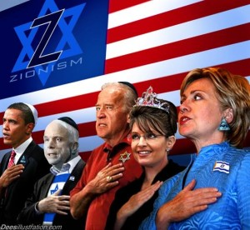
02 - THE PLEDGE TO ISRAEL
https://www.youtube.com/watch?v=AC8pJvY8Wdo
03 - Pro-Israel Highlights of Barack Obama Speech for AIPAC
https://www.youtube.com/watch?v=033gCiurxbg
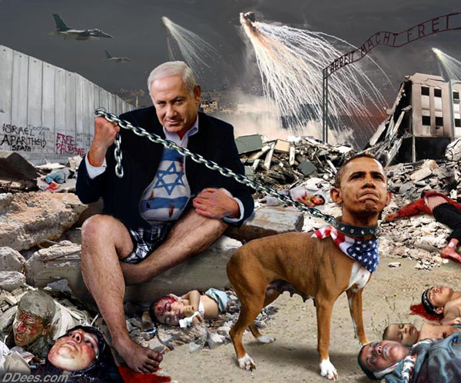

04 - Congressman Pete McCloskey describes ADL bullying
https://www.youtube.com/watch?v=MSIOIP9fEO4
- 6:28 – “Victor John Ostrovsky ... former member of the Mossad, has written about the cooperation of the American Jewish community with the Israeli government.”
05 - Jim Traficant talks about Jewish control of America
https://www.youtube.com/watch?v=GsVLnaHmMjE
FYI: The main reason the US engages in so many wars in the Middle East is to destroy threats to Israel.
06 - Hannity and Traficant Get into Shouting Match Over Israel Lobby and U.S. Policy
https://www.youtube.com/watch?v=2xMzb-SvWcE
07 - The Death Of James Traficant
https://www.youtube.com/watch?v=LjTdpqTsqZ8
08 - How Much Power Does Israel Have in America?
https://www.youtube.com/watch?v=2xz-EzwNsaA
09 - AIPAC Proves Its Power in America
https://www.youtube.com/watch?v=CNbBEh5FLOY
Watch the beginning - 49:40
10 - Ilhan Omar, Anti-Semitism, Noahide Laws, & Alex Jones
https://www.youtube.com/watch?v=7R-TX1e3UaU
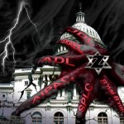

If you just ate, you might want to wait a while before you watch this next video; it might make you sick to your stomach.
11 - U.S. Congress gives Israeli PM Netanyahu over 25 standing ovations
https://www.youtube.com/watch?v=ESPRVsGY2dw
12 - US to send $7,000 per MINUTE to Israel
https://www.youtube.com/watch?v=ONXKxL3px50
Read this excerpt from Helen Thomas: Playboy Interview
PLAYBOY: Do you have a personal antipathy toward Jews themselves?
THOMAS: No. I think they’re wonderful people. They had to have the most depth. They were leaders in civil rights. They’ve always had the heart for others but not for Arabs, for some reason. I’m not anti-Jewish; I’m anti-Zionist. I am anti Israel taking what doesn’t belong to it. If you have a home and you’re kicked out of that home, you don’t come and kick someone else out. Anti-Semite? The Israelis are not even Semites! They’re Europeans, and they’ve come from somewhere else. But even if they were Semites, they would still have no right to usurp other people’s land. There are some Israelis with a conscience and a big heart, but unfortunately they are too few.
PLAYBOY: In the wake of your anti-Israel comments, a blogger from The Atlantic argued there’s really no distinction between anti-Zionism and anti-Semitism. He wrote, “Thomas was fired for saying that the Jews of Israel should move to Europe, where their relatives had been slaughtered in the most devastating act of genocide in history. She believes that once the Jews are evacuated from their ancestral homeland, the world’s only Jewish country should be replaced by what would be the world’s 23rd Arab country. She believes that Palestinians deserve a country of their own but that the Jews are undeserving of a nation-state in their homeland, which has had a continuous Jewish presence for 3,000 years.…”
THOMAS: [Interrupts] Did a Jew write this? [Editor’s note: The writer is Jeffrey Goldberg.]
PLAYBOY: “…and has been the location of two previous Jewish states. This sounds like a very anti-Jewish position to me, not merely an anti-Zionist position.”
THOMAS: This is a rotten piece. I mean it’s absolutely biased and totally—who are these people? Why do they think they’re so deserving? The slaughter of Jews stopped with World War II. I had two brothers and many relatives who fought in that war against Hitler. We believed in it. Every American family was in that fight. But they were liberated since then. And yet they carry on the victimization. American people do not know that the Israeli lobbyists have intimidated them into believing every Jew is a persecuted victim forever—while they are victimizing Palestinians.
PLAYBOY: Let’s get to something else you said more recently. In a speech in Detroit last December, you told an Arab group, “We are owned by the propagandists against the Arabs. There’s no question about that. Congress, the White House and Hollywood, Wall Street, are owned by the Zionists. No question, in my opinion. They put their money where their mouth is. We’re being pushed into a wrong direction in every way.” Do you stand by that statement?
THOMAS: Yes, I do. I know it was horrendous, but I know it’s true. Tell me it’s not true and I’ll be happy to be contradicted. I’m just saying they’re using their power, and they have power in every direction.
PLAYBOY: That stereotype of Jewish control has been around for more than a century. Do you actually think there’s a secret Jewish conspiracy at work in this country?
THOMAS: Not a secret. It’s very open. What do you mean secret?
PLAYBOY: Well, for instance, explain the connection between Hollywood and what’s happening with the Palestinians.
THOMAS: Power over the White House, power over Congress.
PLAYBOY: By way of contributions?
THOMAS: Everybody is in the pocket of the Israeli lobbies, which are funded by wealthy supporters, including those from Hollywood. Same thing with the financial markets. There’s total control.
PLAYBOY: Who are you thinking about specifically? Who are the Jews with the most influence?
THOMAS: I’m not going to name names. What, am I going to name the Ponzi guy on Wall Street [Bernard Madoff] or the others? No.
PLAYBOY: Then how do you make the claim that Jews are running the country?
THOMAS: I want you to look at the Congress that just came in. Do you think [New York Democratic senator Charles] Schumer and Lehtinen—whatever her name is—in Florida [Republican representative Ileana Ros-Lehtinen, a strong supporter of Israel] are going to be pro-Arab? No. But they’re going to be very influential. Eric Cantor, the majority leader of the Republicans, do you think he’s going to be for the Arabs? Hell no! I’m telling you, you cannot get 330 votes in Congress for anything that’s pro-Arab. Nothing. If you’re not in, you’re eased out, just as Senator William Fulbright was in the 1960s [after claiming that millions of tax-deductible dollars from American philanthropies were being sent to Israel and then funneled back to the U.S. for distribution to organizations with pro-Israel positions]. Congressman Paul Findley from a little old rural district in Illinois made the mistake of shaking hands with Yasir Arafat years ago. It ended up costing him his reelection. He later wrote a book called They Dare to Speak Out about how impossible it is to have a position in this country that takes on Israel. Maybe there is a handful that can, but in general you cannot speak against any Zionist movement in this country.
PLAYBOY: Do you begrudge people like Steven Spielberg? He created the Shoah Foundation to chronicle the life stories of Holocaust survivors. What’s your feeling about him?
THOMAS: There’s nothing wrong with remembering it, but why do we have to constantly remember? We’re not at fault. I mean, if they’re going to put a Holocaust museum in every city in Germany, that’s fine with me. But we didn’t do this to the Jews. Why do we have to keep paying the price and why do they keep oppressing the Palestinians? Do the Jews ever look at themselves? Why are they always right? Because they have been oppressed throughout history, I know. And they have this persecution. That’s true, but they shouldn’t use that to dominate.
PLAYBOY: In America you’re talking about a relatively small community. Jews make up roughly two percent of the U.S. population. On a worldwide level, the percentage is well under one percent. Those numbers don’t exactly spell domination.
THOMAS: I get where you’re leading with this. You know damn well the power they have. It isn’t the two percent. It’s real power when you own the White House, when you own these other places in terms of your political persuasion. Of course they have power. You don’t deny that. You’re Jewish, aren’t you?
PLAYBOY: Yes.
THOMAS: That’s what I thought. Well, you know damn well they have power.
PLAYBOY: Why did it take you so long to speak out like this?
THOMAS: It hasn’t taken that long. I’ve told all my friends and so forth. This has been an issue for me since I first came to Washington.
PLAYBOY: You’ve kept quiet publicly since the 1940s?
THOMAS: It was certainly on my mind back then. The United Nations Partition Plan was being debated at the UN and in the Arab community, and I knew what the Arabs were going through since I have an Arab background. I was part of that community. Like I said, I’ve never hesitated to tell my views to all my friends. They knew exactly where I stood. But I finally wanted to speak the truth. And I think I’m old enough to get away with it. Well, almost. Not quite.
PLAYBOY: Were you surprised that people like David Duke and even Hezbollah came out and said you were courageous and a hero for them?
THOMAS: I don’t want to be a hero to anyone. I just want to be me, and I want to tell the truth. I want everyone to accept the truth. It’s horrible to say some of my best friends are Jews, but they are and they have been.
PLAYBOY: Don’t take this the wrong way, but the question many people have is, Has Helen Thomas lost her mind? You’re 90, after all. Do you still have all your faculties?
THOMAS: I resent that question! I thoroughly resent it. Why are you interviewing me if I’m crazy? It wouldn’t be worth it to you, would it?
PLAYBOY: It’s not an unreasonable question.
THOMAS: I resent it. You should apologize.
PLAYBOY: But it’s the question everyone wants answered—and you’re the one who always tells journalists to ask the hard questions.
THOMAS: They want to know if I’m crazy? You have to be crazy to criticize Israel? You have to be crazy to criticize tyranny? I learned before Hitler that you have to stand up for something. You have to stand up. We always have to take a stand against human tyranny wherever it occurs. [pauses] Would you like a Coke or a ginger ale?
PLAYBOY: No, thank you.
THOMAS: We have Diet Coke. Wine?
PLAYBOY: No, we’re good.
THOMAS: Scotch?
PLAYBOY: No, thank you. How’s your health, by the way?
THOMAS: I’m a little rickety.
PLAYBOY: Do people live a long time in your family?
THOMAS: I had a brother who just died at 100.
PLAYBOY: Wow. How long did your parents live?
THOMAS: Into their 60s. I’d like to live a long life.
PLAYBOY: Do you fear dying?
THOMAS: No, but I’m not ready to go. You never know, though. It’s fate.
PLAYBOY: Life is unpredictable, that’s for sure.
THOMAS: There’s an Arab expression, “Maktub.”
PLAYBOY: Which means?
THOMAS: “It is written.”
PLAYBOY: Meaning whatever will be will be?
THOMAS: I don’t know if I’m that fatalistic, but yes.
PLAYBOY: Do you picture heaven in any way? What would heaven be for you?
THOMAS: I never thought about heaven per se. I think when you’re dead, you’re dead. If anything happens after that, you just hope you don’t go to hell.
PLAYBOY: When people write your obituary——
THOMAS: [Eyes suddenly fill with tears] Oh, I know what they’re going to say: “anti-Semite.”
PLAYBOY: That has to bother you after all your years of hard work.
THOMAS: [Starts to cry] I’m a reporter.
PLAYBOY: What’s making you emotional?
THOMAS: I’m a reporter. [sobs] I know damn well what they’re going to say because they have their print, they have their ink. They don’t give a damn about the truth. They have to have it their way, and they’ll be writing my obituary.
PLAYBOY: Isn’t that their job?
THOMAS: Well, I don’t want to be treated that way. [pauses but continues to cry] I’m sorry. But what am I supposed to do, love every Jew because they want to take Palestine? It’s a real cause with me. They should have a conscience and they don’t if that’s what they’re going to do. Is there such a thing as a conscience? I think there is. Stop taking what doesn’t belong to you! Stop killing these people. These children throw stones at them, and they shoot them. Where is the Jewish conscience? I want to know. Have some feeling. They can’t just come in and say, “This is my home,” knock on the door at three in the morning and have the Israeli military take them out. That’s what happens. And that’s what happened to the Jews in Germany. Why do they inflict that same pain on people who did nothing to them? [takes another break to compose herself]I sure didn’t want to cry. But I do care about people. And I don’t care what they write about me. They’ve already written it. My family will be disappointed in me for crying.
PLAYBOY: We in the public never get to see you cry. Helen Thomas has always been the picture of toughness and strength.
THOMAS: Oh, I’ve cried all my life. I’m a crybaby. It’s not that I’m soft; I just cry at the drop of a hat.
PLAYBOY: Let’s shift gears. You have literally had a front-row seat on the presidency. What should the American people know about how the White House really operates?
THOMAS: They don’t know how intense the pressure from different special interests is on the president and congressmen. Politicians more often than not give in to that pressure. These elected officials are supposed to be doing what we want them to do. But I suppose that’s the reason we have the Tea Party. People are unhappy. The trouble is, swinging to the right is always dangerous. We end up losing so much in the rush to conservatism. But even Obama has fallen down that hole. He’s pushing a conservative agenda.
PLAYBOY: The right doesn’t see Obama that way. How is Obama conservative?
THOMAS: Look at Guantánamo. With a stroke of a pen, the day after Obama took the oath he should have said, “We’re getting the hell out of here.” Same thing with Iraq and Afghanistan. There’s no reason for us to be in a war. “They’ll all come here if we don’t go there.” That is baloney. Go halfway around the world to kill and die? Why? Now the veterans can’t get jobs. I see stories every day about soldiers being liberated from Iraq only to end up unemployed. Where is Obama? How can he continue these Bush policies that were so mean and rotten and unjust? People had this impression that Obama would be a peaceful president, but there he is, as hawkish as any of them. And Hillary Clinton is no liberal either. She put out the word to “capture or kill” for Afghanistan. What would she do that for, really? Capture or kill? What does this mean? I thought, naively perhaps, that she and Obama would bring change, that they would be different. I assumed wrongly that they would be liberal because he’s black and she’s a woman. It’s maddening.
Source: http://web.archive.org/web/20110606115913/http://www.playboy.com/articles/helen-thomas-playboy-interview/index.html?page=2
After a remarkable career, here’s how the Times of Israel referred to her after her death:
Journalist Helen Thomas, who said Jews ‘should get the hell out of Palestine,’ dies at 92
Veteran White House correspondent covered 10 presidents and was known for her fiery manner, but her career came to an end over anti-Israel remarks
Source: https://www.timesofisrael.com/pioneering-and-controversial-journalist-helen-thomas-dies-at-92/
All Part of the Plan
13 - Jewish-American Journalist Carl Bernstein reveals the role 'Jewish Neocons' in Launching Iraq War
https://www.youtube.com/watch?v=ZRlatDWqh0o
“No.” Yes.
14 - Iraq, the Neocons and the Israel Lobby - John Mearsheimer
https://www.youtube.com/watch?v=htmO1Cyl73s
- 4:16 – “It was the events of 9/11 that created circumstances where they could help convince both President Bush and Vice President Cheney that invading Iraq was a smart idea.” I don’t think Bush and Cheney needed convincing, but 9/11 was used to convince many others.
15 - How Pro Israel Neocons Pushed for War in Iraq (Alison Weir)
https://www.youtube.com/watch?v=dbx_Qncpzjg
- 2:33 – “It’s the war the neoconservatives wanted. It’s the war the neoconservatives marketed. Those people had an idea to sell when September 11 came, and they sold it. Oh boy, did they sell it. So this is not a war that the masses demanded. This is a war of an elite.”
- 3:58 – The Bush administration was: “… peppered with people who have long records of activism on behalf of Israel in the United States, of policy advocacy in Israel, and of promoting an agenda for Israel often at odds with existing U.S. policy. These people, who can fairly be called Israeli loyalists, are now at all levels of government, from desk officers at the Defense Department to the deputy secretary level at both State and Defense, as well as on the National Security Council staff and in the vice president’s office.”
- 6:40 – “… describing how some of these individuals, including Perle and Wolfowitz, had been investigated through the years by US intelligence agencies for security lapses benefitting Israel. Yet, despite a pattern of highly questionable actions suggestive of treason they continued to procure top security clearances for themselves and cronies.”
- 7:31 – “The Israeli article I mentioned earlier, reported that the goal was far more than just an invasion of Iraq. At a deeper level, the piece said, it is a greater war, to ‘consolidate a new world order, to create a new Middle East.’ ‘The Iraq war,’ the article said, ‘is really the beginning of a gigantic historical experiment.’”
16 - Former Israeli officials in the U.S. government pushed war against Iraq – Dahlia Wasfi
https://www.youtube.com/watch?v=md3AMFFGeqk
- 3:02 – “A Clean Break was written by Richard Perle, Douglas Feith and David Wurmser. All three of them had high-ranking positions in the government of Benjamin Netanyahu in 1996.”
- 6:41 – “On the political side there are actually quotes from Phillip Zellkow who was named 9/11 Commissioner. He’s one of the neoconservative Zionists who is in the Bush administration’s cabal at the time of the invasion.”
17 - THE GREATER ISRAEL PROJECT
https://www.youtube.com/watch?v=uexEtkDwsLk
18 - We're Marching to Zion
https://www.youtube.com/watch?v=CsvzLXCUHeg
Another Look at Terrorists and Terrorism
19 - When False Flags Don't Fly
https://www.youtube.com/watch?v=TJgv39GtcJ0
20 - WTC 1993 was an FBI job
https://www.youtube.com/watch?v=_2vpcABWJiY
21 - The FBI Fosters, Funds and Equips American Terrorists
https://www.youtube.com/watch?v=TBobEiXInxQ
22 - 2001 Anthrax Case Solved?
https://www.youtube.com/watch?v=bcvIF0W7WRM
23 - FBI: Anthrax Case Closed
https://www.youtube.com/watch?v=ybFWdrAKH2k
24 - Anthrax Attacks, Inside Job | Brainwash Update
https://www.youtube.com/watch?v=8ecu0JM9pEc
And the media played their part.
25 - Anthrax Anybody!
https://www.youtube.com/watch?v=ti8lZMyIU1M
26 - Talks about Anthrax the day after 9/11
https://www.youtube.com/watch?v=WKKJ0-FD1d0
27 - Future Anthrax Attacks Predicted in 1999: NBC News 2/11/1999 (Pre-Millennium Plot/9-11)
https://www.youtube.com/watch?v=d5foXo23kF0
28 - Graeme MacQueen Reveals The Anthrax Deception
https://www.youtube.com/watch?v=oVHTvUFxUH4
- 37:23 - 43:01 – Just like the 2008 financial crisis.
- 43:24 - 46:15 – From video number 4 (above): “Victor John Ostrovsky ... former member of the Mossad, has written about the cooperation of the American Jewish community with the Israeli government.”
29 - Anthrax: The Forgotten False Flag and the Illegal Invasion of Iraq
https://www.youtube.com/watch?v=BP2G-cejYhI
30 - Al Qaeda Doesn't Exist (Documentary) – 2
https://www.youtube.com/watch?v=VnV_pNe_BB0
31 - Al Qaeda Doesn't Exist Documentary 3
https://www.youtube.com/watch?v=rSs1Z8aglV0
Watch the beginning - 48:38
32 - Who Is REALLY Behind ISIS?
https://www.youtube.com/watch?v=8LSIwvE0Nvo
- 33:56 - 38:06 – “… Saudi’s former ambassador to the United States is leading the effort to prop up the Syrian rebels.” “… intelligence agents from Saudi Arabia, the US, Jordan, and other allied States are working at a secret joint operation center in Jordan to train and arm hand-picked Syrian rebels.” The Saudis and the CIA are together at a secret base which trains terrorists in the Middle East. Some of these people even joined ISIS. All of this will come into play later.
- 44:08 - 48:38 – Israel and the Greater Israel Project. “Israel’s designs on Iraq have been well known and well understood for a long time, but I think we have to see all of these invasions and overthrows and all of the destabilization in the Middle East in recent years as part of a grander Zionist project for reshaping the Middle East that we can say not only predates that five year plan that General Wesley Clark talks about, but predates it by decades, at the very least, documentably and on the record.” “And that will only come through the destabilization of its various neighbors through ethnic and racial and religious infighting; and that specifically, again, has been laid out, not only, of course, with Iraq but also with Syria. And we see that playing out today.”
33 - Isis Is Not Islamic! It's The Israeli Secret Intelligence Service (ISIS)
https://www.youtube.com/watch?v=wzQowPAagRI
34 - British Special Forces “Dressing Up” As ISIS…What Could Go Wrong?
https://www.corbettreport.com/british-special-forces-dressing-up-as-isis-what-could-go-wrong/
35 - Netanyahu: Continuing To Fund Hamas Key To Keeping Palestinians Divided
https://www.youtube.com/watch?v=MOZS87Mz-xA
36 - CNN anchor asks Jeffrey Lord about Jewish terrorist attacks
https://www.youtube.com/watch?v=MbH4-F752VQ
This next video presents information that is key, information that you have to keep in mind. Understand: It’s not exactly Israel, Netanyahu, the US and others who are running the show and carrying out attacks, it’s the Elite through these countries and people. You have to keep this in mind or you’ll be driven back to blaming governments and only seeing governments.
37 - Rothschild Mossad Working With Saudi Arabian Mafia Boss
https://www.youtube.com/watch?v=3-0rXnX9_wg
- 14:13 – “It didn’t matter on 911 what the religion of the Saudi royals was. The fact is, they financed a lot of the operational activity, and they did it in conjunction with assistance from the Pakistani ISI and the US CIA.” All of this Saudi-CIA info will come into play later in the information on September 11 and Ptech.
- 23:10 – “… I think that we need to keep our eyes open on this dangerous nexus that has formed between the Mossad, the Saudi intelligence and the CIA. Think about it, they have already worked together to carry out 911.”
And if you don’t know, the Rothschilds created the state of Israel.
38 - 9/11 Whistleblowers: Michael Springmann
https://www.youtube.com/watch?v=Ooj_KOoVmAI
39 - Milton William "Bill" Cooper predicts 9/11 and MORE on June 28, 2001
https://www.youtube.com/watch?v=KMlE6aiDFfY
40 - Real Terrorists pt.1 of 2
https://www.youtube.com/watch?v=WE3G7_6AQRI
September 11 was the gateway into the Elite’s New World Order. The Patriot Act and similar laws brought in the New World Order control grid. Looking at the words of Zbigniew Brzeziński it becomes even more evident that September 11 was used to bring in the surveillance state.
41 - Real Terrorists pt. 2 of 2
https://www.youtube.com/watch?v=ZLz0m1oSq1A
42 - 9/11: A Conspiracy Theory
https://www.youtube.com/watch?v=yuC_4mGTs98
43 - Cynthia McKinney - On 911 & Zionist Extremism
https://www.youtube.com/watch?v=HfCiCYlNzDk
- 3:02 - 3:21 – “Ever since my refusal to sign that pledge for Israel, the pro-Israel lobby let me know that my political net was in the hangman’s noose. It was the pro-Israel lobby that decided to tighten that noose when I questioned the Bush administration’s actions on and after 911.”
- 4:04 - 4:24 – “When I travelled to Europe and England I encouraged citizen investigations of 911. And I learned that to question 911 was to be labeled an anti-Semite. Even more bizarre, those who questioned the tragedy were equated with holocaust deniers.”
Take a look at this excerpt from Shady Companies With Ties to Israel Wiretap the U.S. for the NSA:
In addition to constructing the Stellar Wind center, and then running the operation, secretive contractors with questionable histories and little oversight were also used to do the actual bugging of the entire U.S. telecommunications network.
According to a former Verizon employee briefed on the program, Verint, owned by Comverse Technology, taps the communication lines at Verizon, which I first reported in my book The Shadow Factory in 2008. Verint did not return a call seeking comment, while Verizon said it does not comment on such matters.
At AT&T the wiretapping rooms are powered by software and hardware from Narus, now owned by Boeing, a discovery made by AT&T whistleblower Mark Klein in 2004. Narus did not return a call seeking comment.
What is especially troubling is that both companies have had extensive ties to Israel, as well as links to that country’s intelligence service, a country with a long and aggressive history of spying on the U.S.
In fact, according to Binney, the advanced analytical and data mining software the NSA had developed for both its worldwide and international eavesdropping operations was secretly passed to Israel by a mid-level employee, apparently with close connections to the country. The employee, a technical director in the Operations Directorate, “who was a very strong supporter of Israel,” said Binney, “gave, unbeknownst to us, he gave the software that we had, doing these fast rates, to the Israelis.”
But Binney now suspects that Israeli intelligence in turn passed the technology on to Israeli companies who operate in countries around the world, including the U.S. In return, the companies could act as extensions of Israeli intelligence and pass critical military, economic and diplomatic information back to them. “And then five years later, four or five years later, you see a Narus device,” he said. “I think there’s a connection there, we don’t know for sure.”
Narus was formed in Israel in November 1997 by six Israelis with much of its money coming from Walden Israel, an Israeli venture capital company. Its founder and former chairman, Ori Cohen, once told Israel’s Fortune Magazine that his partners have done technology work for Israeli intelligence. And among the five founders was Stanislav Khirman, a husky, bearded Russian who had previously worked for Elta Systems, Inc. A division of Israel Aerospace Industries, Ltd., Elta specializes in developing advanced eavesdropping systems for Israeli defense and intelligence organizations. At Narus, Khirman became the chief technology officer.
A few years ago, Narus boasted that it is “known for its ability to capture and collect data from the largest networks around the world.” The company says its equipment is capable of “providing unparalleled monitoring and intercept capabilities to service providers and government organizations around the world” and that “Anything that comes through [an Internet protocol network], we can record. We can reconstruct all of their e-mails, along with attachments, see what Web pages they clicked on, we can reconstruct their [Voice over Internet Protocol] calls.”
Like Narus, Verint was founded by in Israel by Israelis, including Jacob “Kobi” Alexander, a former Israeli intelligence officer. Some 800 employees work for Verint, including 350 who are based in Israel, primarily working in research and development and operations, according to the Jerusalem Post. Among its products is STAR-GATE, which according to the company’s sales literature, lets “service providers … access communications on virtually any type of network, retain communication data for as long as required, and query and deliver content and data …” and was “[d]esigned to manage vast numbers of targets, concurrent sessions, call data records, and communications.”
In a rare and candid admission to Forbes, Retired Brig. Gen. Hanan Gefen, a former commander of the highly secret Unit 8200, Israel’s NSA, noted his former organization’s influence on Comverse, which owns Verint, as well as other Israeli companies that dominate the U.S. eavesdropping and surveillance market. “Take NICE, Comverse and Check Point for example, three of the largest high-tech companies, which were all directly influenced by 8200 technology,” said Gefen. “Check Point was founded by Unit alumni. Comverse’s main product, the Logger, is based on the Unit’s technology.”
According to a former chief of Unit 8200, both the veterans of the group and much of the high-tech intelligence equipment they developed are now employed in high-tech firms around the world. “Cautious estimates indicate that in the past few years,” he told a reporter for the Israeli newspaper Ha’artez in 2000, “Unit 8200 veterans have set up some 30 to 40 high-tech companies, including 5 to 10 that were floated on Wall Street.” Referred to only as “Brigadier General B,” he added, “This correlation between serving in the intelligence Unit 8200 and starting successful high-tech companies is not coincidental: Many of the technologies in use around the world and developed in Israel were originally military technologies and were developed and improved by Unit veterans.”
Source: https://www.wired.com/2012/04/shady-companies-nsa/
“The National Security Agency routinely shares raw intelligence data with Israel without first sifting it to remove information about US citizens, a top-secret document provided to the Guardian by whistleblower Edward Snowden reveals.
Details of the intelligence-sharing agreement are laid out in a memorandum of understanding between the NSA and its Israeli counterpart that shows the US government handed over intercepted communications likely to contain phone calls and emails of American citizens. The agreement places no legally binding limits on the use of the data by the Israelis.
The disclosure that the NSA agreed to provide raw intelligence data to a foreign country contrasts with assurances from the Obama administration that there are rigorous safeguards to protect the privacy of US citizens caught in the dragnet. The intelligence community calls this process ‘minimization’, but the memorandum makes clear that the information shared with the Israelis would be in its pre-minimized state.
The deal was reached in principle in March 2009, according to the undated memorandum, which lays out the ground rules for the intelligence sharing.
The five-page memorandum, termed an agreement between the US and Israeli intelligence agencies ‘pertaining to the protection of US persons’, repeatedly stresses the constitutional rights of Americans to privacy and the need for Israeli intelligence staff to respect these rights.
But this is undermined by the disclosure that Israel is allowed to receive ‘raw Sigint’ – signal intelligence. The memorandum says: ‘Raw Sigint includes, but is not limited to, unevaluated and unminimized transcripts, gists, facsimiles, telex, voice and Digital Network Intelligence metadata and content.’
According to the agreement, the intelligence being shared would not be filtered in advance by NSA analysts to remove US communications. ‘NSA routinely sends ISNU [the Israeli Sigint National Unit] minimized and unminimized raw collection’, it says.”
Source: https://www.theguardian.com/world/2013/sep/11/nsa-americans-personal-data-israel-documents
Additional source
What Was the Israeli Involvement in Collecting U.S. Communications Intel for NSA?
https://www.haaretz.com/did-israelis-gather-intel-for-the-nsa-1.5275806
Previously stated: “… peppered with people who have long records of activism on behalf of Israel in the United States, of policy advocacy in Israel, and of promoting an agenda for Israel often at odds with existing U.S. policy. These people, who can fairly be called Israeli loyalists, are now at all levels of government, from desk officers at the Defense Department to the deputy secretary level at both State and Defense, as well as on the National Security Council staff and in the vice president’s office.”
“… describing how some of these individuals, including Perle and Wolfowitz, had been investigated through the years by US intelligence agencies for security lapses benefitting Israel. Yet, despite a pattern of highly questionable actions suggestive of treason they continued to procure top security clearances for themselves and cronies.”
44 - Your Phone Call is Listen too in ISRAEL, ISRAEL gets us into WARS
https://www.youtube.com/watch?v=jL5OgM2HvR8
45 - 911 - The Israeli Connection
https://www.youtube.com/watch?v=DcToxgr4xWw
“Stated they served in military intelligence, electronic surveillance intercept and or explosive ordinance units.”
Cheering Movers and Art Student Spies: Was Israel Tracking the Hijackers Before the 9/11 Attacks?
https://www.democracynow.org/2007/2/8/cheering_movers_and_art_student_spies
The actions and statements of these Israeli spies prove they had prior knowledge.
And remember, there were “the movers” and the “art students.”
46 - THIS WILL SHOCK YOU TO YOUR CORE 911 From Cheney to Mossad
https://www.youtube.com/watch?v=9THVsoKt8OA
Additional Information
https://www.antiwar.com/rep/DEA_Report_redactedxx.pdf
https://www.gelitin.net/projects/b-thing/
47 - 9/11 Suspects: The Dancing Israelis
https://www.youtube.com/watch?v=2XHm56O2NTI
Newly Released FBI Docs Shed Light on Apparent Mossad Foreknowledge of 9/11 Attacks
https://www.mintpressnews.com/newly-released-fbi-docs-shed-light-on-apparent-mossad-foreknowledge-of-9-11-attacks/258581/
48 - Al Franken - The Jew Call
https://www.youtube.com/watch?v=NUaV-xeHmZc
It’s been stated that only a small Jewish faction desired 9/11, or that only Zionist Jews desired 9/11, but what do you say about the fact that other Jews were given advanced warnings about 9/11? “You’re one of us so...”
49 - 9/11 Trillions: Follow The Money
https://www.youtube.com/watch?v=n3xgjxJwedA
Ptech
https://wikispooks.com/wiki/Ptech
P-TECH-911 Software. FAA Hacked on 911?
http://www.abovetopsecret.com/forum/thread653370/pg1
50 - PTech and the 9/11 Software
https://www.bitchute.com/video/UuZRMpt_Tas/
https://www.corbettreport.com/ptech-and-the-911-software/
51 - 9/11 Suspects: Philip Zelikow
https://www.youtube.com/watch?v=j1VtozvvG4c
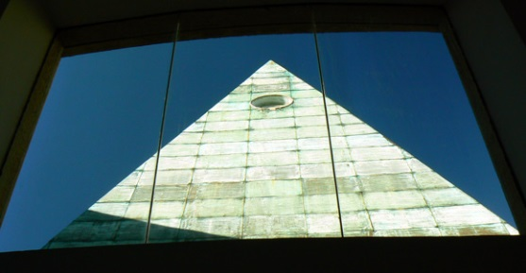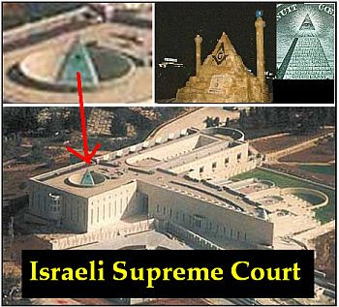
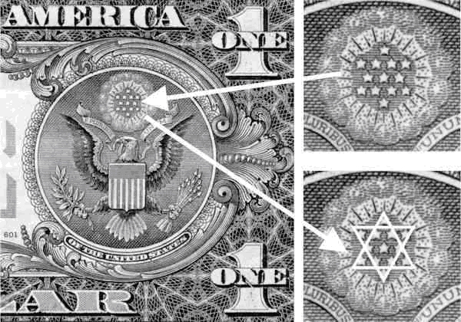
Another Look at the World Trade Center Buildings
History of the Twin Towers
1939 | At the World's Fair in Flushing, NY the "World trade center" pavilion is dedicated to "world peace through trade."
1959 | Downtown Lower Manhattan Association is created by real estate developer David Rockefeller to revitalize lower Manhattan and begins to promote the idea of a "world trade and finance center" in New York City.
January 1960 | David Rockefeller presents a plan for a world trade center along the East River of Manhattan. The Port of New York Authority is commissioned to study the plan.
March 1961 | On March 10, Port Authority issues a favorable report on the feasibility of developing a world trade center.
February 1962 | New York and New Jersey authorize the development of the World Trade Center.
December 1962 | World Trade Center location moves to West Side amidst protests by displaced business owners.
November 1963 | The Port Authority wins legal challenge in the development of the WTC.
January 1964 | The Port Authority unveils an architectural plan for the WTC featuring the world's tallest buildings.
March 1966 | Construction begins on March 21 at the WTC site with the demolition of 78 Dey Street.
August 1966 | Excavation work begins for the WTC. First use of "slurry wall" method in the United States.
June 1967 | New York City Board of Estimates formally approves the WTC legislation.
October 1970 | The North Tower of the WTC exceeds the height of Empire State Building, making it the tallest building in the world.
December 1970 | The first tenants move into North Tower of the WTC on December 15.  The North Tower of the WTC is topped off at 1,368 feet on December 23.
July 1971 | The South Tower of the WTC is topped off at 1,362 feet on July 19.
September 1971 | The first tenant moves into Two World Trade Center (South Tower).
March 1972 | The first tenant moves into Five World Trade Center (Northeast Plaza Building).
April 1973 | The World Trade Center is dedicated on April 4.
Source: https://www.panynj.gov/wtcprogress/history-twin-towers.html
(the Port Authority of New York and New Jersey)
“The fair exhibit was temporary, but soon city bigwigs were talking about creating a permanent trade center. An early champion of this idea was Winthrop Aldrich, chairman of Chase National Bank and scion of the Aldrich dynasty. In 1946, Aldrich, who had helped organize the World's Fair exhibition, was selected to lead the World Trade Center Corporation, a body created by the state legislature to study the feasibility of a permanent trade center in New York.”
Source: http://gothamist.com/2016/09/08/wtc_twin_towers_flashback.php#photo-1
So, we have David Rockefeller and Winthrop Aldrich. That’s not good.
“The 1939 New York Worlds Fair included an exhibit called the World Trade Center that was dedicated to the concept of ‘world peace through trade.’ Seven years later, one of the exhibit’s organizers, Winthrop W. Aldrich, headed a new state agency whose proposed goal was a permanent trade exposition based in New York. Market research indicated that the city would benefit more by modernizing its ports, however, and the plan was soon scrapped.
Aldrich’s nephew, David Rockefeller, didn’t forget the idea. The grandson of Standard Oil founder John D. Rockefeller, David decided to revive the World Trade Center concept as the core of a revitalized lower Manhattan. In May 1959, Rockefeller formed the Downtown-Lower Manhattan Association, which planned a $250 million complex near the Fulton Fish Market on the East River, including a single 70-story office tower and several smaller buildings.”
Source: https://www.history.com/topics/landmarks/world-trade-center
“… the plan was scrapped.” “… Rockefeller didn’t forget the idea.” That’s their twist on the truth.
“The idea of establishing a World Trade Center in New York City was first proposed in 1943. The New York State Legislature passed a bill authorizing New York Governor Thomas E. Dewey to begin developing plans for the project[14] but the plans were put on hold in 1949.[15] During the late 1940s and 1950s, economic growth in New York City was concentrated in Midtown Manhattan. To help stimulate urban renewal in Lower Manhattan, David Rockefeller suggested that the Port Authority build a World Trade Center in Lower Manhattan.[16]
One World Trade Center and Two World Trade Center, commonly the Twin Towers, the idea of which was brought up by Minoru Yamasaki, were designed as framed tube structures, which provided tenants with open floor plans, uninterrupted by columns or walls.[85][86] They were the main buildings of the World Trade Center.[57] The North Tower (One World Trade Center), the tallest building in the world at 1,368 feet (417 m) by the time of its completion, began construction in 1966 with the South Tower (2 World Trade Center);[87] extensive use of prefabricated components helped to speed up the construction process, and the first tenants moved into the North Tower in December 1970, while it was still under construction.”
Source: https://en.wikipedia.org/wiki/World_Trade_Center_(1973%E2%80%932001)
He “suggested”?
This is more like it:
What David Rockefeller Wanted Built Got Built
https://www.nytimes.com/2017/03/26/nyregion/david-rockefeller-development-nyc.html
“David and Nelson were not just the names of two Rockefeller brothers. They were the names of the twin towers at the World Trade Center. More accurately, they were nicknames given to the towers — David, because David Rockefeller, as chairman of the Downtown-Lower Manhattan Association, originated the idea; Nelson, because Gov. Nelson A. Rockefeller of New York signed the legislation that made it possible.”
A little on Nelson W. Aldrich:
“His daughter Abigail Greene ‘Abby’ Aldrich was a philanthropist[13] who married philanthropist John Davison Rockefeller, Jr.,[14] and their second son Nelson Aldrich Rockefeller was a four-term Governor of New York who campaigned for the Republican presidential nomination in 1960, 1964, and 1968, and was named Vice President of the United States under President Gerald Ford by the Congress in 1974.[15] Aldrich's son Richard S. Aldrich served in Congress from 1923 to 1933,[16] and his son Winthrop Williams Aldrich served as chairman of the Chase National Bank.[17] American film director, writer and producer, Robert Aldrich was his grandson.”
“The panic of 1907 led to the passage of the Aldrich–Vreeland Act in 1908, which established the National Monetary Commission, sponsored and headed by Aldrich. After issuing a series of 30 reports, this commission drew up the Aldrich Plan, forming the basis for the Federal Reserve system.
Following the Panic of 1907, Aldrich took control as chairman of the Congressionally established National Monetary Commission. A proponent of Progressive Era themes of Efficiency and scientific expertise, he led a team of experts to study the European national banks. After his trip, he came to believe that Britain, Germany and France had much superior central banking systems.[9] He worked with several key bankers and economists, including Paul Warburg, Abram Andrew and Henry Davison, to design a plan for an American central bank in 1911. In 1913 Woodrow Wilson signed into law the Federal Reserve Act patterned after Aldrich's vision, creating the modern Federal Reserve System.”
Source: https://en.wikipedia.org/wiki/Nelson_W._Aldrich
Parts of that sounded a little like the official story but we’ll let that pass for now.
“I am a most unhappy man. I have unwittingly ruined my country. A great industrial nation is controlled by its system of credit. Our system of credit is concentrated. The growth of the nation, therefore, and all our activities are in the hands of a few men. We have come to be one of the worst ruled, one of the most completely controlled and dominated governments in the civilized world. No longer a government by free opinion, no longer a government by conviction and the vote of the majority, but a government by the opinion and duress of a small group of dominant men.” – President Woodrow Wilson (1916)
"Some of the biggest men in the United States, in the field of commerce and manufacture, are afraid of something. They know that there is a power somewhere so organized, so subtle, so watchful, so interlocked, so complete, so pervasive, that they had better not speak above their breath when they speak in condemnation of it." —President Woodrow Wilson.
"We shall have World Government, whether or not we like it. The only question is whether World Government will be achieved by conquest or consent." —Statement made before the United States Senate on Feb. 7, 1950 by James Paul Warburg, son of Paul Moritz Warburg, nephew of Felix Warburg and of Jacob Schiff, both of Kuhn, Loeb & Co.
"The real truth of the matter is, as you and I know, that a financial element in the large centers has owned the government of the U.S. since the days of Andrew Jackson." —U.S. President Franklin D. Roosevelt in a letter written November 21, 1933 to Colonel E. Mandell House.
People who have thoroughly researched the World Trade Center buildings and 9/11 already know about the irrefutable proof showing that bombs were placed in the buildings, and that the buildings were brought down by controlled demolitions (and there’s the nano-thermite and much more). Here’s some of the proof supporting controlled demolitions. You’ll see at the end why I’m showing you this.
52 - Who is this man? 9-11 official story started minutes after.
https://www.youtube.com/watch?v=A0wHeekgPqk
53 - IRREFUTABLE - 1 of 5
https://www.youtube.com/watch?v=yapQLt4DChg
54 - Donald Trump on 9/11 "BOMBS EXPLODED SIMULTANEOUSLY"
https://www.youtube.com/watch?v=Ig82nOhg-E8
55 - 9/11 - firemen , police saying there are bomb's in the buildings
https://www.youtube.com/watch?v=PfxkcBmZfK0
The FBI believed that there might have been a car or truck packed with explosives underneath the buildings, or in other words, in or near the basement. And it was also mentioned that it was suspected that there were bombs at the base of the building. Keep this in mind for later. Also listen for statements about explosions occurring before the collapse in the upcoming videos.
56 - Bombs + Explosions at the WTC Complex on 9/11/01
https://www.youtube.com/watch?v=huGNzqtLN0k
57 - 9/11 Inside Job:Bombs in Buildings
https://www.youtube.com/watch?v=Pjmktbt-F_Q
58 - 9/11 CLEAR bomb going off in WTC BEFORE first plane EVER hit
https://www.youtube.com/watch?v=NLlMXkWW_LM
59 - 9/11 Twin Towers Demolition
https://www.youtube.com/watch?v=rE-2to1LUsE
60 - 9/11: Blueprint For Truth (part 9 of 13) - AE911Truth.org
https://www.youtube.com/watch?v=8wmdmMnZog8
61 - 9/11 Violates Laws of Physics
https://www.youtube.com/watch?v=RNKnL_j6epo
62 - 9/11 Freefall
https://www.youtube.com/watch?v=8poukqraEpc
You will see more on building number 7 later.
63 - 9/11 "Inevitable" Collapse?
https://www.youtube.com/watch?v=85KuLHpo8zo
64 - 9/11 Squibs
https://www.youtube.com/watch?v=5smFV-waRvU
65 - 9/11: Blueprint For Truth (part 10 of 13) - AE911Truth.org
https://www.youtube.com/watch?v=iwN-koZt1Ig
66 - 9/11: Blueprint For Truth (part 11 of 13) - AE911Truth.org
https://www.youtube.com/watch?v=1ID6a6jSsPY
67 - 9/11 Twin Towers Explosions
https://www.youtube.com/watch?v=K9-2YxiSE4Y
68 - 9/11 Twin Towers Pre-Plane Explosion
https://www.youtube.com/watch?v=r7EGoxRPnec
69 - Popular Mechanics' 9/11 Fireball Explanation Debunked
https://www.youtube.com/watch?v=vypQEYZ691Y
70 - 9/11 Debunkers' Explosion Explanation Debunked
https://www.youtube.com/watch?v=4IzVfQ7LeM8
71 - Popular Mechanics' "Couldn't have rigged the towers" Argument Debunked
https://www.youtube.com/watch?v=evoBRuIMdEs
72 - 9/11 Witness Reactions
https://www.youtube.com/watch?v=D_gpdtqs1Nk
73 - 9/11 WTC 7 Demolition
https://www.youtube.com/watch?v=EjX8VcgmAps
74 - RARE 9/11 TESTIMONY: Eyewitness Exposes Bombs In Building 7 (RIP Barry Jennings)
https://www.youtube.com/watch?v=aaArkbtQSGg
75 - 9/11 WTC Building 7 Explosions
https://www.youtube.com/watch?v=rj9-TEFJNiU
76 - WTC 7 Sound Evidence for Explosions - DavidChandler911
https://www.youtube.com/watch?v=X0EyqImTdks
77 - 9/11 - WTC 7 Collapse or Demolition ?
https://www.youtube.com/watch?v=tuJ5-tr0C1M
78 - Absolute Proof! WTC 7 was Controlled Demolition!
https://www.youtube.com/watch?v=t9Qa0V0Ca_g
79 - 9/11 Truth: What Happened to Building 7
https://www.youtube.com/watch?v=iEuJimaumW4
Pull “it,” not pull “them”?
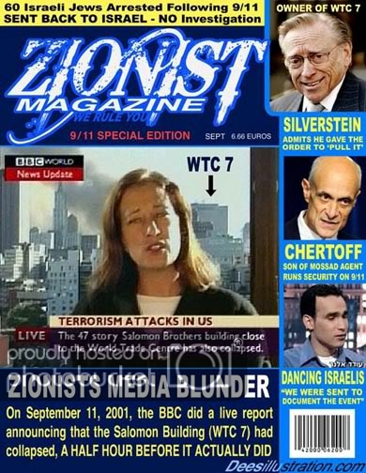
80 - 9/11 *RARE* CLEAR Video of WTC Building 7 Controlled Demolition
https://www.youtube.com/watch?v=kqG6v7KZ_s8
81 - Larry Silverstein WTC7 Controlled Demolition 7 Hours after the 911 Attack!!!
https://www.youtube.com/watch?v=vvtyyGBJfSY
“Zionist businessmen Larry Silverstein and Lewis Eisenberg, who are close friends of Israeli Prime Minister Benjamin Netanyahu, made billions of dollars from the destruction of the Twin Towers on September 11, 2001, says Dr. Kevin Barrett, an American academic who has been studying the events of 9/11 since late 2003.”
Source: https://www.presstv.com/Detail/2019/01/07/585156/Larry-Silverstein-and-Lewis-Eisenberg-made-billions-of-dollars-from-destruction-of-Twin-Towers?fbclid=IwAR0u7qP5GpN_BcAjhgfyYreo8cjuza9Ywix4mU__hWQAxqswGxFZNgHGx-Q
82 - 9/11 Suspects: Rudy Giuliani
https://www.youtube.com/watch?v=Cl85JSvDmsA
83 - **MUST WATCH** Israel Did 9-11 Jewish Ex-Marine SPEAKS OUT
https://www.youtube.com/watch?v=zxJm9z8UwFc
84 - FALSE FLAG? Al Qaeda, Jews, Synagogues
https://www.bitchute.com/video/f1Et6UwdY8L0/
85 - Remembering 9/11: 10 Years of War
https://www.youtube.com/watch?v=6xkpzTYbQFc
We were told we needed wars, increased surveillance, TSA, government funding, and we need to give up freedom, privacy and rights because Bin Laden and his group attacked us on September 11. But that didn’t happen! What we were told about September 11 was a total lie. That means we didn’t need, and do not need, to do any of this stuff! It ALL has to be reversed now. This has to be the demand NOW. No compromise.
Documentaries on 9/11
9/11: Blueprint For Truth
9/11 In Plane Sight – Directors Cut
Loose Change 2nd Edition
9/11: Core of Corruption – In the Shadows
Loose Change Final Cut
Fabled Enemies
911 Press for Truth
TerrorStorm
Conspiracy Theory with Jesse Ventura: 9/11: The Pentagon (Season 2, Episode 8)
Documentaries on the Iraq War
Uncovered: The War On Iraq
Hijacking Catastrophe: 9/11, Fear & the Selling of American Empire
Weapons of Mass Deception
Iraq For Sale
War Made Easy
Additional information on 9/11 can be found here
http://www.historycommons.org/project.jsp?project=911_project
https://wikispooks.com/wiki/9-11/Israel_did_it
World Trade Center buildings 1, 2 and 7 came down by controlled demolitions … controlled demolitions within a totally controlled country.
86 - What is Predictive Programming? | 100% Proof of Hollywood Brainwashing & Foreknowledge
https://www.youtube.com/watch?v=_AUclXzapJo
The destruction of the towers was planned many years in advance. Isn’t it safe to say that September 11 was the true reason they were built?
"We are grateful to the Washington Post, the New York Times, Time magazine and other great publications whose directors have attended our meetings and respected the promises of discretion for almost forty years. It would have been impossible for us to develop our plan for the world if we had been subject to the bright lights of publicity during those years. But, the world is now more sophisticated and prepared to march towards a world-government. The supranational sovereignty of an intellectual elite and world bankers is surely preferable to the national auto determination practiced in past centuries" —David Rockefeller, in an address to a Trilateral Commission meeting in June of 1991.
"For more than a century ideological extremists at either end of the political spectrum have seized upon well-publicized incidents such as my encounter with Castro to attack the Rockefeller family for the inordinate influence they claim we wield over American political and economic institutions. Some even believe we are part of a secret cabal working against the best interests of the United States, characterizing my family and me as ‘internationalists’ and of conspiring with others around the world to build a more integrated global political and economic structure – one world, if you will. If that’s the charge, I stand guilty, and I am proud of it." —David Rockefeller, from his book, Memoirs.
Previously stated: “The Israeli article I mentioned earlier, reported that the goal was far more than just an invasion of Iraq. At a deeper level, the piece said, it is a greater war, to ‘consolidate a new world order, to create a new Middle East.’ ‘The Iraq war,’ the article said, ‘is really the beginning of a gigantic historical experiment.’”
I don’t share Christopher’s positive views of Trump or approval of Farrakhan, but he offers some helpful information in this next video.
87 - Christopher Bollyn: The Man Who Solved 9/11
https://www.youtube.com/watch?v=pLWIV0TTcbI
- 58:00 – Maybe not with nano-thermite, but a controlled demolition was planned.
And as Adam stated at 31:06 of his video The Prohibition of "Anti-Semitism", they’ll create real attacks, hoaxes, and/or use backlash as an excuse to clamp down even further. Remember that before you resort to violence.
Additional information – Iran
Interview 1506 – Ryan Cristian on the Assassination of Soleimani
https://www.corbettreport.com/interview-1506-ryan-cristian-on-the-assassination-of-soleimani/
Did Soleimani Kill 600 Americans? – Questions For Corbett #050
https://www.corbettreport.com/did-soleimani-kill-600-americans-questions-for-corbett-050/
Solutions
The true way out of this mess is to repent and get right with God. You may not believe it will work but it will.
If you don't believe in "all that God stuff," the only other option you have for not falling victim to this system is to fight it or change it. But how are you going to do that when you don't have any kind of power?
As far as the government, there’s nothing to talk about or discuss with any government official. Almost every single one of them is a traitor, and there is no way they should be able to travel anywhere in the US without being in fear for their lives. They’re entire lives should be spent in absolute terror. The same way they fear the Elite will do to them what they did to Kennedy, is the same way they should fear the public, and even greater. This is what is should be like.
You military men and women are some of the biggest problems. You are hit men, not heroes. You kill innocent people for a paycheck and benefits. You never, ever, protect your country. It’s bad enough that you work for a government that is corrupt, but you work for a government that has been hijacked, meaning you work for the hijackers.

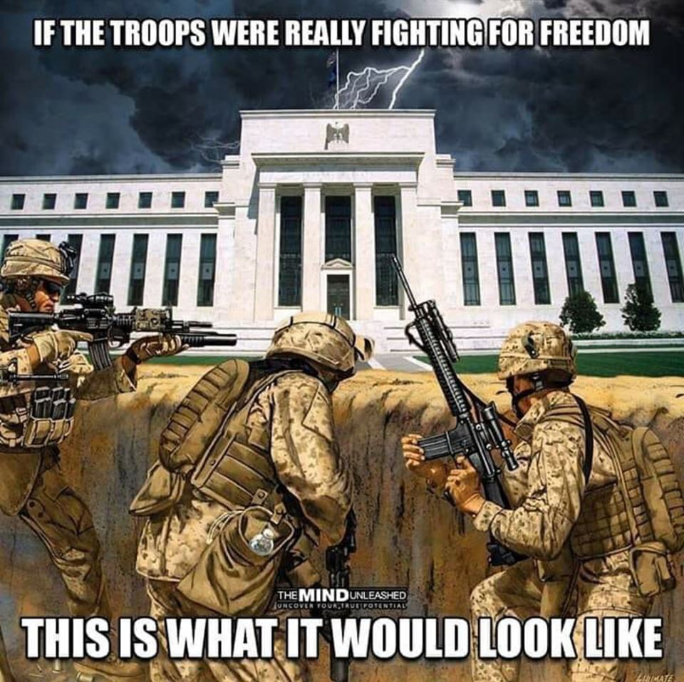

And it’s the same for every military around the world working for corrupt governments that have been hijacked by outsiders. All of you constitute one of the main instruments of power for the Elite. They need you. Without you, what would they do? Are they going to operate the war machine themselves?
All militaries around the world need to do what’s right and start actually protecting their own countries. Leave the service and go work directly for the community you came from. As many families as you military men and women have destroyed around the world you owe your lives to fix this problem, as do many cheerleading American civilians. And do note, your higher-ups are your enemies. They are your overseers. The same goes for police officers in the US. Why work in a job fighting fires the FBI, CIA, ATF and Jewish controlled Hollywood and rap music creates? Will it be you or the military who will defy the Constitution and take citizen’s guns for this New World Order? You all need to wake up and stop seeing yourself as a part of the governmental system and see yourself as a part of the citizenry. Quit your jobs and work directly for your communities. Protect your communities, your friends and families, from State and Federal government instead of being a slave who is helping to enslave them.
And no one should join the US military. That’s just insane.
It’s over. You’re on your way to slavery. Succession is a must. Yes, there are movements that are already taking place, but how do you know these movements are not control by hidden powers?
https://en.wikipedia.org/wiki/List_of_active_separatist_movements_in_North_America#United_States
Who’s making the decisions, a body of people or the people? It’s risky to go with something that’s already established, especially if they’re not making decision based on the desires of the people. And do realize, these groups are going through the legal process. The circumstances actually call for a total disregard for that process.
Everyone has to start forming true communities now. Set up true communities where goods and services, especially those that are needs, are provided by your community. FYI: As a human being on earth, if you leave this type of social system, you will suffer. (Stop and think about how crazy it is to rely on one or a few corporations for your food.) The communities (families) of a territory should rule that territory. The territories should work together when internal or external threats arise.
88 - What Are You Going To Be When You Grow Up?
https://www.youtube.com/watch?v=rFY8WeEJTkg
Show Notes:
https://www.corbettreport.com/what-are-you-going-to-be-when-you-grow-up/
If you are a male, in particular, you have to seek to master at least two trades that would be needed to form the basis of a true community.
Tradesman
https://en.wikipedia.org/wiki/Tradesman#Modern_use_and_list_of_skilled_trades
Types of Trades
https://www.theworkingcentre.org/types-trades/393
89 - Where We’re Going, We Don’t NEED Roads!
https://www.youtube.com/watch?v=nvGr9lIHFYY
While the people transfer from a life where they’re dependent on the System, the military and the police have to go back to their communities and work for their communities, getting paid by their communities, right now. You all can go the legal route while you’re seceding if you want, but secession is a must right now regardless of the Federal government’s decisions. And what they say no longer matters anyway. They have pledged allegiance to a foreign power which sacrifices and terrorizes the citizens of this nation for their own purposes. They are a bunch of lying, criminal, traitors and they’re words are worthless. Even their actions are worthless. They are nothing more than actors who act like they care; who act like they’re against a thing; who act like they’re scolding someone who is brought in for questioning. All they do is act. They’re the ones that take legal and illegal bribes to give the Elite access to us in every single way. They pass laws that poison us through food, air and water. They pass laws that destroy our children at birth with vaccines. They pass laws that disarm us. They’re the ones that send us to war while they sit back and make money from it. They are the ones who participate in rituals, sex orgies, and child molestation. They are the ones who don’t imprison or execute anyone who does the most damage to society. They are the ones who allow corporations and industries to use and abuse us on a daily basis, making our lives hell. There is no dealing with these people. They are enemies and need to be treated as such. True or false, most of them should be hunted down and imprisoned for life, or hunted down and executed?
The Elite want the destruction of all governments and the establishment of a one world government, so eliminating this government would seem to fit their plans. But this has to be done. There’s no way they can remain in power. They all have to go. At least it will be done under your terms. But it’s a must that the military and the police wake up and help.
“When in the Course of human events, it becomes necessary for one people to dissolve the political bands which have connected them with another, and to assume, among the Powers of the earth, the separate and equal station to which the Laws of Nature and of Nature's God entitle them, a decent respect to the opinions of mankind requires that they should declare the causes which impel them to the separation.
We hold these truths to be self-evident, that all men are created equal, that they are endowed by their Creator with certain unalienable Rights, that among these are Life, Liberty, and the pursuit of Happiness. That to secure these rights, Governments are instituted among Men, deriving their just powers from the consent of the governed, That whenever any Form of Government becomes destructive of these ends, it is the Right of the People to alter or to abolish it, and to institute new Government, laying its foundation on such principles and organizing its powers in such form, as to them shall seem most likely to effect their Safety and Happiness. Prudence, indeed, will dictate that Governments long established should not be changed for light and transient causes; and accordingly all experience hath shown, that mankind are more disposed to suffer, while evils are sufferable, than to right themselves by abolishing the forms to which they are accustomed. But when a long train of abuses and usurpations, pursuing invariably the same Object evinces a design to reduce them under absolute Despotism, it is their right, it is their duty, to throw off such Government, and to provide new Guards for their future security. —Such has been the patient sufferance of these Colonies; and such is now the necessity which constrains them to alter their former Systems of Government. The history of the present King of Great Britain is a history of repeated injuries and usurpations, all having in direct object the establishment of an absolute Tyranny over these States. To prove this, let Facts be submitted to a candid world.” – The Declaration of Independence.

http://www.usa.gov/Contact/Elected.shtml
http://www.house.gov/representatives/find/
http://www.house.gov/representatives/
All Glory to Yahua (God) and Yahusha (Jesus)

Franklin Miller (Writeous1)
http://howmanyknow.com/
writeousservant@gmail.com
writeous1@howmanyknow.com
https://www.bitchute.com/channel/YhZAtGMGFLe1/
https://www.youtube.com/channel/UC6UWuuP9KUSYMIYU-nxmHNw

