Welcome to the New Age

*If a video becomes unavailable, search the internet by its title, and then filter your results by “videos”. Alternatively, you can notify me at one of the emails at the end of this document, and I’ll upload it here. If a link to a web page has been changed or is unavailable go here, enter the address in the box, press Enter and then select a date.
If possible, download all files and this document, burn them to a disc, make copies, and distribute them. Use a website or browser plugin to download. Here are some sites (Watch out for popups. And never install anything.):
https://www.y2mate.com/en1/home
https://ddownr.com/
https://www.onlinevideoconverter.com/en/youtube-converter
Go through the information in order like reading a book, even if it takes time like a book, and the overall picture will form. You will see.
-------------------------------------------------------------------------
- Introduction - 2
- Censorship - 7
- Paid Trolls - 14
- Controlling the Mind - 21
- The New World Order Control Grid - 53
- Solutions - 87
------------------------------------------------------------------------
Introduction

It is crucial that you understand what I’m about to explain next, as it is the key to seeing the big picture presented in this document. This is not the place to present all of the evidence, so I’ll just give a synopsis.
From its inception the US was a Jewish country, created by a revolution which was guided by Jewish Freemasonry. From its inception the US was controlled by the Rothschilds and other Jewish families from overseas. They even had Jewish and gentile agents planted within the US. These are facts, not conspiracy theories.
In the early years of the US, the country was a land of crops and farmlands filled with mom and pop stores. This all changed when the people we call the industrialists or robber barons, most of whom were Rothschild agents, advanced the Industrial Revolution.
Some of the companies they owned and/or controlled are still around today, and since the time of the Industrial Revolution (or Revolutions) these people have acquired and created other companies. Nearly every major company you see today is there’s. This is especially true when it comes to corporations. There is no competition in “the majors” in America, it’s all an illusion. The Elite either directly or indirectly control it all. Any million dollar company can be ruthlessly crushed by these multi-trillionaires. Do you think you as a small-time drug dealer can go on streets controlled by the Mob and sell drugs there while they have their people selling drugs there also? You’re either going to work for them in some capacity, or you’ll be eliminated. It’s the same with these people and business.
If you are someone who is new to this type of information, the following video will help you see the truth in about an hour. Watch the entire video, even though you may get to a part you may not understand.
01 - How Big Oil Conquered the World
https://www.youtube.com/watch?v=ySnk-f2ThpE
Additional information can be gleaned from these:
https://www.bibliotecapleyades.net/bloodlines/index.htm#menu
https://criminalbankingmonopoly.wordpress.com/
Please realize that many government officials, particularly those with positions of power that would be beneficial to the Elite, either came directly from corporations and banks, or were paid by corporations and banks (through several avenues). This means the people who create, change and uphold the laws are fully controlled by corporations and banks. And who controls almost all corporations and banks? The Elite. They also created the healthcare system, intelligence agencies, the scientific community, the education system, and more. It’s just that you were never taught this. The government officials are also controlled through their memberships in secret societies and policy groups.
Here’s a little information on the education system (why you don’t know about what actually happened in early American history):
The Origin of Compulsory Schooling
http://www.thrivemovement.com/follow-money-education
Almost all the food the population consumes comes from corporations, while almost all the information the population consumes comes from mass media that is owned and controlled by corporations. The entire environment is the Elite’s. And with the environment being there’s, they use goods and services (yes, services too) to shape and mold the population on an ongoing daily basis – a fake, manufactured life that can be called the Matrix.
“The conscious and intelligent manipulation of the organized habits and opinions of the masses is an important element in democratic society. Those who manipulate this unseen mechanism of society constitute an invisible government which is the true ruling power of our country. …We are governed, our minds are molded, our tastes formed, our ideas suggested, largely by men we have never heard of. This is a logical result of the way in which our democratic society is organized. Vast numbers of human beings must cooperate in this manner if they are to live together as a smoothly functioning society. …In almost every act of our daily lives, whether in the sphere of politics or business, in our social conduct or our ethical thinking, we are dominated by the relatively small number of persons…who understand the mental processes and social patterns of the masses. It is they who pull the wires which control the public mind.” ― Edward L. Bernays, Propaganda
These same people, the Elite, have plans for the future, our future, and they use their power and control over our environment (everything they created and sold to us) to bring us into this future. The goods and services they use to manipulate us and bring us into this future emanate from companies, making these companies front companies. A front company is essentially a company that operates and promotes itself as carrying out particular purposes while in reality it exists to accomplish hidden purposes.
What is FRONT COMPANY?
This is a term used for an entity, be it an individual or group or organization used to inhibit the identification of an owner or member of another company or organization. In legal proceedings, it is often identified as a cover used to conceal illegal activities. It can be a subsidiary or shell company of a larger company. It is almost always used to hide another company or individual from liability, scrutiny, or negative press.
Source: https://thelawdictionary.org/front-company/
Front organization
A front organization is any entity set up by and controlled by another organization, such as intelligence agencies, organized crime groups, banned organizations, religious or political groups, advocacy groups, or corporations. Front organizations can act for the parent group without the actions being attributed to the parent group thereby allowing them to hide from public view.
Front organizations that appear to be independent voluntary associations or charitable organizations are called front groups. In the business world, front organizations such as front companies or shell corporations are used to shield the parent company from legal liability. In international relations, a puppet state is a state which acts as a front (or surrogate) for another state.

Intelligence agencies
Intelligence agencies use front organizations to provide "cover", plausible occupations and means of income, for their covert agents. These may include legitimate organizations, such as charity, religious or journalism organizations; or "brass plate firms" which exist solely to provide a plausible background story, occupation, and means of income.
The airline Air America, an outgrowth of Civil Air Transport of the 1940s, and Southern Air Transport, ostensibly a civilian air charter company, were operated and wholly owned by the CIA, supposedly to provide humanitarian aid, but flew many combat support missions and supplied covert operations in Southeast Asia during the Vietnam War.^{[1]} Other CIA-funded front groups have been used to spread American propaganda and influence during the Cold War, particularly in the Third World.^{[2]}
Source: https://en.wikipedia.org/wiki/Front_organization
You just read the definition of every major corporation in the US. You believe they are operating to sell you the goods or services you see advertised, but in reality they exist as a covert part of a total system of control. Others that do not can simply be called on and they will obey orders.
One way the Elite ensures this type of obedience and control is to allow only those people who have taken oaths in secret societies to rise to certain levels in the business world.
The person acting as the head of a company doesn’t have to know the true purpose, they are only there to make sure the company lives, and their greed is what sustains its life/fuels it (the system of capitalism). And while their greed fuels it, the hidden agenda continues to be accomplished.
FYI: You are absolutely surrounded by these front companies. Your entire environment is not what you think it is. You were born into a totally controlled environment where even how you see life (your reality) has been given to you through carefully selected and censored information you’ve been fed through controlled sources of information (from school to television) your whole life. Do you notice how every source of information left out all of that extremely important information about people like the Rockefellers?
FYI: What the government does or doesn’t do is what the Elite has them do or not do. The government is totally controlled. When the government gets blamed, and in those rare occasions the media shows you something that makes the government look bad, it all aids an overall plan to make people hate government (aiding an Illuminati plan to abolish all governments).
FYI: The Elite use governments and their wars as excuses to develop technology that is then used on the people (through goods and services … through companies).
FYI: The Elite’s philanthropy is the same trap as government assistance/welfare – dependency. So, when these organizations, schools, scientists and their labs become dependent on this funding, the control follows.

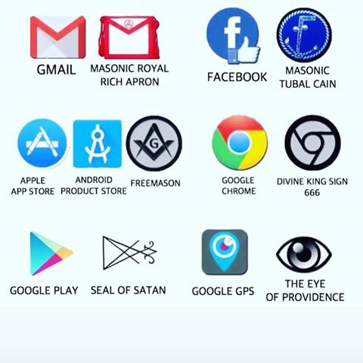
And what you see is correct; you can look it up yourself. So, doesn’t that mean that Google, Apple and Facebook are on the same team? Secret societies are one way to ensure people who are allowed to have power in the System are kept under control.

Censorship
2 - The Past, Present and Future of Internet Censorship https://www.youtube.com/watch?v=spapXznZf4I
***** Deleted*****
YouTube Just Gave Government Agents "Super Flagging" Ability to Remove Videos and Channels – YouTube
https://www.youtube.com/watch?v=bBrxJEeeyI0
As Twitter, Facebook and YouTube ramp up selective censorship, GoodGopher.com alternative search is more important than ever!
http://www.naturalnews.com/053296_internet_censorship_Good_Gopher_search_engines.html#
3 - What's an algorithm? - David J. Malan
https://www.youtube.com/watch?v=6hfOvs8pY1k
4 - Spiders, Bots, and Crawlers
https://www.youtube.com/watch?v=uhFf7YBkmlE
“Oh, this is cool, they’re going to help raise our rank in the search results.” No. Now they know every single word, picture and video on your site (just like your computer and virus removal software). Censorship. And not only censorship, the knowledge you put out is going to be given to one of their puppets working on an agenda or the news media, and then spun or countered. Trust me, I know.
5 - How does Google Search work?
https://www.youtube.com/watch?v=KyCYyoGusqs
***** Deleted*****
GOOGLE Misrouting Search Results to CONTRARY Websites
https://www.youtube.com/watch?v=oZhx8XM7nhA&feature=youtu.be
EXCLUSIVE: Google to block all anti-cancer, “anti-vax” and anti-GMO websites at the browser level as tech giant goes all-in with pharma drug cartels
https://www.naturalnews.com/2019-07-02-google-to-block-all-anti-cancer-anti-vax-and-anti-gmo-websites-at-the-browser-level.html?fbclid=IwAR3FuffxXCE__tjIv_RQGCZ2ejAbOeAfSHhDEhD4huTPdUWnzFqKtuBgK_4
6 - It's Official: This Is Straight out of Orwell's 1984...
https://www.youtube.com/watch?v=vrKs_vduiKU
- 8:30 – Prediction technology for pre-crime. This will come into play later.
The video-maker’s comment on Youtube:
PS - We have a computer program that automatically thumbs down each video we submit the moment we upload it. Probably immediately flags the content as well for the memory hole virtual holding pen. Nice, right? Happens every single time... No person could be sitting there, poised to press thumbs down the moment the video goes up at random times throughout the day and night... It's robotic auto-censorship. We need a better site. As they keep cracking down on free speech, this place is about to become a graveyard of apolitical YT "stars" and cat videos...﻿
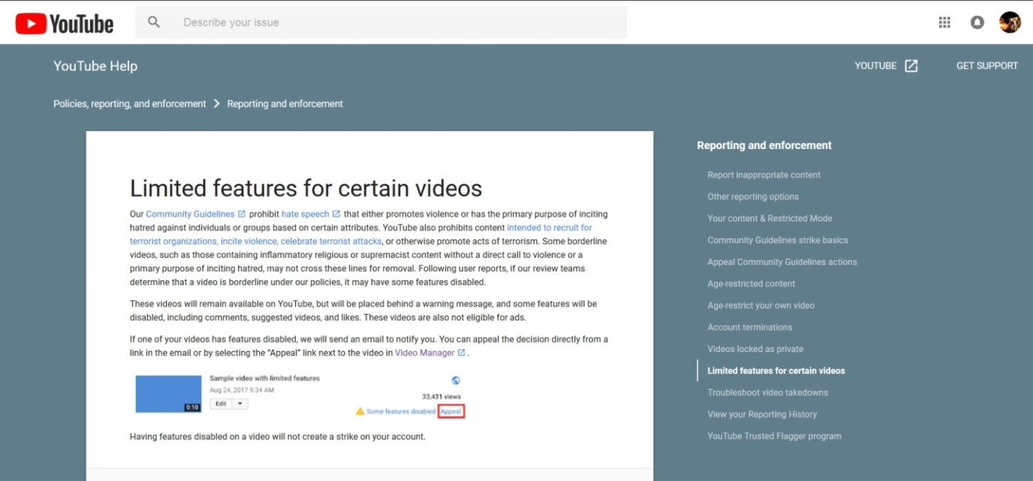
If they don’t have a good enough reason to ban it, they take away certain features. Isn’t it interesting that you see the same thing with gun laws.
7 - YouTube Censorship, AI Machines And The Cable Company Monopoly
https://www.youtube.com/watch?v=J-NVc-_Uv8A
If you prove with historical documentation that all the leaders of a certain group or movement were Jewish it will be labeled “hate speech” or “offensive”. If you prove that six million Jews did not die in the holocaust, it will be labeled “hate speech” or “offensive” (and “holocaust denial” by others although all you did was deny one aspect of the holocaust). The internet used to be an effective weapon in combating their lies and brainwashing, but now the powers that be are taking away its effectiveness and increasingly using the internet as a weapon against us.
The Secretive Bilberbergs Are Worried About Populism & US Hegemony In A "Post-Truth" World
https://www.zerohedge.com/news/2018-06-06/bilberbergs-hold-annual-secretive-meeting-discuss-populism-post-truth-world
“Founder” of Facebook, Mark Zuckerberg – Jewish. “Founders” of Google (which owns Youtube), Sergey Mikhaylovich Brin and Lawrence Edward Page – Jewish. The New World Order – Jewish. This may seem anti-Semitic, but it’s not. You don’t know Jewish history.
8 - Anti-Semitic Conspiracy Theories Censored w A.I. Algorithms says ADL
https://www.youtube.com/watch?v=qbE3bbbAHgw

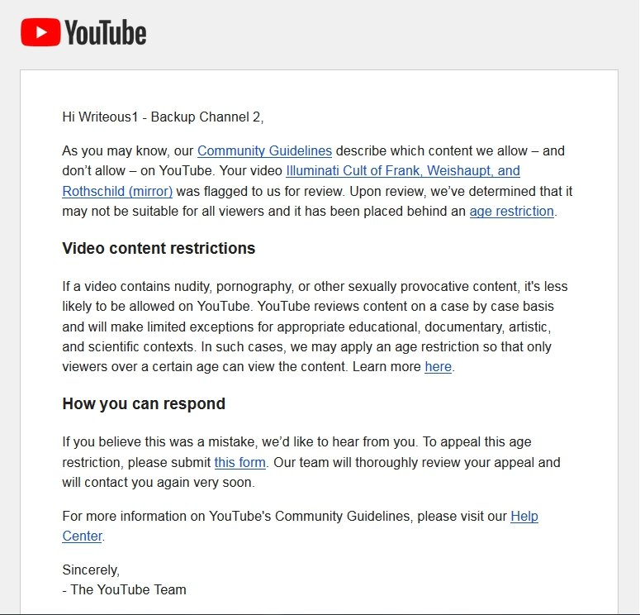

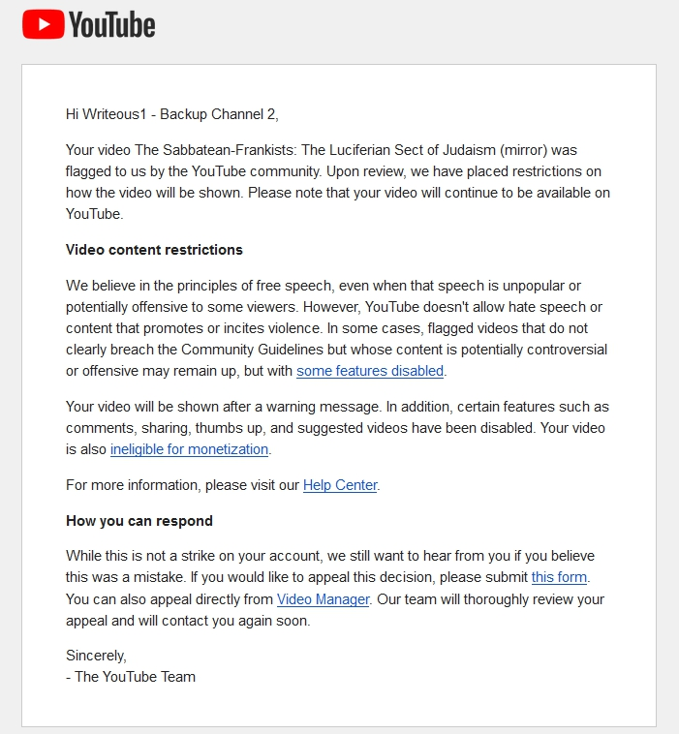

And Facebook censorship is no different. One of their tactics: Deciding who and how many people will see your post or comment. I know all about Facebook censorship.
9 - Attack Of The Algorithm
https://www.youtube.com/watch?v=duyDmilxaJg
***** Deleted*****
Youtube Censored - Comments Being Hidden on My Videos Against My Consent
https://www.youtube.com/watch?v=YbwbuUTpmO8
***** Deleted*****
Ohhh Youtube You've Done it Again
https://www.youtube.com/watch?v=dqq-9rQ2k-g
***** Deleted*****
Does This Explain Youtube's Changes to Free Speech?
https://www.youtube.com/watch?v=ZzNTJs-hfwo
And because people like me were using Youtube and Facebook to prove certain events were hoaxes, Youtube and Facebook started attacking us with censorship and penalties. Just recently Youtube went on another purge, deleting tons of videos proving many violent events to be staged hoaxes and deleting many accounts.
Go here for an example of all the evidence Youtube has disposed of (covered up):
http://howmanyknow.com/2016/08/the-pulse-nightclub-shooting-hoax/
They also changed their policies.
Under “Harassment and cyberbullying policy”: “Content claiming that specific victims of public violent incidents or their next of kin are actors, or that their experiences are false”
https://support.google.com/youtube/answer/2802268?hl=en
Under “Hate speech policy”: “Deny that a well-documented, violent event took place.”
https://support.google.com/youtube/answer/2801939?hl=en&ref_topic=9282436
Hello?! How obvious is that? Based on this and many other clues (one example: 1:40 - 10:50), it’s obvious that Youtube is a part of the System. And it’s also obvious the powers that be had more hoaxes planned. And Youtube actually got a two-for-one deal out of that new hate speech rule. Now no one can present real, truthful, documented evidence that we’re being lied to about the Holocaust and other events.
10 - WOW! You will NOT Believe what words YouTube HATES! (PROOF)
https://www.youtube.com/watch?v=E4Y1zAMzXd0
11 - When YouTube Gives Us Lemons (Suppressing views, Unsubbing Subs) We Make Lemonade
https://www.youtube.com/watch?v=5s7PIRIep3I
12 - Social Media Censorship Is Out of Control! Here's one solution. https://www.youtube.com/watch?v=qGpoYP9Mb4I
If the government and media lies about an event, how is the public going to find out that it’s a lie when the warning messages are being intercepted and destroyed? Many of the content creators who reveal government and media lies have left Youtube and Facebook, but the audience has not. This is a problem.
Paid Trolls
You may be accustomed to the idea of an internet troll being a regular person like you, sitting behind a computer having nothing better to do but to annoy or cause problems online. Although that’s what the label means to most people, something totally different has emerged under the troll label.
13 - Monsanto Employing Troll Army To Silence Online Dissent?
https://www.youtube.com/watch?v=dK__WF96F8I
Monsanto is not the only company which employs trolls.
14 - ‘They try to discredit people like me’: Monsanto sued for allegedly hiring internet trolls
https://www.youtube.com/watch?v=rrHnP9n8wYo
Though they are called trolls, this label doesn’t even come close to giving you an idea of who is behind some of these other profiles, or their mission.
15 - Online Government Trolls Have Infiltrated the Internet
https://www.youtube.com/watch?v=egjqYxow_34
In essence, we are dealing with online COINTELPRO.
They have profiles that look 100% real - pictures, videos, posts, comments, friends and all. They can give themselves “likes”/“thumbs up”/“vote up” and subscribers/members/friends. They can delete your comment, or make it so that others won’t see it. They can operate several profiles. And they can even ban you. I have even had a few of them on Facebook admit to me on three different occasions, using the “like” feature, that they were working. These people and/or computers are wreaking havoc on the internet, and hardly anyone knows about them. Oh, and another thing, they have access to a special profile on you, giving them all the information they need to know about you.
16 - How the Government Manipulates Your Thoughts Online | Big Brother Watch
https://www.youtube.com/watch?v=HUWnGXAfabA
Inside Israel’s million dollar troll army
https://daysofpalestine.com/post/12196/the-electronic-intifada-you-are-here-inside-i-srael%E2%80%99s-million-dollar-troll-army
Read this excerpt from Sockpuppet nation: How fake commenters and other online ploys skew what you read By Simona Weinglass
On Yavin, the founder and CEO of a company called Online Performance Ltd, said there is a social media manipulation industry in Israel and he is part of it, although his company stops short of practices he considers unethical, like creating sockpuppets or commenting under a fake name. The industry, Yavin said, is called “online reputation management,” and he agreed to share with The Times of Israel how it works and the lengths to which some of his colleagues will go.
“It makes sense that most of the public doesn’t realize how pervasive ORM is,” he explained. “My best guess is that the field is about a decade old but has taken off in the last 3-4 years. And there is a guerrilla marketing aspect to it,” he added, noting that for an ORM campaign to be effective, it is better if internet users don’t know it’s happening.
Yavin said that each ORM company decides for itself what its boundaries are and some have no problem with creating armies of fake profiles to try to influence online discussion.
“Some people maintain their fake profiles for months or years. They do it so well it’s almost impossible to know they are fake.”
Yavin said that ORM has pervaded Israel’s internet space to the point where “at least 15 percent of comments on Israeli news sites, and possibly as many as to 25-30 percent, are fake. Articles of a political nature are most likely to attract paid trolls — not just right-wing commenters, he added, but those of every political persuasion.
“To the extent that a political party has more funding, you will see more paid trolls on their behalf. There are some political parties in Israel that have double or triple the funds of others,” he said, indicating that Israel’s larger parties are more likely to engage in the practice.
Yavin is shy about naming his clients, but lists some of the services he provides for them — including cultivating them as thought leaders in their field, content marketing, creating highly shareable videos, and taking part in online forums like Quora, where his clients can show off their expertise. But the two most important aspects of online reputation management are SEO (search engine optimization) on sites like Google, and social media campaigns.
When clients come to him, Yavin will often create and promote Facebook pages on their behalf as well as pay social media influencers — millennials who have managed to acquire a large following on Instagram or Twitter or Vine — to write about them.
As for SEO — the practice of boosting one’s prominence on Google by gaming the search engine’s algorithm — almost all Israeli politicians do it, Yavin said. If you Google the name of a Knesset member, Yavin estimates about half of the first page of results are likely to be there as a result of SEO manipulation.
“It’s about 50 percent of the results according to my personal knowledge, with the caveat that I did not check every Knesset member,” he said.
Asked whether politicians in Israel employ “troll armies,” such as those widely reported to exist in Russia or China, Yavin said, “I’ve seen it all: operations with one employee, 12 employees or 100 or more. The last operation was a political organization but I can’t comment beyond that.”
Not just politicians but anyone with a profit motive hires ORM firms, he stressed.
Source: https://www.timesofisrael.com/sockpuppet-nation-how-fake-commenters-and-other-online-ploys-skew-what-you-read/
17 - CIA Media Infiltration Operation Mockingbird Brainwash Update
https://www.youtube.com/watch?v=fQl9H-gi9NE
Here’s one shill speaking on shills. “Misinformation,” in this next video = information they don’t want you to consume.
18 - Governments Hire Web Trolls to Sway Public Opinion
https://www.youtube.com/watch?v=7zVgy9Jk0Ec
19 - What You Need To Know About The Government And Social Media
https://www.youtube.com/watch?v=L9ljlOpPiQE
Watch the beginning – 4:00

20 - ALERT! ~ "Government Hires Trolls, Shills to Monitor, Disrupt Comment Sections" ~ Gang Stalking
https://www.youtube.com/watch?v=MAXbRC30WgM
Read this excerpt from Twitter Executive Revealed to Be 'Psyops' Soldier Linked to Spreading Disinformation Across Social Media: 'A Threat to Our Democracy' By Tareq Haddad
A Twitter executive with editorial responsibility for the Middle East and North Africa is also a reservist officer of the British Army's psychological warfare and propaganda unit, a new report has revealed.
Gordon MacMillan, who joined Twitter in 2013 and is listed as the company's Head of Editorial for EMEA, also serves with the 77th Brigade—an outfit formed in 2015 to conduct "information warfare" and develop "non-lethal" ways of conducting war.
The report, published in Britain's Middle East Eye, revealed how MacMillan served with the unit for several years.
Twitter has downplayed MacMillian's links to the army and said it supports its staff in their external volunteer commitments.
...
David Miller—a professor of political sociology in the School for Policy Studies at England's University of Bristol, who studies propaganda and public relations efforts concerning the British government—is one such academic. He told Newsweek he believes a link is there, adding that it was a "threat to our democracy."
"I would say I know a good amount about army propaganda and 'psyops' operations as they're called, but what is interesting is how little information we have 77th Brigade," he said." I suppose it means that all their work is covert, but what I would like to know is what they exactly are they doing?
"Are they just tracking accounts or are they trying to influence people's views? What we do know is that the Brigade has locked its own Twitter account so it cannot be seen so we assume they are trying to influence people under the operatives' own names. And because we know so little about exactly what they're doing, we have to look elsewhere for clues for example.
...
"If we look at the documents leaked by Edward Snowden about the NSA and its JTRIG [Joint Threat Research Intelligence Group] program, we can see that governments are clearly lying and deceiving people by creating troll farms and fake accounts that try to influence the way people think.
"What the governments will say is that they are trying to prevent radicalization and acts of terrorism, but I think it's deceptive and is a threat to our democracy.
"Twitter is also deceiving us because it is not acting as transparently as it could. If they are working with army personnel in this way, it is extremely damaging to our democracy. Given Twitter's closure of accounts alleged to be used by foreign governments, it's a very hypocritical stance of Twitter to take."
Source: https://www.newsweek.com/twitter-executive-revealed-psyops-soldier-spreading-disinformation-across-social-media-1462406
21 - Government Spies & Internet Trolls: What you should KNOW!
https://www.youtube.com/watch?v=2F_y1I-ggkw

“One of their favorite things to do is to call for violence.” I’ve stated it several times online that I was banned from of a Facebook group for telling people not to be violent while trolls were in a group (a black group) trying to get people to arm themselves during one of the police shootings. And right now, they are all over the internet, particularly Youtube and Facebook, persuading blacks to dislike whites, take up arms, and desire a war with white people whom the Matrix has labeled “white supremacy”. And this is for the racial tension/race war agenda. It’s so sad that many blacks have already fallen for this and have become racist and ready to fight white people.
22 - How To Spot A Government Troll And What To Do About It
https://www.youtube.com/watch?v=wFn_SFNKVRw
23 - Yes There Is a Government Troll Training Program
https://www.youtube.com/watch?v=x-gX8CGceoE
How Covert Agents Infiltrate the Internet to Manipulate, Deceive, and Destroy Reputations
https://theintercept.com/2014/02/24/jtrig-manipulation/
These trolls are advancing New World Order agendas. They are a key part of the racial tension/race war agenda and the anti-Christian/anti-religion agenda. They support other Matrix programming as well, such as evolution and global warming/climate change.
This next video shows something different than the trolls you just saw. It shows another way profiles can be used online. Look closely at what was stated in the post, and think about the reaction it would get from black people.
24 - BUSTED! Gov. Running #Ferguson Twitter Psyop
https://www.youtube.com/watch?v=giOvj8-s8oU
They have flooded Youtube with comments like the one in that video, garnering a desired reaction from blacks and causing everyone to think “this is what white people believe”/white people are racist/racism is out of control and something must be done.
25 - Twitter Threatens Suspension For Exposing Gov Accounts
https://www.youtube.com/watch?v=6vPl89Eii6w
The powers that be do things like this, and then they tell you that they have to take measures to combat “hate” online, but their measures are aimed at combating truth online. It’s the same lie you see in terrorism – the people who create the terrorists tell you that they have to take measures to combat terrorism, but their measures are aimed at combating freedom and advancing the New World Order.

***** Deleted*****
Where Do Paid Internet Trolls Come From? Their Role And Purpose https://www.youtube.com/watch?v=kN2_Q7HkQnk
This gives you an idea of what the other side of Youtube, Facebook, and Twitter looks like, or what’s connected to these internet platforms (and others).
26 - Trump opens Global Center for Combating Extremist Ideology
https://www.youtube.com/watch?v=9oJzrorOlP0
These trolls are not the only ones who are hired to work on agendas. Youtube video-makers are also among the workers. Some people within the “Truth Community” already know this and have exposed several of these video-makers. The trolls support the videos of these workers.
Here’s a more extreme case of an online asset:
27 - Cynthia McKinney vs. the F.B.I.
https://www.youtube.com/watch?v=UJJe-OIbTEg
This is what trolls and other workers are trained on:
Propaganda techniques
https://en.wikipedia.org/wiki/Propaganda_techniques
Controlling the Mind
28 - US Gov has legalized psychological operations against citizens
https://www.youtube.com/watch?v=LOEqFFZCsr8
As stated in the video: “… through press, publications, radio, motion pictures, the internet, and other information media including social media, and through information centers, instructors, and other direct or indirect means of communication.” These “instructors” are the “knowledgeable” gurus you see all around you, from the East Indian ones teaching you Eastern religious concepts while throwing out an attack against Christianity here and there, to the black ones teaching you Egyptian religious concepts while throwing out an attack against Christianity here and there.
Now, if you go to the comment section of the video Key witness in Amber Guyger trial shot to death you’ll see a comment saying, “I think we all know who killed him...” These are the types of comments the trolls leave to help push the belief the rest of the System (moles/puppets/workers, the news, Hollywood, celebrities, etc.) is pushing.
Now go to his/her channel/profile. One thing about Youtube, the fake profiles are usually pretty empty. On Facebook it’s the opposite – they usually look like a normal person’s profile, full of friends, pictures, comments, current posts, likes, shares, etc.
Now find other similar comments and go to their channels/profiles.
Take a look at this Youtube comment made by RickyboyH:
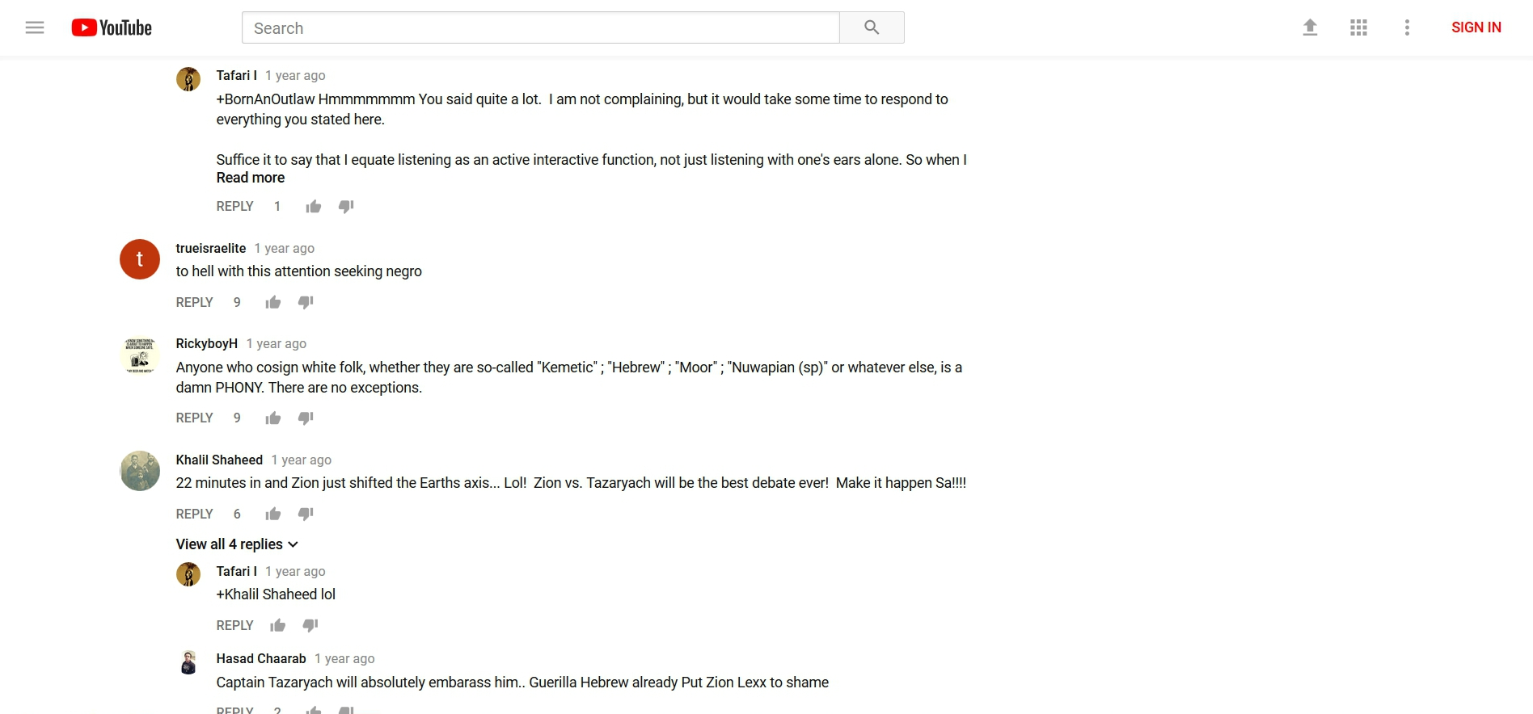

Now take a look at “his” channel:
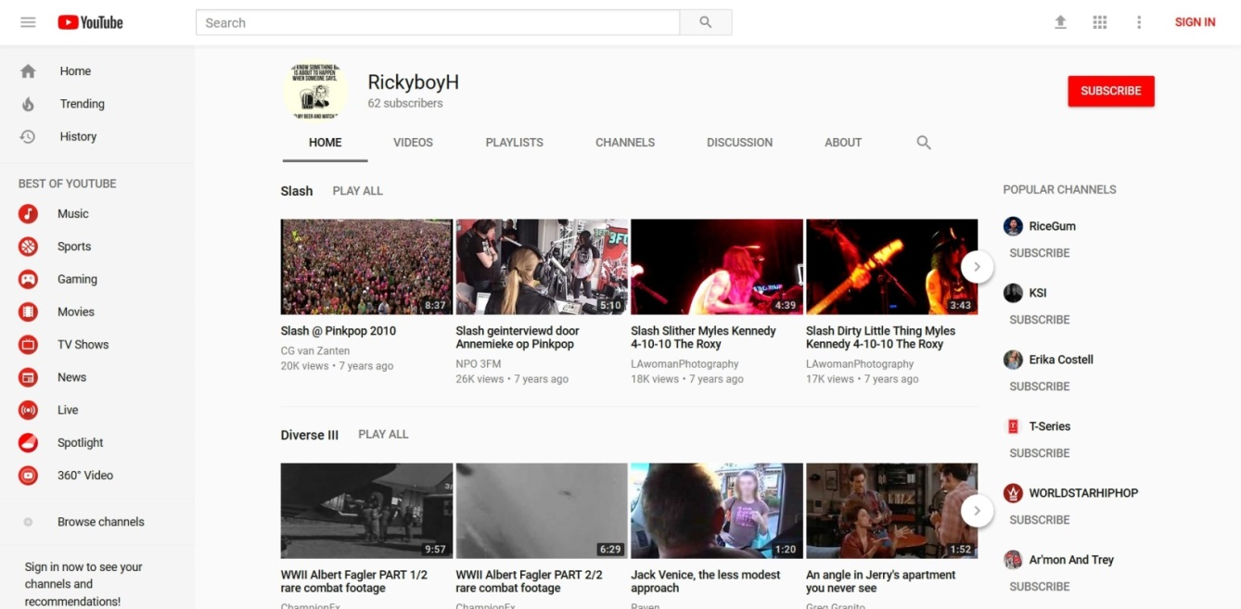
What are the odds that “he” has those tastes?
It’s the same thing the FBI used to do (and I’m sure still does):
“Anonymous letters and telephone calls: During the 60s, activists received a steady flow of anonymous letters and phone calls which turn out to have been from government agents. Some threatened violence. Others promoted racial divisions and fears. Still others charged various leaders with collaboration, corruption, sexual affairs with other activists' mates, etc. As in the Seberg incident, inter-racial sex was a persistent theme. The husband of one white woman involved in a bi-racial civil rights group received the following anonymous letter authored by the FBI:
--Look, man, I guess your old lady doesn't get enough at home or she wouldn't be shucking and jiving with our Black Men in ACTION, you dig? Like all she wants to integrate is the bedroom and us Black Sisters ain't gonna take no second best from our men. So lay it on her man--or get her the hell off [name]. A Soul Sister”
Source: COINTELPRO Revisited - Spying & Disruption by Brian Glick (author of War at Home, South End Press)
Let me show you how it’s done. With the agenda to have blacks face the police: A police shooting of a black person, real or staged, is made the important topic by the media. Videos are created on Youtube by regular people, puppets/informants (people contracted to do a job for intelligence agencies and others), and agents (actual intelligence agency employees); and memes and videos are created and spread on Facebook by regular people, puppets, and agents. These memes and videos express anger and a sense of urgency to act no matter the circumstances of the shooting. The trolls then leave comments that steer the minds of those reading. “These white people ….” “White supremacy ….” “I’m getting my weapons ready right now.” And these comments will have the most Likes or Thumbs up, something those controlling the profiles can do at will (I’ve even seen the comments on Facebook pop up already Liked). This creates the consensus, which the readers gravitate towards. The same occurs across the entire web on forums to other social media sites like Twitter. And while all of this is occurring online, the media is playing their part with their topics, scripts, and people they choose to interview. Celebrities/entertainers (musicians, actors, sports players, comedians, etc.), slaves under the threat of death if they don’t comply, are made to come forward and speak, especially if the event is a hoax. And teachers/leaders in the Black Conscious and Israelite communities speak on the event, steering the minds of the people further. That’s what takes place with an event, but with a long range agenda, TV shows, movies, and books are included. This is reality creation. This is the new-and-improved Matrix. This is how it’s done. If you control a person’s information, you can control their reality.
If you know about hoaxes, you may recall that in many of the hoaxes of the past they had the black Christian victim’s family or friends immediately forgive the killer. The same thing was written into the script of the Botham-Amber shooting hoax. And in case you’re wondering why they write this into these scripts, it’s because they “get some licks in” on Christianity while they’re doing the hoaxes for other agendas (race war/racial tension/hate laws and federalizing the police). After they do this, the black moles/puppets they have planted in the black community on Youtube, Facebook, on the streets, etc. then spring into action and start attacking Christianity/the Black Church for the anti-Christianity/anti-religion agenda, trying to get black people away from Christianity and into the created communities (the Black Conscious community, New Age community and Israelite community) where they’ll be brainwashed into being weapons against Christianity, white people and the police. The fake profiles on social media also spring into action and do their part. Note: Hoaxes are not the only news stories where this happens. Regular news stories (propaganda) are also used. The story of the so-called Slave Bible is an example. Can guess which agenda this was for? Now, if you would like to see how the media outright lied, targeting the black community with lies for the agenda, read the end of page 25 to the middle of page 30 here: http://howmanyknow.com/2019/07/black-histrianity-and-the-slave-bible/
If you would like to see how black puppets have been lying to black people about Christianity as it pertains to black history, read the entire thing.
The Botham-Amber shooting hoax proved the link between the underground black information sources, like Phil Scott, and the mainstream information sources. But the clues where always there. For instance, why do you think these black workers constantly talk about white supremacy and white privilege, but the media does also? Just the fact that the media was saying these things should have been a red flag just by itself. I thought the media was a weapon of white supremacy? I thought Hollywood was too? So, black people are getting their proof of white supremacy and white privilege from white supremacy? Well, it makes more sense when you know who really controls the media, Hollywood, Facebook, Youtube, and more. And it just so happens to be that two of their main targets are white people and Christianity. What a coincidence. It must be another coincidence that most of the black workers come out of New York.
If you are a person who has spent any considerable amount of time in the so-called conspiracy theory community you probably already know about what’s frequently referred to as controlled opposition – someone/something that appears to be opposing the enemy but is really controlled by them. You may also know that one Youtuber after another was exposed for being controlled opposition. Well, here’s someone else, from a totally different Youtube genre, who is former insider, speaking about Youtube plants and much more.
29 - I won’t be surprised if YT removes this.
https://www.youtube.com/watch?v=8UHKcJ8CxyY
There are even people planted on Youtube to push the New Age movement/religion. Many of them are convincing viewers that though they are having dangerous, violent and terrifying interactions with spirits to just keep going.
30 - Let's talk fr fr about "Van Girl" possibly being a YT plant.
https://www.youtube.com/watch?v=_6ztn1r8nVo
Youtube is now television. There are people who are paid openly and covertly to produce content. There are commercials/ads. There are channels (channels) dedicated to pushing products and services. There is carefully crafted, manipulative news content from the Youtubers who get paid to be newscasters who shape how you should feel about topics and events. Most of the reality TV-like content is staged (just like reality TV on normal television). Nearly all of the documentaries allowed on the platform are agenda driven just like TV. Youtube is almost entirely fake now.
Here’s a mainstream-like source (really controlled opposition) stating how celebrities are puppets for agendas. This is actually pleading to a lesser charge with a drop of disinformation. The control is far beyond this. There’s no need for the string pullers to go through the government to have celebrities, TV networks and others do their bidding.
Watch from 5:22 - 8:57 on Youtube, or full video clip if you have the disc
31 - Emails describe Ellen as gov’t propaganda tool
https://youtu.be/vkunhmA8v_Y?t=322
- 7:49 - 7:57 – Wait. What was that again? “… and you really realize it’s a whole system working hand-in-glove to manufacture consent from Americans. It’s very elaborate, and it is a system.”
Some of the comments:
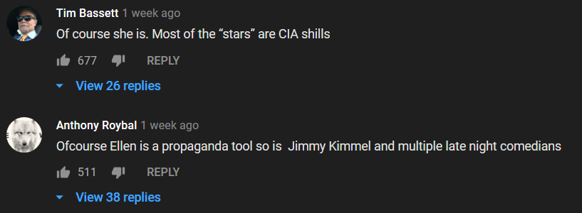
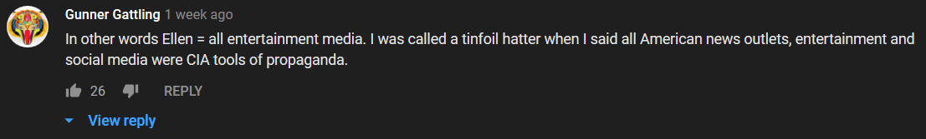
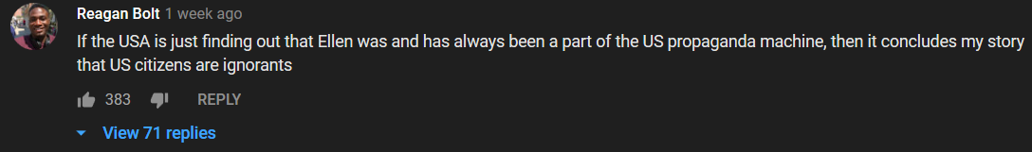
Here’s another example of puppets speaking out on behalf of an agenda:
32 - Celebs and Activists Rally to Call Out White Supremacy | NowThis
https://www.youtube.com/watch?v=Pf4BmGvISz8
Though this woman is speaking on something different than what I’m presenting she confirms the system that’s in place, and how it’s shaping your reality.
33 - Former CBS Reporter Exposes Media Lies, Internet Shills _ Astroturfing - MUST SEE!!!
https://www.youtube.com/watch?v=0s__qs0cBek
- The beginning - 1:27 – There you have it. It’s a system of reality management (create, maintain and tear down). And when people like me go through and around this system to dig up the truth and bring it to the public (the victims), this is where the censorship, punishment and defamation from the System comes in.
- 2:20 - 2:27 – “The whole point of AstroTurf is to try to give the impression there’s widespread support for or against an agenda when there’s not.”
So, groups of people believe that other groups of people like, dislike, or have a certain opinion when they don’t. Everyone may not like a thing, and they’ll all wonder why “everyone else” does. Everyone may not believe a thing, but they’ll all wonder why “everyone else” does. I think they’re going even further than this. I think it’s even being used in the music industry to give the illusion of popularity to newly signed artists. It’s definitely being used on Youtube for the puppets working on agendas – their subscribers, views, troll comments (and the Thumbs up on their comments), and the Thumbs up on their videos. It makes a puppet seem popular, and they will become popular as a result (because people are trained to go to what’s popular).
- End of Commentary -
A guy posted this on his blog, and someone posted it on Facebook not too long ago: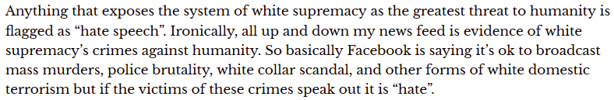
He actually debunks his theory on what’s flagged and not flagged, but what he said about the news feed is true. That’s what you’ll find in most black people’s feeds and in groups related to the Black Conscious community and Israelite community.
And speaking of censorship, my Facebook is totally censored. It went from partial censorship to total censorship after I exposed hoax after hoax in 2016. Almost no to no one sees my posts or comments. And they make sure any post of mine that’s shared isn’t seen. No one will see what shared of mine.

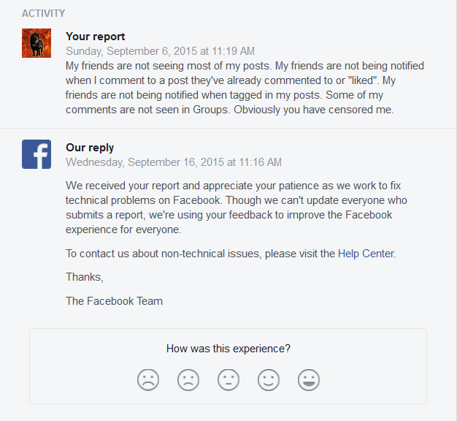
Here is a post I recently did about Facebook’s filtration system:
https://www.facebook.com/franklin.miller.169/posts/3394517273893530
Here’s the text of that post:
Why are videos like these almost nonexistent on Facebook?
If you can choose what people see and don’t see, like the media and Facebook does, you can make them see life how you want them to see it.
FYI: Facebook is a propaganda/brainwashing tool, and Facebook is WORSE than the media. Do you know how bad something has to be in order to be worse than the media???
As you watch the videos, do note that I didn’t even do an exhaustive search to find these videos.
And make sure you look at the dates of these videos.
What if I was Facebook or the media and I only showed you videos of whites being attacked by cops? What if I had a narrative with it like “The cops are after white people” or “Look what white people go through”?
Overturned Finding of Excessive Force at San Jose State Library
https://www.youtube.com/watch?v=BLIC3gaAiBc
Ex-cop caught on camera assaulting suicidal patient in hospital
https://www.youtube.com/watch?v=1_VglD_QsbA
Bodycam video refutes police claim that a deputy shot a man who opened his door and aimed a gun
https://www.youtube.com/watch?v=45n-QRBR0sA
Man Shoots And Kills Possible Intruder In Lancaster
https://www.youtube.com/watch?v=qwJFsVxEV7w
I-Team: Video Captures Police Demanding To Enter Framingham Home Without Warrant
https://www.youtube.com/watch?v=cJ4P820AT1U
Police fatally shoot man brandishing screwdriver | New York Post
https://www.youtube.com/watch?v=tU-d42Di3_A
Arizona cop punches woman in face during arrest
https://www.youtube.com/watch?v=ddC2Bs9ZIjU
US police officer violently arrests woman on beach
https://www.youtube.com/watch?v=Ye8EwifAIOI
California Cop Drags 20-Year-Old Woman Out of Car by Her Hair
https://www.youtube.com/watch?v=b85Dw0R4ipg
Suspect Spits on Cop, Cop Knocks Him Out
https://www.youtube.com/watch?v=1clsPeXT9Io
And if you go to that video-maker’s channel and scroll through the videos within the last year (or more if you want) you’re not only going to see black people, you’re going to see white people. Where is this on Facebook?
https://www.youtube.com/cha…/UCXMYxKMh3prxnM_4kYZuB3g/videos
What if I as Facebook only showed you the following videos?
Note: Videos like these … this is everyday black America.
Video shows Downtown Austin shooting | KVUE
https://www.youtube.com/watch?v=AzwPmn5pnuk
Brooklyn Man Shot Dead While Defending Daughter
https://www.youtube.com/watch?v=zf7XS7Jprk4
Surveillance video released in gas station shooting
https://www.youtube.com/watch?v=HCvKkLko3k4
Mother, daughter charged in murder of five family members
https://www.youtube.com/watch?v=zKn5A2eD8fE
Two men shot in busy parking lot
https://www.youtube.com/watch?v=C4LGfszjEVA
Man shot near courthouse says it was another act of senseless gun violence
https://www.youtube.com/watch?v=8aM27HhnjJk
- End of Text -
And to add to that…
2015/2016:
“In 2015, The Counted estimates, at least 306 black people were killed by police. The Washington Post puts the number of black people who were shot dead last year at 258.”
Source: http://www.huffingtonpost.com/entry/black-people-killed-by-police-america_us_577da633e4b0c590f7e7fb17
That number includes those who got into shootouts with officers, pulled guns on officers, fought with officers, etc. So, those who were innocently murdered is far less.
“At least 319 people have been slain in Chicago this year, about a 50% increase over this period last year. The number of shootings and the number of shooting victims in 2016 have also increased at about the same rate.”
Source: http://fox6now.com/2016/07/05/gun-violence-in-chicago-2000-shooting-victims-at-least-319-killed-in-2016/
And what about these videos? They’ll make it to the local news, but not to Fox and the others; and definitely not to Facebook, particularly black people’s feeds or groups.
https://www.bitchute.com/channel/abbegguyfaryoo/
https://www.bitchute.com/channel/itsoktobewhite/
Here’s part of another post:
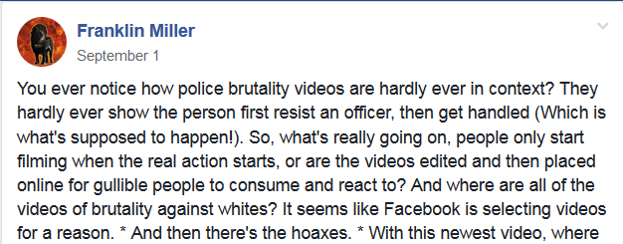

More examples of Facebook propaganda
Anti-Christian agenda:
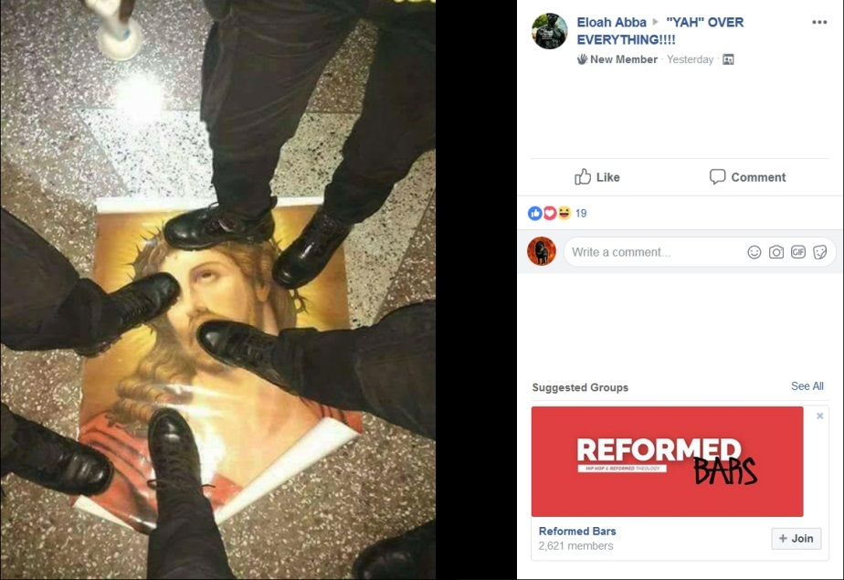
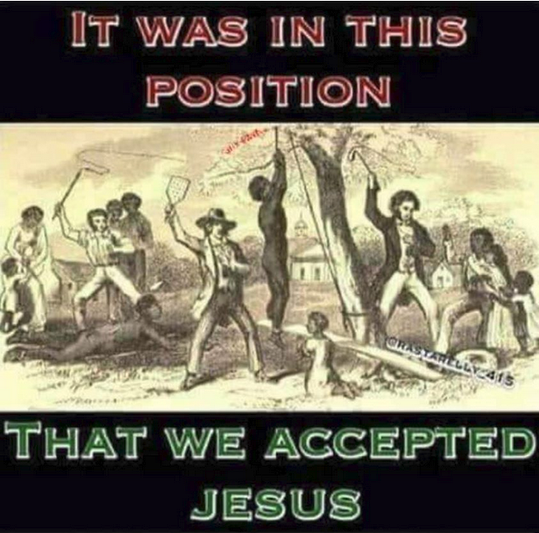

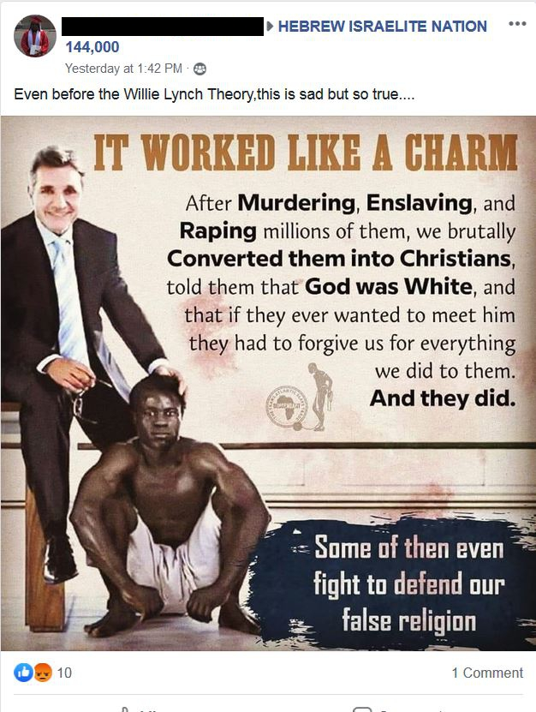
Racial tension/race war agenda:
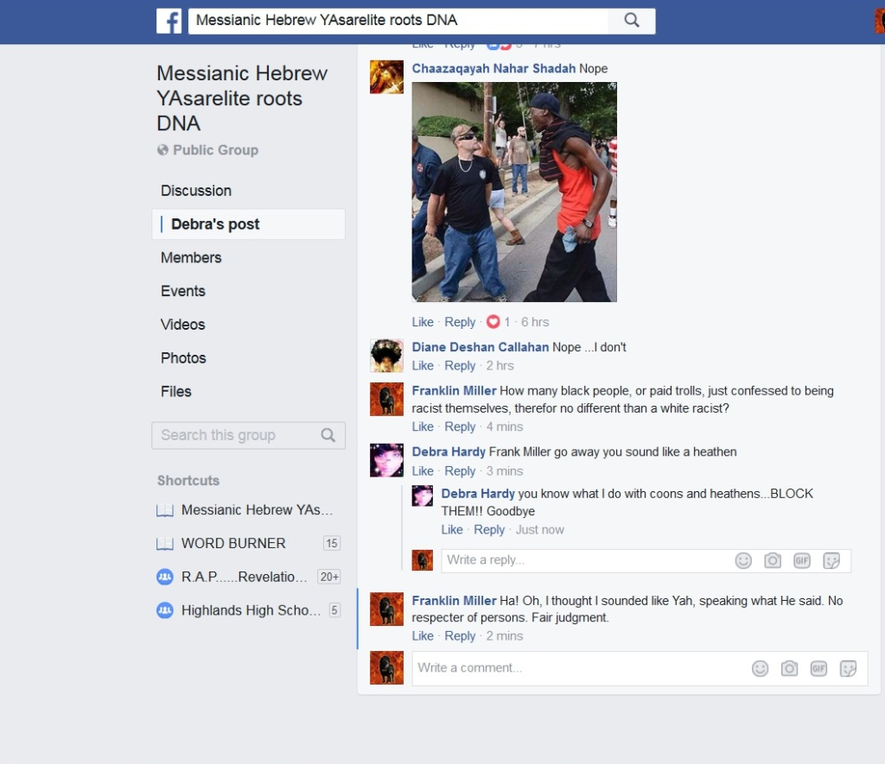

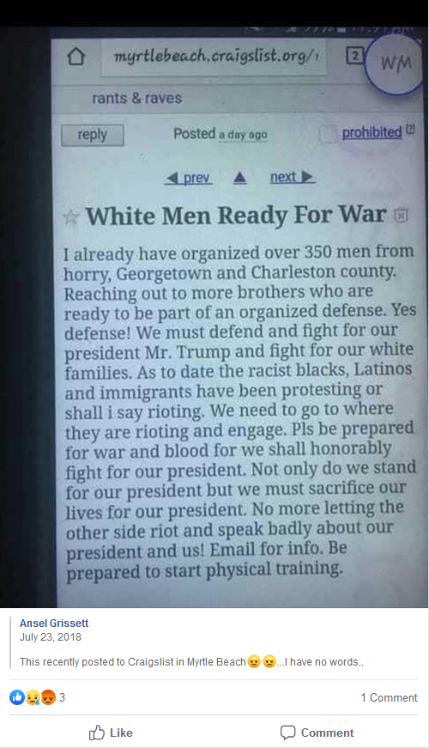
* I got this pic when it was first posted. I’ve seen this same post before having much more feedback.

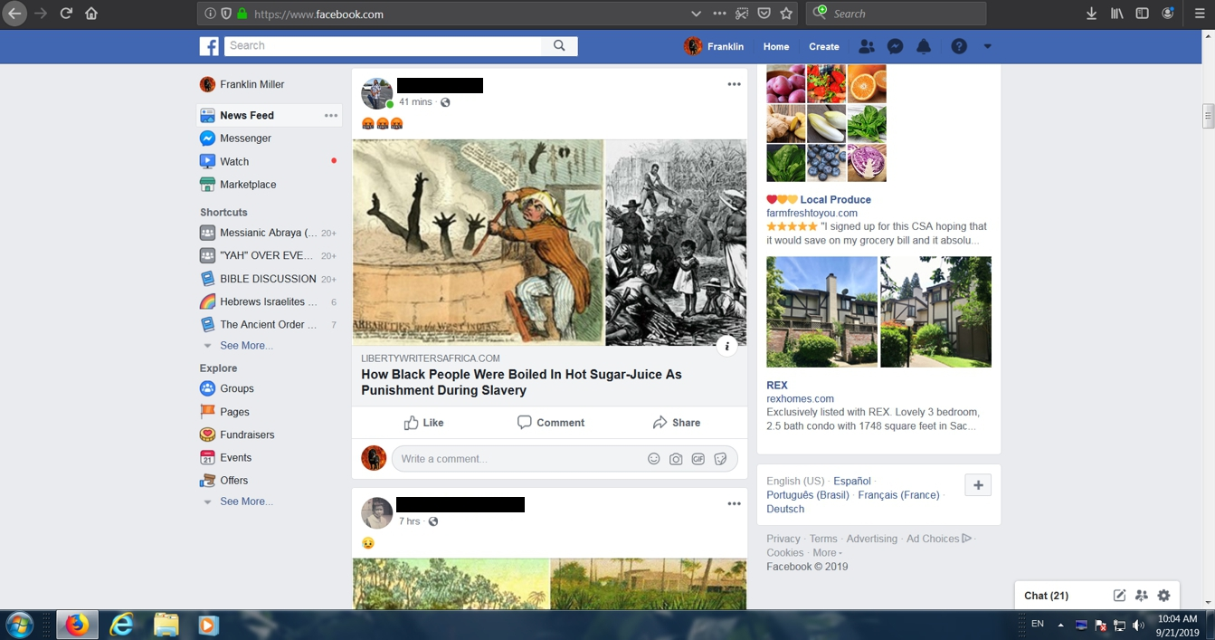
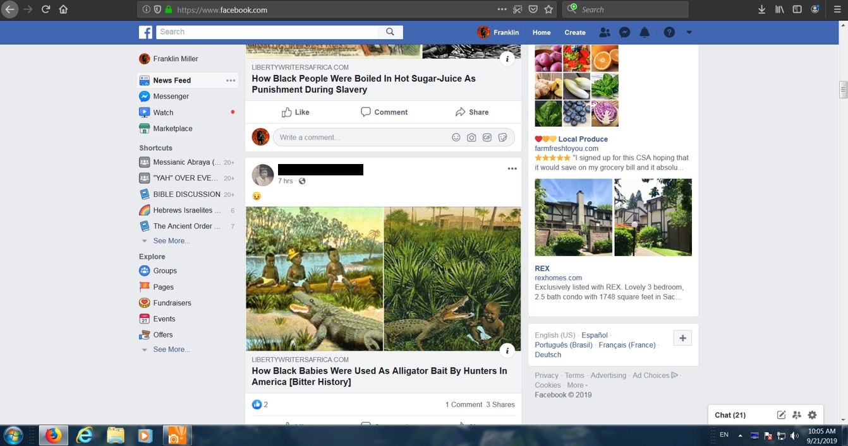
That’s back-to-back in my feed.
And that’s every day, all day, for black people on Facebook, especially when in certain groups. And that’s because the Israelite community, like the Black Conscious community, was created to brainwash blacks into accomplishing New World Order agendas.
“The most brilliant propagandist technique will yield no success unless one fundamental principle is borne in mind constantly – it must confine itself to a few points and repeat them over and over.” – Joseph Goebbels
“If you tell the same lie enough times, people will believe it; and the bigger the lie, the better.” – Joseph Goebbels
“It would not be impossible to prove with sufficient repetition and a psychological understanding of the people concerned that a square is in fact a circle. They are mere words, and words can be molded until they clothe ideas and disguise.” – Joseph Goebbels
“The essence of propaganda consists in winning people over to an idea so sincerely, so vitally, that in the end they succumb to it utterly and can never escape from it.” – Joseph Goebbels
“This is the secret of propaganda: Those who are to be persuaded by it should be completely immersed in the ideas of the propaganda, without ever noticing that they are being immersed in it.” – Joseph Goebbels
“Propaganda works best when those who are being manipulated are confident they are acting on their own free will.” – Joseph Goebbels
“Propaganda must facilitate the displacement of aggression by specifying the targets for hatred.” – Joseph Goebbels
34 - Who is Manipulating Facebook? - Smarter Every Day 215
https://www.youtube.com/watch?v=FY_NtO7SIrY
- 6:26 – Know More News made a video about who actually controls Russia. And the same people who control Russia control the US.
Who’s manipulating Americans? Does Russia control the mainstream media, protest groups, police departments, businesses, and the FBI who all work together as one along with online accounts during staged events/hoaxes? When the mainstream media is only showing police brutality against blacks, and Facebook is doing the same, or in other words, when you can clearly see that Facebook is on the same page as the mainstream media, is that coming from Russia? How about the fact the Hollywood is on the same page, is that coming from Russia?
- 7:36 - 7:44 – “Oftentimes different companies, and we at Facebook do this, will draw a line and say there’s a certain type of content that we’re not going to allow on the platform.” And what does that say when Facebook allows anything and everything against whites and Christianity?
- 8:04 - 8:11 – There you have it. And as certain people consistently get closer and closer to that line, a line they will never give the true details off, they get less engagement, not more.
- 8:42 – “Another thing we can do is reduce, which is what you’re getting at. And, that is, reducing the distribution of it so fewer people see it.” There it is. So, they fully control what you see and don’t see. So, when black people are getting a constant flow of “Look what white people did to you”... And when no one is seeing my posts... That’s not Russia.
8:48 - 9:15 – “And the third that we can do is give people more information.” In her first example: They label what they want to label, and don’t label what they don’t want to label. Her second example: “More context.” This is the same thing Youtube does. They’re giving you disinformation. Did you see how it was linked to a Wikipedia article? Just like Youtube. And remember how Alexa and other similar devices linked to Wikipedia? You’ll see more on Wikipedia later in this document, and it will reveal why.
9:16 - 9:30 – What a bunch of crap. What Facebook “discovered when they realized they were under attack”? “These bad guys”? “Purchased advertisements”? The Internet Research Agency is the bad guys? Wow.
So, someone is using content to divide and anger specific groups of people? Christians are targeted? Why is Facebook allowing this? Why is a front company funded by the CIA, who enflames ethnic and religious tensions around the world, allowing this?
9:36 – Probably a Christian Zionist. FYI: The powers that be regularly have their puppets say, “I’m a Christian.”
9:50 - 9:56 – I feel the same way about this video. That’s why I said what I said for the 9:36 mark.
10:58 – “We use human review as well as artificial intelligence...” Soooo ... you have AI? Just as I suspected. I noticed this in the comments section in Facebook groups a while ago. It’s replacing the “trolls”. Facebook won’t tell you that AI is also responding to comments, and doing so for agendas.
12:16 - 12:30 – They remove over a million fake accounts a day. So, just how many fake accounts are there on Facebook for them to remove over a million a day and still have the high number of accounts they have? Fakebook. It’s nothing more than a social engineering tool.
- End of Commentary -
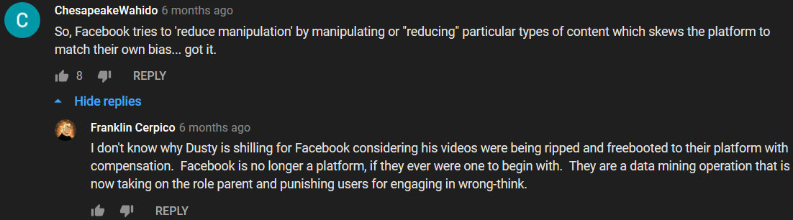
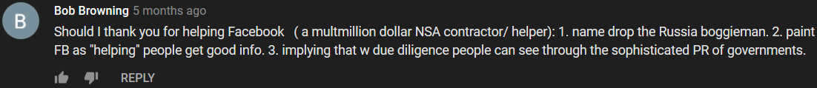
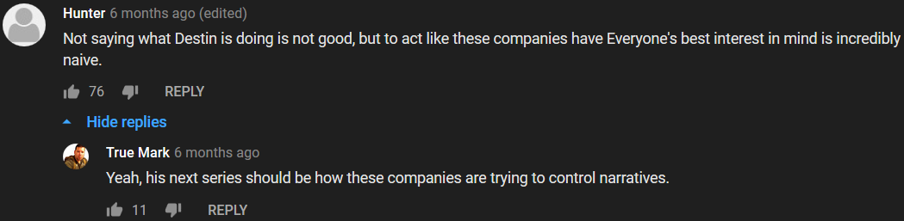
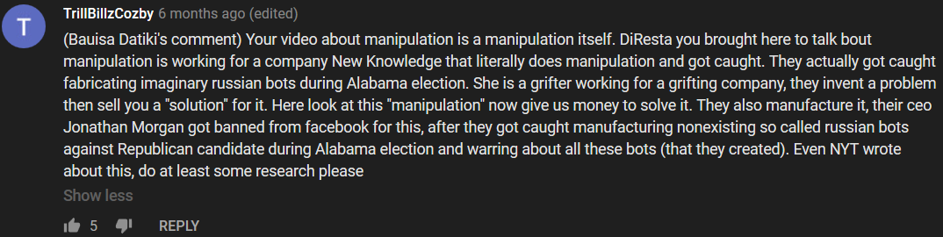
“Long before Donald Trump met Twitter, Russia was famous for its troll factories – outside Russia, anyway. Allegations of covert propagandists invading chatrooms go back as far as 2003, and in 2012 the Kremlin-backed youth movement Nashi was revealed to be paying people to comment on blogs. However most of what we know now comes from a series of leaks in 2013 and 2014, most concerning a St Petersburg company called Internet Research Agency, then just ‘Internet Research’. It is believed to be one of several firms where trolls are trained and paid to smear Putin’s opponents both at home and internationally.
“According to internal documents released by a group of hackers in 2013, Internet Research Agency employed more than 600 people across Russia, and had an implied annual budget of $10m – half of which was paid out in cash. Employees were expected to post on news articles 50 times a day. Those who wrote blogs had to maintain six Facebook accounts and publish at least three posts daily. On Twitter, they had to have at least 10 accounts, on which they would tweet 50 times. All had targets for the number of followers and the level of engagement they had to reach.”
Source: https://www.theguardian.com/media/2016/nov/06/troll-armies-social-media-trump-russian
“US cyber-security experts have blamed Russia for meddling in American elections since 2016. Now it has emerged that authors of a Senate report on ‘Russian’ meddling actually ran a ‘false flag’ meddling operation themselves.
“A week before Christmas, the Senate Intelligence Committee released a report accusing Russia of depressing Democrat voter turnout by targeting African-Americans on social media. Its authors, New Knowledge, quickly became a household name.
“Described by the New York Times as a group of ‘tech specialists who lean Democratic,’ New Knowledge has ties to both the US military and intelligence agencies. Its CEO and co-founder Jonathon Morgan previously worked for DARPA, the US military's advanced research agency. His partner, Ryan Fox, is a 15-year veteran of the National Security Agency who also worked as a computer analyst for the Joint Special Operations Command (JSOC). Their unique skill sets have managed to attract the eye of investors, who pumped $11 million into the company in 2018 alone.”
Source: https://www.rt.com/usa/447619-new-knowledge-russia-bots-scandal/
Excerpt from U.S. Unleashes Military to Fight Fake News, Disinformation By Pete Norman August 31, 2019, 6:43 AM PDT
Fake news and social media posts are such a threat to U.S. security that the Defense Department is launching a project to repel “large-scale, automated disinformation attacks,” as the top Republican in Congress blocks efforts to protect the integrity of elections.
The Defense Advanced Research Projects Agency wants custom software that can unearth fakes hidden among more than 500,000 stories, photos, video and audio clips. If successful, the system after four years of trials may expand to detect malicious intent and prevent viral fake news from polarizing society.
...
Famously, Oscar-winning filmmaker Jordan Peele created a fake video of former President Barack Obama talking about the Black Panthers, Ben Carson, and making an alleged slur against Trump, to highlight the risk of trusting material online.
Source: https://www.bloomberg.com/news/articles/2019-08-31/u-s-unleashes-military-to-fight-fake-news-disinformation
Yep ... he’s a puppet/shill.
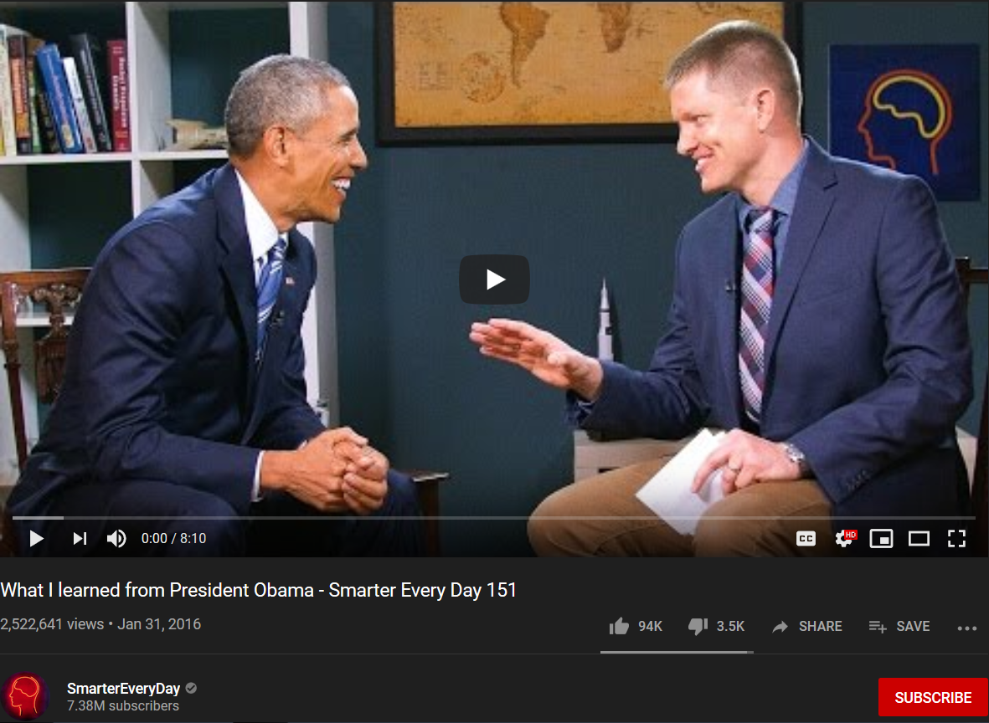
Quick Youtube Fact: Youtubers, fake profile comments, suggested and popular videos along with ratings are used simultaneously to push false conspiracy theories and disinformation.
Think of being strapped to a chair, unable to move. Now think about your eyelids being forced opened and you being made to watch images. Now think about being in that same chair and being forced to listen to sounds. That description matches forced brainwashing, correct? What if you could have the same effect as being forced, that is, being made to stay, being stuck, without forcing a person? An equivalent example would be the US government changing from mandatory military service to using many trained recruiters who know how to lie and manipulate a person into joining; along with advertisements, money as bait, etc. You can have the same result while looking innocent.
The fact that the information in this next video was even on the mainstream media shows that this is something the controllers wanted the population to know. Possible reasons: They’re pleading to a lesser charge and absolving themselves from guilt by telling the people (in their eyes). For a fact, one of the goals of Facebook is to change how people interact with one another. It’s all part of an overall plan to totally restructure society, building it (us) up the way they (the Elite) want it to be. This is related to the destruction of gender, male and female roles, traditions, patriotism, etc.
35 - Anonymous - This will Change Everything You Know... (2018-2019)
https://www.youtube.com/watch?v=39RS3XbT2pU
Skinner Box. So, when dopamine has you locked to Facebook, selected audio and images which Facebook filters - for instance, only showing you injustice against blacks - are being pumped into your mind. You’re “strapped to the chair,” being brainwashed. That’s one of the true purposes. Facebook is worse than television.
- 8:44 - 9:27 – Oh, like trying to provoke black Americans to fight the police and white people using hoaxes, and then completely censoring people like me who expose it? The System (the media, Hollywood, Facebook, moles/puppets, etc.) had many black people online so brainwashed they believed they were going to be “purged” by white people back in 2016! That’s how scary this is. And at 9:16 he told you what’s going on, but it’s not just the political term “bad actors,” it’s also literally bad actors. “… where bad actors can now manipulate large swaths of people to do anything you want.”
- 9:40 – The short-term signals (like “Good boy!” in dog training) – hearts, likes, thumbs up equals truth/true. This is what the troll/fake profile program operates on. They manipulate these things to give the impression of consensus (follow the crowd) to a population that was already socially engineered through other means to operate in groupthink. These people are unsure so they go with what appears to be the crowd. That is truth to them. Even the spread of “Trending” is a part of molding people into this type of thinking and behavior.
- 11:30 - 11:44 – Lies.
- End of Commentary -
36 - Kentucky is in Syria (and other anomalies of MSM geography) - #PropagandaWatch
https://www.youtube.com/watch?v=Z1UOQSrRPfE
- 1:28 – Wait, so you’re telling me they stage live streams too??? Wow. Who would have ever thought.
- 7:05 – “Oh my God, can you believe this atrocity is happening...” Like the media and Facebook showing what appears to be happening to blacks on a massive scale.
- 7:14 – “… as long as you give me the pictures, I’ll make the war.” Like the media, Facebook, Hollywood, and workers on Youtube carefully selecting images/videos - which also consists of excluding all the images/videos involving police injustice against whites, black injustice against whites, etc. - to present to blacks in order to create a race war or a war against the police.
37 - Neurotaylor talks about types of brainwashing
https://www.youtube.com/watch?v=oP-ZxGiL5a8
“… there’s the brainwashing by force, where you’re basically just battering someone into submission and trying to force them into believing something different; and then there’s the much more subtle brainwashing by stealth, which is when you’re trying to slip persuasive ideas past someone’s guard without them really noticing; and trying to change their mind and their behavior without them really being aware of it.”
38 - Neurotaylor talks about brainwashing’s core techniques
https://www.youtube.com/watch?v=skCoCaXryTY
“There are five core concepts, or techniques, that you might want to think about when you’re trying to analyze what goes on in brainwashing. Those five techniques are: isolation, control, uncertainty, repetition, and emotion. And in any case where brainwashing is alleged, such as, for example, thought reform during the Korean War, or in cults; in any case where it is alleged you will find these five being used.”
There’s no need to physically take you and put you into an environment when “they” already control the environment you’re currently in.
The “New” Environment (your current environment): Education. Television (everything on television). Movies in theaters. Newspapers. Magazines. Books. Radio. Music. Internet: 1. Websites owned and/or controlled by those who are controlled by the System (WebMD is an example). 2. Rigged search results (Google). 3. Social media environment: Paid individuals (trolls and actual agents) and organizations on Facebook operating fake profiles that look 100% real—the source of agenda-driven groups, videos and memes on Facebook—giving certain videos and memes Likes or Dislikes, and their own brainwashing, agenda-driven comments many Likes; with a similar approach being taken on Youtube and other platforms. 4. Contracted individuals and groups who push certain agendas, like Alex Jones, Umar Johnson, the New Black Panthers, teachers in underground communities, and even individual Youtube video-makers.
When it comes to the News media, Youtube, Facebook, Twitter, and every other source of information—“they” have control over the content (information/stimuli) presented; there is extreme censorship of content that will break the programming/brainwashing; and there are attacks against people bringing content (truth) that will break the programming/brainwashing. It’s the same as a person being brainwashed in a cult compound where friends and family can’t say or do anything that will snap them out of the programming.
“The whole point of brainwashing is that those being brainwashed don’t know it.” — Graham Haley
Further control of information (further control of the mind)
There’s a reason why I only take pieces of Wikipedia articles, and even before doing so there are several things I consider. The reason is because Wikipedia is also a part of the Matrix system. It’s used to aid agendas.
From Wikipedia (it’s been changed since):
Christianity grew out of Judaism^{[24][25][26]} as a Second Temple Judaic sect in the 1st century^{[2][27]} in the Roman province of Judea. Other religious influences of early Christianity are Zoroastrianism and Gnosticism.^{[27][28]} John Bowker states that Christian ideas such as "angels, the end of the world, a final judgment, the resurrection and heaven and hell received form and substance from ... Zoroastrian beliefs".^{[29]}
Source: https://en.wikipedia.org/wiki/Christianity
Look at the information following the first sentence. Do you know why that was placed there and stated in that way (… influences on Christianity)? The anti-Christian/anti-religion agenda. This aids the programming that has been coming from the rest of the System.
All of that is debunked here: http://howmanyknow.com/2017/01/is-your-religion-the-problem-part-2/
Being controlled, or under no control, someone writes something in a book. This is found and used on Wikipedia. And because it’s a citation, and it’s a book, it’s automatically true to most of the population.
39 - Israel's Internet Censorship War - If Americans Knew
https://www.youtube.com/watch?v=Vqhi16iikxk
Read this excerpt from Facebook Says It Is Deleting Accounts at the Direction of the U.S. and Israeli Governments
In September of last year, we noted that Facebook representatives were meeting with the Israeli government to determine which Facebook accounts of Palestinians should be deleted on the ground that they constituted “incitement.” The meetings — called for and presided over by one of the most extremist and authoritarian Israeli officials, pro-settlement Justice Minister Ayelet Shaked — came after Israel threatened Facebook that its failure to voluntarily comply with Israeli deletion orders would result in the enactment of laws requiring Facebook to do so, upon pain of being severely fined or even blocked in the country.
The predictable results of those meetings are now clear and well-documented. Ever since, Facebook has been on a censorship rampage against Palestinian activists who protest the decades-long, illegal Israeli occupation, all directed and determined by Israeli officials. Indeed, Israeli officials have been publicly boasting about how obedient Facebook is when it comes to Israeli censorship orders:
Shortly after news broke earlier this month of the agreement between the Israeli government and Facebook, Israeli Justice Minister Ayelet Shaked said Tel Aviv had submitted 158 requests to the social media giant over the previous four months asking it to remove content it deemed “incitement.” She said Facebook had granted 95 percent of the requests.
She’s right. The submission to Israeli dictates is hard to overstate: As the New York Times put it in December of last year, “Israeli security agencies monitor Facebook and send the company posts they consider incitement. Facebook has responded by removing most of them.”
What makes this censorship particularly consequential is that “96 percent of Palestinians said their primary use of Facebook was for following news.” That means that Israeli officials have virtually unfettered control over a key communications forum of Palestinians.
...
Needless to say, Israelis have virtually free rein to post whatever they want about Palestinians. Calls by Israelis for the killing of Palestinians are commonplace on Facebook, and largely remain undisturbed.
As Al Jazeera reported last year, “Inflammatory speech posted in the Hebrew language … has attracted much less attention from the Israeli authorities and Facebook.” One study found that “122,000 users directly called for violence with words like ‘murder,’ ‘kill,’ or ‘burn.’ Arabs were the No. 1 recipients of hateful comments.” Yet there appears to be little effort by Facebook to censor any of that.
Though some of the most inflammatory and explicit calls for murder are sometimes removed, Facebook continues to allow the most extremist calls for incitement against Palestinians to flourish.
Source: https://theintercept.com/2017/12/30/facebook-says-it-is-deleting-accounts-at-the-direction-of-the-u-s-and-israeli-governments/
And on Youtube and Facebook you can say or post anything about white people and Christianity, even if it involves outright lies, violence and genocide. Why? Because, right now, these are the main two targets of this Jewish New World Order. And if I or someone else was to comment with evidence disproving what’s been said or posted, all sorts of tricks and attacks would be employed against us. In fact, I got banned not too long ago for something I posted involving Jews! Here’s part of a Facebook post I made about it:
http://howmanyknow.com/wp-content/uploads/2019/08/Facebook2.jpg
On Sunday the 4th, I posted a table of contents for something I had released some time ago, along with additional statements.
http://howmanyknow.com/wp-content/uploads/2019/08/Capture1.jpg
These are the statements that were not liked:
http://howmanyknow.com/wp-content/uploads/2019/08/Capture2.jpg
Was that anti-Semitic?
Shady “Fact Checking” Sources Snopes and Politifact DEBUNKED!
https://wearechange.org/shady-fact-checking-sources-snopes-politifact-debunked/?doing_wp_cron=1502417754.6625230312347412109375
They do not want you to snap out of their programming/brainwashing. If you go here you can see one of the newly supplied definitions on Youtube:
"What in the World are They Spraying?" - Official Trailer
https://www.youtube.com/watch?v=te_FOsKL_5Q
The video is about chemtrails, but they direct you to contrails, telling you that a chemtrail is really a contrail – a belief the System has already spread into the minds of the public.
40 - The Myth of the Unbiased Search Engine
https://www.youtube.com/watch?v=_15b703Guo8
Your mind is like a judge in a courtroom. It makes decisions based on the information/evidence/proof presented. If you aren’t presented with crucial information – it was unjustly kept from you or altered, or files aren’t coming up in a search – a witness is not allowed to testify; a witness is deceived, discredited, paid off or threatened; a witness has been “knocked off,” or if you are persuaded by whatever means to favor one side over the other, then your final decision will be a perversion of truth, not truth. If someone else controls all of these variables, they can determine the outcome of the case—what you the judge will or won’t feel, think/believe, say or do.
41 - Beyond Censorship: Destroying Free Thought Online
https://www.youtube.com/watch?v=JLAHkdm21ao
42 - Prince Breaks On The Internet
https://www.youtube.com/watch?v=viJchSS1Byk
The New World Order Control Grid

“At the same time, the capacity to assert social and political control over the individual will vastly increase. As I have already noted, it will soon be possible to assert almost continuous surveillance over every citizen and to maintain up-to-date, complete files, containing even most personal information about the health or personal behaviour of the citizen, in addition to more customary data. These files will be subject to instantaneous retrieval by the authorities.” ― Zbigniew Brzeziński - America in the Technetronic Age
“In the technotronic society the trend would seem to be towards the aggregation of the individual support of millions of uncoordinated citizens, easily within the reach of magnetic and attractive personalities exploiting the latest communications techniques to manipulate emotions and control reason.” ― Zbigniew Brzeziński, Between Two Ages: America's Role in the Technetronic Era
“Another threat, less overt but no less basic, confronts liberal democracy. More directly linked to the impact of technology, it involves the gradual appearance of a more controlled and directed society. Such a society would be dominated by an elite whose claim to political power would rest on allegedly superior scientific knowhow. Unhindered by the restraints of traditional liberal values, this elite would not hesitate to achieve its political ends by using the latest modern techniques for influencing public behavior and keeping society under close surveillance and control. Under such circumstances, the scientific and technological momentum of the country would not be reversed but would actually feed on the situation it exploits.
… Persisting social crisis, the emergence of a charismatic personality, and the exploitation of mass media to obtain public confidence would be the steppingstones in the piecemeal transformation of the United States into a highly controlled society.” ― Zbigniew Brzeziński, Between Two Ages: America's Role in the Technetronic Era
Looking back at those quotes you can see 9/11 and Obama.
This is where the information at the beginning of this document really comes into play.
43 - DARPA Exposed
https://www.youtube.com/watch?v=iq2V_LkgRdo
- 8:34 – With DARPA “investing in” and “donating to” businesses across the country you see how even a business which started as a normal civilian venture can become a front company.
- 13:00 - Telepathic spies? Yes, the powers that be do have them.
- 13:23 – FutureMap? Something very similar is being used – pre-crime.
- 15:38 – Wouldn’t a telepathic sky be HAARP, chemtrails, and/or Wi-Fi? Is that how they’re reading people’s minds?
- 27:41 – Windows, the World Wide Web, and video teleconferencing.
- 29:25 – Google Maps.
- 30:24 – It may have come from Israel.
- 31:04 – Apple’s Siri.
- 31:36 – PAL.
- 32:55 - 34:31 – “… DARPA is in some ways almost inseparable from Google, and Microsoft, and Apple; and the other big companies …” “Director of DARPA departs Pentagon for Google, further reinforcing government ties.” Regina Dugan – Former Director at DARPA to Executive at Google. And remember, the same people who control the government control the banks and corporations.
- 37:21 - 38:42 – Remember these DARPA robots for later.
- 38:43 - 41:11 – DARPA’s Smart Dust. Do chemtrails contain Smart Dust? And you’ll hear more on Smart Cities later. So, already, you see a connection between DARPA and Smart Cities.
44 - How Big Brother Seeded the Tech Revolution
https://www.bitchute.com/video/6VWORs0I1DFr/
- 2:06 – Aluminum chaff – chemtrails.
- 5:27 – MITRE.
- 6:44 – In-Q-Tel and the CIA. “In 2000, an article in the Independent announced that the CIA was looking to invest in a search engine for managing, sorting and analyzing the ever-expanding information on the World Wide Web.” This will come into play later.
- 8:57 – The relationship between NSA and Google.
Google Bankrolled By The CIA by Jon King
http://www.jmccanneyscience.com/GOOGLE_SOCIAL_NETWORKING_CIA_NSA_CASH_LAUNDERING_Sub-Page.HTM
Here’s the PAL technology at work in another form:
45 - Amazon's Alexa And The CIA - #Vault7 Connection - Siri, Google Now, Assistant
https://www.youtube.com/watch?v=r3TSXukx1ds
1. Your voice is on file.
2. Information about your current mental and emotional state can be gained from your voice.
3. Information can be obtained from background noise, even knowledge of who is at your house at what time. And you can best believe that that person who is at your house already has a file, so when they speak it will be matched to their profile.
4. The audio of your life is being recorded.
And this technology can respond to your questions with this degree of sophistication, don’t you think computers can do the same online? Don’t you think computers can do what paid internet trolls are doing in the comment sections of websites?
46 - Alexa do you work for the CIA?
https://www.youtube.com/watch?v=dTNnSnCY7nM
47 - Alexa turns self off when asked about NSA
https://www.youtube.com/watch?v=eG_mj9T_yZ0
48 - Don't Be An Idiot! Get Rid of Alexa!
https://www.youtube.com/watch?v=NSbWAo-LMxg
49 - Tattling Smart Device Calls Police During Domestic Dispute
https://www.youtube.com/watch?v=QCUQY2JLjOc
And even these inventions are being used for other agendas.
50 - Google Home wont say Jesus Christ
https://www.youtube.com/watch?v=ERMmcLzThb4
51 - Hey Google…Who is Jesus, Allah, Brahman, New Age…interesting!
https://www.youtube.com/watch?v=qb_ceWfPaHk
52 - GOOGLE HOME can’t tell me Who JESUS CHRIST IS??? #GOOGLE
https://www.youtube.com/watch?v=xIF41VZ8sfg
The lady in this next video actually proves that the name/title Jesus Christ was targeted.
53 - Google Home talks about Jesus
https://www.youtube.com/watch?v=IIdP-nghubo
54 - Who is Jesus (Alexa)
https://www.youtube.com/watch?v=Tm86_IdBqVQ
If Alexa can do it, shouldn’t Google be able to do it? Of course. But check this out … that video was posted January 26, 2018.
This next video was posted November 24, 2017. And be sure to listen for the answers that align with other agendas.
55 - Amazon’s Alexa Denies Jesus Christ: Antichrist Spirit Is Increasing
https://www.youtube.com/watch?v=Mr402a9wUNc
There are things the people in power want the population to believe, and not believe. There are things they want the population to do, and not do. You’re about to hear them in this next video. You probably don’t know about the feminist agenda, but basically those who control the country tweaked everything so that women were favored over men. At the same time they did this they pumped feminism into the minds of women through music, movies, TV shows, magazines, etc. With this, came programming that made women believe that all men were cheating dogs who were oppressing them (the enemy). And there’s more, but I’ll leave it at that. But what all of this did was create a pride filled, man-hating population of women (mostly those in their early 40’s and younger) who will never be able to keep a man (who a man will never be able to stay with), destroying relationships. How can a man-hater and a man get along? The non-stop flow of feminism also reversed the male/female role, turning women into men, the same way the social engineers reversed and blurred gender through the homosexual agenda. All of this destroys the structure of the society, and thus the society. And this is being done for a reason(s).
And did you know that Black Lives Matter is a front organization that’s a part of the blacks vs. police and racial tension/race war agendas? You’ll hear support for them also.
56 - Amazon’s Alexa proves to be a SJW and says “Jesus is a fictional character”
https://www.youtube.com/watch?v=ekCeZwzQkTE
***** Deleted*****
TECHNOLOGY IN 100 YEARS
https://www.youtube.com/watch?v=RlbMzpi571Q
57 - Googles shocking ongoing plans and technology revealed by Whistleblowing scientist Leuren Moret
https://www.youtube.com/watch?v=bmBhrnFwl2M
- There are plans for people to be artificially inseminated. Remember that for later.
- Tracking by electromagnetic frequencies…. “Every living thing is an antenna that transmits and receives.”

Now think about HAARP, chemtrails and Wi-Fi.
Is the aluminum and other particles in the chemtrails boosting the signals from your body? Is the combination of phones, routers and other “smart” technology at ground level carrying or boosting this on a massive scale? It’s definitely intruding the body.

58 - How does your mobile phone work?
https://www.youtube.com/watch?v=1JZG9x_VOwA
59 - Quantum computing explained in 10 minutes | Shohini Ghose
https://www.youtube.com/watch?v=QuR969uMICM
60 - How Quantum Computing Will Change The World!
https://www.youtube.com/watch?v=3BKIJCTLy-s
- Companies like Google, Microsoft and IBM; and the US government.
- “… why are all of the major powers that influence our lives interested in them?”
- One benefit of a quantum computer is that it can perform rapid searches of complicated databases.
“In support of NASA's Quantum Artificial Intelligence Laboratory (QuAIL), the NAS facility hosts a 1,097-qubit D-Wave 2X™ quantum computer. The QuAIL project is a collaborative effort among NASA, Google, and Universities Space Research Association (USRA) to explore the potential for quantum computers to tackle optimization problems that are difficult or impossible for traditional supercomputers to handle.”
Source: https://www.nas.nasa.gov/projects/quantum.html
“Google wants NASA to help it prove quantum supremacy within a matter of months, according to a Space Act Agreement obtained by MIT Technology Review.
Quantum supremacy is the idea, so far undemonstrated, that a sufficiently powerful quantum computer will be able to complete certain mathematical calculations that classical supercomputers cannot. Proving it would be a big deal because it could kick-start a market for devices that might one day crack previously unbreakable codes, boost AI, improve weather forecasts, or model molecular interactions and financial systems in exquisite detail.”
Source: https://www.technologyreview.com/s/612381/google-has-enlisted-nasa-to-help-it-prove-quantum-supremacy-within-months/
It can be used to boost AI. FYI: Improving weather forecasts would mean improving weather predictions. Now apply that to human beings.
“‘The D-Wave took about a hundredth of a second’ to solve the problem, says Neven, with a classical computer the same problem would take about 100 days.
The actual problem that computer scientists threw at the D-Wave Two is pretty esoteric. To oversimplify it, they asked the machine to pick the optimum choice out of a large jumble of information with nearly 1,000 variables.”
Source: https://www.popularmechanics.com/technology/gadgets/a18475/google-nasa-d-wave-quantum-computer/
It’s simulating human life and choice, which means it can be used to make predictions.
The news anchors in this next video give their reasons (the script they were made to recite) for Google’s move, but you should know by now what’s really going on – a DARPA in Google’s clothing.
61 - GOOGLE BUYS ROBOTS - MILITARY ROBOT COMPANIES! - 8 OF THEM SO FAR!
https://www.youtube.com/watch?v=Zkk4iO9L32E
Google and driverless cars … remember that for later.
***** Deleted*****
Facebook Working On How To Read Your Mind
https://www.youtube.com/watch?v=Avl_N1g2FUQ
62 - Facebook Opens Mind-Reading Division
https://www.youtube.com/watch?v=UI1Z5mpc3pw
Watch 4:51 – 10:41
63 - Birth of the Mind-Reading Brain-Chipped Super Soldier - #NewWorldNextWeek
https://youtu.be/7kGZemt2P9M?t=291
64 - Top DARPA Projects That Should Creep You Out
https://www.youtube.com/watch?v=Rh1tg5lyP6s
Death rays on drones? I’m sure they plan to put death rays on UFOs too if they every carry out their staged alien invasion/visitation.
“In 2003, news surfaced that the Pentagon was launching a sweeping new research project called the Embryonic Lifelog Program which aimed to collect every single piece of information available on a person to populate a massive database with the goal to ‘trace the threads of an individual’s life’.” “Supposedly it was canceled after civil liberties advocates complained about, you know, the project’s privacy implications. Supposedly.”
“The embryonic LifeLog program would dump everything an individual does into a giant database: every e-mail sent or received, every picture taken, every Web page surfed, every phone call made, every TV show watched, every magazine read.
All of this – and more – would combine with information gleaned from a variety of sources: a GPS transmitter to keep tabs on where that person went, audio-visual sensors to capture what he or she sees or says, and biomedical monitors to keep track of the individual's health.”
Source: https://www.wired.com/2003/05/a-spy-machine-of-darpas-dreams/
“Rather than reviewing archival data, it may use current data to predict the future. IARPA is modeled after the Defense Advanced Research Projects Agency…. IARPA does for NSA what DARPA does for the military.”
All of this will come into play later.
65 - USA - Under Surveillance Always
https://www.youtube.com/watch?v=nriMqbMb71U
House Passes Cyber Security Bill with Expanded Gov’t Powers in Surprise Vote
https://www.democracynow.org/2012/4/27/headlines/house_passes_cyber_security_bill_with_expanded_govt_powers
66 - How Long Have They Really Been Listening In?
https://www.youtube.com/watch?v=aDQQIdRHHqs
Front companies.
And if all of that is not bad enough…
Watch 4:54 - 10:02
67 - Israeli Company Hacking iPhone for FBI - #NewWorldNextWeek
https://youtu.be/qabSgWHWPDs?t=294
- 9:02 – “… it’s valiant Apple fighting for your privacy.” The powers that be have had other companies play this phony role also. Amazon.com comes to mind.
Take a look at this excerpt from Shady Companies With Ties to Israel Wiretap the U.S. for the NSA:
In addition to constructing the Stellar Wind center, and then running the operation, secretive contractors with questionable histories and little oversight were also used to do the actual bugging of the entire U.S. telecommunications network.
According to a former Verizon employee briefed on the program, Verint, owned by Comverse Technology, taps the communication lines at Verizon, which I first reported in my book The Shadow Factory in 2008. Verint did not return a call seeking comment, while Verizon said it does not comment on such matters.
At AT&T the wiretapping rooms are powered by software and hardware from Narus, now owned by Boeing, a discovery made by AT&T whistleblower Mark Klein in 2004. Narus did not return a call seeking comment.
What is especially troubling is that both companies have had extensive ties to Israel, as well as links to that country’s intelligence service, a country with a long and aggressive history of spying on the U.S.
In fact, according to Binney, the advanced analytical and data mining software the NSA had developed for both its worldwide and international eavesdropping operations was secretly passed to Israel by a mid-level employee, apparently with close connections to the country. The employee, a technical director in the Operations Directorate, “who was a very strong supporter of Israel,” said Binney, “gave, unbeknownst to us, he gave the software that we had, doing these fast rates, to the Israelis.”
But Binney now suspects that Israeli intelligence in turn passed the technology on to Israeli companies who operate in countries around the world, including the U.S. In return, the companies could act as extensions of Israeli intelligence and pass critical military, economic and diplomatic information back to them. “And then five years later, four or five years later, you see a Narus device,” he said. “I think there’s a connection there, we don’t know for sure.”
Narus was formed in Israel in November 1997 by six Israelis with much of its money coming from Walden Israel, an Israeli venture capital company. Its founder and former chairman, Ori Cohen, once told Israel’s Fortune Magazine that his partners have done technology work for Israeli intelligence. And among the five founders was Stanislav Khirman, a husky, bearded Russian who had previously worked for Elta Systems, Inc. A division of Israel Aerospace Industries, Ltd., Elta specializes in developing advanced eavesdropping systems for Israeli defense and intelligence organizations. At Narus, Khirman became the chief technology officer.
A few years ago, Narus boasted that it is “known for its ability to capture and collect data from the largest networks around the world.” The company says its equipment is capable of “providing unparalleled monitoring and intercept capabilities to service providers and government organizations around the world” and that “Anything that comes through [an Internet protocol network], we can record. We can reconstruct all of their e-mails, along with attachments, see what Web pages they clicked on, we can reconstruct their [Voice over Internet Protocol] calls.”
Like Narus, Verint was founded by in Israel by Israelis, including Jacob “Kobi” Alexander, a former Israeli intelligence officer. Some 800 employees work for Verint, including 350 who are based in Israel, primarily working in research and development and operations, according to the Jerusalem Post. Among its products is STAR-GATE, which according to the company’s sales literature, lets “service providers … access communications on virtually any type of network, retain communication data for as long as required, and query and deliver content and data …” and was “[d]esigned to manage vast numbers of targets, concurrent sessions, call data records, and communications.”
In a rare and candid admission to Forbes, Retired Brig. Gen. Hanan Gefen, a former commander of the highly secret Unit 8200, Israel’s NSA, noted his former organization’s influence on Comverse, which owns Verint, as well as other Israeli companies that dominate the U.S. eavesdropping and surveillance market. “Take NICE, Comverse and Check Point for example, three of the largest high-tech companies, which were all directly influenced by 8200 technology,” said Gefen. “Check Point was founded by Unit alumni. Comverse’s main product, the Logger, is based on the Unit’s technology.”
According to a former chief of Unit 8200, both the veterans of the group and much of the high-tech intelligence equipment they developed are now employed in high-tech firms around the world. “Cautious estimates indicate that in the past few years,” he told a reporter for the Israeli newspaper Ha’artez in 2000, “Unit 8200 veterans have set up some 30 to 40 high-tech companies, including 5 to 10 that were floated on Wall Street.” Referred to only as “Brigadier General B,” he added, “This correlation between serving in the intelligence Unit 8200 and starting successful high-tech companies is not coincidental: Many of the technologies in use around the world and developed in Israel were originally military technologies and were developed and improved by Unit veterans.”
Source: https://www.wired.com/2012/04/shady-companies-nsa/
“The National Security Agency routinely shares raw intelligence data with Israel without first sifting it to remove information about US citizens, a top-secret document provided to the Guardian by whistleblower Edward Snowden reveals.
Details of the intelligence-sharing agreement are laid out in a memorandum of understanding between the NSA and its Israeli counterpart that shows the US government handed over intercepted communications likely to contain phone calls and emails of American citizens. The agreement places no legally binding limits on the use of the data by the Israelis.
The disclosure that the NSA agreed to provide raw intelligence data to a foreign country contrasts with assurances from the Obama administration that there are rigorous safeguards to protect the privacy of US citizens caught in the dragnet. The intelligence community calls this process ‘minimization’, but the memorandum makes clear that the information shared with the Israelis would be in its pre-minimized state.
The deal was reached in principle in March 2009, according to the undated memorandum, which lays out the ground rules for the intelligence sharing.
The five-page memorandum, termed an agreement between the US and Israeli intelligence agencies ‘pertaining to the protection of US persons’, repeatedly stresses the constitutional rights of Americans to privacy and the need for Israeli intelligence staff to respect these rights.
But this is undermined by the disclosure that Israel is allowed to receive ‘raw Sigint’ – signal intelligence. The memorandum says: ‘Raw Sigint includes, but is not limited to, unevaluated and unminimized transcripts, gists, facsimiles, telex, voice and Digital Network Intelligence metadata and content.’
According to the agreement, the intelligence being shared would not be filtered in advance by NSA analysts to remove US communications. ‘NSA routinely sends ISNU [the Israeli Sigint National Unit] minimized and unminimized raw collection’, it says.”
Source: https://www.theguardian.com/world/2013/sep/11/nsa-americans-personal-data-israel-documents
Additional source
What Was the Israeli Involvement in Collecting U.S. Communications Intel for NSA?
https://www.haaretz.com/did-israelis-gather-intel-for-the-nsa-1.5275806
This is a perfect spot to branch off into the September 11th “attacks,” but this is not the focus of this presentation.
68 - Orthodox Woman Named NSA Cybersecurity Chief
https://www.youtube.com/watch?v=cU3iedXTr-s
69 - Israel Hacking Elections Worldwide
https://www.youtube.com/watch?v=K67uPqzsmt8
70 - Israel Hacking the World
https://www.youtube.com/watch?v=5VGpWl56ZF0
- 16:26 – Netanyahu wants UN of the internet. I wonder who will oversee it. “‘There should be a sort of UN for the internet. A coalition of the leading companies in the cyber world…and in my opinion Israel is the most advanced,’ he added.”
Cyber security – you know the weaknesses and backdoors. Research and development – you create it so that it benefits you.
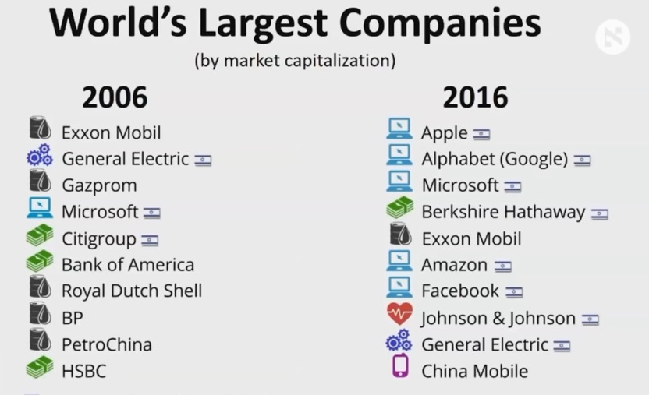
Driverless cars? Israel is leading in this.

***** Deleted*****
Alert! Snapchat Just Reserved Rights to Store and Use ALL Selfies Taken https://www.youtube.com/watch?v=8bcQAdE678k
71 - SnapChat Will Start Selling Your Deleted Photos And Videos
https://www.youtube.com/watch?v=XC55FLfRzkY
“After a backlash from users, Instagram clarified its terms of service to ensure they would have absolute ownership of their own images. But photographers on the site are finding that terms of service and community guidelines don't stop businesses, publishers and other users from helping themselves.”
Source: https://www.theguardian.com/technology/us-news-blog/2013/feb/05/instagram-users-fightback-stolen-photos
CONFIRMED: Twitter collects all your nude pics and private photos, builds a profile and sells your data for profit
https://www.naturalnews.com/2018-01-16-confirmed-twitter-collects-all-your-dick-picks-and-private-photos.html
“The former National Security Agency contractor Edward J. Snowden said in a wide-ranging interview published on Sunday that the oversight of surveillance programs was so weak that members of the United States military working at the spy agency sometimes shared sexually explicit photos they intercepted.”
Source: https://www.nytimes.com/2014/07/21/us/politics/edward-snowden-at-nsa-sexually-explicit-photos-often-shared.html
“The National Security Agency is harvesting huge numbers of images of people from communications that it intercepts through its global surveillance operations for use in sophisticated facial recognition programs, according to top-secret documents.
The spy agency’s reliance on facial recognition technology has grown significantly over the last four years as the agency has turned to new software to exploit the flood of images included in emails, text messages, social media, videoconferences and other communications, the N.S.A. documents reveal. Agency officials believe that technological advances could revolutionize the way that the N.S.A. finds intelligence targets around the world, the documents show. The agency’s ambitions for this highly sensitive ability and the scale of its effort have not previously been disclosed.
The agency intercepts ‘millions of images per day’ — including about 55,000 ‘facial recognition quality images’ — which translate into ‘tremendous untapped potential,’ according to 2011 documents obtained from the former agency contractor Edward J. Snowden.”
Source: https://www.nytimes.com/2014/06/01/us/nsa-collecting-millions-of-faces-from-web-images.html
“‘The government and the private sector are both investing billions of dollars into face recognition’ research and development, said Jennifer Lynch, a lawyer and expert on facial recognition and privacy at the Electronic Frontier Foundation in San Francisco. ‘The government leads the way in developing huge face recognition databases, while the private sector leads in accurately identifying people under challenging conditions.’”
Source: https://www.nytimes.com/2014/06/01/us/nsa-collecting-millions-of-faces-from-web-images.html
72 - FBI Facial Recognition Database Is Out Of Control - NWO Agenda https://www.youtube.com/watch?v=ZhUXCVAaqgM
In the US, they used police brutality as an excuse to place video cameras on police officers. In the future, when cameras are on every officer, the moment you are in view of an officer’s camera all of your information will pop up, and that officer will know everything about you, even where you’re “supposed to be” at that time. It will be complete control.
Watch the beginning - 4:11
73 - Amazon Marketing Creepy Facial Recognition Tech to Police - #NewWorldNextWeek
https://www.youtube.com/watch?v=Kv96lelMnCs
With license plate reading technology, cell phone signals, and facial recognition technology they don’t really need to chip anyone. They already know where we are.
Do you see the cameras at the stoplights? If they’re hooked up to license plate reading software they know when your vehicle passes through a particular intersection. If it’s hooked up to facial recognition software they know when you are in that area.
74 - Streets So Filled With Surveillance, No One Even Knows What All That Tech Junk Is...
https://www.youtube.com/watch?v=TLlE3iuiLYI
One comment:
- Wait till all the drones are in the air.﻿

You would probably never believe that this country is so fake and controlled that most of the popular inventions and ideas that have been introduced to the public in recent years are a part of a bigger scheme which includes these front companies.
Link your email to your Facebook. Link your Google account to ____. Sign up with your Facebook account. Protect your account by providing your phone number. Install this app (Giving them access to what?). And it goes on and on.

You know how the FBI and other agencies do a psychological profile on a suspect, like what you see on crime shows such as CSI? This is what’s being done with us.
One way to find out about a person is to know what they say and do in certain circumstances. Another way to find out about a person is to know how they feel about certain things (what they like, dislike, love, etc.).

At the stores, your phone number is used to track your purchases, and so are cashless purchases. Now think about Amazon.com and Ebay.com where we make purchases and leave a purchase history. Your purchases give vital information about you and your life.
DVRs give your watch history, just as other watch or listen history. Valuable information is gained from this.

Aren’t you happy that dating sites now offer a psychological profile you can fill out for them? Yep, that’s part of it too. And it goes on and on.
In this next video they use the official story that these companies are collecting data for the sole purpose of selling it and making money. This is not true. There is a bigger agenda, which you will see later.
75 - This is how Google is spying on everything you do
https://www.youtube.com/watch?v=dTF8_DwDjW4
76 - How Facebook tracks and manipulates everyone, everything, and everywhere - Delete your Facebook now
https://www.youtube.com/watch?v=9sFl2qGedFQ
77 - Data is the New Oil
https://www.youtube.com/watch?v=b7E9ZsrYnU0
78 - 5 Privacies You Didn't Know You Lost
https://www.youtube.com/watch?v=rtJw35Vmpxk
Pay close attention to the first half of this video. And remember: One benefit of a quantum computer is that it can perform rapid searches of complicated databases.
79 - 'Every router in America has been compromised' – McAfee on CIA exploits
https://www.youtube.com/watch?v=_vLpzKo6NI8
Now, take all that you’ve learned thus far …
80 - NSA Whistle-Blower Tells All: The Program | Op-Docs | The New York Times
https://www.youtube.com/watch?v=r9-3K3rkPRE
“… think of a domain as an activity … a specific type of activity … phone calls … or banking is another domain.… … the trick now is to map through all the domains … pulling together all the attributes that any individual has in every domain, so that now I can pull your entire life together from all those domains and map it out and show your entire life over time.” “And there is another real problem ... unfortunately the software … once it takes in data it will build profiles on everybody in that data.” “You build social networks for everybody; that then turns into the graph, and then you index all that data to that graph, which means you can pull out a community … that gives you the outline of the life of everybody in the community. And if you carry it over time from 2001 up, you have ten years worth of their life that you can lay out in a timeline.” A timeline. So, what do you think Facebook’s timeline is really about? You’re giving them information for your NSA timeline.
Previous information (above):
“In 2003, news surfaced that the Pentagon was launching a sweeping new research project called the Embryonic Lifelog Program which aimed to collect every single piece of information available on a person to populate a massive database with the goal to ‘trace the threads of an individual’s life’.” “Supposedly it was canceled after civil liberties advocates complained about, you know, the project’s privacy implications. Supposedly.”
“The embryonic LifeLog program would dump everything an individual does into a giant database: every e-mail sent or received, every picture taken, every Web page surfed, every phone call made, every TV show watched, every magazine read.

All of this – and more – would combine with information gleaned from a variety of sources: a GPS transmitter to keep tabs on where that person went, audio-visual sensors to capture what he or she sees or says, and biomedical monitors to keep track of the individual's health.”
“Rather than reviewing archival data, it may use current data to predict the future. IARPA is modeled after the Defense Advanced Research Projects Agency…. IARPA does for NSA what DARPA does for the military.”
81 - FaceBook & CIA (+URL referenced Citations!)
https://www.youtube.com/watch?v=NZXHzh0r8yA

Information placed in the Description Box by the uploader (if you want it)
Much of the video's revelations are covered in http://www.theage.com.au/news/general... but I went step-by-step through the video and verified. I even updated many of the Wikipedia entries so that one can just follow the footnotes/references there. Mind you there is no WikiPedia entry for Anita Jones.

=== Verifying info at 2:03

=== "an Accel partner, Jim Breyer, made a controversial bet on a Harvard dropout. In April 2005, he spearheaded Accel's $12.7 million investment in the fledgling social network, at a near $100 million valuation. He also took a stake for himself." http://dealbook.nytimes.com/2011/01/1...

=== Verifying info at 2:10

=== "He is the former chairman of the National Venture Capital Association". http://www.artdaily.com/index.asp?int...

=== Verifying info at 2:18

=== Gilman_Louie "is the founder and former CEO of In-Q-Tel, a strategic venture fund created to help enhance national security by connecting the Central Intelligence Agency and U.S. intelligence community with venture-backed entrepreneurial companies... has served on a number of boards of directors, including... the National Venture Capital Association". http://cnsi.ctrl.ucla.edu/file-sharin...

=== Verifying info at 2:32 & 2:52

=== "The BBN Board of Directors includes... Jim Breyer... of Accel Partners; and Anita K. Jones" http://www.bbn.com/news_and_events/pr... and yes she did become director of BBN in 2004 http://www.allbusiness.com/company-ac... but no, Gilman Louie was not then nor ever (as far as my searching revealed) working for either BBN or Raytheon (who bought out BBN in 2009) although he did sit on a committee in 2009 where there were Raytheon employees also. http://books.nap.edu/openbook.php?rec...

=== Verifying info at 2:52

=== Anita Jones is still (in 2001) on the board of In-Q-Tel http://www.iqt.org/about-iqt/our-team... "From 1993 to 1997 I served as Director of Defense Research and Engineering at the U.S. Department of Defense. In that position I was responsible for the science and technology program of the Department of Defense, including the Defense Advanced Research Projects Agency and oversight of the Department's laboratories." http://www.nsf.gov/about/congress/107... "Jones served Director of Defense Research and Engineering at the U.S. Department of Defense from 1993 to 1997, overseeing the department's science and technology program, research laboratories and the Defense Advanced Research Projects Agency." http://www.virginia.edu/uvatoday/news...

=== Verifying info at 3:10

=== "Funding for the controversial Terrorism Information Awareness program has ended for 2004. The prototype system was formerly housed within the DARPA Information Awareness Office. Several related data mining research and development programs, now under different agencies, are designed to provide better advance information about terrorist planning and preparation activities to prevent future international terrorist attacks against the United States at home or abroad. A goal of datamining is to treat worldwide distributed database information as if it were housed within one centralized database." http://fpc.state.gov/documents/organi...

***** Deleted*****
Facebook Messenger Switch Pure Evil !!! Facebook can Listen to You, Read your Contacts & more!
https://www.youtube.com/watch?v=qSw9dZ_5JTQ
82 - The Weird DARPA/Facebook "Coincidence" You Never Heard About
https://www.youtube.com/watch?v=1_yMGQ5Uv0I
83 - We Are Becoming the Internet, the Internet Is Becoming Us
https://www.youtube.com/watch?v=GnLyjsO7mZc
I don’t have an app on my phone but I’ve had Facebook give me a friend suggestion based on a phone conversation I had almost two weeks prior. And what makes it worst is that the person’s name wasn’t even mentioned, only their relationship to my friend and a situation that we all had been involving in over a decade ago. 1. My phone and my Facebook is linked somewhere. 2. There is “thinking” taking place.
- 8:58 – “In the background, the intelligence community is running quantum computers. The NSA is using all of our harvested data – our tracked phone calls, social network posts, GPS tracking, internet searches … all of it – to run something called a Sentient World Simulation. The program has now amassed databases so vast they can analyze our lives and predict our thoughts and future actions with relative certainty.”
84 - Eagle Eye: We The People
https://www.youtube.com/watch?v=44S3f3s4e24
Don’t be stupid and believe everything stated about the computer in these next clips (the why, the when, etc.).
85 - Person of Interest - Behind the Machine
https://www.youtube.com/watch?v=XR9KGlTgbAs
From the same people who brought you terrorism and September 11 … the Elite. And the “perfect society” was planned and being carried out before September 11. Brave New World, Nineteen Eighty Four, and Between Two Ages: America's Role in the Technetronic Era were all made before September 11.
And it’s pretty interesting that my best theory for the mark of the beast involves the 9-digit Social Security Number.
86 - Person Of Interest (1x11) - Nathan Ingram, Price of the Machine
https://www.youtube.com/watch?v=zRL2sRkUvYk
87 - Person of Interest S01E01 - Finch Explains the Machine
https://www.youtube.com/watch?v=cOdKerzcpWo
Additional technology:
http://howmanyknow.com/2012/08/more-than-15-minutes-of-fame/
http://howmanyknow.com/2012/02/kiss-privacy-goodbye/
http://howmanyknow.com/2012/02/a-microchipped-society/
88 - 5G going UP: To ALL youtubers You may want to watch this
https://www.youtube.com/watch?v=-yOwzTXUTuA
89 - US Army General Warns 5G is a Weapon
https://www.youtube.com/watch?v=7dPyuHL5vQ4
90 - It's Called The 5G BEAST SYSTEM For A Reason (2018)
https://www.youtube.com/watch?v=EVrw7svZp-s
5G and microchips are a perfect match.
91 - Employees Getting Microchipped in the US - #NewWorldNextWeek
https://www.youtube.com/watch?v=ovd_75lH7Dc
“What technologies is the CIA interested in now? One clear area of focus is energy. In 2007 In-Q-Tel plugged into AdaptivEnergy, a company that develops products that harvest energy from impulse shocks, vibrations, and even footfalls. It also likes companies that are working on making smaller batteries, like Qynergy, a New Mexico-based company working on radioisotope batteries, and Infinite Power Solutions, a Colorado developer of thin-film batteries that can power RFID (Radio Frequency Identification) tracking chips.
Speaking of RFID, In-Q-Tel seems to see potential there. In 2008 it invested in Massachusetts-based ThingMagic, a company that makes RFID chips that can ‘track anything.’ The Florida State Attorney's Office for West Palm Beach uses them to track felony case files, and Ford offered them up as an additional feature for pickup trucks. A contractor can put the tags on all of his tools, so that a quick scan of the truck bed with an RFID scanner will reveal everything in there. ThingMagic was acquired last month by GPS device maker Trimble Navigation for an undisclosed amount. In-Q-Tel has also invested in GainSpan, a company finding ways to make everything wi-fi-enabled, from refrigerators to health monitoring devices, for richer information on something than just its location.
Experts say the next big trend in data is going to be geolocation, and the power to predict where you're going to go next and who you spend the most time with. Several companies focusing on geospatial technology are in the In-Q-Tel portfolio, including Image Tree Corp., which can help show where illicit crops are being grown, and Fortius One and Geosemble, which map people, places and things instantly using location data from RSS feeds and tweets.”
Source: https://www.forbes.com/2010/11/19/in-q-tel-cia-venture-fund-business-washington-cia.html#259128426aea
Additional Information
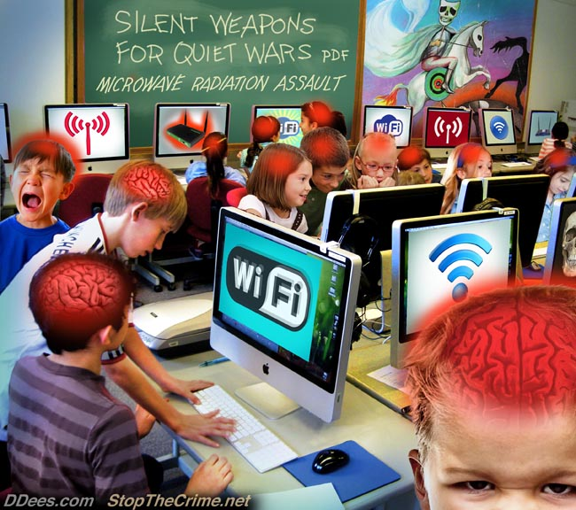
92 - What They Never Bothered to Tell Us...
https://www.youtube.com/watch?v=A8-0JKFWJKE
93 - Wireless Warfare Exposed. Includes ways to protect your family.
https://www.youtube.com/watch?v=F9bdU_uw2Dc
If someone had a virus in a spray bottle and went around spraying people, causing cancer, various illnesses, and even death; then what they have is a weapon, and you have every right to stop them by any means necessary. They have committed attempted murder. So, whether it’s a Wi-Fi tower or chemtrail plane ... “No, you have to let me spray you with this virus.”
FYI: China was taken over during the Opium Wars. It’s controlled by the same Elite who control the US and Russia.
94 - Life Inside China's Total Surveillance State
https://www.youtube.com/watch?v=OQ5LnY21Hgc
- 2:25-2:29 – Interesting. Nearly every time I go into a store with a theft-detection system at the door, it goes off. Yes, when I go into the store, and usually when I come out also. I’ve tried different belts, and have had on different shoes. I recently found out that it wasn’t my phone either. And this has happened at Best Buy, Ross, as well as several different Kmarts and Walmarts, some more than one hundred miles from each other. That should give you an indication of the type of system that’s in place right now in the US.
- 4:25 – So, a QR code can contain your name, social security number, and other information.
95 - China: facial recognition and state control | The Economist
https://www.youtube.com/watch?v=lH2gMNrUuEY
Watch from 6:32 - 11:42 on Youtube, or full video clip if you have the disc
96 - Artificial Wombs to Make Women Obsolete
https://youtu.be/urfg72ISjm8?t=392
Looking at your environment, do you see how phones and other electronic devices (technology), in particular, seem to be constantly evolving, causing you to upgrade again and again, always taking you to the next step? Do you see how these electronic devices are being constructed so that more and more tasks can be accomplished through them? Do you see how children are now growing up in an environment where electronic devices, especially devices with screens, are the main focus, and nearly everything is done through an electronic device? Do you see how children are growing up in an environment where socialization occurs through electronic devices, and on platforms with favorable and unfavorable feedback – ratings systems? Do you remember how I said goods and services are being used to mold society?
97 - China Banning People From Transit for Bad "Social Credit" Scores
https://www.youtube.com/watch?v=o6Buhli5MYk
With the behavior rating system, you’re “forced” into a mold.
98 - China ranks 'good' and 'bad' citizens with 'social credit' system
https://www.youtube.com/watch?v=NXyzpMDtpSE
99 - Canadian POLICE Are Tracking People’s “NEGATIVE BEHAVIOUR” In A “RISK” Database!!!
https://www.youtube.com/watch?v=g_mEAMA6CU0
100 - China's Great Leap to Wallet-Free Living | Moving Upstream
https://www.youtube.com/watch?v=75AXINUL47g
You’re going to see a part in this next video showing real-time taxi tracking. The taxis won’t be the only thing tracked in real-time.
101 - How we design and build a smart city and nation | Cheong Koon Hean | TEDxSingapore
https://www.youtube.com/watch?v=m45SshJqOP4
A quantum computer would fit well with a smart city, right?
102 - Agenda 21 Smart Cities: Orwell's Dystopic Nightmare Comes True
https://www.youtube.com/watch?v=T9DK0JThOio
Darwin completes Australia's largest smart city project
https://www.smartcitiesworld.net/news/news/darwin-switches-on-australias-largest-smart-city-4290
TecNation: Sacramento | Smart Cities
https://www.uschamber.com/event/tecnation-sacramento-smart-cities?fbclid=IwAR0mIrXv1Wm7OOcyIN2-QidVQSGxSzW6UsECgTd46KIWUsY8nCjxWve-0BE
More:
https://www.smartcitiesworld.net/smart-cities-profile
I guess what this next video exposes is where the Socialism/Communism part of the New World Order will lead to. And everyone has already been conditioned to not desire ownership – forever paying payments and upgrading.
103 - The Privacyless, Freedomless Smart City of 2030 the Elite Are Engineering
https://www.youtube.com/watch?v=GRybM76qx6I
Israel has set itself up to dominate technology and the cyber world. Technology and the cyber world are moving towards smart cities and the internet of things. Clearly, Israel will rule the world.
104 - The 5G Dragnet
https://www.youtube.com/watch?v=BXbvL0uZkrY
If you could prove that all of what you’ve seen so far was planned out wouldn’t that prove that the agencies and companies involved were a part of carrying it out? Between Two Ages: America's Role in the Technetronic Era was published in 1970 (with a reprint in 1972); America in the Technetronic Age was printed in a 1968 journal; Brave New World was published in 1932; Nineteen Eighty-Four was published in 1949. Here’s a 1993 movie to go with that.
105 - DEMOLITION MAN Predicted iPads, RFID Implants, Self-Driving Cars, Life Extension Tech, Biometrics
https://www.youtube.com/watch?v=Xvz_iO2uxZI
106 - DEMOLITION MAN Predictions That Actually Came True
https://www.youtube.com/watch?v=exILtC-3c_I
And you should know by now it wasn’t a prediction, it was planned.
107 - Demolition Man – Awakening
https://www.youtube.com/watch?v=yk_5cJ180xc
108 - Demolition Man - The Three Seashells
https://www.youtube.com/watch?v=gdnuOa7tDco
“We are not used to physical contact greetings.” Isn’t that where Facebook and other social media is clearly taking us?
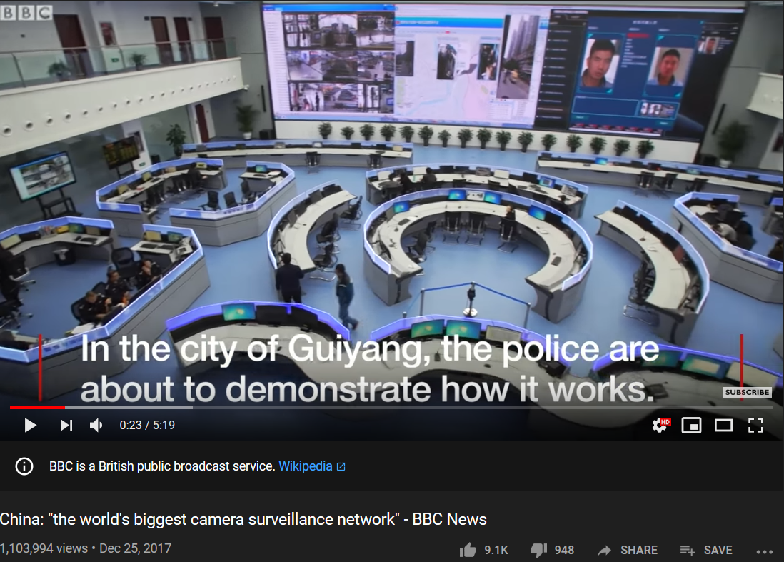
109 - Demolition Man - Would You Like To Have Sex? – SD
https://www.youtube.com/watch?v=67DN3uvwXkE
They also showed sex through virtual reality (VR) in the 1992 movie The Lawnmower Man. Even now people are putting on virtual reality headsets and meeting other people in places within the virtual world as they would in the real world. And they can even have a type of virtual sex, giving and receiving pleasure to the real bodies in the real world using special sex toys.
Right now you can put on a virtual reality headset and work on your computer from inside the virtual world. And with everything becoming digital, and robots taking over manual labor, how long before people start working through a virtual body – almost always plugged-in? How long before people start living through robots as displayed in the movie Surrogates? This next phase is already starting. There are also plans to stream VR games and environments into VR headsets or glasses from the cloud using 5G. And when VR really takes off people will be having business meetings, instructional classes on topics from cooking to math, dates, “vacations,” internet use, gambling, shopping, a more advanced “Face-time,” strip clubs, sports games, concerts, “meeting” celebrities, and more. Now, when considering all of that, it should be obvious that scores of people will be plugged-in for large portions of the day. VR is going to totally change this society. And once humans are bred outside of a human womb we’ll really be in The Matrix.
Read this excerpt from Facebook Buys Oculus, Virtual Reality Gaming Startup, For $2 Billion
Facebook isn't just buying into mobile messaging -- it's also going for gaming. In a Tuesday afternoon shocker, Facebook announced it is buying hot virtual reality gaming company Oculus VR for $2 billion.
...
“Mobile is the platform of today, and now we’re also getting ready for the platforms of tomorrow,” Zuckerberg said in a statement. “Oculus has the chance to create the most social platform ever, and change the way we work, play and communicate.”
...
In a Facebook post about the deal, Zuckerberg said Oculus "is really a new communication platform."
"After games, we're going to make Oculus a platform for many other experiences," he wrote. "Imagine enjoying a court side seat at a game, studying in a classroom of students and teachers all over the world or consulting with a doctor face-to-face -- just by putting on goggles in your home."
Source: https://www.forbes.com/sites/briansolomon/2014/03/25/facebook-buys-oculus-virtual-reality-gaming-startup-for-2-billion/#1be0be242498
“This is really a new communication platform. By feeling truly present, you can share unbounded spaces and experiences with the people in your life. Imagine sharing not just moments with your friends online, but entire experiences and adventures.
These are just some of the potential uses. By working with developers and partners across the industry, together we can build many more. One day, we believe this kind of immersive, augmented reality will become a part of daily life for billions of people.”
Source: https://www.facebook.com/zuck/posts/10101319050523971?stream_ref=1
Additional Information
Apple AR Glasses (2020) - The NEXT iPhone!
https://www.youtube.com/watch?v=7PG0EUTHUIg
Back to the Future Part 2 (5/12) Movie CLIP - The Future McFlys (1989) HD
https://www.youtube.com/watch?v=5ztwns5PkJY
12 Back to the Future 2 Predictions That Came True
https://www.youtube.com/watch?v=7bZk51itOZ0
NOSEDIVE (Black Mirror)
https://www.youtube.com/playlist?list=PLJk1a21GKEZXxT9wwmnVle-zautJw4q12
Solutions
Even though it’s probably too late for this, stop giving out your information in stores and online. Don’t link accounts or install apps on your phone. Drown the system with false information. Change your travel routes. Try not to leave any trace. Start leaving your cell phone at home. Stop upgrading technology (you’re being led into a trap while being milked for your cash); downgrade if you can. Seriously, it’s very important that you don’t upgrade (if you don’t move, they can’t move). Rebel against technology. And most of all, change your entire lifestyle to fit a pre-technological age as much as possible. Get a home phone and an answering machine. Never use Wi-Fi. Leave social media, especially Facebook, unless you use it for business or a purpose other than entertainment. And if you do, you should probably still leave Facebook (alternatives here and here; though a look at MeWe’s history, owner, and current complaints makes that a horrible choice). It’s a must that you leave Youtube now (alternatives here, here, here, and here), and don’t use Google search (alternatives here and here). If necessary, pay for an email service that’s more secure than the free services (possibilities here) and start communicating by email, or some other means besides these controlled platforms. Get people’s email addresses and create special contact folders for certain people in order to sort out the emails. Use electronic (email) mailing lists instead of social media. And you should go beyond all of this and go back to living from the land, being self-sufficient, not dependent on the System. Your goods and services, especially those that are needs, have to come from your community. It’s a must that you go back to a lifestyle similar to the Amish, or perish. You’re probably on your way to the simple life anyway by a blow or total collapse of the economy.
But even with all of this, do realize that the real problem will remain – the people behind all of this, their companies and their control. So, making the changes you see above, or others, is a needed started, but it’s not all that needs to be done. This seems to be the line in the sand.
Additional Information
110 - Don't Throw Big Tech in the Briar Patch!
https://www.youtube.com/watch?v=xoBgtfnsiSg
The Town That Made Its Own Internet
https://psmag.com/news/the-town-that-made-its-own-internet
Become Your Own Private ISP Today
https://www.whoishostingthis.com/blog/2015/03/09/start-your-own-isp/
Municipal Broadband Is Roadblocked Or Outlawed In 26 States
https://broadbandnow.com/report/municipal-broadband-roadblocks/
Comcast Tries To Stop Colorado City From Even Talking About Building Its Own Broadband Network
https://www.techdirt.com/articles/20171106/09481638554/comcast-tries-to-stop-colorado-city-even-talking-about-building-own-broadband-network.shtml
All Glory to Yahua (God) and Yahusha (Jesus)

Franklin Miller (Writeous1)
http://howmanyknow.com/
writeousservant@gmail.com
writeous1@howmanyknow.com
https://www.bitchute.com/channel/YhZAtGMGFLe1/
https://www.youtube.com/channel/UC6UWuuP9KUSYMIYU-nxmHNw

