Anti-Semitism?

*If a video becomes unavailable, search the internet by its title, and then filter your results by “videos”. Alternatively, you can search for the video here or here. If a link to a web page has been changed or is unavailable go here, enter the address in the box, press enter and then select a date.
If possible, download all files and this document, burn them to a disc, make copies, and distribute them. Use a website or browser plugin to download. Here are some sites (Watch out for popups. And never install anything.):
https://www.y2mate.com/en1/home
https://ddownr.com/
https://www.onlinevideoconverter.com/en/youtube-converter
*The video list starts on page 74. When you get to the videos, watch the videos in order like reading a book, even if it takes time like a book, and the overall picture will form. You will see.
----------------------------------------------------------------------------------------
- What is Anti-Semitism? - 2
- Israel’s Right To Exist - 9
- Holocaust Denier - 10
- It’s The Worst Atrocity In Human History - 12
- Who Are These People? - 14
- Who Are The Palestinians?- 37
- The Jewish DNA Evidence - 39
- The Samaritans - 63
- Jewish Racism And Supremacy VS. The Bible - 69
- Conclusion - 71
- Video List - 74
----------------------------------------------------------------------------------------

What Is Anti-Semitism?

Before you start, you should know some things about me. I’m not some white, racist neo-Nazi who hates blacks and Jews. I’m a black, American male who has views that are almost 100% like Martin Luther King. I don’t subscribe to the views of the Nation of Islam, and don’t even like the Nation of Islam. I don’t like racism from anyone. But I have done my research. And I’m going to state the truth without partiality.

When I searched for the definition of Anti-Semitism using Google, my first search result was the State Department’s definition of Anti-Semitism. And then, coming in at number two …
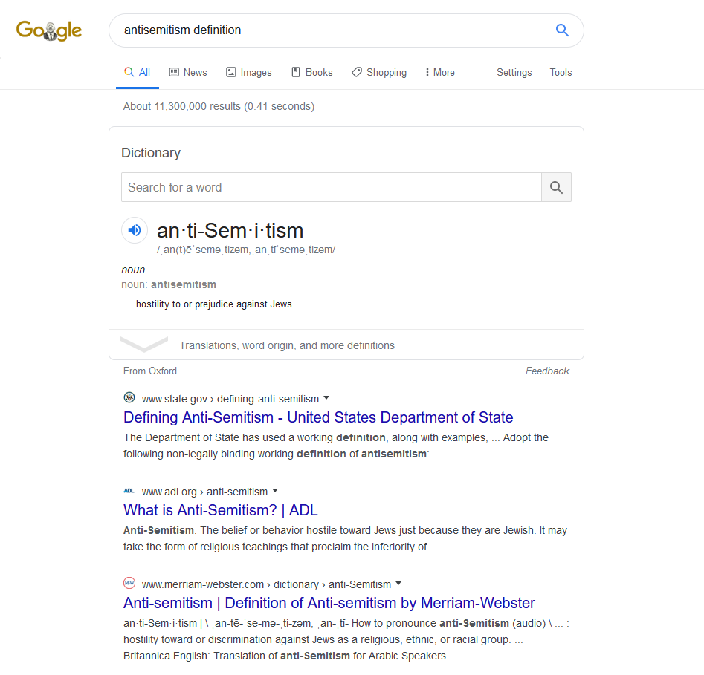
According to the State Department
On 26 May 2016, the Plenary in Bucharest decided to:
Adopt the following non-legally binding working definition of antisemitism:
“Antisemitism is a certain perception of Jews, which may be expressed as hatred toward Jews. Rhetorical and physical manifestations of antisemitism are directed toward Jewish or non-Jewish individuals and/or their property, toward Jewish community institutions and religious facilities.”
To guide IHRA in its work, the following examples may serve as illustrations:
Manifestations might include the targeting of the state of Israel, conceived as a Jewish collectivity. However, criticism of Israel similar to that leveled against any other country cannot be regarded as antisemitic. Antisemitism frequently charges Jews with conspiring to harm humanity, and it is often used to blame Jews for “why things go wrong.” It is expressed in speech, writing, visual forms and action, and employs sinister stereotypes and negative character traits.
Contemporary examples of antisemitism in public life, the media, schools, the workplace, and in the religious sphere could, taking into account the overall context, include, but are not limited to:
- Calling for, aiding, or justifying the killing or harming of Jews in the name of a radical ideology or an extremist view of religion.
- Making mendacious, dehumanizing, demonizing, or stereotypical allegations about Jews as such or the power of Jews as collective — such as, especially but not exclusively, the myth about a world Jewish conspiracy or of Jews controlling the media, economy, government or other societal institutions.
- Accusing Jews as a people of being responsible for real or imagined wrongdoing committed by a single Jewish person or group, or even for acts committed by non-Jews.
- Denying the fact, scope, mechanisms (e.g. gas chambers) or intentionality of the genocide of the Jewish people at the hands of National Socialist Germany and its supporters and accomplices during World War II (the Holocaust
- Accusing the Jews as a people, or Israel as a state, of inventing or exaggerating the Holocaust.
- Accusing Jewish citizens of being more loyal to Israel, or to the alleged priorities of Jews worldwide, than to the interests of their own nations.
- Denying the Jewish people their right to self-determination, e.g., by claiming that the existence of a State of Israel is a racist endeavor.
- Applying double standards by requiring of it a behavior not expected or demanded of any other democratic nation.
- Using the symbols and images associated with classic antisemitism (e.g., claims of Jews killing Jesus or blood libel) to characterize Israel or Israelis.
- Drawing comparisons of contemporary Israeli policy to that of the Nazis.
- Holding Jews collectively responsible for actions of the state of Israel.
Antisemitic acts are criminal when they are so defined by law (for example, denial of the Holocaust or distribution of antisemitic materials in some countries).
Criminal acts are antisemitic when the targets of attacks, whether they are people or property – such as buildings, schools, places of worship and cemeteries – are selected because they are, or are perceived to be, Jewish or linked to Jews.
Antisemitic discrimination is the denial to Jews of opportunities or services available to others and is illegal in many countries.
Source: https://www.state.gov/defining-anti-semitism/
Maybe you don’t understand. That is coming from the government, those who create and enforce the laws of the land. That’s beyond disturbing. But it makes since when you know who controls the US government, something you’ll definitely find out in the videos (particularly Banking on Anti-Semitism). You’ll also find out, if you don’t already know, that what you just read is an attempt to cover up the truth.

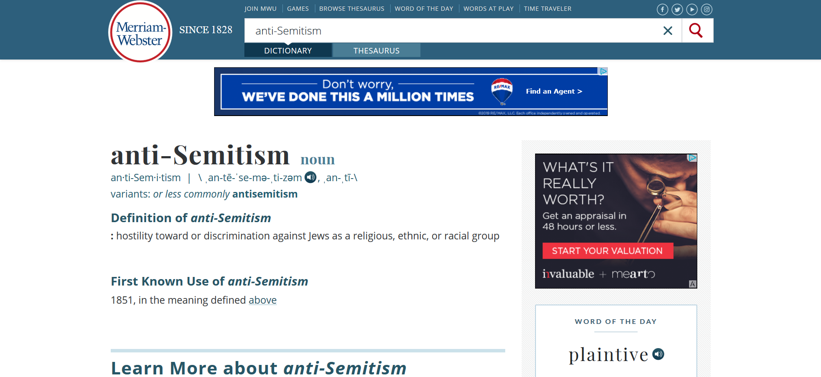
Source: https://www.merriam-webster.com/dictionary/anti-Semitism

Now replace “Jews” with “whites” or “blacks”. Do you as a white person have a term that is made specifically for you? How about you as a black person? All of these years of racism against blacks, and there’s no special name for it? And what do you call the huge smear campaign/brainwashing campaign against Christianity that has taken place (coming from all of mass media)? So, you can be anti-Christian but not anti-Jewish?
And according to this source the first known use was in 1851! That can’t be right, not with what we hear about anti-Semitism.
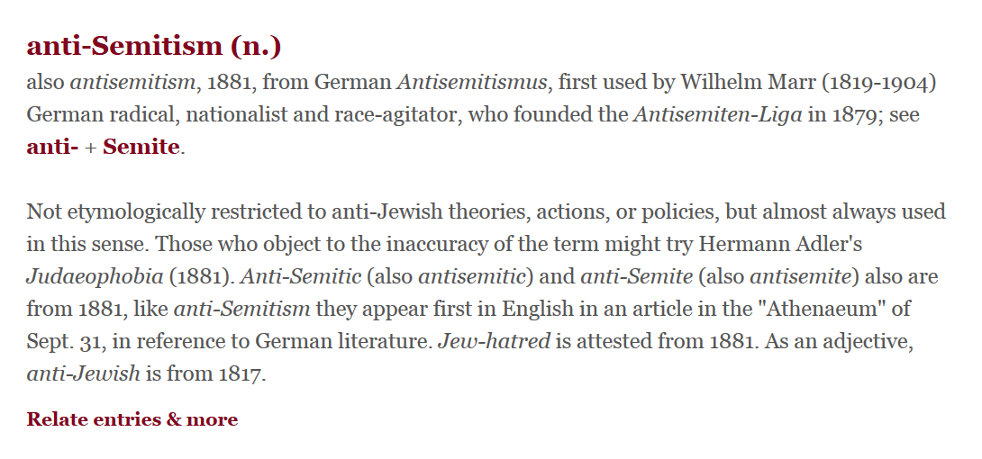
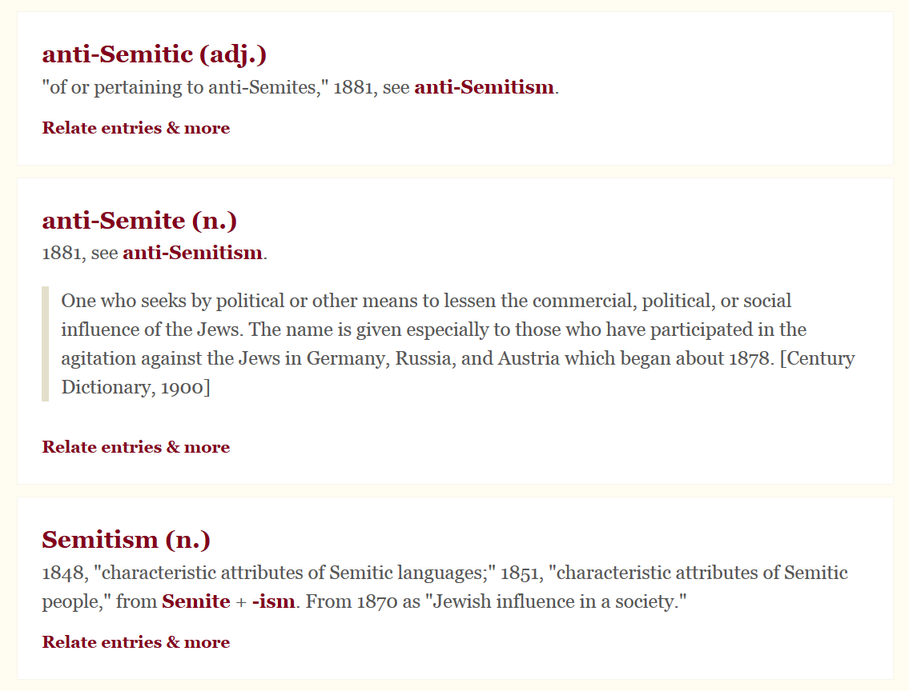
Source: https://www.etymonline.com/search?q=anti-semitism&ref=searchbar_searchhint
ANTI-SEMITISM. In the political struggles of the concluding quarter of the 19th century an important part was played by a religious, political and social agitation against the Jews, known as “Anti-Semitism.” The origins of this remarkable movement already threaten to become obscured by legend. The Jews contend that anti-Semitism is a mere atavistic revival of the Jew-hatred of the middle ages. The extreme section of the anti-Semites, who have given the movement its quasi-scientific name, declare that it is a racial struggle—an incident of the eternal conflict between Europe and Asia—and that the anti-Semites are engaged in an effort to prevent what is called the Aryan race from being subjugated by a Semitic immigration, and to save Aryan ideals from being modified by an alien and demoralizing oriental Anschauung. There is no essential foundation for either of these contentions. Religious prejudices reaching back to the dawn of history have been reawakened by the anti-Semitic agitation, but they did not originate it, and they have not entirely controlled it. The alleged racial divergence is, too, only a linguistic hypothesis on the physical evidence of which anthropologists are not agreed (Topinard, Anthropologie, p. 444; Taylor, Origins of Aryans, cap. i.), and, even if it were proved, it has existed in Europe for so many centuries, and so many ethnic modifications have occurred on both sides, that it cannot be accepted as a practical issue. It is true that the ethnographical histories of the Jews and the nations of Europe have proceeded on widely diverging lines, but these lines have more than once crossed each other and become interlaced. Thus Aryan elements are at the beginning of both; European morals have been ineradicably semitized by Christianity, and the Jews have been Europeans for over a thousand years, during which their character has been modified and in some respects transformed by the ecclesiastical and civil polities of the nations among whom they have made their permanent home. Anti-Semitism is then exclusively a question of European politics, and its origin is to be found, not in the long struggle between Europe and Asia, or between the Church and the Synagogue, which filled so much of ancient and medieval history, but in the social conditions resulting from the emancipation of the Jews in the middle of the 19th century.
Source: 1911 Encyclopædia Britannica/Anti-Semitism
https://en.wikisource.org/wiki/1911_Encyclop%C3%A6dia_Britannica/Anti-Semitism
Hatred and discrimination against someone because their skin is “black” goes back to when? The 5th century? How about the Jewish fatal attraction to black people? You can definitely date that back to the mid 1400’s for sure. And it has definitely been nonstop since then. Now, compare that to the 1800’s.
Major steps towards world domination had already been taken by people within the Jewish community in the 15th century, and have been ongoing since. This means that after this time Jews would have been doing, and were doing evil, underhanded things in one country after another. This would have led to distrust and a bad reputation. And what about the other practices? What about human sacrifice and the overt disrespect of the religion of the people whose lands they were in? And what were the Rothschilds and other Jews doing in the 1700’s and 1800’s before this term anti-Semitism was created? So, for a fact, a history of consistent wickedness coming from many members of this very small group of people the size of a secret society preceded the creation of this term.
If I had a group that was similar to a secret society, and every country we went to many people of my group, which made up a very small percentage of the country, intentionally did whatever they could to gain control of certain positions of power so that we could work together for our own goals; and this destroyed certain aspects of that country in the process, what would be the consequences if our plans were uncovered? You don’t think the news, the warnings, would spread to other countries as well? What would be the consequences then? I wonder if we would be kicked out of one nation after another. “You’re persecuting us.” If I’m trying to kill you and your family, or enslave you and your family, and you say anything about me or what I’m doing or trying to do, you’re a bigoted anti-me-ist. You’re just jealous of what I have gained from my killing and enslavement spree.
A white person harms a black person, and as a result that black person dislikes that white person and all white people. A black person harms a white person, and as a result that white person dislikes that black person and all black people. The perceived injustice of one person of a group, up to all of the people of a group, can be, and will be, taken as all of those people by some people outside of that group. We’ve seen this throughout history. But if the victimizer is Jewish….
It’s okay to not like black people. It’s okay to not like white people. But to not like Jewish people, that’s anti-Semitic, and that’s illegal.
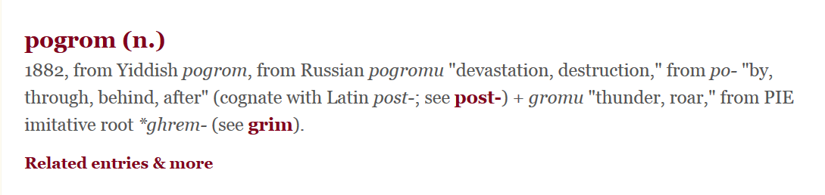
Source: https://www.etymonline.com/search?q=pogrom
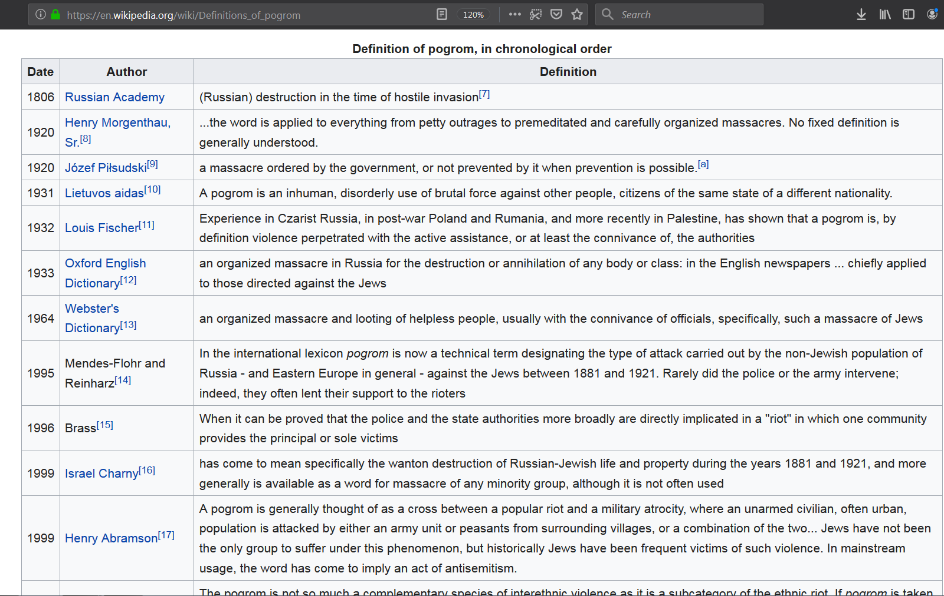

Israel’s Right To Exist
Look closely at the deceptive words and statements they choose. “Israel’s right to exist.” That’s how you would speak of a person, and that person living or dying, correct? There are many other ways this could have been stated, but this was intentionally chosen to scare people away from being the type of person who has the views they label as “denying Israel the right to exist.” It lessens the likelihood of people having those views because it’s like, according to them, you’re saying you want them to die.
If someone broke into your home and started living there, and then you wanted them out, that’s denying their right to exist. What, you didn’t know that? If law enforcement or the judicial system believed the occupation was unlawful, so what! That’s denying that invader’s right to exist. If your neighbor disagrees with what happened so started protesting, then they would be wrong. They would be denying that invader’s right to exist. So, how about this? How about we go occupy government buildings? How about we take the governmental powers back, especially since it’s lawfully ours? And any person, group, country or political body that interferes, especially the UN, will be denying our right to exist.
Holocaust Denier
This is the same trickery used with global warming/climate change. They say that anyone denying any aspect of the global warming/climate change “fact” is denying global warming/climate change, and everyone knows there’s global warming/climate change. Everyone knows the holocaust occurred.
“I don’t believe any Jews died in gas chambers.”
“You’re a holocaust denier!”
“I believe somewhere around 10,000 Jews died in gas chambers.”
“You’re a holocaust denier!”
“I don’t believe 6 million Jews died in the holocaust.”
“You’re a holocaust denier!”
Take a look at this:
Lets stop with the Auschwitz lies
https://rense.com/lets_stop_with_the_auschwitz_lies.htm.html
The Auschwitz Swimming Pool
http://heretical.com/miscella/swimpool.html
“Holocaust denier!”
Straw man
A straw man is a form of argument and an informal fallacy based on giving the impression of refuting an opponent's argument, while actually refuting an argument that was not presented by that opponent.^{[1]} One who engages in this fallacy is said to be "attacking a straw man".
The typical straw man argument creates the illusion of having completely refuted or defeated an opponent's proposition through the covert replacement of it with a different proposition (i.e., "stand up a straw man") and the subsequent refutation of that false argument ("knock down a straw man") instead of the opponent's proposition.^{[2][3]} Straw man arguments have been used throughout history in polemical debate, particularly regarding highly charged emotional subjects.
…

Structure
The straw man fallacy occurs in the following pattern of argument:
- Person 1 asserts proposition X.
- Person 2 argues against a superficially similar proposition Y, falsely, as if an argument against Y were an argument against X.
This reasoning is a fallacy of relevance: it fails to address the proposition in question by misrepresenting the opposing position.
For example:
- Quoting an opponent's words out of context—i.e., choosing quotations that misrepresent the opponent's intentions (see fallacy of quoting out of context).^{[3]}
- Presenting someone who defends a position poorly as the defender, then denying that person's arguments—thus giving the appearance that every upholder of that position (and thus the position itself) has been defeated.^{[2]}
- Oversimplifying an opponent's argument, then attacking this oversimplified version.
- Exaggerating (sometimes grossly exaggerating) an opponent's argument, then attacking this exaggerated version.

Examples
Straw man arguments often arise in public debates such as a (hypothetical) prohibition debate:
- A: We should relax the laws on beer.
- B: No, any society with unrestricted access to intoxicants loses its work ethic and goes only for immediate gratification.
The original proposal was to relax laws on beer. Person B has misconstrued/misrepresented this proposal by responding to it as if it had been something like "(we should have) unrestricted access to intoxicants." It is a logical fallacy because Person A never advocated allowing said unrestricted access to intoxicants (this is also a slippery slope argument).
Source: https://en.wikipedia.org/wiki/Straw_man
Also see:
https://en.wikipedia.org/wiki/Propaganda_techniques
And even if you did deny that the holocaust ever took place, so what! It’s a crime for you to personally believe the holocaust never happened? Do you realize how crazy that is?
It’s The Worst Atrocity In Human History
Let’s take a look at one of many others.
“Leopold's administration of the Congo was characterised by murder, torture, and atrocities, resulting from notorious systematic brutality. The hands of men, women, and children were amputated when the quota of rubber was not met. These and other facts were established at the time by eyewitness testimony and on-site inspection by an international Commission of Inquiry (1904). Millions of the Congolese people died: modern estimates range from 1 million to 15 million deaths, with a consensus growing around 10 million. Some historians argue against this figure, citing the absence of reliable censuses, the enormous mortality of diseases such as smallpox or sleeping sickness, and the fact that there were only 175 administrative agents in charge of rubber exploitation.^{[1][2]} In 1908, the reports of deaths and abuse induced the Belgian government to take over the administration of the Congo from Leopold.”
Source: https://en.wikipedia.org/wiki/Leopold_II_of_Belgium
“He turned his ‘Congo Free State’ into a massive labour camp, made a fortune for himself from the harvest of its wild rubber, and contributed in a large way to the death of perhaps 10 million innocent people.”
Source: http://news.bbc.co.uk/2/hi/africa/3516965.stm
Soooo … where are the movies? Where is this in the history books? And what do they think they’re doing arguing over the number of deaths. You can’t do that! That’s denial.
Take a look at the following article. You may be able to spot some interesting things.
https://en.wikipedia.org/wiki/List_of_genocides_by_death_toll

Definition of genocide
Article 2 of the Convention defines genocide as
... any of the following acts committed with intent to destroy, in whole or in part, a national, ethnical, racial or religious group, as such:
(a) Killing members of the group;
(b) Causing serious bodily or mental harm to members of the group;
(c) Deliberately inflicting on the group conditions of life calculated to bring about its physical destruction in whole or in part;
(d) Imposing measures intended to prevent births within the group;
(e) Forcibly transferring children of the group to another group.
— Convention on the Prevention and Punishment of the Crime of Genocide, Article 2^{[4]}
Article 3 defines the crimes that can be punished under the convention:
(a) Genocide;
(b) Conspiracy to commit genocide;
(c) Direct and public incitement to commit genocide;
(d) Attempt to commit genocide;
(e) Complicity in genocide.
— Convention on the Prevention and Punishment of the Crime of Genocide, Article 3^{[4]}
The convention was passed to outlaw actions similar to the Holocaust by Nazi Germany during World War II.
Source: https://en.wikipedia.org/wiki/Genocide_Convention#Definition_of_genocide
Using history as proof, that definition has several hidden exceptions: Unless the victims are non-Jewish whites, blacks or Christians. And unless the victimizer is Jewish, a Freemason, a Luciferian, the FBI, CIA, banks, corporations, or anyone or anything the Elite doesn’t want to receive punishment.
Here, the Holocaust is also number 1:
https://www.worldatlas.com/articles/most-horrific-genocides-in-human-history.html

Who Are These People?
This is not the time or place to present all of the evidence proving their origins, or that they’re not descendants of the Biblical Israelites, so I won’t be doing that. I will, however, give you the basics along with some of the proof.
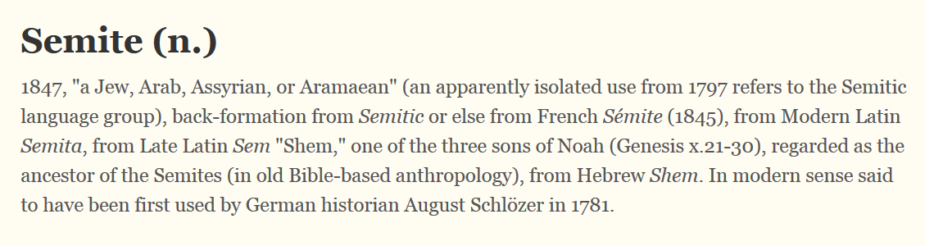
Source: https://www.etymonline.com/word/Semite?ref=etymonline_crossreference
“Responding to Behar's question whether or not she considered herself to be anti-Semitic, Thomas said: ‘Hell no! I'm a Semite of Arab background,’ and saying of the Jews: ‘They're not Semites. I mean, most of them are from Europe.’”
Source: https://www.haaretz.com/jewish/1.5124590
“The Ashkenazim are Jews who settled in Central and Eastern Europe, probably about a millennium ago. Their 13 million descendants, about 80% of the global Jewry, now live everywhere. About eight million live in the U.S., about 2 percent of the country’s population.”
Source: https://geneticliteracyproject.org/2014/09/23/are-modern-jews-converted-khazarian-pagans-more-evidence-of-middle-eastern-roots/?relatedposts_hit=1&relatedposts_origin=228249&relatedposts_position=0
In today’s controlled world of academia there are only two theories on the origin of European Jews that are truly considered to be credible, the Rhineland Hypothesis and the Khazarian Hypothesis.
“The Rhineland Hypothesis has been the favoured explanation for the origins of present-day European Jews, until now. In this scenario Jews descended from Israelite-Canaanite tribes left the Holy Land for Europe in the 7th century, following the Muslim conquest of Palestine. Then, in the beginning of the 15th century, a group of approximately 50,000 left Germany, the Rhineland, for the east. There they maintained high endogamy, and despite wars, persecution, disease, plagues, and economic hardships, their population expanded rapidly to around 8 million in the 20th century. Due to the implausibility of such an event, this rapid expansion was explained by Prof Harry Ostrer, Dr Gil Atzmon, and colleagues as a miracle. Under the Rhineland Hypothesis, European Jews would be very similar to each other and would have a predominant Middle Eastern ancestry.
The rival explanation, the Khazarian Hypothesis, states that the Jewish-convert Khazars -- a confederation of Turkic, Iranian, and Mongol tribes who lived in what is now Southern Russia, north of Georgia and east of Ukraine, and who converted to Judaism between the 7th and 9th centuries -- along with groups of Mesopotamian and Greco-Roman Jews, formed the basis of eastern Europe's Jewish population when they fled eastward, following the collapse of their empire in the 13th century. European Jews are thus expected to exhibit heterogeneity between different communities. While there is no doubt that the Judeo-Khazars fled into Eastern Europe and contributed to the establishment of Eastern European Jewry, argument has revolved around the magnitude of that contribution.”
Source: https://www.sciencedaily.com/releases/2013/01/130116195333.htm
The education system and mass media told a very different story. They told a tale of Jews going into Europe in the 1st century CE after the destruction of Jerusalem. The belief that they were Jews was built upon that theory.
From 50, 000 to 8 million in 500 years is a miracle, and it’s accepted as such?
Who controls this system which upholds these two theories? What about the other theories?
If you look through the New Testament and history you’ll see that there was a clear distinction between Jews/Israelites and Europeans/Greeks/Romans. They are clearly identified as being from totally different groups of people. And if you look at the book of Acts and history, you will see that there were European converts to Judaism throughout Europe in the 1st century. Questions: What happened to all those European converts, people who we can assume looked 100% European like the European Jews? Where are their descendants today? Where are their descendants in history? Where are the descendants of the Khazars and anyone they might have converted? Where are the descendants of the people converted by the Radhanite Jews? Where are the descendants of the people who were converted to Judaism by the 1st and 2nd century CE Israelites who wanted to combat Christianity? And the European Jews today look 100% European, and not mixed at all, right? That alone should be a red flag. And don’t worry; you’ll see information on DNA later.
The people being called Jews today are not descendants of the Israelites of the Bible. Nearly the entire Jewish community is made up of converts from around the world, with some people having the blood/genes of the original fake Jews, the Edomite-Nebataeans.
*Don’t let my use of Wikipedia for general information deter you.
Antipater the Idumaean
Antipater I the Idumaean (died 43 BC) was the founder of the Herodian Dynasty and father of Herod the Great. According to Josephus, he was the son of Antipas (I) and had formerly held that name.^{[1]}
A native of Idumaea, southeast of Judea between the Dead Sea and the Gulf of Aqaba, which during the time of the Hebrew Bible had been known as the land of Edom,^{[2]} Antipater became a powerful official under the later Hasmonean kings and subsequently became a client of the Roman general Pompey the Great when Pompey conquered Judea in the name of Roman Republic.
…
Background
Though historians understand that Antipater’s family converted to Judaism in the second century BCE, different stories had circulated in the wake of his sons coming to power.^{[3]} They demonstrate the tensions that existed between the Jewish people and the powerful Idumaeans who appear at this time. Nicolaus of Damascus, the court historian for Herod, wrote that Herod’s ancestors were among the historical elite in Jerusalem who had been taken by King Nebuchadnezzar into Babylonian captivity in the sixth century BCE.^{[4]} This account serves two purposes; when the Persian King Cyrus sent the captives in Babylon back to Judea, it is likely that some chose to settle elsewhere. A legitimate dispersion such as this would shroud the fact that Herod’s ancestry is undocumented in the meticulous records of returned Jewish families.^{[5]} Claiming a heritage among the Jews from as early as the Babylonian captivity provides credibility for a pro-Roman and Hellenized Herod as a King over the Jews, for they were highly contemptuous of him.^{[6]} Josephus explains this rendering by critiquing its author: Nicolaus wrote to please Herod and would do so at the cost of truthfulness.^{[7]}
Instead Josephus explains that Antipater's family converted to Judaism during the forced conversions by the Sadducee-influenced Hasmonean leader John Hyrcanus. Hyrcanus threatened that any Idumeaan who wished to maintain their land would need to be circumcised and enter into the traditions of the Jews.^{[8]} Forcible conversion was not recognized by the dominant Pharisaic tradition, so even though Antipater and Herod the Great may have considered themselves of the Jewish faith, they were not considered Jewish by the observant and nationalist Jews of Judea.^{[6]} This influential family was resented for their Edomite ancestry, their Hellenistic incursions upon Jewish tradition, and their collusion with the Roman invaders.
Antipater married Cypros, a Nabataean noblewoman, which helped endear the Nabateans to him.^{[9]} Their marriage helped bring about a close friendship between him and the King of the Arabia, Aretas, to whom Cypros was related. The two men had such a relationship that Antipater entrusted his children to his friend when he went to war with the Hasmonean Aristobulus II. They had four sons: Phasael, Herod, Joseph, and Pheroras, and a daughter, Salome, one of several Salomes among the Herodians.^{[10]} Antipater also had a brother named Phalion, who was killed in battle against Aristobulus at Papyron.^{[11]}
Antipater served as a governor of Idumea under King Alexander Jannaeus and Queen Salome Alexandra, the parents of the feuding heirs.^{[1]} Josephus writes that he was a man of great authority among the Idumeans, both wealthy and born into a dignified family.^{[12]} Indeed it is clear in the various forms of assistance that Antipater provides to both Hyrcanus II, brother of Aristobulus, and the Romans, that he possessed great resources, and brilliant military and political capabilities.^{[13]}
At the Hasmonean court
Antipater laid the foundation for Herod's ascension to the throne of Judea partly through his activities in the court of the Hasmoneans, the heirs of the Maccabees, who were the hereditary leaders of the Jews, and partly by currying favor with the Romans, who were growing more involved and dominant over the region at this time.
Soon after Hyrcanus succeeded his widowed mother as ruler and took the office of the high priest, he was immediately attacked by his brother and surrendered. Hyrcanus agreed to retire from public life.^{[14]} Antipater, who seems to have succeeded his father as governor of Idumæa, had reason to fear that King Aristobulus would not retain him in this position.^{[1]}
Antipater was known as a seditious and trouble-making man, and he exploited the weak-willed Hyrcanus for the sake of his ambition.^{[15]} After Hyrcanus stepped down, Antipater persuaded him to contend against his brother for his rightful position, and even convinced the unsuspecting and reluctant Hyrcanus that his younger brother intended to kill him.^{[16]} He arranged for Hyrcanus to come under the protection of the Arabian King Aretas III in Petra. Together they attacked Aristobulus in Jerusalem, and there was a great upheaval that drew the attention of the Roman magistrate Pompey assigned to the eastern Mediterranean province.^{[17]}
Although Pompey and his lieutenant Scaurus initially ruled in Aristobulus’ favor when the brothers brought their case forward, on the third intervention Pompey ordered the brothers to wait. Aristobulus impatiently provoked a political offense that brought Pompey to appoint Hyrcanus the ethnarch of Judea.^{[18]}
Hyrcanus proved ineffective as either an administrator, or more importantly, as tax collector. Antipater was able to insinuate himself into a position of influence, and soon exercised the authority that ostensibly belonged to Hyrcanus as high priest.^{[19]} Antipater recognized Rome's growing dominance in the region and exploited it to his advantage. Due his loyalty to Rome and reliability as a statesman, he was placed in charge of Judea, with responsibilities and privileges that included mediating civil disturbance and tax collecting.^{[20]}
Roman Procurator and appointments of sons
With Hyrcanus established, Antipater thrived and laid the foundation for his family’s success by navigating conflicts of loyalty and power-shifting within the Roman elite. When Julius Caesar and Pompey went to battle in Egypt, Pompey was killed, so Antipater in 47 BCE shifted his allegiance to Caesar, and indeed ingratiated himself with Caesar. While Caesar was besieged in Alexandria, Antipater rescued him with three thousand men and the aid of numerous nearby friends. For his “demonstrations of valor” Caesar elevated Antipater to Roman citizenry, freed him from taxes, and showered him with honors and declarations of friendship.^{[21]}
Later when accused by Aristobulus’ son, Antigonus, who returns from Roman bondage to contest for power, Antipater made a great scene of his scars from fighting for Caesar’s life in Egypt. He defended himself with a history of unfailing loyalty to the Romans.^{[22]} This appeal persuaded Caesar who then appointed Antipater the first Roman Procurator of Judea.^{[23]} This amity allowed the Jews a special degree of protection and freedom to govern themselves and enjoy Rome’s good will.^{[24]} Josephus notes that with his newfound rights and honors, Antipater immediately began to rebuild the wall of Jerusalem that Pompey had destroyed when subduing Aristobulus.^{[25]} He established order by tempering civil disturbances in Judea and threatening to become a “severe master instead of a gentle governor” should the people grow seditious and unruly. Matters in Judea were finally calm for a time.^{[26]}
At this time came the defining point in Antipater's legacy, whereby he made his son, Phasael, governor of Jerusalem, and Herod the governor of Galilee, to the north of Samaria between the Sea of Galilee and Mediterranean. Herod quickly set about ridding Galilee of what his court historian calls "robbers", although they may also have been people resisting Roman rule. His activities eventually resulted in complaints raised with the Sanhedrin.^{[19]}
…
Antipater’s work as power-broker between the Hasmoneans, the Arabians, and the Romans inaugurated dramatic dynamics and steep changes in the history of the Jewish nation. The diplomacy and artful politics of Antipater produced the Herodian dynasty; he paved the way for the rise of his son Herod the Great, who married the Hasmonean princess Mariamne,^{[33]} endeared himself to Rome, and usurped the Judean throne to become king of Judea under Roman influence.
Source: http://en.wikipedia.org/wiki/Antipater_the_Idumaean
“Forcible conversion was not recognized by the dominant Pharisaic tradition, so even though Antipater and Herod the Great may have considered themselves of the Jewish faith, they were not considered Jewish by the observant and nationalist Jews of Judea. This influential family was resented for their Edomite ancestry, their Hellenistic incursions upon Jewish tradition, and their collusion with the Roman invaders.”

Herod the Great

Herod (/ˈhɛrəd/; Hebrew: הוֹרְדוֹס‎, Hordos, Greek: Ἡρῴδης, Hērōdēs; 74/73 BCE – 4 BCE),^{[1][2][3][4][5]} also known as Herod the Great and Herod I, was a Roman client king of Judea,^{[6][7][8]} referred to as the Herodian kingdom. He has been described as "a madman who murdered his own family and a great many rabbis",^{[9]} "the evil genius of the Judean nation",^{[10]} "prepared to commit any crime in order to gratify his unbounded ambition"^{[11]} and "the greatest builder in Jewish history".^{[9]} He is known for his colossal building projects throughout Judea, including his expansion of the Second Temple in Jerusalem (Herod's Temple), the construction of the port at Caesarea Maritima, the fortress at Masada and Herodium. Vital details of his life are recorded in the works of the 1st century CE Roman–Jewish historian Josephus.
Upon Herod's death, the Romans divided his kingdom among three of his sons—Archelaus became ethnarch of the tetrarchy of Judea, Herod Antipas became tetrarch of Galilee and Peraea, and Philip became tetrarch of territories east of the Jordan.
Biography
Herod was of Arab (Nabatean) and Edomite descent, whose ancestors converted to Judaism. Herod was ashamed of his origins and he attempted to invent Jewish genealogy for himself.^{[12][13][14][15]} Herod was born around 74 BCE in Idumea, south of Judea.^{[16][17]} He was the second son of Antipater the Idumaean, a high-ranked official under ethnarch Hyrcanus II, and Cypros, a Nabatean. He was raised as a Jew^{[18][19]} A loyal supporter of Hyrcanus II, Antipater appointed Herod governor of Galilee at 25, and his elder brother, Phasael, governor of Jerusalem. He enjoyed the backing of Rome but his brutality was condemned by the Sanhedrin.^{[20]}
Two years later Antigonus, Hyrcanus' nephew, took the throne from his uncle with the help of the Parthians. Herod fled to Rome to plead with the Romans to restore him to power. (The Roman general Pompey the Great had conquered Jerusalem in 63 BC). There he was appointed King of the Jews by the Roman Senate.^{[21]} Josephus puts this in the year of the consulship of Calvinus and Pollio (40 BCE), but Appian places it in 39 BCE.^{[17]} Herod went back to Judea to win his kingdom from Antigonus and at the same time he married the teenage niece of Antigonus, Mariamne (known as Mariamne I), in an attempt to secure a claim to the throne and gain some Jewish favor. However, Herod already had a wife, Doris, and a three-year-old son, Antipater, and chose therefore to banish Doris and her child.
Three years later, Herod and the Romans finally captured Jerusalem and executed Antigonus. Herod took the role as sole ruler of Judea and the title of basileus (Βασιλεύς, "king") for himself, ushering in the Herodian Dynasty and ending the Hasmonean Dynasty. Josephus reports this as being in the year of the consulship of Agrippa and Gallus (37 BCE), but also says that it was exactly 27 years after Jerusalem fell to Pompey, which would indicate 36 BCE. Cassius Dio also reports that in 37 "the Romans accomplished nothing worthy of note" in the area.^{[22]} According to Josephus, Herod ruled for 37 years, 34 of them after capturing Jerusalem.
As Herod's family were converts to Judaism, his religious commitment was questioned by some elements of Jewish society.^{[23]} When John Hyrcanus conquered the region of Idumaea (the Edom of the Hebrew Bible) in 140–130 BCE, he required all Idumaeans to obey Jewish law or to leave; most Idumaeans thus converted to Judaism, which meant that they had to be circumcised,^{[24]} and many had intermarried with the Jews and adopted their customs.^{[25]} While Herod publicly identified himself as a Jew and was considered as such by some,^{[26]} this religious identification was undermined by the decadent lifestyle of the Herodians, which would have earned them the antipathy of observant Jews.^{[27]}
Herod later executed several members of his own family, including his wife Mariamne I.^{[28]}
Reign in Judea
Herod’s rule marked a new beginning in the history of Judea. Judea had been under the rule of the Hasmonean dynasty from 140 BCE until 63 BCE; Herod overthrew the Hasmonean Antigonus and established the Herodian Dynasty, ruling until his death in 4 BCE.
Herod was granted the title of "King of Judea" by the Roman Senate,^{[29]} as such he was a vassal of the Roman Empire, expected to support the interests of his Roman patrons. Not long after he assumed control of Judea, Herod needed to show his worthiness as king of Judea to the new emperor, Augustus (who was known as Octavian), after he showed support for Augustus’ opponent Mark Antony. Herod was able to win the support of Augustus and continue to rule his people as he saw fit. Despite the freedom afforded to Herod in his reign over Judea, restrictions were placed upon him in his dealings with other kingdoms.^{[30]}
Herod’s support from the Roman Empire played a major role in allowing him to maintain his authority over Judea. There have been mixed interpretations concerning Herod’s popularity during his reign. In The Jewish War, Josephus characterizes Herod’s rule generally in favorable terms, and gives Herod the benefit of the doubt for the infamous events that took place during his reign. However, in his later work, Jewish Antiquities, Josephus emphasizes the tyrannical authority that many scholars have come to associate with Herod’s reign.^{[31]}
Herod’s tyrannical authority has been demonstrated by many of his security measures aimed at suppressing the contempt his people, especially Jews, had towards him. For instance, it has been suggested that Herod used secret police to monitor and report the feelings of the general populace towards him. He sought to prohibit protests, and had opponents taken away by force.^{[31]} He had a bodyguard of 2,000 soldiers.^{[32]} Josephus describes various units of Herod's personal guard taking part in Herod's funeral, including the Doryphnoroi, and a Thracian, Celtic (probably Gallic) and Germanic contingent.^{[32]} While the term Doryphnoroi does not have an ethnic connotation, the unit was probably composed of distinguished veteran soldiers and young men from the most influential Jewish families.^{[32]} Thracians had served in the Jewish armies since the Hasmonean dynasty, while the Celtic contingent were former bodyguards of Cleopatra given as a gift by Augustus to Herod following the Battle of Actium.^{[32]} The Germanic contingent was modeled upon Augustus's personal bodyguard, the Germani Corporis Custodes, responsible for guarding the palace.^{[32]}
Herod spent lavish sums on his various building projects and generous gifts to other kingdoms, including Rome. His buildings were very large, ambitious projects. Herod was responsible for the construction of the Temple Mount, a portion of which remains today as the Western Wall. In addition, Herod also built the harbor at Caesarea. While Herod's zeal for building transformed Judea, his motives were far from selfless. All these vast projects were aimed at gaining the support of the Jews and improving his reputation as a leader.^{[33]} However, in order to fund these expenses, Herod utilized a Hasmonean taxation system that weighed heavily on the people of Judea. Despite the burden paying for Herod’s building projects and gifts caused, the employment they created also created opportunities for people to provide for themselves and their families.^{[34]} In some instances, Herod took it upon himself to provide for his people during times of need, such as during a severe famine that occurred in 25 BCE.^{[35]}
In regards to religious policies, Herod experienced a mixed response from the Jewish populace. Although Herod considered himself king of the Jews, he let it be known that he also represented the non-Jews living in Judea, building temples for other religions outside of the Jewish areas of his kingdom. Many Jews questioned whether he was truly Jewish due to his Idumean background and the infamous murders he committed against members of his family. However, he generally respected traditional Jewish observances in his public life. For instance, he minted coins without human images to be used in Jewish areas and acknowledged the sanctity of the Second Temple by employing priests in the construction of the Temple.^{[36]}
Despite some of Herod’s attempts at conforming to traditional Jewish laws, there were many instances where Herod was insensitive to these laws. As highlighted in Jewish Antiquities, one of the major complaints from Jews towards Herod was exactly this. In Jerusalem, he introduced foreign forms of entertainment, and had a golden eagle erected at the entrance of the Temple, suggesting he did not truly represent the interests of the Jewish populace.^{[34]} The taxes Herod put in place earned him a bad reputation as well. Because of his constant concern for his reputation, Herod often donated expensive gifts, spending large amounts of money. Herod’s leadership methods upset the Jews because they were forced to pay for his lavish spending.^{[33]} The two major Jewish sects during his reign, the Pharisees and the Sadducees, also showed opposition to Herod. The Pharisees were angry with Herod because he disregarded many of the demands they made for the construction of the Temple. Simultaneously, the Sadducees, who were known for their priestly responsibilities in the Temple, were opposed to Herod because he replaced the high priests with priests from Babylonia and Alexandria (in an attempt to gain support from Jews in the diaspora).^{[37]} Unfortunately for Herod, his efforts did not satisfy his intentions. At the end of Herod’s reign, anger and dissatisfaction were common feelings amongst the Jews. Heavy outbreaks of violence (such as riots) followed Herod’s death, in many cities including Jerusalem. All the grievances the Jews had toward Herod's actions during his reign, such as heavy taxes and violating the rules, built up during the years before he died. Because of the treatment the Jews were receiving, they were ready to break free from Roman Rule. Herod’s leadership sparked such anger, that eventually it became one of the causes driving the Great Revolt of 70 C.E.^{[33]}
…
New Testament references
Herod appears in the Gospel according to Matthew (2:1-23), which describes an event known as the Massacre of the Innocents. According to this account, after the birth of Jesus, "wise men from the East" visited Herod to inquire the whereabouts of "the one having been born king of the Jews", because they had seen his star in the east and therefore wanted to pay him homage. Herod, as King of the Jews, was alarmed at the prospect of a usurper. Herod assembled the chief priests and scribes of the people and asked them where the "Anointed One" (the Messiah, Greek: Ο Χριστός (ho christos)) was to be born. They answered, in Bethlehem, citing Micah 5:2. Herod therefore sent the "wise men" to Bethlehem, instructing them to search for the child and, after they had found him, to "report to me, so that I too may go and worship him". However, after they had found Jesus, the Magi were warned in a dream not to report back to Herod. Similarly, Joseph was warned in a dream that Herod intended to kill Jesus, so he and his family fled to Egypt. When Herod realized he had been outwitted by the Magi, he gave orders to kill all boys of the age of two and under in Bethlehem and its vicinity. Joseph and his family stayed in Egypt until Herod's death, then moved to Nazareth in Galilee in order to avoid living under Herod's son Archelaus.
Source: http://en.wikipedia.org/wiki/Herod_the_Great
“Herod was ashamed of his origins and he attempted to invent Jewish genealogy for himself.” That sounds familiar.
One of the most important statements: “Herod, as King of the Jews, was alarmed at the prospect of a usurper.” This Herodian/Edomite/“Jewish” belief that they should be ruling, and their bloodline is the royal bloodline, is the source of nearly all the problems in the world today. And I wouldn’t doubt that they were promised rule by a fallen angel. And if Yahua/Yahweh/God has His own chosen people, wouldn’t Satan have his?
EDOX, IDUMEA
After the conquest of Judah by the Babylonians, the Edomites were allowed to settle in southern Palestine. At the same time they were driven by the Nabatæans from Idumea. In southern Palestine they prospered for more than four centuries. Judas Maccabeus conquered their territory for a time (B.C. 163; "Ant." xii. 8, §§ 1, 6). They were again subdued by John Hyrcanus (c. 125 B.C.), by whom they were forced to observe Jewish rites and laws (ib. xiii. 9, § 1; xiv. 4, § 4). They were then incorporated with the Jewish nation, and their country was called by the Greeks and Romans "Idumea" (Mark iii. 8; Ptolemy, "Geography," v. 16). With Antipater began the Idumean dynasty that ruled over Judea till its conquest by the Romans. Immediately before the siege of Jerusalem 20,000 Idumeans, under the leadership of John, Simeon, Phinehas, and Jacob, appeared before Jerusalem to fight in behalf of the Zealots who were besieged in the Temple (Josephus, "B. J." iv. 4, § 5).
From this time the Idumeans ceased to be a separate people, though the name "Idumea" still existed the time of Jerome.
Source: http://www.jewishencyclopedia.com/articles/5434
“The Hasmoneans adopted a deliberate policy of imitating and reconstituting the Davidic kingdom, and as part of this forcibly converted to Judaism their neighbours in the Land of Israel. The conversions included Nabateans (Zabadeans) and Itureans, the peoples of the former Philistine cities, the Moabites, Ammonites and Edomites. Attempts were also made to incorporate the Samaritans, following takeover of Samaria. The success of mass-conversions is however questionable, as most groups retained their tribal separations and mostly turned Hellenistic or Christian, with Edomites perhaps being the only exception to merge into the Jewish society under Herodian dynasty and in the following period of Jewish-Roman Wars.^{[29]}”
Source: http://en.wikipedia.org/wiki/Jewish_diaspora
Zealot Temple Siege

Background
The Zealots were a political movement in 1st century Judaism that sought to incite the people of Iudaea Province to rebel against the Roman Empire and expel it from the Holy Land by force of arms. The Great Jewish Revolt began in the year 66 with Greek and Jewish religious tensions and expanded into anti-taxation protests and attacks upon Roman citizens.^{[1]} However, by the year 68, Jewish resistance in the North had been crushed and the Roman General Vespasian had established his headquarters at Caesarea Maritima. The leaders of the collapsed Northern revolt, John of Giscala and Simon Bar Giora, managed to escape to Jerusalem, but brutal civil war erupted as the Zealots and the fanatical Sicarii executed anyone advocating surrender.
Siege
In 68 CE, there was growing unrest in Jerusalem. Ananus ben Ananus incited the people to rise up against the Zealots, who were robbing the people and using the Temple of Jerusalem as their base of operations. Ben Hanan began to recruit for armed conflict. The Zealots, who were quartered in the Temple, learned that ben Hanan was preparing for battle, and sallied forth, attacking all in their way. Ben Hanan quickly organized the people against them. The skirmish began with the belligerents throwing rocks at one another, then javelins, then finally hand-to-hand combat with swords ensued. Eventually the Zealots retreated to the inner court of the Temple, and 6,000 of ben Hanan's men held the first (outer) court.
According to Josephus, John of Giscala, who secretly sought to rule Jerusalem, had cultivated a friendship with Ananus:
“[John of Giscala] was a man of great craft, and bore about him in his soul a strong passion after tyranny, and . . . he pretended to be of the people's opinion, and went all about with Ananus when he consulted the great men every day, and in the night time also when he went round the watch; but he divulged their secrets to the zealots, and every thing that the people deliberated about was by his means known to their enemies, even before it had been well agreed upon by themselves.^{[2]}”
John was suspected of being a spy, and so was made to swear an "oath of goodwill" to Ananus ben Ananus and the people. After swearing the oath, Ananus sent John of Giscala into the inner court, to speak with the Zealots on his behalf. John immediately turned coat, "as if his oath had been made to the zealots," telling them that they were in imminent danger, and could not survive a siege. He told them that they had two options: 1) to surrender, in which case they'd either face execution, vigilantism, or retribution for the "desperate things they had done"; or 2) to ask for outside assistance. John told the Zealots that Ananus had sent ambassadors to Vespasian to ask him to come take the city. This in fact was not true, but convinced them that they could not endure a siege without help.^{[2]}
“[The Zealots] hesitated a great while what they should do, considering the shortness of the time by which they were straitened; because the people were prepared to attack them very soon, and because the suddenness of the plot laid against them had almost cut off all their hopes of getting any foreign assistance; for they might be under the height of their afflictions before any of their confederates could be informed of it. However, it was resolved to call in the Idumeans [Edomites]; so they wrote a short letter to this effect: That Ananus had imposed on the people, and was betraying their metropolis to the Romans; that they themselves had revolted from the rest, and were in custody in the temple, on account of the preservation of their liberty; that there was but a small time left wherein they might hope for their deliverance; and that unless they would come immediately to their assistance, they should themselves be soon in the power of Artanus, and the city would be in the power of the Romans.^{[2]}”
The messengers managed to sneak out of the Temple and successfully deliver their message to the rulers of the Edomites, who were greatly alarmed, and quickly raised an army of 20,000 to march on Jerusalem, "in order to maintain the liberty of their metropolis."^{[2]} Upon receiving word that 20,000 Edomites were marching on Jerusalem, ben Hanan ordered the gates shut against them, and the walls guarded. Jesus, one of the elder high priests, made a speech from the walls, denouncing the Zealots as robbers and telling the Edomites to throw down their arms. Simon, son of Cathlas, one of Idumean commanders, quieted the tumult of his own men and answered: "I can no longer wonder that the patrons of liberty are under custody in the temple, since there are those that shut the gates of our common city to their own nation, and at the same time are prepared to admit the Romans into it; nay, perhaps are disposed to crown the gates with garlands at their coming, while they speak to the Idumeans from their own towers, and enjoin them to throw down their arms which they have taken up for the preservation of its liberty. . . ."^{[2]}
That night a thunderstorm blew over Jerusalem, and the Zealots sneaked from the Temple to the gates, and cut the bars of the gates with saws, the sound masked by the sound of the wind and thunder. They opened the gates of Jerusalem to the Edomites, who fell upon the guards and made their way to the Temple. They slaughtered Ananus' forces there, killing him as well. After freeing the Zealots from the Temple, they massacred the common people. Eventually, after learning that Vespasian had never been contacted by Ananus ben Ananus, the Edomites repented and left the city.^{[3]}
Aftermath
Jerusalem remained in the hands of the Zealots until the Siege of Jerusalem (70 CE) by Roman legions under Titus resulted in the sack of the city and the capture and imprisonment of Zealot leaders.
Source: http://en.wikipedia.org/wiki/Zealot_Temple_Siege

For a more detailed account according to the works of Josephus
Josephus Part 6: The Factions Battle for Power January 68 - May 70 CE by G. J. Goldberg
http://www.josephus.org/FlJosephus2/warChronology6Factions.htm

Alternative source:
VISUAL TIMELINE OF THE ROMAN-JEWISH WAR
http://www.preteristarchive.com/JewishWars/timeline_factional.html

After the Roman armies destroyed Jerusalem, what happened to these “Jews” who were against the Israelites and desired the land of Israel for themselves? Did some go north towards the Caucasus Mountains? Did some go to Babylon? Did some go to North Africa? Did some go the Iberian Peninsula? Did some go into other parts of Europe? Being an Edomite “Jew,” with a history of partnerships with the Romans, you could easily go into Europe.
After this point in time in history it takes more than just being called Jewish to determine if a person was Jewish. Or at least it should. But why haven’t you been told this?
And when looking at historical documents, references to Jews, especially after the 1st century CE, are most likely referring to people who practiced the Jewish religion, not people who were Israelites. It’s like saying Christians. This is something else they won’t tell you.
So, you have two major problems when researching (or at least you should). 1. Is the reference to Jews referring to Israelites or Edomite-Nabateans? 2. Is the reference to Jews referring to genetic Israelites or people who practice “Judaism”?
To make a long story short, they spread to the Arabian Peninsula, Babylon, North Africa and elsewhere as Jews, converting the locals into Judaism. And I wouldn’t doubt that women within these populations were a part of this process, spreading Edomite-Nabatean/Arab/Middle Eastern DNA into these populations. I guess you can call this the Edomite Hypothesis.
One problem with stealing the identity of the Israelites is that they, real leaders in the Jewish community, had to get others below them to actively mold themselves and outside circumstances to fit the prophecies and try to make prophecies come to pass. This is one of the reasons they had to convert people from around the world.
“In his 1650 Hope of Israel and his 1655 Humble Address to Oliver Cromwell to admit the Jews to England, Menasseh proclaimed the necessary dispersal of the Jews to all countries of the world, including America, before their final return to the Holy Land as a fulfillment of Daniel’s prophecy of the Last Days.”
Source: https://www.tabletmag.com/jewish-news-and-politics/200301/regaining-jerusalem
You know what a mulatto is, right? Have you seen later Egyptian art depicting people who were part African and part European? Can you recall what other mixed people look like, and how some mixed people can pass for one side or the other? Now look at “world Jewry”. Look at how the Jews of each location look just like the native population they abide in (unless there was migration)? The Middle Eastern Jews look Middle Eastern. The African Jews look African. The Chinese Jews look Chinese. The Indian Jews look Indian. The European Jews look ... European. It’s another miracle! Black don’t crack, and Jewish DNA don’t sway. Somehow if you mix with Jews, your children will look like the non-Jew. Where are all the people who can pass for Jewish in these populations? There should be a small percentage of Middle Eastern, African, Chinese, and Indian Jews who look the same, right? We should be able to see “Jewish” in these people and populations. (What, are everyone else’s genes that much more dominate over Jewish genes? Is that what you’re saying?) But no, they’re a bunch of converts. This is why I call it the convert coalition. Have you ever seen the cartoon Voltron?
To be a Jew is really to be a member of a secret society. World Jewry operates as a secret society. And that’s not surprising seeing how the progenitors were occultists who hated the God of the Israelites/real Jews. That’s why the Talmud conflicts with the entire the Bible. Just like in the Garden of Eden, He tells you one thing; the Talmud tells you another.
The Radhanites (also Radanites, Arabic الرذنية ar-Raðaniyya; Hebrew sing. רדהני Radhani, pl. רדהנים Radhanim) were medieval Jewish merchants. Only a limited number of primary sources use the term, and it remains unclear whether they referred to a specific guild, or to a clan, or generically to Jewish merchants in the trans-Eurasian trade network. Jewish merchants operated in trade between the Christian and Islamic worlds during the early Middle Ages (approximately 500–1000).
…

Activities
The activities of the Radhanites are documented by ibn Khordadbeh – the postmaster, chief of police (and spymaster) for the province of Jibal, under the Abbasid Caliph al-Mu'tamid – when he wrote Kitab al-Masalik wal-Mamalik (Book of Roads and Kingdoms), in about 870. Ibn Khordadbeh described the Radhanites as sophisticated and multilingual. He outlined four main trade routes utilized by the Radhanites in their journeys; all four began in the Rhone Valley in southern France and terminated on the east coast of China. Radhanites primarily carried commodities that combined small bulk and high demand, including spices, perfumes, jewellery, and silk. They are also described as transporting oils, incense, steel weapons, furs, and slaves.

Text of Ibn Khordadbeh's account
These merchants speak Arabic, Persian, Roman,^{[5]} the Frank,^{[6]} Spanish, and Slav languages. They journey from West to East, from East to West, partly on land, partly by sea. They transport from the West eunuchs, female slaves, boys, brocade, castor, marten and other furs, and swords. They take ship from Firanja (France^{[7]}), on the Western Sea, and make for Farama (Pelusium). There they load their goods on camel-back and go by land to al-Kolzum (Suez), a distance of twenty-five farsakhs. They embark in the East Sea and sail from al-Kolzum to al-Jar and al-Jeddah, then they go to Sind, India, and China. On their return from China they carry back musk, aloes, camphor, cinnamon, and other products of the Eastern countries to al-Kolzum and bring them back to Farama, where they again embark on the Western Sea. Some make sail for Constantinople to sell their goods to the Romans; others go to the palace of the King of the Franks to place their goods. Sometimes these Jew merchants, when embarking from the land of the Franks, on the Western Sea, make for Antioch (at the head of the Orontes River); thence by land to al-Jabia (al-Hanaya on the bank of the Euphrates), where they arrive after three days’ march. There they embark on the Euphrates and reach Baghdad, whence they sail down the Tigris, to al-Obolla. From al-Obolla they sail for Oman, Sindh, Hind, and China.
These different journeys can also be made by land. The merchants that start from Spain or France go to Sus al-Aksa (in Morocco) and then to Tangier, whence they walk to Kairouan and the capital of Egypt. Thence they go to ar-Ramla, visit Damascus, al-Kufa, Baghdad, and al-Basra, cross Ahvaz, Fars, Kerman, Sind, Hind, and arrive in China.
Sometimes, also, they take the route behind Rome and, passing through the country of the Slavs, arrive at Khamlidj, the capital of the Khazars. They embark on the Jorjan Sea, arrive at Balkh, betake themselves from there across the Oxus, and continue their journey toward Yurt, Toghuzghuz, and from there to China.^{[8]}
…
Some scholars believe that the Radhanites may have played a role in the conversion of the Khazars to Judaism.^{[15]} In addition, they may have helped establish Jewish communities at various points along their trade routes, and were probably involved in the early Jewish settlement of Eastern Europe, Central Asia, China and India.
Source: https://en.wikipedia.org/wiki/Radhanite
Map of Eurasia showing the trade network of the Radhanites (in blue), c. 870, as reported in the account of ibn Khordadbeh in the Book of Roads and Kingdoms. Other trade routes of the period shown in purple
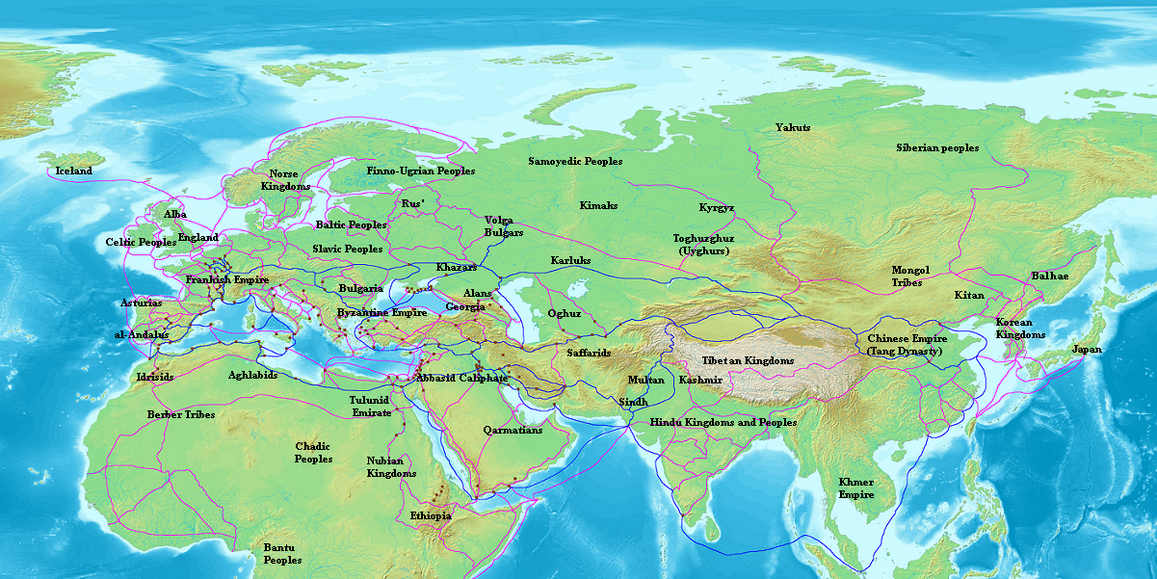
Source: https://en.wikipedia.org/wiki/Radhanite
And what went on in 1492 with the Jews of Spain and Portugal and with Columbus is connected to the Radhanites and the map above – capturing global trade and commerce (from the Radhanites to the Rothschilds). And once again, slaves were a major part of the trade. But all of this is another story for another time.
Question: Whether the Radhanite Jews, or “Jews,” converted the Khazars or not, couldn’t they have converted other groups of people along their route? Doesn’t their route correspond to the ancestral roots of modern-day Jews? And take note of their activity in modern day Iran.
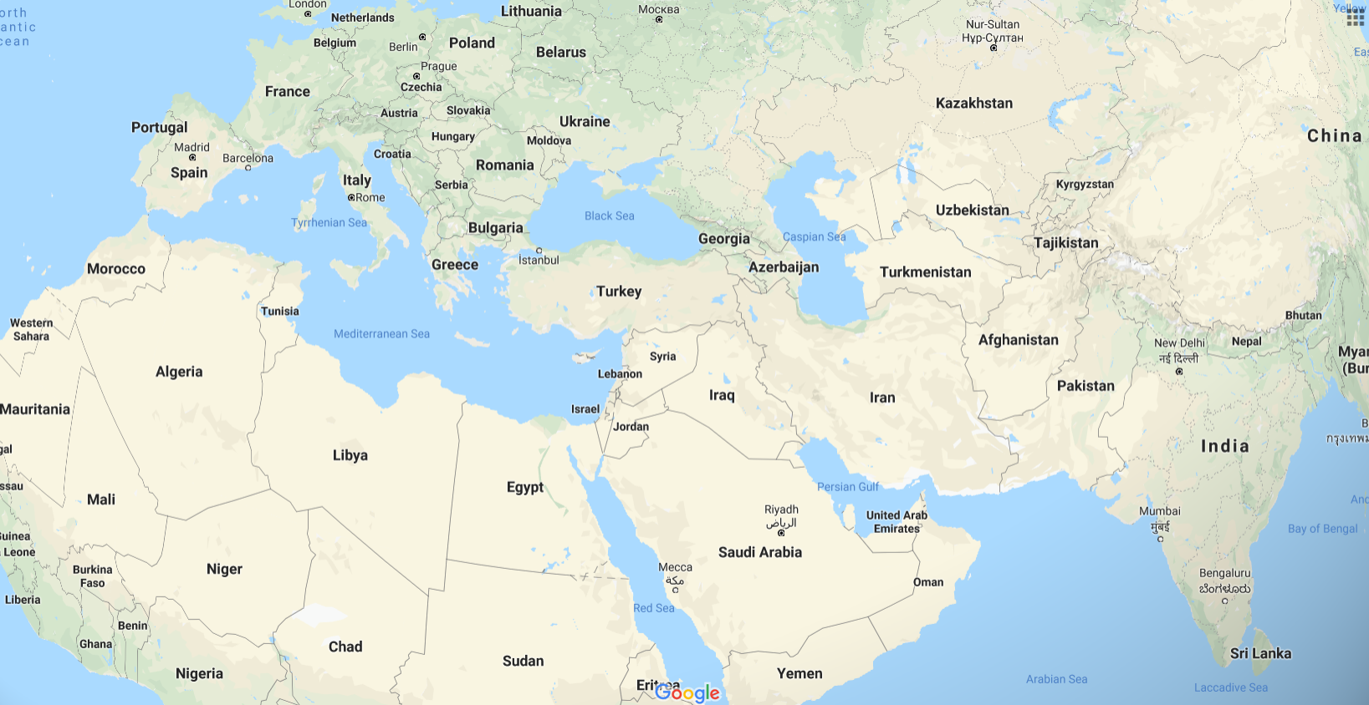
Origins. The Khazars were a Turkic¹ people who originated in Central Asia. The early Turkic tribes were quite diverse, although it is believed that reddish hair was predominant among them prior to the Mongol conquests. In the beginning, the Khazars believed in Tengri shamanism, spoke a Turkic language, and were nomadic. Later, the Khazars adopted Judaism, Islam, and Christianity, learned Hebrew and Slavic, and became settled in cities and towns thruout the north Caucasus and Ukraine. The Khazars had a great history of ethnic independence extending approximately 800 years from the 5th to the 13th century.
…
Khazaria was an important trade route connecting Asia and Europe. For example, the "Silk Road" was an important link between China, Central Asia, and Europe. Among the things traded along the Khazar trade routes were silks, furs, candlewax, honey, jewelry, silverware, coins, and spices. Jewish Radhanite traders of Persia passed thru Itil on their way to western Europe, China, and other locations. The Iranian Sogdians also made use of the Silk Road trade, and their language and runic letters became popular among the Turks. Khazars traded with the people of Khwarizm (northwest Uzbekistan) and Volga Bulgharia and also with port cities in Azerbaijan and Persia.
…
Ancient communities of Jews existed in the Crimean Peninsula, a fact proven by much archaeological evidence. It is significant that the Crimea came under the control of the Khazars. The Crimean Jewish communities were later supplemented by refugee Jews fleeing the Mazdaq rebellion in Persia, the persecutions of Byzantine emperors Leo III and Romanus I Lecapenus, and for a variety of other reasons. Jews came to Khazaria from modern-day Uzbekistan, Armenia, Hungary, Syria, Turkey, Iraq, and many other places, as documented by al-Masudi, the Schechter Letter, Saadiah Gaon, and other accounts. The Arabic writer Dimashqi wrote that these refugee Jews offered their religion to the Khazar Turks and that the Khazars "found it better than their own and accepted it". The Jewish Radhanite traders may have also influenced the conversion. Adopting Judaism was perhaps also a symbol of political independence for Khazaria, holding the balance of power between Muslim Caliphate and the Christian Byzantine Empire.

Under the leadership of kings Bulan and Obadiah, the standard rabbinical form of the Jewish religion spread among the Khazars. King Bulan adopted Judaism in approximately the year 838, after supposedly holding a debate between representatives of the Jewish, Christian, and Muslim faiths. The Khazar nobility and many of the common people also became Jews. King Obadiah later established synagogues and Jewish schools in Khazaria. The books of the Mishnah, Talmud, and Torah thus became important to many Khazars. Saint Cyril came to Khazaria in 860 in a Byzantine attempt to convert the Khazars to Christianity, but he was unsuccessful in converting them away from Judaism. He did, however, convince many of the Slavs to adopt Christianity. By the 10th century, the Khazars wrote using Hebrew letters. The major Khazar Jewish documents from that period were written in the Hebrew language. The Ukrainian professor Omeljan Pritsak estimated that there were as many as 30,000 Jews in Khazaria by the 10th century.
Source: http://www.khazaria.com/khazar-history.html
"It is certain that Khazar Jews lived in Phanagoria (Tmutorokan), since over sixty tombstones bearing Jewish symbols (such as seven-branched menorahs, shofars, and lulavs) on one side and Turkic tribe symbols (tamgas) on the other side were found on the Taman peninsula. Many of these tombstones date from the eighth or ninth century. Khazarian tombstones on the Crimean peninsula also depict the shofar, menorah, and staff of Aaron, as well as Turkic tribe symbols... The artifacts from Taman and Crimea are extremely significant since their tamgas show that these Jews were ethnic Turks." - Kevin Alan Brook, in The Jews of Khazaria (Jason Aronson, 1999), page 142
Source: http://www.khazaria.com/khazar-diaspora.html
The great migrations
Western historians refer to the period of migrations that separated Antiquity from the Middle Ages in Europe as the Great Migrations or as the Migrations Period. This period is further divided into two phases.
The first phase, from 300 to 500 C.E., saw the movement of Germanic and other tribes and ended with the settlement of these peoples in the areas of the former Western Roman Empire, essentially causing its demise.
The second phase, between 500 and 900 C.E., saw Slavic, Turkic and other tribes on the move, re-settling in Eastern Europe and gradually making it predominantly Slavic. Moreover, more Germanic tribes migrated within Europe during this period, including the Lombards (to Italy), and the Angles, Saxons, and Jutes (to the British Isles). The last phase of the migrations saw the coming of the Hungarians to the Pannonian plain.
German historians of the nineteenth century referred to these Germanic migrations as the Völkerwanderung, the migrations of the peoples.
The European migration period is connected with the simultaneous Turkic expansion which at first displaced other peoples towards the west, and by High Medieval times, the Seljuk Turks themselves reached the Mediterranean.
Source: https://www.newworldencyclopedia.org/entry/Human_migration
Additional information on the Khazars and their Judaism can be found here:
http://www.khazaria.com/khazar-diaspora.html
Take a look at this excerpt from Who is Esau-Edom? by Charles A. Weisman:
The best historical evidence therefore, shows that the Jews are not descended directly from the Israelites of the Bible but derive much of their ancestry from the Khazars and other people of Turkish-Asiatic blood. The Khazars are also of Edomite stock and both stocks make up the present day Jews, as the historian H. G. Wells states, “. . .the ldumeans (Edomites) were. . . made Jews, . . and a Turkish people (Khazars) were mainly Jews in South Russia. . . .The main part of Jewry never was in Judea and had never come out of Judea”^{l0} According to the Jewish Encyclopedia, the original stock of the Khazars came from the land of Edom:

Hasdai ibn Shaprut, who was foreign minister to Abd
al-Rahman, Sultan of Cordova, in his letter to King Joseph
of the Chazars (about 960), . . . speaks of the tradition
according to which the Chazars once dwelt near the Seir
Mountains."¹¹
The "Seir Mountains" are none other than the original land of Esau-Edom – "Thus dwelt Esau in mount Seir: Esau is Edom" (Genesis 36:8). Seir was a mountain range south of the Dead Sea and was also known as the "land of Edom" (Gen. 36:21). The Seir mountains were the home of the Edomites for nearly a millennium.¹² Thus, it should be no surprise that migrants from that land would recall the name of their original homeland.
If the Khazars did originally "dwell near the Seir Mountains" then the Khazars, and thus world Jewry, are racially of Edomite stock. But how and when did Edomites get to Khazaria? There is evidence that in the 6th century B.C., some of the Edomites fled their homeland of Seir and migrated north:
"After the fall of Jerusalem, in 586 B C', the Edomites began to press northward (Ezek. 36:5)."¹³
The extent and ultimate destination of this northward trek is not found in history but it is likely that it brought some Edomites to the region of Khazaria. The Edomites were also cast out of Palestine and dispersed in different directions in 70 A.D., when the Romans sacked Jerusalem. Many thousands of these people are known to have migrated northward to Asia Minor and around the Black Sea region.¹⁴

¹⁰ H. G. Wells, The Outline of Histoty, 3rd ed., MacMillian-1921, p.494.

¹¹ The Jewish Encyclopedia, Vol. IV, (1905) p. 3.

¹² "The Edomites arrived in Edom or Seir at the end of the 14th and
beginning of the 13th century B.C." Ency. Judaica, Vol 6, p. 372.

¹³ The New Westminster Dictionary of the Bible, Ed. by Henry S. Gehman,
The Westminster Press – Philadelphia, 1970, p. 418.

¹⁴ Ewald, History of Israel, (J.E. Carpenter, Trans 1874) vol. 5, p. 239.

Links to the book:
http://www.thechristianidentityforum.net/downloads/Esau-Edom.pdf

http://www.scribd.com/doc/46566146/Who-is-Esau-Edom#scribd

Here is source number 11 of that book:
http://www.jewishencyclopedia.com/search?utf8=%E2%9C%93&keywords=v4+p3&commit=search

https://commons.wikimedia.org/wiki/File:Jewish_Encyclopedia_Volume_4.pdf
(Direct link: https://upload.wikimedia.org/wikipedia/commons/b/b7/Jewish_Encyclopedia_Volume_4.pdf)
https://www.scribd.com/doc/237958436/1901-Jewish-Encyclopedia-Volume-4
“If the Khazars did originally ‘dwell near the Seir Mountains’ then the Khazars, and thus world Jewry, are racially of Edomite stock.”

“The extent and ultimate destination of this northward trek is not found in history but it is likely that it brought some Edomites to the region of Khazaria. The Edomites were also cast out of Palestine and dispersed in different directions in 70 A.D., when the Romans sacked Jerusalem. Many thousands of these people are known to have migrated northward to Asia Minor and around the Black Sea region.”

Here is source number 14 of that book:

“It is somewhat difficult to survey all the foreign cities and countries to which the Judeans, with the Samaritans often close at their side, spread during these centuries, and where they made themselves settled homes. …. The main stream of the dispersion ran on this as on other occasions through the dominions of the ruling nation, first of the Macedonian-Greeks and then of the Romans. Many others settled in Phoenicia and northern Syria, particularly in the numerous towns founded or renovated in these regions by the Greeks. The most attractive place was the Seleucian capital, Antioch ; ² but Damascus and the districts dependent upon it subsequently gathered in a great many. ³ In Asia Minor, which was then rapidly becoming almost wholly Greek, numbers of Judeans were to be met with in almost every part, but their principal places of resort were the wealthy and in most respects independent commercial cities on the western coast, such as Ephesus, Pergamus, Miletus, Sardis, Laodicea, Adramyttium (Hadrumetum) and Halicarnassus. ⁴
From Asia Minor, however, it was easy to pass northwards and westwards to the countries on the Euxine as far as the Tauric peninsula, to Thrace, Macedonia, ⁵ and others further still.

² See p. 237 ; 2 Macc. iv. 36-40 ; Jos. Ant. xii. 3, 1, Contr. Ap. ii. 4, Bell. Jud. vii. 3, 3, 5, 2 ; Acts xi. 19 sqq. According to Jos. Bell. Jud. vii. 5, 2, the rights of the Judeans in Antioch were publicly recorded on bronze tables, and this was also done in Alexandria and elsewhere.

³ Jos. Bell. Jud. ii. 20, 1, vii. 8, 7 ; Acts ix. 22. It is certainly these Judeans who under subsequent circumstances are called Arabians, Acts ii. 11.

⁴ See the decrees referring to such cities in Jos. Ant. xii. 3, 2, xiv. 10, 11-25, xvi. 6, 1-4, 6-8 ; Cic. Pro L. Flacc. cap. 28, and the well-kuown passages in the New Testament.”

Source: History of Israel (1869) by Ewald, Heinrich, 1803-1875; Carpenter, J. Estlin (Joseph Estlin), 1844-1927; Smith, John Frederick; Martineau, Russell, 1831-1898
https://archive.org/details/historyofisrael05ewaluoft

“In Asia Minor, which was then rapidly becoming almost wholly Greek, numbers of Judeans were to be met with in almost every part, but their principal places of resort were the wealthy and in most respects independent commercial cities on the western coast, such as Ephesus, Pergamus, Miletus, Sardis, Laodicea, Adramyttium (Hadrumetum) and Halicarnassus. From Asia Minor, however, it was easy to pass northwards and westwards to the countries on the Euxine as far as the Tauric peninsula, to Thrace, Macedonia, and others further still.”
Judeans were the inhabitants of Judea, which included Edomites.

I think it can be agreed upon that the book of Revelation was written in the 1st Century CE, correct?

“Early Church tradition dates the book to end of the emperor Domitian (reigned AD 81–96), and most modern scholars agree, although the author may have written a first version under Vespasian (AD 69–79) and updated it under Domitian.”
Source: https://en.wikipedia.org/wiki/Book_of_Revelation

Argument for an earlier date: https://www.ecclesia.org/truth/revelation.html

REVELATION
CHAPTER 1
4 JOHN to the seven churches which are in Asia: Grace be
unto you, and peace, from him which is, and which was,
and which is to come; and from the seven Spirits which are
before his throne;

This Asia is the land mass north and northeast of Patmos, and west of Antioch, commonly called Asia Minor.

ASIA, in a restricted sense, the name of the first Roman province east of the Aegean, formed (133 B.C.) out of the kingdom left to the Romans by the will of Attalus III. Philometor, king of Pergamum. It included Mysia, Lydia, Caria and Phrygia, and therefore, of course, Aeolis, Ionia and the Troad. In 84 B.C., on the close of the Mithradatic War, Sulla reorganized the province, forming 40 regiones for fiscal purposes, and it was later divided into conventus. From 80 to 50 B.C. the upper Maeander valley and all Phrygia, except the extreme north, were detached and added to Cilicia. In 27 B.C. Asia was made a senatorial province under a pro-consul. As the wealthiest of Roman provinces it had most to gain by the pax Romano, and therefore welcomed the empire, and established and maintained the most devout cult of Augustus by means of the organization known as the Koinon or Commune, a representative council, meeting in the various metropoleis. In this cult the emperor came to be associated with the common worship of the Ephesian Artemis. By the reorganization of Diocletian, a.d. 297, Asia was broken up into several small provinces, and one of these, of which the capital was Ephesus, retained the name of the
original province (see Asia Minor).
Source: Encyclopedia Britannica (1911)

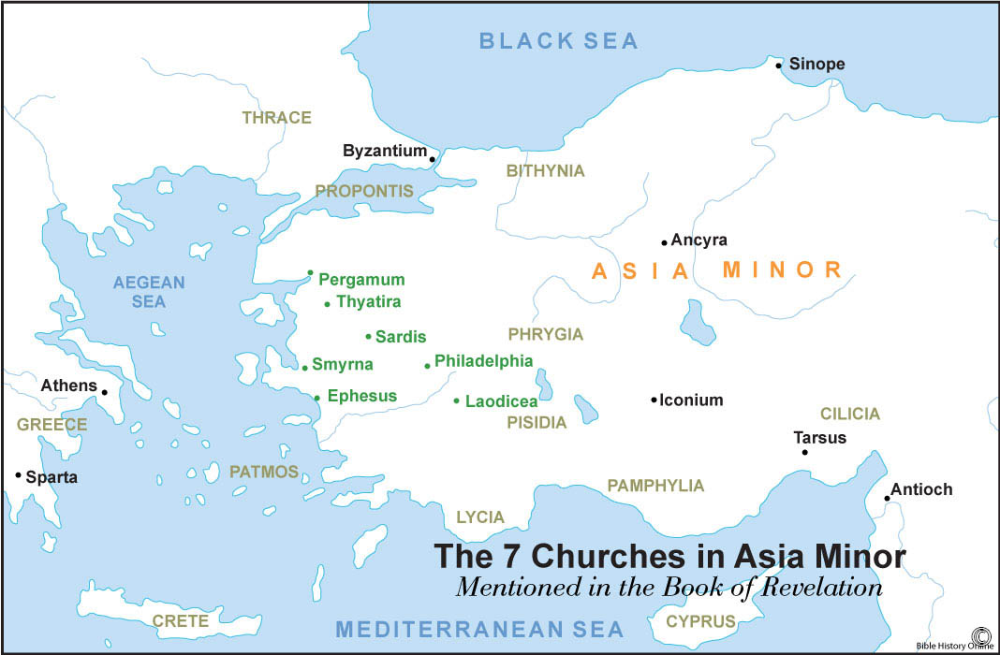
Source: https://www.bible-history.com/biblemaps/revelation-7-churches-asia-minor/

Revelation chapter 1 continued:
9 I John, who also am your brother, and companion in
tribulation, and in the kingdom and patience of Jesus Christ,
was in the isle that is called Patmos, for the word of God,
and for the testimony of Jesus Christ.
10 I was in the Spirit on the Lord’s day, and heard behind
me a great voice, as of a trumpet,
11 Saying, I am Alpha and Omega, the first and the last:
and, What thou seest, write in a book, and send it unto the
seven churches which are in Asia; unto Ephesus, and unto
Smyrna, and unto Pergamos, and unto Thyatira, and unto
Sardis, and unto Philadelphia, and unto Laodicea.
“In Asia Minor, which was then rapidly becoming almost wholly Greek, numbers of Judeans were to be met with in almost every part, but their principal places of resort were the wealthy and in most respects independent commercial cities on the western coast, such as Ephesus, Pergamus, Miletus, Sardis, Laodicea, Adramyttium (Hadrumetum) and Halicarnassus.”

REVELATION
CHAPTER 2
8 And unto the angel of the church in Smyrna write; These
things saith the first and the last, which was dead, and is
alive;
9 I know thy works, and tribulation, and poverty, (but thou
art rich) and I know the blasphemy of them which say they
are Jews, and are not, but are the synagogue of Satan.

REVELATION
CHAPTER 3
7 And to the angel of the church in Philadelphia write;
These things saith he that is holy, he that is true, he that
hath the key of David, he that openeth, and no man
shutteth; and shutteth, and no man openeth;
8 I know thy works: behold, I have set before thee an open
door, and no man can shut it: for thou hast a little strength,
and hast kept my word, and hast not denied my name.
9 Behold, I will make them of the synagogue of Satan,
which say they are Jews, and are not, but do lie; behold, I
will make them to come and worship before thy feet, and to
know that I have loved thee.

So, that’s two different churches in Asia Minor that had a problem with people claiming to be Jews but were not (these statements in Revelation are also prophetic).
Who Are The Palestinians?
The next selection of information may not be one hundred percent correct throughout, but it should open your eyes.
“The basic falsehood that is widely diffused among the member states of the Arabic League (do not call it 'Arab', please) is that there is an Arabic nation, or that the people in all the member states are 'Arabs'. The only historical truth in this respect is that there are no Arabs at all; there are Arabic speaking peoples with striking dissimilarities that testify to and assure only failures in any attempt at a union among these so different peoples. If this absolute and fundamental historical reality is not widely assessed and understood first, nothing good can come out of the Arab League!!!
“In reality, the Lebanese are Phoenicians, who got hellenized and aramaized in Late Antiquity. Arabic speaking Syrians and Iraqis are Aramaeans. So are the Palestinians and the Kuwaitis, as well as the Emirates and the Qataris, who have certainly been intermixed with Persians. Egyptians are Copts, native Egyptians, descendants of the people of Ancient Egypt in their amalgamations with the numerous foreigners, who passed by the valley of the Nile: Aramaeans, Phoenicians, Yemenis, Greeks, Meroitic Sudanese, Romans, and others. Sudanese are descendants of the ancient Meroites and the Nubians. Libyans and the people of the Maghreb are descendants of the Khammitic peoples of the great Atlas, Berbers, in their genuine fusion with Carthaginians and Romans.
“And Yemenis are Yemenis, descendants of the ancient states of Saba, Qataban, Himyar, Hadramout and other; they are closer to Abyssinians (mistakenly called Ethiopians) than to the Arabs of Hegiras these peoples, by accepting Islam, sooner or later, started becoming arabized, but this happened at a linguistic, not at a racial, ethnic level. And we know only too well that the Arabs of the times of the Prophet were not numerous at all. One generation later, when let us say Islamic armies were reaching Carthage in today's Tunisia, Central Asia and the Indus valley, the Muslim fighters were speaking Arabic but among them Arabs were already a minority. Aramaeans from Damascus and Ctesiphon, Egyptians from Alexandria, Yemenis from Muza and Persians from Praaspa were already a majority among them! They learnt the language of Quran, but they did not and could not change their racial and ethnic origin.”
Source: https://phoenicia.org/today.html
“Alexander the Great took control of Jerusalem in 332 B.C. Over the next several hundred years, the city was conquered and ruled by different groups, including the Romans, Persians, Arabs, Fatimids, Seljuk Turks, Crusaders, Egyptians, Mamelukes and Islamists.”
Source: https://www.history.com/topics/ancient-middle-east/history-of-jerusalem
That whole list is comprised almost entirely of Arabs and Europeans. And it’s from this and other foreigners, the Palestinians were born. These Palestinians are not the descendants of the original inhabitants of the land. You can look at the history of these lands and the people that came in and out and you’ll find that the native population has been totally displaced. I’m sure controlled academia is sorry for not telling people that a huge influx of foreign populations flooded the Levant, including people from Europe, and it’s from their descendants that they take DNA samples from, not the original inhabitants of the land.
The Jewish DNA Evidence
Let’s start with a little bit of information on the migration, mixing and displacement of people.
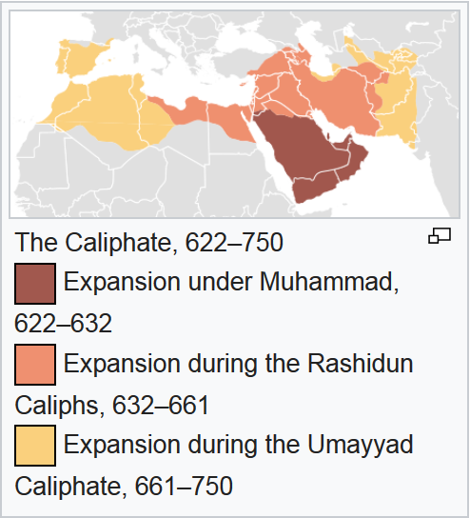
Migration Period
During the early Byzantine–Arab Wars, Arab armies attempted to invade southeast Europe via Asia Minor during the late seventh and early eighth centuries, but were defeated at the siege of Constantinople (717–718) by the joint forces of Byzantium and the Bulgars. During the Khazar–Arab Wars, the Khazars stopped the Arab expansion into Europe across the Caucasus (7th and 8th centuries). At the same time, the Moors (consisting of Arabs and Berbers) invaded Europe via Gibraltar (conquering Hispania—the Iberian Peninsula—from the Visigothic Kingdom in 711), before being halted. These battles broadly demarcated the frontiers between Christendom and Islam for the next millennium. The following centuries saw the Muslims successful in conquering most of Sicily from the Christians by 902.
The Hungarian conquest of the Carpathian Basin from around 895 and the following Hungarian invasions of Europe, and the Viking expansion from the late 8th century conventionally mark the last large movements of the period. Christianity gradually converted the non-Islamic newcomers and integrated them into the medieval Christian order. After that, the German eastward expansion (german: (Deutsche) Ostsiedlung) started in the 11th century in Eastern Europe.

Source: https://en.wikipedia.org/wiki/Migration_Period
Turkic migration
Meanwhile, the Kyrgyz and Uyghurs were struggling with one another and with the Chinese Empire. The Kyrgyz people ultimately settled in the region now referred to as Kyrgyzstan. The Batu hordes conquered the Volga Bulgars in what is today Tatarstan and Kypchaks in what is now Southern Russia, following the westward sweep of the Mongols in the 13th century. Other Bulgars settled in Europe in the 7-8th centuries, but were assimilated by the Slavs, giving the name to the Bulgarians and the Slavic Bulgarian language.
It was under Seljuq suzerainty that numerous Turkmen tribes, especially those that came through the Caucasus via Azerbaijan, acquired fiefdoms (beyliks) in newly conquered areas of Anatolia, Iraq and even the Levant. Thus, the ancestors of the founding stock of the modern Turkish nation were most closely related to the Oghuz Turkmen groups that settled in the Caucasus and later became the Azerbaijani nation.
Source: https://en.wikipedia.org/wiki/Turkic_migration
Turks in the Arab world
The Turks in the Arab world refers to ethnic Turkish people who live in the Arab World. There are significant Turkish populations scattered throughout North Africa, the Levant, and the Arabian Peninsula.
In Libya, There are some who think of themselves as Turkish, or descendants of Turkish soldiers who settled in the area in the days of the Ottoman Empire^{[1]} There is also a significant Turkish minority in Egypt (see Turks in Egypt).^{[2]}
In the Levant, the Turks live across the region. In Iraq and Syria the Turkish minorities are commonly been referred to as "Turkmen", "Turkman" and "Turcoman"; historically, these terms have been used to designate Turkish speakers in Arab areas, or Sunni Muslims in Shitte areas.^{[3]} The majority of Iraqi Turkmen and Syrian Turkmen are the descendants of Ottoman Turkish settlers.^{[4][5][6][7]} and share close cultural and linguistic ties with Turkey, particularly the Anatolian region.^{[8][7]} There are also Turkish minorities located in Jordan (Turks in Jordan) and Lebanon (Turks in Lebanon). The Lebanese Turks live mainly in the villages of Aydamun and Kouachra in the Akkar District, as well as in Baalbek, Beirut, and Tripoli.
In the Arabian Peninsula, there are Turkish minorities who have lived in the region since the Ottoman era. The Turks live predominately in Saudi Arabia (see Turks in Saudi Arabia) and Yemen (see Turks in Yemen).
Source: https://en.wikipedia.org/wiki/Turks_in_the_Arab_world
Genetic studies on Turkish people
In population genetics, research has been made to study the genetic origins of the modern Turkish people (not to be confused with Turkic peoples) in Turkey.
…
According to a 2012 study on ethnic Turkish people, "Turkish population has a close genetic similarity to Middle Eastern and European populations and some degree of similarity to South Asian and Central Asian populations."^{[27]} At K = 3 level, using individuals from the Middle East (Druze and Palestinian), Europe (French, Italian, Tuscan and Sardinian) to obtain a more representative database for Central Asia (Uygur, Hazara and Kyrgyz), clustering results indicated that the contributions were 45%, 40% and 15% for the Middle Eastern, European and Central Asian populations, respectively. For K = 4 level, results for paternal ancestry were 38% European, 35% Middle Eastern, 18% South Asian and 9% Central Asian. K= 7 results of paternal ancestry were 77% European, 12% South Asian, 4% Middle Eastern, 6% Central Asian. However, Hodoglugil et al. caution that results may indicate previous population movements (e.g. migration, admixture) or genetic drift.^{[27]} The study indicated that the Turkish genetic structure is unique, and admixture of Turkish people reflects the population migration patterns.^{[27]} Among all sampled groups, the Adygei population (Circassians) from the Caucasus was closest to the Turkish samples among sampled European (French, Italian), Middle Eastern (Druze, Palestinian), and Central (Kyrgyz, Hazara, Uygur), South (Pakistani), and East Asian (Mongolian, Han) populations.^{[27]}
Source: https://en.wikipedia.org/wiki/Genetic_studies_on_Turkish_people
“Studies have reported that most Irish and Britons are descendants of farmers who left modern day Iraq and Syria 10,000 years ago.^{[14]} Genetic researchers say they have found compelling evidence that four out of five (80% of) white Europeans can trace their roots to the Near East.^{[14]} In another study, scientists analysed DNA from the 8,000-year-old remains of early farmers found at an ancient graveyard in Germany. They compared the genetic signatures to those of modern populations and found similarities with the DNA of people living in today's Turkey and Iraq.^{[15]}”
Source: https://en.wikipedia.org/wiki/Mesopotamia
Wikipedia sources:
14. "Ancient History in depth: Mesopotamia". BBC History. Retrieved 21 July 2017.
15. Finkelstein, J.J. (1955), "Subartu and Subarian in Old Babylonian Sources", (Journal of Cuneiform Studies Vol 9, No. 1)
Most white Europeans can trace their roots to the Near East?! There are genetic similarities between some ancient Germans and people living in today’s Turkey and Iraq?!
Read this excerpt from The Origin of the Europeans; Combining Genetics and Archaeology, Scientists Rough Out Continent's 50,000-Year-Old Story By Nicholas Wade
Nov. 14, 2000
In one of the most detailed genetic reconstructions of population history so far, Dr. Martin Richards of the University of Huddersfield in England and many colleagues have traced the remarkably ancient ancestry of the present-day population of Europe.
Some 6 percent of Europeans are descended from the continent's first founders, who entered Europe from the Near East in the Upper Paleolithic era 45,000 years ago, Dr. Richards calculates. The descendants of these earliest arrivals are still more numerous in certain regions of Europe that may have provided them with refuge from subsequent waves of immigration. One is the mountainous Basque country, where people still speak a language completely different from all other European languages. Another is in the European extreme of Scandinavia. Another 80 percent arrived 30,000 to 20,000 years ago, before the peak of the last glaciation, and 10 percent came in the Neolithic 10,000 years ago, when the ice age ended and agriculture was first introduced to Europe from the Near East.
...
Dr. Richards and his colleagues have analyzed the ancestry of the present European population by looking within the major daughter of Eve branches for subbranches that occur both in Europe and the Near East, from western Iran through Turkey and Arabia to Egypt, because the Near East is the probable source of most of the ancestral populations that entered Europe.
The subbranches from each region were then dated by counting the number of mutations that had occurred in the mitochondrial DNA sequence from the beginning of the subbranch until today. If the subbranch was older in the Near East than Europe, it indicated a migration into Europe. By this method Dr. Richards's team was able to date the migrations into Europe. They also picked up a sizable back-migration from Europe to the Near East.
Source: https://www.nytimes.com/2000/11/14/science/origin-europeans-combining-genetics-archaeology-scientists-rough-continent-s.html
“There are at least three major, highly differentiated populations that have contributed substantial amounts of ancestry to almost everybody that has European ancestry today,” says David Reich, an HHMI investigator at Harvard Medical School. Those include hunter-gatherers from western Europe, the early farmers who brought agriculture to Europe from the Near East, and a newly identified group of ancient north Eurasians who arrived in Europe sometime after the introduction of agriculture.
Source: https://www.hhmi.org/news/modern-europeans-descended-three-groups-ancestors
“Because the Khazar population has left no obvious modern descendants that could enable a clear test for a contribution to Ashkenazi Jewish ancestry, the Khazar hypothesis has been difficult to examine using genetics. Furthermore, because only limited genetic data have been available from the Caucasus region, and because these data have been concentrated in populations that are genetically close to populations from the Middle East, the attribution of any signal of Ashkenazi-Caucasus genetic similarity to Khazar ancestry rather than shared ancestral Middle Eastern ancestry has been problematic.”
Source: No Evidence from Genome-Wide Data of a KhazarOrigin for the Ashkenazi Jews pg. 4
http://digitalcommons.wayne.edu/cgi/viewcontent.cgi?article=1040&context=humbiol_preprints
So, Europeans having genetic links to the Middle East is common! And yet European Jews having genetic links to the Middle East is being used to prove European Jews are from Palestine, and Jews are one people since North African and Middle Eastern Jews (who both have Middle Eastern DNA) share DNA with Europeans Jews (who have Middle Eastern DNA).
Nations are usually identified by family and location, but doing so by family is the only way to remain correct in your observation. A DNA test, for example, might tell you that you’re 30% Egyptian. But what is Egyptian? Were the people who the samples were taken from always in that land? So, the results you receive are based on which people the samples were taken from, not their location. This is one way they trick people with DNA.
This is a perfect summation regarding the authenticity of the Jews and all the DNA testing that has been done:
“Testing whether one is related to the ancient Judaeans, Jesus, Moses, or Muhammad requires actually sequencing the genomes of these people and meticulously comparing it with modern day genomes looking for shared biomarkers. As opposed to the latter three we actually have plenty of ancient Judaeans skeletons that no one has ever sequenced (and probably never will). Why the DNA of the ancient Judaeans has not being sequenced and settle the question of relatedness once and for all is a question that should be directed to Israeli archeologists. It is most unfortunate that the members of the general public have been mislead to believe (no doubt after paying a lot of money to DTC companies) that they are related to ancient figures without any shred of evidence.”
Source: https://homolog.us/blogs/bioinfo/2016/05/06/jewish-genetics-forward-magazine-makes-elhaiks-work-go-viral/
DNA Ethnicity Results Aren’t What You Think
https://www.youtube.com/watch?v=u8lMfGqSrwg
What DNA ancestry tests can — and can’t — tell you
https://www.youtube.com/watch?v=IIWlatQt4KE
“Specific regions of the Y chromosome were analyzed in 1,371 men from 29 worldwide populations, including Jews and non-Jews from the Middle East, North Africa, sub-Saharan Africa, and Europe.
The study, published in the May 9 issue of the Proceedings of the National Academy of Sciences, found that Jewish men shared a common set of genetic signatures with non-Jews from the Middle East, including Palestinians, Syrians, and Lebanese, and these signatures diverged significantly from non-Jewish men outside of this region. Consequently, Jews and Arabs share a common ancestor and are more closely related to one another than to non-Jews from other areas of the world.”
Source: https://www.sciencedaily.com/releases/2000/05/000509003653.htm
Isn’t this what you just read about, the mix between Europeans and Arabs? Or are they unknowingly proving the Edomite Hypothesis by DNA? Or is it both? The Israelites of the Bible were mixed with “Africans” (sons of Ham) more than any other people (it’s actually right there in the Bible) so saying that the Jews are closely related to Arabs and Middle Easterners is actually disproving their identity. And saying they are closely related to Palestinians, who are NOT native to that land, does the same.
*I put the more devious statements of this next article in red.
Jews and Arabs Share Recent Ancestry
By Ann Gibbons Oct. 30, 2000 , 7:00 PM
COLD SPRING HARBOR, NEW YORK--As fighting continues in the Middle East, a new genetic study shows that many Arabs and Jews are closely related. More than 70% of Jewish men and half of the Arab men whose DNA was studied inherited their Y chromosomes from the same paternal ancestors who lived in the region within the last few thousand years.
The results match historical accounts that some Moslem Arabs are descended from Christians and Jews who lived in the southern Levant, a region that includes Israel and the Sinai. They were descendants of a core population that lived in the area since prehistoric times. And in a recent study of 1371 men from around the world, geneticist Michael Hammer of the University of Arizona in Tucson found that the Y chromosome in Middle Eastern Arabs was almost indistinguishable from that of Jews.
Intrigued by the genetic similarities between the two populations, geneticist Ariella Oppenheim of Hebrew University in Jerusalem, who collaborated on the earlier study, focused on Arab and Jewish men. Her team examined the Y chromosomes of 119 Ashkenazi and Sephardic Jews and 143 Israeli and Palestinian Arabs. Many of the Jewish subjects were descended from ancestors who presumably originated in the Levant but dispersed throughout the world before returning to Israel in the past few generations; most of the Arab subjects could trace their ancestry to men who had lived in the region for centuries or longer. The Y chromosomes of many of the men had key segments of DNA that were so similar that they clustered into just three of many groups known as haplogroups. Other short segments of DNA called microsatellites were similar enough to reveal that the men must have had common ancestors within the past several thousand years. The study, reported here at a Human Origins and Disease conference, will appear in an upcoming issue of Human Genetics.
Source: http://www.sciencemag.org/news/2000/10/jews-and-arabs-share-recent-ancestry
At least in the last study they tell you who was sampled. Notice how they included Sephardic Jews, Jews whose DNA would most definitely link to non-Jewish Middle Easterners. And how many Germans and Turks have DNA linking them to the Middle Eastern?
Haplogroups were mentioned in that piece. This is another DNA trick that is used by many people, and not just within, or for the benefit of, the Jewish population. Many people are pushing the idea that haplogroups are derived from the autosomal DNA testing done to determine if, and how closely, one person is related to another. This is not true. In short, at certain times there are unique mutations within genes. These mutations are then passed down. After enough generations have inherited this mutation, some governing body in the scientific world might, at their discretion, call that a new haplogroup. The mtDNA haplogroups are all the females who inherited a mutation; and Y chromosomal haplogroups are all the males who inherited a mutation. It’s basically telling you who came in contact with whom.
Let’s go through a short “class” on haplogroups so you won’t be fooled.
“DNA contains single nucleotide polymorphisms, or SNPs. A SNP is a mutation in the DNA sequence that is only one base pair long. At a certain place in his or her genome, a person may have a ‘T’ (thymine) instead of a ‘G’ (guanine). This can occur in both nuclear DNA and mitochondrial DNA.
…
Mitochondrial DNA is passed down maternally and is not recombined. So, every individual inherits a pattern of SNPs in their mitochondrial DNA from their mother only. This is a useful clue for tracing ‘deep ancestry’, in which we can look back for many generations. Scientists have used information from the mitochondrial DNA in people living today and the rate of mutation in mitochondria to help them understand the migration of homo sapiens sapiens out of Africa and across the Earth.
A haplogroup is a group of people who all share the same pattern of SNPs in their mitochondrial DNA.”
Source: http://ase.tufts.edu/chemistry/hhmi/documents/Detailed_Haplogroup_Activity.pdf
“An allele (UK: /ˈæliːl/, /əˈliːl/; US: /əˈliːl/; from German Allel and Greek ἄλλος állos, "other")^{[1][2][3]} is a variant form of a given gene,^{[4]} meaning it is one of two or more versions of a known mutation at the same place on a chromosome. It can also refer to different sequence variations for a several-hundred base-pair or more region of the genome that codes for a protein. Alleles can come in different extremes of size. At the lowest possible end one can be the single base choice of a single nucleotide polymorphism (SNP).^{[5]} At the higher end, it can be the sequence variations for the regions of the genome that code for the same protein which can be up to several thousand base-pairs long.^{[6][7]}”
Source: https://en.wikipedia.org/wiki/Allele
“A single-nucleotide polymorphism (SNP; /snɪp/; plural /snɪps/) is a substitution of a single nucleotide that occurs at a specific position in the genome, where each variation is present at a level of more than 1% in the population.^{[1]}
For example, at a specific base position in the human genome, the C nucleotide may appear in most individuals, but in a minority of individuals, the position is occupied by an A. This means that there is a SNP at this specific position, and the two possible nucleotide variations – C or A – are said to be the alleles for this specific position.”
Source: https://en.wikipedia.org/wiki/Single-nucleotide_polymorphism
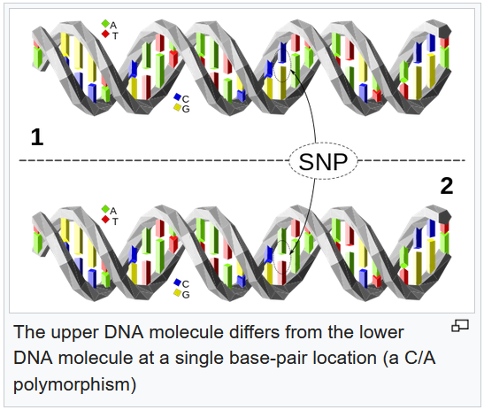
A haplotype (haploid genotype) is a group of alleles in an organism that are inherited together from a single parent.^{[1][2}
Source: https://en.wikipedia.org/wiki/Haplotype
As stated, they are telling you a location and calling it a people, but were the people who live there now tested, or the skeletal remains of people who lived there thousands of years ago? How can a DNA company have a single map with no date? I can see if they gave people several maps, or an animated map, to show the movement and change of the haplogroups over time, but people are given one map. Think about it, are the people who inhabit the land mass known as North America today the same people who inhabited North America two thousand years ago? No. So, how could you get a map showing you haplogroups of an area such as North America? A particular haplogroup would be dominate in a particular area for a particular length of time. From whom did the samples come from? This is what you need to know.
Here’s some example of maps that have been created:
https://commons.wikimedia.org/wiki/File:World_Map_of_Y-DNA_Haplogroups.png
https://en.wikipedia.org/wiki/File:MtDNA_haplogroup_tree_and_distribution_map.gif
List of Y-chromosome haplogroups in populations of the world
https://en.wikipedia.org/wiki/List_of_Y-chromosome_haplogroups_in_populations_of_the_world
“But genealogy was not always a popular hobby. It was not until the early civil rights movement of the late 19th century that non-elites began researching their ancestry and celebrating their newly found identities. Before then, genealogy had been something elites used to legitimate political rule.
Digital technology has recently improved the accessibility of genealogical records. But even in the best-case scenario, genealogical records could take us back only about 500 years. Now, genetic research allows us to establish findings far beyond five centuries.
Genetic tools for genealogical research initially consisted of classifying individuals into paternal and maternal haplogroups, each prevalent in a different part of the world (eg. western Europe or Oceania). However, these haplogroups allowed for only very imprecise chronological placement or identification within the past 2,000 to 20,000 years. By 2003, new genetic genotyping technology enabled a newly comprehensive – and affordable – analysis. This new technique drew on the remaining 22 chromosomes (called autosomal), which reveal a great deal more information than techniques based only on haplogroups. Analysis based on autosomal characteristics tells us more about the genome, allowing broader and more specific inferences of the past. Comprising of more than 90 per cent of our genomes, autosomal chromosomes enable major advances in genealogical research. Since they are inherited from both parents, they also preserve their genetic signatures, allowing us to learn about our family’s genetic history.”
Source: https://aeon.co/ideas/how-dna-traced-the-ashkenazic-jews-to-northeastern-turkey
“This is a public service announcement. If you are a user of direct-to-consumer personal genomics services, please do not pay any attention to your mtDNA and Y chromosomal haplogroups. Why? Because they hardly tell you anything about your individual ancestry. What do I mean by this? Your mtDNA comes down from your mother’s-mother’s-mother’s-mother… and similarly for your Y chromosomal lineage if you are a male. These few individuals are not any more likely to contribute to your ancestry than all those multitudes and multitudes who do not contribute to your mtDNA or Y lineages; also known as almost all your ancestors! What you should pay attention to are your autosomal results. Inferences made from most of your genome. These results may be more difficult to parse, but difficulty is no sin, and elegant ease is no virtue, in this case. That’s because you are interested in your ancestry, not a convenient interpretable story.
Of course I am not saying that mtDNA and Y chromosomal haplogroups are useless. They are useful for population scale phylogeography. But please don’t make inferences about yourself from one data point. At least in most cases.”
Source: http://blogs.discovermagazine.com/gnxp/2013/05/please-ignore-mtdna-and-y-chromosomal-haplogroups/#.XX6k_397lEY
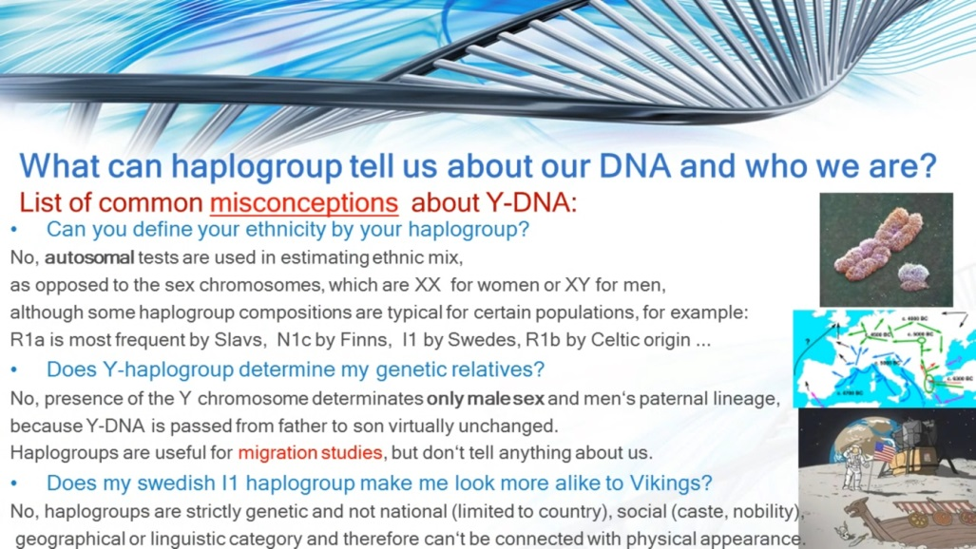
Picture this: Thousands of years ago, a male in people/Group A develops a mutation in his gene. He then has male children with a woman of his people, Group A. Those male children then have male children with women of that people, Group A; and this goes on for the number of generations/amount of time needed for scientists to consider it a haplogroup. Would every male of Group A have or have had this mutation? No. Now imagine one of the males from Group A who had this mutation/haplotype having a male child with a woman from Group B, a totally different people. Now imagine that mixed Group A/Group B male having a male child with a woman from his people, Group B. Now imagine that child having one or more male children with a woman from Group B, and those males and their descendants from that point on only had male children with women of Group B; and likewise, males of group A only had children with women from Group A. After many years you would see that haplogroup in two totally different groups of people. So, to some people today, those two totally different groups of people would be the same people. That’s dangerous, right? But legitimate scientists and others are using haplogroups in conjunction with other data, such as historical migration patterns, not how DNA companies and the general population uses it.
Watch the beginning - 13:12
What are Haplogroups and does it matter?
https://www.youtube.com/watch?v=AabWNnVbXUU
Class over.
“For, according to a new scientific study, Jews are the genetic brothers of Palestinians, Syrians and Lebanese, and they all share a common genetic lineage that stretches back thousands of years.”
Source: https://www.sciencedaily.com/releases/2000/05/000509003653.htm
And you’ve already seen the other possibilities aside from them being descendants of Biblical Israelites.
Blood Brothers: Palestinians and Jews Share Genetic Roots
Jews break down into three genetic groups, all of which have Middle Eastern origins – which are shared with the Palestinians and Druze.
Josie Glausiusz Oct 20, 2015 2:38 PM
“The closest genetic neighbors to most Jewish groups were the Palestinians, Israeli Bedouins, and Druze in addition to the Southern Europeans, including Cypriots,” as Ostrer and Skorecki wrote in a review of their findings that they co-authored in the journal Human Genetics in October 2012.
Source: http://www.haaretz.com/israel-news/science/1.681385
Israelis: Can you tell the difference between Jews and Arabs?
https://www.youtube.com/watch?v=0BIAuLaD7Bs
I agree with this caption by Michael Hoffman:
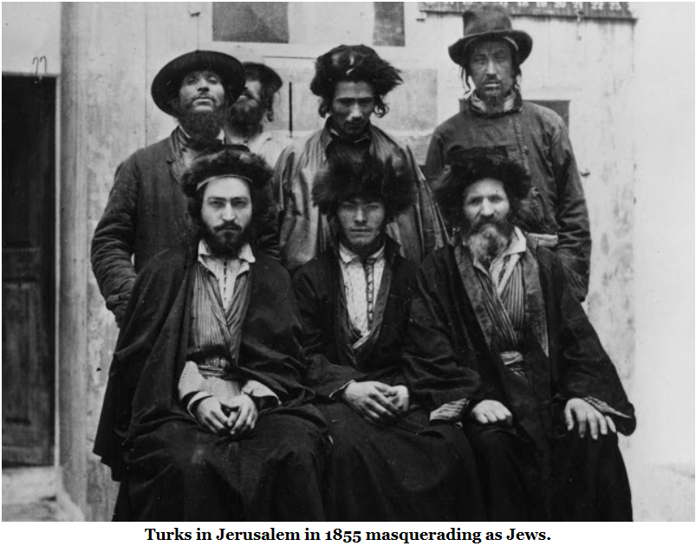
Source: https://revisionistreview.blogspot.com/2016/04/latest-genetic-research-on-impostor-jews.html
Here’s an excerpt from a very pro-Jewish article:
Israeli Researcher Challenges Jewish DNA links to Israel, Calls Those Who Disagree 'Nazi Sympathizers'
A paper published in 2000 by geneticists Harry Ostrer, a professor of genetics at the Albert Einstein College of Medicine, and University of Arizona geneticist Michael Hammer showed that most Ashkenazis, Italians, North Africans, Iraqi, Iranian, Kurdish and Yemenite Jews share common Y-DNA haplotypes that are also found among many Arabs from Palestine, Lebanon and Syria. Only a small percentage of the Y-DNA of Jews originated outside of the Middle East—some in the Caucuses. The competing Rhineland and Khazarian theories were most recently discussed by Ostrer in two studies published in 2012 and in his well received book, Legacy: A Genetic History of the Jewish People. He found that geographically and culturally distant Jews still have more genes in common than they do with non-Jews around them, and that those genes can be traced back to the Levant, an area including modern-day Israel. “All European [Ashkenazi] Jews seem connected on the order of fourth or fifth cousins, Ostrer has said.
…
The DNA that links Ashkenazi, Sephardi and Mizrahi, three prominent culturally and geographically distinct Jewish groups, could conceivably be used to support Zionist territorial claims —except, as Ostrer has pointed out, some of the same markers can be found in Palestinians, distant genetic cousins of the Jews, as well.
Source: http://www.forbes.com/sites/jonentine/2013/05/16/israeli-researcher-challenges-jewish-dna-links-to-israel-calls-those-who-disagree-nazi-sympathizers/#779cd5cddb23
“... showed that most Ashkenazis, Italians, North Africans, Iraqi, Iranian, Kurdish and Yemenite Jews share common Y-DNA haplotypes that are also found among many Arabs from Palestine, Lebanon and Syria.” Do you realize how vague that is? And all it’s really saying is that someone at some time in the genetic history of most Ashkenazis came in contact with Arabs and Europeans, the people who came into these areas. “... those genes can be traced back to the Levant, an area including modern-day Israel.” No, those genes can be traced back to people who invaded the Levant from surrounding areas, and even Europe. That’s how we got the Palestinians. And as stated previously: “For, according to a new scientific study, Jews are the genetic brothers of Palestinians, Syrians and Lebanese, and they all share a common genetic lineage that stretches back thousands of years.” In other words, Jews are the genetic brothers of people who are not indigenous to the Levant.
It was after his findings that claims of the Jewish people, implying all Jewish people, were of one people were spread like wildfire. But you never saw any details of the study. You never saw what it was that specifically linked them. How do you know it wasn’t the European or Middle Eastern genes? “Ashkenazis, Italians, North Africans, Iraqi, Iranian, Kurdish and Yemenite Jews ... found among many Arabs from Palestine, Lebanon and Syria.” And it was based on haplotypes!
“Ostrer’s research on ‘Abraham’s Children in the Genome Era,” published in The American Journal of Human Genetics, sampled 652,000 gene variants from each of 237 unrelated individuals from seven Jewish populations: Iranian, Iraqi, Syrian, Italian, Turkish, Greek and Ashkenazi. These sequences were then compared with reference samples from non-Jews drawn from The Human Genome Diversity Project, a global database of genetic information gathered from populations across the world.”
Source: http://www.haaretz.com/israel-news/science/1.681385
You can just look at the Jews who were tested and assume beforehand they had European and/or Middle Eastern DNA – a link. Knowing migration history and former DNA results you could easily choose certain people to get a certain outcome like lawyers choosing a jury. It is equally interesting that these populations were called “Jews from around the world,” “Jews,” and “the Jewish people” in the media. Where are the Africans, Indians and others?
And proving that the Ashkenazi are not related to the Khazars is not proving that they are descendants of the Israelites of the Bible, or that they do not descend from other Europeans; or from converts.
“An analysis of the gene database shows that the original Ashkenazi Jews were about half European and half Middle Eastern. They lived in the medieval era, about 600 to 800 years ago, according to the analysis – and numbered just 350 or so people.
‘Our analysis shows that Ashkenazi Jewish medieval founders were ethnically admixed, with origins in Europe and in the Middle East, roughly in equal parts,’ said Shai Carmi, a post-doctoral scientist who works with Pe’er and conducted the analysis. ‘[The] data are more comprehensive than what was previously available, and we believe the data settle the dispute regarding European and Middle Eastern ancestry in Ashkenazi Jews.’”
Source: https://www.timesofisrael.com/ashkenazi-jews-descend-from-350-people-study-finds/
... about 600 to 800 years ago? It settles the dispute regarding European and Middle Eastern ancestry in Ashkenazi Jews? Something always settles the dispute; then gets debunked. Here’s some previous information: “According to a 2012 study on ethnic Turkish people, ‘Turkish population has a close genetic similarity to Middle Eastern and European populations and some degree of similarity to South Asian and Central Asian populations.’^{[27]} At K = 3 level, using individuals from the Middle East (Druze and Palestinian), Europe (French, Italian, Tuscan and Sardinian) to obtain a more representative database for Central Asia (Uygur, Hazara and Kyrgyz), clustering results indicated that the contributions were 45%, 40% and 15% for the Middle Eastern, European and Central Asian populations, respectively.”
Read this excerpt from New Study Shows YU Researcher, Others Appear To Have Cooked The Genetic Books To ‘Prove' Middle Eastern Origin Of The Jewish People When One May Not Really Exist
But Elhaik's study did find that there is a genetic continuum linking the Jews of Iran, the Caucasus, Azerbaijan and Georgia with the European Jews. These groups could share common ancestors - probably the Khazars.
Elhaik says that among the various groupings of European and non-European Jews there is no common genetic origin.
"The various groups of Jews in the world today do not share a common genetic origin. We are talking here about groups that are very heterogeneous and which are connected solely by religion…[the] genome of European Jews is a mosaic of ancient peoples and its origin is largely Khazar,” he told Ha’aretz.
But what about other much-publicized studies which claim to show common genetic descent for Jews?
Many of these papers and books were written by noted professors and published by respected academic journals and publishers – for example, for example, Oxford University Press published, "Legacy: A Genetic History of the Jewish People," by Yeshiva University’s Dr. Harry Ostrer, who teaches in the departments of pathology, genetics and pediatrics in the university's Albert Einstein College of Medicine. He argues that genetics prove the Jews are one people with a Middle Eastern origin.
Ostrer found no significant evidence for a connection between the Jews and the Khazars. According to Ostrer, genetically Jews are closer to Palestinians, Bedouin and Druze than to the Khazars.
How could Ostrer and so many others have reached conclusions that are co very different from Elhaik’s?
Simple, Elhaik says. First these researchers decided what conclusion they wanted to find, and then they set off to find evidence to support it.
“[Their research] has no empirical basis, sometimes even contradicts itself and offers conclusions that are simply not convincing…It is my impression that their results were written before they began the research. First they shot their arrow - and then they painted the bull's-eye around it,” Elhaik said.
"The majority of Jews do not have the Middle Eastern genetic component in the quantity we would expect to find if they were descendants of the Jews of antiquity,” he said.
To Elhaik, there is no uniquely Jewish gene because each human being is a genetic amalgam, and no population group has ever lived in total isolation from other population groups.
Haaretz says that it asked a number of scholars from Israel and the Diaspora – both historians and geneticists – what they thought about Elhaik’s article.
All of the historians declined to comment on Elhaik’s work, arguing that they were not geneticists and lacked the expertise needed to comment on his work.
But every one of the geneticists Ha’aretz contacted also refused to comment.
Some ignored Haaretz’s request and never answered at all. Other geneticists claimed they were unfamiliar with population research and therefore could not answer. Still others claimed they lacked the time needed to answer the question.
The only scholar who answered Ha’aretz’s question was Tel Aviv University professor of history Shlomo Sand.
Sand wrote the book "The Invention of the Jewish People.” It has now been translated into 22 languages, despite what was until Elhaik’s work was published a stacked deck of genetic research that opposed it.
Sand has tough words for geneticists looking for Jewish genes.
"For an ignoramus like me, genetics had always appeared to be crowned with a halo - as a precise science that deals with quantitative findings and whose conclusions are irrefutable. [But] I discovered geneticists - Jewish geneticists - whose knowledge of history ended at what was necessary for their high-school matriculation exams. Which is how I would describe my knowledge of biology. In high school they had learned that there is one Jewish nation, and, on the basis of this historical narrative, they reconstruct their scholarly findings,” Sand told Ha’aretz.
But what really concerns Sand most is the misuse of genetics to characterize people or nations – something the Nazis did with glee and Sand rightly labels as “dangerous.”
“[I]n the past, anyone who defined the Jews as a race was vilified as an anti-Semite, today anyone who is unprepared to define them as a race is labeled an antisemite.
"I used to think that only in such disciplines as history and literature can facts be given various interpretations, but I then discovered that the same thing is done in genetics. It is very easy to showcase certain findings while marginalizing others and to present your study as scholarly research. In general, specialization in genetics can create an incredibly high level of ignorance in history,” Sand pointed out.
Source: http://failedmessiah.typepad.com/failed_messiahcom/2012/12/new-study-shows-yu-researcher-others-appear-to-have-cooked-the-genetic-books-to-prove-middle-eastern-789.html
"The majority of Jews do not have the Middle Eastern genetic component in the quantity we would expect to find if they were descendants of the Jews of antiquity.” If this is true, I don’t need to ask why we weren’t told this. A small amount of Middle Eastern DNA? Like Edomite-Nabateans mating with the populations they travelled to? Like nearly all Europeans? And as I stated, and can prove, the Israelites were mixed with “Africans” (the children of Ham). And I don’t mean the latter North Africa that got flooded with Europeans and Middle Easterners.
“Their DNA shows that today's Jews from the largest group, the eight million Ashkenazim – most of whom once found their home in central and eastern Europe, and who now represent the majority of American Jews – have few grandmothers. Around half descend from just four women who bear mitochondrial types found almost exclusively in that population. Two million trace their descent from just one of those ancient predecessors.
…
Much of the growth occurred in the Rhine Valley – modern-day Germany. The increase was concentrated among a few well-off families, many of whom had 10 children while the poorest classes had far fewer. As a result, the majority of today's Ashkenazim derive from a small proportion of that population, two million from one mother, quite literally their shared Eve, who probably lived – unknown and unrecognised – in an affluent household in a German or Polish village three centuries ago.”
Source: https://www.telegraph.co.uk/news/science/7346496/View-from-the-Lab-Who-is-a-Jew-DNA-can-hold-the-key.html
“… three centuries ago.”
From previous information: “In another study, scientists analysed DNA from the 8,000-year-old remains of early farmers found at an ancient graveyard in Germany. They compared the genetic signatures to those of modern populations and found similarities with the DNA of people living in today's Turkey and Iraq.”
“Then, in the beginning of the 15th century, a group of approximately 50,000 left Germany, the Rhineland, for the east. There they maintained high endogamy, and despite wars, persecution, disease, plagues, and economic hardships, their population expanded rapidly to around 8 million in the 20th century.”
“Curiously, a 2013 study of the maternal origins of Ashkenazi Jews suggests that their ancestors were prehistoric European women from the Northern Mediterranean—and not the Middle East or the Caucasus, as other research has posited. The study analyzed mitochondrial DNA (loops of genetic material passed down from mother to child in tiny organelles carried by their eggs).
Led by Martin B. Richards of the University of Leeds in the UK, the research suggests that 40 percent of the variation in Ashkenazi mitochondrial DNA can be traced to prehistoric Europe, indicating that the maternal ancestors of most modern Ashkenazi Jews converted to Judaism some 2,000 years ago.”
Source: https://geneticliteracyproject.org/2015/07/09/are-jews-a-genetic-race-or-population-12-examples-of-jewish-genetic-distinctiveness/
But aren’t they Jewish through their mother’s side (the opposite of the Israelites)?
“If these studies hold up, one conclusion from them is that, among the Ashkenazim at least, the a a significant proportion of Jewish Mothers were not, in fact, of Jewish ancestry. In Halacha, Jewish Religious Law, the child of a Jewish mother is a Jew.
‘If being Jewish is defined as genetically descending from the Israelites through the maternal line, then many Ashkenazi Jews fail the test, according to this data,’ Balter says.
However, Jewish law explicitly rejects genetics as a determinative measure of Jewish lineage. An although some Orthodox Jews adopt a strict interpretation of matrilineal descent as a basis for being considered Jewish, Reform and secular Jews—the majority of the world’s Jewish population—do not.”
Source: https://geneticliteracyproject.org/2014/09/23/are-modern-jews-converted-khazarian-pagans-more-evidence-of-middle-eastern-roots/?relatedposts_hit=1&relatedposts_origin=228249&relatedposts_position=0
In other words, when taking their history into account, and looking at the people they’ve used this law to include or exclude, you can conclude that it’s used to include or exclude at will.
Read this excerpt from Ashkenazi Jewish women descended mostly from Italian converts, new study asserts
Jon Entine | October 8, 2013
A groundbreaking paper published in 2000 by Harry Ostrer, a professor of genetics at the Albert Einstein College of Medicine, and University of Arizona geneticist Michael Hammer showed that most modern Jews are descended on their male side from a core population of approximately 20,000 Jews who migrated from Italy over the first millennium and eventually settled in Eastern Europe.
“All European [Ashkenazi] Jews seem connected on the order of fourth or fifth cousins,” Ostrer has said.
Known as the so-called “Rhineland hypothesis,” the consensus research holds that most Ashkenazi Jews, as well as many Jews tracing their lineage to Italy, North Africa, Iraq, Iran, Kurdish regions and Yemen, share common paternal haplotypes also found among many Arabs from Palestine, Lebanon and Syria. Only a small percentage of the Y-DNA of Ashkenazi Jews—less than 25 percent—originated outside of the Near East, presumably as converts.
…
But what about the female lineage? That history is more obscure and contentiously debated. Duke University’s David Goldstein and Mark Thomas of the Center for Genetic Anthropology in London reported in 2002 that much of the mitochondrial DNA of women in Jewish communities around the world that they examined did not seem to be of Middle or Near Eastern origin, and indeed each community had its own genetic pattern. This suggested that migrating Jewish men might have taken on local wives, who converted to Judaism. The estimates of the percentage of Ashkenazi women of European image was probably more than 50 percent, they estimated, but the data was too murky to come up with a firm estimate.
But a subsequent and more extensive study in 2006 by a team based at Technion and Rambam Medical Center in Haifa suggested that Ashkenazi women—40 percent or more—may indeed have had ancient Near and Middle Eastern roots, and may have accompanied their husbands as part of families migrating together.
The new study published in Nature Communications aligns itself more closely with the 2002 hypothesis, although there are differences. Professor Martin Richards, who heads the University of Huddersfield’s Archaeogenetics Research Group (and who participated in the 2002 study), and colleagues sequenced 74 mitochondrial genomes and analyzed more than 3,500 mitochondrial genomes – far more data than the 2006 survey, which reviewed only a short length of the mitochondrial DNA, containing just 1,000 or so of its 16,600 DNA units, in all their subjects.
Richards and his team claim that maternal lineages did not originate in the Near or Middle East or the Khazarian Caucasus but rather, for the most part, within Mediterranean Europe. Another twist in the findings: Jewish women may have been assimilated in Europe as far back as 2,000 years ago—earlier than most other studies have projected. The researchers believe the DNA could trace back to the early Roman Empire, when as much as 10 percent of the population practiced Judaism, many of them converts. Overall, they claim, at least 80 percent of Ashkenazi maternal ancestry comes from women indigenous to Europe while 8 percent originated in the Near East, with the rest uncertain.
Source: https://geneticliteracyproject.org/2013/10/08/ashkenazi-jewish-women-descended-mostly-from-italian-converts-new-study-asserts/
“…that most modern Jews are descended on their male side from a core population of approximately 20,000 Jews who migrated from Italy.” No … 20,000 people who lived in Italy (if the findings are correct). Or how about “20,000 Edomite ‘Jews’ who migrated from the Levant, to North Africa, and then up into Italy”? Or how about “20,000 converts to Judaism in Italy”?
“Overall, they claim, at least 80 percent of Ashkenazi maternal ancestry comes from women indigenous to Europe while 8 percent originated in the Near East, with the rest uncertain.” Now, what percent of the maternal ancestry of Europeans originated in the Near East?
“This suggested that migrating Jewish men might have taken on local wives, who converted to Judaism.” No, this, if accurate, suggests that Middle Eastern men might have had sex with local women, who converted to Judaism. And how is it that from families of people who were supposedly dispersed, only the men were actually dispersed? Edomites? Radhanites (if the Radhinites were not the Edomites)?
And they mentioned the Near East. The Near East since when? After Turks and others flooded into the area? Who was tested?
“Richards and his colleagues analyzed mitochondrial DNA, which is contained in the cytoplasm of the egg and passed down only from the mother, from more than 3,500 people throughout the Near East, the Caucusus and Europe, including Ashkenazi Jews.
The team found that four founders were responsible for 40 percent of Ashkenazi mitochondrial DNA, and that all of these founders originated in Europe. The majority of the remaining people could be traced to other European lineages.
All told, more than 80 percent of the maternal lineages of Ashkenazi Jews could be traced to Europe, with only a few lineages originating in the Near East.
Virtually none came from the North Caucasus, located along the border between Europe and Asia between the Black and Caspian seas.
The finding should thoroughly debunk one of the most questionable, but still tenacious, hypotheses: that most Ashkenazi Jews can trace their roots to the mysterious Khazar Kingdom that flourished during the ninth century in the region between the Byzantine Empire and the Persian Empire, Richards and Ostrer said.
The genetics suggest many of the founding Ashkenazi women were actually converts from local European populations.
‘The simplest explanation was that it was mainly women who converted and they married with men who'd come from the Near East,’ Richards told LiveScience.
Another possibility is that Jews actively converted both men and women among local populations at this time, although researchers would need more detailed study of paternal lineages to test that hypothesis, Richards said.”
Source: https://www.livescience.com/40247-ashkenazi-jews-have-european-genes.html
“The finding should thoroughly debunk one of the most questionable, but still tenacious, hypotheses: that most Ashkenazi Jews can trace their roots to the mysterious Khazar Kingdom…” That depends on who or what was tested. Did the samples come from people who currently live in the region formerly known as Khazaria, lived there decades ago, or the actual remains of Khazarians who lived there long ago?
Scientists reveal Jewish history's forgotten Turkish roots
Israeli-born geneticist believes the Turkish villages of Iskenaz, Eskenaz and Ashanaz were part of the original homeland for Ashkenazic Jews
David Keys Archaeology Correspondent @davidmkeys
Tuesday 19 April 2016 23:15
New research suggests that the majority of the world’s modern Jewish population is descended mainly from people from ancient Turkey, rather than predominantly from elsewhere in the Middle East.
The new research suggests that most of the Jewish population of northern and eastern Europe – normally known as Ashkenazic Jews – are the descendants of Greeks, Iranians and others who colonized what is now northern Turkey more than 2000 years ago and were then converted to Judaism, probably in the first few centuries AD by Jews from Persia. At that stage, the Persian Empire was home to the world’s largest Jewish communities.
According to research carried out by the geneticist, Dr Eran Elhaik of the University of Sheffield, over 90 per cent of Ashkenazic ancestors come from that converted partially Greek-originating ancient community in north-east Turkey.
His research is based on genetic, historical and place-name evidence. For his geographic genetic research, Dr Elhaik used a Geographic Population Structure computer modelling system to convert Ashkenazic Jewish DNA data into geographical information.
Dr Elhaik, an Israeli-born geneticist who gained his doctorate in molecular evolution from the University of Houston, believes that three still-surviving Turkish villages – Iskenaz, Eskenaz and Ashanaz – on the western part of an ancient Silk Road route were part of the original Ashkenazic homeland. He believes that the word Ashkenaz originally comes from Ashguza - the ancient Assyrian and Babylonian name for the Iron Age Eurasian steppeland people, the Scythians.
Referring to the names of the three Turkish villages, Dr Elhaik points out that “north-east Turkey is the only place in the world where these place-names exist”.
From the 690s AD onwards, anti-Jewish persecution by the Christian Byzantine Empire seems to have played a part in forcing large numbers of Jews to flee across the Black Sea to a more friendly state – the Turkic-ruled Khazar Empire with its large Slav and other populations.
Some analyses of Yiddish suggests that it was originally a Slavic language, and Dr Elhaik and others believe that it was developed, probably in the 8th and 9th centuries AD, by Jewish merchants trading along some of the more northerly Silk Roads linking China and Europe.
By the 730s, the Khazar Empire had begun to convert to Judaism – and more people converted to the faith.
But when the Khazar Empire declined in or around the 11th century, some of the Jewish population almost certainly migrated west into Central Europe. There, as Yiddish-speaking Jewish merchants came into contact with central European, often German-speaking, peoples, they began to replace the Slav words in Yiddish with large numbers of German and German-derived words, while retaining some of its Slav-originating grammar. Many Hebrew words also appear to have been added by that stage.
Source: https://www.independent.co.uk/news/science/archaeology/scientists-reveal-jewish-historys-forgotten-turkish-roots-a6992076.html
Also in the Times of Israel:
https://www.timesofisrael.com/new-dna-tech-pinpoints-yiddish-origins-to-north-turkey/
DNA GPS: What is the origin of Yiddish?
https://www.youtube.com/watch?v=rpwmqUnj7vc
Read this:
http://homolog.us/blogs/blog/2016/05/06/jewish-genetics-forward-magazine-makes-elhaiks-work-go-viral/
How much deceit did you just bear witness to? Why would all of that be done if these people were actually the descendants of the Israelites? One thing is sure; the DNA studies DO NOT prove Jews are the descendants of the Israelites. Those same studies prove other theories.
You should question what the information was that was used to determine each Jewish population around the world was Jewish in the first place. I know that in at least one case a Jewish grave (however they determined that) was proof that a Jewish population lived at that location; therefor the people of that location were Jewish.
The Samaritans
The Samaritans descend from a totally different group of people than the Jews and Palestinians, or at least they’re supposed to.
“In the New Testament the Samaritans were considered inhabitants of the district of Samaria. (see Map). They descended from the exchange of population effected by the Assyrians after their conquest of the Northern Kingdom in 722 B.C. Pursuing their policy of transferring conquered peoples, the Assyrians deported many of the original inhabitants of the Northern Kingdom and replaced them with a mixture of people from the east: from Babylon, Avva, Hamath, Sepharvaim and Cuth (deriving from the latter, the Samaritans are often referred to in rabbinic literature as Cuthim).”
Source: https://www.bible-history.com/Samaritans/SAMARITANSBrief_History.htm
These are people who should not look white/European.
Read this excerpt from The Origin and History of the Samaritans by Wayne Brindle
The problem of sources is compounded by the fact that the name "Samaritan" occurs only once in the OT (2 Kgs 17:29-translated in the NASB as "the people of Samaria"), and there it refers not to the "Samaritans" as they appear in the Talmud, Josephus, and the NT, but rather to the people of the Northern Kingdom of Israel before its captivity by Assyria! An accurate understanding of the Samaritans as a religious people must therefore depend on much more than a simple identification based on names and geography.
…
The Samaritans claim to be the true children of Israel, who have remained faithful to the Law of Moses.⁷ The Torah in their hands is "the true, original and faultless Torah in all its sentences, pronunciations, and its style."⁸ The Samaritans claim to be descendants of the tribe of Joseph, and thus descendants of Ephraim and Manasseh. Their priests are from the house of Levi, descendants of Aaron.
…
Yet the name 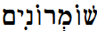 ("Samaritans") occurs only once in the entire OT (2 Kgs 17:29), and there it refers not to the so-called "mixed race" who appear in the NT, but rather to the former inhabitants of Samaria, many of whom were carried off into exile. As Unger states: It is customary to refer "Samaritans" in this passage to the colonists brought by the king of Assyria in place of the deported Israelites; but the text seems rather to mean that these colonists put their gods into the houses of the high places which the "Samaritans," i.e., the former inhabitants of Samaria, had made for their own religious use. ...³¹ Indeed, Coggins claims that "there are no unambiguous references to the Samaritans in the Hebrew Old Testament."³² The LXX has Samaeitai, again only at 2 Kgs 17:29. This word also occurs in Josephus and the NT, and from it the English form is derived. The more usual name found in Josephus and the Talmud is Kutim or Cutheans, which refers to one of the groups of foreign colonists mentioned in 2 Kgs 17:24, 30. This name, of course, emphasizes the supposed heathen origins and syncretistic practice of the Samaritans. Another name used several times by Josephus is "She- chemites" (Sikimitai),33 a name which refers to their principal city. Josephus also says that the Samaritans of the Hellenistic period called themselves "Sidonians in Shechem" when they wanted to dissociate themselves from the Jews and win the support of Antiochus Epiphanes.34
…
According to 2 Kgs 17:24, "the king of Assyria brought men from Babylon and from Cuthah and from Avva and from Hamath and Sephar-vaim, and settled them in the cities of Samaria in place of the sons of Israel." If these were limited mainly to the vicinity of the city of Samaria, this would account well for the fact that the Galilee of NT times remained a Jewish region.⁵² The conquests of several of these nations were referred to later, in 701 B.C., by Rabshakeh when he taunted the people of Jerusalem with these words: Has anyone of the gods of the nations delivered his land from the hand of the king of Assyria? Where are the gods of Hamath and Arpad? Where are the gods of Sepharvaim, Hena and Ivvah? Have they delivered Samaria from my hand? (2 Kgs 18:33-34; cf. Isa 36: 18-20) Additional colonists were imported by Esarhaddon about 680 B.C. and by Ashurbanipal about 669-630 B.C.53 Many of these peoples kept their separate identities for several generations, as is shown by their statement to Zerubbabel (ca. 535 B.C.) that "we have been sacri- ficing to Him [Yahweh God] since the days of Esarhaddon king of Assyria, who brought us up here" (Ezra 4:2).
Source: https://digitalcommons.liberty.edu/cgi/viewcontent.cgi?article=1071&context=sor_fac_pubs
Samaritans
Byzantine times
Further information: Samaritan Revolts
This period is considered as something of a golden age for the Samaritan community, the population thought to number up to a million.^{[61]}
According to Samaritan sources, Eastern Roman emperor Zeno (who ruled 474–491 and whom the sources call "Zait the King of Edom") persecuted the Samaritans. The Emperor went to Neapolis (Shechem), gathered the elders and asked them to convert; when they refused, Zeno had many Samaritans killed, and re-built the synagogue as a church. Zeno then took for himself Mount Gerizim, where the Samaritans worshiped God, and built several edifices, among whom a tomb for his recently deceased son, on which he put a cross, so that the Samaritans, worshiping God, would prostrate in front of the tomb. Later, in 484, the Samaritans revolted. The rebels attacked Sichem, burned five churches built on Samaritan holy places and cut the finger of bishop Terebinthus, who was officiating the ceremony of Pentecost. They elected a Justa (or Justasa/Justasus) as their king and moved to Caesarea, where a noteworthy Samaritan community lived. Here several Christians were killed and the church of St. Sebastian was destroyed. Justa celebrated the victory with games in the circus. According to John Malalas, the dux Palaestinae Asclepiades, whose troops were reinforced by the Caesarea-based Arcadiani of Rheges, defeated Justa, killed him and sent his head to Zeno.^{[62]} According to Procopius, Terebinthus went to Zeno to ask for revenge; the Emperor personally went to Samaria to quell the rebellion.^{[63]}
Some modern historians believe that the order of the facts preserved by Samaritan sources should be inverted, as the persecution of Zeno was a consequence of the rebellion rather than its cause, and should have happened after 484, around 489. Zeno rebuilt the church of St. Procopius in Neapolis (Sichem) and the Samaritans were banned from Mount Gerizim, on whose top a signalling tower was built to alert in case of civil unrest.^{[64]}
Under a charismatic, messianic figure named Julianus ben Sabar (or ben Sahir), the Samaritans launched a war to create their own independent state in 529. With the help of the Ghassanids, Emperor Justinian I crushed the revolt; tens of thousands of Samaritans died or were enslaved. The Samaritan faith, which had previously enjoyed the status of religio licita, was virtually outlawed thereafter by the Christian Byzantine Empire; from a population once at least in the hundreds of thousands, the Samaritan community dwindled to tens of thousands.

Middle Ages
Though initially guaranteed religious freedom after the Muslim conquest of Palestine, Samaritan numbers dropped further as a result of massacres and conversions.^{[65]}
By the time of the early Muslim conquests, apart from Palestine, small dispersed communities of Samaritans were living also in Arab Egypt, Syria, and Iran. Like other non-Muslims in the empire, such as Jews, Samaritans were often considered to be People of the Book. Their minority status was protected by the Muslim rulers, and they had the right to practice their religion, but, as dhimmi, adult males had to pay the jizya or "protection tax". This however changed during late Abbasid period, with increasing persecution targeting the Samaritan community and considering them infidels which must convert to Islam. The tradition of men wearing a red tarboosh may go back to an order by the Abbasid Caliph al-Mutawakkil (847-861 CE) that required non-Muslims to be distinguished from Muslims.^{[66]}
During the Crusades, Samaritans, like the non-Latin Christian inhabitants of the Kingdom of Jerusalem, were second-class citizens, but they were tolerated and perhaps favored because they were docile and had been mentioned positively in the Christian New Testament.^{[67]}

Ottoman rule
While the majority of the Samaritan population in Damascus was massacred or converted during the reign of the Ottoman Pasha Mardam Beq in the early 17th century, the remainder of the Samaritan community there, in particular, the Danafi family, which is still influential today, moved back to Nablus in the 17th century.^{[68]}
The Nablus community endured because most of the surviving diaspora returned, and they have maintained a tiny presence there to this day. In 1624, the last Samaritan High Priest of the line of Eleazar son of Aaron died without issue, but according to Samaritan tradition, descendants of Aaron's other son, Ithamar, remained and took over the office.^{[69]}
By the late Ottoman period, the Samaritan community dwindled to its lowest. In 19th century, with pressure of conversion and persecution from the local rulers and occasional natural disasters, the community fell to just over 100 persons.
…

Genetic studies

Demographic investigation
Demographic investigations of the Samaritan community were carried out in the 1960s. Detailed pedigrees of the last 13 generations show that the Samaritans comprise four lineages:
The Tsedakah lineage, claiming descent from the tribe of Manasseh
The Joshua-Marhiv lineage, claiming descent from the tribe of Ephraim
The Danafi lineage, claiming descent from the tribe of Ephraim
The priestly Cohen lineage from the tribe of Levi.

Y-DNA and mtDNA comparisons
Recently several genetic studies on the Samaritan population were made using haplogroup comparisons as well as wide-genome genetic studies. Of the 12 Samaritan males used in the analysis, 10 (83%) had Y chromosomes belonging to haplogroup J, which includes three of the four Samaritan families. The Joshua-Marhiv family belongs to Haplogroup J-M267 (formerly "J1"), while the Danafi and Tsedakah families belong to haplogroup J-M172 (formerly "J2"), and can be further distinguished by the M67 SNP-- the derived allele of which has been found in the Danafi family-- and the PF5169 SNP found in the Tsedakah family.^{[72]} The only Samaritan family not found in haplogroup J was the Cohen family (Tradition: Tribe of Levi) which was found haplogroup E-M78 (formerly "E3b1a M78").^{[73]} This article predated the change of the classification of haplogroup E3b1-M78 to E3b1a-M78 and the further subdivision of E3b1a-M78 into 6 subclades based on the research of Cruciani, et al.^{[74]}
A 2004 article on the genetic ancestry of the Samaritans by Shen et al. concluded from a sample comparing Samaritans to several Jewish populations, all currently living in Israel—representing the Beta Israel, Ashkenazi Jews, Iraqi Jews, Libyan Jews, Moroccan Jews, and Yemenite Jews, as well as Israeli Druze and Palestinians—that "the principal components analysis suggested a common ancestry of Samaritan and Jewish patrilineages.
Source: https://en.wikipedia.org/wiki/Samaritans
“the principal components analysis suggested a common ancestry of Samaritan and Jewish patrilineages.” Here we go with the vague, devious conclusions that direct people toward a certain belief.
They claim to be the real Israelites, and most of the information about them comes from them, not actual documented history. And as you can see they too have a so-called Cohen family that they created from their own people, just like the Jews. Insane.
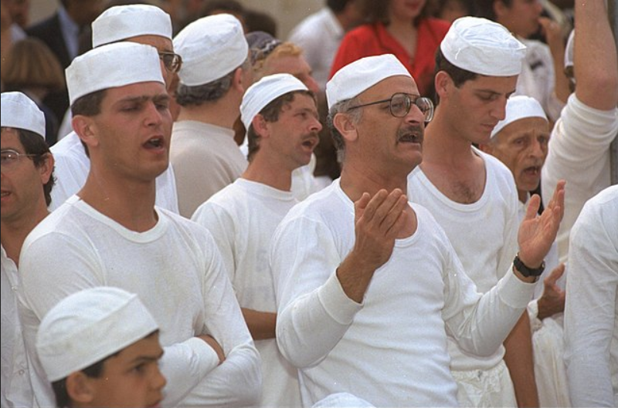
Source: https://en.wikipedia.org/wiki/File:Flickr_-_Government_Press_Office_(GPO)_-_Samaritans_praying_during_Passover_holiday_ceremony_on_mount_Grizim.jpg
If you believe these people are the descendants of the original Samaritans, you need help. This is insane. If you put different clothes on them, and maybe change their facial hair, they could pass for Europeans, Jews and Palestinians, correct? And you remember how the Palestinians were formed?
ARE SAMARITANS A DISAPPEARING PEOPLE ? June 18th 2013
https://www.youtube.com/watch?v=wu6qhJ2HvyY
Inside the Samaritan high priest’s fruity sukkah, literally
https://www.youtube.com/watch?v=fDv9r4NOsmY
Faces of Semite isolated groups (Samaritans & Mandaeans )
https://www.youtube.com/watch?v=WELyKv3gi6w
No one in the Holy Land today is authorized to be there by the Bible or the God of the Bible! There are people who chose to invade the house, and others who chose to join the party taking place inside the occupied house. And it was made clear beforehand who this house belonged to, correct? And all these people spat on that, correct? So, in the future, save the wining and crying and statements about how innocent people are being killed.
Jewish Racism And Supremacy VS. The Bible
The Old Testament, the Bible, and the God of the Bible does not promote or condone racism or supremacy, even by the Israelites/Jews. This is a fact. You will only find this in the Jew’s Talmud and other works, as well as statements made by their leaders. Don’t get the two people and two “religions” mixed up.
Here is the Biblical proof (originally aimed at false doctrine in the Black Israelite community) if you want it:
The Dross and the Chaff – 05 – The Gentile Issue
https://drive.google.com/open?id=1dFl28F8J300OrGjUQxkppbvbly0S6_qM
The Dross and the Chaff – 06 – Is Yah Racist?
https://drive.google.com/open?id=1du9bwkr_qPto9pK66G6XmeFiw9A5yoIx
Note: This also proves that the Tanakh/Old Testament, Bible and God of the Bible does NOT tell Israelites to go take over the land. God told those Israelites during that time period to do so for a specific reason.
The Dross and the Chaff – 07 – The Race Doctrine
https://drive.google.com/open?id=1p06g5rNcd3atZmB8UsFoO-d_SunD5QEd
Here’s an alternative download source:
The Dross and the Chaff – 05 – The Gentile Issue
http://howmanyknow.com/wp-content/uploads/2019/04/05-The-Gentile-Issue.doc
The Dross and the Chaff – 06 – Is Yah Racist?
http://howmanyknow.com/wp-content/uploads/2019/04/06-Is-Yah-racist.doc
The Dross and the Chaff – 07 – The Race Doctrine
http://howmanyknow.com/wp-content/uploads/2019/04/07-The-Race-Doctrine.doc
And if you want Biblical proof that Yahusha/Yeshua/Jesus is the Messiah, animal sacrifices are not said to return, and a third temple is not to be built you can find it here:
The Dross and the Chaff – 12 – Issues With Yahusha/Jesus
https://drive.google.com/open?id=1ojTZ2drfjXsqFCYFBYjdPiMH53O3eL-i
*This document might have too many pages to render a preview in Google Drive.
Alternative download source:
The Dross and the Chaff – 12 – Issues With Yahusha/Jesus
http://howmanyknow.com/wp-content/uploads/2019/07/12-Issues-With-Yahusha-Jesus.doc
And what about the fact that many Jews living in Israel right now are atheists? If they don’t believe there is a God, do they believe He died or something? If there is no God, and was no God, there weren’t any promises made to Abraham, Isaac and Jacob; therefor their claim to the land doesn’t exist.
Conclusion
1. There is no such thing as anti-Semitism!
2. It must be horrible to be an honest “Jewish” person.
3. Boycott Youtube, Facebook, Hollywood, the music industry (especially rap), the mainstream media, and leave porn alone for good. Boycott Israel and China (yes, China; it’s their baby and they have plans for it).

EZEKIEL
CHAPTER 35
MOREOVER the word of the LORD came unto me, saying,
2 Son of man, set thy face against mount Seir, and prophesy
against it,
3 And say unto it, Thus saith the Lord GOD; Behold, O
mount Seir, I am against thee, and I will stretch out mine
hand against thee, and I will make thee most desolate.
4 I will lay thy cities waste, and thou shalt be desolate, and
thou shalt know that I am the LORD.
5 Because thou hast had a perpetual hatred, and hast shed
the blood of the children of Israel by the force of the sword
in the time of their calamity, in the time that their iniquity
had an end:
6 Therefore, as I live, saith the Lord GOD, I will prepare
thee unto blood, and blood shall pursue thee: sith thou hast
not hated blood, even blood shall pursue thee.
7 Thus will I make mount Seir most desolate, and cut off
from it him that passeth out and him that returneth.
8 And I will fill his mountains with his slain men: in thy
hills, and in thy valleys, and in all thy rivers, shall they fall
that are slain with the sword.
9 I will make thee perpetual desolations, and thy cities shall
not return: and ye shall know that I am the LORD.
10 Because thou hast said, These two nations and these two
countries shall be mine, and we will possess it; whereas the
LORD was there:
11 Therefore, as I live, saith the Lord GOD, I will even do
according to thine anger, and according to thine envy which
thou hast used out of thy hatred against them; and I will
make myself known among them, when I have judged thee.
12 And thou shalt know that I am the LORD, and that I have
heard all thy blasphemies which thou hast spoken against
the mountains of Israel, saying, They are laid desolate, they
are given us to consume.
13 Thus with your mouth ye have boasted against me, and
have multiplied your words against me: I have heard them.
14 Thus saith the Lord GOD; When the whole earth
rejoiceth, I will make thee desolate.
15 As thou didst rejoice at the inheritance of the house of
Israel, because it was desolate, so will I do unto thee: thou
shalt be desolate, O mount Seir, and all Idumea, even all of
it: and they shall know that I am the LORD.
EZEKIEL
CHAPTER 36
ALSO, thou son of man, prophesy unto the mountains of
Israel, and say, Ye mountains of Israel, hear the word of the
LORD:
2 Thus saith the Lord GOD; Because the enemy hath said
against you, Aha, even the ancient high places are ours in
possession:
3 Therefore prophesy and say, Thus saith the Lord GOD;
Because they have made you desolate, and swallowed you
up on every side, that ye might be a possession unto the
residue of the heathen, and ye are taken up in the lips of
talkers, and are an infamy of the people:
4 Therefore, ye mountains of Israel, hear the word of the
Lord GOD; Thus saith the Lord GOD to the mountains, and
to the hills, to the rivers, and to the valleys, to the desolate
wastes, and to the cities that are forsaken, which became a
prey and derision to the residue of the heathen that are
round about;
5 Therefore thus saith the Lord GOD; Surely in the fire of
my jealousy have I spoken against the residue of the
heathen, and against all Idumea, which have appointed my
land into their possession with the joy of all their heart,
with despiteful minds, to cast it out for a prey.
6 Prophesy therefore concerning the land of Israel, and say
unto the mountains, and to the hills, to the rivers, and to the
valleys, Thus saith the Lord GOD; Behold, I have spoken in
my jealousy and in my fury, because ye have borne the
shame of the heathen:
7 Therefore thus saith the Lord GOD; I have lifted up mine
hand, Surely the heathen that are about you, they shall bear
their shame.
8 ¶ But ye, O mountains of Israel, ye shall shoot forth your
branches, and yield your fruit to my people of Israel; for
they are at hand to come.
9 For, behold, I am for you, and I will turn unto you, and ye
shall be tilled and sown:
10 And I will multiply men upon you, all the house of
Israel, even all of it: and the cities shall be inhabited, and
the wastes shall be builded:
11 And I will multiply upon you man and beast; and they
shall increase and bring fruit: and I will settle you after your
old estates, and will do better unto you than at your
beginnings: and ye shall know that I am the LORD.
12 Yea, I will cause men to walk upon you, even my people
Israel; and they shall possess thee, and thou shalt be their
inheritance, and thou shalt no more henceforth bereave
them of men.
13 Thus saith the Lord GOD; Because they say unto you,
Thou land devourest up men, and hast bereaved thy
nations;
14 Therefore thou shalt devour men no more, neither
bereave thy nations any more, saith the Lord GOD.
15 Neither will I cause men to hear in thee the shame of the
heathen any more, neither shalt thou bear the reproach of
the people any more, neither shalt thou cause thy nations to
fall any more, saith the Lord GOD.
Video List
01 - Jewish Kabbalistic Occult Ritual Child Murder throughout history
https://www.bitchute.com/video/EwN5G9rItuKB/
Alternative source:
https://www.bitchute.com/video/EwN5G9rItuKB/
02 - Vicki Devil Worship - 1989 Oprah Winfrey Show Interview With A Jewish Woman
https://www.bitchute.com/video/SWQF31X7NHbQ/
Alternative source:
https://www.bitchute.com/video/lQzLQJei5rYy/
03 - Satan's Children - Terrifying, True Stories of Satanic Ritual Abuse
https://www.youtube.com/watch?v=OH75pRWE4Bw
04 - Michael Hoffman & Texe Marrs - Dark Secrets Of The Talmud (1_2)
https://www.youtube.com/watch?v=A2MBdlOP_HM
Alternative source:
https://archive.org/details/youtube-TAhnqti_R3k
05 - Michael Hoffman & Texe Marrs - Dark Secrets Of The Talmud (2_2)
https://www.youtube.com/watch?v=8ENIivsnflg
Alternative source:
https://archive.org/details/youtube-uwcJ9kV36Mg
06 - Truth about the Talmud - Racist Rabbinic Hate Literature
https://www.youtube.com/watch?v=WhnaAm39QYM
Alternative source:
https://www.dailymotion.com/video/x2uznkg
07 - Secrets of Kabbalah
https://www.youtube.com/watch?v=ELhxhAPdiic
Watch the beginning - 37:56
08 - 1666 Sabbatean - Frankist Illuminati History [edit]
https://www.youtube.com/watch?v=vWMxHBuuP6U
Alternative source:
https://www.bitchute.com/video/4eqlkGf3TVEX/
09 - Sabbatai Sevi, the Zohar and Usury, pt 2 of 5
https://www.bitchute.com/video/u1Jy7ZT1Wh8h/
10 - The Rise of the Rothschild’s Communism
https://www.youtube.com/watch?v=WilvbIpBzqk
Alternative source:
https://www.brighteon.com/5303e953-a159-4908-bc70-ae820b6dd53e
11 - Can You Handle The Facts About Some Jews
https://www.bitchute.com/video/Kmk5Adc3LHD3/
12 - Capitalist Elites Funded the Bolshevik Revolution - Professor Antony Sutton
https://www.youtube.com/watch?v=SCFgwoQRtGU
13 - Christopher Jon Bjerknes - Zionist Massacres 1913-2016
https://www.youtube.com/watch?v=VeFNImHFlaU
Alternative source:
https://www.brighteon.com/5856561872001
14 - NEW WORLD ORDER PLEDGED TO JEWS
https://www.youtube.com/watch?v=GJnR3yJ88Xk
Alternative sources:
https://www.youtube.com/watch?v=3279s87zSQs
https://archive.org/details/NEWWORLDORDERPLEDGEDTOJEWSOctober61940Trans22
15 - Richard Grove on the Rothschilds and WWI [edit]
https://www.bitchute.com/video/X5foKdJrxj4C/
16 - How the Jewish Rothschild Zionists Created Modern Israel
https://www.bitchute.com/video/2qlGVkHaeFc/
Alternative source:
https://www.bitchute.com/video/dMLeUsDaN9e6/
Watch 28:15 - 36:18
17 - Who Funded Hitler -- Questions For Corbett 008 [edit]
https://youtu.be/rQH-ING_yds?t=1695
Alternative source:
https://www.corbettreport.com/who-funded-hitler-questions-for-corbett-008/
Watch 56:01 – the end
18 - 1666 Sabbatean-Frankist Illuminati History
https://youtu.be/vWMxHBuuP6U?t=3361
Alternative source:
https://www.bitchute.com/video/wIOC0h1aS8g8/
Additional information
https://www.amazon.com/1666-Redemption-Through-Sin-Conspiracy/dp/1943494010
https://ia801901.us.archive.org/3/items/1666-redemption-through-sin-global-conspi-robert-sepehr/1666-Redemption-Through-Sin-Global-Conspi-Robert-Sepehr.pdf
19 - Secret NAZI National Socialism and Zionism agreement revealed
https://www.bitchute.com/video/kj6t0UOrRtOk/
20 - An Honest Conversation About the Jewish Holocaust
https://www.bitchute.com/video/q-KT1IHcxyA/
21 - Historical Dispute Between Germans and Jews During WW2 [edit]
https://www.bitchute.com/video/Bh2IjMufUAUe/
Alternative source:
Watch 15:39 – the end
https://videopress.com/v/eOMxgmQz?at=940
22 - Raul Hilbergs Stunning Admission [edit]
https://www.youtube.com/watch?v=2q51wqEE1fM
Alternative sources:
https://www.bitchute.com/video/ZOXNQUiJaruN/
https://www.bitchute.com/video/p1gemxr2OuE3/
23 - The Truth Behind the Gates of Auschwitz - by David Cole
https://archive.org/details/TheTruthBehindTheGatesOfAuschwitzByDavidCole
Alternative sources:
https://archive.org/details/DavidCole-TheTruthBehindTheGatesOfAuschwitz/DavidCole-TheTruthBehindTheGatesOfAuschwitz1of2.mp4
https://www.bitchute.com/video/0hHuDez96oUK/
24 - Auschwitz versus Science - a documentary about the gas chambers and crematoria of the holocaust
https://archive.org/details/youtube-Boj4tEU66Pg
Alternative source:
https://www.bitchute.com/video/IlgU1oSDjTIz/
25 - Probing The Holocaust - Part I
https://archive.org/details/youtube-3xfJFYHl3kk
Alternative source:
https://153news.net/watch_video.php?v=9SYWOX926784
26 - Eyewitness Testimony of the Holocaust
https://www.bitchute.com/video/BB33QJW0KRBr/
27 - The Jewish Gas Chamber Hoax
https://www.bitchute.com/video/Tslr28aefZI5/
Alternative source:
https://www.bitchute.com/video/cbu0OPqTVFoB/
28 - Auschwitz The surprising hidden truth
https://www.bitchute.com/video/70Vkz1SR377K/
29 - Not a single Jew died in a gas
https://www.bitchute.com/video/9kFMiq2MPt2E/
30 - Holocaust Survivors who told the Truth
https://www.bitchute.com/video/zKcxCnP2PfeP/
Watch 19:26 – 1:01:45
31 - David Irving on the alleged Holocaust [edit]
https://www.bitchute.com/video/xTDzIiYmK81c/
32 - Schindlers List is a work of fiction
https://www.bitchute.com/video/kQ6R236IIbcQ/
33 - AUSCHWITZ - Produced by Steven Spielberg Features Meryl Streep
https://www.youtube.com/watch?v=ZJAdbZnPZ_c
34 - The First Holocaust The surprising origin of the Six Million figure
https://www.bitchute.com/video/ggwlhZGICiAf/
35 – Six Million
https://www.bitchute.com/video/v1VZDFuzjFig/
Alternative source:
https://archive.org/details/SixMillionJews19151938
36 - 6,000,000 LIE - Part I
https://www.bitchute.com/video/gTgjA6wuIsAM/
37 - The Changing Auschwitz Death Toll
https://www.bitchute.com/video/jPA3NoMmE4nC/
38 - Six Million Jews
https://www.bitchute.com/video/9gbB5u1mjxM6/
39 - What the jews did to the Germans
https://www.bitchute.com/video/zWtGkzgWejLm/
Alternative source:
https://www.bitchute.com/video/4YpVn8ZPo47k/
40 - Ernst Zundel Warns The Jews Are Doing To America What They Did To Weimar Germany
https://archive.org/details/ErnstZundelWarnsTheJewsAreDoingToAmericaWhatTheyDidToWeimarGermanySD360p
Alternative sources:
https://www.bitchute.com/video/7JWWj3isSOEz/
https://www.youtube.com/watch?v=ie3C-WS_8kQ
41 - Banking on Anti-Semitism 1 of 3
https://www.bitchute.com/video/RZFhpqt8bMlS/
Alternative source:
https://www.brighteon.com/3c718074-817e-4c67-bb98-7bdb7586a80a
42 - Banking on Anti-Semitism 2 of 3
https://www.bitchute.com/video/0Dm5ZL1gXagR/
43 - Banking on Anti-Semitism 3 of 3
https://www.bitchute.com/video/XzQcFnQVYetg/
44 - Jewish senator Chuck Schumer says he serves Israel "first and foremost", not America.
https://www.bitchute.com/video/ImyVOYL6zATl/
45 - Goldman Sachs Rips Off Libya, Donald Trump Admits Screwing Gaddafi
https://www.youtube.com/watch?v=BvIPUHVI3Cg
46 - Gaddafi's Stolen Billions - Max Keiser Explains Financial Terrorism
https://www.youtube.com/watch?v=YUkNnQE-9B4
47 - Meet Goldman Sachs, the Vampire Squid
https://www.bitchute.com/video/FHNAZMIcFNg/
Alternative source:
https://www.youtube.com/watch?v=FHNAZMIcFNg
48 - Putin, KGB, Chabad, & Mossad
https://www.bitchute.com/video/hoQhXh_Q0AU/
Alternative sources:
https://www.bitchute.com/video/sjamqYPk2lPz/
https://www.bitchute.com/video/MhlpYrkuMlfg/
49 - Banksta's Paradise feat. Donald Trump
https://www.bitchute.com/video/qHQQ7XiSQoJi/
Alternative source:
https://www.youtube.com/watch?v=YW4CvC5IaFI
50 - The Jews Who Own The Media
https://www.bitchute.com/video/bNWeWz8l8dEi/
Alternative source:
https://www.brighteon.com/fa408d18-43a5-468d-b732-d72233f3398e
51 - Jewish Hollywood's Fatal Embrace
https://archive.org/details/BrotherNathanaelKapnerArchives/JewishHollywoodsFatalEmbrace.mp4
Alternative sources:
https://www.brighteon.com/94882f29-9df8-4923-83be-0f31838c5f62
https://www.dailymotion.com/video/x66b1xi
52 - Unless you are Jewish, you are nobody in Hollywood
https://www.youtube.com/watch?v=Vgt2J54iZOQ
Alternative sources:
https://www.youtube.com/watch?v=Yqcox0I8kh0
https://www.brighteon.com/f153116e-585e-4a24-852b-83a73f3cc8b1
53 - Hollywoodism [edit]
https://www.bitchute.com/video/46H0DarofZkC/
Alternative source:
https://www.brighteon.com/b0e1936b-1d0c-4e80-9267-eb4852617cc1
54 - We Run Rap Music - Part 1
https://www.youtube.com/watch?v=gkyuy3_HR2c
Alternative sources:
https://www.bitchute.com/video/xe5ZOJxrCrFy/
https://www.brighteon.com/2de3a4d0-91bd-4e49-97a2-22769a7c2d73
55 - We Run Rap Music - Part 2
https://www.bitchute.com/video/r3r0uvfCuLro/
Alternative source:
https://www.brighteon.com/09c178be-a786-4927-b6b5-c4d7c4a4b065
56 - The Tall Israeli That Runs The Rap Industry - Illuminati Satanic Music Industry Exposed
https://www.youtube.com/watch?v=OO3WF1Ek7RU
Alternative sources:
https://www.bitchute.com/video/PWpU9HKfTXu0/
https://www.brighteon.com/f6ac30f5-c4bc-4c40-9d2d-254835406fcd
57 - Jewish Influence Part II - The Porn Industry - Mark Collett
https://www.brighteon.com/acffb00d-d816-4cab-a197-0033a475ebe7
Alternative source:
https://www.bitchute.com/video/k2UIIKvEYMo/
58 - America is Owned (Wake-up Goyim)
https://www.bitchute.com/video/fZgNkmP9B9so/
59 - How The Jews Mock Jesus Christ
https://www.youtube.com/watch?v=LHfzWHL8GG4
60 - Dr. David Duke - Jewish Racism Against Gentiles (Goyim)
https://archive.org/details/youtube-fhJ31nR2XdQ
Alternative sources:
https://www.bitchute.com/video/U9bTfy4UsnvE/
https://www.youtube.com/watch?v=fhJ31nR2XdQ
61 - Jewish $upremacy EXPOSED!!!
https://www.bitchute.com/video/LVwhUeT6TDs/
Alternative source:
https://www.youtube.com/watch?v=LVwhUeT6TDs
Watch the beginning - 27:10
62 - The ADL, SPLC & the Scourge of Jewish Supremacism [edit]
https://www.bitchute.com/video/sbyBgMR0RqBf/
63 - Zionist - How To Kill Goyim Children And Families,, Influence People
https://www.bitchute.com/video/MW5Lyso7lyNm/
Alternative sources:
https://www.youtube.com/watch?v=NDztvLWURd8
https://www.youtube.com/watch?v=7t_LxpCY2G8
64 - Rabbis Against Zionism
https://www.bitchute.com/video/FuinbTjxqIoW/
65 - Empire Files: How Palestine Became Colonized
https://www.youtube.com/watch?v=BT5L4YU_Fl4
Alternative source:
https://www.bitchute.com/video/xez77uwbHj1D/
Watch the beginning - 1:16:50
66 - ISRAHELL ON EARTH [edit]
https://www.bitchute.com/video/IgyKdMgVr7A1/
Alternative sources:
https://vimeo.com/192434222
https://www.youtube.com/watch?v=Yt3d3Fmouh4
https://archive.org/details/israhell-on-earth_2012
67 - Alison Weir 2006 “Off the Charts”
https://www.youtube.com/watch?v=ziSTY408h6k
Alternative sources:
https://www.youtube.com/watch?v=T5yO_uI2m38
https://archive.org/details/Off_the_Charts-_Alison_Weir
https://archive.org/details/oalisonweir2006offthecharts
68 - The Truth of Children as Human Shields in Palestine
https://www.bitchute.com/video/Z0S0dF9xco4f/
69 - Video screened at UN Human Rights Council meeting, February 28, 2019
https://www.youtube.com/watch?v=UzTYXjVQRaA
Alternative source:
https://www.youtube.com/watch?v=tPuxOyDPDFM
70 - Israel Committed War Crimes Against Palestine Says UN
https://www.youtube.com/watch?v=_E0ChWNOMM8
71 - Netanyahu Lies Blames Hamas — EXPOSED
https://www.bitchute.com/video/9C8YXFdWYhmk/
72 - Empire Files: Israelis Speak Candidly to Abby Martin About Palestinians
https://www.youtube.com/watch?v=1e_dbsVQrk4
Watch the beginning - 22:03
73 - Empire Files: Inside Palestine’s Refugee Camps [edit]
https://www.youtube.com/watch?v=HxvNZisaB8E
74 - 5 reasons why Israel is an Apartheid State - weapons of mass distraction
https://www.youtube.com/watch?v=RPX0F-UqF-k
Alternative source:
https://www.youtube.com/watch?v=hw-8BVPfSK4
75 - The Black Man's Burden
https://www.bitchute.com/video/5glddAsBJwEt/
Alternative source:
https://www.brighteon.com/e670af51-3e91-4889-ada0-99211b638503
76 - Jews Dominated The Slave Trade - Ft Public Enemy
https://www.bitchute.com/video/TgRb7IGTICEF/
77 - Black PALESTINE In Israel
https://www.youtube.com/watch?v=yHz7CbOxTV8
Alternative source:
https://www.youtube.com/watch?v=RXGNQG2hcdY
78 - Ethiopian Jews in Israel
https://www.bitchute.com/video/sdRFV9FNU7qc/
Watch the beginning - 5:12
79 - Israel's Forced Eugenics Exposed | Brainwash Update [edit]
https://www.youtube.com/watch?v=Fmwkx2Aab7s
80 - Ethiopian Israelis in Nishmat
https://www.youtube.com/watch?v=PDHvuPfQiws
81 - Empire Files: Anti-Black Racism Reveal's Israel's White Supremacy
https://www.youtube.com/watch?v=5YtaYX7Rstc
Alternative source:
https://www.bitchute.com/video/xez77uwbHj1D/
82 - Israel NO BLACKS ALLOWED!
https://www.bitchute.com/video/vps4rJj1AkdT/
83 - Israel's New Racism - The Persecution of African Migrants in the Holy Land
https://www.dailymotion.com/video/x76rid3
Alternative sources:
https://www.youtube.com/watch?v=t6Ww_DtVXDs
https://www.youtube.com/watch?v=dXTMJr7tuXI
https://www.youtube.com/watch?v=dPxv4Aff3IA
84 - The Outrageous Racist Hypocrisy of Israel and World Zionism!
https://www.youtube.com/watch?v=-TvSiYu8z2M
Alternative source:
https://archive.org/details/youtube-iUep1TLzeUs
85 - Dr. David Duke - How Zionists Divide and Conquer
https://www.bitchute.com/video/YysgntGSDAID/
Alternative source:
https://www.youtube.com/watch?v=wY1TG3yehzI
86 - What World Famous Men Said About Jews
https://archive.org/details/What.World.Famous.Men.Said.About.Jews
Alternative source (the beginning - 21:21):
https://www.youtube.com/watch?v=b5Xu6Ka4NrA
87 - Quotes on Jews from famous persons of history
https://www.bitchute.com/video/yht8NkbeOy42/
Alternative sources:
https://archive.org/details/QuotesOnJewsFromFamousPersonsOfHistory
https://archive.org/details/QuotesOnJewsFromFamousPersonsOfHistory_201803
88 - The Truth About Anti-Semitism
https://www.bitchute.com/video/rf3a0Qv7WxWK/
Alternative source:
https://www.youtube.com/watch?v=-RNF2GnDP4o
89 - Anti-Semitism Czar Press Conference Analysis
https://www.bitchute.com/video/dT-RIos3fnE/
Alternative source:
https://www.youtube.com/watch?v=dT-RIos3fnE
90 - The Prohibition of Anti-Semitism
https://www.bitchute.com/video/x7dL8yVagnM/
Alternative source:
https://www.youtube.com/watch?v=x7dL8yVagnM
All glory to Yahua (God) and Yahusha (Jesus)

Franklin Miller (Writeous1)
http://howmanyknow.com/
writeousservant@gmail.com
writeous1@howmanyknow.com
https://www.bitchute.com/channel/YhZAtGMGFLe1/
https://www.youtube.com/channel/UC6UWuuP9KUSYMIYU-nxmHNw

