COVID Truth – Reality Redefined

What a lot of people hate most about this whole COVID-19 situation is the lockdowns and being required to wear masks. But me, what I hate most about this whole thing is going outside and seeing all the dead bodies; and seeing all the people coughing up blood. I hate going to the stores and seeing all the human suffering, all the coughing and groaning, and people dying right in front of me. I hate hearing about one friend and family member after another being hospitalized or dying from COVID-19.
Oh, sorry, I was just day-dreaming about a deadly pandemic. But don’t worry, I’m back to reality now … the opposite of all that you just read.

In order to truly understand this COVID-19 pandemic, you must understand COVID-19 vocabulary.

COVID-19 Vocabulary
infected with COVID-19 – 1. A person who received a positive test result from a PCR test. 2. A person who received a positive test result from an antibody test. 3. A person who received a positive test result from an antigen test. 4. A person who received a COVID positive diagnosis made through a clinical diagnosis, meaning a medical professional looked at some of the symptoms the person had and came to that conclusion without performing a test. 5. A medical professional wrote COVID-19 in the paperwork. 6. A coroner wrote COVID-19 on the death certificate.
case – same as above.
case of COVID – same as above.
new case – same as above.
confirmed case – same as above.

COVID hospitalization – A person who checked into a medical facility for whatever reason, but was also found to be infected with COVID-19 (see above) before or after checking in.
hospitalized due to COVID – same as above.
COVID patient – same as above.
patient with COVID – same as above.

COVID death – A person who died from any cause, but was also found to be infected with COVID-19 (see above) before, during or after the death; even months after the death.
deaths from COVID – same as above.
confirmed deaths – same as above.
died from COVID – same as above.
have been killed by COVID – same as above.
COVID death count – The total number of COVID deaths (see above).

case fatality rate – The number of known cases (see above) divided by the number of COVID deaths (see above).
pandemic – A declaration made by an authority based on new cases (see above for COVID-19).
COVID model – A scientific model used to simulate how COVID-19 will behave in the future. It’s based on collected data, the most important of which being the confirmed cases (see above) and confirmed deaths (see above). Governments and others then create policy based on these models.
asymptomatic case of COVID-19 – A case of COVID-19 (see above) where the person doesn’t have any symptoms.
R₀ – How communicable a disease is within a population (a disease’s potential for transmission). This is calculated by taking the ratio between the number of infections (see above for COVID-19) and the number of contacts the initial infected person had.

And now all you have to do is read. What will you be reading? Several segments of quoted and sourced information on the tests, and then the deaths; things you may have never heard before or seen in this light.

“‘I think that the Chinese laboratories have been amazingly fast,’ says Dr. Stanley Perlman, a coronavirus scientist at the University of Iowa. ‘I haven't seen any publications to show they're validated — and that's of course what you want to know. But I think they are really capable of doing this pretty quickly.’ Validating the test is critical — otherwise you have no idea how many false findings you're getting. You don't want to flag people who have simply been infected with one of harmless coronaviruses that are already in wide circulation. And you don't want a test that misses a lot of cases either.”
Source: How A Coronavirus Blood Test Could Solve Some Medical Mysteries
(February 28, 2020)
https://www.npr.org/sections/health-shots/2020/02/28/810131079/how-a-coronavirus-blood-test-could-solve-some-medical-mysteries

“To identify the virus, the C.D.C. test used three small genetic sequences to match up with portions of a virus’s genome extracted from a swab. A German-developed test that the W.H.O. was distributing to other countries used just two, potentially making it less precise. But soon after the F.D.A. cleared the C.D.C. to share its test kits with state health department labs, some discovered a problem. The third sequence, or ‘probe,’ gave inconclusive results.”
Source: The Lost Month: How a Failure to Test Blinded the U.S. to Covid-19
(Published March 28, 2020 Updated April 1, 2020)
https://www.nytimes.com/2020/03/28/us/testing-coronavirus-pandemic.html

“WHO has shipped almost 1.5 million tests to 120 countries.”
Source: WHO Director-General's opening remarks at the media briefing on COVID-19
(March 16, 2020)
https://www.who.int/dg/speeches/detail/who-director-general-s-opening-remarks-at-the-media-briefing-on-covid-19---16-march-2020

“On Feb 12, the CDC announced that several test kits sent to public health labs had an issue with a test reagent, which caused the negative control to generate a test response where there should have been none.”
Source: As CDC warns of US COVID-19 spread, labs frustrated over lack of tests
(Febuary 25, 2020)
https://www.cidrap.umn.edu/news-perspective/2020/02/cdc-warns-us-covid-19-spread-labs-frustrated-over-lack-tests

“Stenzel is a highly-regarded scientist and diagnostics expert. He was on the ground in Atlanta to deal with technical issues and happened to stumble upon the inappropriate procedures and possible contaminants.”
Source: Scoop: Lab for coronavirus test kits may have been contaminated
(Updated March 1, 2020)
https://www.axios.com/cdc-lab-coronavirus-contaminated-6dc9726d-dea3-423f-b5ad-eb7b1e44c2e2.html

“Administrators did not reveal whether the contamination in the Atlanta lab was the root of the problem in the first batch of test kits or if the incidents were unrelated. They also declined to say if the contamination was an isolated problem or a systematic issue.”
Source: CDC lab producing coronavirus test kits may have been contaminated
(March 02, 2020)
https://www.washingtonexaminer.com/news/cdc-lab-producing-coronavirus-test-kits-may-have-been-contaminated

“On Tuesday, Dr. Deborah Birx, the White House's coronavirus response coordinator, also discussed why the United States had not adopted a test distributed by WHO as the CDC-developed test struggled. ‘Because quality testing for our American people is paramount to us,’ Birx said before suggesting that other tests have been inaccurate. ‘It doesn't help to put out a test where 50% or 47% are false positives. ‘Imagine what that would mean to the American people,’ she added. ‘Imagine their level of concern now in telling people that they're false positive.’ CNN has reached out to the White House for comment. The New York Times reported Tuesday that Birx later clarified her comments, saying that, while she was responding to a question about the WHO test, she was referring to a study of an early coronavirus test used in China. The study found that, in China, nearly half of asymptomatic people could test positive for Covid-19, the disease caused by the novel coronavirus, without being actually infected. Regarding the test distributed by the World Health Organization, Birx said ‘I assume it is functional,’ according to the Times.”
Source: WHO and CDC never discussed providing international test kits to the US, global health agency says
(March 18, 2020)
https://edition.cnn.com/2020/03/18/health/who-coronavirus-tests-cdc/index.html

“On March 12th, the F.D.A. allowed the Wadsworth Laboratory, in Albany, to authorize other labs in the state to develop and run COVID-19 tests. The next day, President Trump signed a memorandum instructing the F.D.A. to allow every other state public-health lab the same regulatory authority, which the agency put into effect on March 16th. Bill Whitmar, of Missouri, told me that he had received dozens of e-mails from companies seeking approval for their tests. ‘If I had a nickel for every company that said, “I’ve got a COVID-19 test. I want you to take a look at her. Give me a call,” I’d have enough for a tank of gas, for sure, and I’ve got a big truck.’ As another clinical-lab director put it, ‘Every company is coming out of the woodwork saying, “I have the best test in the world,” and ninety-five per cent of them will probably be crap.’ The clinical lab director expressed concern that granting regulatory authority to the states means that ‘we are now in the Wild West of laboratory regulation. It’s really a let-the-buyer-beware world. Essentially, apart from the F.D.A.’s E.U.A. process, there is very limited regulation of the quality, accuracy, and specificity of diagnostic tests for COVID-19, and I think that’s a dangerous situation.’”
Source: Why Widespread Coronavirus Testing Isn’t Coming Anytime Soon
(March 24, 2020)
https://www.newyorker.com/news/news-desk/why-widespread-coronavirus-testing-isnt-coming-anytime-soon

“On Monday, (three days after Crenshaw made his claim) the FDA announced another change to its policies and put state officials in charge of coronavirus tests developed by laboratories in their states, meaning labs would engage with state officials and not the FDA. It also removes the requirement for these labs to apply for an Emergency Use Authorization for their tests.”
Source: Fact-check: Did FDA regulations slow testing for coronavirus?
(Mar 20, 2020)
https://www.statesman.com/news/20200320/fact-check-did-fda-regulations-slow-testing-for-coronavirus

“We were working with over 100 developers of tests during that period of time, including commercial laboratories. And David, it's really important understand getting an accurate and reliable test on the market's important. Our team can provide you with an abstract that was recently published in the literature about a test that was performed in another country that demonstrated a 47% false positive rate. Now, think about that, David. What that means is that if you had a positive test, it was pretty close to a flip of a coin as to whether it was real or not. … Our manufacturers that we've been working with throughout these last couple of months have told us that it normally takes them six months to develop a test and they've done it in four to six weeks in collaboration with the FDA.”
Source: Transcript: Full Transcript With FDA Commissioner Stephen Hahn
(March 20, 2020)
https://www.npr.org/2020/03/20/818855649/transcript-full-transcript-with-fda-commissioner-stephen-hahn

“Results: When the infection rate of the close contacts and the sensitivity and specificity of reported results were taken as the point estimates, the positive predictive value of the active screening was only 19.67%, in contrast, the false-positive rate of positive results was 80.33%. The multivariate-probabilistic sensitivity analysis results supported the base-case findings, with a 75% probability for the false-positive rate of positive results over 47%. Conclusions: In the close contacts of COVID-19 patients, nearly half or even more of the 'asymptomatic infected individuals' reported in the active nucleic acid test screening might be false positives.”
Source: [WITHDRAWN: Potential false-positive rate among the 'asymptomatic infected individuals' in close contacts of COVID-19 patients].
(March 5, 2020)
https://www.ncbi.nlm.nih.gov/pubmed/32133832?fbclid=IwAR0TDVA0cw8F1gRsfeDY4gc-a59T3jfgaZIYOt0pmqdlMfAbYvYqFXdCZnk
Alternative source:
[RETRACTED][Potential false-positive rate among the 'asymptomatic infected individuals' in close contacts of COVID-19 patients]
http://archive.is/Wvy2P#selection-1885.0-1885.127

PCR tests create copies of DNA or RNA to levels where it can be detected. This multiplication process is called amplification, and the completion of this process one time would constitute one cycle. One cycle turns 1 into 2; a second cycle turns 2 into 4; a third cycle turns 4 into 8, and so on. Well, it turns out that the standard cycle threshold (number of cycles done on a sample) for COVID-19 testing has been 40 cycles, which is absolutely insane.

Watch 3:03:10 - 3:13:19, if watched from Bitchute of Odysee.
*This was a live stream, and Youtube corrupts his live streams, so the Youtube copy may not be the same as the other two.
Capitol Timeline Reveals Truth, Microsoft Vaccine Passport & PHD Says ‘SARS-CoV-2 Never Isolated’
https://www.thelastamericanvagabond.com/capitol-timeline-reveals-truth-microsoft-vaccine-passport-phd-says-sars-cov-2-never-isolated/

Watch 11:21 - 22:33
The 4th Annual Fake News Awards!
https://www.corbettreport.com/fakenews4/

Take a look at these excerpts from FDA Admits PCR Tests Give False Results, Prepares Ground For Biden To "Crush" Casedemic
The FDA today joined The WHO and Dr.Fauci in admitting there is a notable risk of false results from the standard PCR-Test used to define whether an individual is a COVID "Case" or not. … Here are a few headlines from those experts and scientific studies:
1. Experts compiled three datasets with officials from the states of Massachusetts, New York and Nevada that conclude:“Up to 90% of the people who tested positive did not carry a virus."
2. The Wadworth Center, a New York State laboratory, analyzed the results of its July tests at the request of the NYT: 794 positive tests with a Ct of 40: “With a Ct threshold of 35, approximately half of these PCR tests would no longer be considered positive,” said the NYT. “And about 70% would no longer be considered positive with a Ct of 30! “
3. An appeals court in Portugal has ruled that the PCR process is not a reliable test for Sars-Cov-2, and therefore any enforced quarantine based on those test results is unlawful.
4. A new study from the Infectious Diseases Society of America, found that at 25 cycles of amplification, 70% of PCR test "positives" are not "cases" since the virus cannot be cultured, it's dead. And by 35: 97% of the positives are non-clinical.
5. PCR is not testing for disease, it's testing for a specific RNA pattern and this is the key pivot. When you crank it up to 25, 70% of the positive results are not really "positives" in any clinical sense, since it cannot make you or anyone else sick
… In mid-November, none other than he who should not be questioned - Dr. Anthony Fauci - admitted that the PCR Test's high Ct is misleading:
“What is now sort of evolving into a bit of a standard,” Fauci said, is that “if you get a cycle threshold of 35 or more … the chances of it being replication-confident are minuscule.”
“It’s very frustrating for the patients as well as for the physicians,” he continued, when “somebody comes in, and they repeat their PCR, and it’s like [a] 37 cycle threshold, but you almost never can culture virus from a 37 threshold cycle.”
So, I think if somebody does come in with 37, 38, even 36, you got to say, you know, it’s just dead nucleotides, period.”
So, if anyone raises this discussion as a "conspiracy", refer them to Dr.Fauci.
Source: FDA Admits PCR Tests Give False Results, Prepares Ground For Biden To "Crush" Casedemic
(January 05, 2021)
https://www.zerohedge.com/covid-19/fda-admits-pcr-tests-give-false-results-prepares-ground-biden-virus-rescue-miracle

COVID TESTING FRAUD UNCOVERED
https://www.bitchute.com/video/d7NLLMTDXfSA/

And now the W.H.O. and others are pushing for labs to run PCR tests at a much lower CT, knowingly lowering the amount of positive test results as a consequence. And I wonder what the citizens of countries around the world will be told is the reason why they are now seeing fewer cases.

Watch:
33:37 - 56:14 if watched from Bitchute or Odysee.
35:06 - 57:42 if watched from Youtube (possibly corrupted).

Many PCR Tests Pre-Set At False Positive Levels & Cambridge Vote Finds ‘Lockdown Was a Mistake’
https://www.thelastamericanvagabond.com/many-pcr-tests-pre-set-false-positive-levels-cambridge-vote-finds-lockdown-was-mistake/

Watch:
40:55 - 1:34:54 if watched from Bitchute or Odysee.
42:20 - 1:35:58 if watched from Youtube (possibly corrupted).

Biden’s New “In-Home Test” Will Drive COVID Illusion & Masks Are Making You Sick, While Not Working
https://www.thelastamericanvagabond.com/bidens-new-in-home-test-will-drive-covid-illusion-masks-making-you-sick-while-not-working/

Watch:
2:26:41 - 2:42:47 if watched from Bitchute or Odysee.
The Youtube version is corrupted.

Chinese CDC Says "Didn't Isolate" COVID-19, GameStop Fiasco, Revisiting Masks & Bacterial Pneumonia
https://www.thelastamericanvagabond.com/chinese-cdc-says-didnt-isolate-covid-19-gamestop-fiasco-revisiting-masks-bacterial-pneumonia/

Watch 1:56:00 - 1:58:46, if watched from Odysee or Bitchute.

Patreon Deletes TLAV, Huge Mask Study Confirms Dangers, Vaccine Passports & Our Runaway Government
https://www.thelastamericanvagabond.com/patreon-deletes-tlav-huge-mask-study-confirms-dangers-vaccine-passports-our-runaway-government/

Watch 48:08 - 1:09:14, if watched from Odysee or Bitchute.

Lethal Candida Outbreak Blamed On COVID, WHO Admits co2 Mask Buildup & US Gov Role In Myanmar Chaos
https://www.thelastamericanvagabond.com/lethal-candida-outbreak-blamed-on-covid-who-admits-co2-mask-buildup-us-gov-role-in-myanmar-chaos/

Now let’s turn to China at the beginning of this plandemic/scamdemic.

Take a look at these excerpts from A Novel Coronavirus from Patients with Pneumonia in China, 2019
In late December 2019, several local health facilities reported clusters of patients with pneumonia of unknown cause that were epidemiologically linked to a seafood and wet animal wholesale market in Wuhan, Hubei Province, China.¹¹ On December 31, 2019, the Chinese Center for Disease Control and Prevention (China CDC) dispatched a rapid response team to accompany Hubei provincial and Wuhan city health authorities and to conduct an epidemiologic and etiologic investigation. We report the results of this investigation, identifying the source of the pneumonia clusters, and describe a novel coronavirus detected in patients with pneumonia whose specimens were tested by the China CDC at an early stage of the outbreak. We also describe clinical features of the pneumonia in two of these patients.
Methods
Viral Diagnostic Methods
Four lower respiratory tract samples, including bronchoalveolar-lavage fluid, were collected from patients with pneumonia of unknown cause who were identified in Wuhan on December 21, 2019, or later and who had been present at the Huanan Seafood Market close to the time of their clinical presentation. Seven bronchoalveolar-lavage fluid specimens were collected from patients in Beijing hospitals with pneumonia of known cause to serve as control samples. Extraction of nucleic acids from clinical samples (including uninfected cultures that served as negative controls) was performed with a High Pure Viral Nucleic Acid Kit, as described by the manufacturer (Roche). Extracted nucleic acid samples were tested for viruses and bacteria by polymerase chain reaction (PCR), using the RespiFinderSmart22kit (PathoFinder BV) and the LightCycler 480 real-time PCR system, in accordance with manufacturer instructions.¹² Samples were analyzed for 22 pathogens (18 viruses and 4 bacteria) as detailed in the Supplementary Appendix. In addition, unbiased, high-throughput sequencing, described previously,¹³ was used to discover microbial sequences not identifiable by the means described above. A real-time reverse transcription PCR (RT-PCR) assay was used to detect viral RNA by targeting a consensus RdRp region of pan β-CoV, as described in the Supplementary Appendix.
…
Detection and Isolation of a Novel Coronavirus
Three bronchoalveolar-lavage samples were collected from Wuhan Jinyintan Hospital on December 30, 2019. No specific pathogens (including HCoV-229E, HCoV-NL63, HCoV-OC43, and HCoV-HKU1) were detected in clinical specimens from these patients by the RespiFinderSmart22kit. RNA extracted from bronchoalveolar-lavage fluid from the patients was used as a template to clone and sequence a genome using a combination of Illumina sequencing and nanopore sequencing. More than 20,000 viral reads from individual specimens were obtained, and most contigs matched to the genome from lineage B of the genus betacoronavirus — showing more than 85% identity with a bat SARS-like CoV (bat-SL-CoVZC45, MG772933.1) genome published previously. Positive results were also obtained with use of a real-time RT-PCR assay for RNA targeting to a consensus RdRp region of pan β-CoV (although the cycle threshold value was higher than 34 for detected samples). Virus isolation from the clinical specimens was performed with human airway epithelial cells and Vero E6 and Huh-7 cell lines. The isolated virus was named 2019-nCoV.
Source: A Novel Coronavirus from Patients with Pneumonia in China, 2019
(January 24, 2020)
https://www.nejm.org/doi/10.1056/NEJMoa2001017

Additional info:
Del Bigtree with Dr. Andrew Kaufman details how virus has not been isolated purified July 16, 2020
https://www.bitchute.com/video/vdglKzi6Qh9h/

MSM Just Admitted They Didn't ISOLATE THE VIRUS! It's All Based on a LIE!
https://www.bitchute.com/video/mGYefByrG0h0/

Chief epidemiologist of Chinese CDC admitted "they didn't isolate the virus"
https://www.bitchute.com/video/C8yATnGHnVje/

But what about the antibody tests?

“On Thursday, the FDA amended their emergency policy around diagnostic testing for SARS-CoV-2, the novel coronavirus that causes COVID-19. Following on a change made March 16, the agency opened the door for a number of specific private entities and labs to develop and distribute tests that can provide results on the spot in as little as 15 minutes — but there are some pretty big caveats to keep in mind as you hear about more of these coming to market.
“The tests, which are ‘serological,’ meaning they identify the presence of antibodies in a person’s blood, differ considerably from the molecular testing that is currently in use under Emergency Use Authorization (EUA) by FDA-approved labs and drive-through testing sites. The serological tests show that a person has developed antibodies to SARS-CoV-2, which means they very likely came into contact with it (and either have it, or have already recovered from having it). The molecular tests actually detect the presence of viral DNA in the blood stream, which is a much more definitive indicator that they currently have an active infection (at least at the time the swab was taken).
“Serological tests have still been used widely in countries where the response to the COVID-19 pandemic has been shown to be effective, including in China, Taiwan and Singapore. They’ve also been used in different communities in the U.S., based on earlier guidelines around private lab diagnostics. But on March 26, the FDA named 29 entities that provided notification to the agency as required and are now therefore able to distribute their tests.
It’s important to note that these tests have not been reviewed or validated by the FDA, unlike those molecular tests that are included in the organization’s emergency use category. Instead, the FDA ‘does not intend to object to the development and distribution by commercial manufacturers’ of these tests, provided they meet a number of criteria, including qualifying the results of their reported test results with the following information:
- This test has not been reviewed by the FDA.
- Negative results do not rule out SARS-CoV-2 infection, particularly in those who have been in contact with the virus. Follow-up testing with a molecular diagnostic should be considered to rule out infection in these individuals.
- Results from antibody testing should not be used as the sole basis to diagnose or exclude SARS-CoV-2 infection or to inform infection status.
- Positive results may be due to past or present infection with non-SARS-CoV-2 coronavirus strains, such as coronavirus HKU1, NL63, OC43, or 229E.
“The FDA specifically notes in its emergency use FAQ that these entities have reported their own validation of these tests, and that they won’t be pursuing Emergency Use Authorization. That said, there’s now nothing stopping the entities on this list from distributing their tests, which means they will be able to be put to use in testing Americans and painting a larger picture of the potential spread of the novel coronavirus — with the caveat noted above that the FDA doesn’t consider these tests used alone to be positive confirmation of a definite SARS-CoV-2 case, or conversely, a sure indicator that someone doesn’t have the virus.”
Source: The FDA just okayed multiple 15-minute blood tests to screen for coronavirus, but there are caveats
(March 27, 2020)
https://techcrunch.com/2020/03/27/the-fda-just-okayed-multiple-15-minute-blood-tests-to-screen-for-coronavirus-but-there-are-caveats/
For a fact, the positive antibody test results get reported as new and confirmed cases of COVID-19 when certain clinical or laboratory criteria are met, such as a cough. A cough along with a positive antibody test result would be considered a new case of COVID-19, and added to the toll.

“Additionally, false-positive results – that is, a test showing that a person is infected when they are not – could occur if the antibodies on the test strip also recognize antigens of viruses other than COVID-19, such as from human coronaviruses that cause the common cold.”
Source: Advice on the use of point-of-care immunodiagnostic tests for COVID-19
(April 8, 2020)
https://www.who.int/news-room/commentaries/detail/advice-on-the-use-of-point-of-care-immunodiagnostic-tests-for-covid-19

“The clinical features of low pathogenic non-SARS CoV infections are undistinguishable from those found in patients with influenza virus (up to 61,000 lethal infections per year only in the US according to the Centers for Disease Control and Prevention, ¹⁶). As with influenza and respiratory syncytial virus (RSV) infections, the majority of CoV infections usually lead to an asymptomatic or mild flu-like syndrome. Hence, without molecular diagnosis, these viral respiratory diseases, which all follow a seasonal pattern with a higher incidence in winter, are classed together as ‘flu’, irrespective of their exact infectious etiology. Non-SARS like CoV account for up to 20% of upper respiratory tract infections in adults ¹⁷ (Table 1). However, non-SARS-like CoVs can be occasionally associated with severe acute respiratory illness (SARI) in the elderly, diabetics, and those with immunosuppression from any cause, although they have never been associated with major epidemics regionally or globally.”
Source: Coronavirus infections: Epidemiological, clinical and immunological features and hypotheses
(March 2, 2020)
https://www.ncbi.nlm.nih.gov/pmc/articles/PMC7064018/

“Human coronaviruses (HCoVs) HCoV-NL63, HCoV-HKU1, HCoV-229E, and HCoV-OC43 circulate worldwide and cause a range of respiratory symptoms [1]. Infections are often asymptomatic or associated with mild to moderate upper respiratory tract illness in immunocompetent children and adults; HCoVs are considered the second most common cause of the common cold [2]. Infections can also result in lower respiratory tract illness including bronchiolitis and pneumonia, especially in immunocompromised individuals, infants, and older adults [1].”
Source: Human coronavirus circulation in the United States 2014–2017
(January 31, 2018)
https://www.sciencedirect.com/science/article/pii/S1386653218300325

How about a little more?
“Britain’s attempt to ramp up mass coronavirus testing has been dealt a blow after key components ordered from overseas were discovered to be contaminated with coronavirus, the Telegraph can disclose. Laboratories across the country were on Monday warned to expect a delay after traces of the virus were detected in parts due for delivery in the coming days.”
Source: Coronavirus testing effort hampered by kits contaminated with Covid-19
(March 30, 2020)
https://www.telegraph.co.uk/news/2020/03/30/uks-attempt-ramp-coronavirus-testing-hindered-key-components/?fbclid=IwAR1sPH17AXFO0CK5midR9kgXKe8CYXWRGyOT92lI4d0pmXEIw0PCkw0IeYE
But how many labs in Britain and in other countries received and used those tests?

“But China's efforts to help haven't gone smoothly, as several countries have reported faults with Chinese-made supplies. This began with Spain's recall of about 58,000 inaccurate rapid COVID-19 test kits late last week, and Turkey also casting aside a number of sample test kits that were faulty. … China's Shenzhen Bioeasy Biotechnology was identified as the manufacturer of Spain's faulty test kits, which local health authorities said had an accuracy rate of about 30 percent.”
Source: China's coronavirus supplies are being rejected — how do we ensure quality in a pandemic?
(Updated April 6, 2020)
https://www.abc.net.au/news/2020-04-04/china-coronavirus-covid-19-medical-supplies-recalled-regulation/12105110

“The majority of rapid test coronavirus test kits supplied by China to Spain and the Czech Republic are faulty, local news outlets reported. Up to 80 percent of the 150,000 portable, quick coronavirus test kits China delivered to the Czech Republic earlier this month were faulty, according to local Czech news site Expats.cz. The tests can produce a result in 10 or 15 minutes but are usually less accurate than other tests. Because of the high error rate, the country will continue to rely on conventional laboratory tests, of which they perform about 900 a day.”
Source: China Supplied Faulty Coronavirus Test Kits to Spain, Czech Republic
(March 26, 2020)
https://www.nationalreview.com/news/china-supplied-faulty-coronavirus-test-kits-to-spain-czech-republic/

Nepal rejects China's COVID-19 testing kits | Government of Nepal | Coronavirus
https://www.youtube.com/watch?v=qdUqCiwX9rI

When the media tells you that someone died of COVID-19, or that there was a certain number of COVID deaths yesterday, last week, in the US, and elsewhere, what does that really mean? Do you remember your COVID-19 vocabulary? Well, let’s take a look at some of the evidence for that.
Let’s start with the director of the Illinois Department of Public Health.
Dr. Ngozi Ezike | How COVID Deaths are Classified
https://www.youtube.com/watch?v=Tw9Ci2PZKZg

Dr Ngozi Ezike Tells You That the Numbers Are Wrong
https://www.bitchute.com/video/PHPhY8zCqViq/
Alternative source:
https://www.bitchute.com/video/Gabjz50ZzJb6/

Dr. Deborah Birx | Recording Covid-19 as Cause of Death No Matter What
https://www.youtube.com/watch?v=GGHp1GdOD4k
Alternative source:
https://www.bitchute.com/video/9spM5hD1vYXD/

MN Sen. Dr. says reported coronavirus deaths may be off
https://www.youtube.com/watch?v=XlL0MrLEUhM

BREAKING: Funeral Directors in COVID-19 Epicenter Doubt Legitimacy of Deaths Attributed to Pandemic
https://www.youtube.com/watch?v=g5f_6ltv7oI
Alternative source:
https://www.bitchute.com/video/g5f_6ltv7oI/

Go through the images here (click on the photo, then click on the right-arrow):
https://twitter.com/GregR19709804/status/1243886018387984385/photo/1

Now take a look at these:
https://www.facebook.com/realCandaceOwens/photos/a.1599506136787248/3618024191602089/?type=3&theater
https://www.facebook.com/realCandaceOwens/posts/3615079238563251?__tn__=-R
https://www.facebook.com/realCandaceOwens/photos/a.1599506136787248/3619217084816133/?type=3&theater

Take a look at these excerpts from Covid19 Death Figures A Substantial Over-Estimate.
A few weeks ago we reported that, according to the Italian Institute of Health (ISS), only 12% of Italy’s reported Covid19 deaths actually listed Covid19 as the cause of death. Given that 99% of them had at least one serious co-morbidity (and that 80% of them had two such diseases) this raised serious questions as to the reliability of Italy’s reported statistics. … Surely all the other countries of the world are employing rigorous standards for delineating who has, and has not, fallen victim to the pandemic, right? Wrong. In fact, rather than learning from Italy’s example, other countries are not only repeating these mistakes but going even further. In Germany, for example, though overall deaths and case-fatality ratio are far lower than Italy’s, their public health agency is still engaging in similar practice. On March 20th the President of Germany’s Robert Koch Institute confirmed that Germany counts any deceased person who was infected with coronavirus as a Covid19 death, whether or not it actually caused death. Government agencies all across the UK are doing the same thing. Northern Ireland’s HSC Public Health Agency is releasing weekly surveillance bulletins on the pandemic, in those reports they define a “Covid19 death” as: individuals who have died within 28 days of first positive result, whether or not COVID-19 was the cause of death NHS England’s Office of National Statistics releases weekly reports on nation-wide mortality. Its latest report (Week 12 – March 14th-20th) was released on March 31st and made special mention of Covid19, explaining they were going to change the way they report the numbers in future. The ONS system is predicated on the registration of deaths. Meaning they count, not the number of people who die every week, but the number of deaths registered per week. This, naturally, leads to slight delays in the recording of numbers as the registration process can take a few days. However, with coronavirus deaths, since its a “national emergency”, they are now including “provisional figures” which will be “included in the dataset in subsequent weeks”. This leaves them wide open to – either accidentally or deliberately – reporting the same deaths twice. Once “provisionally”, and then once “officially” a week later. … Italy, Germany, the United States, Northern Ireland and England. That’s five different governments, across four countries, all essentially saying it’s OK to just assume a patient died of Covid19, and then add that to the official statistics. Is that really responsible practice during a potential pandemic? Are any other countries doing the same? To what extent can we trust any official death statistics at all, at this point?
Source: Covid19 Death Figures “A Substantial Over-Estimate”
(April 5, 2020)
https://off-guardian.org/2020/04/05/covid19-death-figures-a-substantial-over-estimate/
“In fact, rather than learning from Italy’s example, other countries are not only repeating these mistakes but going even further.” Mistakes? These are not mistakes.
“On March 20th the President of Germany’s Robert Koch Institute confirmed that Germany counts any deceased person who was infected with coronavirus as a Covid19 death, whether or not it actually caused death.” And a person is “infected with coronavirus” when….

Padding Covid-19 Numbers (Full Segment)
https://www.youtube.com/watch?v=HbrTrMs01AI
- 4:53 – “Right now Medicare’s determined that if you have a COVID-19 admission to the hospital, you’ll get paid $13,000. If that COVID-19 patient goes on a ventilator, you get $39,000.” So, there’s an incentive for providers to give people the COVID-19 label and place people on ventilators. And the coding guidelines ensure that the label sticks, flowing through the system until it ends up as a new COVID-19 death. And according to many medical professionals, being placed on a ventilator is a sure way to die.

“New York City has revised its Covid-19 death toll sharply upwards to more than 10,000 people, with the city now firmly established as being at the heart of the global coronavirus crisis. The soaring death toll has been fueled by the adding of 3,778 people who were not tested for Covid-19 but are presumed to have died from it. Last week, Bill de Blasio, New York City’s mayor, admitted that the official death toll was probably too low as many people who died at home or in nursing homes were not included. Adding these likely Covid-19 deaths to bring the official death toll to 10,367 will help New York City determine the scope of the crisis, according to Oxiris Barbot, the city’s health commissioner.”
Source: New York City coronavirus death toll jumps past 10,000 in revised count
(April 15, 2020)
https://www.theguardian.com/us-news/2020/apr/15/new-york-city-coronavirus-death-toll-jumps-revised-count

“Previously, the city had not counted people who died at home without getting tested for the coronavirus, or who died in nursing homes or at hospitals, but did not have a confirmed positive test result. Mayor Bill de Blasio admitted last week that the true number of deaths was far higher than the official tally, and said the city would start including presumed coronavirus cases in its data. The latest statistics include probable coronavirus deaths through Monday. And even the new statistics may understate the death toll. Probable deaths were recorded as people who did not have a positive lab test for Covid-19, but did have Covid-19 or something similar listed as the cause of death on their death certificate. … People whose death certificates don’t mention the virus still are not counted. From March 11 through April 13, 8,184 city residents died of causes not classified as confirmed or probable coronavirus. Among probable coronavirus deaths, 60 percent happened in hospitals, 22 percent in the victim's home and 18 percent in nursing homes or long-term care facilities.”
Source: NYC death toll jumps by 3,700 after uncounted fatalities are added
(April 14, 2020)
https://www.politico.com/states/new-york/albany/story/2020/04/14/new-york-city-coronavirus-death-toll-jumps-by-3-700-after-uncounted-fatalities-are-added-1275931
Following that link provided in the story to other stories, it seems that all of this emerged on April 7. This may be related to the April 5th change to make COVID-19 a nationally notifiable disease. And you have to question why New York wouldn’t include people who died at home in their numbers. Looking at the way it all played out it’s highly likely that it was done to create a sudden rise in deaths which the media reported as new COVID-19 deaths, and sometimes with a disclaimer in “small print” they knew the public wouldn’t catch, understand, or care about.

Take a look at these excerpts from Pa. removes 200 deaths from state coronavirus count as questions mount about reporting process, accuracy
Pennsylvania has corrected its coronavirus data multiple times over the past week to account for irregularities, according to new reports. Earlier this week, Pennsylvania started to include “probable deaths” in its fatalities. As a result, the total number of coronavirus deaths grew by 276, then 360, in successive nights, almost doubling the number of deaths in the state in two days. The Pennsylvania Department of Health (DOH) subsequently removed 200 deaths from its count after facing mounting questions about the accuracy of the count.
Health Secretary Rachel Levine spoke to the Philadelphia Inquirer about the initial decision to include probable deaths, as well as the decision to later remove those from the count.
A “probable death” is one that a doctor believes is caused by COVID-19, even though the patient is never tested for the virus.
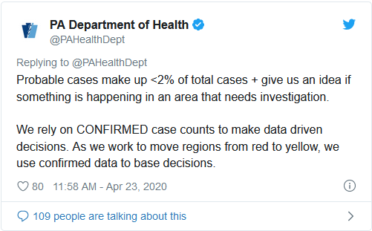
“We realize that this category can be confusing, since it does change over time,” Levine said.
“At times, there are things we need to review, and potentially revisit the way the data is being analyzed,” she said. “And this is one of those times.”
Levine clarified that both spikes in numbers due to “probable deaths” included deaths that occurred days, even weeks earlier.
The discrepancy initially came to light weeks ago when coroners reported that their numbers did not match what the DOH reported.
“There’s a discrepancy in the numbers,” Charles E. Kiessling Jr., president of the Pennsylvania Coroners Association and coroner in Lycoming County, told the Inquirer. “I’m not saying there’s something going on... I’m not a conspiracy theory guy. But accuracy is important.”
“This is why I’m so upset,” Kiessling added. “Our job is to investigate... We do this every day.”
Kiessling said it was a matter of public safety that the DOH clarify the discrepancy. Coroners have complained over the past month regarding discrepancies in the death figures.
The DOH initially claimed that a computer glitch caused an issue with reconciling multiple reporting systems and the “culmination of that data-validating effort.”
“We will now be reporting probable deaths related to COVID-19 in addition to confirmed deaths,” Levine announced Tuesday, but department spokesperson Nate Wardle told the Inquirer that “probable deaths” had been included in the count far earlier than that.
He later retracted his statement, saying the department only started to include “probable deaths” starting Tuesday, when Levine made the announcement.
Source: Pa. removes 200 deaths from state coronavirus count as questions mount about reporting process, accuracy
(April 24, 2020)
https://www.foxnews.com/us/pa-removes-200-deaths-official-coronavirus-count-questions-mount-reporting-process-data-accuracy
If that doesn’t convince you that you’re dealing with liars, I don’t know what will. And how stupid would you be to continue to trust any of these people … federal and state government, media, celebrities, etc.?
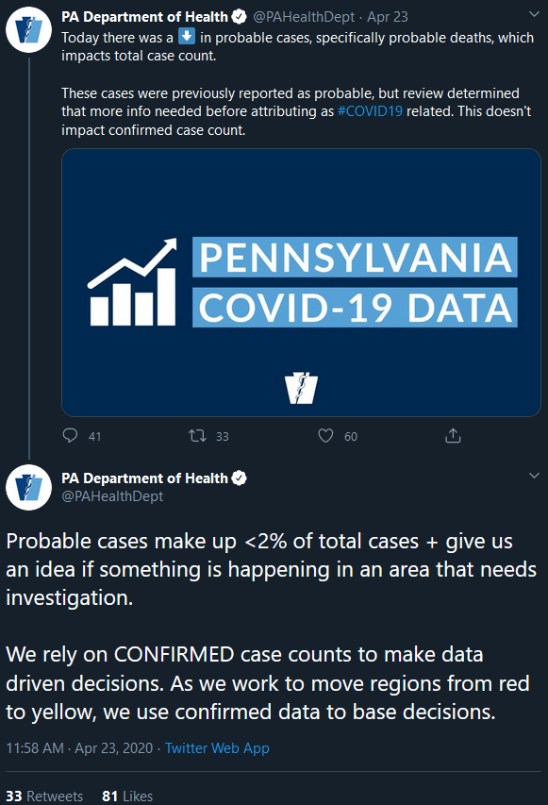
Source: https://twitter.com/i/status/1253397752358281217
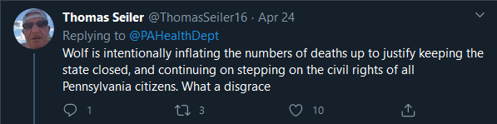
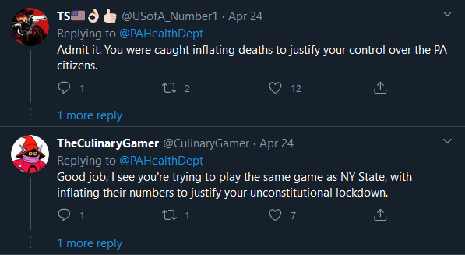
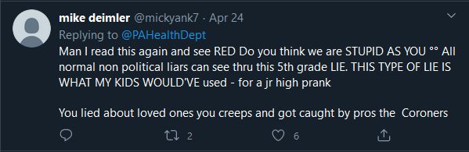
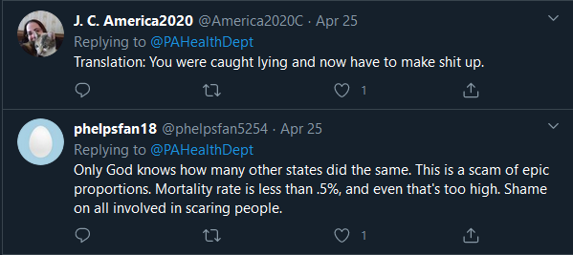
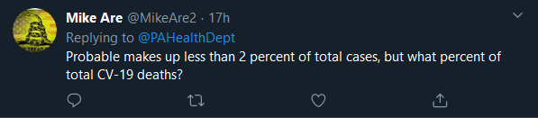
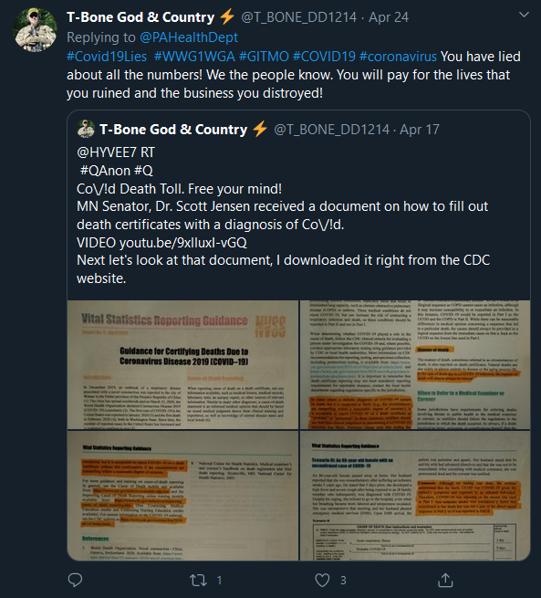
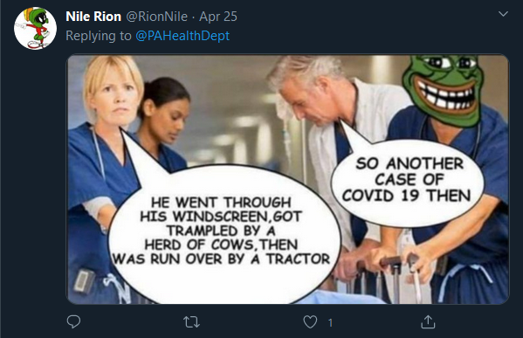

New COVID-19 Death Dispute: Colorado Coroner Says State Mischaracterized Death
(May 14, 2020)
https://denver.cbslocal.com/2020/05/14/coronavirus-montezuma-county-coroner-alcohol-poisoning-covid-death/?fbclid=IwAR0ziVsU1j_Xv_vFlQv55noPJQldO1QhT0o5r-zW4cH6ESXXrePO5AwTOhk
Alternative source for video:
https://www.brighteon.com/83a5e8cc-0d88-4fb4-9427-c68e0fc25607
They “mischaracterized” this death? No, this is a widespread practice that is even being done in other countries. And why, after he clearly died of alcohol poisoning, do you think they would test him for COVID-19?

Shelby County woman who passed away 6 months ago gets letter saying she is COVID-19 positive
https://www.localmemphis.com/article/news/investigations/i-team/shelby-county-woman-died-6-months-ago-letter-covid-19-positive/522-bcd8c6e1-5d75-4e07-af99-ed7babed909b?fbclid=IwAR2oXe3lO6GmONOcJhICa-v-VBKD3Xr6EhYjtuBITYGuGeKB4IzWatFbi-k

LOOK AT THIS: UNBELIEVABLE FAKE CORONA DEATH CAUGHT ON CAMERA!!
https://www.youtube.com/watch?v=uMxwK3dekm4
Alternative source:
https://www.brighteon.com/8e1c325e-af9d-48c9-b49f-75f33309d766

Go through the images here:
https://twitter.com/GregR19709804/status/1243886018387984385/photo/1

Someone on Facebook shared the following post:
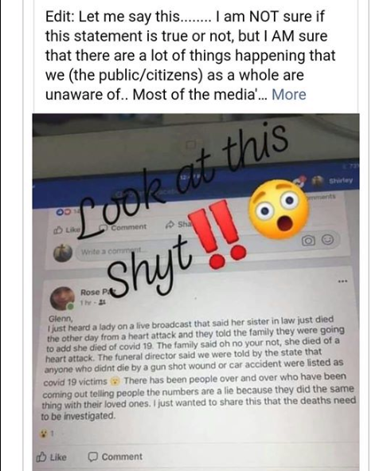

Facebook’s response?
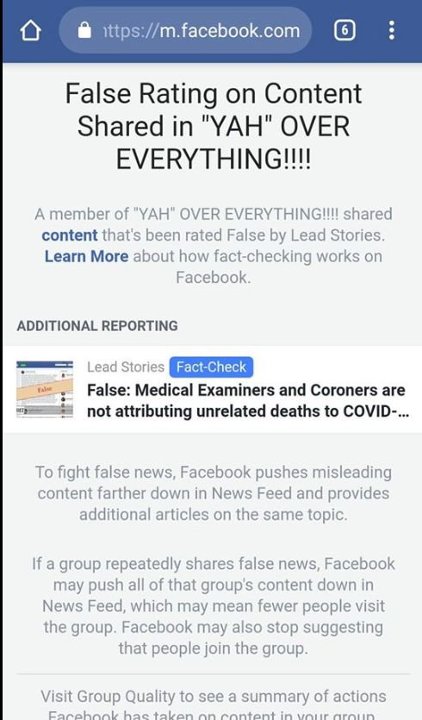
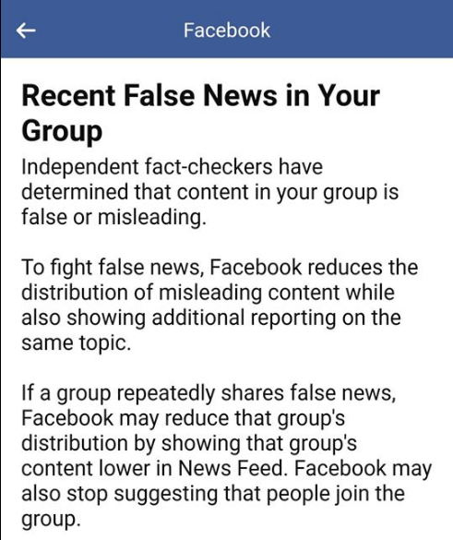

Fact Check: COVID-19 NOT Being Blamed For Deaths Primarily Due To Unrelated Causes
https://leadstories.com/hoax-alert/2020/04/Fact-Check-COVID19-NOT-Being-Blamed-For-Deaths-Primarily-Due-To-Unrelated-Causes.html?fbclid=IwAR1sUOOJ97OYzioQgOGi88WOa6FvYvi5OYz_z9dNebTX-m2w-G_UZ3mUFE4

Facebook will start warning people who 'like' or react to fake coronavirus news
https://www.cnbc.com/amp/2020/04/16/facebook-will-warn-people-who-like-or-react-to-fake-coronavirus-news.html

And don't believe the videos about COVID-19 affecting blacks more than others. Think about it, the numbers are being faked, through different means, so this can't be true. What, they faked more black COVID-19 deaths than others?

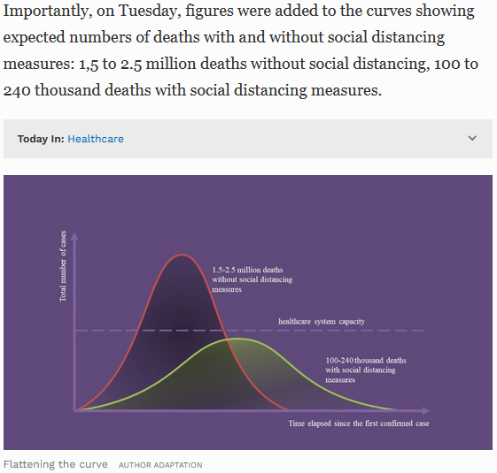
Source: Accuracy Of Estimate Of 100,000 To 240,000 Covid-19 Deaths Hinges On Key Assumptions
https://www.forbes.com/sites/joshuacohen/2020/04/02/accuracy-of-estimate-of-100000-to-240000-covid-19-deaths-hinges-on-key-assumptions/#2e89cdc4144e

Watch from 31:39 - the end
Episode 376 – Lies, Damned Lies and Coronavirus Statistics
https://www.corbettreport.com/coronastats/

And now you should go over your COVID-19 vocabulary again, and then continue below.

Conclusion???

White House Press Corps Caught on Hot Mic "Take Off the Masks...It's a HOAX!"
https://www.bitchute.com/video/WCgW-t9Bplc/

The real hoax reporter caught on tape
https://www.bitchute.com/video/5WSwS8hwfApK/

The Coronavirus Hoax (Ron Paul)
https://www.youtube.com/watch?v=WYH0LskZWVg

Mike Pompeo Refuses To Answer If The Coronavirus Is a Hoax Or Not
https://www.bitchute.com/video/B2vZw0IiRCPJ/

'It's all fake!': Chinese official heckled by residents on visit to Wuhan
https://www.youtube.com/watch?v=Yo81j6o97Z4

For the full story of COVID-19, see the following:
Cured – Your Friendly Guide to COVID-19
http://howmanyknow.com/2020/06/cured-your-friendly-guide-to-covid-19/

