Monkeypox Exposed
The Lies You’re Being Told

- Definitions – 2
- COVID 2.0 – 3
- Name That Bump – 15
- A Brief Monkeypox History Lesson – 35
- The Official Story – 47
- The Case Count – 58
- The Monkeypox Vaccines – 83
- Another Rabbit Hole – The Vaccinia Virus – 110

Definitions

These are terms you will come across that may cause confusion if you’re not aware of what they mean.
- Variola virus (VARV) – the virus that causes smallpox; it comes in two forms – variola major and variola minor
- Monkeypox virus (MPXV) – the virus that causes monkeypox
- Vaccinia virus (VACV or VV) – a virus in the same genus as variola, cowpox, monkeypox, and others (orthopoxviruses) used to make smallpox and monkeypox vaccines
- Post-exposure prophylaxis (PEP) – treatment or measure (prophylaxis ) taken after a known exposure; for instance, vaccinating someone after you believe they’ve been exposed
- Expanded PEP (PEP++) – prophylaxis for persons at increased risk, but without a known exposure
- Pre-exposure prophylaxis (PrEP) – prophylaxis taken before a known exposure; for instance, vaccinating someone before they are exposed; but commonly used as a term for HIV/AIDS drugs
- Lymphadenopathy – inflammation of lymph nodes

COVID 2.0

Operation Pacific Eclipse, Possible Smallpox False Flag Update
https://153news.net/watch_video.php?v=NSX4ROA78MHO

Watch 9:11 - 16:26
Monkey(pox) Business as Usual - #NewWorldNextWeek
https://archive.org/details/nwnw20220526
“That means it’s real.” Actually, that points to it being totally fake – a complete hoax.
And don’t rappers go to prison for making songs about crimes that happened exactly how they described them in their songs? Wouldn’t you go to prison also?
Monkeypox simulation results: Fictional nation, terror group and massive outbreak
https://www.wionews.com/photos/monkeypox-simulation-was-conducted-last-year-with-bizarre-results-481793#monkeypox-virus-simulation-at-munich-security-conference%C2%A0-481774
“The exercise scenario was on the initial outbreak which was caused by a ‘terrorist attack’ using a pathogen engineered in a laboratory with inadequate biosafety and biosecurity provisions and weak oversight. ... Bizzarly, the scenario looked at the period between May 15, 2022 to June 2022 as the first scenario with the monkeypox outbreak in Brinia with 1,421 cases and 4 deaths with no international warnings or advisories.”
The intelligence community doesn’t want to find out if this group of people created the outbreak or if they are connected to someone who did? The evidence indicates planned bioterrorism, right? So where are they? Where is Homeland Security? Where is the media?

Additional Information (if you want it)
Strengthening Global Systems to Prevent and Respond to High-Consequence Biological Threats
Strengthening Global Systems to Prevent and Respond to High-Consequence Biological Threats

2016
“Infection of index cases results from direct contact with the blood, bodily fluids, or cutaneous or mucosal lesions of infected animals. In Africa human infections have been documented through the handling of infected monkeys, Gambian giant rats and squirrels, with rodents being the major reservoir of the virus. Eating inadequately cooked meat of infected animals is a possible risk factor. Secondary, or human-to-human, transmission can result from close contact with infected respiratory tract secretions, skin lesions of an infected person or objects recently contaminated by patient fluids or lesion materials. Transmission occurs primarily via droplet respiratory particles usually requiring prolonged face-to-face contact, which puts household members of active cases at greater risk of infection. Transmission can also occur by inoculation or via the placenta (congenital monkeypox). There is no evidence, to date, that person-to-person transmission alone can sustain monkeypox infections in the human population.”
Source: Moneypox – World Health Organization
(30 November 2016)
https://web.archive.org/web/20180430052148/https://www.who.int/en/news-room/fact-sheets/detail/monkeypox

2017
“Primary infection is through direct contact with the blood, bodily fluids, or cutaneous or mucosal lesions of an infected animal. Eating inadequately cooked meat of infected animals is also a risk factor. Human-to-human transmission can result from close contact with infected respiratory tract secretions, skin lesions of an infected person or objects recently contaminated by patient fluids or lesion materials. Household members of active cases are at greater risk of infection via droplet respiratory particles during prolonged face-to-face contact. Transmission can also occur by inoculation or via the placenta (congenital Monkeypox). Monkeypox can easily be confused with other rash illnesses such as smallpox, chickenpox, measles, bacterial skin infections, scabies, syphilis, and medication-associated allergies. In the early stage of the disease Monkeypox can be distinguished from smallpox because the lymph gland gets enlarged. A laboratory test is needed for a definitive diagnosis.”
Source: Monkeypox has resurfaced in Nigeria. What you need to know
(Published: October 12, 2017)
https://theconversation.com/monkeypox-has-resurfaced-in-nigeria-what-you-need-to-know-85532

2018
“If you are a UK resident and have read certain headlines over the past few weeks, you might be wondering – What the hell is monkeypox? And should I be worried? That is because three people in the UK have been admitted to hospital with the virus in the last month alone. Two contracted the disease in Nigeria (where there is currently an outbreak) in completely unrelated but coincidental cases. The third is a healthcare worker who helped care for one patient at Blackpool Victoria Hospital. ... First thing's first – don't worry. British medical experts have confirmed that these cases aren't about to trigger a national outbreak and Public Health England has said the general public is not at risk. ‘The fact that only one of the 50 contacts of the initial monkeypox-infected patient has been infected shows how poorly infectious the virus is,’ Jonathan Ball, a professor of molecular virology at the University of Nottingham, UK, told BBC News. In most cases, monkeypox is a mild sickness. However, there is a risk of death and somewhere between 1 and 10 percent of patients do die as a result, particularly if they are young. Children are the most at risk. Fortunately, the virus has a really terrible infection rate and has particular difficulty spreading between people. That's not to say that it's not possible – it can be passed from person to person via bodily fluids and airborne droplets (if you get very, very close). These droplets rarely travel further than a meter (3.3 feet).”
Source: What Exactly Is Monkeypox – And Should You Be Worried?
(Oct 1, 2018)
https://www.iflscience.com/what-exactly-is-monkeypox-and-should-you-be-worried-49943?fbclid=IwAR2q1DjsPXVFy5by78wX9wMLBRXPguovWmQqZMhSle3bEsu5iRTPeJtdaZk

Note: They speak of child deaths, but guess what that’s comprised of? Children in Africa where monkeypox has been for decades. “In Africa, mortality due to monkeypox infection has ranged from 1.5% to 17% and occurs overwhelmingly in children, a regrettable consequence most likely due to inaccessible medical care [30]. One-fifth of pediatric patients in the US outbreak developed serious complications that could have resulted in death if intensive medical intervention was not available.” (Clinical Characteristics of Human Monkeypox, and Risk Factors for Severe Disease - Published:December 15, 2005)

2019
“Monkeypox infection in adults is usually mild and can heal itself. More severe conditions are found in children.”
(May 31, 2019)
Source: We don’t have a cure for monkeypox virus, but the body can heal itself
https://theconversation.com/we-dont-have-a-cure-for-monkeypox-virus-but-the-body-can-heal-itself-117435

2022
Let the fear begin!

The NHS just edited their Monkeypox page…to make it scarier
https://off-guardian.org/2022/05/24/the-nhs-just-edited-their-monkeypox-page-to-make-it-scarier/

“No one has died of monkeypox infection outside of Africa during this outbreak. And for many people, the disease is relatively mild and resolves on its own in a few weeks without any need for medical intervention. However, the new paper reports that monkeypox can cause pain so intense that a substantial proportion of people with the virus require hospitalization for pain management.”
Source: Monkeypox is being driven overwhelmingly by sex between men, major study finds
(July 22, 2022)
https://www.nbcnews.com/nbc-out/out-health-and-wellness/monkeypox-driven-overwhelmingly-sex-men-major-study-finds-rcna39564

Let’s check out that link and see what that pain is all about.
For some, severe pain
According to a recent World Health Organization report, perhaps 10% of monkeypox cases for which there is data in the outbreak have led to hospitalization, either for treatment or isolation purposes. A recent U.K. study found that hospital admissions were due to pain or infection of skin lesions.
Some of the men who spoke with NBC News said that while their skin lesions may have been rather mild, they have experienced extraordinary pain in their anorectal or genital area, in particular when urinating or defecating.
“It is the most painful s--- you’ll ever take in your life,” Short said. “To the point where I almost passed out.”
For Hall, a lesion in his urethra has left him dreading urinating. “It sort of feels like 1,000 burning knives are trying to come out of my urethra at the same time,” he said.
New Yorker Gerald Febles, 25, said monkeypox saddled him with harrowing pain all over his body, including lesions in his mouth and on his gums. His lymph nodes in his groin swelled to the size of fists, making it agonizing to do anything but lie down, he said.
“The pain became so unbearable,” Febles said as he waited for hours at Lenox Hill Hospital in Manhattan last week. “Every joint in my body hurts.”
Ultimately, Febles, who is an employee relations manager for the urgent care company MedRite, was given antibiotics and a single oxycodone pill and sent home with a lidocaine topical solution. His discharge note, which he shared with NBC News, didn’t indicate the morphine prescription written for him. So he went an extra day in extreme pain before he realized the opioid was waiting for him at the pharmacy.
Febles said that after he gave an interview to a local NBC affiliate, he got a call from an infectious disease team at Columbia University, led by Dr. Jason Zucker, about receiving the antiviral tecovirimat on an investigational basis. His lesions have since been clearing up — an effect he attributed to the antiviral. In an email to NBC News, Zucker confirmed he has been prescribing the antiviral to people with monkeypox under what’s known as an expanded access protocol developed by the CDC.
Harun Tulunay, 35, also spoke last week from the hospital, in his case in London. He had been unable to eat for days due to lesions in his mouth and swelling in the lymph nodes in his neck that was so intense he couldn’t swallow. His left nostril was covered in a purple-black lesion. Like Febles, he said he was experiencing extreme pain all over his body, which physicians were treating with opioids while also giving him tecovirimat.
Tulunay, who is a training and volunteer coordinator at the HIV nonprofit Positively UK and is HIV positive, said he has heard of other Londoners with monkeypox refusing to isolate. He said he hoped that by sharing his ordeal, he could help persuade people to be more cautious.
Source: Lesions, headaches, debilitating pain: Gay men with monkeypox share their stories
https://www.nbcnews.com/nbc-out/out-health-and-wellness/lesions-headaches-debilitating-pain-gay-men-monkeypox-share-stories-rcna36789

Clearly, some of those ailments are specific to them and their actions, if it’s even true. And the location of their lesions makes all the difference.
- “According to a recent World Health Organization report, perhaps 10% of monkeypox cases for which there is data in the outbreak have led to hospitalization, either for treatment or isolation purposes.”
Notice how two different reasons are combined – treatment and isolation. And “treatment or isolation” ... that’s not saying anything. From the WHO report: “It’s important to understand what the data from the European Region are telling us. The WHO Regional Office for Europe (WHO/Europe) and the European Centre for Disease Prevention and Control (ECDC) are issuing weekly joint monkeypox surveillance bulletins ... Where information is available, close to 10% of patients were reported to have been hospitalized either for treatment or for isolation purposes, and one patient has been admitted to an ICU. Fortunately, no people are reported to have died so far. The vast majority of cases have presented with a rash and about three quarters have reported systemic symptoms such as fever, fatigue, muscle pain, vomiting, diarrhoea, chills, sore throat or headache.” (Source: Statement - No room for complacency)
1. It’s for Europe. 2. They left out the part about that one person because it would show that the others were not in the ICU, therefore not serious. And who knows why that one person was sent to the ICU. It could have been something totally unrelated. 3. They left out the part about the vast majority of cases – a rash and the flu, which is not severe pain.

- “A recent U.K. study found that hospital admissions were due to pain or infection of skin lesions.”
The reasons are combined once again. And we have no idea what the pain was due to. It could have been anything. From the UK study: “Five (9%) of 54 individuals required admission to hospital, mainly due to pain or localised bacterial cellulitis requiring antibiotic intervention or analgesia.” (Source: Demographic and clinical characteristics of confirmed human monkeypox virus cases in individuals attending a sexual health centre in London, UK: an observational analysis)

Now look again at what NBC stated: “However, the new paper reports that monkeypox can cause pain so intense that a substantial proportion of people with the virus require hospitalization for pain management.”
That’s crazy. Someone needs to go to jail over that. But that’s what the media always does, and nothing is ever done about it.

“‘We have an outbreak that has spread around the world rapidly, through new modes of transmission, about which we understand too little,’ Tedros said. ‘For all of these reasons, I have decided that the global monkeypox outbreak represents a public health emergency of international concern.’ Five people in Africa have died of monkeypox this year. No deaths outside Africa have been linked to the current outbreak.”
Source: The symptoms and causes of monkeypox infections, now diagnosed in more than 20,000 people
(May 19, 2022)
https://www.nbcnews.com/health/health-news/monkeypox-virus-symptoms-rcna29510

- “Five people in Africa have died of monkeypox this year.” They know that no one knows that monkeypox is common in Africa. There are always five people dying in Africa from monkeypox!
“Nigerian authorities confirmed the country's first monkeypox death this year, in addition to six more cases. WHO says thousands of cases are reported from Nigeria and Congo every year.” (Source: WHO: Monkeypox won't turn into pandemic, but many unknowns - May 30, 2022)
“The first monkeypox case in a human was diagnosed in 1970. Since then, most infections have been concentrated in the Democratic Republic of the Congo and Nigeria. The DRC reports thousands of cases annually and Nigeria has reported hundreds of confirmed or suspected cases since 2017.” (Source: The symptoms and causes of monkeypox infections, now diagnosed in more than 20,000 people - May 19, 2022)
And what’s going on in Africa has absolutely nothing to do with the “current outbreak,” but look at what they state before that statement and afterwards. They threw in that totally unrelated, but factual statement about deaths in Africa and tried to make it seem as though it’s a part of the current outbreak! They know that when the average person reads that it’s going to be combined into a single understanding. But this is the sick crap that they always do.

Take a look at this one. This first portion is from the official story, and makes sense if the virus was spread through sex like they said it was (makes sense but that doesn’t mean the official story is true).
“The study authors reported that 95% of the cases were likely transmitted through sexual close contact. What’s more, their paper offers strong new evidence that anal sex itself, although not necessarily ejaculation, is a major source of transmission. ‘The strong likelihood of sexual transmission was supported by the findings of primary genital, anal, and oral mucosal lesions, which may represent the inoculation site,’ the study authors wrote.”
Source: Monkeypox is being driven overwhelmingly by sex between men, major study finds
(July 22, 2022)
https://www.nbcnews.com/nbc-out/out-health-and-wellness/monkeypox-driven-overwhelmingly-sex-men-major-study-finds-rcna39564

... the parts of the body where there was contact, probably with bodily fluid.
“In the current outbreak, lesions on the genitalia and perianal lesions have been more common due to the outsized role of sexual transmission.^{25, 51}
Source: Master Question List for Monkeypox Virus (MPXV) - July 2022
https://www.dhs.gov/sites/default/files/2022-07/22_0712_st_monkeypox_mql.pdf
But you’re being told that this virus is different from other monkeypox viruses ... it causes bumps on your genital area. Wikipedia is even being used to push this narrative. Just scroll down and look at the photos here. They obviously want you very afraid, especially of having sex.

Now, take a look at this excerpt from an NPR article.
“In textbooks (and on many agency websites), monkeypox is described as a disease that begins with flu-like symptoms, including a fever, tiredness and a single swollen lymph node. Then about a week later, a rash appears, first on the face and then on the extremities. This rash contains painful blisters that eventually fill with pus and crust over. Eventually it can cover the trunk or whole body. ‘So in the classic monkeypox, described in textbooks, you're supposed to have two phases,’ Vinh says. But in this current outbreak, many people's symptoms don't fit this profile at all, say Vinh and several doctors involved with these cases. For starters, the rash often isn't on the face or extremities at all. Instead, it typically begins on the genitals or the anus. And sometimes it doesn't spread to other parts of the body. ‘You don't have head-to-toe skin pox lesions,’ Vinh says. ‘Instead it's localized to just one region of the body, like the genital regions. And some people have just one or two pox. So it's not numerous.’ ‘Sometimes it's not even a pox,’ he says, ‘but rather an ulcer or a crater.’ But even if only a small part of the body is affected, monkeypox isn't necessarily a mild illness. ‘The rash can be really painful, and some patients have reported needing prescription pain medicine to manage that pain,’ says the CDC's Jennifer McQuiston. ‘The sores can also cause long term scarring on the skin.’”
Source: Monkeypox can look different than what doctors thought. Here's what they're learning
(Updated July 23, 2022)
https://www.npr.org/sections/goatsandsoda/2022/06/03/1102945017/monkeypox-signs-symptoms-rash

“...it typically begins on the genitals or the anus.” That’s saying that if you end up catching it through the air or some other means (what the media has said or alluded to) the bumps usually begin on the genitals or anus. True or false? In that article they also push the idea that the virus is going undetected in the population and anyone can have it and not know it. Translation: Be very afraid.

Here’s another one.
“Some 36% of patients in the BMJ study reported rectal pain or pain during defecation and 15.7% had fluid retention in the penis. Some patients in the US have reported proctitis, a painful inflammation of the rectal lining that can cause diarrhea, bleeding and discharge, according to the Mayo Clinic, as well as a continuous feeling of needing to use the bathroom. The CDC has warned that the differing presentation can cause monkeypox to be misdiagnosed or missed altogether.”
Source: Monkeypox Cases Up Over 40% This Week: Here Are the Symptoms to Look For
(Aug. 11, 2022)
https://www.cnet.com/health/medical/monkeypox-symptoms-heres-what-to-look-for/

They know that you are ignorant about monkeypox so they try to get you to believe that what they’re telling you is what monkeypox causes all the time. And you’re really going to see that they’re deceiving you after reading A Brief Monkeypox History Lesson (below).

On the flu vaccine...
“In concert with the ramp-up in death statistics, the government-steered vaccination industry has run an elaborate bureaucracy designed to hype vaccine use, as seen in a slide show presentation last April by Glen Nowak, the CDC’s spokesman for the National Immunization Program, to the American Medical Association. Here is the ‘Recipe that fosters influenza vaccine interest and demand,’ in the truncated language that appears on his slides: ‘Medical experts and public health authorities [should] publicly (e.g. via media) state concern and alarm (and predict dire outcomes) – and urge influenza vaccination.’ This ‘recipe,’ the slide show indicated, would result in ‘A. Significant media interest and attention [and] B. Framing of the flu season in terms that motivate behaviour (e.g. as ‘very severe,’ ‘more severe than last or past years,’ ‘deadly’).’ Other aspects of the CDC’s ‘Seven-Step Recipe for Generating Interest in, and Demand for, Flu (or any other) Vaccination’ includes ‘Continued reports (e.g., from health officials and media) that influenza is causing severe illness and/or affecting lots of people – helping foster the perception that many people are susceptible to a bad case of influenza.’ and ‘Visible/tangible examples of the seriousness of the illness (e.g., pictures of children, families of those affected coming forward) and people getting vaccinated (the first to motivate, the latter to reinforce).’ This motivational slide show was designed to push the bounds of the vaccinated. Where once only at-risk populations were targeted – chiefly the elderly – the vac-crats now aspire to vaccinate the healthy. In the 2002-2003 flu season, the last for which the CDC has reliable numbers, almost 21 million healthy Americans between the ages of two and 64 were vaccinated. The unabashed goal of the vaccination ideologues is universal vaccination, starting with the universal vaccination of children.”
Source: Vaccine fevers
(October 24, 2004)
https://cpi.probeinternational.org/2004/10/24/vaccine-fevers/
Additional Information
The 7-step Recipe For Creating Vaccine Demand

How many people in the US develop a bump somewhere on their body each day? What about a rash? Well, now they’re going to suspect monkeypox. Every flea, mosquito, and especially spider bite will be suspected monkeypox. And just think about acne and other skin conditions. I’m declaring a global health emergency for the fear virus. I’ve traced the source of the virus back to globalists, governments, media, and the pharmaceutical industry.

Monkeypox is not new, so there are plenty of available old images for the media to use; and they did just that, while at the same time claiming many people had the virus.
Go here and scroll down to the infamous Monkeypox image. https://www.npr.org/sections/goatsandsoda/2017/11/16/564357363/monkeypox-on-the-rise-how-worried-should-we-be
Did you read the caption? They licensed it from Getty Images!
Take a look at this:
https://www.gettyimages.in/detail/news-photo/in-this-1971-center-for-disease-control-handout-photo-news-photo/2068022?adppopup=true
“BONDUA, LIBERIA - UNDATED: In this 1971 Center For Disease Control handout photo, monkeypox-like lesions are shown on the arm and leg of a female child in Bondua, Liberia.”
Here it is again in a 2018 article:
https://www.stemlynsblog.org/monkeypox-has-arrived-is-the-panic-justified-st-emlyns/
And there are many others.

It’s just like the COVID scamdemic:
ABC Caught Using Video From Italy Hospital, Says It Is NYC Hospital
https://www.brighteon.com/3178e704-56b0-4624-b711-d62560275840

Here’s another example of a fake:
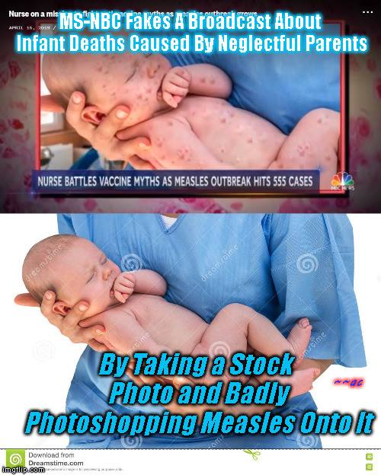

- Simulation before actual event
- Fear-mongering
- Using images that are not from the current outbreak to represent the current “outbreak”
It all points to this being another scamdemic.

And just in case you don’t believe the monkeypox outbreak is real, they are ready with a safety-net story just like with COVID – “It came from a lab.”
“The last case of naturally-occurring smallpox was in 1977, with the World Health Organization declaring the disease eradicated on a global scale in 1980, according to the National Institutes of Health. But even though smallpox does not naturally exist, the disease does still exist in laboratories in Atlanta, where the Centers for Disease Control and Prevention has its headquarters, and in Russia. The vaccine was created in case the disease were to return, whether that was man-made or through melting of the permafrost, said Dr. Phillip Pittman, chief of USAMRIID’s Department of Clinical Research. While smallpox is likely in the permafrost in Russia, it is unclear if it could be grown, according to NPR.”
Source: Fort Detrick's connection to a new smallpox vaccine
(Oct 13, 2019)
https://www.fredericknewspost.com/fort-detricks-connection-to-a-new-smallpox-vaccine/article_1cd978ab-fa30-5d27-8f03-c1a45ecf7242.html
The people controlling the world are seeking a one-world government. The ultimate goal is to abolish all governments, so they don’t care about your government, nor do they have an allegiance to your country. Because of this they will use your government as a scapegoat, and have you angry at your government, before they allow you to know that an event was totally fake/staged.

Additional Information
http://howmanyknow.com/2020/06/cured-your-friendly-guide-to-covid-19/
http://howmanyknow.com/2021/01/covid-truth-reality-redefined/
http://howmanyknow.com/2021/04/covid-vaccines-and-your-dna-fact-check/

Name That Bump

“Detailed clinical information was available for 30 cases reported in Illinois and Wisconsin. Among these, the earliest reported onset of illness was on May 15 (Figure 1). For the majority of patients (22 [73%]), a febrile illness has either preceded or accompanied the onset of a papular rash (Figure 2); respiratory symptoms (16 [64%]), lymphadenopathy (14 [47%]), and sore throat (10 [33%]) also were prominent signs and symptoms (Table). The rash typically progressed through stages of vesiculation, pustulation, umbilication, and encrustation. Early lesions became ulcerated in some patients. Rash distribution and lesions have occurred on the head, trunk, and extremities; many patients had initial and satellite lesions on palms, soles, and extremities. Rashes were generalized in some patients.”
Source: CDC - Multistate Outbreak of Monkeypox --- Illinois, Indiana, and Wisconsin, 2003
(June 13, 2003)
https://www.cdc.gov/mmwr/preview/mmwrhtml/mm5223a1.htm
“The monkeypox patients typically fell ill with signs and symptoms like fever, headaches, dry cough, swollen lymph nodes, chills and drenching sweats, Wisconsin health officials said. One to 10 days later, the patients developed rashes consisting of blisterlike pimples that filled with pus, broke open and later produced scabs. The rash often erupted in different stages, or crops, as it appeared on the head, trunk and arms and legs. Monkeypox lesions can scar the skin like smallpox or chickenpox.”
Source: 20 Cases of Disease Related to Smallpox Found in the U.S.
(June 8, 2003)
https://www.nytimes.com/2003/06/08/national/20-cases-of-disease-related-to-smallpox-found-in-the-us.html
“The rash that typically follows this phase is initially papular and progresses through stages of vesiculation, pustulation, umbilication (a depression at the apex of a lesion) and crusting. In some patients the early lesions become ulcerated. The rash often begins on the face and is distributed on the head, trunk and extremities. Many patients have initial and satellite lesions on their palms, soles and extremities (see Figure). (For additional photographs go to http://research.marshfieldclinic.org/crc/monkeypox.asp). Unlike smallpox, which tends to have lesions at similar stages of evolution, rashes caused by monkeypox tend to occur in crops.³”
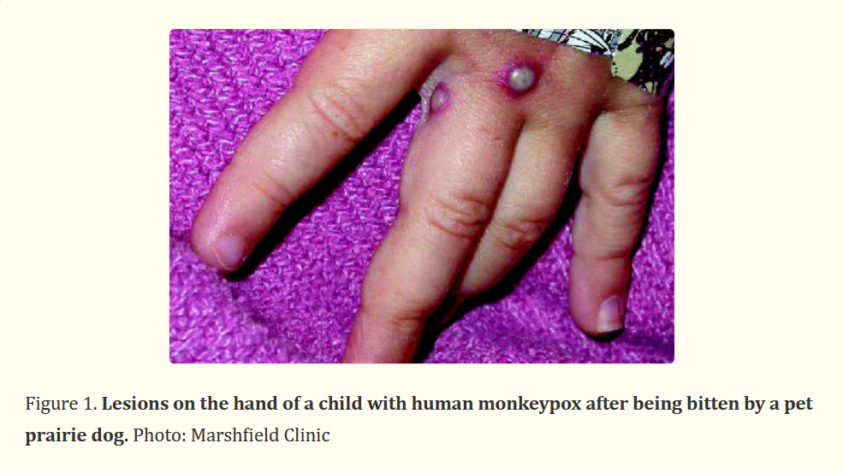
Source: Monkeypox outbreak among pet owners
(2003 Jul 8)
https://www.ncbi.nlm.nih.gov/pmc/articles/PMC164943/
Additional photographs:
https://web.archive.org/web/20031001183932/http://research.marshfieldclinic.org/crc/monkeypox.asp

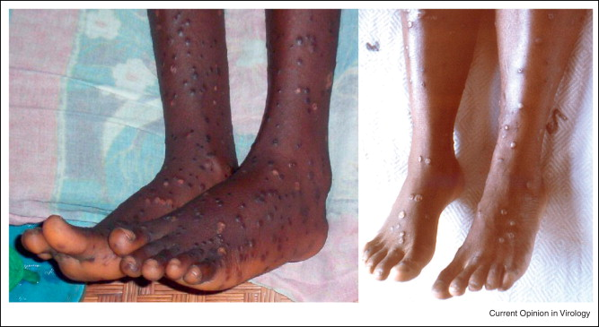
Source: Factors affecting the likelihood of monkeypox's emergence and spread in the post-smallpox era
https://www.sciencedirect.com/science/article/pii/S1879625712000314

According to the World Health Organization in 2016:
“... the skin eruption period (within 1-3 days after appearance of fever) where the various stages of the rash appears, often beginning on the face and then spreading elsewhere on the body. The face (in 95% of cases), and palms of the hands and soles of the feet (75%) are most affected. Evolution of the rash from maculopapules (lesions with a flat bases) to vesicles (small fluid-filled blisters), pustules, followed by crusts occurs in approximately 10 days. Three weeks might be necessary before the complete disappearance of the crusts. The number of the lesions varies from a few to several thousand, affecting oral mucous membranes (in 70% of cases), genitalia (30%), and conjunctivae (eyelid) (20%), as well as the cornea (eyeball).”
Source: Monkeypox
(30 November 2016)
https://web.archive.org/web/20180430174002/https://www.who.int/news-room/fact-sheets/detail/monkeypox

But now the science has changed. The “science” now has to fit the narrative.
“...the skin eruption usually begins within 1–3 days of appearance of fever. The rash tends to be more concentrated on the face and extremities rather than on the trunk. It affects the face (in 95% of cases), and palms of the hands and soles of the feet (in 75% of cases). Also affected are oral mucous membranes (in 70% of cases), genitalia (30%), and conjunctivae (20%), as well as the cornea. The rash evolves sequentially from macules (lesions with a flat base) to papules (slightly raised firm lesions), vesicles (lesions filled with clear fluid), pustules (lesions filled with yellowish fluid), and crusts which dry up and fall off. The number of lesions varies from a few to several thousand. In severe cases, lesions can coalesce until large sections of skin slough off.”
Source: Monkeypox
(19 May 2022)
https://www.who.int/news-room/fact-sheets/detail/monkeypox

Notice how there’s nothing about the bumps spreading or being on different parts of the body at the same time. The new science is: “it may pop up here or there on one body part or another.”

According to the Department of Health and Human Services in 2022:
“Monkeypox disease symptoms always involve the characteristic rash, regardless of whether there is disseminated rash. Historically, the rash has been preceded by a prodrome including fever, lymphadenopathy, and often other non-specific symptoms such as malaise, headache, and muscle aches. In the most recent reported cases, prodromal symptoms may not have always occurred; some recent cases have begun with characteristic, monkeypox-like lesions in the genital and perianal region, in the absence of subjective fever and other prodromal symptoms. For this reason, cases may be confused with more commonly seen infections (e.g., syphilis, chancroid, herpes, and varicella zoster). The average incubation period for symptom onset is 5–13 days. The typical monkeypox lesions involve the following: deep-seated and well-circumscribed lesions, often with central umbilication; and lesion progression through specific sequential stages—macules, papules, vesicles, pustules, and scabs. Synchronized progression occurs on specific anatomic sites with lesions in each stage of development for at least 1–2 days. The scabs eventually fall off¹. Lesions can occur on the palms and soles, and when generalized, the rash is very similar to that of smallpox including a centrifugal distribution. Monkeypox can occur concurrently with other rash illnesses, including varicella-zoster virus and herpes simplex virus infections. Case fatality for monkeypox is reported to range between 1 and 11%. Confirmatory laboratory diagnostic testing for monkeypox is performed using real-time polymerase chain reaction assay on lesion-derived specimens.”
Source: Monkeypox Virus Infection in the United States and Other Non-endemic Countries—2022
https://www.dhhs.nh.gov/sites/g/files/ehbemt476/files/documents2/han-monkeypox-virus-05202022.pdf

“In textbooks (and on many agency websites), monkeypox is described as a disease that begins with flu-like symptoms, including a fever, tiredness and a single swollen lymph node. Then about a week later, a rash appears, first on the face and then on the extremities. This rash contains painful blisters that eventually fill with pus and crust over. Eventually it can cover the trunk or whole body. ‘So in the classic monkeypox, described in textbooks, you're supposed to have two phases,’ Vinh says. But in this current outbreak, many people's symptoms don't fit this profile at all, say Vinh and several doctors involved with these cases. For starters, the rash often isn't on the face or extremities at all. Instead, it typically begins on the genitals or the anus. And sometimes it doesn't spread to other parts of the body. ‘You don't have head-to-toe skin pox lesions,’ Vinh says. ‘Instead it's localized to just one region of the body, like the genital regions. And some people have just one or two pox. So it's not numerous.’ ‘Sometimes it's not even a pox,’ he says, ‘but rather an ulcer or a crater.’ But even if only a small part of the body is affected, monkeypox isn't necessarily a mild illness. ‘The rash can be really painful, and some patients have reported needing prescription pain medicine to manage that pain,’ says the CDC's Jennifer McQuiston. ‘The sores can also cause long term scarring on the skin.’”
Source: Monkeypox can look different than what doctors thought. Here's what they're learning
(Updated July 23, 2022)
https://www.npr.org/sections/goatsandsoda/2022/06/03/1102945017/monkeypox-signs-symptoms-rash

Wow, it’s so strange how it doesn’t fit the science now. I wonder what the reason is for that.

Watch the beginning - 6:22
Is this Monkeypox rash?
https://www.youtube.com/watch?v=j0XPTImrjf8
1. Flat lesion
2. Raised lesion
3. Fluid-filled blisters
4. Pus-filled blisters
5. Scabs
And that is consistent with the information above.

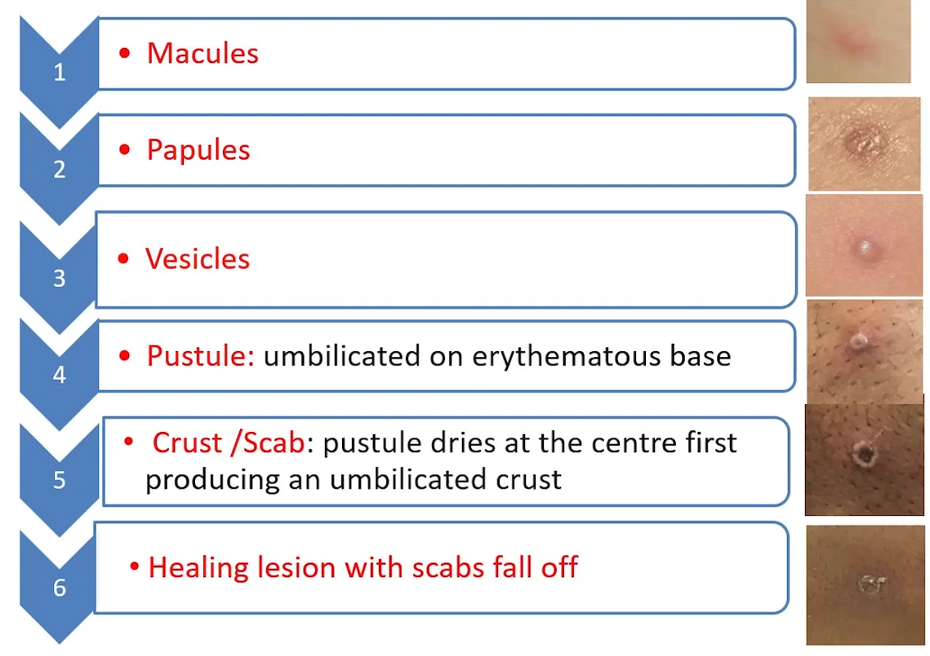

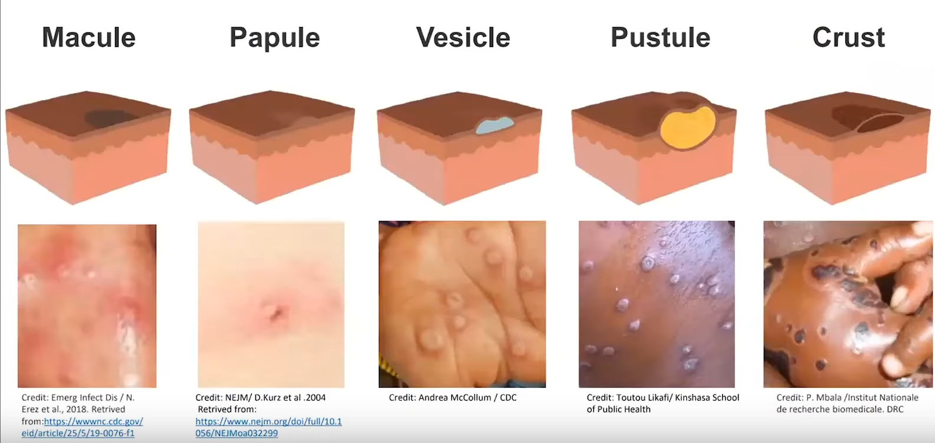

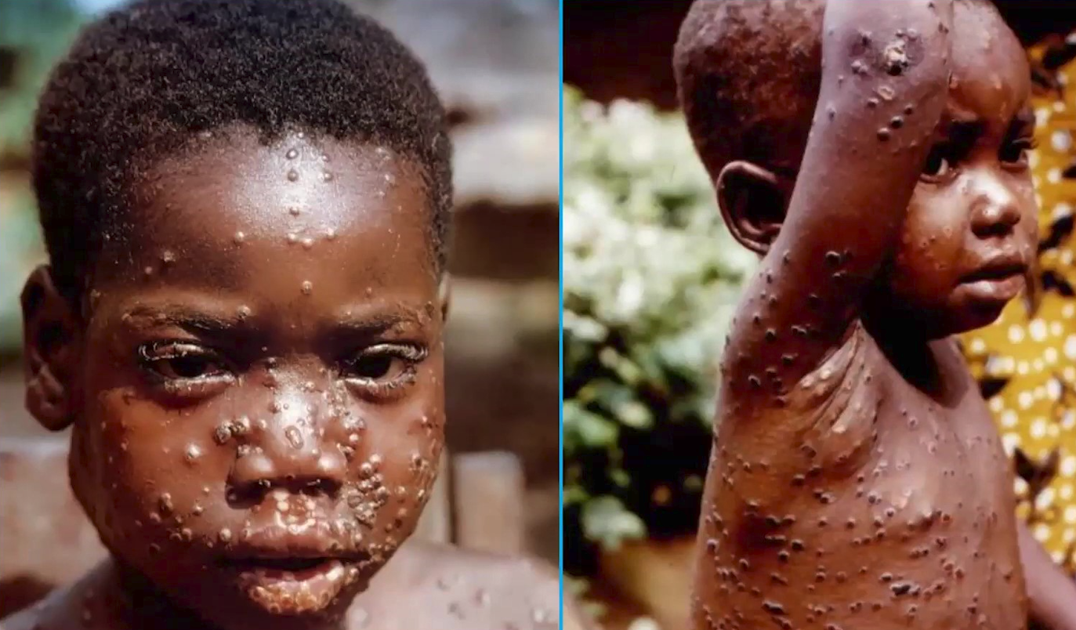
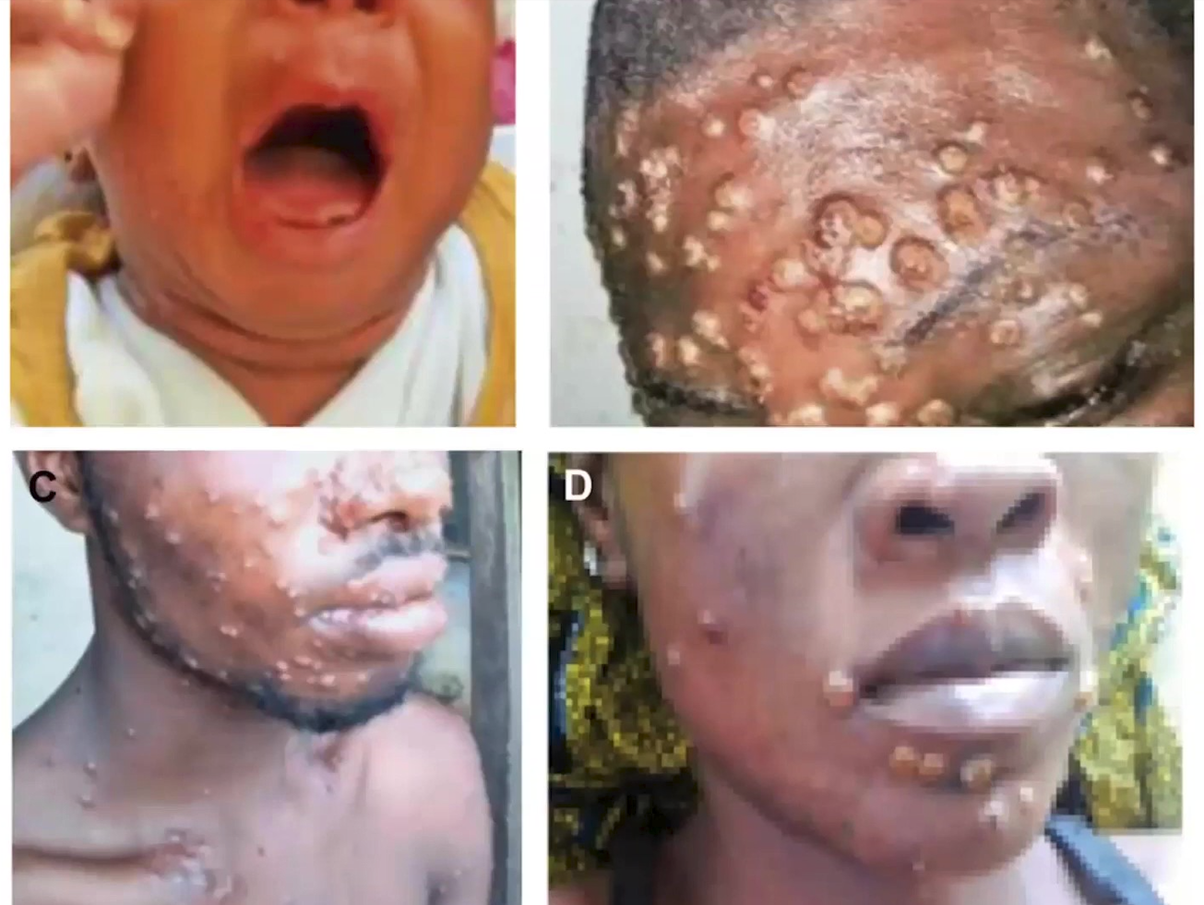
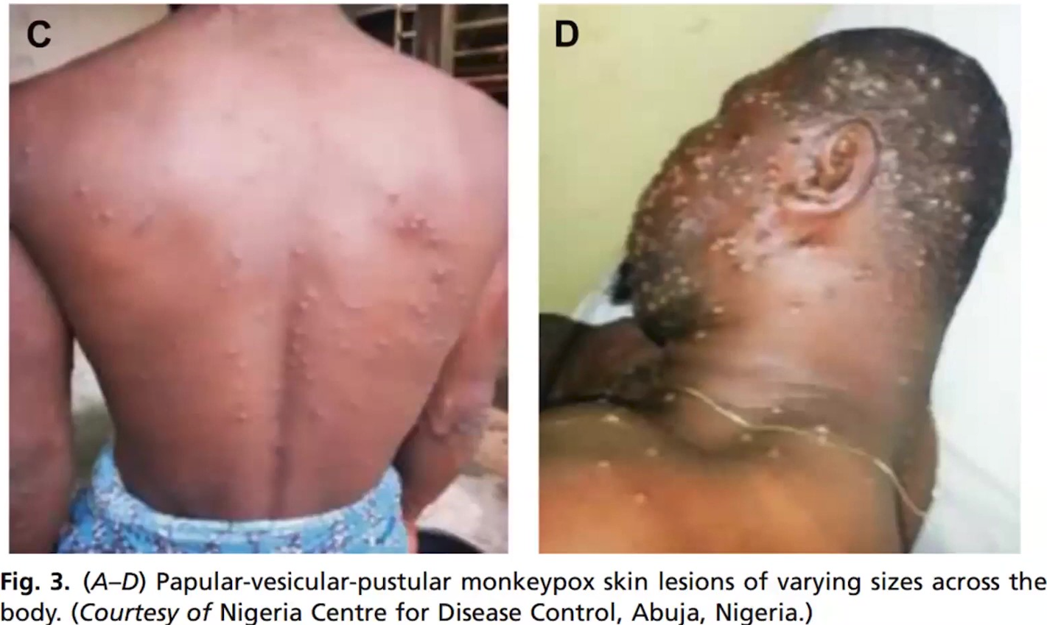

1. Flat lesion
2. Raised lesion
3. Fluid-filled blisters
4. Pus-filled blisters
5. Scabs
2022 monkeypox
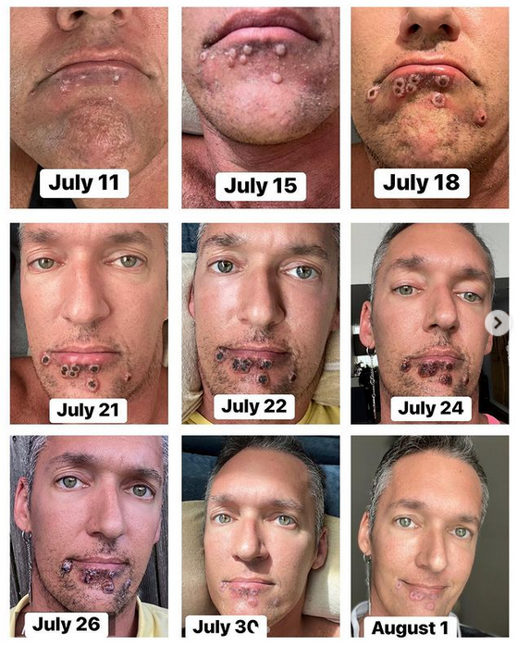
Source: https://www.yahoo.com/news/monkeypox-symptoms-patients-photo-timeline-190834350.html
https://www.instagram.com/reel/CgckoYbgQJA/?utm_source=ig_web_copy_link
https://www.instagram.com/p/ChAe5DHudmL/?utm_source=ig_web_copy_link
https://abc13.com/video/embed/?pid=12075005

If you believe the placement of his bumps was due to oral sex then wouldn’t his lips have bumps as well? And look at the way he goes from frowning to smiling in these pictures that are claimed to have been taken over three weeks. That’s what you’ll find in a commercial or photo shoot for a product.

Houston man with monkeypox says pain, stigma, isolation are the hardest parts
https://www.youtube.com/watch?v=dunLfSbBHtY

'It hurts to exist' | Houston man describes battle with monkeypox
https://www.youtube.com/watch?v=83aWtAVrp-Q

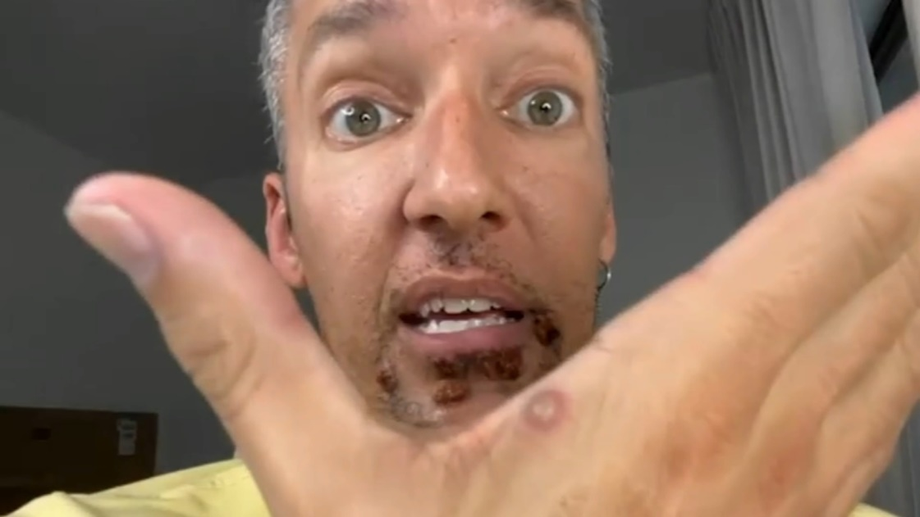

Ultimate fail!

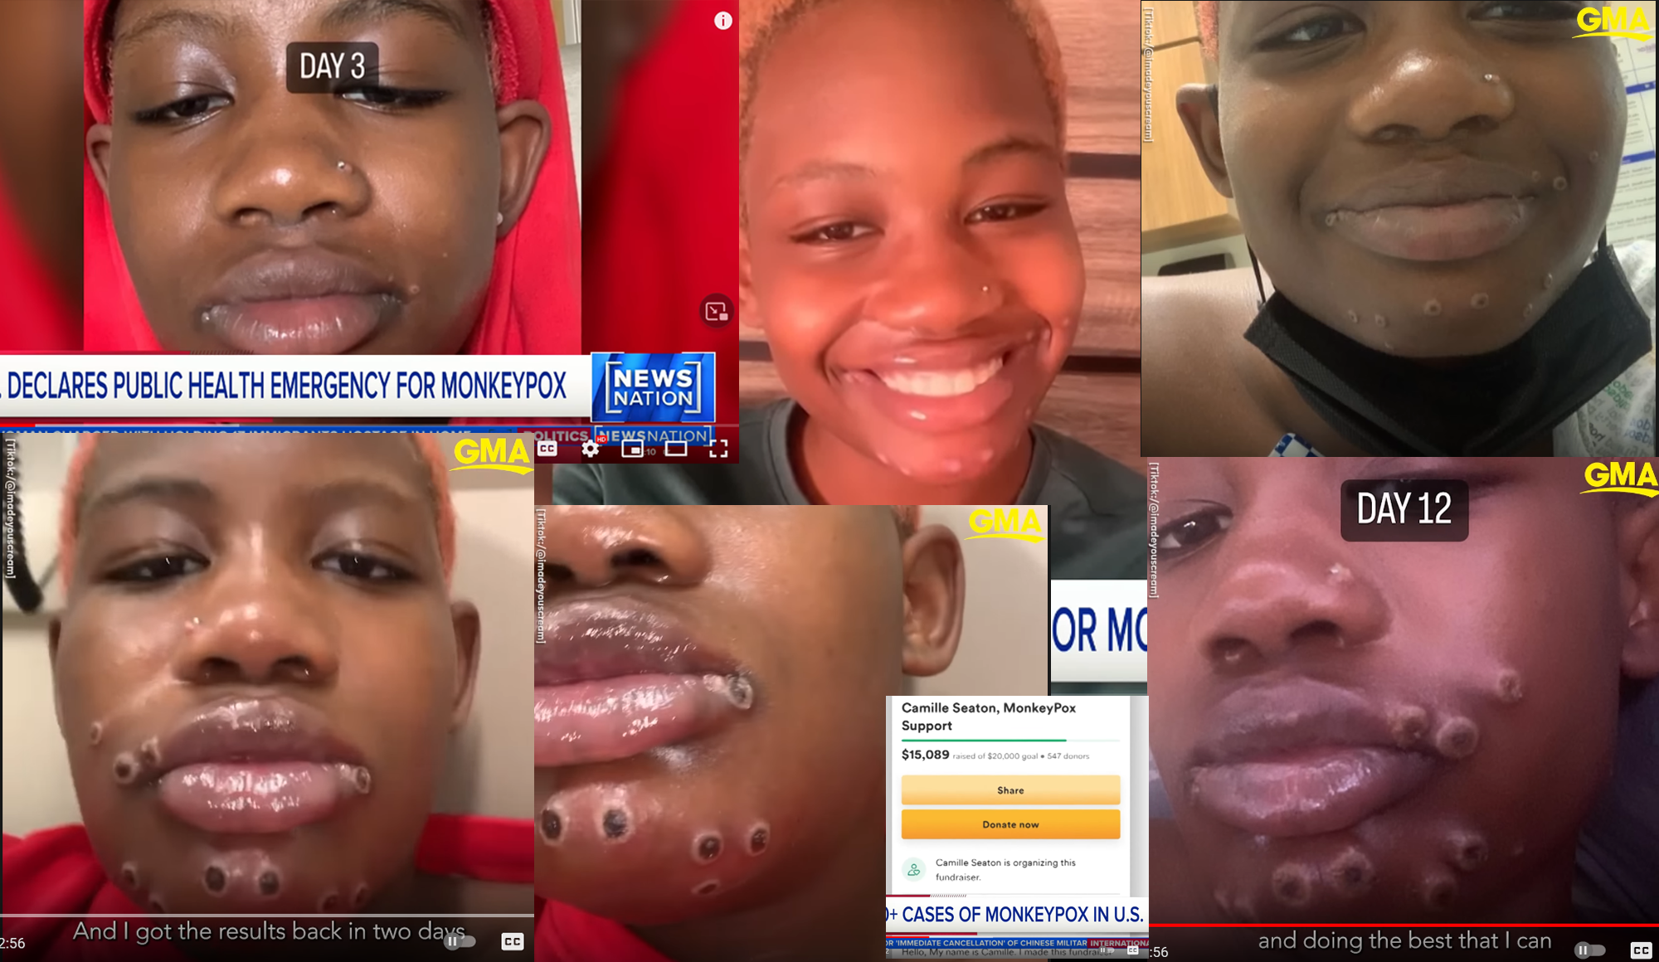
*Photos are not in chronological order, and one photo is flipped horizontally.

She seems to be sick in this video:
The First Positive For Monkeypox In The State Of Georgia! | Pictures
https://www.youtube.com/watch?v=1e_O828J_BI

But why is that?
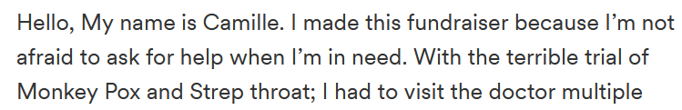
Source: Camille Seaton, MonkeyPox Support
https://www.gofundme.com/f/bw9mb2-camille-seaton

Strep throat has absolutely nothing to do with monkeypox. And you don’t see other people with strep throat.

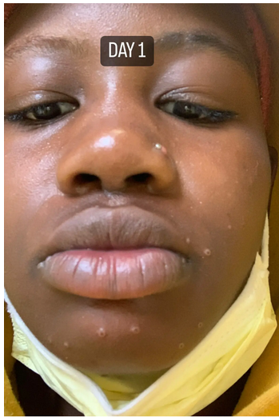 | 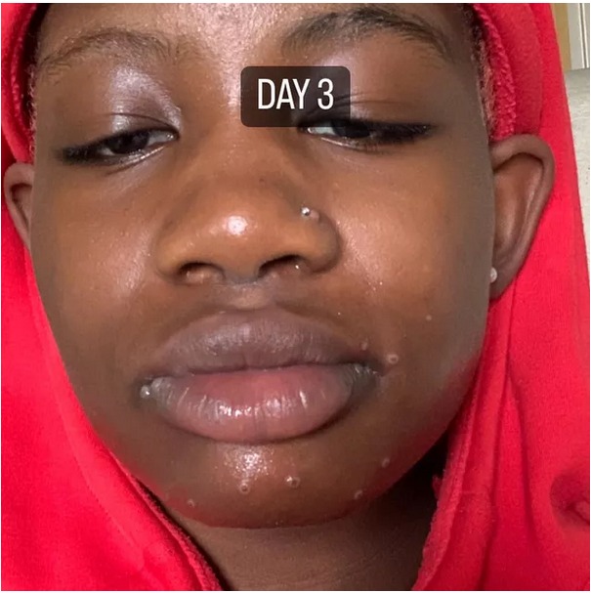
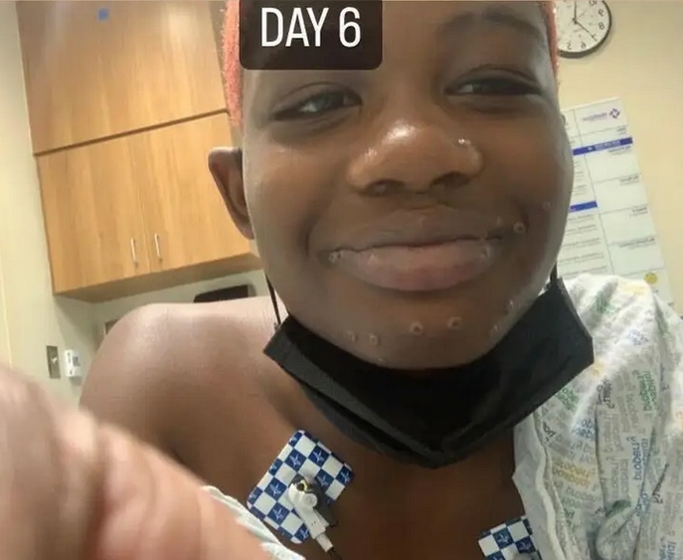 | 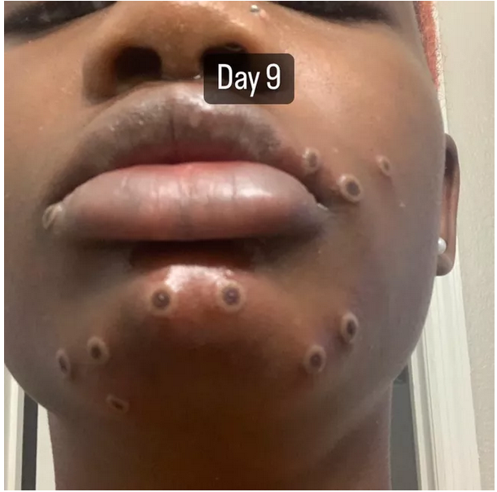
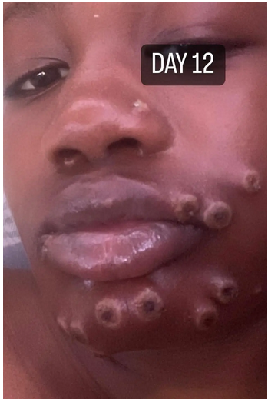 | 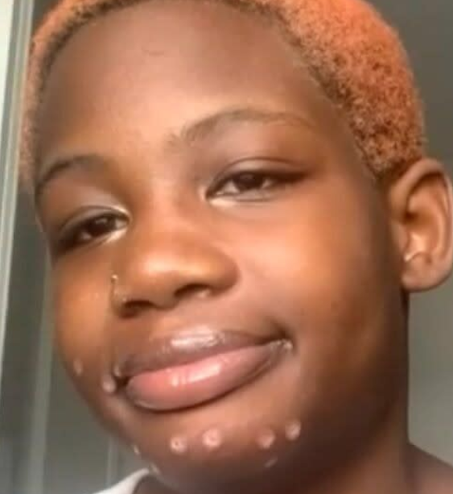

Take a look at this:
https://www.tiktok.com/@imadeyouscream/video/7127752216236231982
“Something just happened with one of my scars so I have a Band-Aid on it right now.”
“Something just happened”? Why not say what happened?

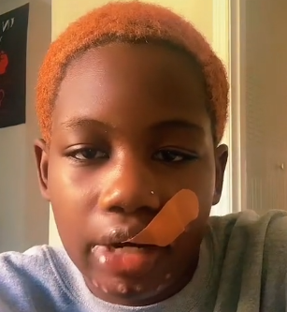

No signs of bumps being on the front of her upper torso:
https://www.tiktok.com/@imadeyouscream/video/7132191092715441454
https://www.tiktok.com/@imadeyouscream/video/7125829186559970606

Monkeypox patient contracted virus at Georgia gas station | LiveNOW from FOX
https://www.youtube.com/watch?v=ZDFDynwHM40
*Come back and watch this video again after reading A Brief Monkeypox History Lesson.
- 0:51 - 1:46 – The first day, she thought they were pimples. Day two and three, she didn’t know what they were and called the ER on day three. But she started documenting from day one of having bumps ... unless the picture titled “Day 1” is just when she first started documenting, making “Day 1” day 3 or something. Either way, it doesn’t match monkeypox.
- 3:33 – “... but in my case, they started and stayed on my face for a week and a half. And when my face was finally at the healing stages, they started to pop up all over my body; so I had to start over my healing process. So, the healing process for monkeypox is two to four weeks; I took three and a half.”

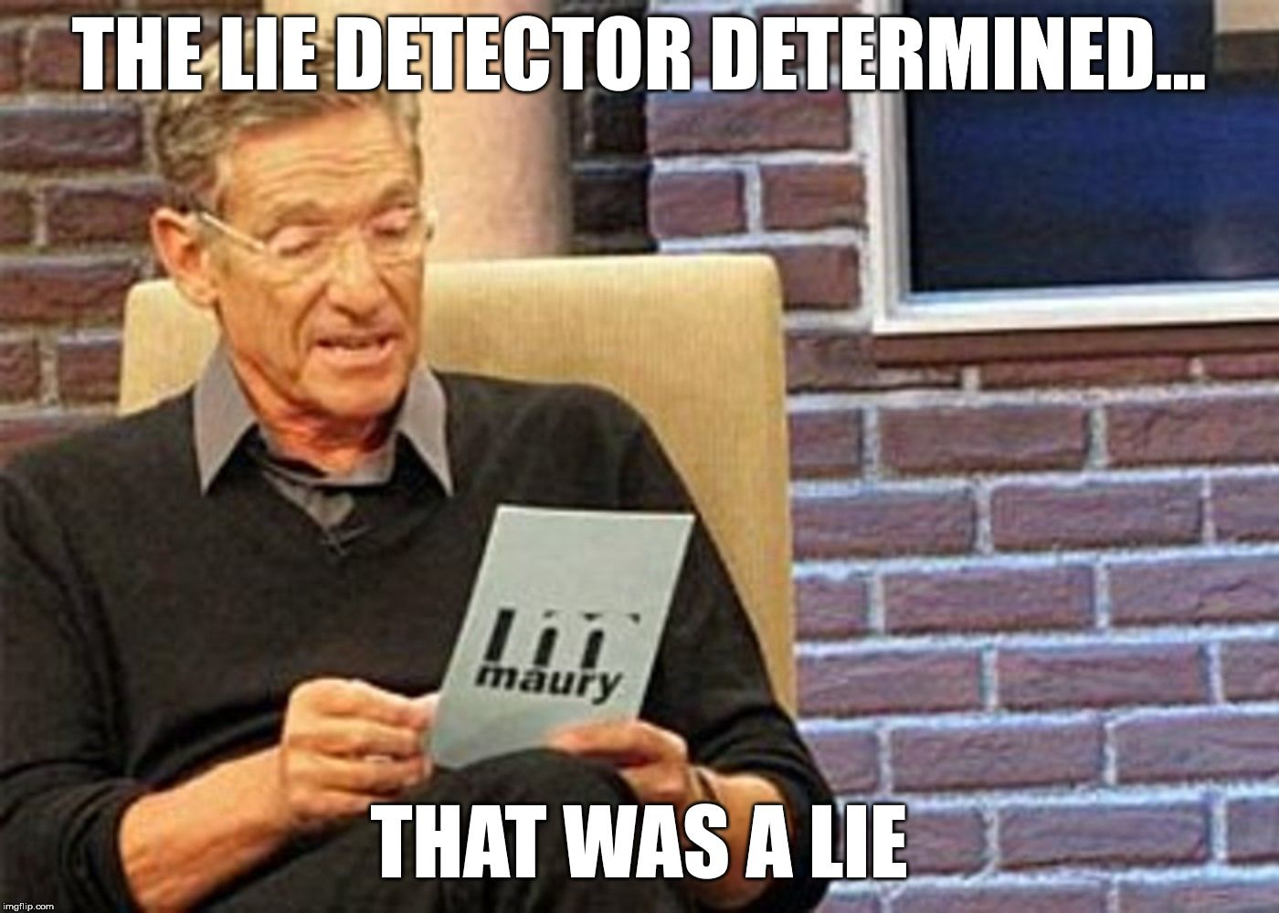

Ultimate fail!
Life with Monkeypox: "You feel very alone in this" | NewsNation Prime
https://www.youtube.com/watch?v=F4D2CnE3nmI
- 0:01 – That’s probably not an image of monkeypox. It looks like the chickenpox shown at 9:00 - 11:19 of Is this Monkypox rash? (the video above).
- 0:16 – That’s a picture that was used online as a picture of shingles, but it’s now being used by multiple media outlets to depict monkeypox. You’ll see more on this later.
And, as you’ll see later in A Brief Monkeypox History Lesson, the way she thinks she may have caught it does not match the science at all, but they want you to be afraid. “According to the CDC anyone within close contact with someone with monkeypox can get it. And now over 7500 cases in the US, and a lack of available vaccines, many are wondering how to slow the growing problem.” The other news report stated: “So how do you get it? Close or skin-to-skin contact, generally through intimate physical contact.”
Before
... respiratory particles usually requiring prolonged face-to-face contact ... touching the skin lesions of an infected person or objects recently contaminated by patient fluids or lesion materials.
Now
Just touching something they touched. Just being anywhere close to them. If your skin touches their skin.
Watch the beginning - 0:36
Monkeypox vaccinations proceed despite scientists' debate
https://www.youtube.com/watch?v=QS477T3K6Bk
Flight Attendants Claim They Caught Monkeypox
https://www.youtube.com/watch?v=fQgmykRgvGw
Stanford experts document non-sexual transmission of monkeypox
https://www.youtube.com/watch?v=gUEEOgR356A

All of this is coming from people, the media and government, who have staged shootings and bombings, even going as far as to use amputee actors and fake blood to trick the public. If you can make someone’s leg look like it’s been blown off, I’m sure it wouldn’t be hard for you to fake some bumps.
You don’t have to watch the entire length of these next videos, just look at the end result so you can get an idea of what can be done.
Scary Hand Special Effects SFX Makeup | Satisfying or Gross | Halloween Makeup Idea
https://www.youtube.com/watch?v=JqQ9szZdWWA
HOW TO MAKE ACNE Makeup Tutorial / HalloweenXTRA 3 (2017)
https://www.youtube.com/watch?v=6uAXZIOx-6c
Easy Halloween Makeup | SFX Makeup Boils and Blisters inspired by Slither
https://www.youtube.com/watch?v=cgDTw-5hsNY
PLAGUE BOILS HALLOWEEN MAKEUP- Speed Painting
https://www.youtube.com/watch?v=I5lhbwdQoNg
CREATING FAKE BLISTERS! | SFX MAKEUP
https://www.youtube.com/watch?v=uibGjdf2XmQ
FX Makeup Series: Acne
https://www.youtube.com/watch?v=6fSfvQI_TE4
Acne - SFX Makeup - DIY Bondo Transfer Prosthetics
https://www.youtube.com/watch?v=kDGqhjw-8DU
Scab - SFX makeup Tutorial
https://www.youtube.com/watch?v=2Os_uPUWNzs
Rash - SFX makeup Tutorial
https://www.youtube.com/watch?v=FjAUIlftj_8

Scroll through the images here:
What monkeypox looks like compared to 7 skin conditions including acne, herpes, and syphilis
http://archive.today/xBVPL

Enterovirus
Image 1
Image 2
Image 3
Image 4

They are literally throwing everything at you and calling it monkeypox!
Some of the 2022 monkeypox cases
- Image 1
- Image 2
- Image 3
- Image 4
- Image 5
Man Diagnosed With Monkeypox Says It's Worse Than It Sounds
https://www.youtube.com/watch?v=RCDfPhyzzyY
Miami man shares journey with monkeypox
https://www.youtube.com/watch?v=N7Z7xfD-mvA
* That’s more like it, but still could be something else or faked.
This is what it’s like living with monkeypox
https://www.youtube.com/watch?v=qHJc3bbzBe0

“In addition to a clinical appearance similar to that of smallpox, human monkeypox is often confused with other rash illnesses; up to 50% of suspected monkeypox cases in the Democratic Republic of Congo are actually Varicella-Zoster virus (VZV) infections (Jezek et al., 1988; Meyer et al., 2002).”
Source: Evaluation of the Tetracore Orthopox BioThreat® antigen detection assay using laboratory grown orthopoxviruses and rash illness clinical specimens
https://www.tetracore.com/wp-content/uploads/2021/02/JVMethods_2013_Orthopox.pdf

“Because suspected cases of monkeypox might actually represent varicella infections, patients should be assessed for history of varicella or having received varicella vaccine. Rash illness suspected to be monkeypox should be confirmed by laboratory evaluation, particularly if use of smallpox vaccine is being considered for purposes of monkeypox outbreak control.”
Source: Update: Multistate Outbreak of Monkeypox --- Illinois, Indiana, Kansas, Missouri, Ohio, and Wisconsin, 2003
https://www.cdc.gov/mmwr/preview/mmwrhtml/mm5224a1.htm

Chickenpox versus shingles—What’s the difference?
http://archive.today/DMH34

“Shingles is caused by the reactivation of the chickenpox virus, which can live in the nerves of the body for many years after an initial infection. Freeman said that in healthy people, shingles causes a patch of painful, fluid-filled bumps in a very specific pattern related to the nerves, on one side of the body. People with weakened immune systems can get atypical rashes, she said. Kovarik said that it can be tough to distinguish between shingles and monkeypox because both can cause flu-like symptoms and a cluster of painful bumps. However, monkeypox patients get characteristic indented lesions, while shingles patients don't.”
Source: What monkeypox looks like compared to 7 skin conditions including acne, herpes, and syphilis
https://www.insider.com/what-does-monkey-pox-look-like-rash-symptoms-2022-7
- “People with weakened immune systems can get atypical rashes...” Oh, you mean like people who took the COVID shot?

“If you have had chickenpox, you are at risk for later developing shingles. After you recover from chickenpox, the chickenpox virus stays in your body. It moves to the roots of your nerve cells (near the spinal cord) and becomes inactive (dormant). Later, if the virus becomes active again, shingles is the name given to the symptoms it causes. What exactly causes the virus to become active is not known. A weakened immune system seems to allow reactivation of the virus. This may occur with normal aging, immune-suppressing medicines, or another illness, or after major surgery. It can also happen as a complication of cancer or AIDS or treatment of these illnesses. Chronic use of steroid drugs may trigger shingles.”
Source: Shingles (Herpes Zoster)
https://healthyhorns.utexas.edu/HT/HT_shingles.html

It was already stated in 2021 by top scientists who didn’t go along with the COVID hoax that the COVID vaccines would cause dormant viruses to resurface. So, now all of these shingles outbreaks, and other outbreaks caused by the vaccines, will be seen as monkeypox.

Chris Sky: 'Monkeypox?... NO! Its Called Shingles and its a Known Adverse Reaction to the Covid Jab'
https://www.bitchute.com/video/c4xTxzP3fWLT/
I looked into it, it’s true. Go to Google images and look up “shingles rash”.

WHAT DID I FIND WHEN SEARCHING VAERS COVID INJECTIONS INVOLVING "SHINGLES?"
https://www.bitchute.com/video/mM6mpBW2eHWx/

This One Is For Those Who Think That Rash's & Shingles Aren't Directly Related to the Vaxx
https://www.bitchute.com/video/C2MFFgAU6xqE/

Philippines SHINGLES - MY DAD ALSO CAUGHT SHINGLES TWICE AFTER EACH JAB. I TRIED TO WARN HIM
https://www.bitchute.com/video/wnyWmA2Dbo06/

27 Year Old With Shingles Because Of Pfizer Shot
https://www.bitchute.com/video/1dKL8iWX7IwG/

Monkeypox is not shingles and there is no evidence that the Monkeypox outbreak has anything to do with the COVID-19 vaccines
https://www.newswise.com/factcheck/monkeypox-is-not-shingles-and-there-is-no-evidence-that-the-monkeypox-outbreak-has-anything-to-do-with-the-covid-19-vaccines/?article_id=772183
- “Shingles is not the same disease as monkeypox, the two diseases are caused by viruses from different families, and they are unlikely to be mistaken for each other based on laboratory tests or physical symptoms, despite online claims that suspected monkeypox cases reported around the world in recent weeks are really shingles episodes. ... Monkeypox is a different virus than the herpes zoster virus; zoster is commonly known as shingles. It causes a different type of rash. While these two viruses are not overlapping, we understand that sometimes the lesions can look somewhat similar, which may lead to some confusion.”

Now everything is monkeypox – exactly how your government and media wants it.

Stranger Films Woman With Skin Condition on Train
https://www.youtube.com/watch?v=73hjzimCaq8

Now people who have any sort of bump or rash visible on their body may self-isolate even if they know the condition they have is not monkeypox.
This is what your government and media keeps doing to you, and like an abused spouse, you keep going right back to them.

A Brief Monkeypox History Lesson

“Orthopoxvirus is a genus of viruses in the family Poxviridae and subfamily Chordopoxvirinae. Vertebrates, including mammals and humans, and arthropods serve as natural hosts. There are 12 species in this genus. Diseases associated with this genus include smallpox, cowpox, horsepox, camelpox, and monkeypox.^{[1][2]} The most widely known member of the genus is Variola virus, which causes smallpox. It was eradicated globally by 1977, through the use of Vaccinia virus as a vaccine. The most recently described species is the Alaskapox virus, first isolated in 2015.^{[3]} ”
Source: Orthopoxvirus
https://en.wikipedia.org/wiki/Orthopoxvirus
The genus contains the following species:
- Abatino macacapox virus
- Akhmeta virus
- Alaskapox virus
- Camelpox virus
- Cowpox virus
- Ectromelia virus
- Monkeypox virus
- Raccoonpox virus
- Skunkpox virus
- Taterapox virus
- Vaccinia virus
- Variola virus
- Volepox virus
Source: Orthopoxvirus
https://en.wikipedia.org/wiki/Orthopoxvirus

“Monkeypox is a zoonotic disease with transmission from animals (e.g., NHPs and rodents) to humans.^{13, 34} Primary reservoir is unknown but is likely rodents. The Gambian pouched rat andrope squirrels are of particular interest.^{16, 24, 34-38} The name monkeypox comes from the fact that the virus was first isolated from a monkey. Although NHPs are often intermediate hosts, they are not likely to be the reservoir.^{19, 34, 39} Other potential hosts include multiple rodent species (prairie dogs, rabbits, porcupines, hamsters), opossums, anteaters, and hedgehogs.^{13, 24, 39-42}”
Source: Master Question List for Monkeypox Virus (MPXV) - July 2022
https://www.dhs.gov/sites/default/files/2022-07/22_0712_st_monkeypox_mql.pdf

“Monkeypox virus is an enveloped double‐stranded DNA virus with a genome size of around 190 kb. ... The clinical presentation of MPX includes symptoms and lesions that may be difficult to distinguish from smallpox, other orthopoxvirus and parapoxvirus infections, and, to some extent, chickenpox. The main difference between smallpox and MPX is that MPXV causes lymphadenopathy (e.g. in the cervical or inguinal region) while smallpox virus and chickenpox virus usually do not [20]. Other orthopoxviruses (i.e. cowpox virus, camelpox virus, buffalopox virus) and parapoxviruses (i.e. orf virus, pseudocowpox virus, bovine papular stomatitis virus) usually cause localised skin lesions in humans. However, MPX can also present with localised skin lesions. ... Although the disease name suggests that monkeys are the primary host, the specific animal reservoir of MPXV remains unknown [25]. In nature, many animal species were found to be infected with MPXV, including rope and tree species of squirrels, Gambian giant rats, striped mice, dormice, and primates [1]. Some evidence suggests that native African rodents such as Gambian giant rats (Cricetomys gambianus) and squirrels might be a natural reservoir of the virus [32,33]. In 1970, the first human isolate of MPXV was reported in a child in the equatorial region of the Democratic Republic of the Congo (DRC), nine months after the eradication of smallpox in that country [5]. Subsequently, sporadic cases were reported from the rainforest areas of central and western Africa, and large outbreaks were identified, mainly in the DRC, where the disease is currently considered endemic [5,34].”
Source: Factsheet for health professionals on monkeypox
https://www.ecdc.europa.eu/en/all-topics-z/monkeypox/factsheet-health-professionals

“Animal-to-human (zoonotic) transmission can occur from direct contact with the blood, bodily fluids, or cutaneous or mucosal lesions of infected animals. In Africa, evidence of monkeypox virus infection has been found in many animals including rope squirrels, tree squirrels, Gambian pouched rats, dormice, different species of monkeys and others. The natural reservoir of monkeypox has not yet been identified, though rodents are the most likely. Eating inadequately cooked meat and other animal products of infected animals is a possible risk factor. People living in or near forested areas may have indirect or low-level exposure to infected animals. Human-to-human transmission can result from close contact with respiratory secretions, skin lesions of an infected person or recently contaminated objects. Transmission via droplet respiratory particles usually requires prolonged face-to-face contact, which puts health workers, household members and other close contacts of active cases at greater risk.”
Source: Monkeypox
http://archive.today/7izwu

“Two genetic clades of Monkeypox virus have been characterized including the West African and the Central African clade. These two clades are geographically separated and have defined epidemiological and clinical differences. The West African clade demonstrates a case fatality rate (CFR) <1%, and no human-to-human transmission was ever documented. In comparison, the Congo Basin clade (also known as the Central African clade) show a CFR up to 11% (14), and documented human-to-human transmission up to 6 sequential events was observed. The isolates from the West African clade originated from outbreaks in Nigeria, Liberia, Ivory Coast, Sierra Leone, and USA (imported from Ghana) while the isolates belonging to the Central African clade came from Gabon, Cameroon, the Republic of Congo (ROC), Central African Republic (CAR), Sudan, and the DRC (14–17). According to available data, the Congo Basin clade is more common than the West African clade given it is endemic in the DRC where more than 2,000 suspected cases are reported every year (18). However, MPX is not part of mandatory reporting in other countries than the DRC, which might introduce a bias (19). MPX has always been considered a rare sporadic disease with a limited capacity to spread between humans (20).”
Source: Emergence of Monkeypox as the Most Important Orthopoxvirus Infection in Humans
(04 September 2018)
https://www.frontiersin.org/articles/10.3389/fpubh.2018.00241/full

They tell you about a virus based on information coming from circumstances such as this
“Following the declaration of smallpox eradication in 1980 by the World Health Assembly, the World Health Organization sponsored enhanced MPX surveillance efforts in the central regions of the DRC and some limited animal and human ecologic studies were undertaken [6]. This led to a major increase in the reported incidence of MPX.”
Source: Factsheet for health professionals on monkeypox
https://www.ecdc.europa.eu/en/all-topics-z/monkeypox/factsheet-health-professionals
This is the type of circumstance where they would tell you that there’s an outbreak or a virus is spreading.

“Human monkeypox is a zoonosis occurring sporadically in the tropical rain forest of western and central Africa. The exact incidence and geographical distribution are unknown, since many cases are not recognized. Special surveillance was established in three regions in Zaire in 1981 that led to a substantial increase in reported cases. The question arose as to the possibility that clinical diagnostic errors cause some cases of monkeypox to be misdiagnosed as other eruptive diseases. This paper presents the results of a study assessing the extent of and reasons for these clinical diagnostic errors in areas where health staff as well as the general public are aware of human monkeypox. In Zaire in the period 1981-1986, 977 persons with skin eruption not clinically diagnosed as human monkeypox were laboratory tested. 3.3% of human monkeypox cases were found among 730 patients diagnosed as cases of chickenpox, 7.3% among cases diagnosed as ‘atypical chickenpox’ and 6.1% among cases with skin rash for which clinical diagnosis could not be established.”
Source: Human monkeypox: confusion with chickenpox
(1988 Dec)
https://pubmed.ncbi.nlm.nih.gov/2907258/
And that means the fatality rate is actually lower.

“The most common diagnostic challenge that confronted investigators during monkeypox outbreaks in Africa was distinguishing monkeypox vesicular rash eruptions from those of chickenpox [31]. In the largest reported outbreaks, which occurred in the Democratic Republic of Congo during 1996–1998 and in 2001, interpretation of clinical data specific to monkeypox disease was restricted by potential case misclassification, owing to significant cocirculation of varicella virus in affected communities, and by the small fraction of cases confirmed by diagnostic laboratory analysis [7, 8].”
Source: Clinical Characteristics of Human Monkeypox, and Risk Factors for Severe Disease
(Published:15 December 2005)
https://academic.oup.com/cid/article/41/12/1742/344953

And then they tell you this:
“Congo Basin monkeypox viruses are particularly virulent, with human case fatality rates during outbreaks in parts of Africa estimated to be around 10%.”
Sources: Monkeypox
https://www.cfsph.iastate.edu/Factsheets/pdfs/monkeypox.pdf

“Human disease associated with West African MPXV infection is less severe and is
associated with <1% mortality, whereas Congo Basin MPXV infection has a 10% case
fatality rate in unvaccinated persons.²⁰”
Source: Master Question List for Monkeypox Virus (MPXV) - July 2022
https://www.dhs.gov/sites/default/files/2022-07/22_0712_st_monkeypox_mql.pdf

And then they leave out the following:
“In Africa, mortality due to monkeypox infection has ranged from 1.5% to 17% and occurs overwhelmingly in children, a regrettable consequence most likely due to inaccessible medical care [30]. One-fifth of pediatric patients in the US outbreak developed serious complications that could have resulted in death if intensive medical intervention was not available.”
Source: Clinical Characteristics of Human Monkeypox, and Risk Factors for Severe Disease (Published:December 15, 2005)
https://academic.oup.com/cid/article/41/12/1742/344953

“Monkeypox infection in adults is usually mild and can heal itself. More severe conditions are found in children.”
Source: We don’t have a cure for monkeypox virus, but the body can heal itself
(May 31, 2019)
https://theconversation.com/we-dont-have-a-cure-for-monkeypox-virus-but-the-body-can-heal-itself-117435

But if that’s not bad enough, they, and everyone else, elude to person-to-person transmission being the only route of infection when it comes to Africans contracting the virus. They never tell anyone that:
“Infection of index cases results from direct contact with the blood, bodily fluids, or cutaneous or mucosal lesions of infected animals. In Africa human infections have been documented through the handling of infected monkeys, Gambian giant rats and squirrels, with rodents being the major reservoir of the virus. Eating inadequately cooked meat of infected animals is a possible risk factor. Secondary, or human-to-human, transmission can result from close contact with infected respiratory tract secretions, skin lesions of an infected person or objects recently contaminated by patient fluids or lesion materials. Transmission occurs primarily via droplet respiratory particles usually requiring prolonged face-to-face contact, which puts household members of active cases at greater risk of infection. Transmission can also occur by inoculation or via the placenta (congenital monkeypox). There is no evidence, to date, that person-to-person transmission alone can sustain monkeypox infections in the human population.” (Source: Monkeypox – World Health Organization - 30 November 2016)
“Last week, a top adviser to WHO said the monkeypox outbreak in Europe, U.S., Israel, Australia and beyond was likely linked to sex at two recent raves in Spain and Belgium. That marks a significant departure from the disease's typical pattern of spread in central and western Africa, where people are mainly infected by animals like wild rodents and primates.” (Source: WHO: Monkeypox won't turn into pandemic, but many unknowns - May 30, 2022)
And there’s a long documented history of viruses being spread in Africa, and the entire world, through vaccination campaigns, but somehow vaccines are never questioned.
Now think about how they are making this 2022 virus seem. According to them it’s spreading like wildfire, right? And it’s person-to-person, right? ...just being in the same room with a person or touching their skin....

“In 2003, the first reported outbreak of human monkeypox in the Western Hemisphere occurred in the midwestern United States [13–16]. Infection was linked to direct contact with pet prairie dogs (Cynomys species) that became ill after being housed with various imported rodents shipped from Ghana [13, 14].”
Source: Clinical Characteristics of Human Monkeypox, and Risk Factors for Severe Disease
(Published:15 December 2005)
https://academic.oup.com/cid/article/41/12/1742/344953

“As of July 8, 2003, a total of 71 cases of monkeypox have been reported to CDC from Wisconsin (39), Indiana (16), Illinois (12), Missouri (two), Kansas (one), and Ohio (one); these include 35 (49%) cases laboratory-confirmed at CDC and 36 (51%) suspect and probable cases under investigation by state and local health departments (Figure 1). Eleven cases were excluded from those reported previously because they met the exclusion criteria outlined in the updated national case definition, and one new case was added (1). The number of cases increased from May 15 through the week ending June 8 and declined subsequently; the date of onset for the last case was June 20.”
Source: Update: Multistate Outbreak of Monkeypox --- Illinois, Indiana, Kansas, Missouri, Ohio, and Wisconsin, 2003
https://www.cdc.gov/mmwr/preview/mmwrhtml/mm5227a5.htm

“In 2003, forty-seven confirmed and probable cases of monkeypox were reported from six states—Illinois, Indiana, Kansas, Missouri, Ohio, and Wisconsin. All people infected with monkeypox in this outbreak became ill after having contact with pet prairie dogs. The pets were infected after being housed near imported small mammals from Ghana. This was the first time that human monkeypox was reported outside of Africa. ... All people infected with monkeypox became ill after having contact with infected pet prairie dogs. A study conducted after the outbreak suggested that certain activities associated with animals were more likely to lead to monkeypox infection. These activities included touching a sick animal or receiving a bite or scratch that broke the skin. Another important factor was cleaning the cage or touching the bedding of a sick animal. No instances of monkeypox infection were attributed exclusively to person-to-person contact.”
Source: Monkeypox – CDC
https://web.archive.org/web/20211119052450/https://www.cdc.gov/poxvirus/monkeypox/outbreak/us-outbreaks.html?CDC_AA_refVal=https%3A%2F%2Fwww.cdc.gov%2Fpoxvirus%2Fmonkeypox%2Foutbreak.html

“There was limited or no spread of monkeypox virus through human contact during this outbreak.²⁰ Person-to-person transmission documented in African outbreaks has rarely extended beyond three or four transmission cycles. Worst-case–scenario models suggest the disease is not self-sustaining in human populations, even in the total absence of immunity provided by smallpox vaccination.²⁴ In Africa, outbreaks of monkeypox in humans are primarily associated with the hunting, skinning, preparing, and eating of infected rodents and monkeys.^{9,25} ”
Source: The Detection of Monkeypox in Humans in the Western Hemisphere
(January 22, 2004)
https://www.nejm.org/doi/full/10.1056/NEJMoa032299

According to their computer models the disease is not self-sustaining in human populations, even in the total absence of immunity provided by smallpox vaccination. This means that even if people in Africa were not vaccinated against smallpox, monkeypox still wouldn’t spread like they claim it’s spreading today. If monkeypox did spread like they claim it’s spreading today, how many people in Africa would have had it by now?

Additional Information
The Detection of Monkeypox in Humans in the Western Hemisphere

The 2003 outbreak was identified as the West African variant, and it did absolutely nothing. The current “outbreak” is also from the West African variant.

“Researchers have found that the West African strain of monkeypox is responsible for the current outbreak. That’s good news, because the death rate from this strain is much lower than the Congo Basin strain (about 1 percent to 3 percent versus 10 percent).”
Source: What to Know About Monkeypox
(May 25, 2022)
https://hms.harvard.edu/news/what-know-about-monkeypox

“There are two types of monkeypox virus: West African and Congo Basin. Infections in the current outbreak are from the West African type.”
Source: About Monkeypox - Frequently Asked Questions
(Updated August 5, 2022)
https://www.cdc.gov/poxvirus/monkeypox/faq.html

“Person-to-person transmission has been reported in previous outbreaks but was not
common. ¹⁷⁻¹⁹ West African MPXV infection has historically been rarely associated with human-to-human transmission.²⁰ However, up to six sequential person-to-person Congo Basin MPXV transmissions have been documented prior to this outbreak.^{9, 21}”
Source: Master Question List for Monkeypox Virus (MPXV) - July 2022
https://www.dhs.gov/sites/default/files/2022-07/22_0712_st_monkeypox_mql.pdf

“Two men travelling from Nigeria to the UK were identified as having monkeypox in 2018.”
Source: Monkeypox contacts: a puzzling problem
(Published: September 22, 2018)
https://www.thelancet.com/journals/lancet/article/PIIS0140-6736(18)32254-2/fulltext

“If you are a UK resident and have read certain headlines over the past few weeks, you might be wondering – What the hell is monkeypox? And should I be worried? That is because three people in the UK have been admitted to hospital with the virus in the last month alone. Two contracted the disease in Nigeria (where there is currently an outbreak) in completely unrelated but coincidental cases. The third is a healthcare worker who helped care for one patient at Blackpool Victoria Hospital. ... First thing's first – don't worry. British medical experts have confirmed that these cases aren't about to trigger a national outbreak and Public Health England has said the general public is not at risk. ‘The fact that only one of the 50 contacts of the initial monkeypox-infected patient has been infected shows how poorly infectious the virus is,’ Jonathan Ball, a professor of molecular virology at the University of Nottingham, UK, told BBC News. In most cases, monkeypox is a mild sickness. However, there is a risk of death and somewhere between 1 and 10 percent of patients do die as a result, particularly if they are young. Children are the most at risk. Fortunately, the virus has a really terrible infection rate and has particular difficulty spreading between people. That's not to say that it's not possible – it can be passed from person to person via bodily fluids and airborne droplets (if you get very, very close). These droplets rarely travel further than a meter (3.3 feet).”
Source: What Exactly Is Monkeypox – And Should You Be Worried?
(Oct 1, 2018)
https://www.iflscience.com/what-exactly-is-monkeypox-and-should-you-be-worried-49943?fbclid=IwAR2q1DjsPXVFy5by78wX9wMLBRXPguovWmQqZMhSle3bEsu5iRTPeJtdaZk

That should have resulted in a worldwide outbreak according to sources today, right? But I believe that a healthcare worker who cared for one of those guys before a diagnosis of monkeypox was made was the only other person to catch it. And nearly all of the contacts they had were tracked down and monitored. But now monkeypox is somehow spreading like wildfire according to the media, government and WHO.

“The reproductive number, R0 (pronounced R naught), is a value that describes how contagious a disease is. For the flu, the R0 tends to be between 1 and 2, which means that for every person infected with the flu, they will infect one to two more people.”
Source: How does COVID-19 relate to the flu?
https://www.vdh.virginia.gov/coronavirus/2022/01/07/covid-19-and-influenza-surveillance/

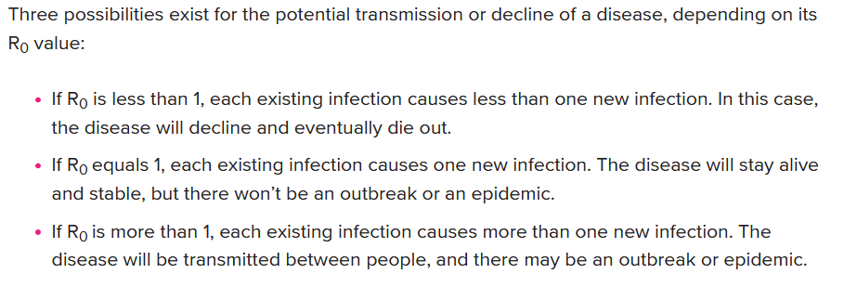
Source: What Is "R-naught"? Gauging Contagious Infections
https://www.healthline.com/health/r-naught-reproduction-number

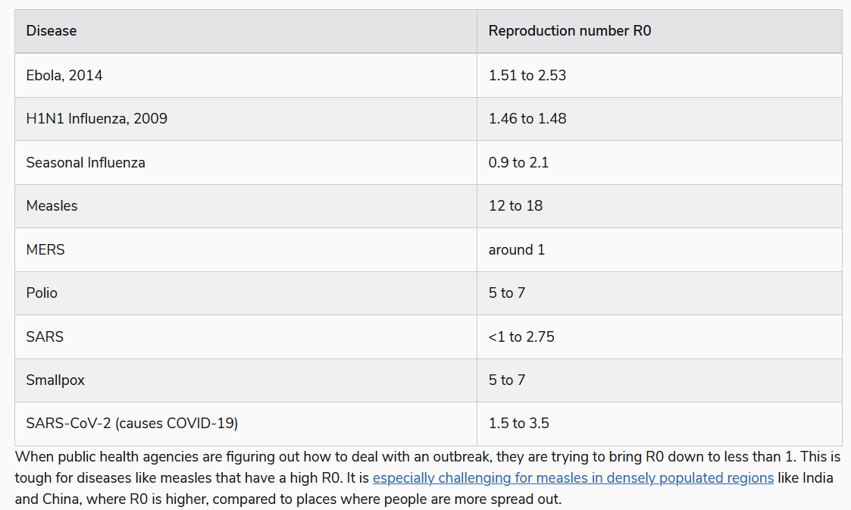
Source: R0: How Scientists Quantify the Intensity of an Outbreak Like Coronavirus and Its Pandemic Potential
https://sph.umich.edu/pursuit/2020posts/how-scientists-quantify-outbreaks.html

“The basic reproductive number (R0) of monkeypox is generally estimated to be between 0.57 to a maximum of 1.25. However, an R0 for the current outbreak has not been determined. ... The basic reproduction number (R0) for MPXV, indicating the average number of new infections arising from one infectious individual in an entirely susceptible population, is estimated to range from 0.57 to 0.96.²⁶⁻²⁷. R0 is a mathematical estimate of the average number of new individuals that a single infected individual will infect in a population without immunity. If this number is less than one, the infection will quickly burn out. If it is greater than one, the infection can spread and cause an epidemic if not controlled. A maximum R0 value of 1.25 was estimated from data on smallpox cross-immunity in the Democratic Republic of the Congo.¹⁰ ... Mutations have been identified in the current outbreak strain that may enhance transmissibility relative to previous West African clade viruses, but these are unlikely to dramatically increase the R0 of the virus.²⁸”
Source: Master Question List for Monkeypox Virus (MPXV) - July 2022
https://www.dhs.gov/sites/default/files/2022-07/22_0712_st_monkeypox_mql.pdf

And that’s based on circumstances within locations in Africa.

CDC: Monkeypox Cases Continue Climbing
https://www.youtube.com/watch?v=3Z50pyaQG2Y

Impossible!

They’re going to have to make it seem like there’s something different about this virus – it’s been created or has mutated in such a way that it’s more infectious. They know they can play on what’s been placed in the minds of the people by Hollywood, a mutation always turns a virus into a beast-of-a-virus, when it’s just not factual.

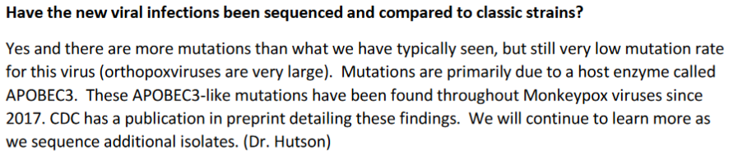
Source: CDC/IDSA Clinician Call: Monkeypox: Updates on Testing, Vaccination & Treatment - July 23, 2022 - Q&A
https://www.idsociety.org/globalassets/idsa/multimedia/clinician-call-slides--qa/qa-7-23.pdf

“Recent work has found that the virus associated with the current outbreak may have an
accelerated evolutionary rate relative to other OPVs, potentially as much as an order of
magnitude greater.²⁸ More corroboration is needed before definitive conclusions are drawn. This enhanced evolutionary rate appears to have led to accumulation of mutations
that would be expected to enhance the transmissibility of the virus.²⁸ Although it is possible that this represents a change in the biology of the virus, it is more likely that it is the result of increased editing by the host RNA editing enzyme APOBEC3, which may be the result of the extensive human-to-human transmission experienced by this strain.²⁸”
Source: Master Question List for Monkeypox Virus (MPXV) - July 2022
https://www.dhs.gov/sites/default/files/2022-07/22_0712_st_monkeypox_mql.pdf

Transmissibility is based on cases – how many, how quickly they pop up, who is being infected, etc. – and each case is determined to be a case by a PCR test along with the WHO and CDC’s definition of a case, but as you’ll see later, the current case numbers are totally fraudulent. So, if they say they found some reason why this virus is “spreading” the way it is, then what does that say about them?

“Like the other viruses it is related to, MPXV evolves very slowly. Its genome changes 100-1,000 times slower than that of SARS-CoV-2. ... Like all OPVs, MPXV has an extremely low evolutionary rate, estimated at 6.5 x 10-6 substitutions/per site/per year, which is approximately 2-3 orders of magnitude slower than RNA viruses like SARS-CoV-2 or Ebola virus.⁸⁵ This evolutionary rate is so low that the inherent error rate of some sequencing technologies can create noise that may artificially inflate apparent evolutionary rates.⁸⁶”
Source: Master Question List for Monkeypox Virus (MPXV) - July 2022
https://www.dhs.gov/sites/default/files/2022-07/22_0712_st_monkeypox_mql.pdf

The Official Story
*You don’t really need to go over this official lie if you don’t want to (it’s here just in case you need it). But I do suggest you read from about the middle of page 51 on because what’s stated from that point on is important.

“On 7 May 2022, the National IHR Focal Point for the United Kingdom notified WHO of a confirmed case of monkeypox in an individual who travelled from United Kingdom to Nigeria from late April to early May 2022 and stayed in Lagos and Delta States in Nigeria. The case developed a rash on 29 April and arrived in the United Kingdom on 4 May, departing Nigeria on 3 May. On the same day (4 May), the case presented to hospital. Based on the travel history and rash illness, monkeypox was suspected at an early stage and the case was isolated immediately. Appropriate use of personal protective equipment was ensured during hospitalization. Monkeypox (West African clade) was laboratory confirmed by reverse transcriptase polymerase chain reaction (RT-PCR) on a vesicular swab on 6 May by the United Kingdom Health Security Agency (UKHSA) Rare and Imported Pathogens Laboratory. ... In the United Kingdom, there have been seven cases of monkeypox previously reported; all importations were related to a travel history to or from Nigeria. In 2021, there were also two separate human monkeypox cases imported from Nigeria reported by the United States of America. Since September 2017, Nigeria has continued to report cases of monkeypox. From September 2017 to 30 April 2022, a total of 558 suspected cases have been reported from 32 states in the country. Of these, 241 were confirmed cases, and among these there were eight deaths recorded (Case Fatality Ratio: 3.3%). From 1 January to 30 April 2022, 46 suspected cases have been reported of which 15 were confirmed from seven states - Adamawa (three cases), Lagos (three cases), Cross River (two cases), Federal Capital Territory (FCT) (two cases), Kano (two cases), Delta (two cases) and Imo (one case). No death has been recorded in 2022. In the present case, the source of infection is currently unknown and the risk of further transmission in Nigeria cannot be excluded. Once monkeypox was suspected in the United Kingdom, authorities promptly initiated appropriate public health measures, including isolation of the case and contact tracing. The risk of potential onward spread related to this case in the United Kingdom is therefore minimal. As the source of infection in Nigeria is not known, there remains a risk of further transmission in Nigeria.”
Source: Monkeypox - United Kingdom of Great Britain and Northern Ireland
https://www.who.int/emergencies/disease-outbreak-news/item/2022-DON381

2022 monkeypox outbreak
Extensive contact tracing of people who had been in contact with the index case both on the international flight from Nigeria to the United Kingdom and within the country following their arrival was carried out, with potential contacts advised to remain aware of the symptoms of monkeypox and immediately isolate if any were to develop within 21 days of the contact event.^{[75]} Following this contact tracing effort, the World Health Organization (WHO) considered further transmission of the virus within the United Kingdom to be of "minimal" risk.^{[75]} Contact tracing was extended to Scotland on 14 May according to Public Health Scotland. A "small number" of people in Scotland were ordered to self-isolate following close contact with the person initially reported to have been infected, although overall risk to the general public remained "very low".^{[58]}
On 12 May two new cases of monkeypox were confirmed by the UK Health Security Agency (UKHSA), both in London,^{[77]} living together in the same household, with no known link between either of them and either the index case or travel to endemic regions. One of the new cases was hospitalised at St Mary's Hospital, while the other case with milder symptoms was said to be self-isolating at home.^{[77]} On 17 May, another four cases of monkeypox were confirmed by the UKHSA in three Londoners and a person in North East England who had previously travelled to London.^{[78]}
Unusually, none of these new cases had any known contact history with the previous three confirmed cases, which suggested a kind of transmission that had not been seen before,^{[79]} a wider community transmission of the virus in the London area. The UKHSA stated that the risk to the general public remained "very low".^{[78][80]} Patients with active monkeypox infection were confirmed to be hospitalised at the Royal Victoria Infirmary in Newcastle upon Tyne and at the Royal Free Hospital and Guy's Hospital in London.^{[78]}
Also on 20 May, UK Health Secretary Sajid Javid reported that another eleven cases had been confirmed, bringing the total in the country to twenty. UKHSA reported on 10 June that 311 of the 314 cases where sex was known were men, and that all of the 151 infected persons who filled out an additional questionnaire and answered questions about sexual practices were men who have sex with men, abbreviated MSM.^{[81]} Dr. Susan Hopkins from the UKHSA urged watchfulness among men who have sex with men.^{[82]} The UK Health Security Agency (UKHSA) advised people who have had close contact with a person infected with monkeypox to self-isolate for 21 days.^{[83]}
Further cases in multiple countries outside the endemic area were reported through the second half of May 2022. On 18 May, Portugal reported 14 cases of monkeypox.^{[84]} In Spain, there were seven confirmed cases as of 18 May.^{[85]} On the same day, the United States confirmed its first 2022 case of monkeypox and Canada reported 13 suspected cases.^{[86][87]}
On 19 May, Sweden, Belgium^{[88][89]} and Italy confirmed their first cases.^{[90]} On 20 May, Australia,^{[91][92]} Germany, France and the Netherlands confirmed their first cases.^{[93][94][95]} For the remainder of May, multiple European countries^{[96][97][98][99]} and Israel confirmed their first cases.^{[100][19]} The United Arab Emirates^{[101]} and Mexico also confirmed their first cases.^{[102]}
On 23 May, David Heymann, an advisor for the World Health Organization, said that the likely theory of how the outbreak started is transmission during sexual intercourse of gay and bisexual men at two raves in Belgium and Spain.^{[103]} On 25 May, The Guardian stated that many scientists suspect the disease was circulating across Europe before reaching the MSM community, possibly misdiagnosed or detected only in isolated cases; four cases were diagnosed in 2018 and 2019, all in individuals who recently arrived from Nigeria.^{[104]}
In addition to more common symptoms, such as fever, headache, swollen lymph nodes, and rashes or lesions, some patients have also experienced proctitis, an inflammation of the rectum lining. CDC has also warned clinicians to not rule out monkeypox in patients with sexually transmitted infections since there have been reports of co-infections with syphilis, gonorrhea, chlamydia, and herpes.^{[105]}
Source: 2022 monkeypox outbreak
https://en.wikipedia.org/wiki/2022_monkeypox_outbreak

Additional Information
Clinical features and novel presentations of human monkeypox in a central London centre during the 2022 outbreak: descriptive case series

“On May 4, a Massachusetts resident developed an anogenital rash 3 days after returning from international travel. This rash progressed to vesicles and pustules and spread to the face and trunk; the patient sought medical care four times at outpatient clinics during May 4–12, during which time common causes were ruled out. The patient was hospitalized on May 12 for management of refractory perianal pain from the rash. Prompted by UKHSA’s announcement regarding the recent monkeypox cases, clinicians notified the MDPH and CDC for testing. On May 17, the patient received a diagnosis of confirmed Orthopoxvirus by the Massachusetts LRN laboratory, and CDC confirmed Monkeypox virus West African clade the following day. The local hospital infection prevention team, MDPH, and CDC responded to identify contacts and determine exposure risk, facilitate PEP with one of two orthopoxvirus vaccines (ACAM2000†† or JYNNEOS§§), and provide guidance on infection prevention and control. Outbreak case definitions were created (Table 1). Exposure risk assessment tools used during investigation of a 2021 travel-associated monkeypox case in Texas (8) were adapted to monitor cases and determine criteria for recommending PEP. Fourteen patients of the 17 patients reported international travel involving 11 different countries during the 21 days preceding symptom onset, and 16 of the 17 patients identified as MSM.”
Source: Monkeypox Outbreak — Nine States, May 2022
https://www.cdc.gov/mmwr/volumes/71/wr/mm7123e1.htm?s_cid=mm7123e1_w

Excerpt from Monkeypox Outbreak — Nine States, May 2022
On May 17, 2022, the Massachusetts Department of Public Health (MDPH) Laboratory Response Network (LRN) laboratory confirmed the presence of orthopoxvirus DNA via real-time polymerase chain reaction (PCR) from lesion swabs obtained from a Massachusetts resident. Orthopoxviruses include Monkeypox virus, the causative agent of monkeypox. Subsequent real-time PCR testing at CDC on May 18 confirmed that the patient was infected with the West African clade of Monkeypox virus. Since then, confirmed cases* have been reported by nine states. In addition, 28 countries and territories,† none of which has endemic monkeypox, have reported laboratory-confirmed cases. On May 17, CDC, in coordination with state and local jurisdictions, initiated an emergency response to identify, monitor, and investigate additional monkeypox cases in the United States. This response has included releasing a Health Alert Network (HAN) Health Advisory, developing interim public health and clinical recommendations, releasing guidance for LRN testing, hosting clinician and public health partner outreach calls, disseminating health communication messages to the public, developing protocols for use and release of medical countermeasures, and facilitating delivery of vaccine postexposure prophylaxis (PEP) and antivirals that have been stockpiled by the U.S. government for preparedness and response purposes. On May 19, a call center was established to provide guidance to states for the evaluation of possible cases of monkeypox, including recommendations for clinical diagnosis and orthopoxvirus testing. The call center also gathers information about possible cases to identify interjurisdictional linkages. As of May 31, this investigation has identified 17§ cases in the United States; most cases (16) were diagnosed in persons who identify as gay, bisexual, or men who have sex with men (MSM). ... New York. On May 4, a traveler returning to New York City (NYC) was evaluated for an oral lesion, and a new painful, perianal rash; the patient was tested and treated for a presumed common STI and sent home. The rash spread, progressing to pustules, and the patient was seen again and treated for a different STI; all testing results were ultimately negative. On May 19, after the announcement of the monkeypox case in Massachusetts, a clinician caring for the NYC patient notified the NYC Department of Health and Mental Hygiene (NYC DOHMH) about the possibility of monkeypox. The patient received a positive orthopoxvirus test result at the NYC LRN laboratory and continued to isolate at home. NYC DOHMH began identifying contacts, determining exposure risk, and facilitating PEP for at-risk contacts.
Other U.S. states. Over the next 5 days from the identification of the NYC case, multiple states received notifications from clinicians about suspected monkeypox cases; on May 23, an incident command structure was created within CDC’s National Center for Emerging and Zoonotic Infectious Diseases to respond to this outbreak. As of May 31, nine states (California, Colorado, Florida, Georgia, Massachusetts, New York, Utah, Virginia, and Washington) have reported 17 patients with confirmed orthopoxvirus infections, which until proven otherwise, are considered to be Monkeypox virus during this outbreak response (Supplementary Figure 1, https://stacks.cdc.gov/view/cdc/117901).
Fourteen patients of the 17 patients reported international travel involving 11 different countries during the 21 days preceding symptom onset, and 16 of the 17 patients identified as MSM.
Source: Monkeypox Outbreak — Nine States, May 2022
https://www.cdc.gov/mmwr/volumes/71/wr/mm7123e1.htm?s_cid=mm7123e1_w

Excerpt from Monkeypox is being driven overwhelmingly by sex between men, major study finds
The global monkeypox outbreak is primarily being driven by sex between men, according to the first major peer-reviewed paper to analyze a large set of cases of the virus. The outbreak, which epidemiologists believe initially began in mid-spring gatherings of gay and bisexual men in Europe, has since alarmed such experts by ballooning to nearly 16,000 cases worldwide. ... Public health experts also theorize that major LGBTQ Pride gatherings in June may have facilitated transmission of the virus. And given the infection’s incubation period — the new paper puts it at seven days, with a range of three to 20 days — the nation is now possibly seeing the resulting downstream effects of sexual encounters in late June and early July. ... All the cases were among men, including one transgender man, 98% of whom identified as gay or bisexual. This stark demographic finding is in keeping with data on the outbreak from around the world, such as a recent report from the British Health Security Agency finding that of the 699 monkeypox cases for which there was available information, 97% were in gay, bisexual or other men who have sex with men. New York City, the U.S. epicenter, has seen only one woman diagnosed with the virus out of 639 cases confirmed through July 19. ... The study authors reported that 95% of the cases were likely transmitted through sexual close contact. What’s more, their paper offers strong new evidence that anal sex itself, although not necessarily ejaculation, is a major source of transmission. “The strong likelihood of sexual transmission was supported by the findings of primary genital, anal, and oral mucosal lesions, which may represent the inoculation site,” the study authors wrote. “The finding that 95% of cases may have been transmitted during sex provides reassurance that this outbreak is primarily caused by very close contact and may explain why it’s been largely limited, so far, to dense social networks of men who have sex with men,” said Dr. Jay K. Varma, an infectious disease expert at Weill Cornell Medicine. Atypical to what has generally been seen in monkeypox cases in the 11 African nations where the virus has become endemic since it was first discovered in humans in 1970, people contracting monkeypox during this outbreak often have their initial development of lesions in the anorectal or genital area. Nearly three-quarters of the men in the new study had lesions in those areas. ... The World Health Organization recently reported that the monkeypox outbreak “continues to primarily affect men who have sex with men who have reported recent sex with new or multiple partners.” The CDC has recommended the Jynneos vaccine for men who report more than four male sexual partners within the past 14 days. The new paper supports these characterizations of the outbreak. This includes its finding that of the nearly three-quarters of men who provided a sexual history, the median number of sexual partners they reported during the previous three months was five, with one quarter of the men reporting 15 or more. During the previous month, 1 in 5 of the men reported they had taken drugs during sex, and one-third had sex at a sex-on-site venue. Of those who received testing, 29 percent had a sexually transmitted infection, or STI. Public health experts have cautioned that monkeypox symptoms are often confused for STIs. Some health authorities, including in the United Kingdom, have advised men who have recovered from monkeypox to wear a condom during sex for eight weeks as a precaution, should the virus remain in semen. Condom use among gay and bisexual men has steadily declined since HIV became a treatable infection in 1996. The advent over the past decade of the HIV prevention pill along with scientific proof that treating HIV prevents transmission has hastened that decline. In a CDC survey published in 2017, nearly three-quarters of gay and bisexual respondents reported condomless sex during the previous 12 months.
Source: Monkeypox is being driven overwhelmingly by sex between men, major study finds
(July 22, 2022)
https://www.nbcnews.com/nbc-out/out-health-and-wellness/monkeypox-driven-overwhelmingly-sex-men-major-study-finds-rcna39564

Let me just say it for them: If everyone refrains from having sex, or uses a condom each time they have sex, we can stop this virus in its tracks.
I’m sure it’s not just a coincidence that this monkeypox scam started just like the HIV/AIDS scam – “It’s a gay thing. Oh wait, it’s not. You can get it too! You’re all going to be infected! Here, take this condom.” Birth control = population control.

The Unofficial Story

“Monkeypox can spread during intimate contact between people, including during sex, as well as activities like kissing, cuddling, or touching parts of the body with monkeypox sores, according to the Ohio Department of Health.”
Source: Two confirmed cases of monkeypox in Cincinnati: What we know
https://www.cincinnati.com/story/news/2022/07/26/2-confirmed-cases-monkeypox-cincinnati-health-officials-say/10159076002/

Another reason for this monkeypox scam, which was also another reason for the COVID scam, is to destroy human-to-human contact.

Why Monkeypox Is a Global Health Threat | WSJ
https://www.youtube.com/watch?v=s8PAcUYRJdE

Right before the COVID scamdemic began I had worked on an informational piece that contained some information on how things in the movie the Demolition Man were being played out. Because of this, when “COVID hit” I was able to immediately see some of the major reasons for masks and social distancing. Now these same reasons are present in the current scamdemic.
Without taking too much time, let me explain. The powers that be are rebuilding mankind. This is one reason why there’s no longer a such thing as a “female color” (like pink and purple used to be). This is one reason why the idea of gender and gender roles has been attacked. This is one of the main reasons for social media, which totally changes the way humans communicate and interact. And all of this is connected to social distancing, staying away from other human beings, and mask wearing, eliminating our ability to see human emotion in the form of facial expressions while also limiting normal human-to-human communication. What are the effects of a human being deprived of human touch? What will your children be like in the future? Combine that with virtual reality.

Covid-19 Sex Rules
https://153news.net/watch_video.php?v=B83N7OY7NMBO

Dr. Fauci Says He Doesn't Think Americans Should Ever Shake Hands Again to Prevent Spread of Coronavirus
https://www.newsweek.com/dr-fauci-americans-should-never-shake-hands-again-coronavirus-influenza-1496772

Couples should wear face masks during sex, new study insists
https://nypost.com/2020/06/02/couples-should-wear-face-masks-during-sex-new-study-insists/

A meme from 2020:

Just watch 27:25 - 29:50
1984 George Orwell - Full Movie - Hollywood best Greatest blockbuster movie Film
https://youtu.be/fCZBnUt6rZ0?t=1645

The movie the Demolition Man was based on the books Brave New World, published in 1932, and Nineteen Eighty-Four, published in 1949, which are books based on plans the elitists have for humanity. If you look at the movie you’ll see the present.

DEMOLITION MAN Predicted iPads, RFID Implants, Self-Driving Cars, Life Extension Tech, Biometrics
https://www.youtube.com/watch?v=Xvz_iO2uxZI

DEMOLITION MAN Predictions That Actually Came True
https://www.youtube.com/watch?v=exILtC-3c_I
And you should know by now it wasn’t a prediction, it was planned.

If you listen closely you’ll understand what happened to their society. The people became germaphobes, and due to outbreaks, all human-to-human contact was outlawed. Sex was through a type of VR headset, and the globalist dream of today had been achieved – licensed procreation.
Demolition Man – Awakening
https://www.youtube.com/watch?v=yk_5cJ180xc

Demolition Man - The Three Seashells
https://www.youtube.com/watch?v=gdnuOa7tDco
- 0:09 – “We are not used to physical contact greetings.”
- 0:13 – “Germs.” And notice how he was holding his hand after it was touched.

Demolition Man 1993
https://www.youtube.com/watch?v=fGMa1Q-45ow
Alternative source:
https://www.youtube.com/watch?v=N_q-DhQwZog

“Be well.” This might have been from a CDC document, but there was a business, might have been in healthcare, that started saying this in 2020 as well.

Who or what fear-causing agent does Simon Phoenix, back from the ashes, actually represent?
Creating the Perfect Society - Demolition Man (1993)
https://www.youtube.com/watch?v=kKP3cAp5z2E
I guess we’ll find out.

"For more than a century ideological extremists at either end of the political spectrum have seized upon well-publicized incidents such as my encounter with Castro to attack the Rockefeller family for the inordinate influence they claim we wield over American political and economic institutions. Some even believe we are part of a secret cabal working against the best interests of the United States, characterizing my family and me as ‘internationalists’ and of conspiring with others around the world to build a more integrated global political and economic structure – one world, if you will. If that’s the charge, I stand guilty, and I am proud of it." – David Rockefeller - Memoirs.

"What is at stake is more than one small country, it is a big idea - a new world order, where diverse nations are drawn together in a common cause…." – George H. W. Bush

"We have before us the opportunity to forge, for ourselves and for future generations, a New World Order. A world where the rule of law, not the law of the jungle, rules all nations. When we are successful–and we will be–we have a real chance at this New World Order. An order in which a credible United Nations can use its peacekeeping forces to fulfill the promise and vision of its founders." – George H.W. Bush, March 21, 1991

“Today Americans would be outraged if U.N. troops entered Los Angeles to restore order; tomorrow they will be grateful. This is especially true if they were told there was an outside threat from beyond, whether real or promulgated, that threatened our very existence. It is then that all peoples of the world will plead with world leaders to deliver them from this evil. The one thing every man fears is the unknown. When presented with this scenario, individual rights will be willingly relinquished for the guarantee of their well being granted to them by their world government.” – Henry Kissinger

The Case Count

Note: An assay is a testing procedure, which for virus detection in a sample, comes with a kit and instructions on how to test the sample. The testing is conducted on a PCR machine. And there are several types of PCR machines.

“The polymerase chain reaction (PCR) is a method widely used to rapidly make millions to billions of copies (complete or partial) of a specific DNA sample, allowing scientists to take a very small sample of DNA and amplify it (or a part of it) to a large enough amount to study in detail. PCR was invented in 1983 by the American biochemist Kary Mullis at Cetus Corporation; Mullis and biochemist Michael Smith, who had developed other essential ways of manipulating DNA,[1] were jointly awarded the Nobel Prize in Chemistry in 1993.”
Source: Polymerase chain reaction
https://en.wikipedia.org/wiki/Polymerase_chain_reaction

Nobel Prize Winner & PCR Inventor Kary Mullis Versus Dr. Anthony Fauci
https://www.altcensored.com/watch?v=_eZQEE2kT9U

Kary Mullis speaks about his invention the pcr test
https://www.altcensored.com/watch?v=jI4LJMDMf9A

“This limitation leads to the most important disadvantage of qPCR, which is its inherent incapability of distinguishing between live and dead cells.”
Source: A Basic Guide to Real Time PCR in Microbial Diagnostics: Definitions, Parameters, and Everything
(02 February 2017)
https://www.frontiersin.org/articles/10.3389/fmicb.2017.00108/full

That’s just a little bit of information on PCR.
FYI: HIV/AIDS is a hoax. I exposed this while exposing COVID in 2020. If you want to see it for yourself, take a look at The HIV/AIDS Connection here.

While searching for more videos on the Ebola hoax of 2014 I came across a video on HIV/AIDS. I know I’m going over PCR and testing right now, but I think you should take a look at this video right now, especially if you’re new to this sort of thing. It will help you to see what we’re dealing with today with monkeypox.
BBC Documentary Proves CDC Wrong -- EBOLA is a HOAX as is HIV
https://153news.net/watch_video.php?v=48HS97BK6BMD

“Polymerase chain reaction (PCR)-based diagnostics are the most reliable diagnostic tools
for MPXV.^{11, 53} PCR-based methods can be used on scab or vesicle material samples with or without virus isolation or propagation.^{14, 16, 41, 48, 55-57} Additionally, PCR-based methods are effective during acute illness¹⁵ and can differentiate between MPXV Congo Basin and MPXV West African strains.⁵⁸ Collaboratively, Roche and TIB Molbiol developed three LightMix Modular Virus kits to detect MPXV using quantitative PCR (qPCR) after nucleic acid extraction. The first kit detects OPVs including, but not limited to, MPXV. The second kit is specific for detecting only the West African and Central African MPXV strains, while the third kit provides a simultaneous detection of OPVs and specific identification of MPXV. These kits have not been fully validated, and are not approved for clinical use.⁵⁹
ELISA-based serological diagnostics can be used to determine if exposure has occurred
after a patient is PCR negative, but cannot differentiate between clades, and may not be
able to differentiate vaccinated from infected individuals.⁶⁰ IgM titers may be positive as early as day 2 after rash onset; it is recommended that samples be collected at least 5 days after onset of rash.⁶⁰ IgG titers may be positive as early as 1-2 days after rash onset; it is recommended that samples be collected after day 14 following onset of rash.⁶⁰ IgM ELISA can distinguish between recent MPXV infection and previous smallpox vaccination.⁶⁰ MPXV-specific IgG was detected in human serum as long as one year post-infection.¹⁵ Confirmation is possible through MPXV isolation and immunohistochemistry from human
samples¹⁶ and animal samples.⁶¹⁻⁶² Intracellular cytokine staining analysis has been used to quantify OPV-specific CD4+ and CD8+ T-cell responses based on gamma interferon and tumor necrosis factor-α production.¹⁵ Confirmation possible through morphological identification consistent with an OPV by electron microscopy.¹⁶ Antibody-based tests and electron microscopy are only sufficient for ‘probable’ case status under the current case definition.⁵⁴”
Source: Master Question List for Monkeypox Virus (MPXV) - July 2022
https://www.dhs.gov/sites/default/files/2022-07/22_0712_st_monkeypox_mql.pdf

Note: Not all PCR tests can differentiate between the MPXV Congo Basin and MPXV West African strains, or, as you’ll see later, monkeypox and orthopoxviruses.
In that document the Department of Homeland Security is talking about testing for antibodies in the blood, and they say that the ELISA-based tests, except for one, may not be able to differentiate between those vaccinated with Vaccinia virus (like the smallpox vaccine and monkeypox vaccines) and those infected with monkeypox. So, keep that in mind for when they start talking about antibody tests.

The World Health Organization
“The clinical differential diagnosis that must be considered includes other rash illnesses, such as chickenpox, measles, bacterial skin infections, scabies, syphilis, and medication-associated allergies. Lymphadenopathy during the prodromal stage of illness can be a clinical feature to distinguish monkeypox from chickenpox or smallpox. If monkeypox is suspected, health workers should collect an appropriate sample and have it transported safely to a laboratory with appropriate capability. Confirmation of monkeypox depends on the type and quality of the specimen and the type of laboratory test. Thus, specimens should be packaged and shipped in accordance with national and international requirements. Polymerase chain reaction (PCR) is the preferred laboratory test given its accuracy and sensitivity. For this, optimal diagnostic samples for monkeypox are from skin lesions – the roof or fluid from vesicles and pustules, and dry crusts. Where feasible, biopsy is an option. Lesion samples must be stored in a dry, sterile tube (no viral transport media) and kept cold. PCR blood tests are usually inconclusive because of the short duration of viremia relative to the timing of specimen collection after symptoms begin and should not be routinely collected from patients. As orthopoxviruses are serologically cross-reactive, antigen and antibody detection methods do not provide monkeypox-specific confirmation. Serology and antigen detection methods are therefore not recommended for diagnosis or case investigation where resources are limited. Additionally, recent or remote vaccination with a vaccinia-based vaccine (e.g. anyone vaccinated before smallpox eradication, or more recently vaccinated due to higher risk such as orthopoxvirus laboratory personnel) might lead to false positive results. In order to interpret test results, it is critical that patient information be provided with the specimens including: a) date of onset of fever, b) date of onset of rash, c) date of specimen collection, d) current status of the individual (stage of rash), and e) age.”
Source: Monkeypox
https://www.who.int/news-room/fact-sheets/detail/monkeypox
Archived: http://archive.today/7izwu
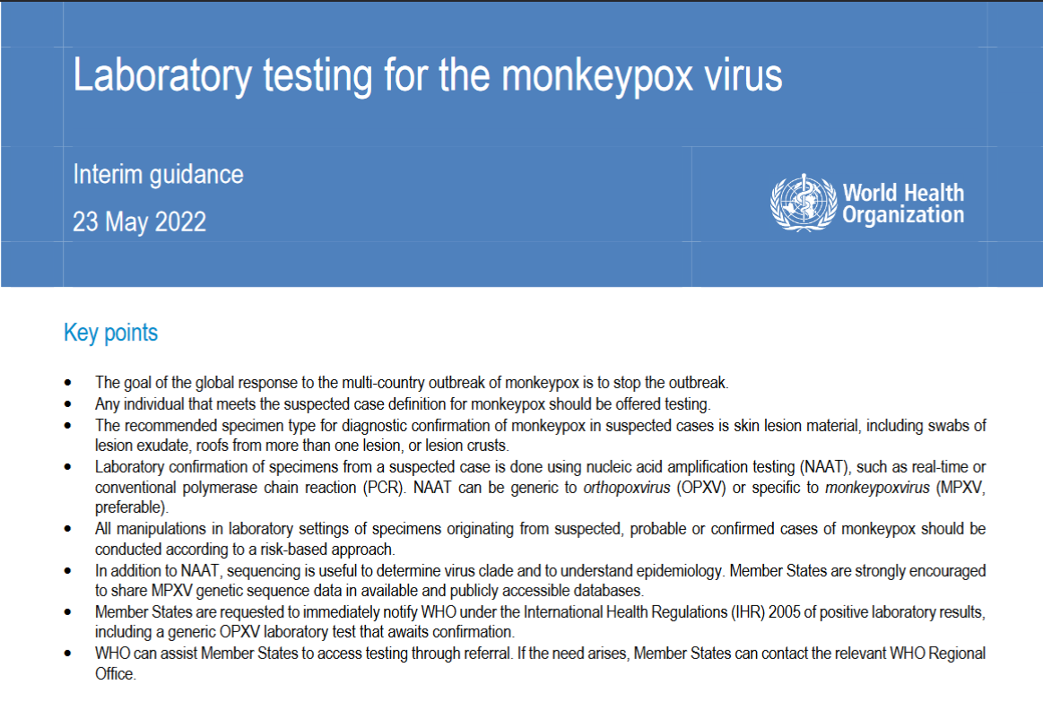
LABORATORY CONFIRMATION ... from a suspected case can be carried out using a test that is generic to orthopoxvirus (OPXV) – the whole genus of viruses. And that includes vaccinia, or in other words, several types of vaccines.

“Smallpox is caused by variola virus, genus Orthopoxvirus. Other members of this genus that can infect humans are vaccinia virus, monkeypox virus, and cowpox virus.”
Source: Smallpox & Other Orthopoxvirus-Associated Infections
https://wwwnc.cdc.gov/travel/yellowbook/2020/travel-related-infectious-diseases/smallpox-and-other-orthopoxvirus-associated-infections

Orthopox viruses (OPV): Host and host specificity
https://www.ncbi.nlm.nih.gov/pmc/articles/PMC3048946/table/T2/?report=objectonly

“Monkeypox virus is an enveloped double‐stranded DNA virus with a genome size of around 190 kb. It belongs to the orthopoxvirus genus of the Poxviridae family. The orthopoxvirus genus also includes vaccinia virus, cowpox virus, variola virus and several other, animal-related poxviruses [2]. ... The clinical presentation of MPX includes symptoms and lesions that may be difficult to distinguish from smallpox, other orthopoxvirus and parapoxvirus infections, and, to some extent, chickenpox. The main difference between smallpox and MPX is that MPXV causes lymphadenopathy (e.g. in the cervical or inguinal region) while smallpox virus and chickenpox virus usually do not [20]. Other orthopoxviruses (i.e. cowpox virus, camelpox virus, buffalopox virus) and parapoxviruses (i.e. orf virus, pseudocowpox virus, bovine papular stomatitis virus) usually cause localised skin lesions in humans. However, MPX can also present with localised skin lesions.”
Source: Factsheet for health professionals on monkeypox
https://www.ecdc.europa.eu/en/all-topics-z/monkeypox/factsheet-health-professionals

Continuing...

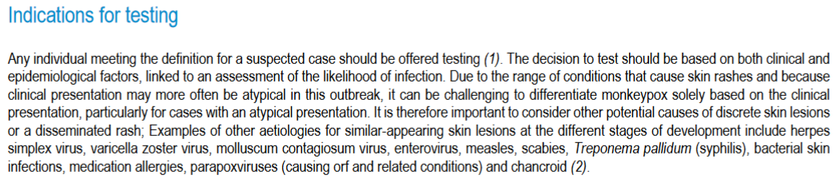
They gave out a whole list of things and said to consider them. Do you think healthcare providers are going to test for all of that before they test for monkeypox? Of course not! And with so much fear being in the air they’re going to go straight for the “monkeypox test.”
Continuing...

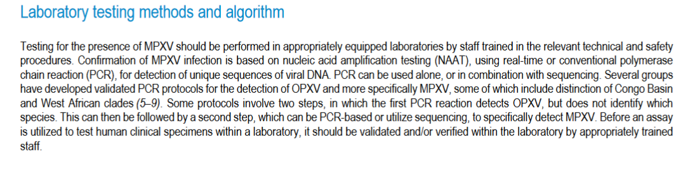
Basically, they just revealed that they know of tests and procedures that can be used to specifically identify OPXV, and yet they don’t demand that these be used.
Continuing...

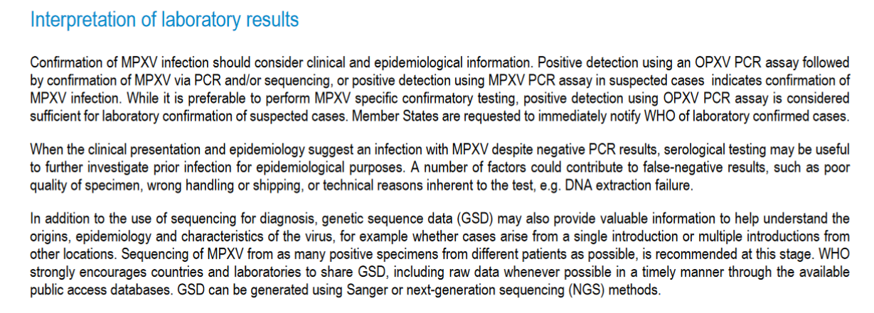
Source: Laboratory testing for the monkeypox virus - Interim guidance - 23 May 2022
https://apps.who.int/iris/bitstream/handle/10665/354488/WHO-MPX-Laboratory-2022.1-eng.pdf

“While it is preferable to perform MPXV specific confirmatory testing, positive detection using OPXV PCR assay is considered sufficient for laboratory confirmation of suspected cases. Member States are requested to immediately notify WHO of laboratory confirmed cases.” There it is. Member States around the world, and others following WHO protocol around the world, are picking up orthopoxviruses and the vaccinia virus in the previously vaccinated. And they said that when clinical presentation and epidemiology suggest an infection, someone seems like they have it (subjective) and were around someone who was positive, but their PCR test was negative, test their blood. But what did you just read about blood tests?

“During 2013, cutaneous lesions developed in two men in the country of Georgia after they were exposed to ill cows. The men had never received vaccination against smallpox. Tests of lesion material with the use of a quantitative real-time polymerase-chain-reaction assay for non–variola virus orthopoxviruses were positive, and DNA sequence analysis implicated a novel orthopoxvirus species. During the ensuing epidemiologic investigation, no additional human cases were identified. However, serologic evidence of exposure to an orthopoxvirus was detected in cows in the patients’ herd and in captured rodents and shrews. A third case of human infection that occurred in 2010 was diagnosed retrospectively during testing of archived specimens that were originally submitted for tests to detect anthrax. ... Lesion specimens were obtained from both patients. These specimens were tested with the use of the non–variola virus orthopoxvirus screening quantitative PCR assay and yielded positive results (cycle-threshold values, 20.2 and 23.6). Subsequent assays to detect cowpox and vaccinia viruses were negative. Limited amplification occurred with the use of the monkeypox virus–specific assay (cycle-threshold values, 25.8 and 29.9). The amplified region of the DNA-dependent RNA polymerase gene shared 96% identity (490 of 513 nucleotides) with monkeypox virus Zaire 1979_005 (GenBank accession number, HM172544) and 98% identity (502 of 513 nucleotides) with cowpox virus UK2000_K2984 (GenBank accession number, HQ420900).¹⁵ Viral DNA sequences from both patients were identical across nine conserved orthopoxvirus genes, with a total alignment length of 24,303 base pairs (GenBank accession numbers, KM046934–KM046942).”
Source: Human Infection with a Zoonotic Orthopoxvirus in the Country of Georgia
https://www.nejm.org/doi/pdf/10.1056/NEJMoa1407647

I’m not sure if these same assays are in use today, but if you know about PCR and want to go down the CT value rabbit hole, take note of the cycle threshold values that were used here. The CDC uses 40, but I’ve also read about 40 cycles being used for orthopoxviruses prior to this monkeypox scam.
And if you want to go down the rabbit hole of PCR testing here’s some info to start with
Monkeypox Virus and Orthopoxvirus ValuPanel Reagents
Test Procedure: Non-variola Orthopoxvirus Generic Real-Time PCR Test
Test Procedure: Monkeypox virus Generic Real-Time PCR Test
Information For Laboratory Personnel
Monkeypox Virus

The CDC
“Although no fully US FDA-approved MPXV-specific assays exist, the US CDC has developed an FDA-cleared test for provisional use via the public health Laboratory Response Network. Currently this capacity includes 67 laboratories in 48 states. Five commercial laboratory companies have received authorization to use the CDC test and have begun receiving testing materials. Within the United States, culture-based diagnostics should only be performed by the Centers for Disease Control and Prevention (CDC) per CDC guidelines. Quantitative polymerase chain reaction (qPCR)-based detection is recommended by CDC, and optimal samples include scab and lesion material.”
Source: Master Question List for Monkeypox Virus (MPXV) - July 2022
https://www.dhs.gov/sites/default/files/2022-07/22_0712_st_monkeypox_mql.pdf

“The test is a polymerase chain reaction, or P.C.R., much like those for Covid-19 that detect a piece of the virus’s genetic material. But testing capacity is still limited. Samples can be sent only to a public health laboratory or one of five commercial labs for analysis. And although the turnaround time has improved, results can take anywhere from 24 hours to three days or more. There is no home test for monkeypox. And even at a clinic, health care workers need a lesion to swab in order to perform a monkeypox test, said Dr. William Morice, the chair of the department of lab medicine and pathology at Mayo Clinic and president of Mayo Clinic Laboratories, which is one of the five commercial laboratories using the C.D.C.’s orthopoxvirus test. If you don’t have any symptoms, or have only fever and flulike symptoms, there is no way to test for monkeypox yet, Dr. Morice said.”
Source: How to Get Vaccinated, Tested and Treated for Monkeypox
https://www.nytimes.com/2022/07/21/well/live/monkeypox-vaccine-treatment.html

Additional Information
Test Procedure: Monkeypox virus Generic Real-Time PCR Test
Multiple lineages of Monkeypox virus detected in the United States, 2021- 2022

Read these excerpts from Rapid Diagnostic Testing for Response to the Monkeypox Outbreak — Laboratory Response Network, United States, May 17–June 30, 2022
As part of public health preparedness for infectious disease threats, CDC collaborates with other U.S. public health officials to ensure that the Laboratory Response Network (LRN) has diagnostic tools to detect Orthopoxviruses, the genus that includes Variola virus, the causative agent of smallpox. LRN is a network of state and local public health, federal, U.S. Department of Defense (DOD), veterinary, food, and environmental testing laboratories. CDC developed, and the Food and Drug Administration (FDA) granted 510(k) clearance* for the Non-variola Orthopoxvirus Real-time PCR Primer and Probe Set (non-variola Orthopoxvirus [NVO] assay), a polymerase chain reaction (PCR) diagnostic test to detect NVO. On May 17, 2022, CDC was contacted by the Massachusetts Department of Public Health (DPH) regarding a suspected case of monkeypox, a disease caused by the Orthopoxvirus Monkeypox virus. Specimens were collected and tested by the Massachusetts DPH public health laboratory with LRN testing capability using the NVO assay. Nationwide, 68 LRN laboratories had capacity to test approximately 8,000 NVO tests per week during June. During May 17–June 30, LRN laboratories tested 2,009 specimens from suspected monkeypox cases. Among those, 730 (36.3%) specimens from 395 patients were positive for NVO. NVO-positive specimens from 159 persons were confirmed by CDC to be monkeypox; final characterization is pending for 236. Prompt identification of persons with infection allowed rapid response to the outbreak, including isolation and treatment of patients, administration of vaccines, and other public health action. To further facilitate access to testing and increase convenience for providers and patients by using existing provider-laboratory relationships, CDC and LRN are supporting five large commercial laboratories with a national footprint (Aegis Science, LabCorp, Mayo Clinic Laboratories, Quest Diagnostics, and Sonic Healthcare) to establish NVO testing capacity of 10,000 specimens per week per laboratory. On July 6, 2022, the first commercial laboratory began accepting specimens for NVO testing based on clinician orders.
LRN was established in 1999† as a partnership among CDC, the Federal Bureau of Investigation, and the Association of Public Health Laboratories, with the goal of ensuring a laboratory infrastructure across the United States that can respond quickly and effectively to biothreats, chemical threats, and emerging infectious diseases (1). LRN provides the framework to rapidly distribute laboratory diagnostic tests, standardized reagents, and standard operating procedures, and to train laboratory personnel, report laboratory test results, and provide critical communication during routine and emergency responses. LRN includes approximately 110 U.S. laboratories, primarily state and local public health and DOD laboratories, as well as veterinary, food, and environmental testing laboratories. LRN laboratories are required to participate in proficiency testing exercises to ensure competency for laboratory test methods distributed to the network.
To effectively respond to a potential Orthopoxvirus outbreak, CDC subject matter experts worked with LRN to design, develop, and validate an assay to detect NVOs, such as Vaccinia, Cowpox, Monkeypox, and Ectromelia viruses, if suspected cases were identified. The NVO assay first received 510(k) clearance by FDA in 2005 and was cleared again in 2018 to update the labeling and use of reagents. The NVO assay does not differentiate Monkeypox virus from other Orthopoxviruses. NVOs are not endemic in the United States; however, the NVO assay has been used to detect cases of Vaccinia virus infection associated with vaccination and two imported cases of monkeypox from travelers in 2021 (2).
CDC recommends that for each patient, clinicians collect two specimens, each from multiple lesions, preferably from different locations on the body and from lesions with differing appearances (3). The CDC Monkeypox virus testing algorithm includes NVO testing, and if results are positive for Orthopoxvirus, further characterization testing at CDC (4). A subset of specimens was characterized at CDC by a Monkeypox virus specific real-time PCR assay and genetic sequencing.§ The median LRN laboratory testing turnaround time was calculated from the time of specimen receipt by LRN testing laboratories to arrival of NVO test results at CDC. Testing capacity was estimated and reported by LRN laboratories. This report describes NVO testing by LRN during May 17–June 30, 2022. This investigation was reviewed by CDC and conducted consistent with applicable federal law and CDC policy.
As of June 10, 68 U.S. LRN laboratories, located in 47 states and the District of Columbia, had implemented the NVO assay updated in 2018 and tested specimens from patients with probable monkeypox cases. These laboratories reported an estimated total testing capacity of 8,000 specimens per week. LRN laboratories reported that capacity of NVO testing laboratories was limited by reagent availability and the requirement for manual DNA extraction. To increase testing throughput and build capacity, the NVO assay was rapidly updated to include additional controls, automated extraction, and real-time PCR instrumentation in collaboration with FDA; the updated assay received 510(k) clearance on June 10, 2022. As of June 30, 2022, 78 LRN laboratories had implemented the NVO assay and have reported a total testing capacity of 24,000 specimens per week with implementation of substantial operational changes such as adding extra shifts, reassigning personnel, and shifting testing priorities based on laboratory emergency response plans.
During May 17–June 30, a total of 2,009 specimens were tested in LRN laboratories (Table); 730 (36.3%) specimens from 395 persons across 31 jurisdictions (including 29 states, District of Columbia, and Puerto Rico) were confirmed positive for Orthopoxvirus using the NVO assay. One positive specimen from each patient (159) was sent to CDC and further characterized as Monkeypox virus belonging to the West African clade; as of June 30, 236 confirmed Orthopoxvirus cases were pending characterization. The median LRN laboratory testing turnaround time was 30.7 hours for all results (Table).
Source: Rapid Diagnostic Testing for Response to the Monkeypox Outbreak — Laboratory Response Network, United States, May 17–June 30, 2022
https://www.cdc.gov/mmwr/volumes/71/wr/mm7128e1.htm
Alternative source: https://www.cdc.gov/mmwr/volumes/71/wr/pdfs/mm7128e1-H.pdf

We’ll get back to those stats later on.

So, everyone who is allowed to test has been equipped with non-variola (non-smallpox) Orthopoxvirus tests – tests that are not specific to monkeypox.
And tests are being sent to the CDC for “verification,” and before “verification” are being called “confirmed cases.”

“The Massachusetts Department of Public Health and the Centers for Disease Control and Prevention (CDC) are investigating a confirmed case of monkeypox in the United States. On May 17, 2022, skin lesions that had several features suspicious for monkeypox—firm, well circumscribed, deep-seated, and umbilicated lesions—on a Massachusetts resident prompted specialized Laboratory Response Network (LRN) testing of swab specimens collected from the resident; preliminary testing confirmed the presence of DNA consistent with an orthopoxvirus using Orthopoxvirus generic and non-variola Orthopoxvirus real-time polymerase chain reaction (PCR) assays. This group of viruses includes monkeypox virus (the causative agent of monkeypox). Testing at CDC on May 18 confirmed the patient was infected with a West African strain of monkeypox virus.”
Source: Monkeypox Virus Infection in the United States and Other Non-endemic Countries—2022
https://www.dhhs.nh.gov/sites/g/files/ehbemt476/files/documents2/han-monkeypox-virus-05202022.pdf

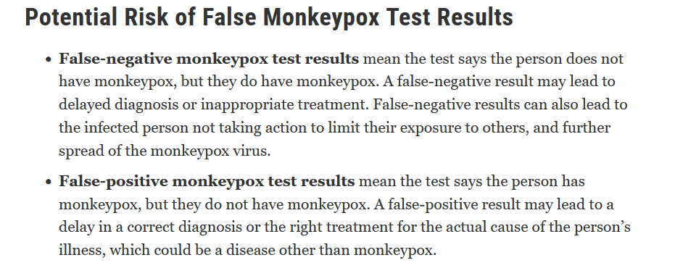
Source: For Monkeypox Testing, Use Lesion Swab Samples to Avoid False Results: FDA Safety Communication
https://www.fda.gov/medical-devices/safety-communications/monkeypox-testing-use-lesion-swab-samples-avoid-false-results-fda-safety-communication

But they don’t state how you could get a false-positive result.
“Labcorp now offers an FDA-cleared test for monkeypox, giving you and your patients the answers they need now.”
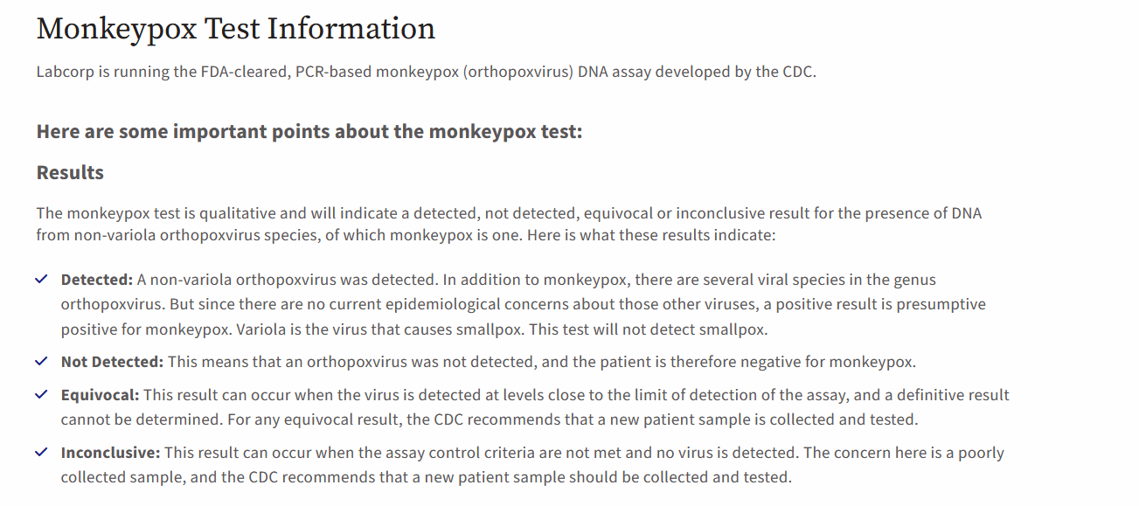
Source: Monkeypox (Orthopoxvirus), DNA, PCR Test
https://www.labcorp.com/infectious-disease/monkeypox
Archived: http://archive.today/o3dK8

Take a look at this from CDC/IDSA Clinician Call: Monkeypox: Updates on Testing, Vaccination & Treatment - July 23, 2022 - Q&A
“This is the Q&A transcript from the Zoom webinar, formatted and edited for spelling and grammar only.”
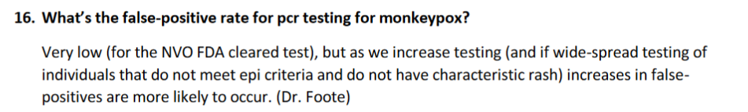
...
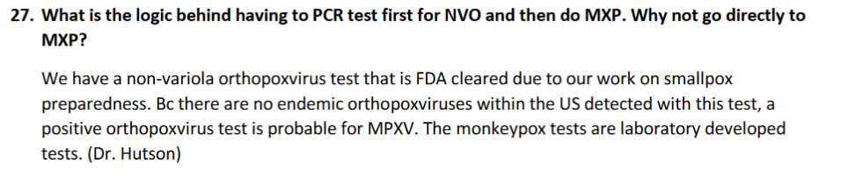
Source: CDC/IDSA Clinician Call: Monkeypox: Updates on Testing, Vaccination & Treatment - July 23, 2022 - Q&A
https://www.idsociety.org/globalassets/idsa/multimedia/clinician-call-slides--qa/qa-7-23.pdf

So, there are even false-positive results among the positive orthopoxvirus results that they say are confirmed cases of monkeypox.
And they claim their logic behind not using a monkeypox-specific test is because there are no endemic orthopoxviruses within the US – that’s their excuse. But what about the people who have been vaccinated with, or around people who have been vaccinated with, the vaccinia virus? And what about the people who have been shot-up with who-knows-what in all of these vaccine clinical trials and released back into society?
Referring to a study on people in the US associated with the 2003 outbreak: “However, given the presence of preexisting poxvirus immunity in much of the population, use of OPX-specific CD4 or B-cell detection as a diagnostic tool in vaccinated populations....” (Source: Monkeypox-Induced Immunity and Failure of Childhood Smallpox Vaccination To Provide Complete Protection) If much of the population has preexisting poxvirus immunity, we must have come in contact with orthopoxviruses and have them in our system. So, even if you never develop a rash, become sick in any way, or are able to infect anyone else, PCR is going to multiply those fragments and give a positive test result for orthopoxvirus.
If you want to check it out, here’s a study on asymptomatic orthopoxvirus circulation: Asymptomatic Orthopoxvirus Circulation in Humans in the Wake of a Monkeypox Outbreak among Chimpanzees in Cameroon

It’s the COVID scam.

How do you make a virus seem to spread? You gradually increase your testing.
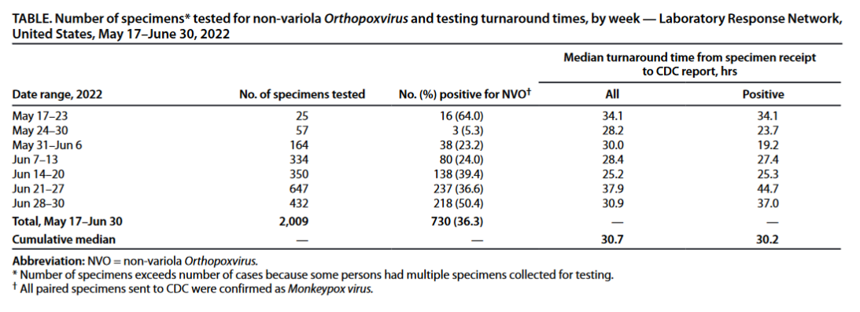
Source: Rapid Diagnostic Testing for Response to the Monkeypox Outbreak — Laboratory Response Network, United States, May 17–June 30, 2022
https://www.cdc.gov/mmwr/volumes/71/wr/mm7128e1.htm
Alternative source: https://www.cdc.gov/mmwr/volumes/71/wr/pdfs/mm7128e1-H.pdf

“During May 17–June 30, a total of 2,009 specimens were tested in LRN laboratories (Table); 730 (36.3%) specimens from 395 persons across 31 jurisdictions (including 29 states, District of Columbia, and Puerto Rico) were confirmed positive for Orthopoxvirus using the NVO assay. One positive specimen from each patient (159) was sent to CDC and further characterized as Monkeypox virus belonging to the West African clade; as of June 30, 236 confirmed Orthopoxvirus cases were pending characterization. The median LRN laboratory testing turnaround time was 30.7 hours for all results (Table).”
From another place in the document:
“During May 17–June 30, 2022, LRN laboratories tested 2,009 specimens from patients with suspected monkeypox. Among these, 730 (36%) specimens from 395 patients were positive for NVO. Specimens from 159 persons with NVO-positive results were confirmed by CDC to be monkeypox; confirmatory testing is pending for 236. LRN laboratories have increased testing capacity from 8,000 per week in June because of NVO assay update”
“CDC recommends that for each patient, clinicians collect two specimens, each from multiple lesions, preferably from different locations on the body and from lesions with differing appearances.”
They only recommended it, so only some people are going to take two specimens. We have no idea how many specimens were taken from each person.
As you can see, they’re muddying the waters by giving us data by specimens and not number of people tested. Look at it, it’s like a trick math question. This is criminal, but what do you expect from criminals.
Having taken 2,009 specimens, some being multiple specimens from the same person, we know for a fact that they tested less than 2,000 people. So, out of less than 2,000 people tested, 395 were positive for non-variola (non-smallpox) Orthopoxviruses. Of those 395 people, 195 were confirmed to have monkeypox. And those 395 people were not from one location, they were from 31 jurisdictions (including 29 states, District of Columbia, and Puerto Rico). Seriously?! We’re supposed to believe this nonsense?! 395 people out of less than 2000 people tested positive for Orthopoxvirus?! But I thought since Orthopoxviruses weren’t endemic in the US the CDC’s use of the non-monkeypox specific tests didn’t matter? And how the heck are so many people testing positive for Orthopoxvirus?! And the rest of the 395 people, 236, have not been confirmed yet, so there could be more monkeypox “positive” cases!

“This week, the Department of Health and Human Services (HHS), through the Centers for Disease Control and Prevention (CDC), began shipping orthopoxvirus tests to five commercial laboratory companies, including the nation’s largest reference laboratories, to quickly increase monkeypox testing capacity and access in every community during the ongoing monkeypox outbreak. The companies include Aegis Science, Labcorp, Mayo Clinic Laboratories, Quest Diagnostics and Sonic Healthcare. These commercial laboratories will dramatically expand testing capacity nationwide and make testing more convenient and accessible for patients and health care providers. Health care providers will be able to use these laboratories by early July and testing capacity through these companies will be ramped up throughout the month.”
Source: HHS Expanding Monkeypox Testing Capacity to Five Commercial Laboratory Companies
https://www.hhs.gov/about/news/2022/06/22/hhs-expanding-monkeypox-testing-capacity-five-commercial-laboratory-companies.html

Aegis Sciences to Begin Monkeypox Testing Today, Increasing Nationwide Testing Capacity
https://www.cdc.gov/media/releases/2022/s0714-aegis-monkeypox-testing.html

It’s the same as COVID, the more testing, the more “positive cases”; the more “positive cases,” the more the virus is “spreading”; the more the virus is “spreading,” the more the government can do.

I guess Quest later developed their own test.
Monkeypox Virus DNA, Qualitative, Real-Time PCR
https://www.questdiagnostics.com/healthcare-professionals/clinical-education-center/faq/faq286
“... test that is also based on the CDC targets for the NVOs as well as West African clade.^{1, 2} ... test is performed from specimens collected in viral transport media, and the liquid media, not the swab, is used for testing.”
Additional Information
From the footnotes
^{1.} Li Y, Olson VA, Laue T, et al. Detection of monkeypox virus with real-time PCR assays. J Clin Virol. 2006;36(3):194-203. doi:10.1016/j.jcv.2006.03.012
^{2.} Li Y, Zhao H, Wilkins K, et al. Real-time PCR assays for the specific detection of monkeypox virus West African and Congo Basin strain DNA. J Virol Methods. 2010;169(1):223-227. doi:10.1016/j.jviromet.2010.07.012

“The recent sharp rise in U.S. monkeypox diagnoses could be driven in part by increased testing, especially after the Centers for Disease Control and Prevention brought onboard five commercial testing companies during the past two weeks.”
Source: Monkeypox is being driven overwhelmingly by sex between men, major study finds
https://www.nbcnews.com/nbc-out/out-health-and-wellness/monkeypox-driven-overwhelmingly-sex-men-major-study-finds-rcna39564

Confirmed or Probable?
When you hear about another case of monkeypox, how do you know if they are telling you about laboratory confirmed cases or probable cases?
Would you agree that anyone who knowingly included probable cases with confirmed cases and tried to pass them off as confirmed cases is a snake and should be executed or imprisoned?

“Scientists at the U.S. Centers for Disease Control and Prevention (CDC), along with state and local public health partners, are tracking 3,487 cases of monkeypox in the United States as of July 25, 2022. CDC is also tracking multiple clusters of monkeypox that have been reported globally in 69 countries that do not normally report monkeypox. ... Domestic: On May 17, 2022, the United States confirmed the first monkeypox case in Massachusetts. As of July 25, 2022, there are 3,487 cases in 45 states, the District of Columbia, and Puerto Rico. These case counts include those who tested positive for either monkeypox virus or orthopoxvirus (OPX) as described in the case definition.”
Source: Technical Report: Multi-National Monkeypox Outbreak, United States, 2022
(Updated July 28, 2022)
https://www.cdc.gov/poxvirus/monkeypox/clinicians/technical-report.html

- “These case counts include those who tested positive for either monkeypox virus or orthopoxvirus (OPX)...” Scam!

Here’s the CDC’s definition:
https://web.archive.org/web/20220811235941/https://www.cdc.gov/poxvirus/monkeypox/clinicians/case-definition.html
Probable Case
No suspicion of other recent Orthopoxvirus exposure (e.g., Vaccinia virus in ACAM2000 vaccination) AND demonstration of the presence of
- Orthopoxvirus DNA by polymerase chain reaction of a clinical specimen OR
- Orthopoxvirus using immunohistochemical or electron microscopy testing methods OR
- Demonstration of detectable levels of anti-orthopoxvirus IgM antibody during the period of 4 to 56 days after rash onset

So, if they don’t “suspect” that a person has had recent Orthopoxvirus exposure, but they have a positive PCR test for Orthopoxvirus or anti-orthopoxvirus IgM antibodies, a health care provider can call it a probable case of monkeypox. So, a probable case could be a positive Orthopoxvirus PCR or antibody test.
And clearly there’s a problem with being tested and having recent Orthopoxvirus exposure, right? And one example they gave was the vaccinia virus in one of the vaccines they are giving out right now, ACAM2000. So, can’t you deduce from this and other related information that the vaccinations will cause the vaccinated to test positive for Orthopoxvirus?
From a previous WHO document: “As orthopoxviruses are serologically cross-reactive, antigen and antibody detection methods do not provide monkeypox-specific confirmation. Serology and antigen detection methods are therefore not recommended for diagnosis or case investigation where resources are limited. Additionally, recent or remote vaccination with a vaccinia-based vaccine (e.g. anyone vaccinated before smallpox eradication, or more recently vaccinated due to higher risk such as orthopoxvirus laboratory personnel) might lead to false positive results.”

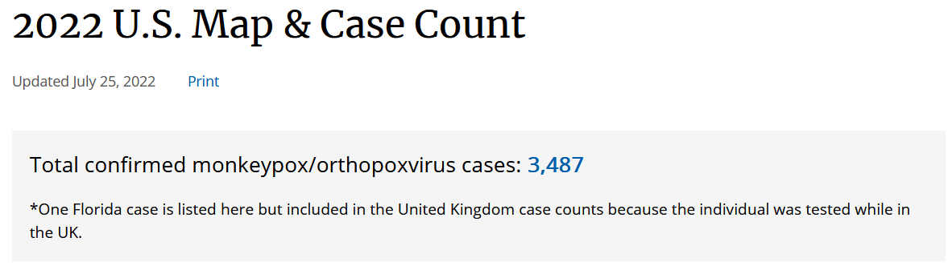
Source: 2022 U.S. Map & Case Count
https://web.archive.org/web/20220726192841/https:/www.cdc.gov/poxvirus/monkeypox/response/2022/us-map.html

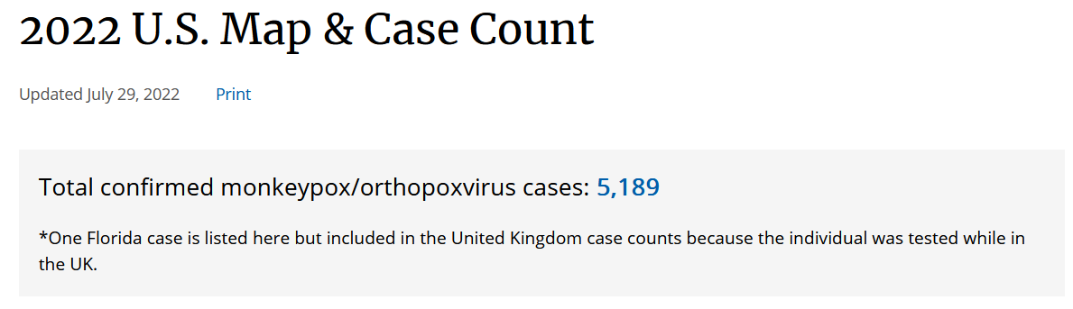
Source: 2022 U.S. Map & Case Count
https://web.archive.org/web/20220801004038/https://www.cdc.gov/poxvirus/monkeypox/response/2022/us-map.html
https://web.archive.org/web/20220000000000*/https://www.cdc.gov/poxvirus/monkeypox/response/2022/us-map.html

Monkeypox/orthopoxvirus cases. And take a look at how much it increased from the 25th to the 29th. It’s not even scientific. Monkeypox doesn’t even spread that fast. But part of the increase is due to the increase in testing. And when they lift restrictions on who can be tested, or increase the availability of tests, you’ll see the same effect. But they’re going to do it at the right time like they did with COVID.

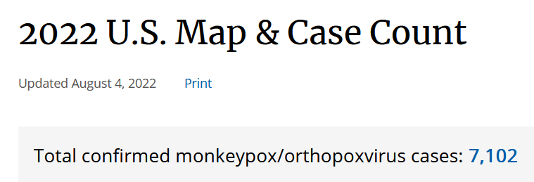
Source: 2022 U.S. Map & Case Count
(Updated August 4, 2022)
https://web.archive.org/web/20220805030913/https://www.cdc.gov/poxvirus/monkeypox/response/2022/us-map.html
https://web.archive.org/web/20220000000000*/https://www.cdc.gov/poxvirus/monkeypox/response/2022/us-map.html

7,102 monkeypox/orthopoxvirus cases.
But what’s stated to the vast majority of people, who don’t go online to any of these sites, and wouldn’t even understand what they were reading if they did?
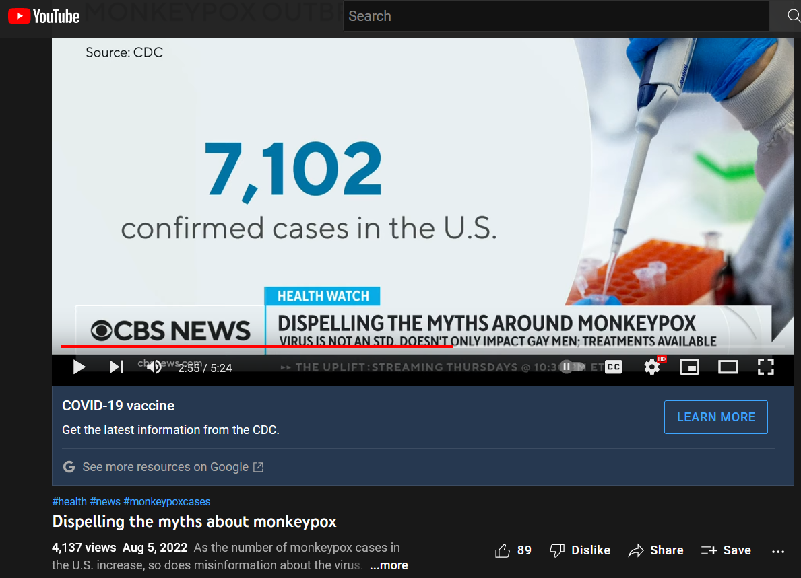
Source: Dispelling the myths about monkeypox
https://www.youtube.com/watch?v=mVqKq6Yv5-U

So, do you see how it’s done? This same thing, and worse, was done with COVID.

“What is the logic behind having to PCR test first for NVO and then do MXP. Why not go directly to MXP?” I believe this question has now been answered truthfully.

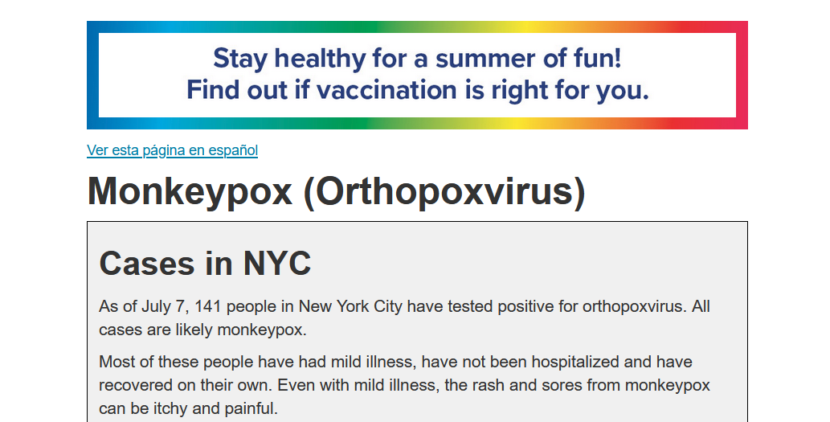
Source: https://web.archive.org/web/20220708092501/https://www1.nyc.gov/site/doh/health/health-topics/monkeypox.page
https://web.archive.org/web/20220000000000*/https://www1.nyc.gov/site/doh/health/health-topics/monkeypox.page

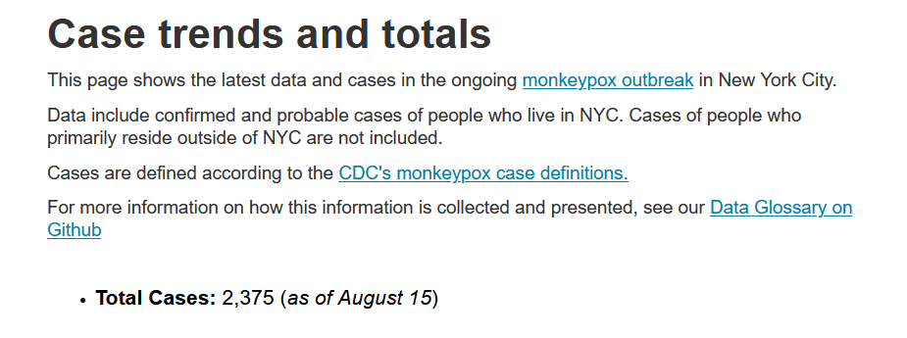
Source: https://www1.nyc.gov/site/doh/data/health-tools/monkeypox.page

“Sacramento County on Thursday confirmed more probable cases of monkeypox, which brings the total of confirmed or suspected cases to 38 within the county.”
Source: Sacramento County now has 38 confirmed or probable cases of monkeypox
https://www.cbsnews.com/sacramento/news/sacramento-county-monkeypox-cases/

“Riverside County Public Health on Monday reported an additional seven monkeypox cases among men in the eastern portion of the county. County spokesperson Jose Arballo Jr. said in an email that the men are between the ages of 30 and 60, and none have been hospitalized. There have been a total of 13 confirmed and probable cases of monkeypox in the county.”
Source: Riverside County reports additional 7 monkeypox cases; total at 13 probable and confirmed cases
https://www.desertsun.com/story/news/health/2022/07/25/riverside-county-reports-additional-7-monkeypox-cases/10144770002/

It’s the COVID scam all over again.

“Aug. 1, 2022, update: Monkeypox cases in Florida have increased in a week — the Florida Department of Health reports 442 total cases, a jump of 169 new cases since July 25. Click on the ‘Aug. 1 report’ link below, which also includes a list of which counties are seeing monkeypox cases. Aug. 1 report: Florida monkeypox cases, confirmed or probable, nears 500, state department of health says Original story posted July 25, 2022: Monkeypox cases in Florida are on the rise. Two months after a presumptive positive case was announced here May 22, the state department of health has reported 273 confirmed or probable cases in 16 counties, according to its tracker on flhealthcharts.gov.”
Source: Florida monkeypox cases, confirmed or probable, at 442 in over 2 months. Here's where they are
https://www.palmbeachpost.com/story/news/2022/07/25/monkeypox-florida-symptoms-where-confirmed-cases-vaccine/10142288002/

“The City of St. Louis Department of Health is reporting the city’s first probable case of monkeypox. The department is awaiting confirmation from the Centers for Disease Control and Prevention.”
Source: Probable Case of Monkeypox Being Investigated in the City of St. Louis
https://www.stlouis-mo.gov/government/departments/health/news/probable-case-monkeypox-under-investigation.cfm

“Probable Cases are those with positive polymerase chain reaction (PCR) for Orthopoxvirus that are awaiting confirmatory Monkeypox-specific testing at the Centers for Disease Control and Prevention (CDC) and are extremely likely to be confirmed as Monkeypox; such cases are managed as confirmed cases until confirmed.”
Source: Monkeypox
https://www.solanocounty.com/depts/ph/bureaus/communicable_disease/monkeypox.asp

Here’s the result
CDC: Monkeypox Cases Continue Climbing
https://www.youtube.com/watch?v=3Z50pyaQG2Y

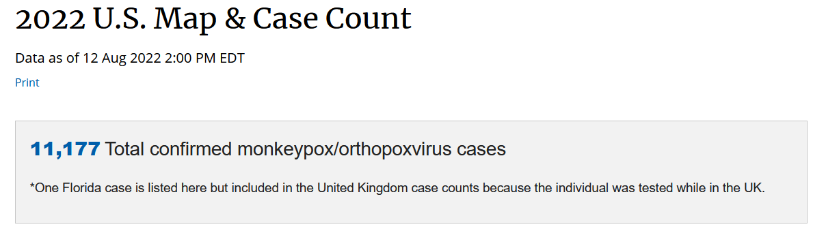
Source: 2022 U.S. Map & Case Count
https://www.cdc.gov/poxvirus/monkeypox/response/2022/us-map.html

“Currently, an outbreak is spreading fast outside of Africa. The virus has been reported in at least a dozen countries, including the U.S., Canada, and Israel and in Europe. As of this writing, Reuters reports more than 100 confirmed or suspected cases, making this the largest known outbreak outside of Africa.”
Source: What to Know About Monkeypox
(May 25, 2022)
https://hms.harvard.edu/news/what-know-about-monkeypox

“Newfoundland and Labrador has its first probable case of monkeypox, and the provincial government says it will begin offering the vaccine to people who are considered close contacts. ... She said public health defines a probable case of monkeypox as a person with unexplained acute rash or lesions and has been exposed to the virus.”
Source: N.L. becomes 6th province to identify probable monkeypox case
https://www.cbc.ca/news/canada/newfoundland-labrador/monkey-pox-newfoundland-1.6534609

Monkeypox: case definitions
https://www.gov.uk/guidance/monkeypox-case-definitions
Aren’t you glad to see that everyone is on the same page?

“‘People who are living in forested areas that come into contact with those small animals occasionally get infected,’ said Jimmy Whitworth, an infectious-disease expert and professor at the London School of Hygiene and Tropical Medicine. ‘That's the normal way in which we see human cases.’ This hypothesis is supported by an outbreak of monkeypox in the US in 2003. The cases were linked back to prairie dogs that had been exposed to a Gambian pouched rat imported from West Africa. This latest monkeypox outbreak, happening away from identifiable vector animals in West Africa, is concerning officials. Humans in Europe and North America — some with no recent travel history in the countries where monkeypox is endemic — now appear to be transmitting the disease to each other.”
Source: Monkeypox has almost nothing to do with monkeys. Here's why the disease was given its misleading name.
https://www.insider.com/monkeypox-human-disease-monkeys-explainer-1958-rodent-2022-5

Go to the link below and take a look at Cases per country and territory in the rest of the world and take a look at the scam. Notice the eleven thousand plus confirmed cases, but nothing in the suspected column. What does that say about the rest of the countries with nothing, or something, in that column? And remember what a confirmed case is anyway.
https://web.archive.org/web/20220813100412/https://en.wikipedia.org/wiki/2022_monkeypox_outbreak

Here are more “confirmed cases”:
https://ourworldindata.org/explorers/monkeypox?tab=table&time=2022-05-24..latest&facet=none&Metric=Confirmed+cases&Frequency=Cumulative&Relative+to+population=false&country=~OWID_WRL

1. The COVID vaccines make people more susceptible to infection, therefore more susceptible to the regular bugs they normally come in contact with each year. At first these immunocompromised people went to be checked for COVID after catching regular bugs, and because of the COVID vaccine, tested positive for COVID, keeping the scam going. Now these people are going to think their flu-like symptoms are COVID or monkeypox, and they’ll go get tested for one or both. 2. If anyone breaks out in bumps for whatever reason, they’re going to go get tested for monkeypox. 3. Once the vaccinia virus starts spreading from those vaccinated with the ACAM2000 vaccine (what you’re about to find out in the next section), giving people the same type of bumps and symptoms as monkeypox, they’ll be running in to get tested for monkeypox. The more the media causes fear, the more they’ll all get tested for monkeypox. The more they all get tested for monkeypox, the more “confirmed cases” there will be.

“In June, CDC updated and expanded the monkeypox case definition and continues to encourage health care providers to consider testing for all rashes with clinical suspicion for monkeypox. Health care providers who see a patient with a rash that resembles monkeypox or might be more characteristic of more common infections (e.g., varicella zoster, herpes zoster, or syphilis) should carefully evaluate the patient for monkeypox (see images and links) and testing should be considered. Anyone who has risk factors for monkeypox and a new rash should seek care and testing.”
Source: HHS Expanding Monkeypox Testing Capacity to Five Commercial Laboratory Companies
https://www.hhs.gov/about/news/2022/06/22/hhs-expanding-monkeypox-testing-capacity-five-commercial-laboratory-companies.html

In other words, if you see anyone with rashes, test them for monkeypox.

The Monkeypox Vaccines

“Smallpox and monkeypox vaccines are developed in formulations based on the vaccinia virus due to cross-protection afforded for the immune response to orthopoxviruses.”
Source: Monkeypox
https://www.who.int/news-room/fact-sheets/detail/monkeypox
Archived: http://archive.today/7izwu

There are several strains of vaccinia virus such as the Western Reserve, Lister, Dryvax, Ankara, and more.

So far there are two vaccines that have been approved for use in this monkeypox scamdemic:
- ACAM2000, unmodified vaccinia virus
- IMVANEX/JYNNEOS/IMVAMUNE, which is modified Vaccinia Ankara–Bavarian Nordic (MVA-BN)
Bavarian Nordic is the name of the company that produces the Modified Vaccinia Ankara (MVA).

According to the World Health Organization
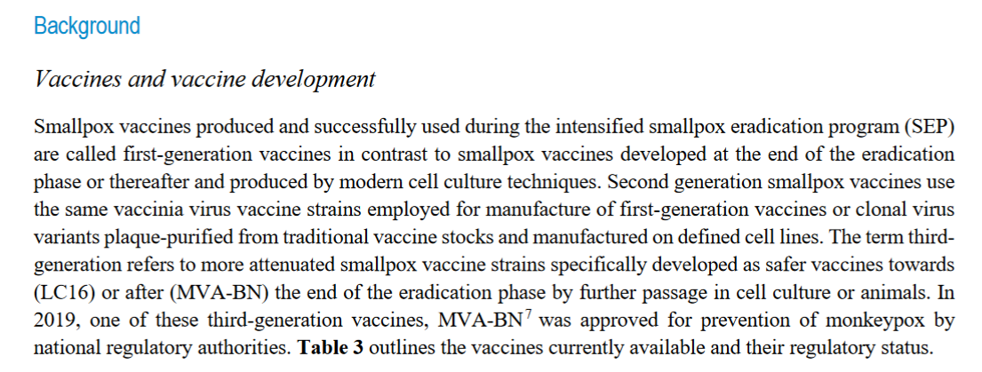
...
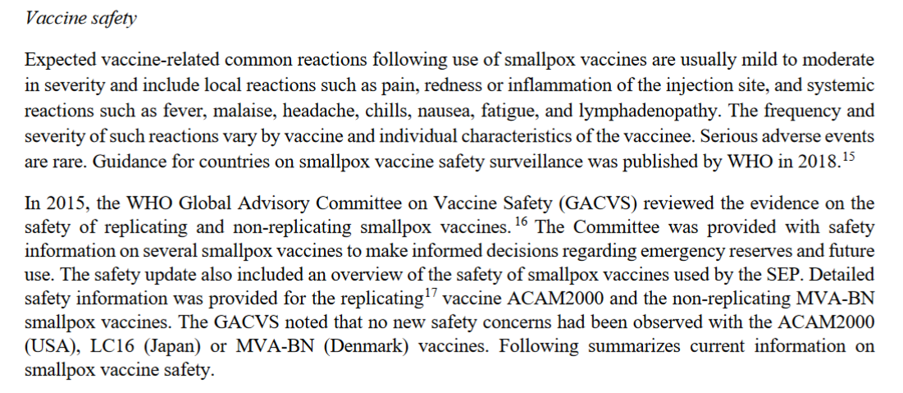
Source: Vaccines and immunization for monkeypox - Interim guidance - 14 June 2022
https://www.who.int/publications/i/item/who-mpx-immunization-2022.1
*They have a list of research material at the end of that document if you’re interested – “Selected WHO documents, reports and recommendations on smallpox and monkeypox”

- ... no NEW safety concerns, but the old ones still exist.

“This document provides interim guidance regarding use of JYNNEOS and ACAM2000 vaccines during the monkeypox outbreak that began in the United States on May 17, 2022. This interim guidance is in addition to standard guidance and recommendations for use of these vaccines from CDC’s Advisory Committee on Immunization Practices (ACIP). Two vaccines may be used for the prevention of monkeypox disease:
- JYNNEOS vaccine is approved for the prevention of monkeypox and smallpox disease.
- ACAM2000 vaccine is approved for immunization against smallpox disease and made available for use against monkeypox under an Expanded Access Investigational New Drug (EA-IND) protocol.”
Source: Interim Clinical Considerations for Use of JYNNEOS and ACAM2000 Vaccines during the 2022 U.S. Monkeypox Outbreak
(Updated August 9, 2022)
https://www.cdc.gov/poxvirus/monkeypox/considerations-for-monkeypox-vaccination.html

“ACAM2000 and JYNNEOS (also known as Imvamune or Imvanex) are the two currently licensed vaccines in the United States to prevent smallpox. ... The Advisory Committee on Immunization Practices (ACIP) recommends that people whose jobs may expose them to orthopoxviruses, such as monkeypox, get vaccinated with either ACAM2000 or JYNNEOS to protect them if they are exposed to an orthopoxvirus. ... ACAM2000 is administered as a live Vaccinia virus preparation that is inoculated into the skin by pricking the skin surface. Following a successful inoculation, a lesion will develop at the site of the vaccination (i.e., a “take”). The virus growing at the site of this inoculation lesion can be spread to other parts of the body or even to other people. Individuals who receive vaccination with ACAM2000 must take precautions to prevent the spread of the vaccine virus and are considered vaccinated within 28 days. JYNNEOS is administered as a live virus that is non-replicating. It is administered as two subcutaneous injections four weeks apart. There is no visible ‘take’ and as a result, no risk for spread to other parts of the body or other people. People who receive JYNNEOS are not considered vaccinated until 2 weeks after they receive the second dose of the vaccine.”
Source: Monkeypox and Smallpox Vaccine Guidance
https://www.cdc.gov/poxvirus/monkeypox/clinicians/smallpox-vaccine.html

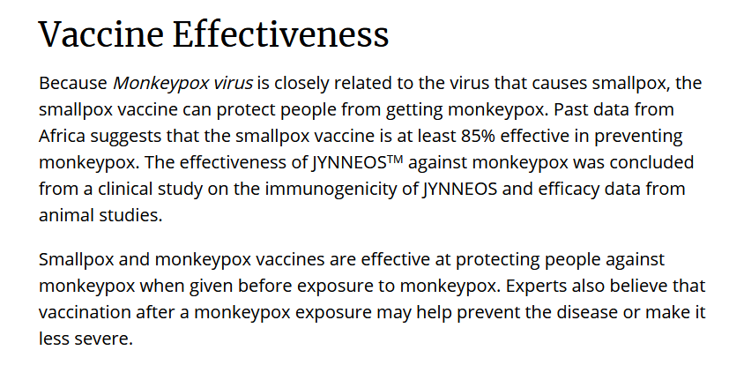
Source: Monkeypox and Smallpox Vaccine Guidance
https://www.cdc.gov/poxvirus/monkeypox/clinicians/smallpox-vaccine.html

As you can see for yourself, the CDC is telling everyone that the monkeypox vaccines are at least 85% effective. Statements of interest: “past data from Africa,” “suggests,” and “efficacy data from animal studies.” You’ll see more on this as you read.

Stanford Health Care Doctor discusses the monkeypox vaccine
https://www.youtube.com/watch?v=T5_Mnt8lG0I
*After you learn about the vaccines be sure to come back and watch this video again.

About 85% effective ... really safe.... Nice!

Everything you need to know about monkeypox and its vaccines l GMA
https://www.youtube.com/watch?v=hmsdJLkpI4Y

Sounds safe to me. And I’m sure if there were any problems the media and government would let us know.

Additional Information
Frequency of Adverse Events after Vaccination with Different Vaccinia Strains
*You would have to take into account the number adverse events that were not reported.
A paper showing how to make a smallpox cousin just got published. Critics wonder why
The complete genomic sequence of the modified vaccinia Ankara strain: comparison with other orthopoxviruses
Clinical Guidance for Smallpox Vaccine Use in a Postevent Vaccination Program

IMVANEX/JYNNEOS/IMVAMUNE - Modified Vaccinia Ankara–Bavarian Nordic (MVA-BN)

“Modified Vaccinia virus Ankara (MVA) was developed by serial passage in chicken fibroblast tissue culture to serve as safer vaccine during the last years of the WHO smallpox eradication campaign. Its ancestor virus is the vaccinia virus strain Ankara which was originally propagated on the skin of calves and donkeys at the Turkish vaccine institute in Ankara for smallpox vaccine production. In 1953, the vaccinia virus strain Ankara was brought to Munich and added to the strain collection of the Institute for Infectious Diseases and Tropical Medicine at the University of Munich. Herrlich and Mayr cultivated the virus on the chorioallantois membranes (CAM) of embryonated chicken eggs and therefore named it as Chorioallantois Vaccinia virus Ankara (CVA) (Herrlich and Mayr, 1954). At the Bayerische Landesimpfanstalt München (Bavarian State Institute for Vaccines), CVA was grown on the skin of calves to manufacture smallpox vaccine for the vaccination campaigns in Munich in 1954/1955. In addition, at the University of Munich, CVA was tested in passage experiments in various tissue cultures to study the genetic stability and the evolution of orthopoxviruses. Mayr and Munz (1964) reported that 371 passages of CVA in primary CEF had resulted in the development of an infection phenotype with restricted host (cell) tropism and it was discussed that similar biological properties were known from poxviruses that are highly adapted to specific hosts, e.g., variola virus (VARV) to humans or fowlpox virus to chicken. Successive passage of vaccinia virus in minced chicken embryo tissue had been described as successful strategy for in vitro amplification of the smallpox vaccine virus in a culture system (Rivers and Ward, 1931, Rivers and Ward, 1933). The serial passage of CVA in CEF was further continued by Anton Mayr and colleagues and, in 1968 after the 516th passage on CEF, the virus was renamed Modifiziertes Vakziniavirus Ankara (MVA) and provided to the Bavarian State Institute for Vaccines to test its suitability for smallpox vaccine production (Stickl and Hochstein-Mintzel, 1971).”
Source: Chapter Five - Modified Vaccinia Virus Ankara: History, Value in Basic Research, and Current Perspectives for Vaccine Development
https://www.sciencedirect.com/science/article/pii/S0065352716300380

“Today, the highly attenuated vaccinia virus strain MVA can be considered as one of the vaccine viruses of choice in preclinical and clinical research. MVA is replication-deficient in cells of mammalian origin and fails to produce many of the virulence factors encoded by conventional vaccinia virus. Because of its safety for the general environment MVA can be handled under conditions of biosafety level 1 (BSL-1). Nonreplicating MVA can enter any target cell and activate its molecular life cycle to express all classes of viral and recombinant genes.”
Source: Modified Vaccinia Virus Ankara
https://www.ncbi.nlm.nih.gov/pmc/articles/PMC7112317/

“The Food and Drug Administration recently approved a new vaccine for smallpox that has its roots in Fort Detrick. The JYNNEOS vaccine, produced by pharmaceutical company Bavarian Nordic, was approved by the FDA in September. It is a live, non-replicating vaccine that will be used to prevent smallpox and monkeypox, according to a release from the U.S. Army Medical Research Institute of Infectious Diseases. In a statement Bavarian Nordic CEO Paul Chaplin called the FDA approval a ‘tremendous milestone’ for the pharmaceutical company and the U.S. Department of Health and Human Services.”
Source: Fort Detrick's connection to a new smallpox vaccine
(Oct 13, 2019)
https://www.fredericknewspost.com/fort-detricks-connection-to-a-new-smallpox-vaccine/article_1cd978ab-fa30-5d27-8f03-c1a45ecf7242.html

“Thanks in part to Army scientists, the world has gained a new weapon in the fight against one of history's most feared diseases: smallpox. A new vaccine approved on Sept. 24 by the U.S. Food and Drug Administration (FDA), prevents both smallpox and the related disease monkeypox in adults. Marketed under the brand name JYNNEOS, the vaccine was developed by biotechnology firm Bavarian Nordic and tested by the U.S. Army Medical Research and Development Command's (USAMRDC) U.S. Army Medical Research Institute of Infectious Diseases (USAMRIID). ... JYNNEOS was developed as an alternative to the current U.S. licensed smallpox vaccine, ACAM2000, which cannot be used by people with certain health conditions.”
Source: Army Study Leads to Approval of New Smallpox Vaccine
(October 16, 2019)
https://www.army.mil/article/228578/army_study_leads_to_approval_of_new_smallpox_vaccine

“JYNNEOS is approved for use in individuals 18 years of age and older who are determined to be at high risk for smallpox or monkeypox infection. It is a live, non-replicating vaccine using Modified Vaccinia Ankara (MVA) virus that was originally developed for use in the event of a smallpox bioterrorist attack in certain populations (e.g., immunocompromised individuals) as an alternative to ACAM2000.”
Source: Key Facts About Monkeypox Vaccine
https://www.fda.gov/vaccines-blood-biologics/vaccines/key-facts-about-monkeypox-vaccine

“Modified Vaccinia Ankara–Bavarian Nordic (MVA-BN) is a third-generation live vaccine that is non-replicative in humans. It was authorized in 2013 by the European Medicines Agency, under the commercial name IMVANEX, to prevent smallpox. The same vaccine (called JYNNEOS in the United States and IMVAMUNE in Canada) was approved in North America in 2019 by the US Food and Drug Administration and in Canada in 2022, to prevent smallpox and monkeypox⁵. These authorizations were based on the following: a challenge trial conducted in macaques demonstrating 100% protection against infection with monkeypox virus after two injections of MVA-BN; and a randomized, controlled, phase 3 trial that assessed immune responses to MVA-BN compared with those to the replicating vaccinia virus in ACAM2000, a second-generation vaccine against smallpox^{6,7}. There are no data on the efficacy of vaccines against monkeypox in humans.”
Source: A prospective national cohort evaluating ring MVA vaccination as post-exposure prophylaxis for monkeypox
https://www.nature.com/articles/d41591-022-00077-1

- “There are no data on the efficacy of vaccines against monkeypox in humans.” From the CDC: “...efficacy data from animal studies.”

“Approval for monkeypox indication comes from survival data gathered from studies conducted in non-human primates. The survival rate ranged from 80%-100% in animals vaccinated with JYNNEOS, compared to 0%-40% in the control group.”
Source: JYNNEOS Vaccine for the Prevention of Smallpox and Monkeypox
https://www.clinicaltrialsarena.com/projects/jynneos-vaccine/

IMVANEX = JYNNEOS in the United States and IMVAMUNE in Canada

“MVA-BN® (Modified Vaccinia Ankara - Bavarian Nordic) is a proprietary and patented vaccine platform technology of Bavarian Nordic. MVA-BN is a robust and adaptable platform suitable for addressing a wide variety of infectious diseases and cancers. It is a further attenuated version of the Modified Vaccinia Ankara (MVA) virus, which is a highly attenuated strain of the poxvirus Chorioallantois Vaccinia virus Ankara (CVA). MVA-BN® is approved as a smallpox vaccine in Canada and the EU (under the trade names IMVAMUNE® and IMVANEX® respectively). A major advantage of MVA-BN is the virus’ inability to replicate in a vaccinated individual, in contrast to the original smallpox vaccines. The replication cycle is blocked at a very late stage, which ensures that new viruses are not generated and released in the body. This means that the virus cannot spread in a vaccinated person, which likely contributes to the favorable safety profile observed for MVA-BN-based vaccines in more than a dozen clinical studies conducted by Bavarian Nordic. More than 7,600 individuals, nearly 1,000 of whom are immunocompromised, have been vaccinated with MVA-BN-based vaccines, showing the platform displays high immunogenicity and a favorable safety profile.”
Source: MVA-BN
https://www.bavarian-nordic.com/pipeline/technology/mva-bn.aspx

They claim that their Modified Vaccinia Ankara (MVA) is different from the regular highly attenuated Modified Vaccinia Ankara.

Take a look at this luck!
Feb 6, 2018 - Bavarian Nordic Announces Positive Results of Pivotal Phase 3 Study of Imvamune Smallpox Vaccine
Dec 21, 2018 - Bavarian Nordic Announces FDA Acceptance and Priority Review of Biologics License Application for MVA-BN Smallpox Vaccine
Mar 11, 2019 - Bavarian Nordic Announces FDA Delay in the Review of the Biologics License Application for MVA-BN Smallpox Vaccine
Jun 19, 2019 - Bavarian Nordic Initiates Phase 3 Trial of Freeze-dried MVA-BN® Smallpox Vaccine
Sep 24, 2019 - FDA Approves Jynneos (Smallpox and Monkeypox Vaccine, Live, Non-replicating) for Prevention of Smallpox and Monkeypox Disease in Adults
Aug 9, 2022 - Monkeypox Update: FDA Authorizes Emergency Use of Jynneos Vaccine to Increase Vaccine Supply
Source: Jynneos FDA Approval History
https://www.drugs.com/history/jynneos.html

“Certain laboratorians and health care personnel can be exposed to orthopoxviruses through occupational activities. Because orthopoxvirus infections resulting from occupational exposures can be serious, the Advisory Committee on Immunization Practices (ACIP) has continued to recommend preexposure vaccination for these persons since 1980 (1), when smallpox was eradicated (2). In 2015, ACIP made recommendations for the use of ACAM2000, the only orthopoxvirus vaccine available in the United States at that time (3). During 2020–2021, ACIP considered evidence for use of JYNNEOS, a replication-deficient Vaccinia virus vaccine, as an alternative to ACAM2000. In November 2021, ACIP unanimously voted in favor of JYNNEOS as an alternative to ACAM2000 for primary vaccination and booster doses.”
Source: Use of JYNNEOS (Smallpox and Monkeypox Vaccine, Live, Nonreplicating) for Preexposure Vaccination of Persons at Risk for Occupational Exposure to Orthopoxviruses: Recommendations of the Advisory Committee on Immunization Practices — United States, 2022 (On May 27, 2022, this report was posted online as an MMWR Early Release.)
https://www.cdc.gov/mmwr/volumes/71/wr/mm7122e1.htm
Additional Information
Summary of Evidence to Recommendations Frameworks for Use of JYNNEOS

They also stated that ACAM2000 was replication-competent.

“The U.S. government has ordered millions of doses of a vaccine that protects against monkeypox. The news follows the first confirmed case in the states—a man in Massachusetts—following an outbreak in the U.K. The order amounts to a $119 million order for Jynneos vaccines, which are used for the prevention of both smallpox and monkeypox. It was announced by biotechnology company Bavarian Nordic, which makes the vaccine, on Wednesday. The order will convert bulk vaccines, which have already been made and invoiced under previous contracts with the U.S. government, into freeze-dried versions which have an improved shelf-life. The total government contract with Bavarian Nordic amounts to $299 million, which would provide 13 million freeze-dried doses. U.S. Buys Millions of Monkeypox Vaccines As Massachusetts Man Infected”
Source: U.S. Buys Millions of Monkeypox Vaccines As Massachusetts Man Infected
https://www.newsweek.com/monkeypox-cased-uk-massachusetts-case-vaccine-ordered-us-1708075

Bavarian Nordic enters smallpox vaccine contract with Canadian government
https://www.biopharma-reporter.com/Article/2022/06/07/bavarian-nordic-enters-smallpox-vaccine-contract-with-canadian-government

According to the World Health Organization:
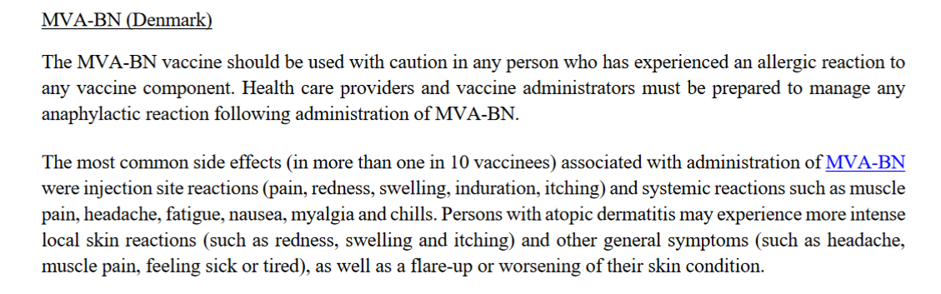
Source: Vaccines and immunization for monkeypox - Interim guidance - 14 June 2022
https://www.who.int/publications/i/item/who-mpx-immunization-2022.1

I searched the internet for information on the safety of the Jynneos/Imvamune/Imvanex vaccine and everything I found said it was harmless, that is, until I found the document containing information from the clinical trials.

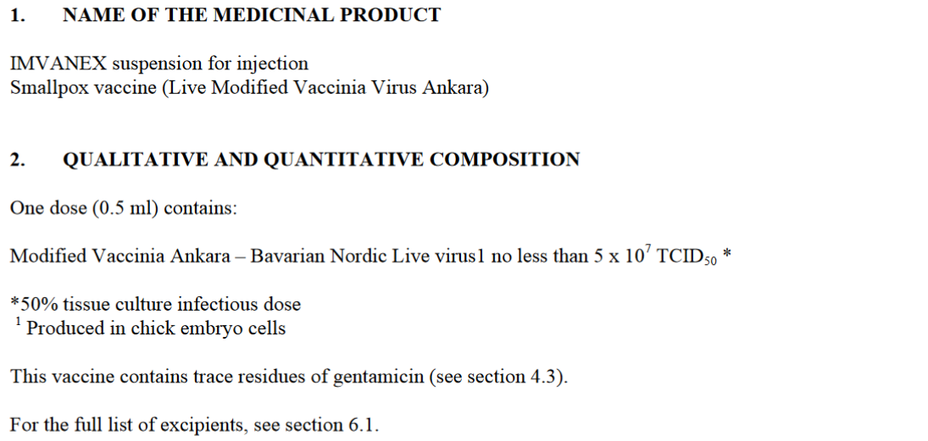
...
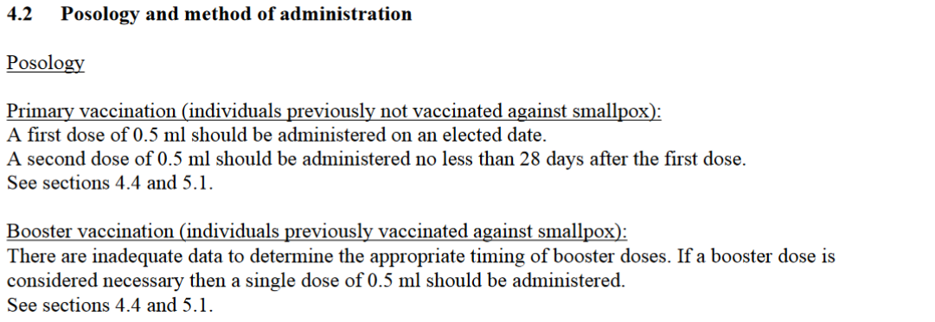
...
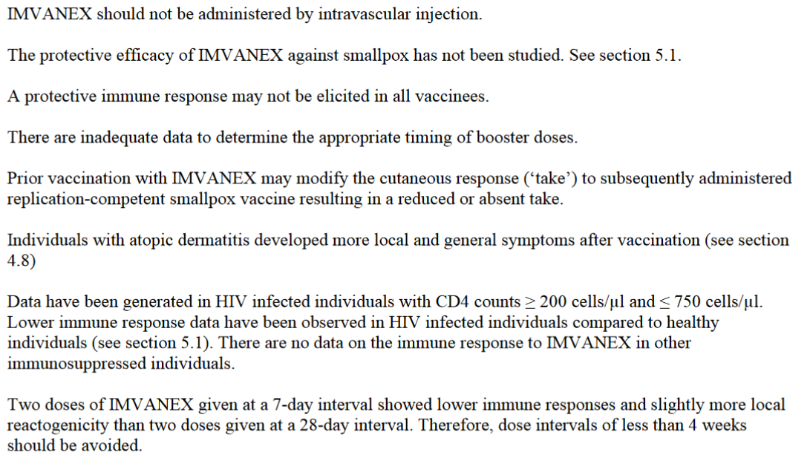
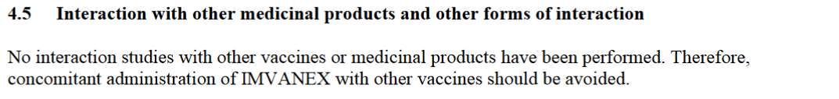
...
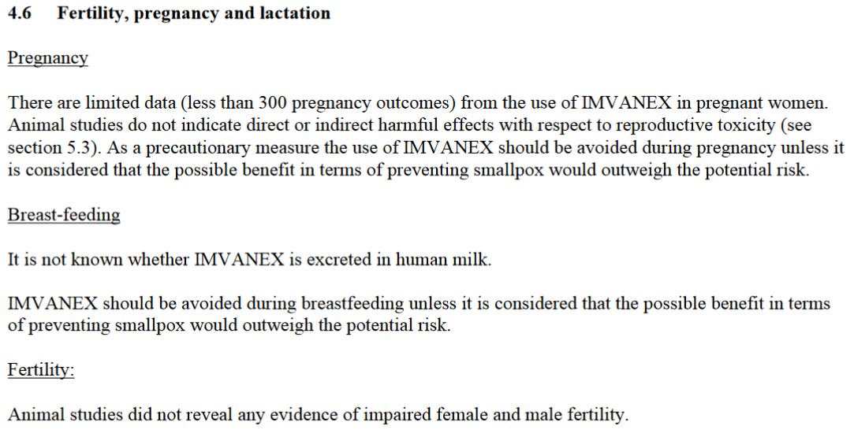
...
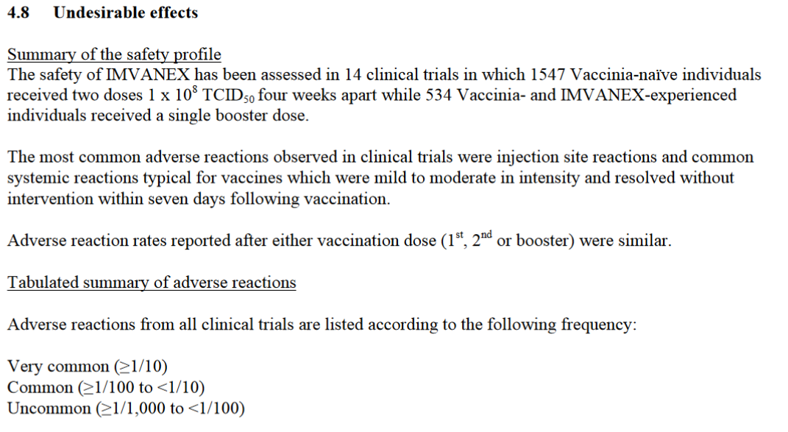
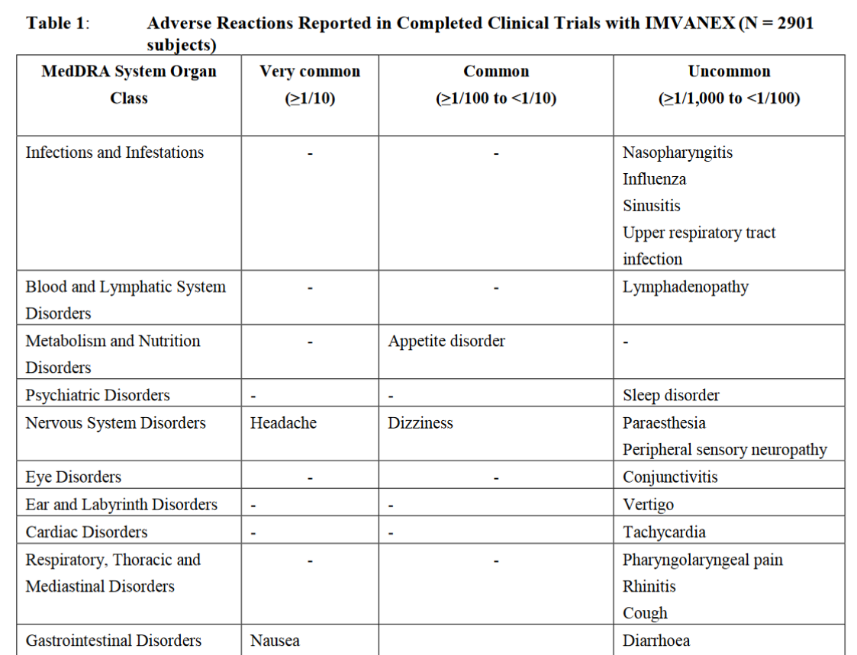
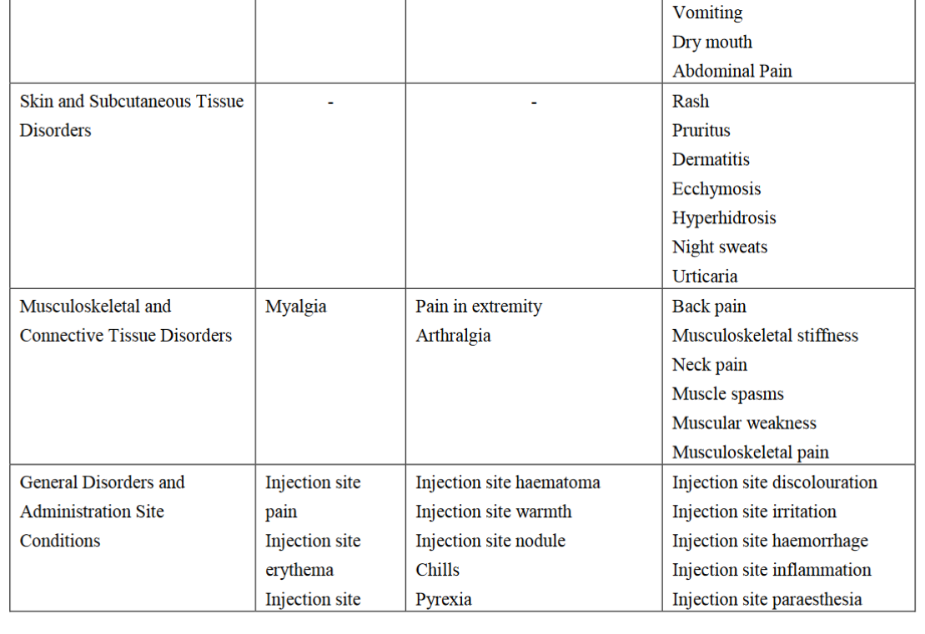
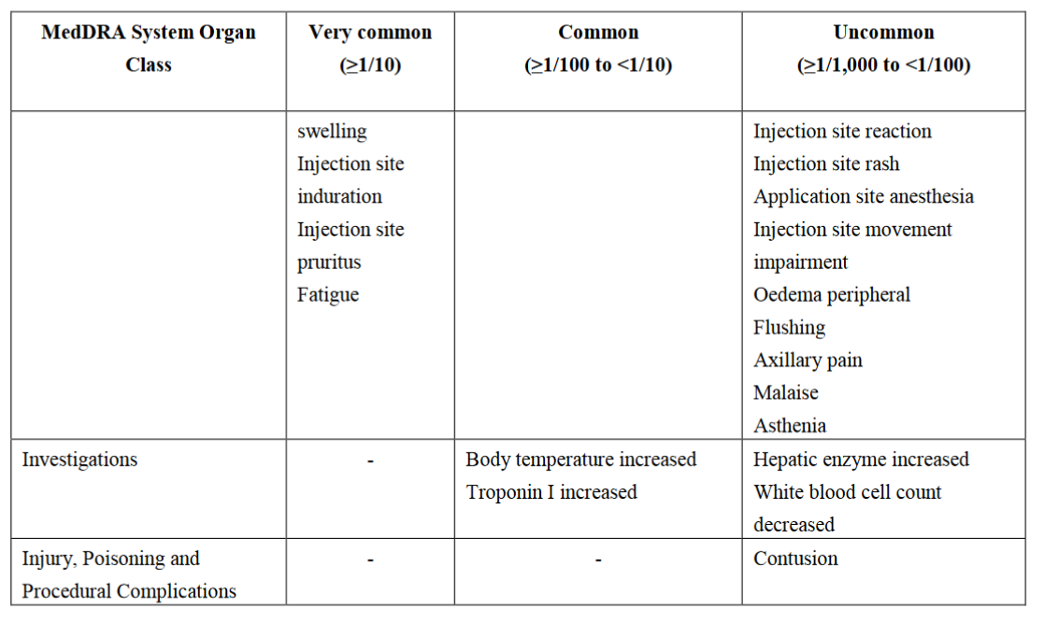
FYI: 1/10 is greater, a higher percentage, than 1/100.
Uncommon: greater or equal to 1/1000 to less than 1/100 means it’s 1/1000 or between 1/101 and 1/999. So, it’s between 1/101 and 1/1000. And that’s if you believe them. And that’s in people who have NOT received a COVID vaccine ... or two, or three, or four.

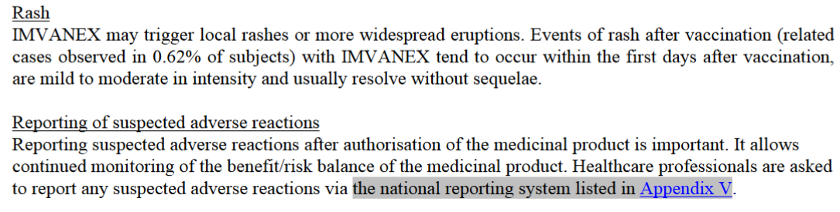
...
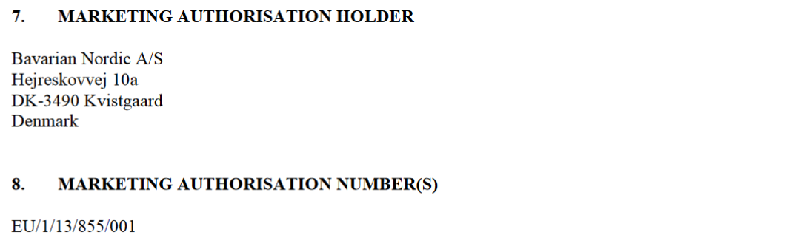
...
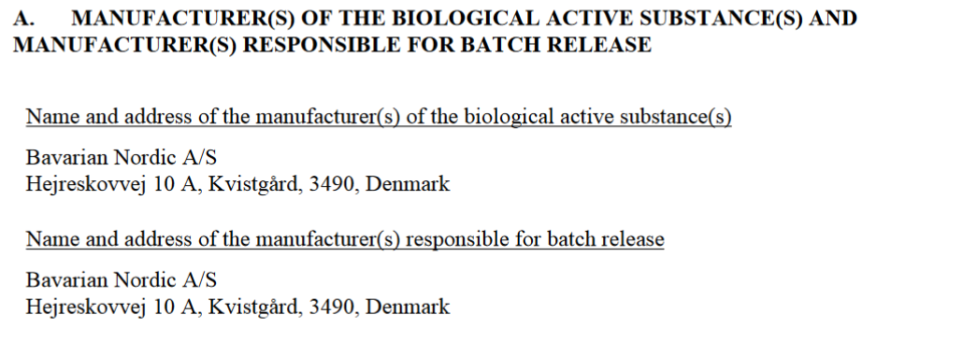

They have a package leaflet in that same document. This is what healthcare workers will get, or might get, but not look at.

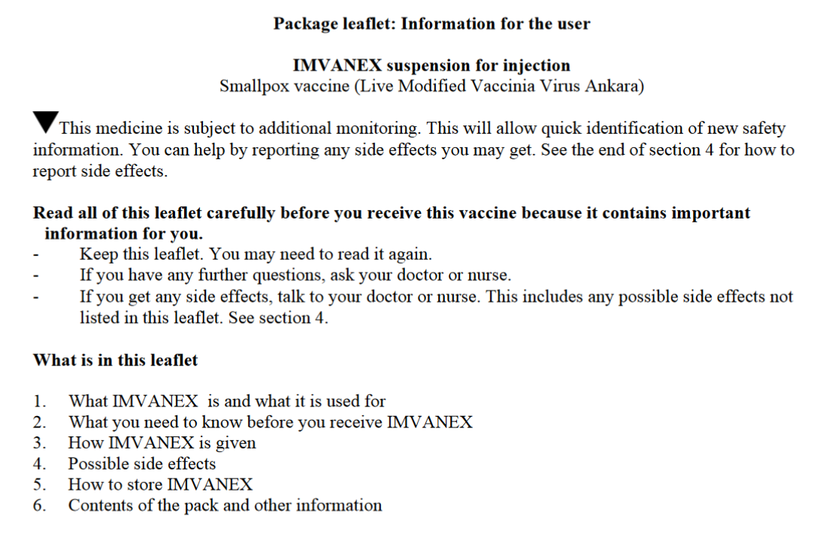
...
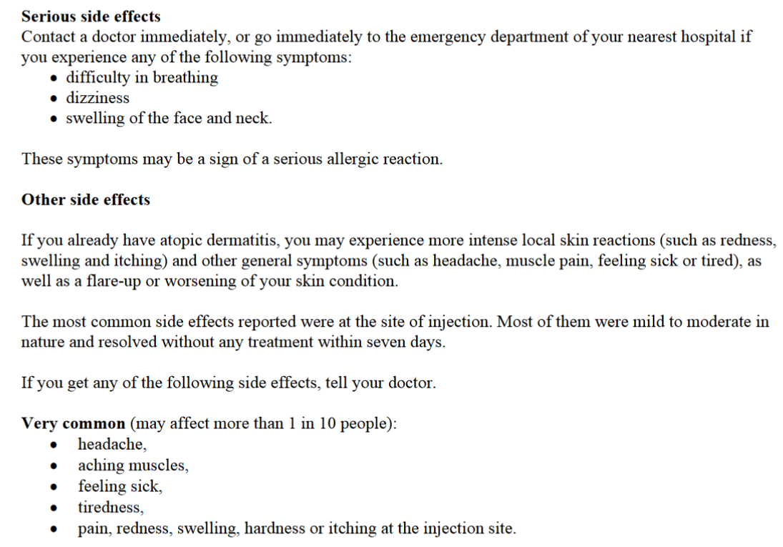
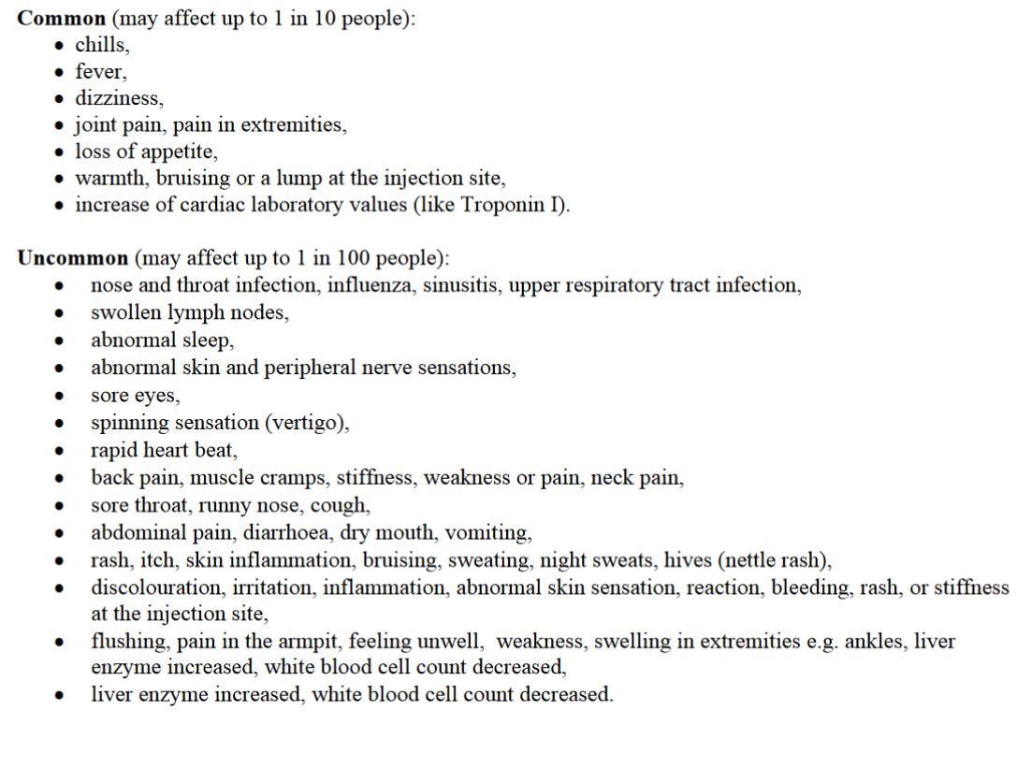
Source: https://ec.europa.eu/health/documents/community-register/2013/20131217127502/anx_127502_en.pdf

Will this vaccine cause you to test positive for Orthopoxvirus like COVID vaccines cause you to test positive for coronavirus? They won’t tell.

FDA allowing one-fifth dose of monkeypox vaccine
https://www.youtube.com/watch?v=H-tKYwUhGPQ

Watch the beginning - 1:49
Monkeypox vaccine maker pushes back on FDA plan to split doses
https://www.youtube.com/watch?v=DUSFiwROpNo

Watch the beginning - 1:30
Infectious disease expert on monkeypox vaccine, latest COVID-19 guidance
https://www.youtube.com/watch?v=KzOWaYpZqhw

Watch the beginning - 2:00
How to tell difference between monkeypox and other rashes
https://www.youtube.com/watch?v=3joSS1Kz2t8

I’m sure their reason isn’t the true reason they’re doing this.

ACAM2000

“Feb 8, 2008 (CIDRAP News) – After vaccinating more than a million personnel with the old-fashioned type of smallpox vaccine grown on the skin of calves, the US military is about to switch to a second-generation vaccine that's grown in laboratory cell cultures. The Department of Defense (DoD) announced last week that it was beginning the change from Dryvax, made by Wyeth, to ACAM2000, which is made by Acambis and was approved by the US Food and Drug Administration (FDA) last August. ... Both ACAM2000 and Dryvax use live vaccinia virus, a close relative of smallpox. The new vaccine is derived from Dryvax, which was used in the global smallpox eradication program. The newer vaccine is grown in lab cultures of African green monkey kidney (Vero) cells, according to a DoD comparison chart. ... In six clinical studies, ACAM2000 and Dryvax were found to have comparable safety profiles, according to DoD. The most common side effects of ACAM2000 are itching, swollen lymph nodes, sore arm, fever, headache, body aches, mild rash, and fatigue. There was no significant difference in the rate of serious adverse events. Inflammation of the heart muscle and lining (myopericarditis) occurs in about 1 in 175 first-time smallpox vaccine recipients, according to the FDA. A DoD safety summary says 140 cases had occurred in the military vaccination program as of last May. Smallpox vaccination can also cause several other serious adverse reactions in rare cases, including localized or systemic spread of the vaccinia virus (eczema vaccinatum) and encephalitis.”
Source: US military switching to new smallpox vaccine
https://www.cidrap.umn.edu/news-perspective/2008/02/us-military-switching-new-smallpox-vaccine
- Myopericarditis occurs in about 1 in 175 first-time smallpox vaccine recipients.
- ... military vaccinations.
- Smallpox vaccination can also cause several other serious adverse reactions in rare cases, including localized or systemic spread of the vaccinia virus (eczema vaccinatum) and encephalitis

According to the FDA in 2018:
Take a look at these excerpts from ACAM2000 (Smallpox Vaccine) Questions and Answers
The vaccine is made from a virus called vaccinia, which is a "pox"-type virus related to smallpox but causes milder disease. ACAM2000 cannot cause smallpox; it does not contain the smallpox virus, but rather the "live" vaccinia virus - not dead virus like many other vaccines. For this reason, attentively caring for the vaccination site is important to prevent the virus from spreading from the vaccination site to other parts of the body, or to other people. ACAM2000 is administered differently than the typical "shot" associated with most vaccinations. A two-pronged stainless steel (or bifurcated) needle is dipped into the vaccine solution and the skin is pricked several times in the upper arm with a droplet of the vaccine. The virus begins growing at the injection site causing a localized infection or "pock" to form. A red, itchy sore spot at the site of the vaccination within 3-4 days is an indicator that the vaccination was successful; that is, there is "a take." A blister develops at the vaccination site and then dries up forming a scab that falls off in the third week, leaving a small scar. The vaccine stimulates a person's immune system to develop antibodies and cells in the blood and elsewhere that can then help the body fight off a real smallpox infection if exposure to smallpox ever occurs. ... Are there any possible side effects associated with the use of ACAM2000? Yes, health complications can occur after receiving the vaccine, and the risk of experiencing serious side effects must be weighed against the risk of experiencing a potentially fatal smallpox infection. The vaccine may cause myocarditis and pericarditis, which are inflammation and swelling of the heart and surrounding tissues and can be very serious. Based on clinical studies, myocarditis and/or pericarditis occur in 1 in 175 adults who get the vaccine for the first time. In the ACAM2000 clinical trial experience, seven individuals of the 2,983 ACAM2000 first-time recipients and three individuals of the 868 Dryvax first-time recipients were suspected to have myocarditis/pericarditis. There were no cases in those subjects who had been vaccinated previously. Serious health problems, including those that are life-threatening, can also occur in unvaccinated people who are accidentally infected by someone who has recently received the vaccine. In particular, unvaccinated people who are pregnant, or have problems with their heart or immune system, or have skin problems like eczema, dermatitis, psoriasis, and have close contact with a vaccine recipient are at an increased risk for serious problems if they become infected with the vaccine virus, either by being vaccinated, or by being in close contact with a person who was vaccinated. It is very important for the ACAM2000 recipient to properly care for the vaccination site to prevent the virus in the vaccine from spreading and infecting another part of the body and other people. These types of serious adverse events are similar to those that occurred in the past with other smallpox vaccines. More commonly observed side effects include: itching, sore arm, fever, headache, body ache, mild rash and fatigue. Who should not be immunized with ACAM2000? A healthcare provider may decide not to give ACAM2000 if a person has a weakened immune system (e.g., leukemia, HIV, AIDS, transplant recipients, people with cancer that has spread, and those undergoing treatment with medicines that suppress the immune system such as steroids, prednisone, and cancer drugs). In addition, healthcare providers may decide not to vaccinate individuals with skin conditions such as eczema, dermatitis or psoriasis who are at increased risk of complications. How will ACAM2000 recipients be informed of its potential risks? Every person who receives the vaccine is required to receive a Medication Guide approved by FDA (21 CFR Part 208). Medication Guides are printed handouts that are specific to particular medical products, and contain FDA-approved information that can help patients avoid serious adverse events. ... ACAM2000 is the first vaccine licensed with a Medication Guide. ... Will ACAM2000 be available to anyone who wants it? No, the manufacturer has stated that the vaccine won't be available to the public commercially, meaning it can't be obtained from a doctor's office. It has been purchased by the federal government for inclusion within the country's Strategic National Stockpile, for distribution by the Department of Health and Human Services, in case it is ever needed. Currently, designated U.S. military personnel receive the vaccine. In addition, laboratory researchers working on certain pox viruses are also be eligible to receive the vaccine. The vaccine is not recommended for use by the general population, as there is no smallpox disease in the world.
Source: ACAM2000 (Smallpox Vaccine) Questions and Answers
(03/23/2018)
https://www.fda.gov/vaccines-blood-biologics/vaccines/acam2000-smallpox-vaccine-questions-and-answers
Archived: http://archive.today/lscqJ

It’s so dangerous that it couldn’t even be made commercially available, and could only be given to certain groups of people who were going to be around smallpox, not monkeypox. Sooooo ... has anyone told you this? They obviously know this.

According to the World Health Organization in 2022:
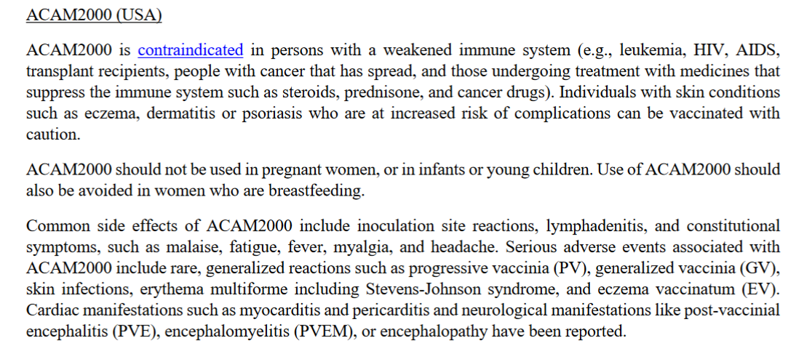
Notice how they give a list of serious adverse events but call them “rare.”
- progressive vaccinia
- generalized vaccinia
- myocarditis and pericarditis
- encephalitis
Continuing...
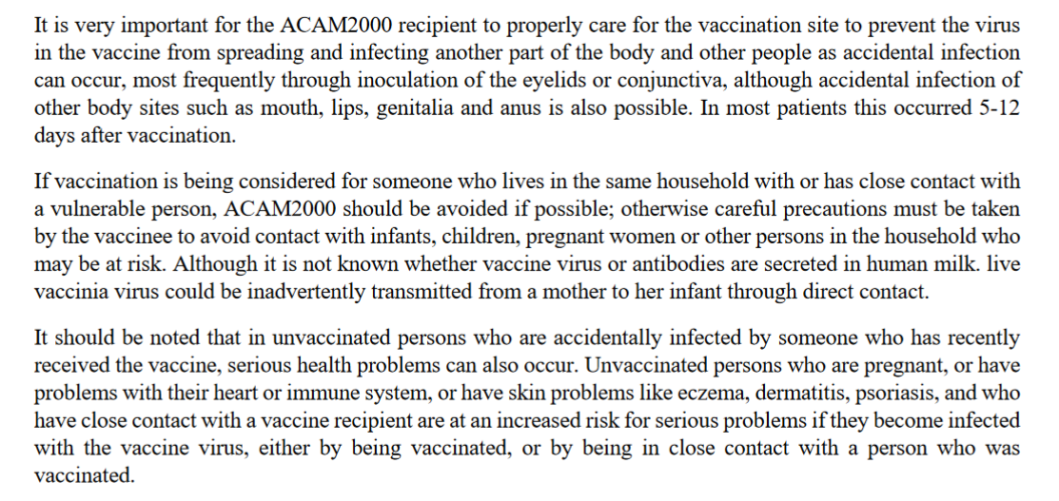
Source: Vaccines and immunization for monkeypox - Interim guidance - 14 June 2022
https://www.who.int/publications/i/item/who-mpx-immunization-2022.1

At least they were honest about that last half, because as you’re about to see, this vaccine is worse than monkeypox.
- The vaccinated can infect the unvaccinated and cause them serious health problems.
- Those who are at an increased risk for serious problems if they are infected by the vaccinated or get vaccinated themselves are persons who: are pregnant, have problems with their heart or immune system, or who have skin problems like eczema, dermatitis, psoriasis. Just about everyone who took the COVID vaccine has problems with their heart, immune system and blood whether they know it or not, so there are millions of people in the US alone who are at an increased risk if they get this vaccine or are around someone who has gotten this vaccine.
WHY ARE HEALTHY ATHLETES COLLAPSING?
https://thehighwire.com/videos/why-are-healthy-athletes-collapsing/
- As previously stated, myocarditis and/or pericarditis occur in 1 in 175 adults who get the vaccine for the first time. 1 in 175! And that’s for adults who get it for the first time! That’s going to be pretty much everybody! And the COVID vaccines have been causing myocarditis!

“Most people who get myocarditis and/or pericarditis seem to get better after a few weeks. But heart problems may last longer in some people, and in rare cases, could lead to death. ... The risks for serious vaccine side effects are greater for people who: have skin problems called eczema or atopic dermatitis; have skin problems, such as burns, impetigo, contact dermatitis, chickenpox, shingles, psoriasis, or uncontrolled acne; have had heart problems; have serious heart or blood vessel problems including angina, previous heart attack, artery disease, congestive heart failure, stroke, or other cardiac problems; smoke or have high blood pressure, high cholesterol, diabetes, high blood sugar, or a family history of heart problems; are breastfeeding; are pregnant, could be pregnant, or plan to become pregnant; are less than 1 year old; are taking steroid eye drops or ointment; have had problems after previous doses or are allergic to ACAM2000 or any part of ACAM2000 such as antibiotics neomycin or polymyxin B.”
Source: Medication Guide Smallpox (Vaccinia) Vaccine, Live ACAM2000®
https://www.fda.gov/media/75800/download

Excerpts from HIGHLIGHTS OF PRESCRIBING INFORMATION - ACAM2000, (Smallpox (Vaccinia) Vaccine, Live)
5.1.3 Myocarditis and Pericarditis in the ACAM2000 Clinical Trial Experience
In clinical trials involving 2983 subjects who received ACAM2000 and 868 subjects who received Dryvax ®, ten (10) cases of suspected myocarditis [0.2% (7 of 2983) ACAM2000 subjects and 0.3% (3 of 868) Dryvax ® subjects] were identified. The mean time to onset of suspected myocarditis and/or pericarditis from vaccination was 11 days, with a range of 9 to 20 days. All subjects who experienced these cardiac events were naïve to vaccinia. Of the
10 subjects, 2 were hospitalized. None of the remaining 8 cases required hospitalization or treatment with medication. Of the 10 cases, 8 were sub-clinical and were detected only by ECG abnormalities with or without associated elevations of cardiac troponin I. All cases resolved by 9 months, with the exception of one female subject in the Dryvax ® group, who had persistent borderline abnormal left ventricular ejection fraction on echocardiogram. The best estimate of risk for myocarditis and pericarditis is derived from the Phase 3 ACAM2000 clinical trials where there was active monitoring for potential of myocarditis and pericarditis. Among vaccines naïve to vaccinia, 8 cases of suspected myocarditis and pericarditis were identified across both treatment groups, for a total incidence rate of 6.9 per 1000 vaccinees (8 of 1,162). The rate for the ACAM2000 treatment group were similar: 5.7 (95% CI: 1.9-13.3) per 1000 vaccinees (5 of 873 vaccinees) and for the Dryvax ® group 10.4 (95% CI: 2.1-30.0) per 1000 vaccinees (3 of 289 vaccinees). No cases of myocarditis and/or pericarditis were identified in 1819 previously vaccinated subjects. The long-term outcome of myocarditis and pericarditis following ACAM2000 vaccination is currently unknown.
5.2 Cardiac Disease
Ischemic cardiac events, including fatalities, have been reported following smallpox vaccination; the relationship of these events, if any, to vaccination has not been established. In addition, cases of non-ischemic, dilated cardiomyopathy have been reported following smallpox vaccination; the relationship of these cases to smallpox vaccination is unknown. There may be increased risks of adverse events with ACAM2000 in persons with known cardiac disease, including those diagnosed with previous myocardial infarction, angina, congestive heart failure, cardiomyopathy, chest pain or shortness of breath with activity, stroke or transient ischemic attack, or other heart conditions. In addition, subjects who have been diagnosed with 3 or more of the following risk factors for ischemic coronary disease: 1) high blood pressure; 2) elevated blood cholesterol; 3) diabetes mellitus or high
blood sugar; 4) first degree relative (for example mother, father, brother, or sister) who had a heart condition before the age of 50; or 5) smoke cigarettes may have increased risks.
5.3 Ocular Complications and Blindness
Accidental infection of the eye (ocular vaccinia) may result in ocular complications including keratitis, corneal scarring and blindness. Patients who are using corticosteroid eye drops may be at increased risk of ocular complications with ACAM2000.
5.4 Presence of Congenital or Acquired Immune Deficiency Disorders
Severe localized or systemic infection with vaccinia (progressive vaccinia) may occur in persons with weakened immune systems, including patients with leukemia, lymphoma, organ transplantation, generalized malignancy, HIV/AIDS, cellular or humoral immune deficiency, radiation therapy, or treatment with antimetabolites, alkylating agents, high-dose corticosteroids (>10 mg prednisone/day or equivalent for ≥2 weeks), or other immunomodulatory drugs. The vaccine is contraindicated in individuals with severe immunodeficiency [See Contraindications (4)]. Vaccinees with close contacts who have these conditions may be at increased risk because live vaccinia virus can be shed and be transmitted to close contacts.
5.5 History or Presence of Eczema and Other Skin Conditions
Persons with eczema of any description such as, atopic dermatitis, neurodermatitis, and other eczematous conditions, regardless of severity of the condition, or persons who have a history of these conditions at any time in the past, are at higher risk of developing eczema vaccinatum. Vaccinees with close contacts who have eczematous conditions, may be at increased risk because live vaccinia virus can shed and be transmitted to these close contacts. Vaccinees with other active acute, chronic or exfoliative skin disorders (including burns, impetigo, varicella zoster, acne vulgaris with open lesions, Darier’s disease, psoriasis, seborrheic dermatitis, erythroderma, pustular dermatitis, etc.), or vaccinees with household contacts having such skin disorders might also be at higher risk for eczema vaccinatum.
5.6 Infants (< 12 months of Age) and Children
ACAM2000 has not been studied in infants or children. The risk of serious adverse events following vaccination with live vaccinia virus is higher in infants. Vaccinated persons who have close contact with infants, e.g., breastfeeding, must take precautions to avoid inadvertent transmission of ACAM2000 live vaccinia virus to infants.
5.7 Pregnancy
ACAM2000 has not been studied in pregnant women. Live vaccinia virus vaccines can cause fetal vaccinia and fetal death. If ACAM2000 is administered during pregnancy, the vaccinee should be apprised of the potential hazard to the fetus [See Use in Specific Populations (8.1)]. Pregnant women who are close contacts of vaccinees may be at increased risk because live vaccinia virus can shed and be transmitted to close contacts.
5.8 Allergy to ACAM2000 Smallpox Vaccine or its Components
ACAM2000 contains neomycin and polymyxin B. Persons allergic to these
components may be at higher risk for adverse events after vaccination.
Source: HIGHLIGHTS OF PRESCRIBING INFORMATION - ACAM2000, (Smallpox (Vaccinia) Vaccine, Live)
https://www.fda.gov/files/vaccines%2C%20blood%20%26%20biologics/published/Package-Insert---ACAM2000.pdf
Alternative source: https://www.fda.gov/media/75792/download

The way this vaccine/virus spreads I’m pretty sure many of us already have, or will have, pieces of it inside of us whether it’s alive or not, or makes us sick or not. And then if we were to ever get tested the PCR would multiply that little bit to an amount where it could be measured, and we would test positive for orthopoxvirus.

“As of July 1, the Strategic National Stockpile (SNS), managed by the HHS Office of the Assistant Secretary for Preparedness and Response (ASPR), has shipped 19,965 doses of JYNNEOS to 15 jurisdictions across the United States as part of the initial phase of the strategy. ... To date, the SNS has distributed more than 800 doses of ACAM2000 to combat the current monkeypox outbreak.”
Source: Biden-Harris Administration Announces Additional Deliveries of Vaccine as Part of Nationwide Vaccine Strategy for Preventing Monkeypox
(July 1, 2022)
https://www.hhs.gov/about/news/2022/07/01/biden-harris-administration-announces-additional-deliveries-vaccine-as-part-of-nationwide-vaccine-strategy-for-preventing-monkeypox.html

“The U.S. has distributed 1,200 doses of Jynneos and ACAM2000 for people who have high-risk exposures to monkeypox, said Dr. Raj Panjabi, who leads the White House pandemic preparedness office, in a call with reporters Friday.”
Source: U.S. has more than 36,000 Jynneos monkeypox vaccine doses immediately available in national stockpile
(Jun 6 2022)
https://www.cnbc.com/2022/06/06/us-has-36000-doses-of-jynneos-monkeypox-vaccine-immediately-available-in-national-stockpile.html

They say that men who have sex with men should be the first to get one of the vaccines. In that group is where you’ll find many men who have multiple sex partners, and whether they start using condoms or not, how likely are they to not touch each other? In that group you’ll find something you probably won’t find elsewhere, and that’s people who know they themselves and/or their sexual partner has an STD and will still have sex with them without protection. It’s the perfect group to start an outbreak in.
If vaccinia spreads it’s going to be called monkeypox based on physical observations and testing. And just like with the COVID vaccine, the vaccine is going to cause you to test positive. And like COVID, they’ll call it a “breakthrough case.”

Another Rabbit Hole - Vaccinia Virus

Watch -1:23:41 to -1:07:48
Dr Tenpenny, What the CDC documents say about vaccines
https://www.altcensored.com/watch?v=n9lw1JNjErk
Alternative sources
23:16 - 39:07
https://www.bitchute.com/video/KoHv6b3olWRx/
https://odysee.com/@VaxxedDoctors:c/Dr-Sherri-Tenpenny,-What-the-CDC-documents-say-about-vaccines:0

“Vaccinia virus (VACV or VV) is a large, complex, enveloped virus belonging to the poxvirus family.[2] It has a linear, double-stranded DNA genome approximately 190 kbp in length, which encodes approximately 250 genes. The dimensions of the virion are roughly 360 × 270 × 250 nm, with a mass of approximately 5–10 fg.[3] The vaccinia virus is the source of the modern smallpox vaccine, which the World Health Organisation used to eradicate smallpox in a global vaccination campaign in 1958–1977.”
Source: Vaccinia
https://en.wikipedia.org/wiki/Vaccinia

“Since vaccination was formerly practiced on such a large scale and since vaccinia virus has a broad host range, it is not surprising that domestic animals were sometimes accidentally infected with the virus (Topciu et aI., 1976). Human beings could, in turn, be infected from the lesions on domestic animals. Dekking (1964) found that in 36 virologically confirmed outbreaks of ‘cowpox’ in cattle in the Netherlands, 28 were caused by cowpox virus and 8 by vaccinia virus. In the USSR, Maltseva et aI. (1966) showed that each of 5 outbreaks of a pox disease affecting cattle and human beings between 1959 and 1963 was caused by vaccinia virus.”
Source: HUMAN MONKEYPOX AND OTHER POXVIRUS INFECTIONS OF MAN
http://www.zero-pox.info/bigredbook/BigRed_Ch29.pdf

“Vaccinia virus infection in the United States usually occurs in conjunction with smallpox vaccination or contact with a smallpox vaccine recipient.”
Source: 510(k) SUBSTANTIAL EQUIVALENCE DETERMINATION DECISION SUMMARY
https://www.accessdata.fda.gov/cdrh_docs/reviews/K181205.pdf
If it spreads, it’s most likely due to vaccination.

“In 2010, the Centers for Disease Control and Prevention (CDC) reported that a woman in Washington had contracted vaccinia virus infection after digital vaginal contact with her boyfriend, a military member who had recently been vaccinated for smallpox. The woman had a history of childhood eczema, but she had not been symptomatic as an adult. The CDC indicated that it was aware of four similar cases in the preceding 12 months of vaccinia infection after sexual contact with a recent military vaccinee.^{[33]} Further cases—also in patients with a history of eczema—occurred in 2012.^{[34]}”
Source: Vaccinia
https://en.wikipedia.org/wiki/Vaccinia
“Observational cohort study conducted through monthly surveillance from 2009 to 2017 of electronic medical records of military service members (SM) for pre-specified cardiac and neurological International Classification of Diseases (ICD) codes reported in the 30 days following smallpox vaccination. ... 897,227 SM who received ACAM2000 smallpox vaccine and 450,000 SM who received Dryvax smallpox vaccine were included in the surveillance population.”
Source: Enhanced safety surveillance study of ACAM2000 smallpox vaccine among US military service members
(15 September 2021)
https://www.sciencedirect.com/science/article/pii/S0264410X21010744?via%3Dihub

“On June 25, 2015, the Advisory Committee on Immunization Practices (ACIP) recommended routine vaccination with live smallpox (vaccinia) vaccine (ACAM2000) for laboratory personnel who directly handle 1) cultures or 2) animals contaminated or infected with replication-competent vaccinia virus, recombinant vaccinia viruses derived from replication-competent vaccinia strains (i.e., those that are capable of causing clinical infection and producing infectious virus in humans), or other orthopoxviruses that infect humans (e.g., monkeypox, cowpox, and variola) (recommendation category: A, evidence type 2 [Box]).”
Source: Use of Vaccinia Virus Smallpox Vaccine in Laboratory and Health Care Personnel at Risk for Occupational Exposure to Orthopoxviruses — Recommendations of the Advisory Committee on Immunization Practices (ACIP), 2015
https://www.cdc.gov/mmwr/volumes/65/wr/mm6510a2.htm

“To prevent transmission of monkeypox, 30 persons (28 adults and two children) in six states have received smallpox vaccine since June 13. Vaccine was administered pre-exposure to seven persons (three veterinarians, two laboratory workers, and two health-care workers) and post-exposure to 23 persons (10 health-care workers, seven household contacts, three laboratory workers, one public health veterinarian, one public health epidemiologist, and one work contact).”
Source: Update: Multistate Outbreak of Monkeypox --- Illinois, Indiana, Kansas, Missouri, Ohio, and Wisconsin, 2003
https://www.cdc.gov/mmwr/preview/mmwrhtml/mm5227a5.htm

“During 2003, because of the concern for biological warfare, the United States government recommended that all first responders be vaccinated with the vaccinia virus. However, vaccination of first responders was halted upon the occurrence of vaccination-related complications, including a previously unrecognized complication, cardiomyopathy. Certain military recruits continue to receive vaccinia vaccine owing to the concern for bioterrorism. Laboratory personnel working with vaccinia and others for whom the benefits outweigh the risks of vaccination may also receive vaccinations. ... Most adverse reactions to vaccinia administration involve the skin and central nervous system (CNS). Progressive vaccinia, also known as vaccinia necrosum, is a rare complication in which viremia can lead to metastatic infection of the organs, necrosis of the skin, and, in some cases, death in immunosuppressed patients, particularly those with T-cell deficiencies. In children younger than 15 years who have eczema, vaccinia virus can also replicate rapidly in the eczematous lesions, leading to eczema vaccinatum. The sequelae of eczema vaccinatum include prolonged hospital stays and, occasionally, death. ... Shedding of the virus can occur for up to 21 days following vaccination.”
Source: Vaccinia
https://healthjade.net/vaccinia/

You have to watch out for those prairie dogs; they can be friendly one day, and trying to wage biological warfare against you the next.

“Human vaccinia infections generally cause self-limited, localized lesions though severe and life-threatening complications can occur, particularly in high-risk populations such as immunocompromised individuals and those with atopic dermatitis. In addition, vaccinia infections present a risk of inadvertent inoculation from infectious virus present in vaccinial lesions. Most vaccinia infections are related to vaccination.”
Source: Orthopoxviruses: Variola, Vaccinia, Cowpox, and Monkeypox
https://link.springer.com/chapter/10.1007/978-1-4899-7448-8_21

“Inadvertent inoculation is the most common adverse event associated with smallpox vaccination. It occurred at a rate of 529 per million vaccinations in a 1968 study.²⁰ Inadvertent or accidental inoculation usually occurs when a person transfers the vaccinia virus from the vaccination site to another location on their body, usually the eyes, mouth, nose, or genitalia.^{20,22}”
Source: Smallpox Vaccine: The Good, the Bad, and the Ugly
(2003 Apr)
https://www.ncbi.nlm.nih.gov/pmc/articles/PMC1069029/

“Accidental/inadvertent vaccinia infection occurs when the vaccinia virus spreads from one part of the body to another. Infections of both the nose and the eyelid are most common, although other sites (eg, the perineum) can also be involved. Contamination occurs when the patient transfers the virus from a recently vaccinated site on the patient or on a vaccinated contact. Although not generally serious in people with healthy immune systems, the infection can spread from the eyelid to the cornea, resulting in permanent damage. When transmission results from sexual contact with a vaccinated individual, painful vulvar ulcers and/or edema may develop 10). These lesions may be accompanied by lymphadenopathy and, in some cases, pruritus and new vaginal discharge. Erythematous rash occurs 4-17 days after vaccination and usually lasts approximately 10 days. The rash may have an appearance similar to the typical rash of roseola or erythema multiforme. The cause of the rash is not known, and full recovery without treatment is common. Generalized vaccinia occurs in immunocompetent individuals for unknown reasons. After vaccination and before protective immunity develops, the virus spreads hematogenously and travels to ectopic sites, where it multiplies in epidermal cells. Lesions similar to the primary vaccination site appear on the skin throughout the body. The irregularity of the lesions and the healthy immune system of affected patients differentiate this disease from erythematous rash and accidental vaccinia.”
Source: Vaccinia
https://healthjade.net/vaccinia/

Vaccine Adverse Reaction Images
***Graphic***
https://www.cdc.gov/smallpox/clinicians/vaccine-adverse-reaction-images.html

“Vaccinia virus is responsible for a zoonosis that usually affects cattle and human beings in Brazil. The initial clinical signs of the infection are focal red skin areas, fever, and general symptoms similar to those of a cold. Then, pustules and ulcerated lesions surrounded by edema and erythema follow, as well as local lymphadenopathy that can last for weeks. Cure and healing of the lesions occur over several weeks, leaving a typical scar in the skin of people and animals affected.”
Source: Clinical signs, diagnosis, and case reports of Vaccinia virus infections
https://pubmed.ncbi.nlm.nih.gov/20563437/

“Vaccinia
Incubation period is 7-19 days; commonly 10-14 days to onset of illness and 2-4 additional days to onset of rash
- Fever followed 2-4 days later with rash on face, extremities, palms and soles, then trunk.
- Cutaneous lesions: macules, papules, vesicles, pustules, scabs.
- Period of communicability: From earliest sign of lesions to disappearance of all scabs.”
Source: Orthopoxvirus Agent Information Sheet
https://www.bu.edu/researchsupport/safety/rohp/agent-information-sheets/vaccinia-virus-agent-information-sheet/

Is it monkeypox or vaccinia?

Previously stated: “ACAM2000 is contraindicated in persons with a weakened immune system (e.g., leukemia, HIV, AIDS...) ... neurological manifestations like post-vaccinal encephalitis (PVE) ... ... although accidental infection of other body sites such as mouth, lips, genitalia and anus is also possible.”
Take a look at this. Monkeypox deaths outside of Africa are unheard of, but take a look at this info on the deaths outside of Africa for this “outbreak”:
“The first death outside of endemic Africa was reported in Brazil on 29 July 2022, in a 41-year-old man with underlying comorbidities.^{[9]} On the same day Spain reported its first death, a 44-year-old man in Alicante, with the cause of death being encephalitis associated with monkeypox infection.^{[106][107][8][108]} Spain reported its second monkeypox-related death on 30 July 2022, in a 31-year-old man in Córdoba, who had also suffered from encephalitis according to reports.^{[8][109][106]} On 31 July 2022, a monkeypox death was reported in Ghana.^{[11]} On 1 August 2022 India confirmed its first monkeypox death, a 22-year-old male who died in Thrissur, Kerala on 30 July.^{[12]} On the same day, Peru reported the death of a monkeypox-affected 45-year-old male, who also had HIV and septic shock.^{[13]}”
Source: 2022 monkeypox outbreak
https://en.wikipedia.org/wiki/2022_monkeypox_outbreak

“Monkeypox viruses (MPXV) cause human monkeypox, a zoonotic smallpox-like disease endemic to Africa, and are of worldwide public health and biodefense concern. ... Human monkeypox (MPX) is a zoonotic viral exanthema with manifestations similar but less severe than smallpox [1]. The virus (MPXV) belongs to the Orthopoxvirus genus of the Poxviridae family and shares many biochemical and physical properties with other orthopoxviruses, such as vaccinia and variola.”
Source: Comparison of Monkeypox Viruses Pathogenesis in Mice by In Vivo Imaging
https://www.ncbi.nlm.nih.gov/pmc/articles/PMC2719101/

“Monkeypox virus is an enveloped double‐stranded DNA virus with a genome size of around 190 kb. It belongs to the orthopoxvirus genus of the Poxviridae family. The orthopoxvirus genus also includes vaccinia virus, cowpox virus, variola virus and several other, animal-related poxviruses [2]. ... The clinical presentation of MPX includes symptoms and lesions that may be difficult to distinguish from smallpox, other orthopoxvirus and parapoxvirus infections, and, to some extent, chickenpox. The main difference between smallpox and MPX is that MPXV causes lymphadenopathy (e.g. in the cervical or inguinal region) while smallpox virus and chickenpox virus usually do not [20]. Other orthopoxviruses (i.e. cowpox virus, camelpox virus, buffalopox virus) and parapoxviruses (i.e. orf virus, pseudocowpox virus, bovine papular stomatitis virus) usually cause localised skin lesions in humans. However, MPX can also present with localised skin lesions.”
Source: Factsheet for health professionals on monkeypox
https://www.ecdc.europa.eu/en/all-topics-z/monkeypox/factsheet-health-professionals

“The Non-variola Orthopoxvirus Real-time PCR Primer and Probe Set is intended for the
in vitro qualitative presumptive detection of non-variola Orthopoxvirus DNA extracted
from human pustular or vesicular rash specimens and viral cell culture lysates submitted
to a Laboratory Response Network (LRN) reference laboratory. The assay detects non-
variola Orthopoxvirus DNA, including Vaccinia, Cowpox, Monkeypox and Ectromelia
viruses at varying concentrations. This assay does not differentiate Vaccinia virus or
Monkeypox virus from other Orthopoxviruses detected by this assay and does not detect
Variola virus.”
Source: 510(k) SUBSTANTIAL EQUIVALENCE DETERMINATION DECISION SUMMARY
https://www.accessdata.fda.gov/cdrh_docs/reviews/K181205.pdf

Previously stated: “The NVO assay does not differentiate Monkeypox virus from other Orthopoxviruses. NVOs are not endemic in the United States; however, the NVO assay has been used to detect cases of Vaccinia virus infection associated with vaccination and two imported cases of monkeypox from travelers in 2021 (2).”

Previously stated: “As orthopoxviruses are serologically cross-reactive, antigen and antibody detection methods do not provide monkeypox-specific confirmation. Serology and antigen detection methods are therefore not recommended for diagnosis or case investigation where resources are limited. Additionally, recent or remote vaccination with a vaccinia-based vaccine (e.g. anyone vaccinated before smallpox eradication, or more recently vaccinated due to higher risk such as orthopoxvirus laboratory personnel) might lead to false positive results.”

Vaccinia virus is also used in other ways.
“There are two types of viral vector-based vaccines i.e. replicating and non-replicating. Non-replicating viral vector-based vaccines use replication-deficient viral vectors to deliver genetic material of a particular antigen to the host cell to induce immunity against the desired antigen. Replicating vector vaccines produce new viral particles in the cells they enter, which then go on to enter more new cells which will also make the vaccine antigen. Non-replicating vector-based vaccines are more commonly utilized. Adenovirus, vesicular stomatitis virus, vaccinia virus, adenovirus associated virus, retrovirus, lentivirus, cytomegalovirus, and sendai virus have been used as vectors.”
Source: Review of COVID-19 viral vector-based vaccines and COVID-19 variants
https://www.ncbi.nlm.nih.gov/pmc/articles/PMC8805485/

“Although vaccinia virus is no longer necessary to prevent smallpox in the general population, vaccinia is now used to generate live recombinant vaccines for the treatment of other illnesses. Vaccinia virus can accept as much as 25 kb of foreign DNA, making it useful for expressing large eukaryotic and prokaryotic genes. Foreign genes are integrated stably into the viral genome, resulting in efficient replication and expression of biologically active molecules. Furthermore, posttranslational modifications (eg, methylation, glycosylation) occur normally in the infected cells. The methods for constructing recombinant vaccinia viruses are well established. ... Recombinant vaccinia technology has resulted in numerous vaccine constructs targeting both infectious diseases and cancer. A recombinant vaccinia virus expressing the rabies glycoprotein was effective in preventing rabies in wild foxes. Vaccines targeted against HIV, malaria, hepatitis, and other infectious diseases have been generated and are being evaluated in clinical trials. Modified vaccinia Ankara is being considered as a candidate pandemic influenza H5N1 vaccine 7). The expression of human tumor antigens in vaccinia virus has been evaluated for the treatment of diverse types of cancer, including gastrointestinal tumors, malignant melanoma, breast cancer, cervical cancer, colorectal cancer, renal cell carcinoma, and hormone-refractory prostate cancer 8). Although these studies are in an early stage of development, the likelihood for exposure to vaccinia virus in the general population is expected to increase over the next several years 9).”
Source: Vaccinia
https://healthjade.net/vaccinia/

SARS vaccine linked to liver damage in ferret study
https://www.cidrap.umn.edu/news-perspective/2004/12/sars-vaccine-linked-liver-damage-ferret-study

“Vaccines against severe acute respiratory syndrome coronavirus 2 (SARS-CoV-2), the causative agent of the coronavirus disease 2019 (COVID-19) pandemic, are urgently needed. We developed two COVID-19 vaccines based on modified vaccinia virus Ankara (MVA) vectors expressing the entire SARS-CoV-2 spike (S) protein (MVA-CoV2-S); their immunogenicity was evaluated in mice using DNA/MVA or MVA/MVA prime/boost immunizations.”
Source: COVID-19 Vaccine Candidates Based on Modified Vaccinia Virus Ankara Expressing the SARS-CoV-2 Spike Protein Induce Robust T- and B-Cell Immune Responses and Full Efficacy in Mice
(March 10, 2021)
https://journals.asm.org/doi/10.1128/JVI.02260-20

“Vaccine development against SARS-CoV-2 has been fierce due to the devastating COVID-19 pandemic and has included all potential approaches for providing the global community with safe and efficient vaccine candidates in the shortest possible timeframe. Viral vectors have played a central role especially using adenovirus-based vectors. Additionally, other viral vectors based on vaccinia viruses, measles viruses, rhabdoviruses, influenza viruses and lentiviruses have been subjected to vaccine development. ... Poxviruses and particularly modified vaccinia virus Ankara (MVA) strain have previously demonstrated to provide protective immunity against influenza virus H5N1 in mice [11]. The MVA vaccinia virus strain has also been considered as a promising candidate for vaccine development against coronaviruses, due to their potential targeting of mucosal surfaces of the respiratory tract [57]. A synthetic MVA-based vaccine platform has been engineered by application of a unique three-plasmid system for co-expression of SARS-CoV-2 S and nucleocapsid proteins [46]. Immunization of mice with fully synthetic MVA (sMVA) vectors induced strong SARS-CoV-2 antigen-specific humoral and cellular immune responses. In another study, the full-length SARS-CoV-2 S protein was expressed from an MVA vector and evaluated for immunogenicity in mice [47]. ... In addition to adenovirus vectors, the vaccinia virus MVA strain has been engineered for the expressionm of the SARS-CoV-2 S protein [46,47] and volunteers are now recruited for the first-in-human phase I clinical trial in healthy volunteers [81]. Safety and tolerability will be evaluated at two doses of 1 × 10⁷ and 1 × 10⁸ IU of the MVA-SARS-COV-2 S vaccine candidate. In another vaccinia virus-based approach, the synthetic MVA expressing various regions of the SARS-CoV-2 genome will be evaluated for safety and tolerability in 129 healthy volunteers in a phase I trial [82].”
Source: Viral Vectors for COVID-19 Vaccine Development
(Published online 2021 Feb 19)
https://www.ncbi.nlm.nih.gov/pmc/articles/PMC7922679/

“COH04S1, a synthetic attenuated modified vaccinia virus Ankara vector co-expressing SARS-CoV-2 spike and nucleocapsid antigens, was tested for safety and immunogenicity in healthy adults. ... Between Dec 13, 2020, and May 24, 2021, 56 participants initiated vaccination.”
Source: Safety and immunogenicity of a synthetic multiantigen modified vaccinia virus Ankara-based COVID-19 vaccine (COH04S1): an open-label and randomised, phase 1 trial
https://www.thelancet.com/journals/lanmic/article/PIIS2666-5247(22)00027-1/fulltext

Bavarian Nordic and Modified Vaccinia Ankara show up again with Ebola and the Ebola hoax of 2014.
“The United Nations (UN) today announced the creation of an emergency Ebola response coordinator, a role that officials hope will tackle the security and political challenges facing the response efforts in the Democratic Republic of the Congo's (DRC's) 10-month-long Ebola outbreak. ... Despite the liberal use of an effective vaccine, the current Ebola outbreak has proven difficult to manage, with an up-and-down transmission pattern caused by frequent violent attacks in the region. Additionally, community resistance to healthcare workers and response team members has made surveillance difficult. ... As of yesterday, 121,868 people in the DRC and surrounding countries had been vaccinated with Merck's unlicensed VSV-ZEBOV vaccine, in a ring vaccination campaign that focuses on case contacts and contacts of contacts. Yesterday, the DRC called for more of Merck's product—and asked that it be licensed—to continue vaccination efforts, rather than introduce Johnson & Johnson's Ebola vaccine into the outbreak setting. ... In other vaccine news, the Uganda Virus Research Institute will begin two human trials of Janssen Pharmaceutical Company's Ebola vaccine candidate in July. The vaccine has already been tested in the United Kingdom. Healthy volunteers will be given two doses, a priming dose and a booster. According to All Africa, the vaccine contains strains from Ebola Zaire, Ebola Tai Forest, and Ebola Sudan viruses, as well as Marburg virus.”
Source: UN names new 'Ebola czar' for growing DRC outbreak
(May 23, 2019)
https://www.cidrap.umn.edu/news-perspective/2019/05/un-names-new-ebola-czar-growing-drc-outbreak

“... there has been a wide range of use of viral vectors as tools of gene therapy and vaccines. Two Ebola vaccines developed from viral vectors were used in Ebola outbreaks in West Africa and in the Democratic Republic of Congo. The rVSV-ZEBOV vaccine is the first dose of Ebola vaccine approved in the United States to be used in December 2019 consisting of genetically engineered VSV virus. Zabdeno/Myabea Ebola vaccine is the second dose using modified vaccinia Ankara, a type of pox virus as the viral vector [4–6].”
Source: Review of COVID-19 viral vector-based vaccines and COVID-19 variants
(Published online 2021 Sep 10)
https://www.ncbi.nlm.nih.gov/pmc/articles/PMC8805485/

“In May 2020, the European Medicines Agency recommended to grant marketing authorisation to a second new vaccine delivered in 2 doses called Zabdeno (Ad26.ZEBOV) and Mvabea (MVA-BN-Filo) for individuals 1 year and older. The vaccine is delivered in 2 doses: Zabdeno is administered first and Mvabea is given approximately 8 weeks later as a second dose. This prophylactic 2-dose regimen is therefore not suitable for an outbreak response where immediate protection is necessary. For individuals at imminent risk of exposure to Ebola (for example, health care professionals and those living in or visiting areas with an ongoing Ebola virus disease outbreak) who completed the Zabdeno and Mvabea 2-dose vaccination regimen, a Zabdeno booster vaccination should be considered if more than 4 months have passed since the second dose was administered.”
Source: Ebola virus disease: Vaccines
(11 January 2020)
https://www.who.int/news-room/questions-and-answers/item/ebola-vaccines

“May 29, 2020 - Pending the European Commission of the MVA-BN Filo vaccine's final approval, Bavarian Nordic would be eligible to receive a milestone payment of USD 10 million under Janssen's license agreement. Bavarian Nordic and Janssen entered an agreement in 2014, under which MVA-BN Filo was licensed to Janssen as part of their commitment to developing an Ebola vaccine regimen. Under the contract, Bavarian Nordic also manufactured a significant amount of vaccines.”
Source: Ebola Vaccine Regimen Zabdeno (Ad26.ZEBOV) and Mvabea (MVA-BN-Filo)
https://www.precisionvaccinations.com/vaccines/ebola-vaccine-regimen-zabdeno-ad26zebov-and-mvabea-mva-bn-filo
Archived: http://archive.today/RSF00

“COPENHAGEN, Denmark, July 1, 2020 – Bavarian Nordic A/S (OMX: BAVA, OTC: BVNRY) announced today that the European Commission has granted marketing authorization for MVABEA® (MVA-BN Filo) together with ZABDENO® (Ad26.ZEBOV), which collectively constitute Janssen’s Ebola vaccine regimen. ... The marketing authorization has been granted to Janssen Vaccines & Prevention B.V., one of the Janssen Pharmaceutical Companies of Johnson & Johnson who obtained a worldwide license to develop, manufacture and commercialize MVA-BN Filo from Bavarian Nordic in 2014.”
Source: Bavarian Nordic Announces European Marketing Authorization for Ebola Vaccine
https://www.bavarian-nordic.com/investor/news/news.aspx?news=6070

“The government of the Democratic Republic of the Congo (DRC) has decided to use the investigational Ebola vaccine regimen currently being developed by the Janssen Pharmaceutical Companies of Johnson & Johnson as part of an expanded public health initiative to help contain the country’s Ebola outbreak. ... To help protect people at risk of Ebola, Janssen has committed to donate up to 500,000 vaccine regimens in support of a new clinical study in the DRC. The first batches of vaccine have been shipped to the country. ... On July 17, 2019, the World Health Organization (WHO) declared the Ebola outbreak in DRC a Public Health Emergency of International Concern (PHEIC), stating that ‘optimal vaccine strategies that have maximum impact on curtailing the outbreak, as recommended by WHO’s Strategic Advisory Group of Experts (SAGE), should be implemented rapidly.’ In line with recent recommendations from SAGE, the new vaccination initiative in the DRC will offer the Janssen investigational vaccine regimen to individuals at some risk of Ebola infection who live in areas close to the current outbreak zone, with the goal of preventing the further geographic spread of the virus. In response to the Ebola outbreak in West Africa in 2014-2016, Johnson & Johnson accelerated the development of Janssen’s Ebola vaccine regimen. To date, more than 6,500 volunteers across the U.S., Europe and Africa have participated in multiple clinical studies of the vaccine. The two-dose regimen includes Ad26.ZEBOV as the first dose, which is based on Janssen’s AdVac® technology, and MVA-BN-Filo as the second dose, which is based on Bavarian Nordic’s MVA-BN® technology and is administered approximately eight weeks later. ... The vaccine regimen was developed in collaboration with global partners, including Bavarian Nordic A/S, the Biomedical Advanced Research and Development Authority (BARDA), part of the Office of the Assistant Secretary for Preparedness and Response at the U.S. Department of Health and Human Services (HHS), the Innovative Medicines Initiative (IMI) funded through the EU Horizon 2020 programme, and the National Institutes of Health (NIH) at HHS.”
Source: Johnson & Johnson Announces Donation of up to 500,000 Regimens of Janssen’s Investigational Ebola Vaccine to Support Outbreak Response in Democratic Republic of the Congo (DRC)
https://www.jnj.com/johnson-johnson-announces-donation-of-up-to-500-000-regimens-of-janssens-investigational-ebola-vaccine-to-support-outbreak-response-in-democratic-republic-of-the-congo-drc

“During the 2018 to 2020 outbreak, Zabdeno/Mvabea was administered to over 20,000 individuals, with 9,560 receiving the second dose [19].”
Source: Current state of Ebola virus vaccines: A snapshot
https://www.ncbi.nlm.nih.gov/pmc/articles/PMC8659338/

“The Johnson & Johnson (J&J) Janssen Ebola prevention vaccine therapy consists of two components, Zabdeno (Ad26.ZEBOV) and Mvabea (MVA-BN-Filo). Zabdeno is given first, and Mvabea is administered approximately 8-weeks later as a vaccine booster. ... Developed by the J&Js Janssen division, Zabdeno (Ad26.ZEBOV) is a monovalent vaccine designed to provide active specific, acquired immunity to the Ebola virus. The vaccine is based on an adenovirus type 26 (Ad26) vector expressing the Ebola virus Mayinga variant's glycoprotein. Janssen has rapidly advanced the vaccine's development with multiple clinical Phase 1, 2, and 3 trials ongoing in parallel in healthy adults, children, elderly and immunocompromised populations across Europe, the USA, and Africa. Mvabea (MVA-BN-Filo) is a multivalent vaccine preparation designed to provide active acquired immunity to the Sudan virus, Ebola virus, Marburg virus, and the Tai Forest virus (formerly known as Côte d'Ivoire ebolavirus). ... On June 4, 2021, Johnson & Johnson welcomed a new recommendation by the WHO's Strategic Advisory Group of Experts on Immunization that supports the use of the Ebola vaccine regimen both during outbreaks for individuals at some risk of Ebola exposure and preventively, in the absence of an outbreak, for national and international first responders in neighboring areas or countries where an outbreak might spread. African countries began evaluating a single dose of Bavarian Nordic's Mvabea (MVA-BN-Filo) to treat the Marburg virus disease during August 2021. ... The initial development of the Mvabea (MVA-BN-Filo) vaccine was sponsored by the U.S. National Institutes of Health and is now managed by Janssen, a Johnson & Johnson company licensed MVA-BN Filo for use from Bavarian Nordic in a prime-boost vaccine regimen together with their adenovirus-based vaccine candidate, Ad26.ZEBOV. These vaccines both use a viral vector approach, where a virus is genetically modified not to replicate but is used to safely express the target virus's essential proteins; in this case, the Ebola virus. Global partners on the vaccine program include the Biomedical Advanced Research and Development Authority and the National Institutes of Health.”
Source: Ebola Vaccine Regimen Zabdeno (Ad26.ZEBOV) and Mvabea (MVA-BN-Filo)
https://www.precisionvaccinations.com/vaccines/ebola-vaccine-regimen-zabdeno-ad26zebov-and-mvabea-mva-bn-filo
Archived: http://archive.today/RSF00

“Ebola booster dose vaccination kicks off in Sierra Leone following administration of the prime dose of the Johnson & Johnson Ebola vaccine in May this year. Frontline health workers, practitioners of traditional medicines or traditional healers and commercial motor bike riders who received the first dose are now being given their second jab to maximize their protection against the disease. The target beneficiaries were identified as high-risk groups and selected for preventive vaccination to protect them in the event there was a cross border transmission of the disease which had re-emerged in Guinea in February 2021. Guineans and Sierra Leoneans have close social and economic ties and the two countries share long borders with several informal crossing points including along the area in Guinea where the February 2021 outbreak occurred. During this period, 8,583 people that had been vaccinated with the first dose would receive their second dose of the vaccine as the full regimen. In addition, health workers who had not been vaccinated with the first dose of the Ebola vaccine, because of the exigency for their second COVID-19 vaccine dose, will now have the chance to be vaccinated with the first dose Ebola vaccine and then wait for their second dose six weeks later. The Johnson & Johnson Ebola vaccine is administered in an individual who had been vaccinated with a COVID-19 vaccine if four weeks has passed. Administration of the second dose of this preventive Ebola vaccination is happening at a time when several highly infectious Viral Haemorrhagic Fever outbreaks are confirmed in two countries in the sub-region. On 9 August, Guinea reported a confirmed case of Marburg - an infectious disease with similar causes and risk factors as Ebola, making it the first ever Marburg case in West Africa and was reported from the same location in Guinea where the 2014 and 2021 Ebola outbreaks were confirmed. Meanwhile, on 14 August, one case of Ebola was confirmed in the Republic of Côte d'Ivoire after an individual that travelled from Guinea presented at a health facility in Abidjan, the capital of Ivory Coast. … An estimated 16,127 beneficiaries including health workers, and high-risk groups in border communities and the major referral public and private hospitals are being prioritised for this preventive vaccination. For this booster dose, the Modified Vaccinia of Ankara-Bivarian Nordic Filo donated by Johnson & Johnson in collaboration with the World Health Organization is being used. The vaccine is safe and efficient to protect against both Ebola and Marburg viral haemorrhagic fevers.”
Source: Ebola vaccine booster doses underway in Sierra Leone
(23 August 2021)
https://www.afro.who.int/news/ebola-vaccine-booster-doses-underway-sierra-leone

“In May 2021, Johnson & Johnson announced it would donate thousands of Ebola vaccine regimens in support of a WHO early access clinical program launched in response to an outbreak in Guinea and aimed at preventing Ebola in West Africa. The program began by vaccinating health workers, other frontline workers and others at increased risk of exposure to the Ebola virus in Sierra Leone. In June 2021, Johnson & Johnson welcomed a new recommendation by the Strategic Advisory Group of Experts (SAGE) on Immunization for the WHO that supports the use of the Johnson & Johnson Ebola vaccine regimen both during outbreaks for individuals at some risk of Ebola exposure, and preventively, in the absence of an outbreak, for national and international first responders in neighboring areas or countries where an outbreak might spread. To date, more than 250,000 individuals participating in clinical trials and vaccination initiatives have received at least the first dose of the Johnson & Johnson Ebola vaccine regimen, including 200,000 who have been fully vaccinated.”
Source: Johnson & Johnson Ebola Vaccine Regimen Demonstrated Robust and Durable Immune Response in Adults and Children in Data Published in The Lancet Infectious Diseases
https://www.jnj.com/johnson-johnson-ebola-vaccine-regimen-demonstrated-robust-and-durable-immune-response-in-adults-and-children-in-data-published-in-the-lancet-infectious-diseases

Additional Information
Bavarian Nordic Board of Directors
Anne Louise Eberhard
Watch 37:04 - 42:10
Senator Burr Remarks on Bio-Defense Preparedness
Paul Chaplin Net Worth

Ebola: a timeline
https://www.youtube.com/watch?v=Ft5DdVEs0mw

Here are some links from an article I put out in 2014 using different videos to prove the outbreak was a hoax, but like every other hoax, Youtube has destroyed nearly all of the evidence. Only the first video remains. I guess you can watch that and just read the titles of the other videos.
PROOF: Ebola Panic STAGED!
http://www.youtube.com/watch?v=6XQGFyHa7Ro
Ebola Hoax: 100% REVEALED! CNN + NYT caught using CRISIS ACTORS! MUST SEE
http://www.youtube.com/watch?v=1ZonCVRQ-2s
EBOLA TO OBAMA: Nina Pham Ebola HOAX Exposed!
http://www.youtube.com/watch?v=Yk-k2NUbTOk
BUSTED! NYC Ebola Patient’s Neighbor Says THAT’S NOT HIM!
http://www.youtube.com/watch?v=fL-Dtt4GrOQ
Ebola HOAX 2014 – Africans Know it’s a HOAX + Some BAD Acting
http://www.youtube.com/watch?v=s-KhAEbu8w
‘Agents’ Dumping Formaldehyde Into Liberia’s Water Supply To FAKE Ebola Crisis! UNFORGIVABLE
http://www.youtube.com/watch?v=1KzNuda1Is4
EBO”LIE” Make This Viral – The World Needs To Know…
http://www.youtube.com/watch?v=iysw0MZLtKE
Ebola Vaccine Agenda Exposed: AXIS OF EVIL – Bill Gates / Monsanto / Tekmira
http://www.youtube.com/watch?v=kMhvNFnIvTA
U.S. Used EBOLA To Regain Control Of Diamond Trade: ALL Diamonds Are Blood Diamonds
http://youtu.be/iysw0MZLtKE?t=4m56s
EBOLA HOAX – Dr. Admits they had “Plan in Place” + Meeting just days before!
http://www.youtube.com/watch?v=FGSTmTpWxUw
Ebola Hoax: Anderson CIA Cooper takes on Ebola Conspiracies! ROFL!
http://www.youtube.com/watch?v=Ufg-isqsigg
Alex Jones + InfoWars Ebola PsyOP COMPLETELY REVEALED! Shills of NWO!
http://www.youtube.com/watch?v=L_fpZoqzWl0
EboLIE: Shep Smith: NOTHING to fear from Ebola: BUT Get your Flu Shot!
http://www.youtube.com/watch?v=t3XUMSVrtn0

Those videos were so good that articles were not even needed to debunk the claims of an outbreak. And this hoax got exposed so badly that those carrying it out had to stop.

Here are some videos that survived.
EBOLA HOAX NYT & CNN caught using CRISIS ACTORS!
https://153news.net/watch_video.php?v=8H8WMRUA9UHN

Dying at the Hospital Door: Ebola Virus Outbreak | The New York Times
https://www.youtube.com/watch?v=xUBpoyKxArU
- 3:17 – ... late stages of Ebola.

CDC Removed the Phrase “Contaminated Air” from Its New Ebola Fact Sheet
https://www.altcensored.com/watch?v=62EI9siY1uM

Watch the beginning - 47:20
The Ebola Deception - Vaccine Agenda Fully Exposed
https://www.bitchute.com/video/aMOp47dFymQU/
Alternative sources
https://www.bitchute.com/video/0KG4izRGlAga/
https://www.bitchute.com/video/sd9uPOG8oZ5p/
https://www.bitchute.com/video/796GnX43O8q4/
https://www.youtube.com/watch?v=zRyWV_HFZ7g

Meet Our Ebola Czar: a Bureaucrat with No Medical Experience Who Helped Fuel the Housing Bubble
https://www.altcensored.com/watch?v=I6SXE6w1Ah0

Bill & Melinda Gates Foundation Commits $50 Million to Support Emergency Response to Ebola
https://web.archive.org/web/20220618002649/https://www.gatesfoundation.org/ideas/media-center/press-releases/2014/09/gates-foundation-commits-$50-million-to-support-emergency-response-to-ebola

Recall: “While it is preferable to perform MPXV specific confirmatory testing, positive detection using OPXV PCR assay is considered sufficient for laboratory confirmation of suspected cases. Member States are requested to immediately notify WHO of laboratory confirmed cases.”
WHO Member States
https://www.who.int/countries
2022 Monkeypox Outbreak Global Map
https://web.archive.org/web/20220819225035/https://www.cdc.gov/poxvirus/monkeypox/response/2022/world-map.html

If you appreciate the work please consider donating.
Paypal:
paypal.me/Writeous1
https://paypal.me/Writeous1?locale.x=en_US
Cash App: $fm171

Don’t worry, I’m not rich ... I’m the opposite of rich.

