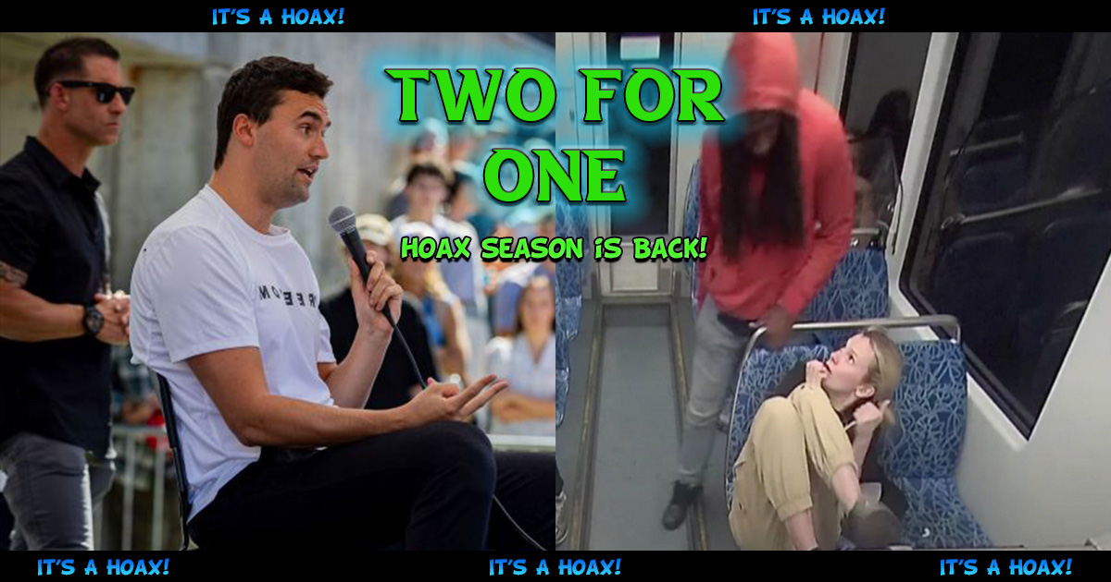
Two For One – Hoax Season Is Back!
Table Of Contents
- The Charlie Kirk Shooting Hoax – pg. 2
- The Charlotte Train Stabbing Hoax – pg. 14
*Important!
For Youtube videos, click on the link, then click on the title of the video in the small pop-up.
*Tip!
If watching a video, and you want to get through it faster, go to the gear icon and increase the playback speed of the video.
The Charlie Kirk Shooting Hoax
This hoax
1. Same basic layout as the Trump shooting hoax
2. Same programming used to paint George Floyd as a martyr.
In the Charlotte train stabbing hoax the blood in the seat looks to be CGI or AI, and it looks like they used CGI or AI in the Charlie shooting hoax as well. In this first video, the video-maker says Charlie had tubing under his shirt. It could be that, or it could be something that caused a burst of air and/or gave him a jolt in order to achieve the “got shot” look. It’s a look similar to that one grocery store shooting hoax where they were using puffs of air to make it seem like people were getting shot. Or the shirt was probably switched to CGI or AI to create the “got shot” look, which explains the blurred face and the weird creases. There was a crisis actor who did an interview and said that Charlie was shot in the heart. It’s possible that it was supposed to be a chest shot and that’s why they did the effect with the shirt. The video-maker also mentions the ring appearing to change fingers, but it actually fell off and stopping the video at the right moment makes it seem like it’s on the pinky finger. You’ll see this in a later video.
MrE: Charlie Kirk Anomalies
https://www.bitchute.com/video/wSpvcmcZLOnf
The spot on his shirt is most likely a wireless lavalier microphone that attaches magnetically. You can see it in other footage. And the part on the inside of his shirt, near the top, is probably what people are seeing in other videos. You can see it here:
10 minutes before the "shot" - Charlie Adjusts The Blood Squib's Fat Unclipped Hose (not a mic)
https://www.bitchute.com/video/BQQiPE0h33Ou
But this doesn’t explain why it moved and became the bullet hole, or disappeared and the bullet hole appeared. This suggests that they did change the shirt to CGI or AI.
Take a look at this video:
https://www.facebook.com/reel/1032530965534262
Charlie kirk assassination psyop hoax with proof updated
https://www.bitchute.com/video/wKhEyRD9Zywa
Here’s another video segment focusing on the shirt.
Watch 4:18 (-27:45 on the right) - 7:15 (-24:48 on the right)
DON'T BE FOOLED BY THE WORLD STAGE! THEY KILLED THE CHARACTER CHARLIE KIRK BUT THE ACTOR IS STILL ALIVE!
https://153news.net/watch_video.php?v=XWBH7477Y3SN
Try to ignore all the symbolism.
The Charlie Kirk Shooting Hoax 100% Exposed!
https://rumble.com/v6ytfgo-charlie-kirk-shooting-hoax-100-exposed.html
10:03 – I think that’s the other side of the mic. But I do think fake blood was used to stain his body and shirt while he was on the ground (when they usually put the blood on). I think the blood that was pouring out of his neck was CGI or AI.
12:37 - 13:01 – Pay attention to the camera you’re seeing the video through, and imagine a person there holding this camera. And the sound of the gunshot can be heard at the same time as the impact, and it actually sounds like it’s coming through the speakers.
- end commentary -
Another crazy angle shows it definitely is not "fake"
https://www.bitchute.com/video/kws256gzHwB8
The Charlie Kirk Shooting Hoax 100% Exposed - The Final Nail In The Coffin!
https://rumble.com/v6ywsv0-the-charlie-kirk-shooting-hoax-100-exposed-the-final-nail-in-the-coffin.html
- 9:57 – The lady with the camera is capturing footage of the other lady running, and was probably supposed to capture her covering her mouth but it looks like she did it too late. When they show you the footage, you’ll see a woman running by, and possibly covering her mouth as though something terrible has happened.
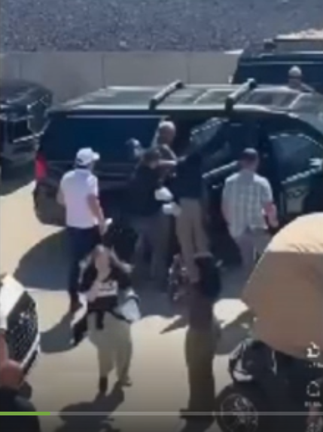
- end commentary -
Charlie Kirk Analysis - Cast And Crew
https://www.youtube.com/watch?v=ynmYzopPETc
Take a look at this one. Somehow, like several other shots, the person decides to scan the crowd inside of focusing on the real action.
https://drive.google.com/file/d/1ItBAkJLAeEION-vvn_3WuLFcp0yYAwGq/view?fbclid=IwY2xjawNAOUFleHRuA2FlbQIxMABicmlkETExWkp6UE1CQlFWSEc1Yk4wAR6KAvH-zA0c1tuStKrVU3oubyAVMDoIa5rOF8hCGnAPFbmmg00pnGlkWXlE0g_aem_T98oWMcM7ooGrJ5Al9jYyg
Charlie Kirk Shooting Hoax - Chia Charlie
https://www.bitchute.com/video/fF2KAlg3xM6G
Charlie Kirk Hoax Recap Short (Speak or Be Silenced!)
https://www.bitchute.com/video/mb2DTerDxKOc
Charlie Kirk Analysis - What's This And Why?
https://www.youtube.com/watch?v=Kt2CubEtmJM
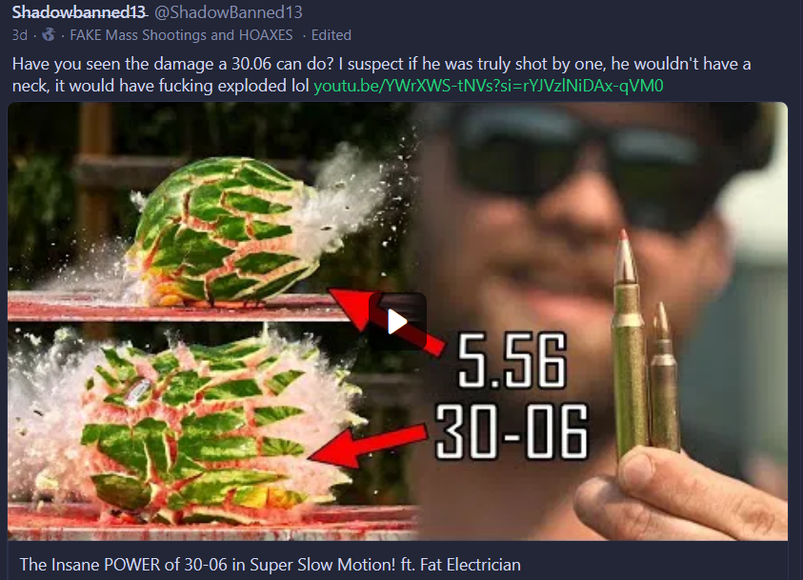
Note: the makers of the next two videos believe the shooting was real.
Watch 4:19 - the end
WTF?! Surgeon for Charlie Kirk says His Neck was "SO SO IMPRESSIVE" it stopped the 30-06
https://www.youtube.com/watch?v=dIPS5t_XE94&t=259s
You can look it up, Andrew Kolve actually is a spokesperson for TPUSA and executive producer of The Charlie Kirk Show.
Charlie Kirk Declared "Man of Steel" By Surgeon. Literally RIDICULOUS
https://www.youtube.com/watch?v=onElfDyeoks
Here are some videos of the ground with no blood:
https://youtube.com/shorts/5qbhzGhbzLU?si=GvHzzdBlPwEGrajg
https://www.washingtonpost.com/video/politics/the-countdown-to-government-shutdown/2025/09/12/f315c616-c74d-4885-b4fd-3dfb0ff113ac_video.html
https://youtube.com/shorts/N7VxBYQJ39I?si=LZdqVNzNwiMLGjJW
https://x.com/EpochTimes/status/1965912967020789913
Charlie Kirk Hoax No Crime Scene Investigation
https://www.bitchute.com/video/s8BMu9Isamil
Charlie Kirk Crime Scene Being Altered, Deck Removed. Kirk Shooting Hoax
https://www.bitchute.com/video/uHskAOuWIWnI
Watch the beginning - 15:56
THAT'S A WRAP! THEY'VE ALREADY COVERED UP THE STAGE OF CHARLIE KIRKS FAKE DEATH WITH CONCRETE!
https://www.bitchute.com/video/cS8EOxPPjWqg
Charlie Kirk Shooting Hoax - Charlie's Wife Bids Farewell to a Dummy in a Casket
https://www.bitchute.com/video/FIflebALTvRM
Charlie Kirk’s wife was mic’ed up for his funeral
https://www.youtube.com/watch?v=6GE6HDpSDMc
Charlie Kirk Hoax - The Fake Body
https://www.bitchute.com/video/cazutlrlC5cN
🚨 Mrs. Erika Kirk FORGIVES the killer of her husband, Charlie Kirk: “That young man, I forgive him.”
https://youtube.com/shorts/VuosS-HzzMM?si=g3wQS9yGmHCo_tUS
Satanism at its best. And just think, this is where you live.

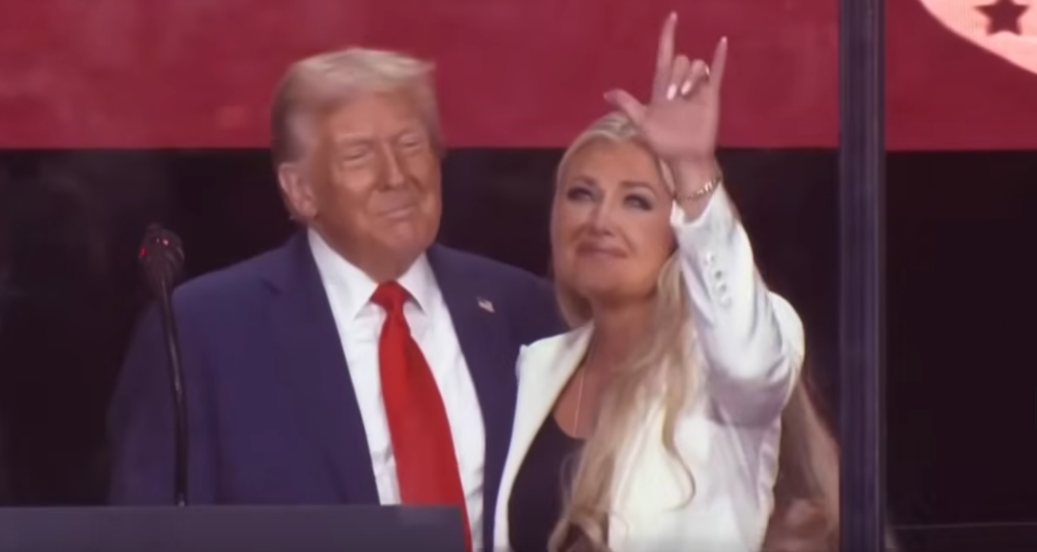
At the memorial.
Candace Owens started off as being a part of the Jewish controlled crowd of online personalities alongside Charlie Kirk until they changed her role and tried to pass her off as an independent anti-Semitic conspiracy theorist that went rogue (actually controlled opposition). And now, for this hoax, they have her pushing the narrative that is floating around – that Israel killed Charlie Kirk. So, it’s up to you if you want to believe what she says in this next video.
"NO BLOOD?!" Candace Owens CLAIMS She Saw UNSEEN Charlie Kirk Footage
https://www.youtube.com/watch?v=Rs6Q7phHJjE
Candace Owens FINALLY Receives Her Negro Wake Up CALL!
https://www.youtube.com/watch?v=Bou--NKQEbo
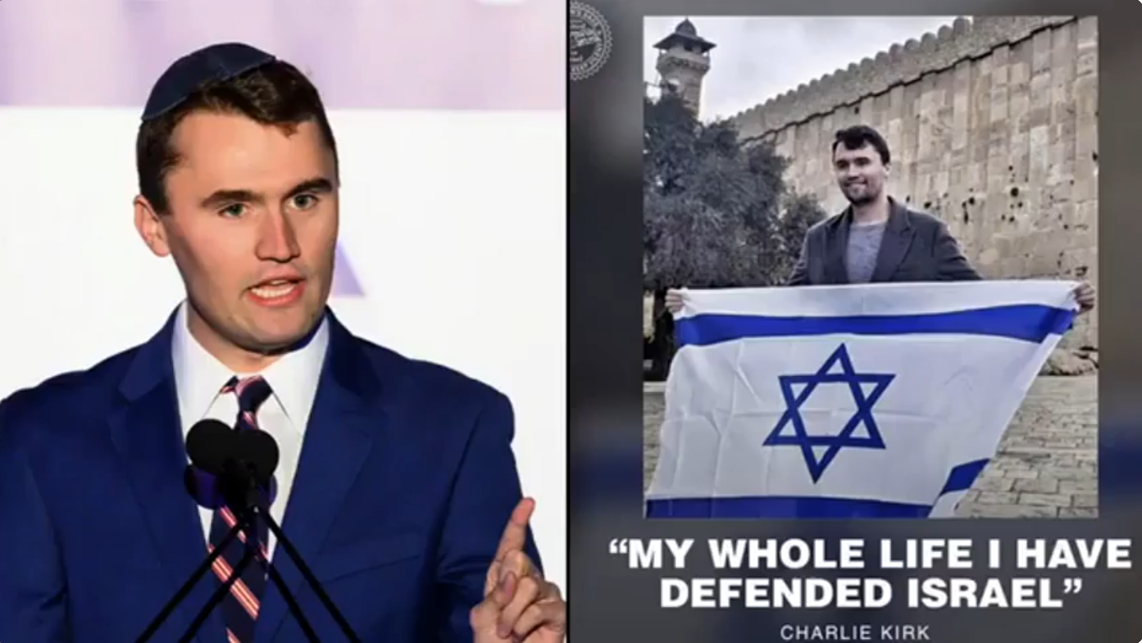
Charlie Kirk Bizarre Eye Witnesses Interview
https://www.youtube.com/watch?v=-Cd19bdlpZA
Charlie Kirk Shooting Hoax - Low Budget Script Writers and Kash Patel's 33 Double-Down
https://www.bitchute.com/video/ZtHNajSVBk6v
Agendas?
I thought the gun grab was only a Democrat thing? Could it be that both Parties are controlled by the same powers? What a shocker. With the staged Trump shootings it should be obvious now that they’re going about gun control in a different way – by using the Republicans. I bet the Charlie Kirk crowd is really rethinking the whole gun thing now.
Besides the gun control agenda, they also had their other agendas. One was mentioned in the first video.
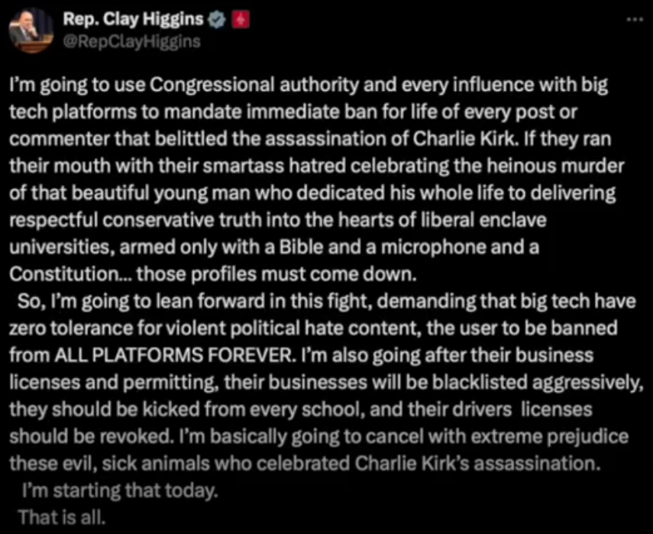
And did you notice what they were saying immediately after the “shooting”?
https://www.tiktok.com/@adammockler/video/7548622287231143223?is_from_webapp=1&sender_device=pc&web_id=7533753290560144927
https://www.tiktok.com/@adammockler/video/7549368562318576910?is_from_webapp=1&sender_device=pc&web_id=7533753290560144927
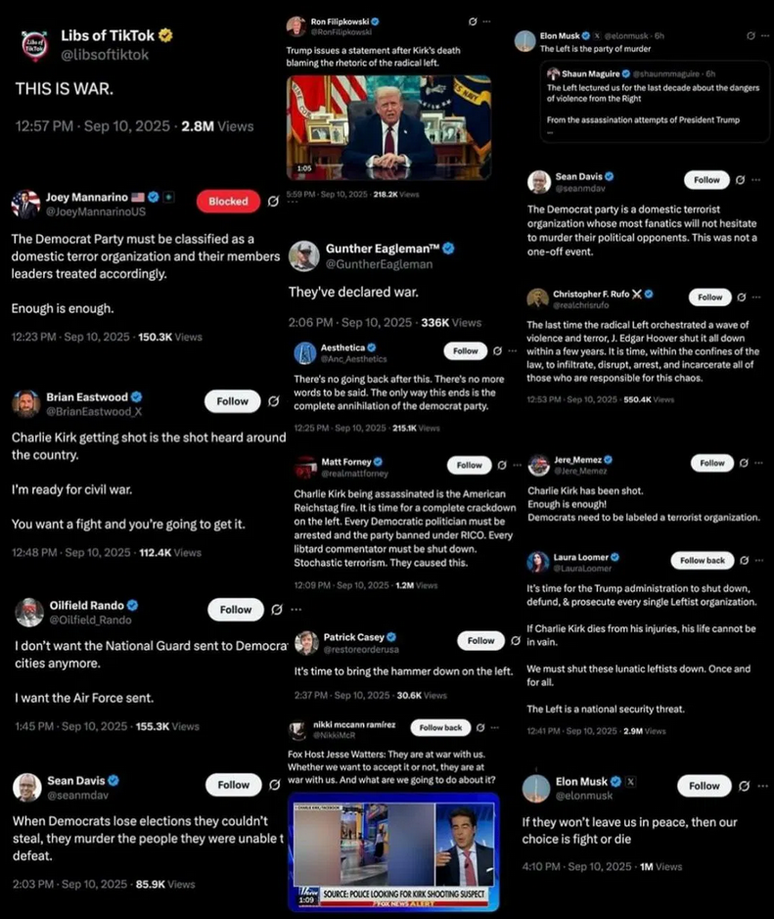
These weirdoes are really creating a true gang-banging rivalry. So much for the Republicans being the party for America. (No, I’m not saying that the Democrats are.) I don’t understand how someone could be pro-American and be Republican anyway. All the major destruction to America happens during Republican administrations – COVID and all that came with it, the financial crisis, war after war, 9/11....
“Based on government and independent analyses, right-wing extremist violence has been responsible for the overwhelming majority of fatalities, amounting to approximately 75% to 80% of U.S. domestic terrorism deaths since 2001.”
Source: Right-wing extremist violence is more frequent and deadly than left-wing violence, data shows
https://www.pbs.org/newshour/politics/right-wing-extremist-violence-is-more-frequent-and-deadly-than-left-wing-violence-data-shows
Fascist Charlie Kirk funeral goes full N@zi #shorts
https://youtube.com/shorts/9_bYCrkHfDk?si=rf7n2lIw7QrdGa40
Elon Melts Down over REAL Charlie Kirk TRUTH
https://www.youtube.com/watch?v=wEX_qFCSCgM
And I’m sure you’ve heard about all the people being fired from jobs and expelled from school for their views on Charlie. From the looks of it “they” are also having content creators lie about being fired so that viewers would fear and bow down.
MSNBC EXPOSED in LEAKED EMAIL... Protecting CHARLIE KIRK?!
https://www.youtube.com/watch?v=YoK99g3f6xQ
"Dumbest Thing You Can Say as AG": Megyn Kelly on Pam Bondi's Comments About "Hate Speech"
https://youtube.com/shorts/7-dteSB2Iw8?si=uNHN1KNn2XEEvAvf
US Senate unanimously approves Charlie Kirk Day. (But wait, there's more)
https://www.youtube.com/watch?v=mJLGAEJJVlY
Watch the beginning - 7:51
Church Plays Ai generated Charlie Kirk mage in Church +"Charlie Kirk died for our Sins" 😱
https://www.youtube.com/watch?v=VDYxaJfpfaY
Florida congresswoman compares Charlie Kirk to JFK and MLK Jr.
https://youtube.com/shorts/96uUPP5zdRU?si=OubVzzbWacb6eOFs
MAGA Bot Farm Charlie Kirk PSYOP Is DEEPLY DISTURBING | The Kyle Kulinski Show
https://www.youtube.com/watch?v=wU9nH2VPO08
If you combine the after-effects of all the fake shootings that have occurred, the effects of this graphic fake shooting, and the constant programming aimed against political violence (similar to when they said “September 11th” over and over again in 2001) then you get a public who wouldn’t dare take a shot at their own evil, oppressive government. “Political violence is never the answer.” That, coming from a government that is doing what to its own citizens? That, coming from a media that is doing what to its own citizens. And think about it, “Political violence is never the answer” coming from a government that murders leaders in other countries. What the powers-that-be did to JFK and RFK surely did put the government in check for good. They know not to ever act up. So, political violence is obviously the answer in many cases – and it works when they do it, and it worked when it was done to them. And they just used political violence as a hoax, so it was obviously the answer to them once again.

The Charlotte Train Stabbing Hoax
Watch the beginning - 28:28 (of the time-counter on the left)
Iryna Zarutska - Victim or Psyop? Jews Want Racewars to Hide The Noticing
https://www.bitchute.com/video/cDS9lYECNc9v
- 1:21 – “... and the attempt to create a Black-on-White or White-on-Black race war in America in order to hide the Jewish problem.” Wow, he understands.
- 17:40 - 17:58 – Fact. And the same would be true for Charlie Kirk.
- 22:50 – I disagree with the “White Christians stopping slavery” comment.
- 28:17 – “...and allow them to get out with no bail or very low bail; thirty... forty times after violent crimes.” Lol. He believes the Jewish narrative.
- end of commentary -
Watch the beginning - 33:14
Governments around the world collapsing, Fake Ukrainian woman stabbing being turned on deep State.
https://www.youtube.com/live/FTvDiOQj_Go
Alternative source
Michael Jaco Situation Update Sep 10: "Governments Around The World Collapsing, Fake Ukrainian Woman Stabbing Being Turned On Deep State"
https://rumble.com/v6yqlei-michael-jaco-situation-update-sep-10-governments-around-the-world-collapsin.html
- 19:22 – No blood, holes, cuts, or marks on the left side or the right side. That leaves the center of her neck – her throat. So, she got stabbed in the throat but she didn’t grab her throat? She got stabbed in the throat but it produced all the blood we see later on?
- 20:47 – She rolls to, and over, the left seat so blood should be on the left seat.
- 21:32 – Watch how the blood stain changes shape.
- 31:00 – “They turned it around on the Deep State.” This and other statements show that he has that weird, Trump era, fake QAnon type of understanding. Ignore this.
- end commentary -
Somehow her wrist and hand didn’t get cut.
Iryna Zarutska Killing The POS Is Heard Saying " I Got That White Girl ".
https://www.bitchute.com/video/yiY1cduGJ8TU
Full version (if you want it)
https://www.bitchute.com/video/7dhHtFG8KLeA
No knife.
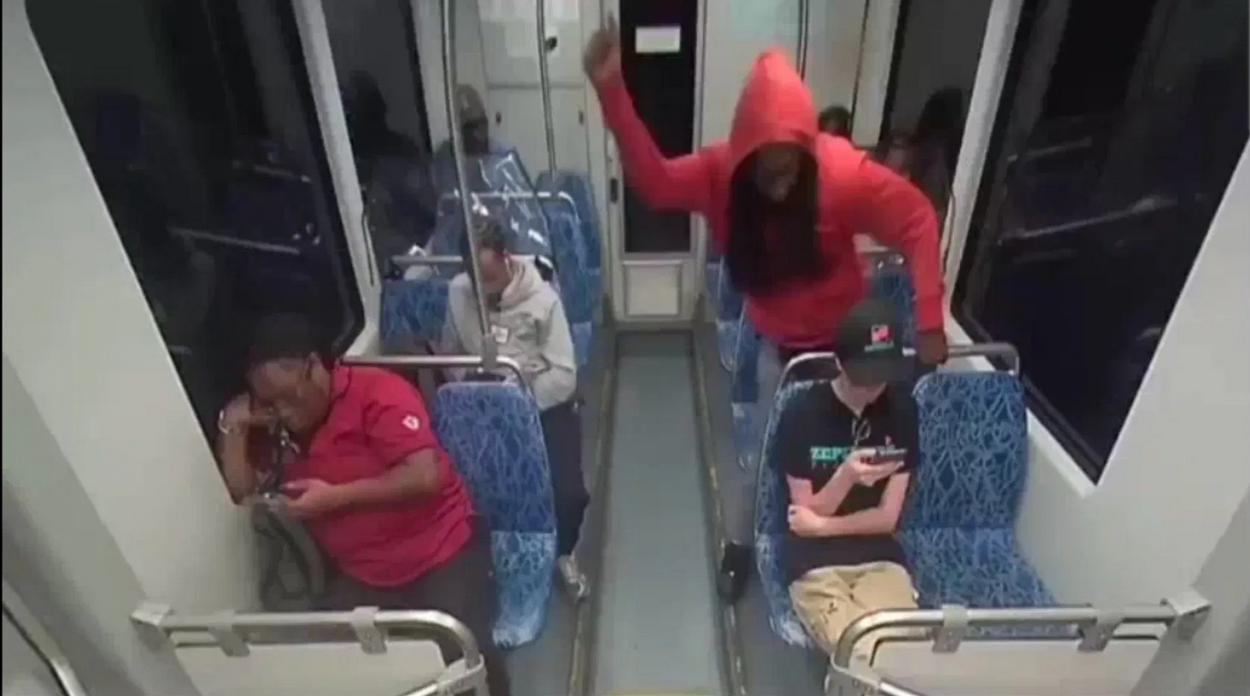
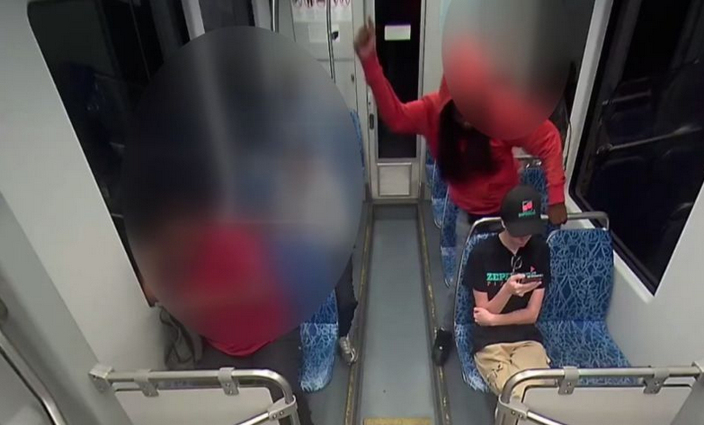
This is the best angle. No wonder all the videos from this angle start after the action.
Raw Footage from the Stabbing of Iryna Zarutska - An important aspect that no one talks about
https://www.bitchute.com/video/M7943gq1Oj4v
To slow it down go to the gear icon and set the speed.
More footage of Iryna Zarutska's murder
https://www.bitchute.com/video/PCwakUZUfGWI
Her wound is definitely fake. But in the footage from the other train car:
1. It looks like he might have cut himself. But he attacked with his right hand, and blood is supposedly dripping from his right hand. And if you look at the moment of attack in slow motion you’ll see that there’s no way he could have cut himself on the right hand.
2. They want it to look like he cut himself.
3. They want it to look like blood is dripping from the knife.
There’s no telling what they intended the story to be, but whatever the case, her injuries are totally fake.
Staged/Fake Stabbing Of Iryna Zarutska?
https://www.bitchute.com/video/7A1ZGkkfUKhi
Go here and cycle through the images:
https://gab.com/Lateralus1/posts/115184870388926180/media/1
Ahhh, just like the old hoax days:
https://www.gofundme.com/f/in-loving-memory-of-iryna
Agendas?
“White people beware, the Black criminals are on the hunt. And you could be next!”
Do you remember the “money shot” in the Trump shooting hoax?
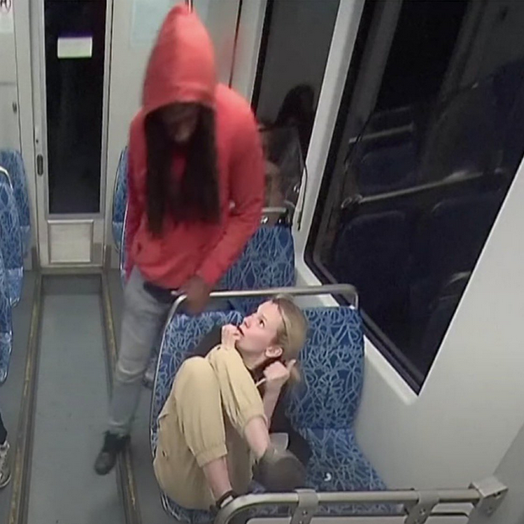
What do you think the creators of this were trying to do within the minds and hearts of White America when they made this part?
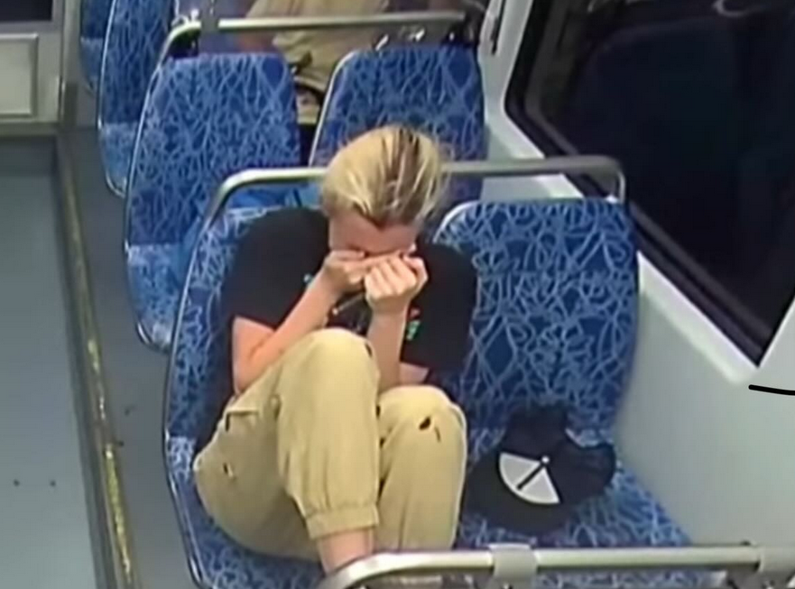
And then they did a classic I remember from the 1980’s, the side-by-side:
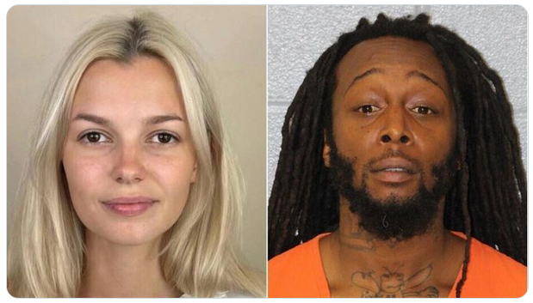
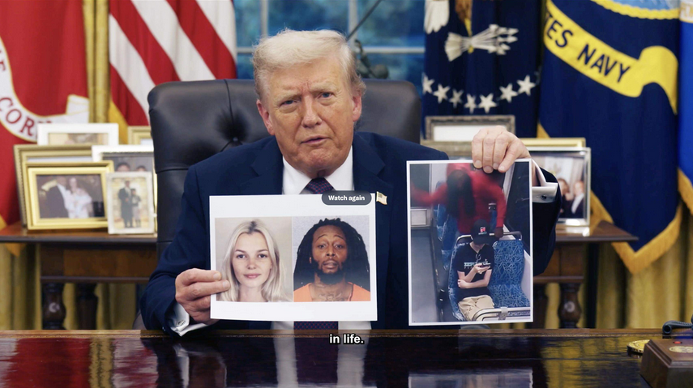
Tragic Footage Of Charlotte Stabbing Aftermath REVEALED
https://www.youtube.com/watch?v=zwmBGG1rY8s
- 2:06 – “... and it’s being allowed to happen across the country.” Huh???
- end of commentary -
Take a look at the comments.
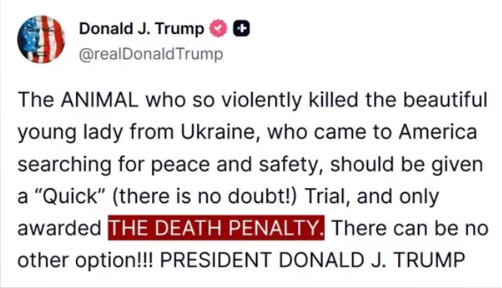
“I have seen the horrific video of a beautiful, young Ukrainian refugee, who came to America to escape the vicious War in Ukraine, and was innocently riding the Metro in Charlotte, North Carolina, where she was brutally ambushed by a mentally deranged lunatic. The perpetrator was a well known career criminal, who had been previously arrested and released on CASHLESS BAIL in January, a total of 14 TIMES. What the hell was he doing riding the train, and walking the streets? Criminals like this need to be LOCKED UP. The blood of this innocent woman can literally be seen dripping from the killer’s knife, and now her blood is on the hands of the Democrats who refuse to put bad people in jail, including Former Disgraced Governor and ‘Wannabe Senator’ Roy Cooper. North Carolina, and every State, needs LAW AND ORDER, and only Republicans will deliver it! Additionally, where is the outrage from the Mainstream Media on this horrible tragedy? VOTE FOR MICHAEL WHATLEY FOR UNITED STATES SENATE, HE WON’T LET THIS HAPPEN AGAIN!” – Donald Trump – X (Twitter) account
Light rail fact check: Here are the claims vs. reality in the Charlotte stabbing
https://www.charlotteobserver.com/news/local/crime/article312121599.html
The Republicans seem to be the Party of lies. Their lying is non-stop, bold, and usually the complete opposite of reality.
Fox News and the Republicans have clearly just said that White people are stupid and like little toys that they can manipulate at will. Not too long ago Fox News presented an absolute lie to their viewers with their doctored cell phone footage and lying statements about the Cincinnati brawl involving Blacks and Russians. What’s even more sickening is that they kept lying as more and more unedited footage and videos of witnesses surfaced online. And the Left side of the media, CNN and others, surely didn’t expose them either (being fake opposition).
In that “brawl”/“melee” Fox News stressed two points:
1. Black people brutally attacked innocent White people.
2. Black people just stood by and did nothing.
Not too long afterwards the powers that be followed up with the Iryna Zarutska stabbing hoax:
1. A Black man fatally stabbed/brutally attacked an innocent White girl.
2. Black people just stood by and did nothing.
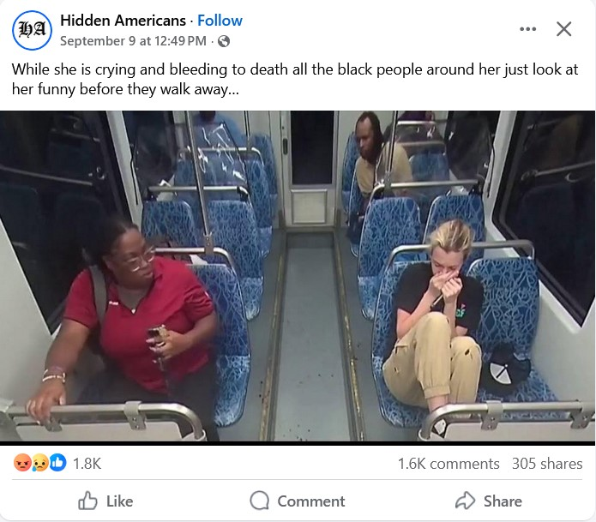
The Murder of Iryna Zarutska: An Important Message to White People
https://www.bitchute.com/video/E1q2K3TViQqa



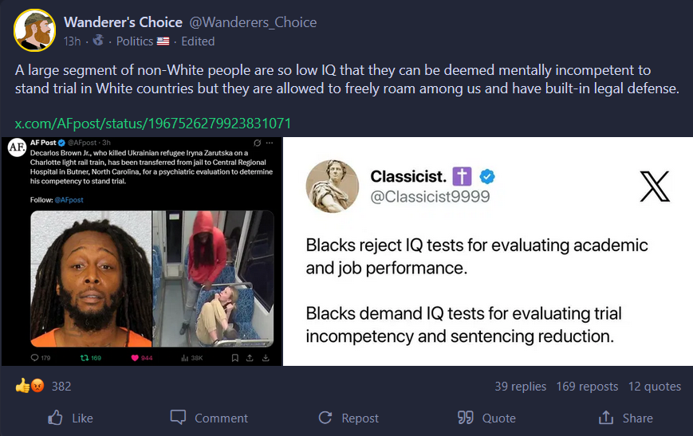
Source: https://gab.com/Wanderers_Choice/posts/115208422573068829

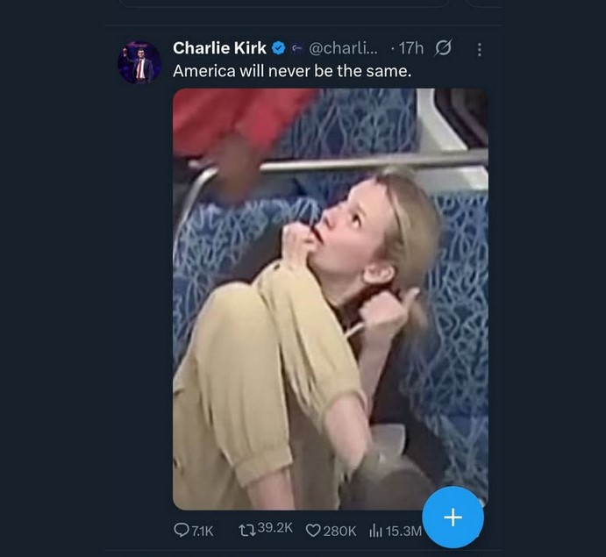


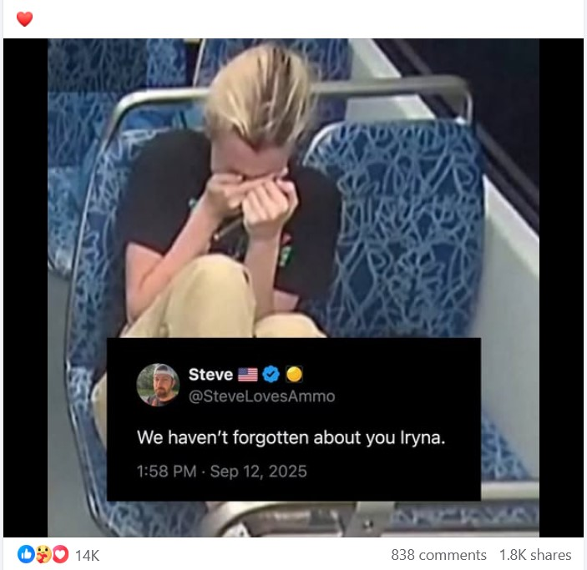
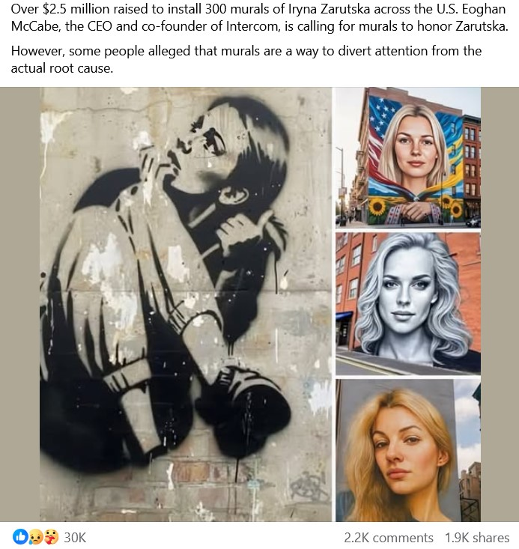
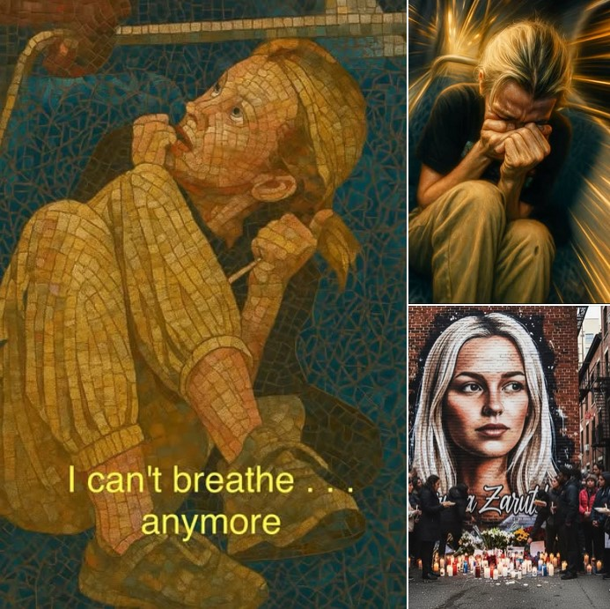
IHIP News: MAGA Christians RAMP UP Violent and DANGEROUS Racism!!
https://www.youtube.com/watch?v=CEFdY_jEG8U
- 6:50 – They have. That’s actually true, but the Republicans don’t say it because they care about Blacks.
- 7:12 – “This White evangelical engine behind Donald Trump....” It’s controlled by White anti-Christian Jews.
- end of commentary -
MAGA RAPPER COSPLAY AND MAKES L*NCHING RAP SONG!
https://www.youtube.com/watch?v=AuDY8txhR10
BLACK GIRL ST*BBED BY WHITE MALE BOARDING A TRAIN SAME CRIME NO OUTRAGE!
https://www.youtube.com/watch?v=0Of4aoYZwt4

